Inverter1.mag -> 4 lamda / 2 lambda NMOS,PMOS transistors

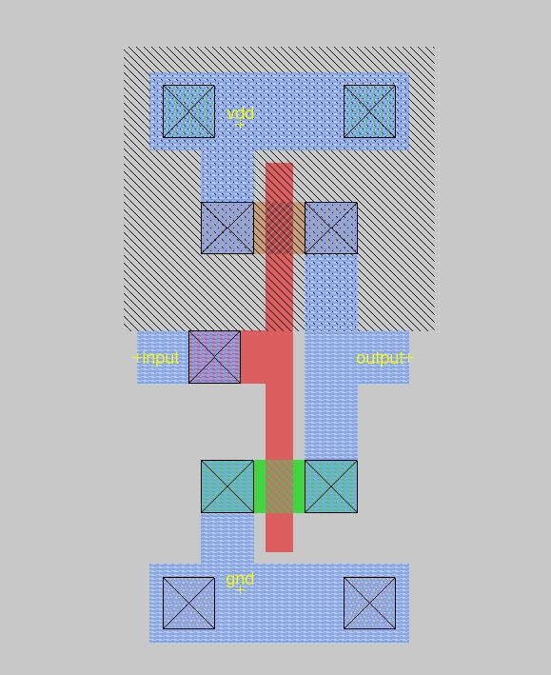

Inverter1.spice

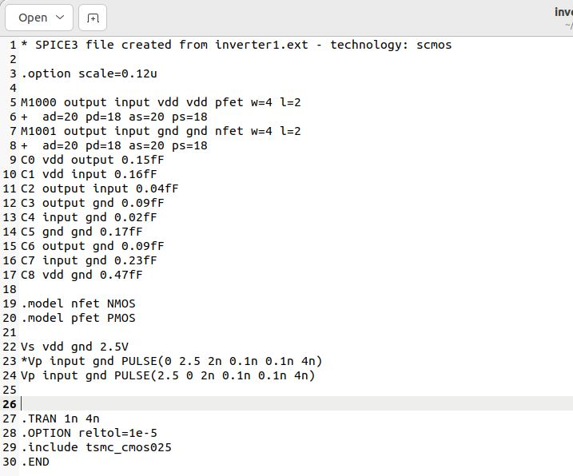

When I want to check to Low to High , I wrote new pulse but I just changed the start and the end Voltage values. Moreover, High to Low pulse will be comment line.

This is H2L of inverter1.ext (inverter which PMOS and NMOS are 4 lambda / 2 lamda )

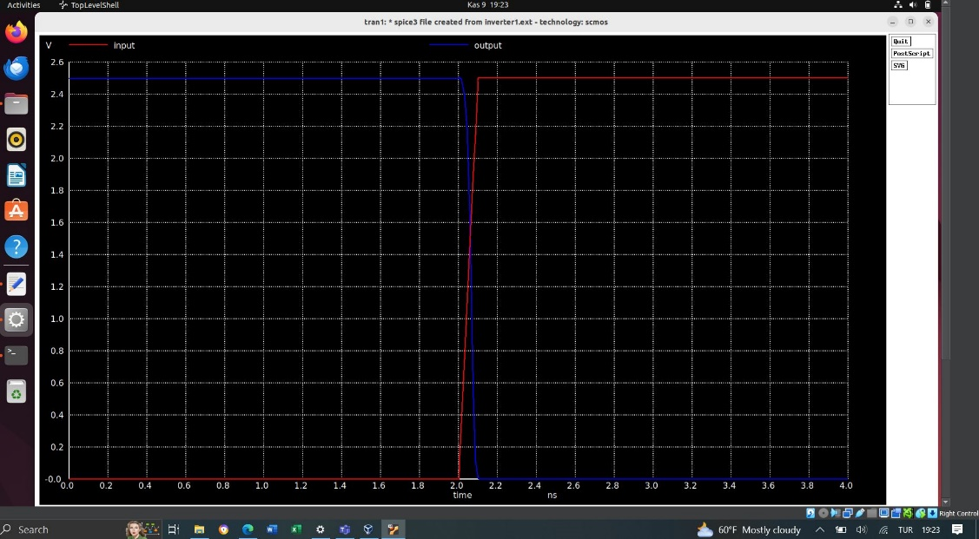

This is the zoom of H2L of inverter1.ext (inverter which PMOS and NMOS are 4 lambda / 2 lamda )

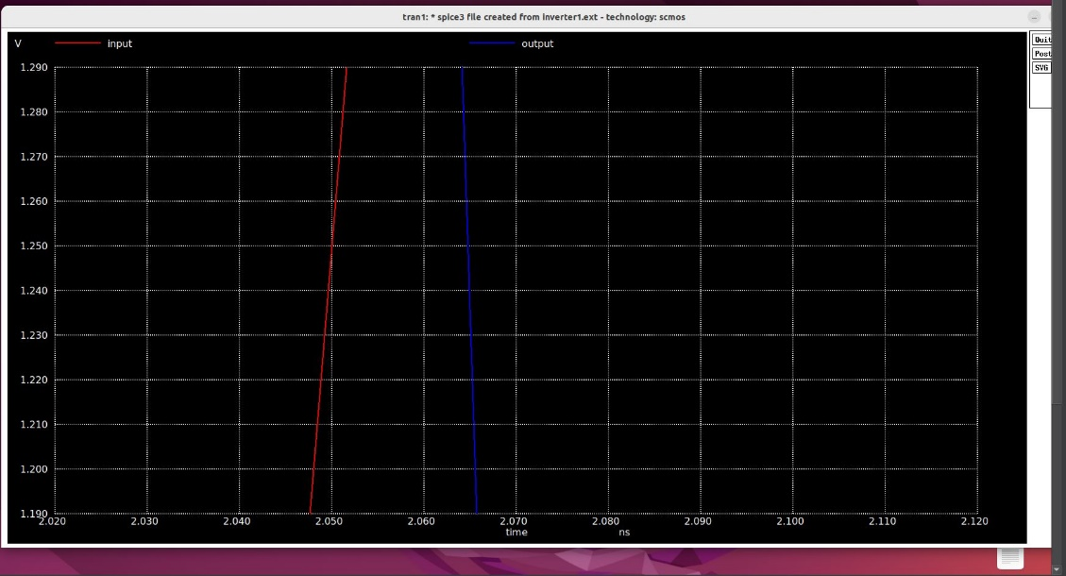

To find the delay , Clicking the input and the output on 1.25V. And the values are seen on the screenshot.

The delay -> 2.06483e-09 – (2.05007e-09) = 0.01476e-09

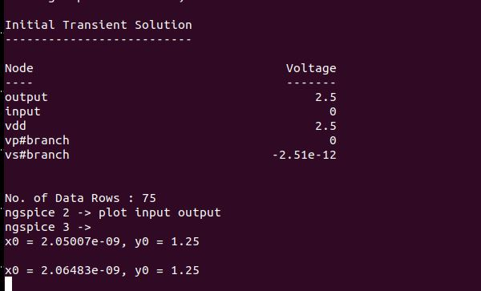

This is L2H of inverter1.ext (inverter which PMOS and NMOS are 4 lambda / 2 lamda )

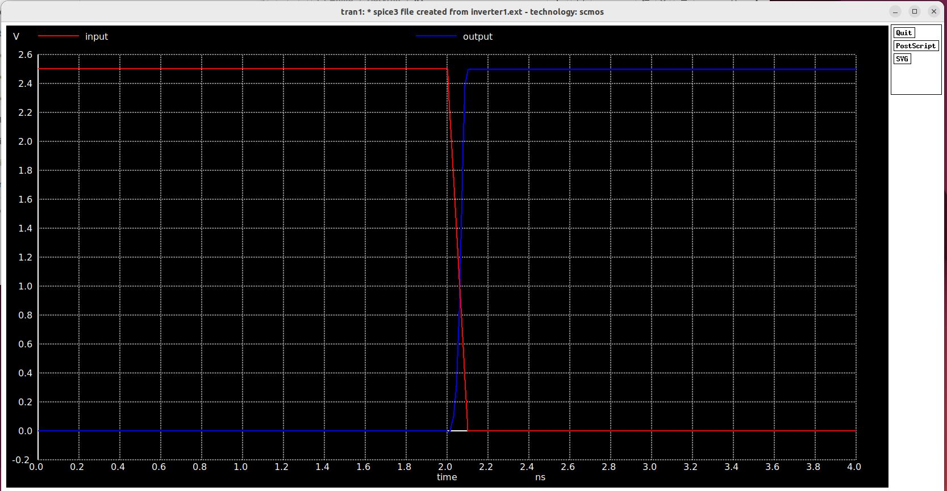

This is the zoom of L2H of inverter1.ext (inverter which PMOS and NMOS are 4 lambda / 2 lamda )

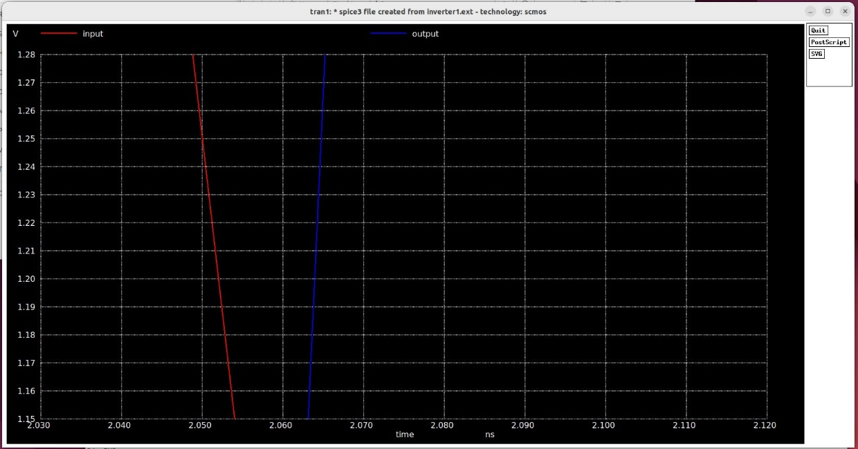

To find the delay , Clicking the input and the output on 1.25V. And the values are seen on the screenshot.

The delay -> 2.0647e-09 – (2.05006e-09) = 0.01464e-09

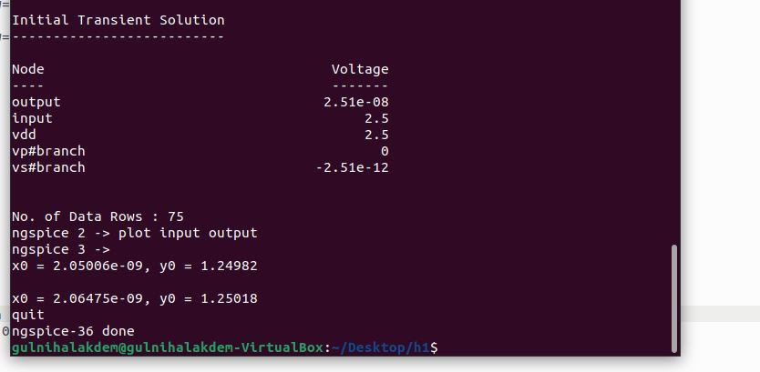

Inverter2.mag -> 8 lamda / 2 lambda NMOS,PMOS transistors

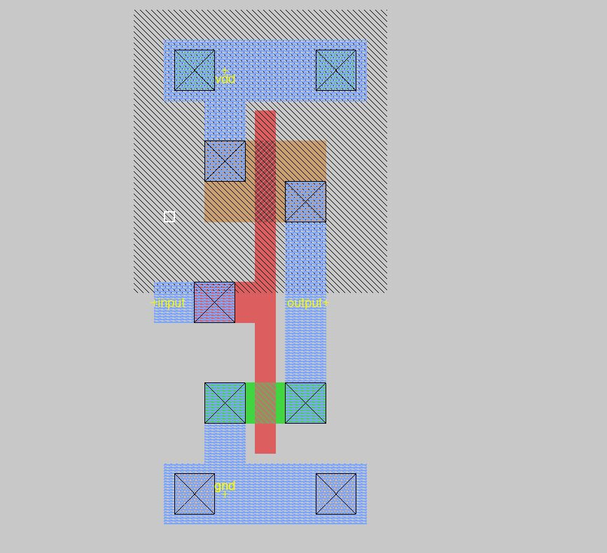

Inverter2.spice

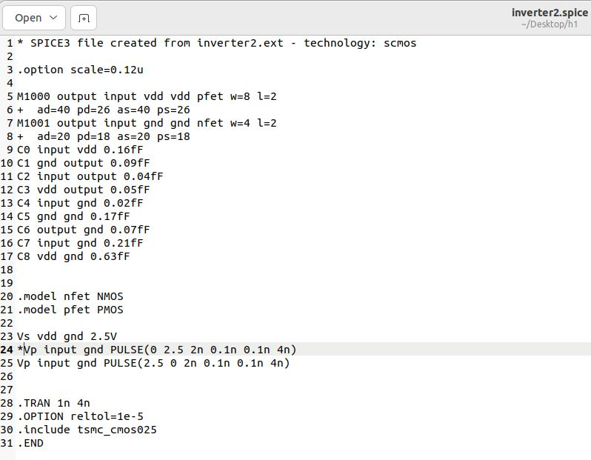

This is H2L of inverter2.ext (inverter which PMOS and NMOS are 8 lambda / 2 lamda )

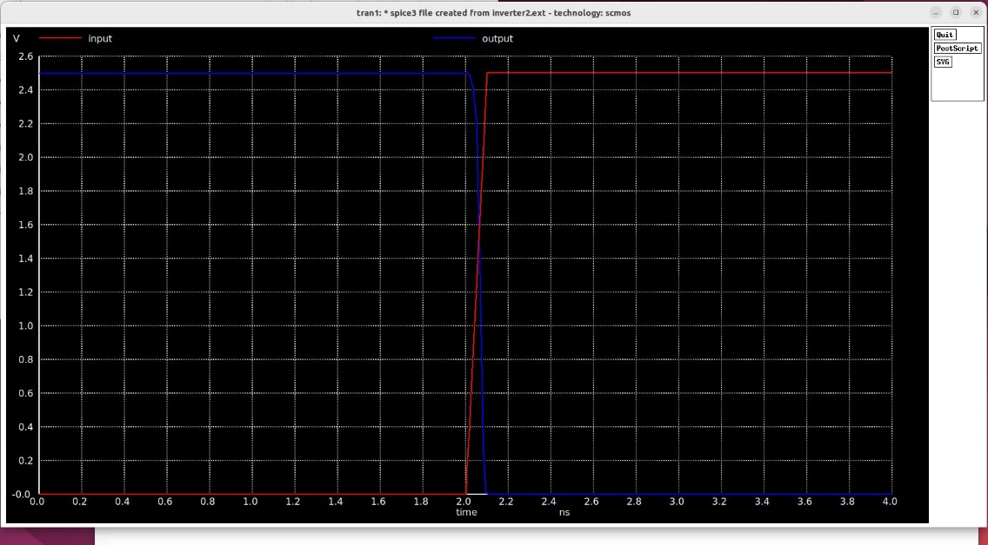

This is the zoom of H2L of inverter2.ext (inverter which PMOS and NMOS are 8 lambda / 2 lamda )

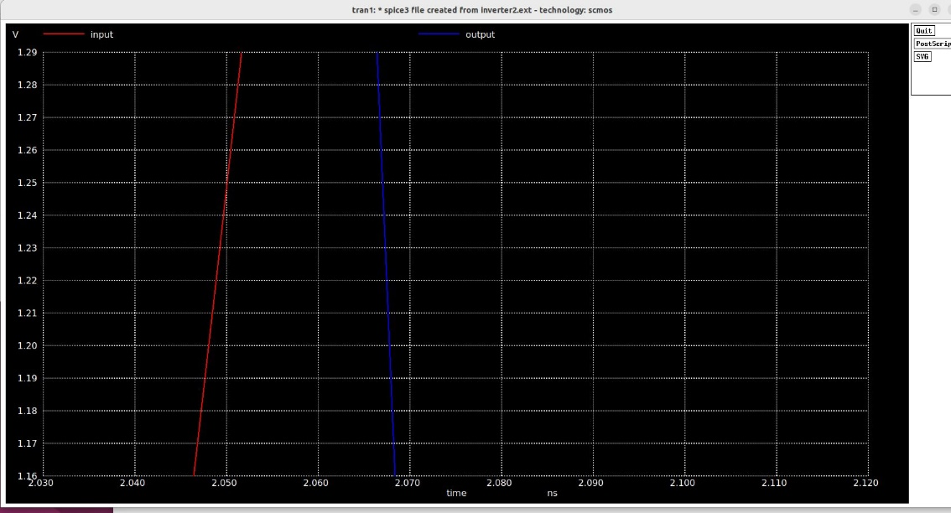

To find the delay , Clicking the input and the output on 1.25V. And the values are seen on the screenshot.

The delay -> 2.06706e-09 – (2.05006e-09) = 0.017e-09

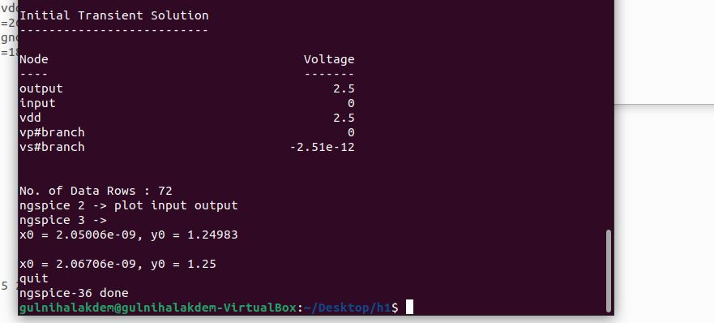

This is L2H of inverter2.ext (inverter which PMOS and NMOS are 8 lambda / 2 lamda )

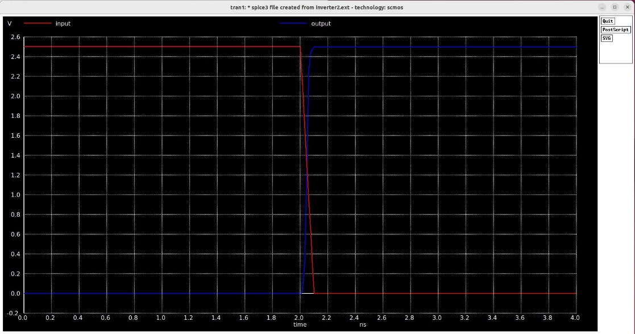

This is the zoom of L2H of inverter2.ext (inverter which PMOS and NMOS are 8 lambda / 2 lamda )

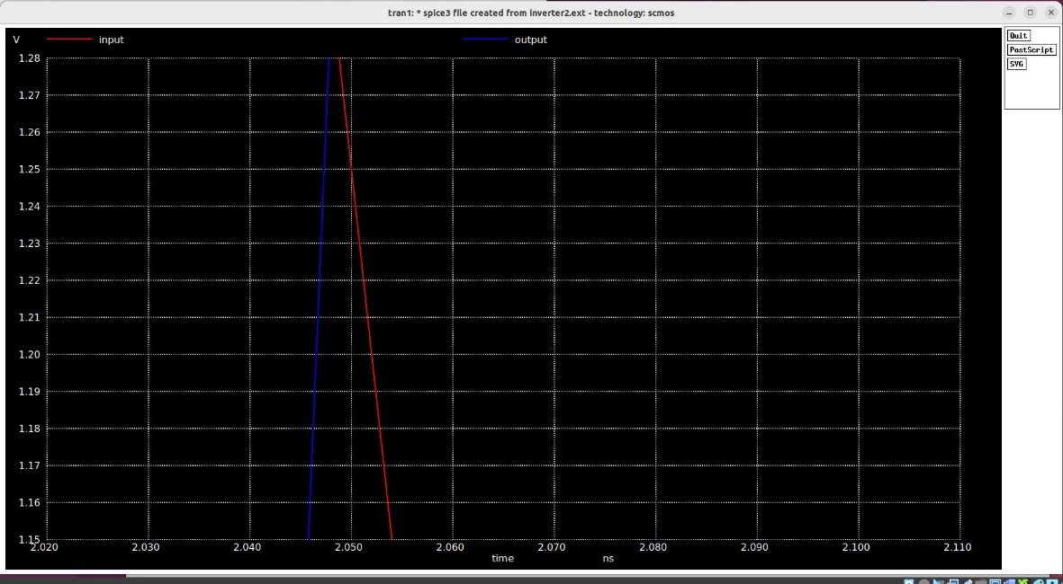

To find the delay , Clicking the input and the output on 1.25V. And the values are seen on the screenshot.

The delay -> 2.05006e-09 – (2.04732e-09) = 0.00274e-09

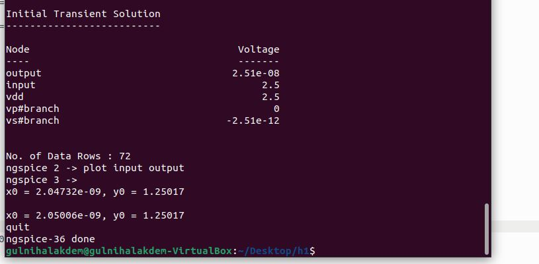

When the witdh of PMOS increases, The values and the plots are not significantly changed because pmos speed is slower that nmos.

When we dont put any taps, Spice is hard to converge. It seems clearer that there is a problem with a floating point.