**Q1: B+ Tree Operations**

You may use the following B+ structures to help complete your diagram.

Notice the first structure has two Text Boxes with preset values (use indentation and blanks to easily fill-in) Feel free to change the content, or remove Textbox if you decide to print & fill.

Some of the diagrams may not be used, and some may be used more than once.

**You can draw your trees from scratch.** (Meaning you don’t have to use any templates)

Template1

Num1 Num2 Num3

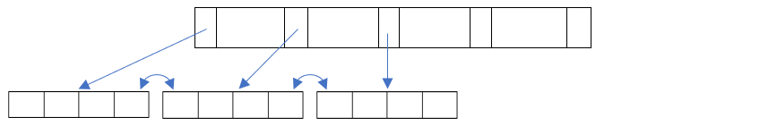

N1* N2* N3* N4* N5* N6* N7* N8*

Template2

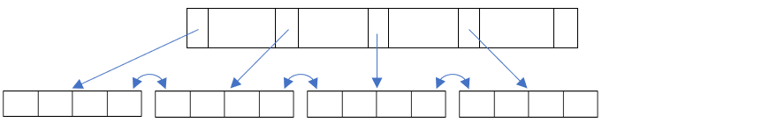

Template3

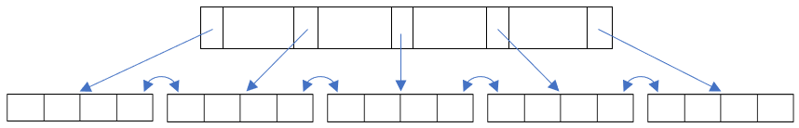

Template4

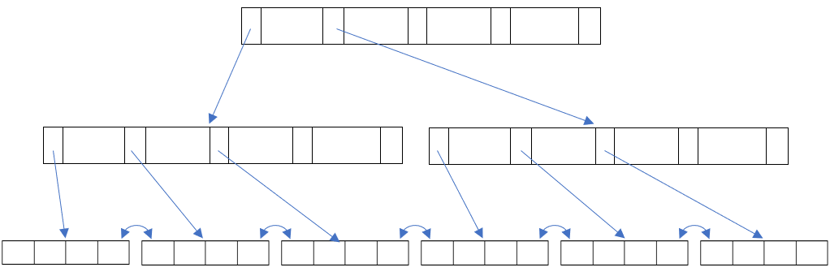

**Q3. Linear Hashing**

You may use the following hashing buckets to help complete your diagram.

“Level ?, N=?” is editable.

**Again, you can draw your diagram from scratch.**

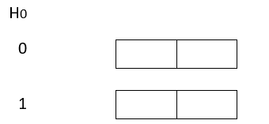

Level ?, N=?

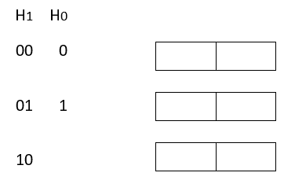

Level ?, N=?

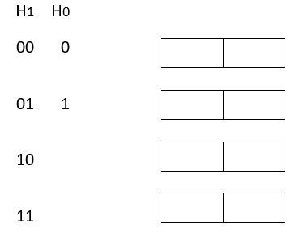

Level ?, N=?

Components may be used:

Pending bucket (can overlap templates above)

Next = ?

Edit Next value and overlap templates at proper location.

**Q4. Extendible Hashing**

You may use the following directory and data pages to help complete your diagram.

Usage: Data Page are editable tables. Edit bucket content on each update and screenshot proper number of Data Pages. Remember to connect Directory to Data page using arrows.

**Again, you can draw your diagram from scratch.**

|  |
| --- |
|  |
|  | |  |

Data Page

  
  
  
     

  
  
  
     

  
  
  
     