

MEDICARE WEBSITE

Module Code: **B9IS108**

Module Title: Developing Content for Cloud

Lecturer: Paul Laird

Group Members: Asha Shahji (10361701)

Jijin Johnykutty (10376573)

Ake Bolaji David (10176370)

Contents

INTRODUCTION 2

SITE -WORKFLOW 3

WEBSITE DESIGN 3

FLOW CHART 3

DATABASE DIAGRAM 6

USER INTERFACE 7

HOME PAGE 7

7

LOG IN PAGE 8

SIGN-UP PAGE 9

ADMIN CONTROL 10

IMPLEMENTATION 10

Implementation achieved: 10

Future implementation: 11

Development environment 11

Future Challenges 11

Costing 12

Reflection 13

References 14

# INTRODUCTION

“Always Laugh When You Can. It Is Cheap Medicine”

Medicare website is designed to help customers to search online medicines nearby pharmacy store from home. Customers must register themselves first to access full website. They can sign up and provide their age details so that vendor came to know the user is above 18 years. Once account verified by admin they can put their preferences.it will help to sorting the medicines and whenever they access the same website they need not to go all through. they would be recognizing as all-time customer and can get details of the medicines whatever they put in the preferences.

# SITE -WORKFLOW

The Site has two major modules which are the Admin and the user module. first time user has to register themselves. As they put email id they will get an one time password (OTP) over the mail and once they put OTP they will be recognized as verified customer. Whenever they want to change the password they would get a reset password option. On home page, there is a dashboard which help them to find nearby pharmacies and their product details. They can access pharmacy menu over there and select preferences of medicines so whenever they came to this site they will get a sorted medicine and need not to search all. They can also block the medicines, so vendor came to know that this medicine is blocked by this person and this is assigned one if the user is not able to collect the medicine they can release it.

The other major module is administration module which has different log in page. Whenever a user submits any queries it will goes to admin system by contact us form and it will be sorted by admin. He can delete or add any data from the website. Admin can give authority to vendors as well. Once a shop is verified by admin. He will provide an id and password to the vendors. Vendor can change the password, but id will be same and update the product. Shopkeeper interacts with the customer according to their use and stocks availability in the shop. Admin is the one who manages the website and its work.

Users can log in by google account, but they need to verify before accessing the site. we are giving pay pal option so that if any user doesn’t have cash they can pay by online. This would be optional to the users like if a user blocked the medicine it will redirect to pay pal page where he can pay by card,but they can skip this as well and pay by cash on the shop.

# WEBSITE DESIGN

## FLOW CHART

Based on the functionality of the system, it is basically divided into three major modules.

1. Administration module
2. User module
3. Email notification
4. Google
5. Pay pal payment

User Flow chart:

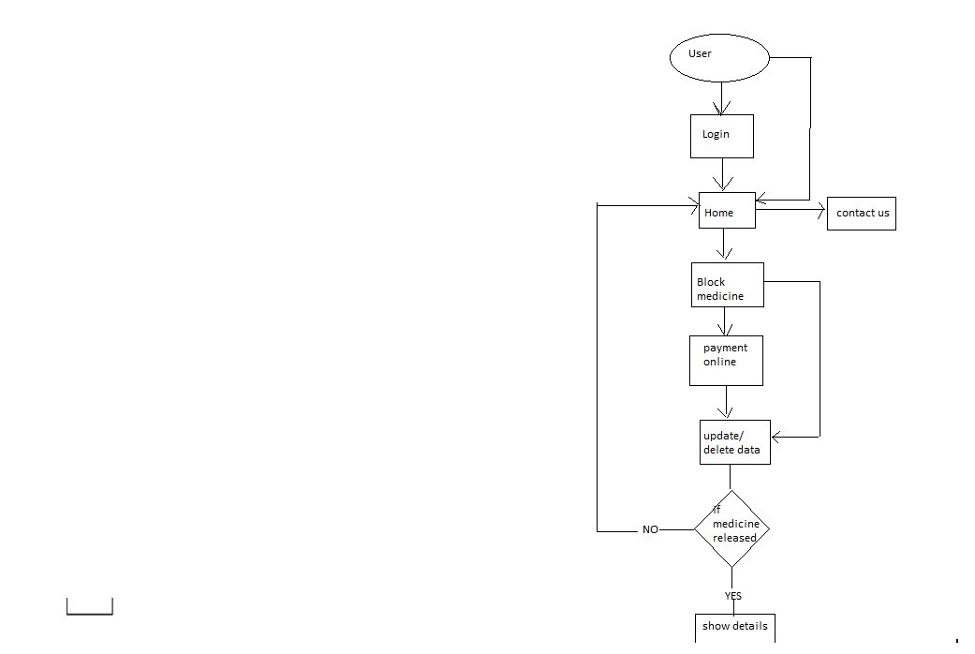

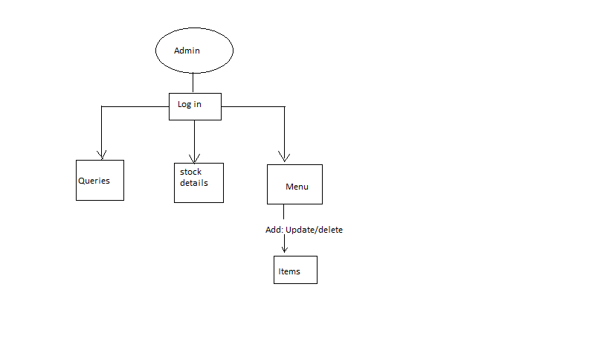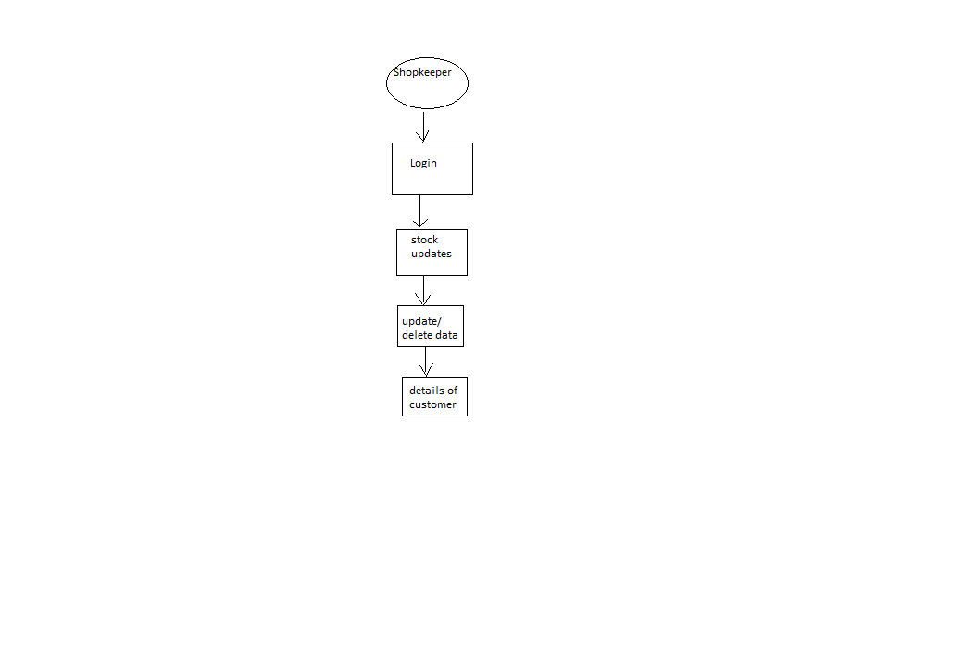

## DATABASE DIAGRAM

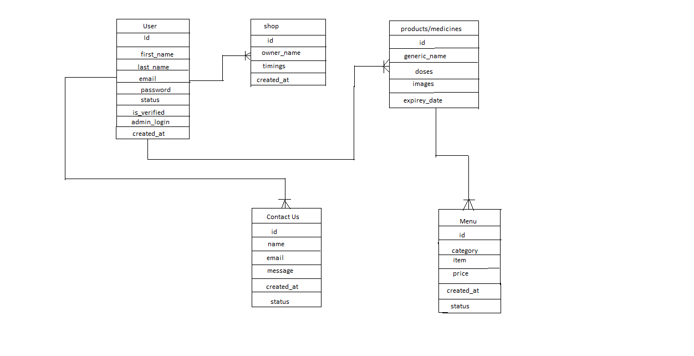

# USER INTERFACE

## HOME PAGE

## 

## LOG IN PAGE

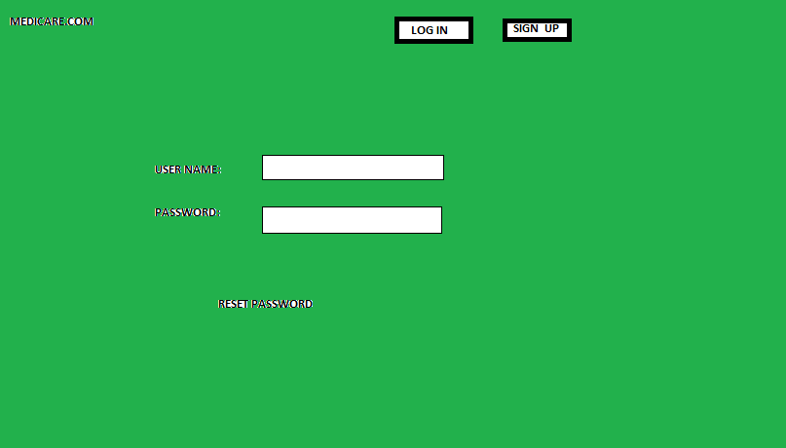

## SIGN-UP PAGE

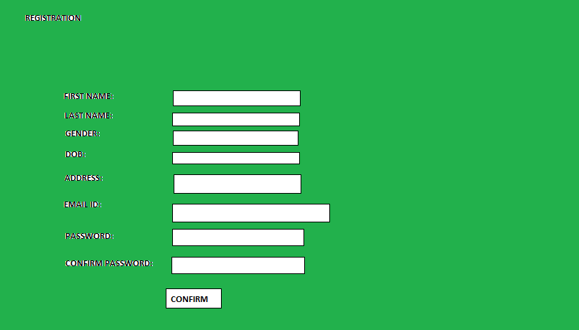

## ADMIN CONTROL

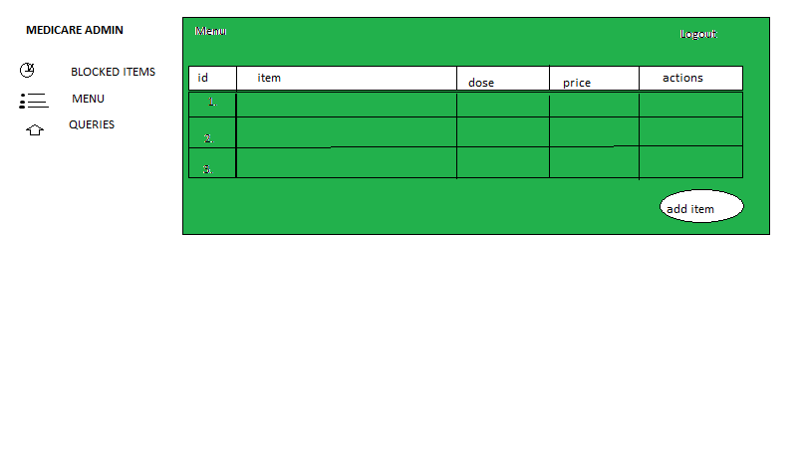

# IMPLEMENTATION

## Implementation achieved:

The website is design for online searching medicine, any user can access and block through this site, we have integrated a log in button for registered user and if the user is not registered, they have to register by their email id and password. Upon registration they will get a confirmation mail and they can continue within the site. As an integration part we are using Google and pay pal so that customer block the medicine by giving certain payment initially .it fully depends on the customer however they can pay online or directly to shopkeeper. using pay pal reduce the cash problem and it gives a certainty to the shopkeeper of buying medicine. Once payment done by user, will get a notification on the mail saying payment has been done successfully. It will be a confirmation mail to the user and even sometimes he can claim if there would be any problem in transaction.

## Future implementation:

This website is mainly designed for those who have faced problem when they did not get medicine in the pharmacy and have to hop from one place to another to find medicine .it will give functionality to those who want urgent prescription and medicine and can search online nearby store where one can find their own prescribed medicine. It will help them to reduce the daily life rush and in an emergency case they can block medicine so nobody else will take it. It is very useful for aged people or above 60 they need not worry a time wherever they want they can access through site and release medicine and go to pharmacy and show them your email notification. Its depends on the criteria of a user and their preferences and what dose they want to choose consulted by doctor. Nowadays people are in very rush and in emergency they could not get medicine, so they need to search another pharmacy that will consume time which is very important part of life.

# Development environment

The development environment is basically how you going to do it and what are the key factors is going to be used, so in the front end we are going to use HTML, CSS and BOOTSTRAP. these going to be our design part. Client side will be angular Js, server side will be on Node Js or java. SQL will be our database. site will be hosted on local server and later will be put on cloud server.

# Future Challenges

According to estimation, challenges will be deploying part because specially when it comes to pharmacy industry there is a lot of security and privacy concern .it should not be used by below 15 age. Without validation no one can access the site. As I mentioned earlier it is based on local host but after some time needs to deploy on cloud will be hard part and real time application without permission of government is not easy. Drugs details and the particles also very important and cost estimation will be high if its going to be real time applicable.

# Costing

Budgeting is an essential part of any project outlay, as it is necessary to anticipate the financial cost of a proposed project and plan. The Product Manager has factored in the cost of various personnel that would be needed to execute the cloud platform. However, it should be noted that these costs could vary slightly upward or downward, not significantly as yearly wages of personnel are extracted from current reality within Ireland from a reputable website. Furthermore, there is the rational of providing two costing plans to meet the implementation date as well as a typical website will take 14weeks at a minimum from start to launch.

Costing for six weeks

|  |  |  |  |  |
| --- | --- | --- | --- | --- |
| PERSONNEL | RATE/HOUR IN EURO | AMOUNT PER DAY IN EURO  (8 HOURS) | NUMBERS OF DAYS ON THE PROJECT | TOTAL IN EUROS |
| WEB DESIGNER | 20 | 160 | 10 | 1600 |
| WEB DEVELOPER | 26 | 208 | 12 | 2496 |
| TECHNICAL ARCHITECT | 42 | 336 | 9 | 3024 |
| BUSINESS ANALYST | 24 | 192 | 6 | 1152 |
| TESTER | 25 | 200 | 7 | 1400 |
| TOTAL |  |  |  | 9672 |

.

Costing for fourteen weeks

|  |  |  |  |  |
| --- | --- | --- | --- | --- |
| PERSONNEL | RATE/ HOUR IN EURO | AMOUNT PER DAY in Euros (8 HOURS) | NUMBERS OF DAYS ON THE PROJECT | TOTAL IN EUROS |
| WEB DESIGNER | 20 | 160 | 25 | 4000 |
| WEB DEVELOPER | 26 | 208 | 28 | 5824 |
| TECHNICAL ARCHITECT | 42 | 336 | 21 | 7056 |
| BUSINESS ANALYST | 24 | 192 | 14 | 2688 |
| TESTER | 25 | 200 | 14 | 2800 |
| TOTAL |  |  |  | 22368 |
|  |  |  |  |  |

# Reflection

This project proposal helped us to understand the topic and deep need of medication in real life. it initiates our thought level and made us implement something which will be helpful one another’s life. As we all have faced in our real life it gives us an idea to design this website medicare.com. two of my team members is not very much familiar with coding part as they are not from IT background still each one giving their best to get done it perfect. It improves our interaction and team leadership property. We are not familiar with GitHub and we are just trying to understand how to push code and data’s over there. overall, it’s a great experience with everyone and something which is not in real going to be done in practically.

References

https://github.com/akebolaji1986/pharmaproject.git