IDP Global Secret Management – Secrets & Certificates
This page centralizes the inventory of secrets, service accounts, certificates, and technical credentials used across the IDP platform ecosystem.
Sensitive values (passwords, certificates, tokens, API keys, client secrets, etc.) are not stored in Confluence.
All secrets are maintained securely in the KeePass database:
- KeePass File: biz-platform.kdbx

Secret Repository
Item | Description
Repository Type | KeePass Database
File Name | biz-platform.kdbx
Storage Location | SharePoint
Access | Restricted to authorized IDP team members
Content | Technical accounts, certificates, API credentials, service users, SSO accounts

1. Apigee Hybrid
Registered Entries:
- Dev
- QA
- UAT
Screenshot:
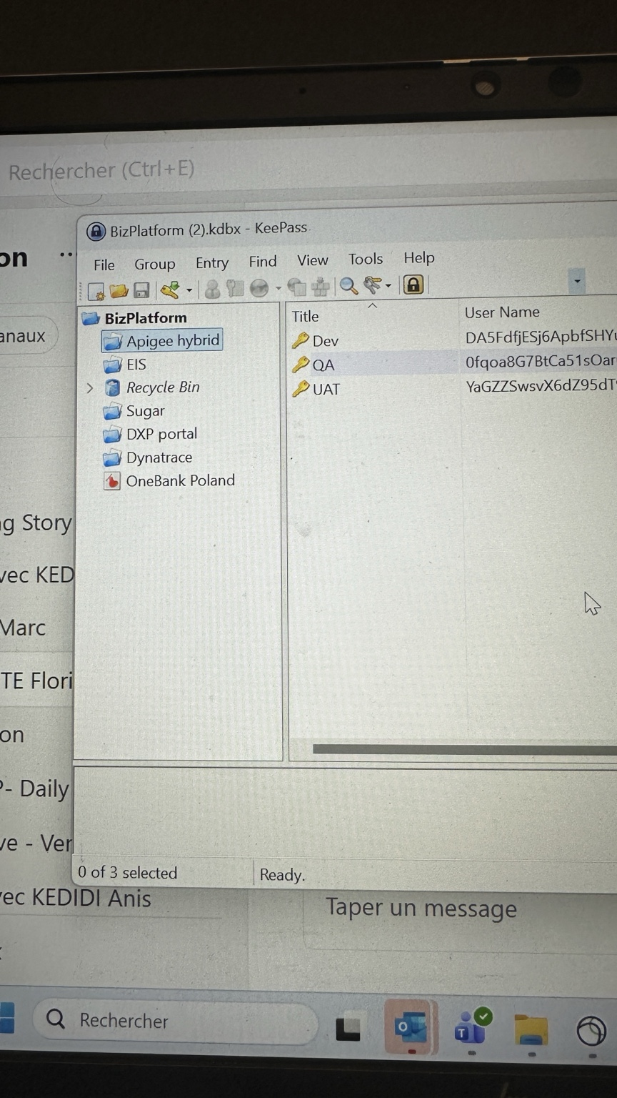

2. EIS
Registered Entries:
- APP01 – compte …
- cidp-system-user …
- QA – UAT
Screenshot:
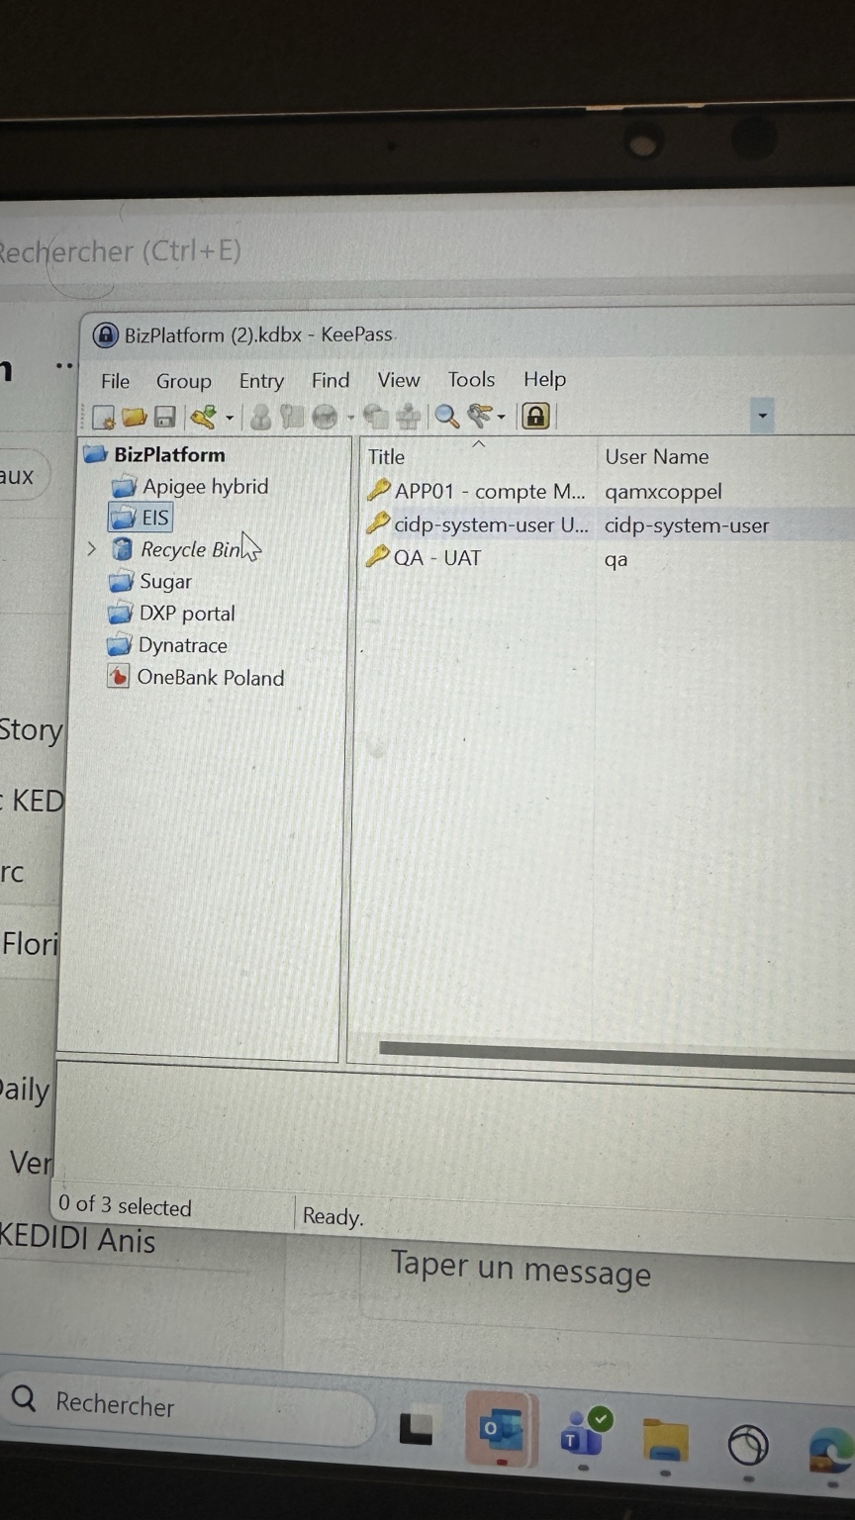

3. Sugar
Registered Entries:
- Compte SESAME pour listing document Sugar – Hors production
- Compte SESAME pour listing document Sugar – PRODUCTION
- Compte SESAME pour upload document dans Sugar – hors production
Screenshot:
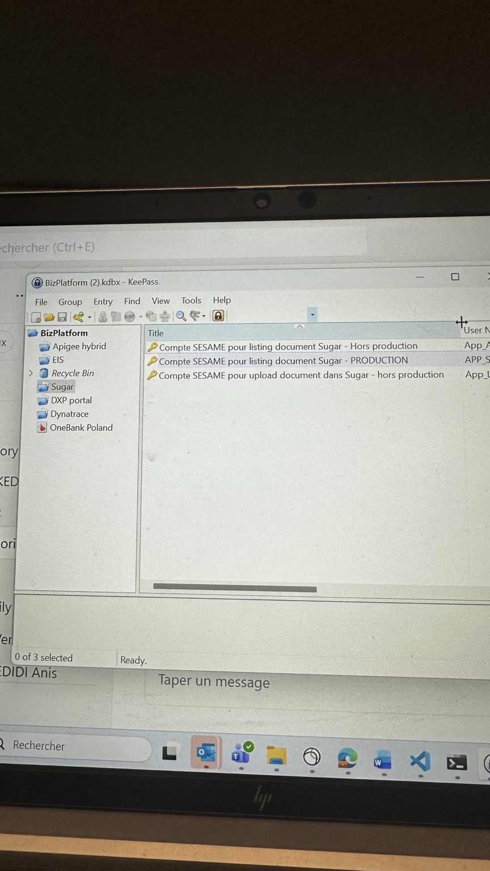

4. DXP Portal
Registered Entries:
- Compte RedhatSSO hors production
- Compte RedhatSSO hors production – All agencies
- Compte RedhatSSO PRODUCTION
Screenshot:
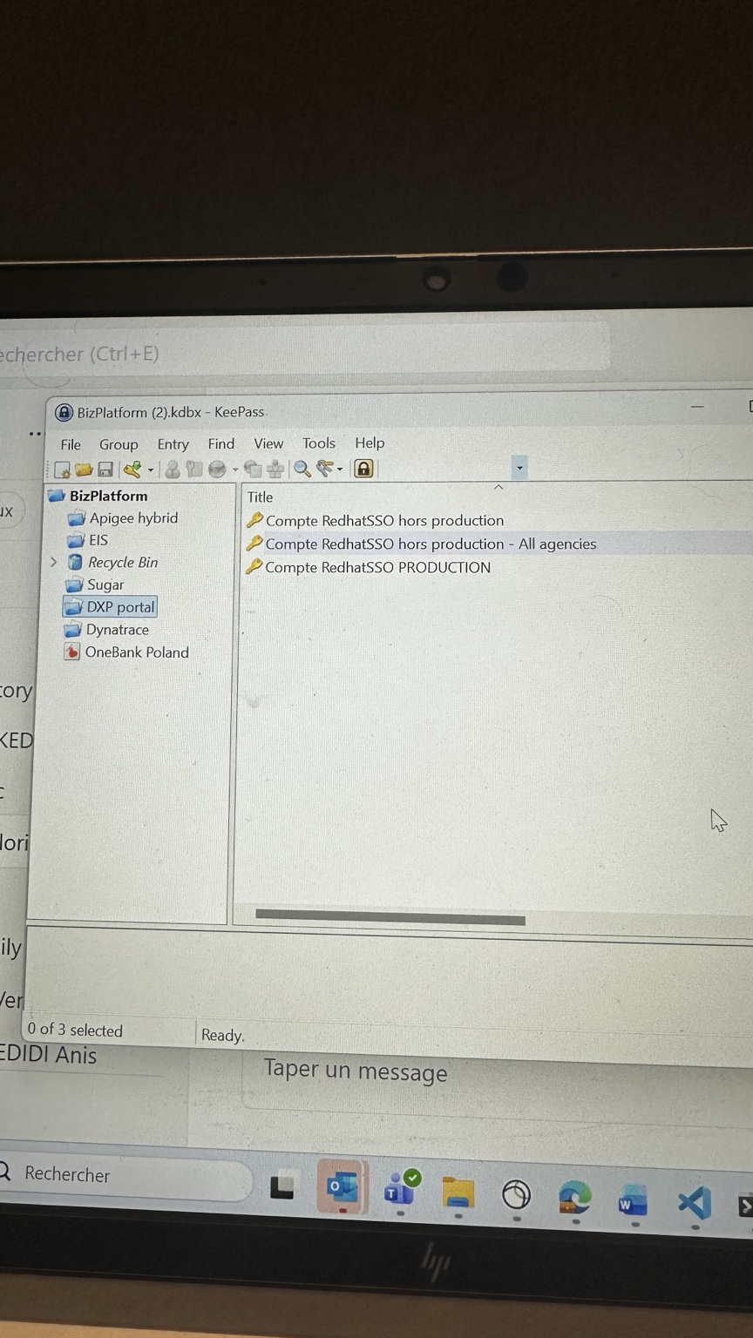

5. Dynatrace
Registered Entries:
- Certificat pour compte robot monitoring Dynatrace
Screenshot:
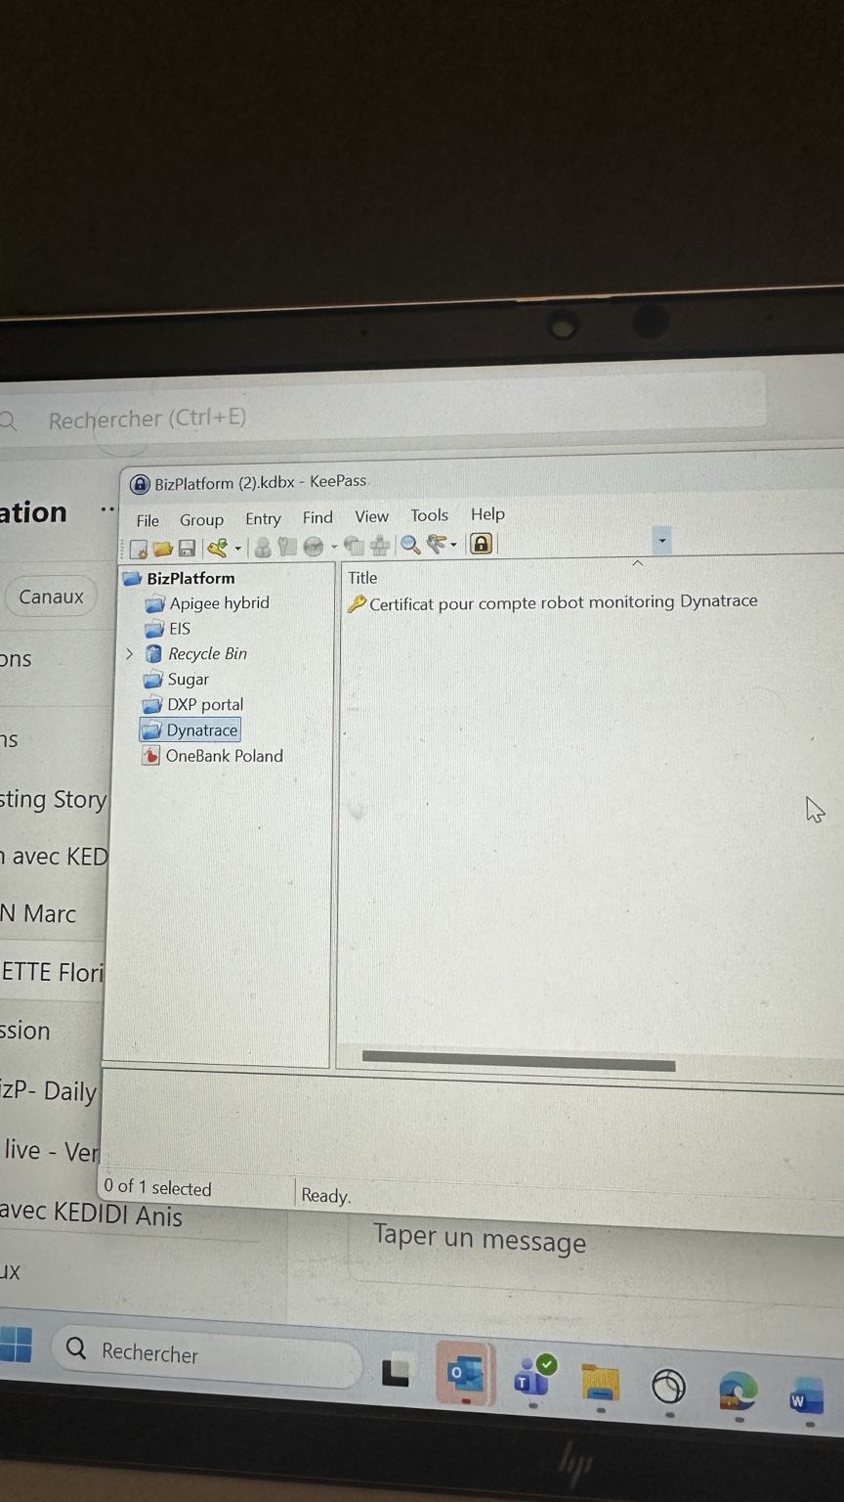

6. OneBank Poland
Registered Entries:
- Compte SESAME TSP – Hors production
- eMA non production
- SMSAPI
Screenshot:
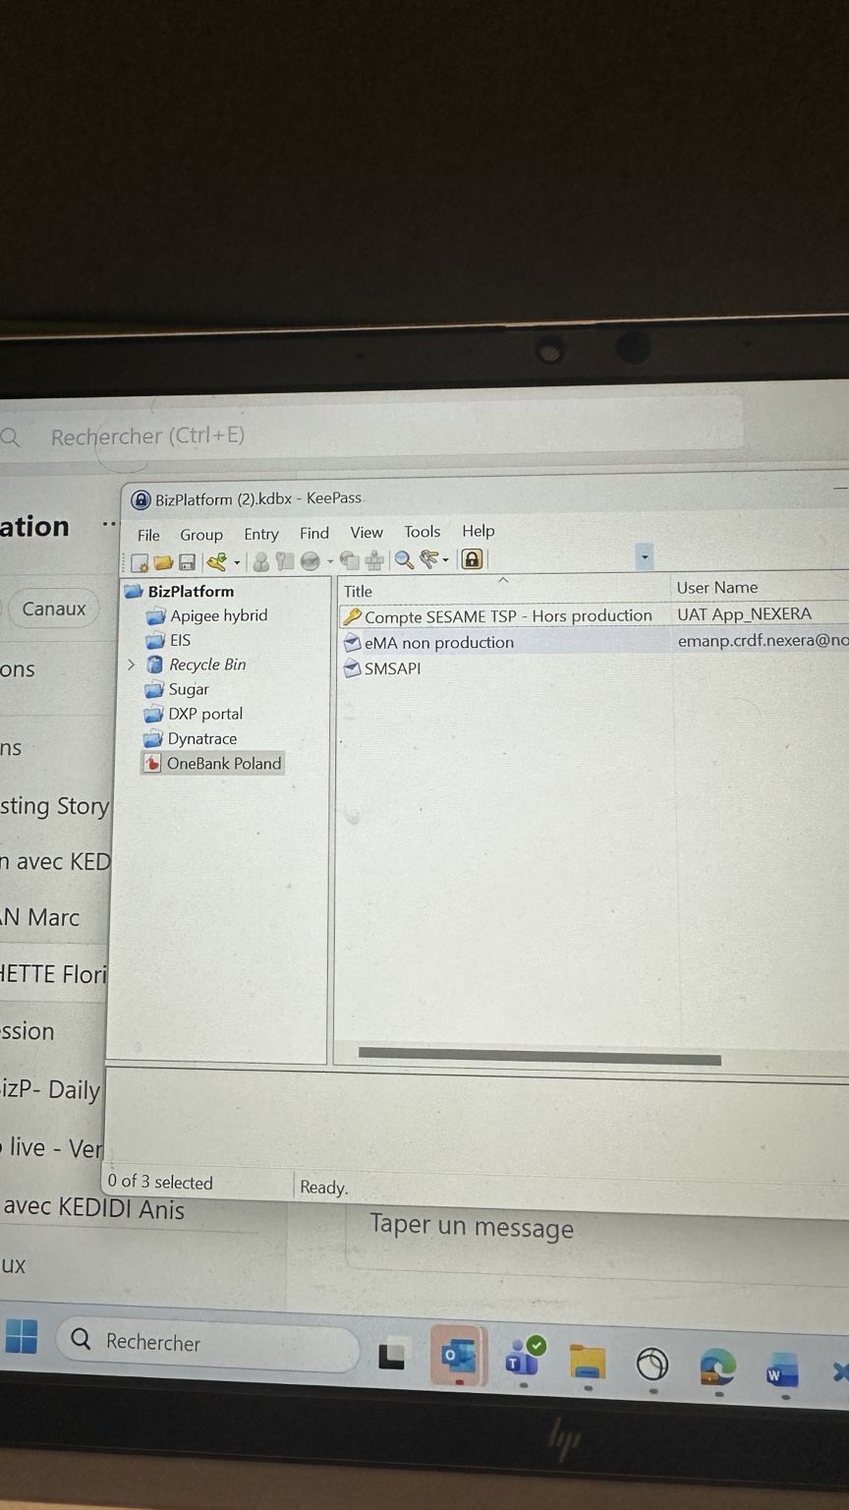

Security Guidelines
- Never store passwords or secret values directly in Confluence.
- Access to the KeePass database must be restricted.
- Secrets should be updated according to the project security policy.
- Production and non-production secrets must remain separated.
- Certificates expiration dates should be monitored regularly.
- Any new application/service account must be registered in the KeePass repository.

SharePoint Reference
[TO BE COMPLETED – SharePoint Link to biz-platform.kdbx]

