**Project : Rock – Paper – Scissors**

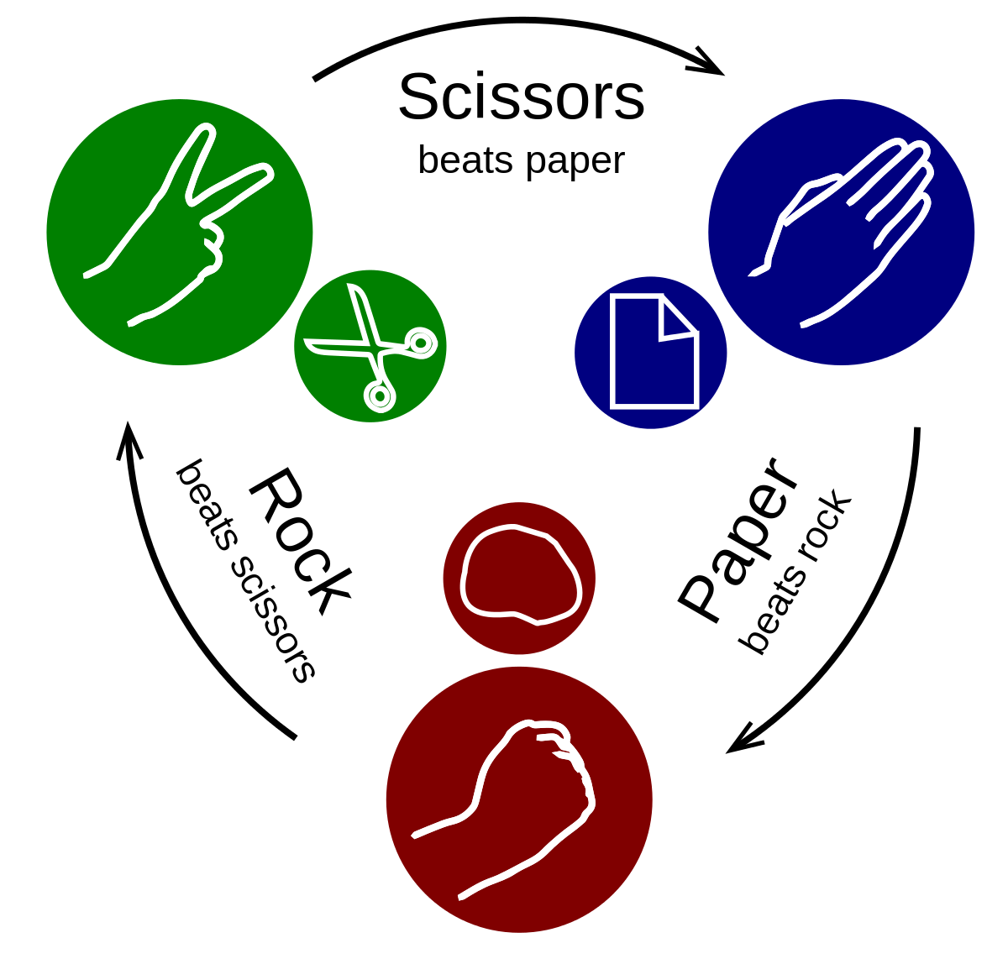

**Aim** :

To make a program replicating the rock-paper-scissors game in which one real time user will play against computer.

Number of rounds will be asked by the user.

In each round user will enter any one of rock/paper/scissors afterwards computer will randomly output one of rock/paper/scissors.

Scores will be awarded according to given rules:

**Game rules:**

1 . Rock vs Scissors : 1-0

2. Paper vs Rock : 1-0

3. Scissors vs Paper : 1-0

4. rock vs rock / paper vs paper / scissors vs scissors : 0-0

Scores of every round will be added to individual scores of the player. The one with more points will win the game.

Note: in case of equal individual points after completion of all the rounds the game will be declared as a draw.

**Example:**

Note: Here three levels are given. Each level adds a new functionality in the program. It’s your choice up to which level you want to complete.

**Level 1-**

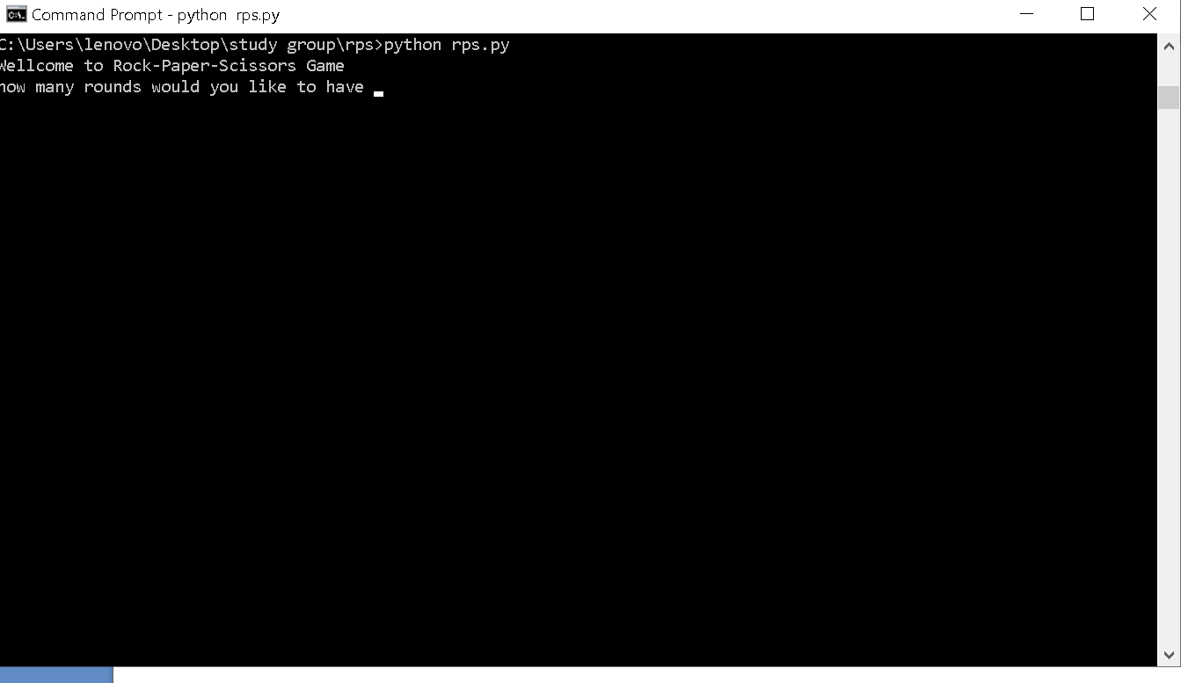

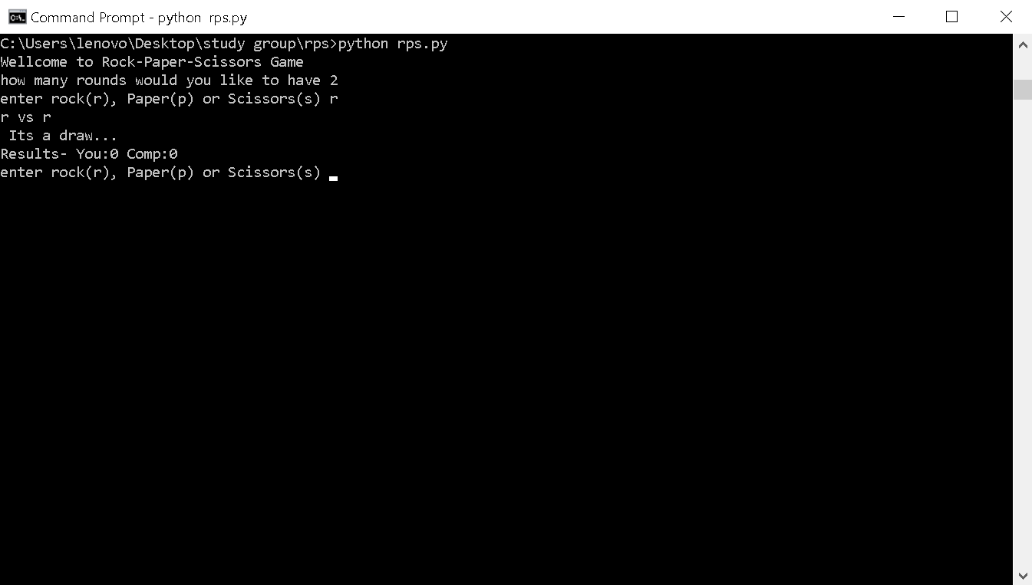

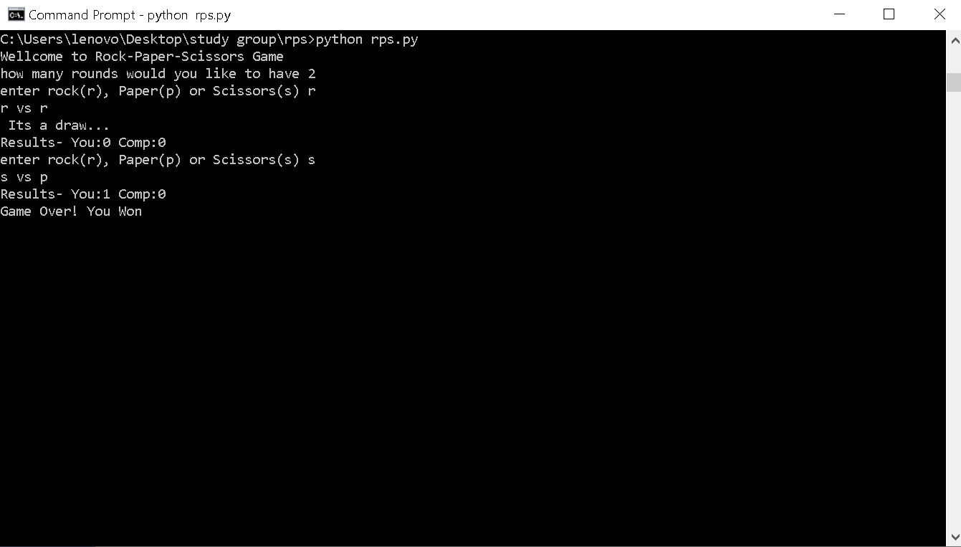

**Level – 2**

After the game is over ask user if he/she wants to play again or they want to exit

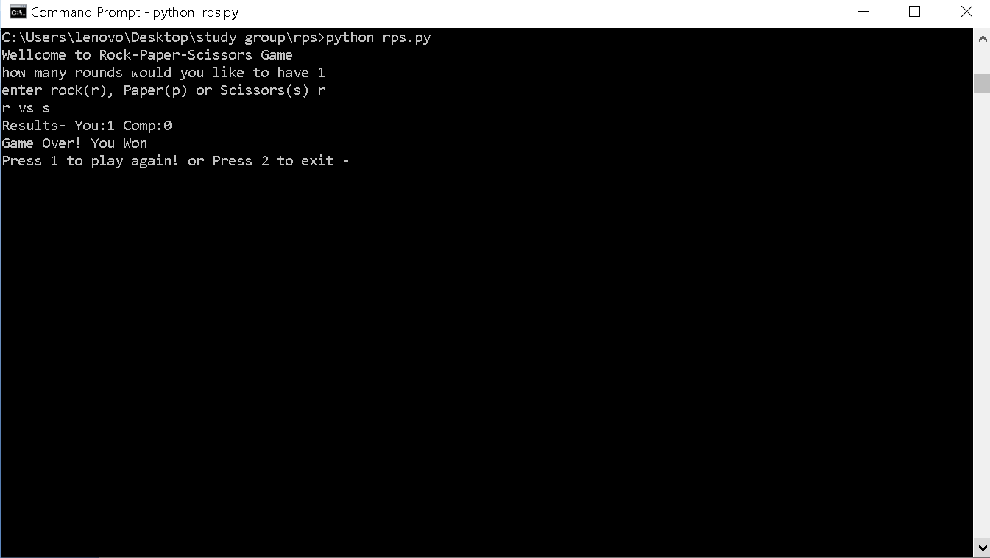

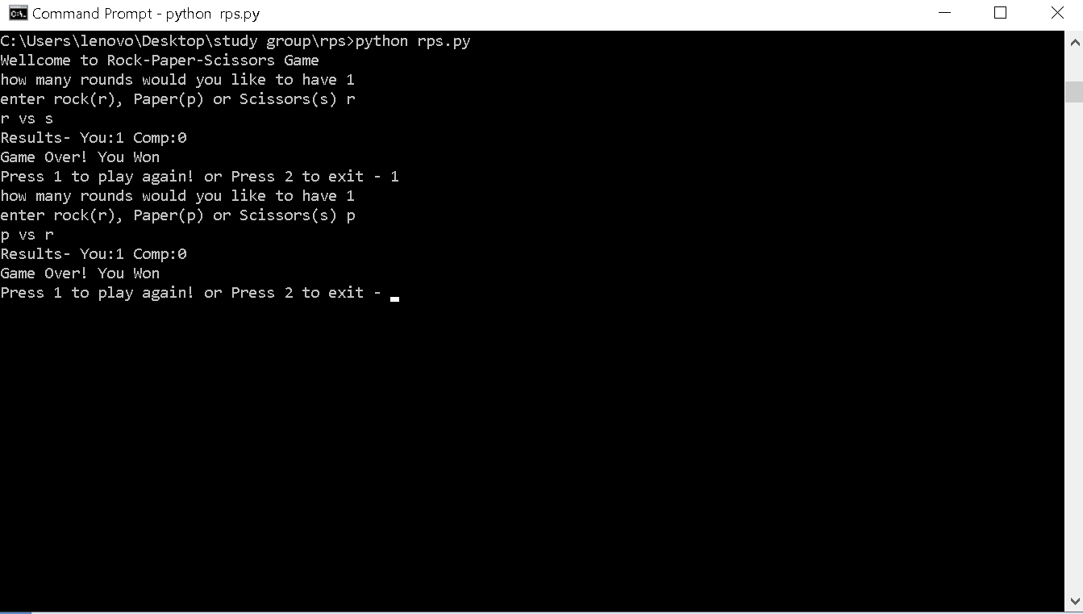

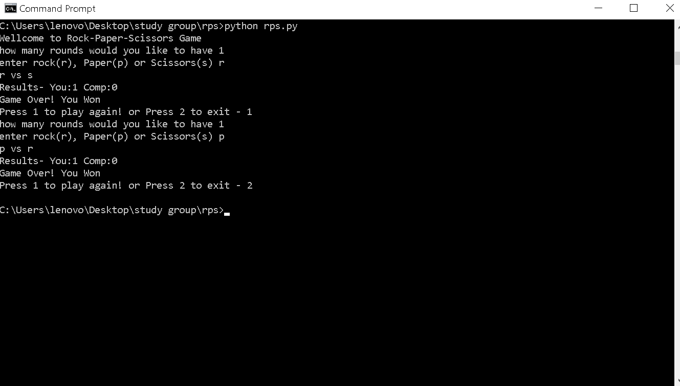

**Level -3**

Validate the input given by user if he/she is entering any one of r/p/s or any other input. If any other input is given output a message for them to enter any one of r/p/s only and re enter the input from user.

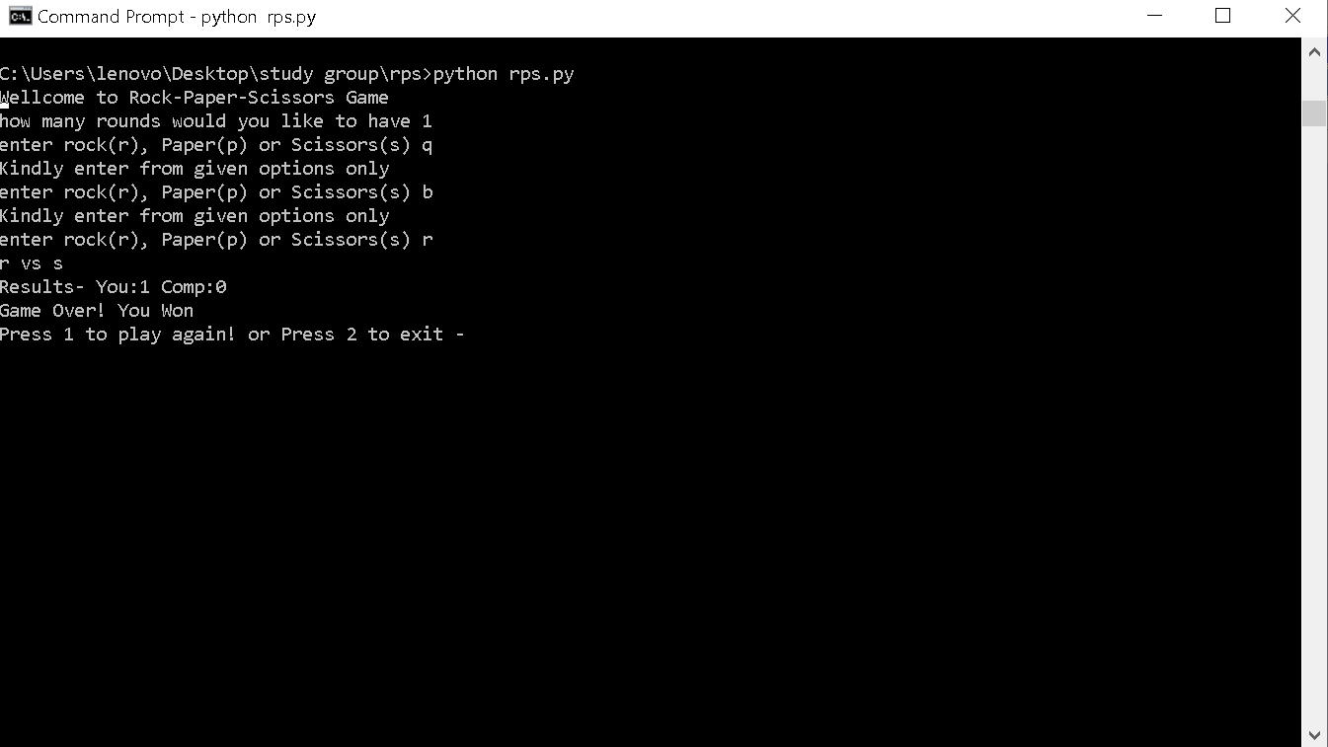

***Concepts you need to know***

**Random**: it’s a library in python consisting of functions that are used to generate or manipulate numbers or strings. These are used mostly in any application requiring random number generation like lotteries, random team selection, match pairing in tournaments and numerous of games.

In our project we need our program to select one option out of (r/p/s) randomly and this is where we can use a random function.

Following links describes various random functions with examples:

<https://www.geeksforgeeks.org/random-numbers-in-python/>

<https://pynative.com/python-random-choice/>

Rest of the concepts you have covered in the course from week 1 to week 5:

* Datatypes
* Lists
* Input/output
* If – else / elif
* For / while loop
* Function

Note: feel free to use any approach to build the project.

**Submission:**

You have to submit your code as yourname_rps.py in project folder inside files folder.

Don’t forget to add comments for better understanding of code!

All the best. Happy learning ☺