# 1：开发文档

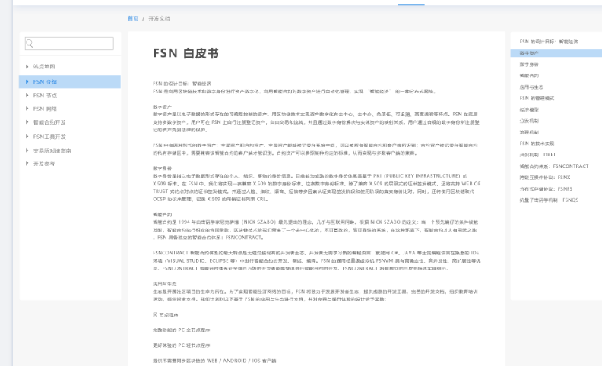

1.1 左侧树接口：

<http://49.235.37.9:8080/fsn/swagger-ui.html#!/document45controller/getTreeUsingGET>

1.2：根据id查询文档详情接口

<http://49.235.37.9:8080/fsn/swagger-ui.html#!/document45controller/getDocumentbyIdUsingGET>

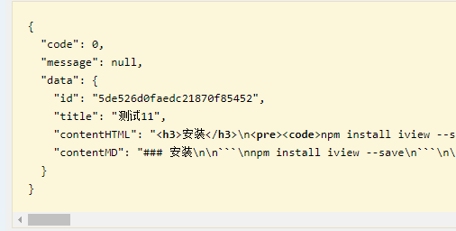

# 2.1文章列表

查询接口

http://49.235.37.9:8080/fsn/swagger-ui.html#!/article45controller/getArticleListUsingGET

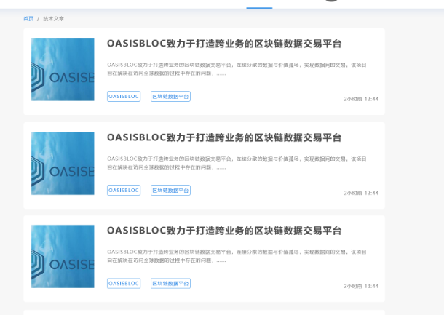

# 2.2文章详情接口

根据文章id，查询详情接口，包含左侧的上下篇信息。

http://49.235.37.9:8080/fsn/swagger-ui.html#!/article45controller/getArticlebyIdUsingGET

