文章涉及到的字段

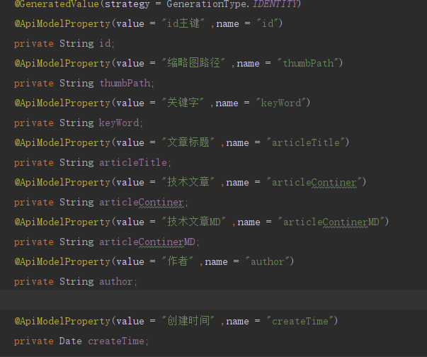

1：文章管理列表

查询接口

http://49.235.37.9:8080/fsn/swagger-ui.html#!/article45controller/getArticleListBackUsingGET

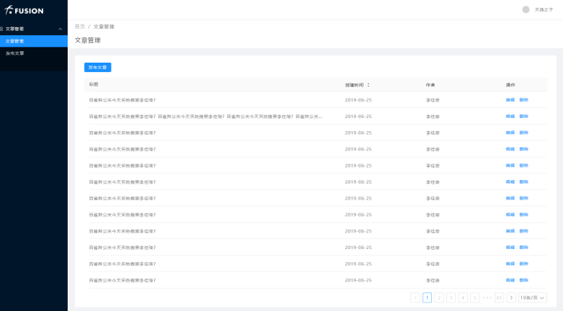

2：根基id获取文章详情接口

<http://49.235.37.9:8080/fsn/swagger-ui.html#!/article45controller/getArticlebyIdBackUsingGET>

3：发布、编辑文章接口（根据id是否为空判断，id为空新增）

<http://49.235.37.9:8080/fsn/swagger-ui.html#!/article45controller/addArticleNewUsingPOST>

4：根据id删除接口:

<http://49.235.37.9:8080/fsn/swagger-ui.html#!/article45controller/deleteArticleByIdUsingDELETE>

5：上传图片接口，返回图片url，（参数文件名是：file）

http://49.235.37.9:8080/fsn/swagger-ui.html#!/file45controller/savephotoUsingPOST