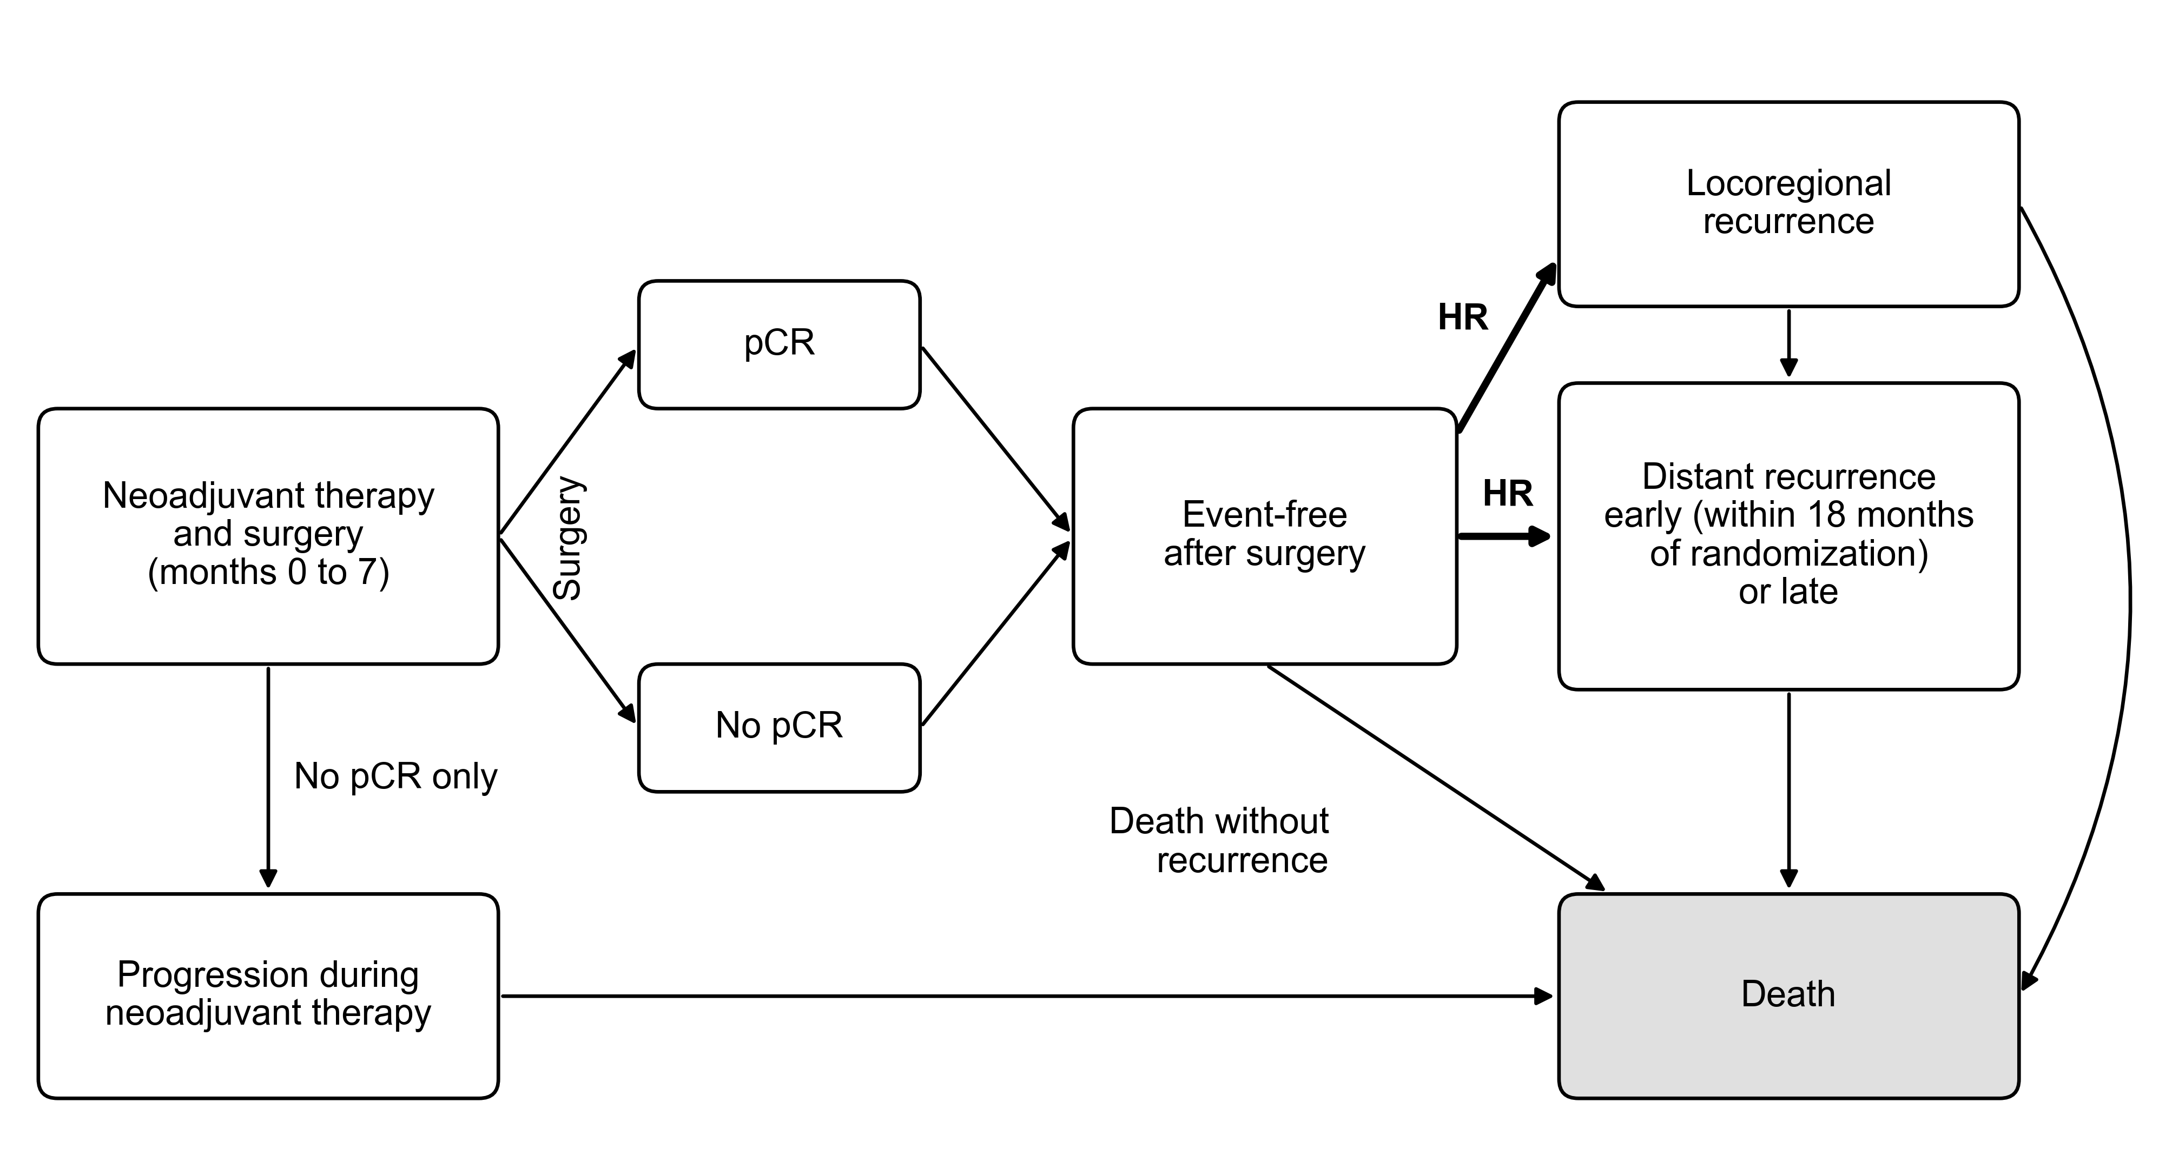
Fig. 1. Structure of the state-transition model✳
All four arms (chemotherapy alone, chemotherapy plus exercise, chemotherapy plus pembrolizumab, and chemotherapy plus pembrolizumab plus exercise) share this structure, in 1-month cycles from the start of neoadjuvant therapy at age 49 years to age 100 years. At surgery (month 7) the cohort is split by pCR, and event-free survival after surgery is modeled separately for each stratum. Progression that precludes surgery occurs only in patients without pCR. Distant recurrence is early (within 18 months of randomization) or late, each with tunnel states by months since recurrence. In the arms with exercise, the two transitions marked HR (thick arrows) are multiplied by the recurrence hazard ratio with exercise. Background mortality applies in every state alive.
✳HR, hazard ratio; pCR, pathological complete response.

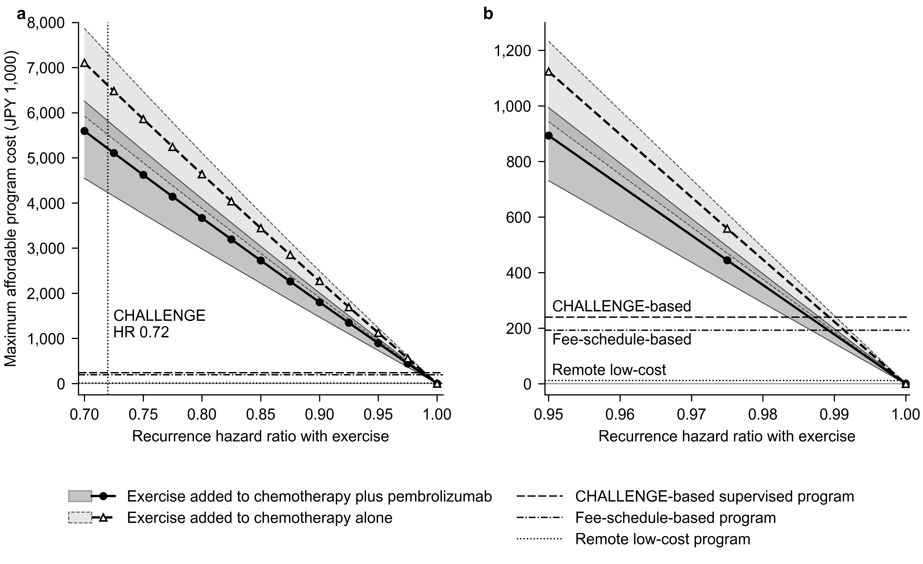
Fig. 2. Maximum affordable cost of an exercise program per patient by the recurrence hazard ratio with exercise✳
(a) Recurrence hazard ratio from 0.70 to 1.00. (b) The same results enlarged for hazard ratios from 0.95 to 1.00. Lines show deterministic estimates at a willingness-to-pay threshold of JPY 5 million per QALY for exercise added to chemotherapy plus pembrolizumab (solid line, circles) and to chemotherapy alone (dashed line, triangles); the dark and light grey bands, edged by thin solid and dashed lines, show their 95% UIs. Horizontal lines mark the costs of the three program designs in Table 1; exercise is cost-effective wherever a curve lies above the line of the program. The dotted vertical line in (a) marks the hazard ratio of 0.72 for disease-free survival with a 3-year exercise program in colon cancer (CHALLENGE trial)⁹. The effect is held for 5 years after randomization and then halves every year. The plotted values are listed in Supplementary Table S4.
✳Modeled cohort: women aged 49 years starting neoadjuvant chemotherapy for stage II or III triple-negative breast cancer in Japan (Table 1). Costs in JPY 1,000 at fiscal year 2026 prices, discounted at 2% per year over a lifetime horizon. 95% UI: 2.5th and 97.5th percentiles of 1,000 probabilistic sensitivity analysis samples. HR, hazard ratio; JPY, Japanese yen; QALY, quality-adjusted life year; UI, uncertainty interval.

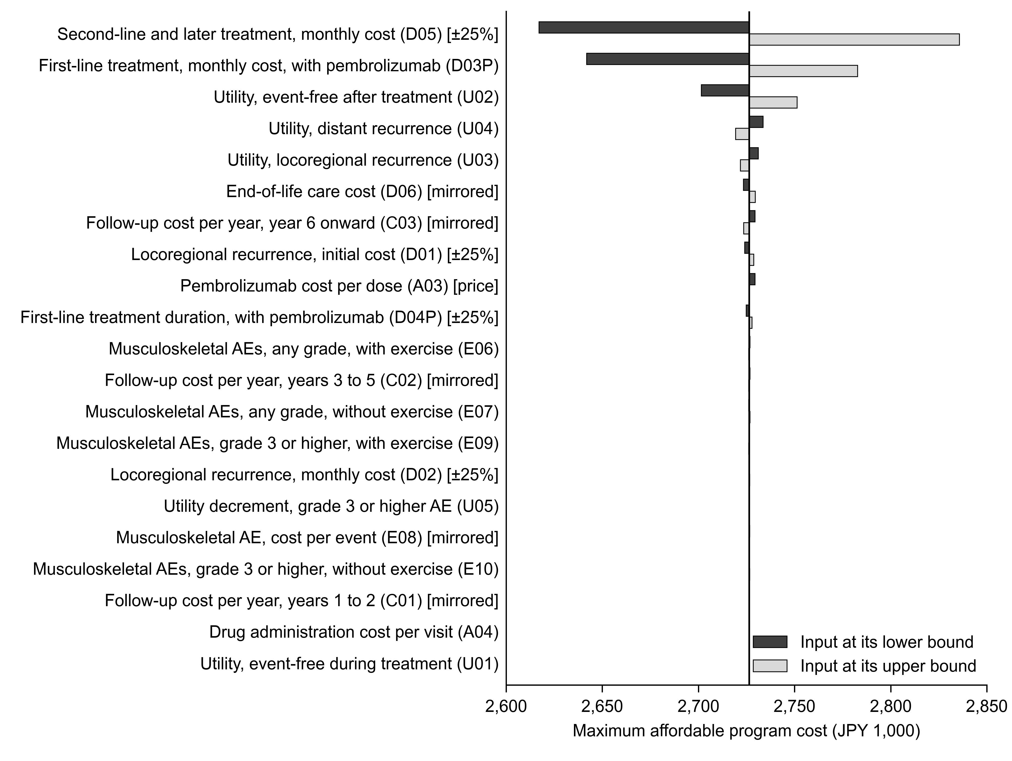
Fig. 3. One-way sensitivity analysis of the maximum affordable program cost for exercise added to chemotherapy plus pembrolizumab at a recurrence hazard ratio of 0.85✳
Bars show the maximum affordable cost per patient at a willingness-to-pay threshold of JPY 5 million per QALY when one input is set to its lower bound (dark bars) or upper bound (light bars) and all other inputs keep their base-case values; the vertical line is the base-case estimate. All 21 inputs that changed the result are shown, ordered by the width of their range. Brackets mark ranges set by rule rather than taken from a source: [±25%], ±25% around the base value where no range was available; [mirrored], the missing bound mirrored where only one bound was given; [price], drug price varied downward only, to 75% of the list price. Codes in parentheses refer to Supplementary Table S2; the plotted values are listed in Supplementary Table S9.
✳Modeled cohort: women aged 49 years starting neoadjuvant chemotherapy for stage II or III triple-negative breast cancer in Japan (Table 1). Costs in JPY 1,000 at fiscal year 2026 prices, discounted at 2% per year over a lifetime horizon. AE, adverse event; JPY, Japanese yen; QALY, quality-adjusted life year.

