Statistics: The Science of Decisions Project Instructions

**Questions For Investigation – Alyse Keim**

1. What is our independent variable? What is our dependent variable?

* Independent: Congruent and Incongruent words
* Dependent: Time to name ink colors

1. What is an appropriate set of hypotheses for this task? What kind of statistical test do you expect to perform? Justify your choices.

If…

$${ μ}_{I}=Incrongruent population mean$$

$${ μ}_{C}=Congruent population mean$$

$μ_{D}=Difference between { μ}_{I} and { μ}_{C}$

then …

$H_{0}: { μ}_{I}=$ ${ μ}_{C}$ (OR ${ μ}_{D}=0$)

$H_{A}: { μ}_{I}≠$ ${ μ}_{C}$ (OR ${ μ}_{D}≠0)$

when…

$∝ =.05, ∝ =.01, ∝ = .001$

Statistical test: We would perform a two – tailed, dependent t – test for paired samples. In this case, it is a within subject design, meaning the sample population includes the same subjects for both tests – it is the same people but circumstances or conditions change. Consequently, it is a *dependent* test. Additionally, we do not know the population standard deviation and thus, we must use a *t-test*. Furthermore, there are 2 conditions resulting in a *paired samples* test and finally, I chose a *two – tailed* test because I want to know if there is a difference in reaction time (in general) rather than if one condition is better or worse than the other.

1. Report some descriptive statistics regarding this dataset. Include at least one measure of central tendency and at least one measure of variability.

$x_{I}=22.016$ $n=24$

$${ x}_{C}=14.051$$

$x_{D}=$ 7.965 (Point Estimate)

$I_{i} and C_{i}$ = values of incongruent and congruent data sample

$$s=\frac{Σ{((I_{i}-C_{i})-x_{D})}^{2}}{n-1}= \frac{544.33}{23}=4.865$$

$$SE=s/{\sqrt{n}}= {4.865}/{\sqrt{24}}= .993$$

1. Provide one or two visualizations that show the distribution of the sample data. Write one or two sentences noting what you observe about the plot or plots.

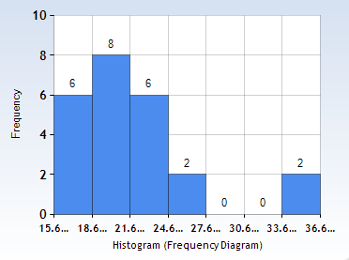 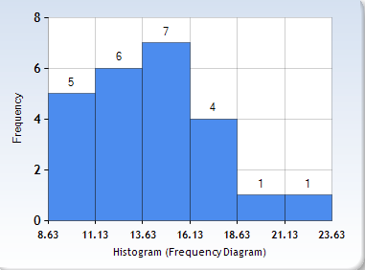

On the left, we have a histogram of the incongruent data. We can see that it is right skewed with a range of 15.6 to 36.6. On the right, we see the histogram of the congruent data. With a range of 8.63 and 23.63, it is also right skewed however the curve is more gradual and thus the median will be farther right in the range of values than the incongruent data (relative to their ranges.

1. Now, perform the statistical test and report your results. What is your confidence level and your critical statistic value? Do you reject the null hypothesis or fail to reject it? Come to a conclusion in terms of the experiment task. Did the results match up with your expectations?

$$t= \frac{x_{D}}{s/{\sqrt{n}}}= \frac{7.965 }{{4.865}/{\sqrt{24}}}= 8.021$$

Confidence Interval:

$$x_{D} ±t \left(s/{\sqrt{n}}\right)= 7.965 ±\left(8.021\right)\left({4.865}/{\sqrt{24}}\right)= 7.965 ±7.965$$

$$(0, 15.930)$$

Critical Values:

$± 2.064$ at $∝ =.05$ (.025 in t table, 23 df)

$± 2.807$ at $∝ =.01$ (.005 in t table, 23 df)

$± 3.768$ at $∝ =.001$ (.0005 in t table, 23 df)

Conclusion: I reject the null hypothesis on all accounts (.05, .01, and .001). The standard deviation of the differences is far past the critical values in the critical region of the sample normal distribution. This means the speed subjects read the congruent words is significantly different then the speed they read incongruent words. There is a causal effect between the condition of words and the speed at which the subject can read it.

Expectation: This is exactly what I expected. When I first tried the experiment myself, I noticed a clear difference in the speed in which I was able to interpret the color. Therefore, as long as others are similar to me, I thought I might see this relationship in the data.

1. Optional: What do you think is responsible for the effects observed? Can you think of an alternative or similar task that would result in a similar effect? Some research about the problem will be helpful for thinking about these two questions!

After reading about the stroop effect online, the reason behind the effects observed is based in psychology: Selective attention theory and Speed of processing theory. It is much easier for people to read a word than it is to see a color, process it, and define it. Additionally, when we are naturally drawn to reading, the incongruent words challenge our attention more as we can not rely on natural instinct. I believe many cognitive studies will have similar results to this. When scientists are testing neural activity against a control (natural instinct), there will often be a significant difference (in successful studies) as they are altering the oscillation between neurons which all humans have.

Sources:

* Udacity - statistics lesson 10/11
* T- table: <https://s3.amazonaws.com/udacity-hosted-downloads/t-table.jpg>
* Histogram Visuals: <http://www.socscistatistics.com/descriptive/histograms/>
* Microsoft word (question sheet), Microsoft Excel (calculations)
* Stroop Effect: <http://psychology.about.com/library/bl-stroopeffect.htm>