Defense 4 — The Simple Version
  - Hiding a power relay’s traffic with one switch, in plain language

The problem in one picture
A control room (“the master”) talks to a power relay (“the SEL-751”) over the network. Even if someone watching the wire cannot read the messages, they can still recognize the relay — and guess what it is doing — just from the shape and timing of the packets. That is called fingerprinting. Our goal: put one switch in front of the relay and make its traffic always look the same, so the watcher learns nothing. We never change a single byte of the DNP3 message.
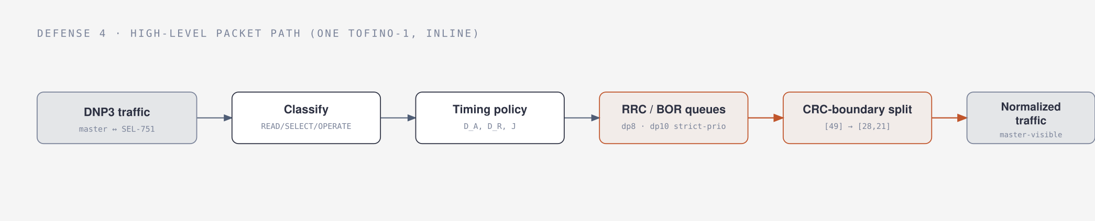
The whole idea in one line: traffic comes in, the switch decides what it is, applies a timing policy, steers it into hold queues, splits the answer on a safe boundary, and the master sees uniform traffic.

What gives the relay away
Three things leak, and none of them need reading the message:
- Size — the relay’s answer is 49 bytes. Different devices send different sizes.
- How it is split — how the answer is broken into network segments is itself a tell.
- Timing — the gap between the network “got it” (the TCP ACK) and the real answer. This is called CLRT. It is set by the relay’s own electronics, so it is like a fingerprint.
A researcher named Formby showed two ways to fingerprint these devices: the CLRT timing above, and how long the device takes to physically act on a command (a relay closing a switch takes a characteristic amount of time). We hide both.

The setup: three boxes in a line
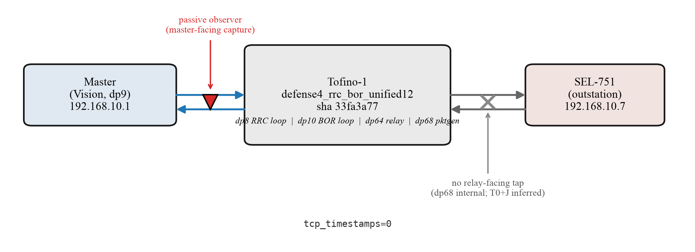
Master → one Tofino-1 switch → SEL-751 relay. The switch is the only thing we add.
The master is a computer. The switch is one Intel Tofino-1 (a switch you can program). The relay is a real SEL-751. Everything runs on real hardware. A watcher sits on the master’s side and sees only what the master sees.

Trick 1 — RRC: make every answer look the same (for reads)
When the master asks the relay to READ, the relay answers. Our switch does three simple things to that answer:
- Cut it on a safe line. A DNP3 message has built-in checkpoints (CRC blocks). We cut only on one of those checkpoints, so the pieces still add back up to the exact original. The 49-byte answer becomes two pieces: 28 bytes + 21 bytes. No byte is changed.
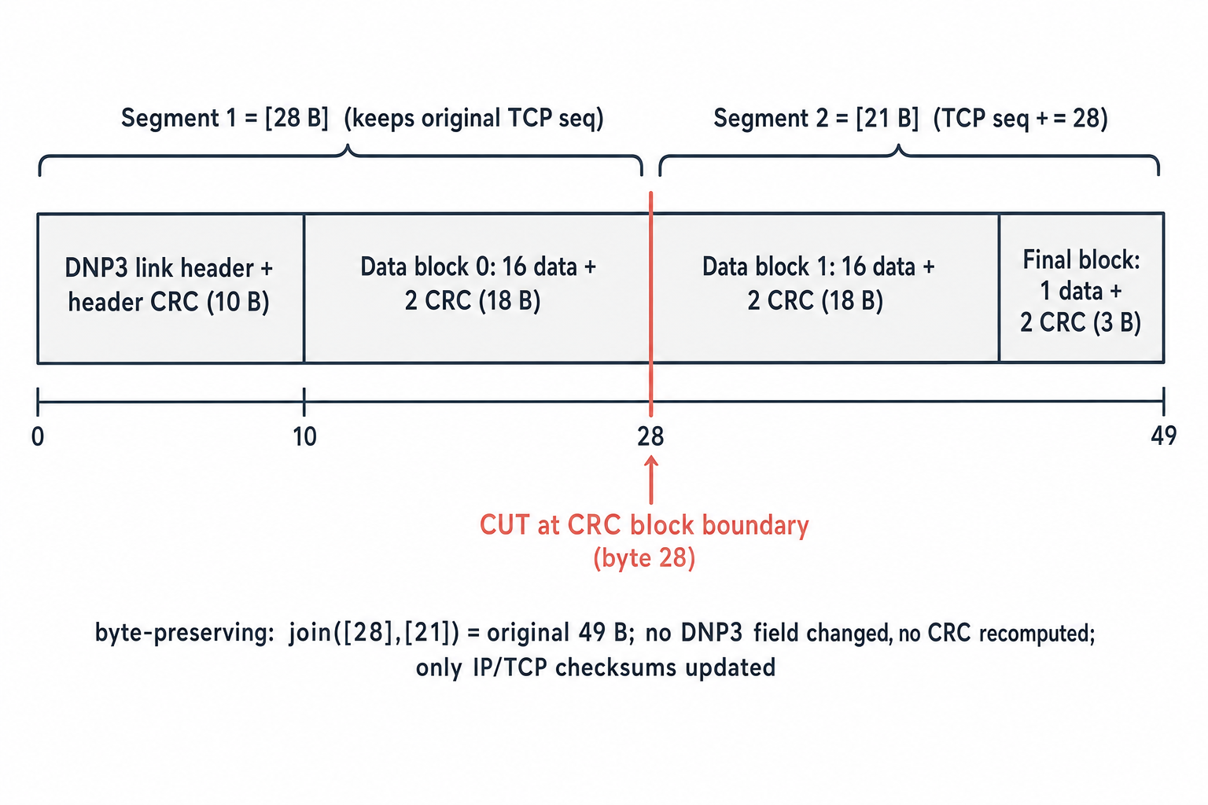
We only ever cut where the message already has a checkpoint. 28 + 21 = the original 49 bytes, unchanged.
- Delay it to a fixed time. We hold the answer inside the switch and let it out at a set moment, so the timing (CLRT) is always the same number instead of the relay’s own varying one.
- Result: every read answer now looks identical — same two pieces, same timing — no matter what the relay actually did.

Trick 2 — BOR: hide the command timing (for control)
Control is the dangerous part. To operate something, the master first sends SELECT (arm it), then OPERATE (do it). Our switch:
- lets exactly one OPERATE through (no accidental double-fire),
- holds it inside the switch, and lets it out at a secret delay the watcher cannot guess,
- but shows the master the “got it” and the echo at fixed times.
The clever part: because those fixed times are anchored to when the OPERATE arrived, the watcher cannot subtract one from the other to figure out the secret delay. So the relay’s real reaction time stays hidden.
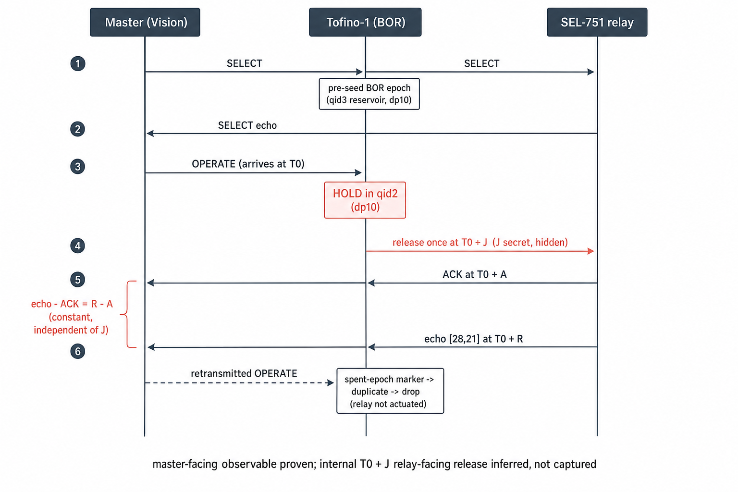
A control command, step by step: the switch holds the OPERATE, releases it on a secret delay, and shows the master fixed times. A repeat command is caught and dropped, so nothing fires twice.

How the switch does it (the short version)
Think of it like Ditto (a known traffic-hiding system) but simpler and purpose-built. Packets go through the switch twice: the first pass parks each answer in a hold queue behind a small stack of “blocker” packets that act as a timer; the packet loops back and the second pass releases it at the right time and cuts it. Reads and commands use two separate lanes inside the switch so they never get in each other’s way.
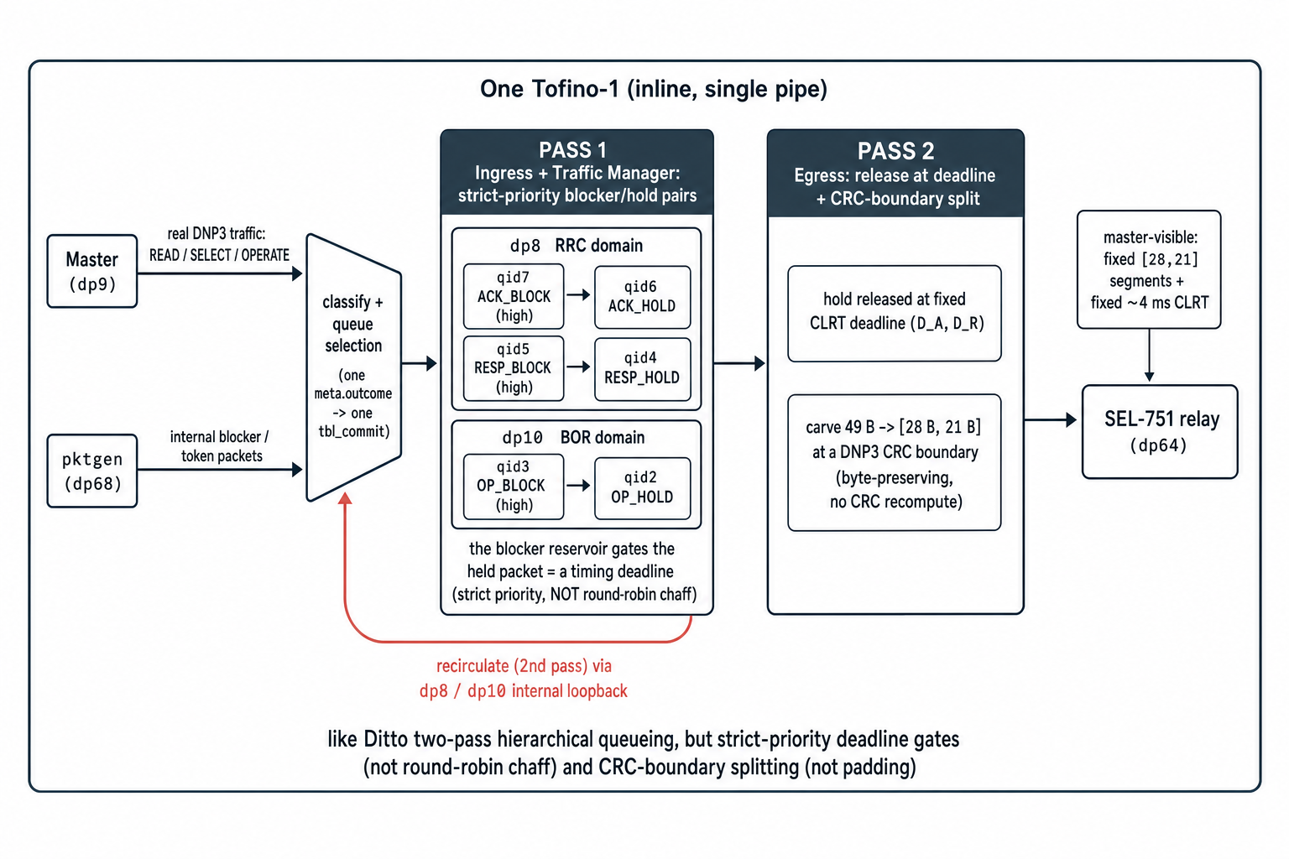
Our switch pipeline: classify → hold behind blockers (two lanes) → loop back → release on time and split. Like Ditto’s two-pass design, but with timing gates instead of filler traffic, and cutting instead of padding.

What we found (on the real relay)
- Size: every defended answer came out as 28 + 21 bytes — 1,280 out of 1,280, with none slipping through as the original 49.
- Timing: the relay’s natural timing (about 1.3–2.1 ms, and jumpy) became a flat 4.0 ms every time.
- Command timing: the visible gap stayed a constant 4.0 ms no matter what secret delay we used — so the secret is unrecoverable.
- The attacker’s guesser: a tool trying to tell “read” from “select” by timing dropped from 59% to 50% — a coin flip.
- Safety: the relay never operated by mistake; all 32 outputs stayed open the whole time.
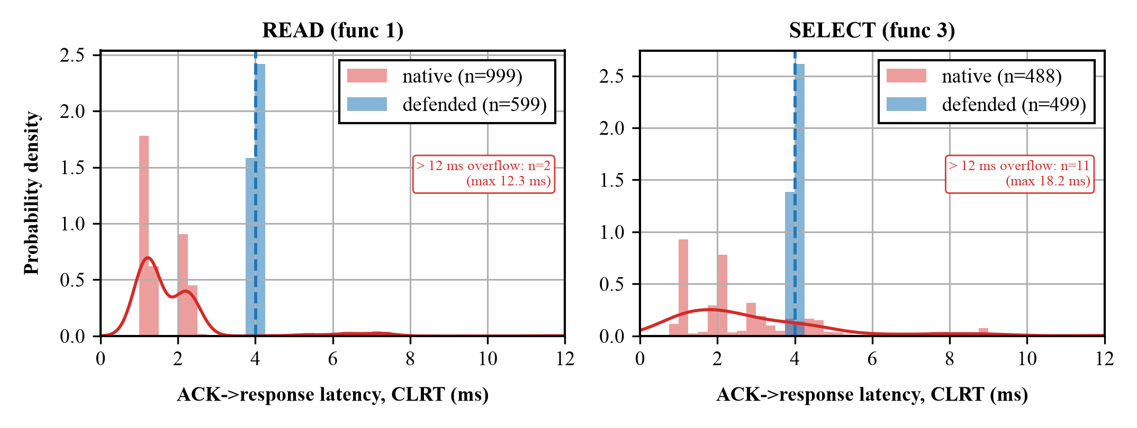
Before and after: the relay’s scattered timing collapses to a single 4 ms spike.
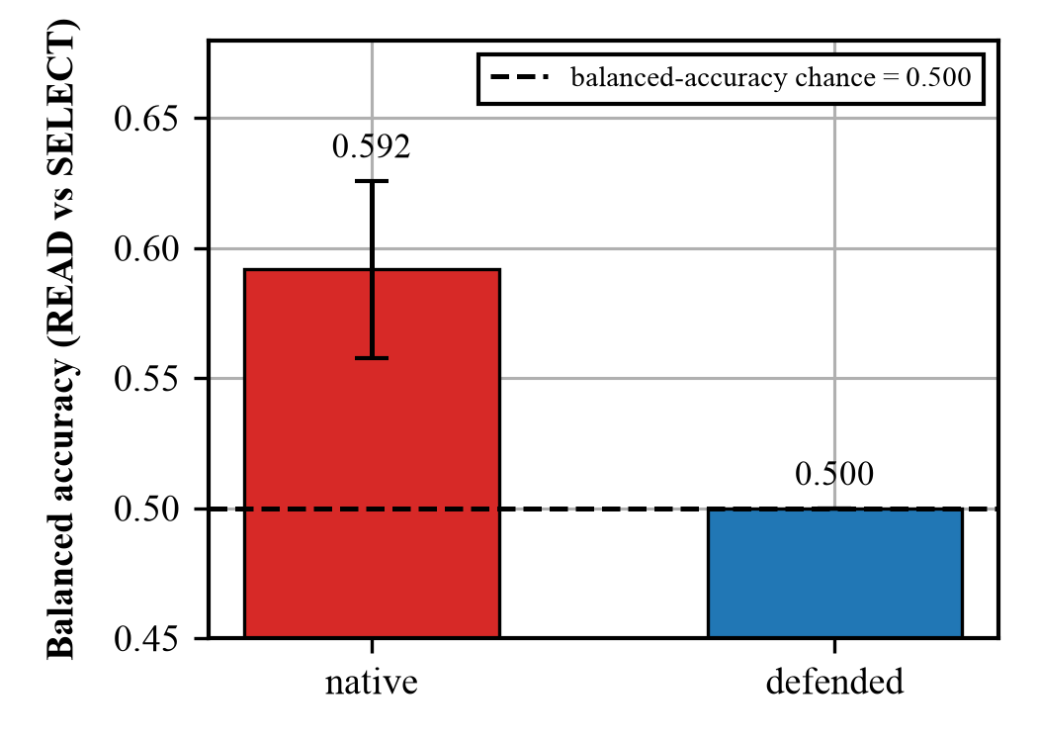
The attacker’s ability to tell transactions apart drops to a coin flip (50%).

What we can and cannot claim
- We can say: the timing is normalized, the size and splitting are uniform, the timing fingerprint is gone, the relay was never mis-operated, and it all fits on one switch.
- We are careful to say: we proved this on one relay (so we replace its fingerprint, we don’t claim it’s now indistinguishable from every other device); and we watched only the master’s side, so the “exactly one command reaches the relay” part is strongly expected but not directly filmed.

Say it in one sentence
We put one programmable switch in front of a power relay and rewrote its network traffic — same size, same splitting, same timing, and control commands released on a hidden delay — so a watcher can no longer fingerprint the device, and we did it without changing any of the relay’s actual messages.
A full technical version (with the P4 code, control-plane steps, and every exact number) is in DEFENSE4_EXPLAINER.pdf; the one-page meeting card is MEETING_REFERENCE.pdf.

