**Project Implementation**

For the implementation of our idea we have chosen Django framework for our website to be hosted and the face recognition will be undertaken using the OpenCV library in Python.

**Django**

**Why Django?** We have chosen Django framework over the other frameworks because it is a Python based language which is highly user friendly and simple to understand. Apart from that, it is worth mentioning that many top companies including Google and NASA utilize Django for the development of their websites. It consists of a robust built-in template system along with inbuilt database management system which uses MySQL. One of the major advantages of Django is that it hides the websites source code making it immune to security attacks. It has protection against XSS, CSRF attacks, SQL Injections and clickjacking.

Django is based on the model-view template ideology. We describe models as the declarations of database wherein MYSQL database is used to implement these models. Views are used to execute the logic and we program it in such a way that we want it to work. It interacts with the models to carry data and renders a template. Templates consist of the frontend part wherein we use HTML, CSS and JavaScript files to interface the user with our server. Initially, when a user accesses a URL, Django responds to it by passing it to a view for processing it and returns the required information which may be just a string also. After processing it in the view, a web response is returned to the user comprising of HTML files. This is managed by templates in Django. Since a request response cycle is processed using views, models and templates, a Django application is also referred as MVT application.

The directory structure of our project is as shown below

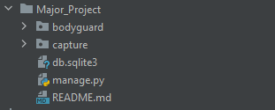

This is the parent directory which consists of our application. Before we look into the contents of the