**Arduino LDR**

Reads the Light Level from an LDR and Prints the result to the Serial Monitor.

*/* Reads an analog input pin and prints the results to the serial monitor */*

const int analogInPin = A0; *// Analog input pin*

int sensorValue = 0; *// value read from the LDR*

void **setup**() *{*

*// initialize serial communications at 9600 bps:*

**Serial**.begin(9600);

}

void **loop**() *{*

*// read the analog in value:*

sensorValue = analogRead(analogInPin);

*// print the results to the serial monitor:*

**Serial**.print("sensor = " );

Appears in the Console Window

**Serial**.println(sensorValue);

*delay(2);*

}

* Add an LED (Arduino Blink) .
* Program it to Light **If**  it’s Dark If(condition)
* Make LED brightness change with LDR reading

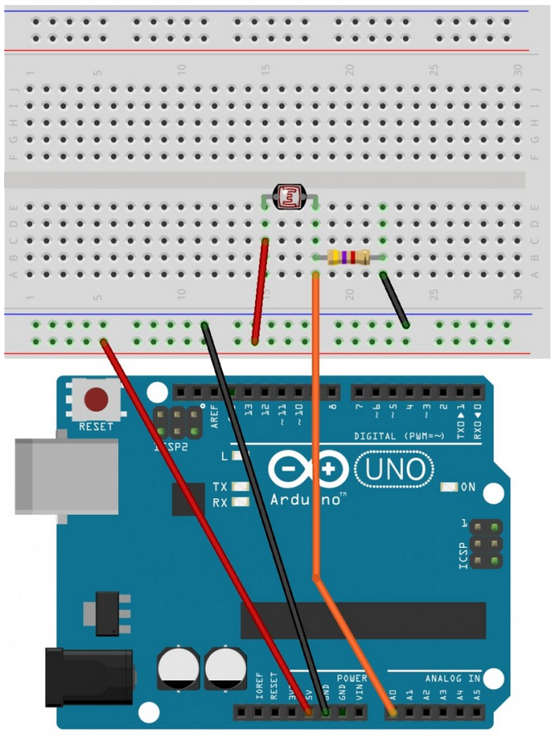

5V

Voltage varies with light

0V

