**Arduino Temperature Sense**

Read a Temperature Sensor IC with Arduino.

*// Pullup sketch*

*// A switch connected to pin 2 lights the LED on pin 13*

const int ledPin = 13; *// output pin for the LED*

const int inputPin = 2; *// input pin for the switch*

void **setup**() {

Turn on internal pull-up on the inputPin

pinMode(ledPin, OUTPUT);

pinMode(inputPin, INPUT);

digitalWrite(inputPin,HIGH);

}

void **loop**(){

int val = digitalRead(inputPin); *// read input value*

if ...*.your code here*. *// check if the input is LOW*

*// turn LED ON*

else

*// turn LED OFF*

}

Use the condition card to figure out how to light the LED if (val==LOW)

QUESTION: Why does the inputPin need a Pullup?

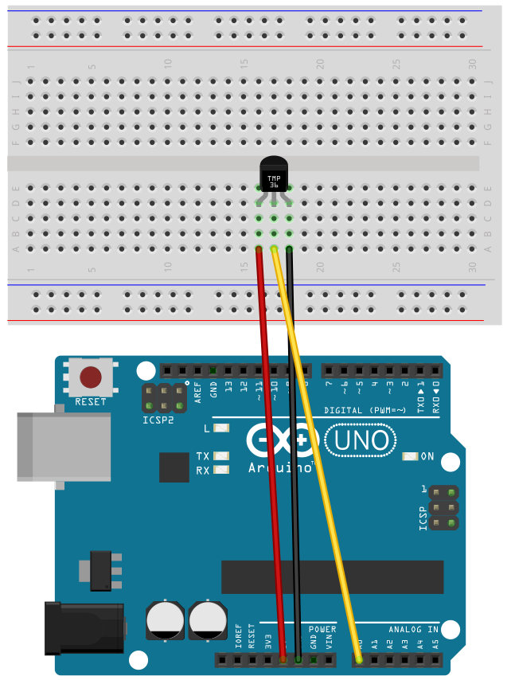

GND

+5V

Make sure the TMP36 is the right way around or it might Burn Up.

