**Esplora Flight Sim Project Card**

Make Esplora behave like a Keyboard and Mouse to control Google Earth’s Flight-Simulation mode.

See the Esplora Keyboard/Mouse card to find out how to fill in the missing code.

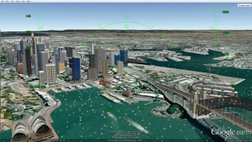

#include <**Esplora**.h>  
int state = 1;

int state_old = 1;

int mode = 0;

int xAxis, xAxis_old = 0;

int yAxis, yAxis_old = 0;

int zAxis, zAxis_old = 0;

void **setup**() {}   
void **loop**()

{

state_old=state;

state = **Esplora**.readButton(SWITCH_4);

if (state_old && !state) { *// SWITCH_4 just Pressed?*

mode = !mode;

if (mode) {

**Mouse**.begin(); *// Take control of the mouse*

**Keyboard**.begin(); *//.. and Keyboard*

**Mouse**.press(); *// Click the Mouse*

delay(100);

**Mouse**.release();

}

Put your code in here

else {

**Mouse**.end();

**Keyboard**.end();

}

}

*// If SWITCH_3 is pressed activate KEY_PAGE_UP*

*// If SWITCH_1 is pressed activate KEY_PAGE_DOWN*

xAxis_old = xAxis;

yAxis_old = yAxis;

xAxis = **Esplora**.readAccelerometer(X_AXIS);

yAxis = **Esplora**.readAccelerometer(Y_AXIS);

int delta_x = xAxis-xAxis_old;

int delta_y = yAxis-yAxis_old;

*// Control the mouse based on the accelerometer tilt*

if (mode) **Mouse**.move(-5*delta_x, 2*delta_y, 0 );

delay(10);

}

To  Start Goolge Earth Flight Simulator mode: (Tools-> Enter Flight Simulator) or (Ctrl+Alt+A)

