**TEAM4OARS**

**Feasibility Study**

***Version 1.0***



**Signature Block**

|  |  |  |
| --- | --- | --- |
| **COSC 4351** | **Name Signature** | **Date** |
| ***SE Team Leader*** |  |  |
| ***SE SQA*** |  |  |

**REPLACE *Team Project* with your** TEAM**?**O**XX**S **all uppercase one word**

Feasibility study content hints:

This document contains the information about the feasibility of the Team Project TEAM**?**O**XX**S that your team is going to OOA, OOD, and OO Implement.

Find existing similar software products:

* get link,
* get screenshots;
* get technology,
* get interface,
* get cost,

Each team member, including the TL should do this research.

Show good ones versus bad ones, and how they solved some of the technical issues, such as live chat, security.

In the process start PROTOTYPING (find the Artist and Psychologist in your Team) your Team Project TEAM**?**O**XX**S and decide on the WEB SITE design (MASTER PAGE wireframe), each web page design, colors, pictures, links, etc. There should be actual work on your Team Project TEAM**?**O**XX**S while investigating similar systems.

# Link: <http://centuryny.com/>

Screenshot:

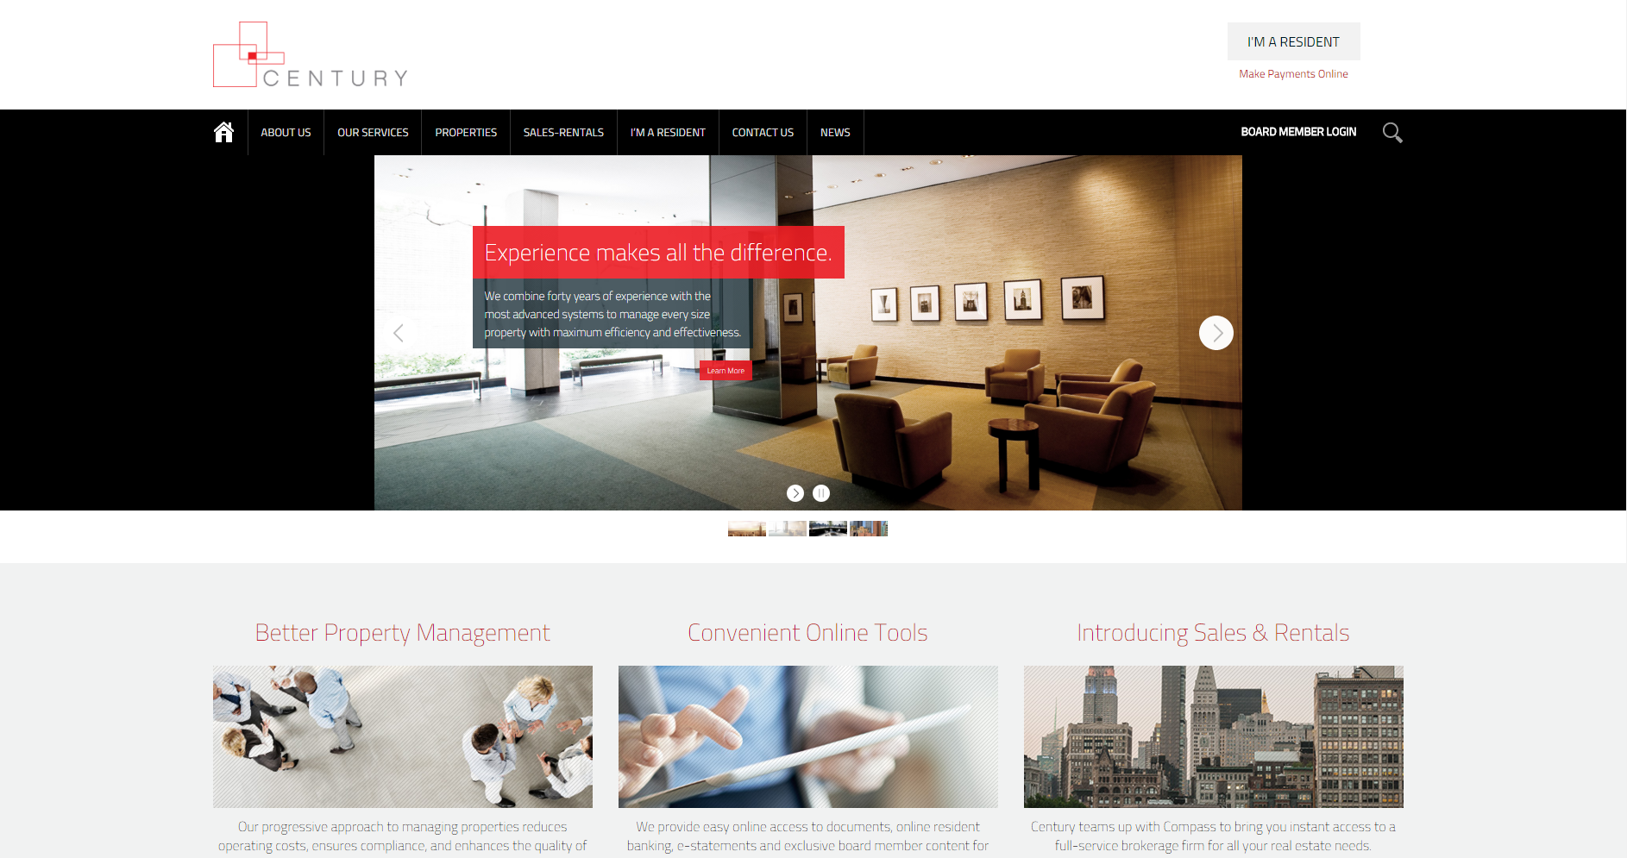

Technology:

Server-Side: PHP & XML

Client-Side: JavaScript

Interface:

Well-organized and very intuitive layout and menu. Good secure site for board member log-in. Myriad of information about the company and their properties.

Cost:

No cost to use the website.

Link:

<http://www.powerpropertymanagement.com/>

Screenshot:

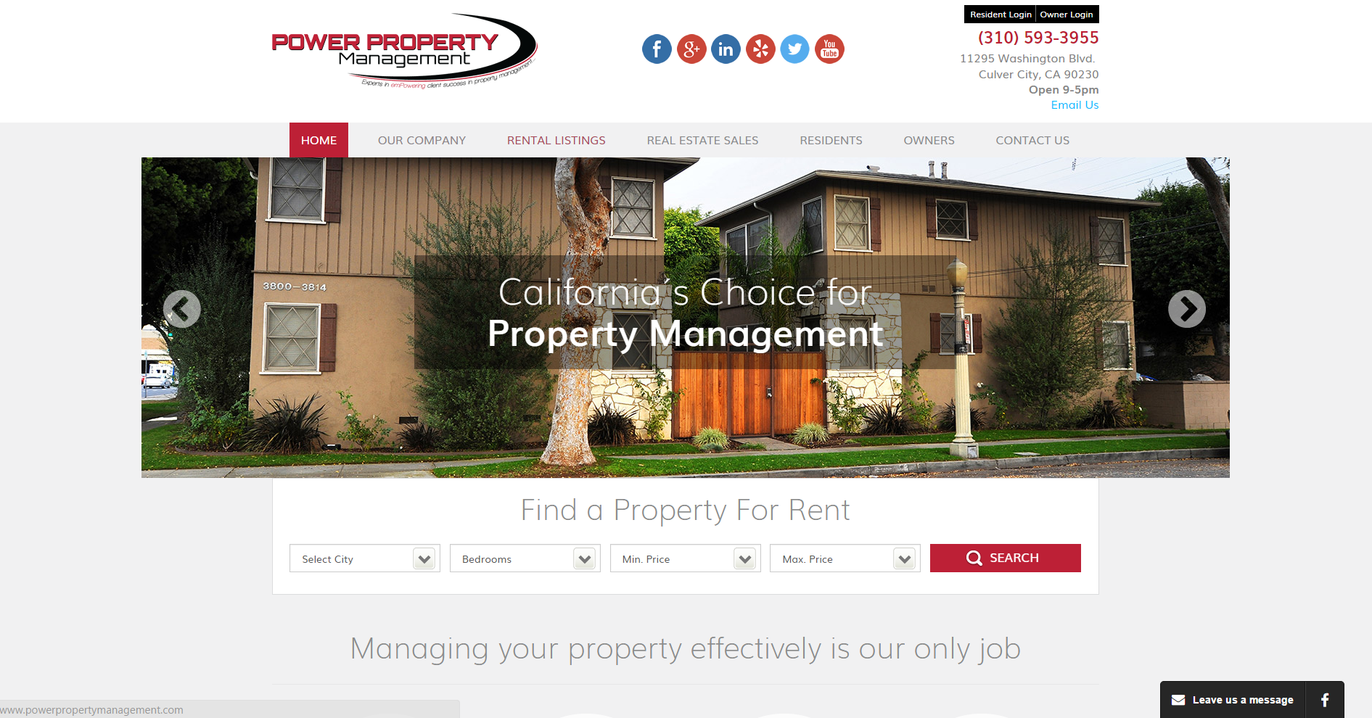

Technology:

Server-Side:

ASP.NET

Client-Side:

JavaScript

Interface:

This site is simple, intuitive, and informative. Has a well designed layout and many ways to get in contact with the company itself.

Cost:

Site is free to use.

# **Document Control**

**Change History**

**Table 1: TLs entries (assigned work and due dates) before releasing to the team**

|  |  |  |  |
| --- | --- | --- | --- |
| Revision | Name | **Due Date** | **Description** |
| 1.1 | TM  Joshua Wilburn | 02/06/2016 | Research similar solutions to Project Requirements that are used in the Real World and send findings |
| 1.1 | TM  Ali Khalid Elsaadi | 02/06/2016 | Research similar solutions to Project Requirements that are used in the Real World and send findings |
| 1.1 | TM  Devin Bellomy | 02/06/2016 | Research similar solutions to Project Requirements that are used in the Real World and send findings |
| 1.1 | DBA  Joseph Nguyen | 02/06/2016 | Research similar solutions to Project Requirements that are used in the Real World and send findings |
| 1.1 | DBA  Stephen Carver | 02/06/2016 | Research similar solutions to Project Requirements that are used in the Real World and send findings |
| 1.1 | SQA  Benjamin Wightman | 02/11/2016 | Research similar solutions to Project Requirements that are used in the Real World and send findings  Review Document after all findings have been submitted |
| 1.1 | TL  Bertol Salgado | 02/06/2016 | Research similar solutions to Project Requirements that are used in the Real World and send findings. Go over and make a note |

**Table 2: Entries when work completed (SVN Commit Comment matches Description)**

|  |  |  |  |
| --- | --- | --- | --- |
| Revision | Name | **Completed Date** | **Description** |
| 1.A | Garrett Bellomy, TM | 02/06/2016 | I found two sites that are good references for our project. |
| 1.B | TM & Name | XX/XX/XXXX | I ….. |
| 1.C | DBA & Name | XX/XX/XXXX | I ….. |
|  |  |  |  |
| 1.X | SQA & Name | XX/XX/XXXX | I reviewed Document |

**Table 3: TL entry for RED DELIVERABLES (SVN Commit Comment matches Description)**

|  |  |  |  |
| --- | --- | --- | --- |
| Revision | Name | **Due Date** | Description |
| 2.0 | TL & Name | XX/XX/XXXX | I changed Version to **2.0** |

**Document Storage**

This file is stored in SVN at https://svn.cs.uh.edu/svn/cosc4351/team**?**/TEAM PROJECT DELIVERABLES/**Feasibility Study.doc**.