EVOLUTION OF RCNNs

1. R-CNN
- proposes a bunch of boxes in the image and sees if any of them correspond to an object
- Creates region proposal boxes using “Selective Search”
  - Selective search looks at the image through windows of different sizes
  - Tries to group adjacent pixels by texture, color, and intensity. Things with similar attributes are probably one object
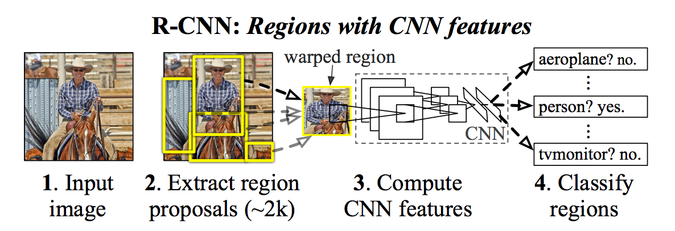
- When all proposals are created each region is warped to a square size and passed through a CNN to extract feature maps.
- Then, an SVM just classifies the feature map.

- Once an object is found, the box can be tightened even more to be more precise
  - Runs a linear regression
  - Input: sub regions of the image that corresponds to each object
  - Output: new bounding box coordinates for each object

Why R-CNN sucks:
- Needs a forward pass through the CNN (step 3) for each region proposal… and there are usually a lot of region proposals so that an object isn’t missed
  - A lot of region proposals also overlap, leading to useless computation
- It has to train 3 different models seperately
  - CNN, the SVM classifier, regression model to tighten box
2. Fast R-CNN

BENEFIT 1: Run the image through the CNN just once per image…

- Region of Interest Pooling (ROI pool):
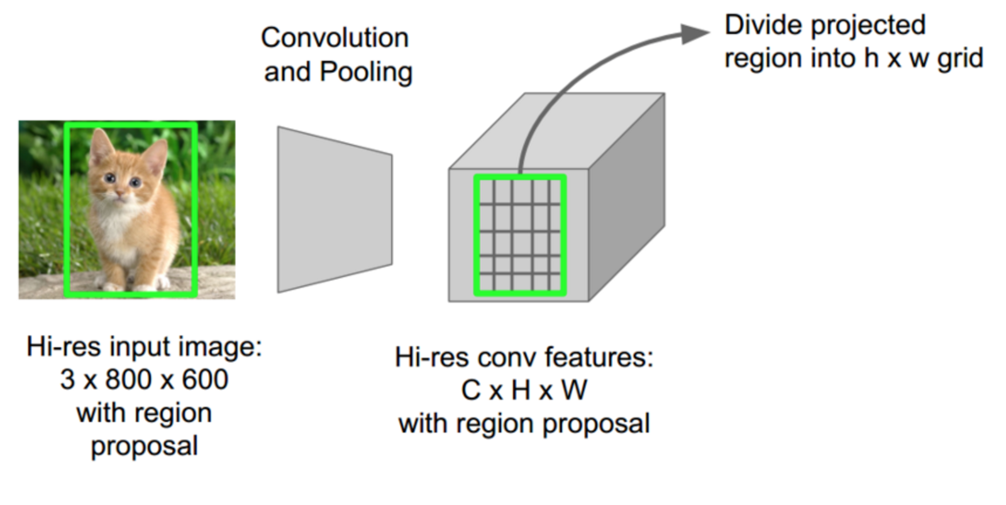
  - ROI pool shares the forward pass for each sub region because it is all done at once
  - features for each region in the original image is obtained by going to the corresponding area in the feature map
  - Then all the features in a region are max pooled, so now the regions with a high value probably have an object in them.

  - IN DEPTH:
    - ROI pooling layer inputs:
      - feature map from deep CNN
      - N x 5 matrix which has a list of ROI, where N in number of regions
        - Each row is a ROI
        - first column = image index
        - last 4 cols = coordinates for corners of region

    - For every inputted region of interest, it takes the corresponding section of the feature map and scales it to some predefined size (p x p)
      - Divide the ROI into ‘p’ number of equal sized sections
      - Max pool each section

  - This is fast because you can use the same feature map for every region proposal, no useless recalculating.

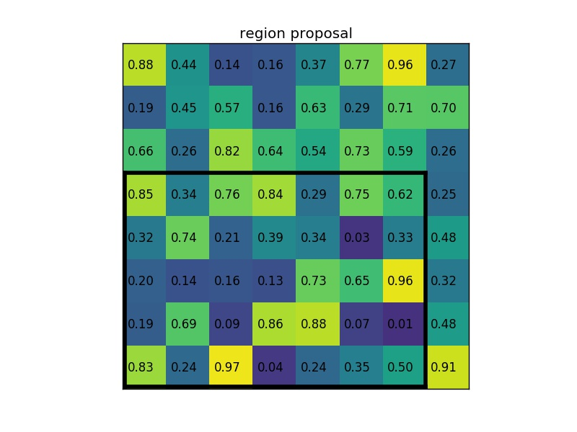
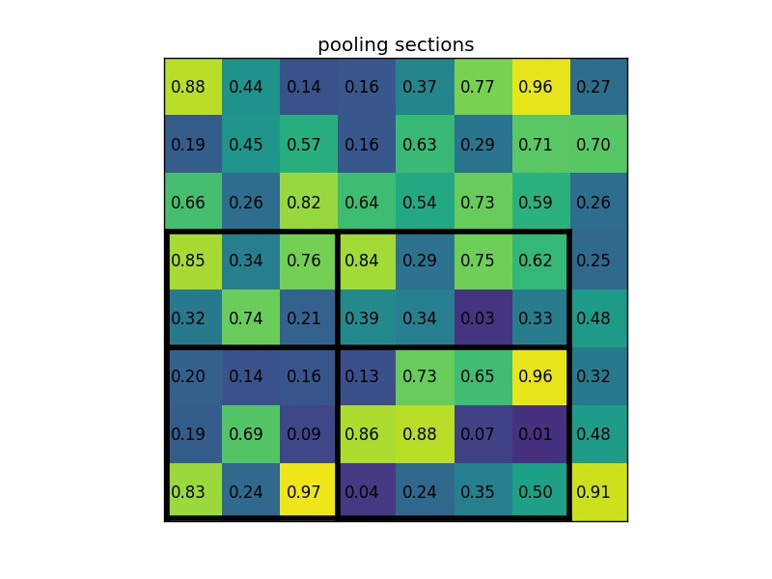

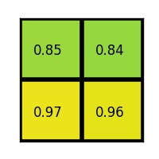

BENEFIT 2: Combine all models into just one network

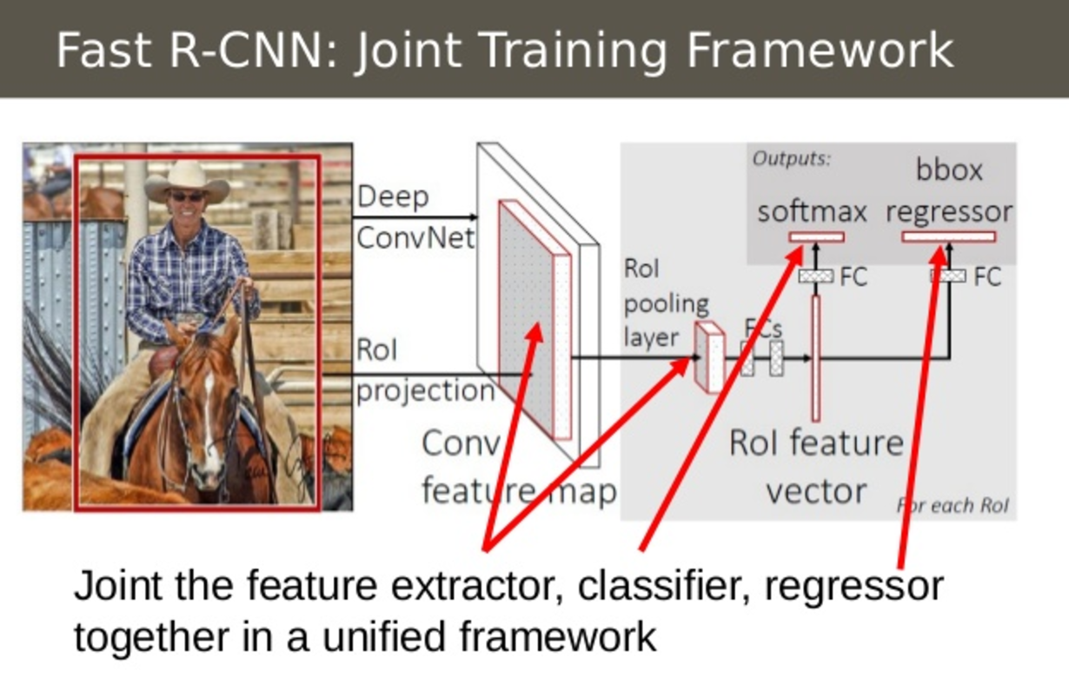
- SVM classifier has been replaced with a softmax layer after the CNN.
- The regression layer is now parallel to the softmax layer.

- Inputs: Images with region proposals
- Outputs: classifications and tighter boxes

3. EVEN FASTER R-CNN

- Problems with Fast R-CNN
  - Region proposal process of selective search is still very slow

- Faster R-CNN uses the feature map extracted from the CNN both to do classification and do extract region proposals

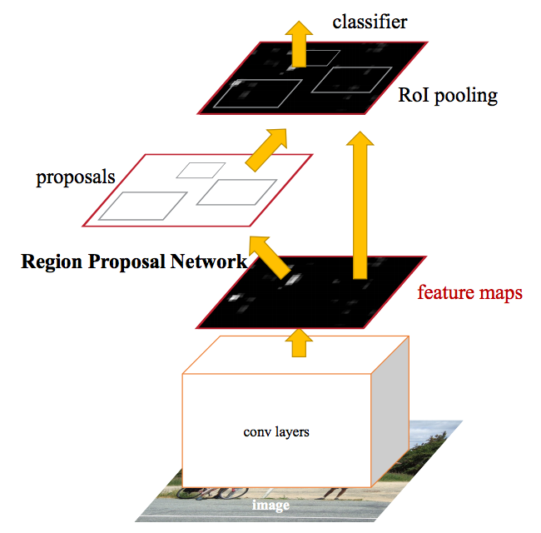

- only one CNN needs to be trained

- Inputs:
  - just the raw image, no need to inputs region proposal boxes since we just generate those with the same feature map
- Outputs:
  - classifications and bounding boxes of objects

But how are the regions generated with just a feature map?!?!?!?!?!

- Region Proposal Network
  - Another CNN operating on the features extracted from the first CNN
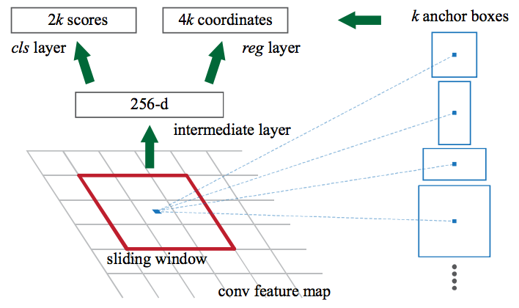
  - Passes a sliding window over the CNN feature map (kind of like a convolution but not rly…)
    - At each window location, the network outputs a score (for whether or not its an object) and the bounding box per anchor
  - In the end, outputs ‘k’ number of potential bounding boxes and scores for each box.

- Anchor boxes:
  - Some common aspect rations for the thing we are looking for
  - Example: we are looking for a ball
    - The aspect ratio of a ball will never be extremely thin so one anchor box could be 1:1
  - For each anchor box like that you output one bounding box and score per position in the image.
    - This lets the network know where the object we are looking for is in the image
  - Inputs:
    - CNN feature map
  - Outputs:
    - 1 bounding box per anchor, and a score representing how likely the thing in there is an object

