Regularization

L2 Regularization (Weight decay)

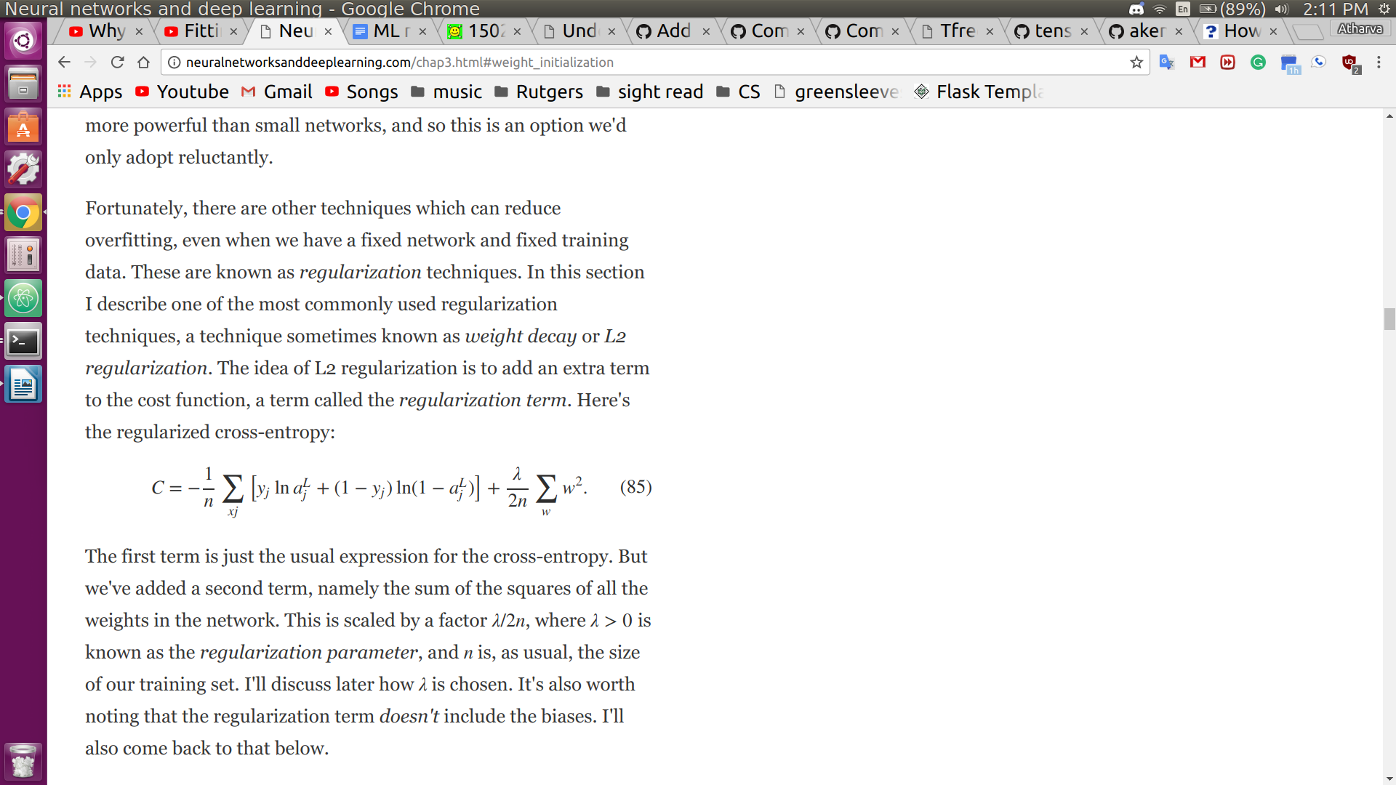

  - The 1st summation is cross entropy, and the 2nd summation is the regularization term
  - Sum of all weight squares is scaled by λ/2n, where λ>0 is the regularization parameter
  - Effect of regularization: make the network prefer to learn smaller weights, since that will reduce error the most
  - Smaller weights means that the behavior of the network won’t change if some random inputs are changes
    - So it is hard for a regularized network to learn to model the local noise
  - Regularized networks try to build simple models (occam's razor??), which generalize better
  - Regularization is compromising between finding small weights, and minimizing the original cost function
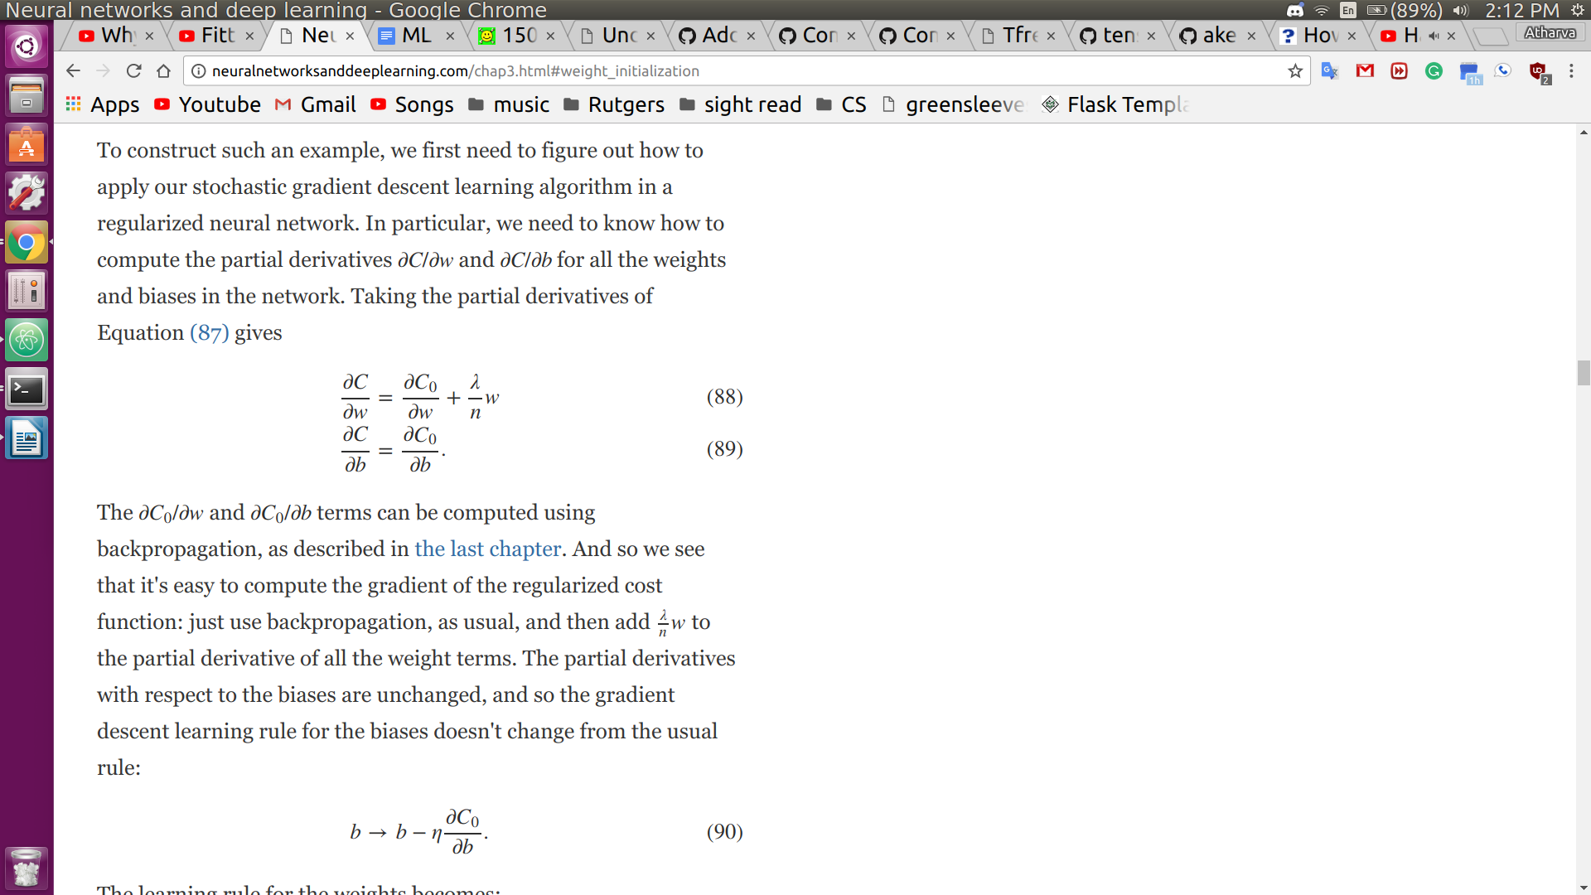
    - If λ is large, network will try to minimize weights, since they will contribute significantly to cost
    - If λ is small, network minimizes original cost function

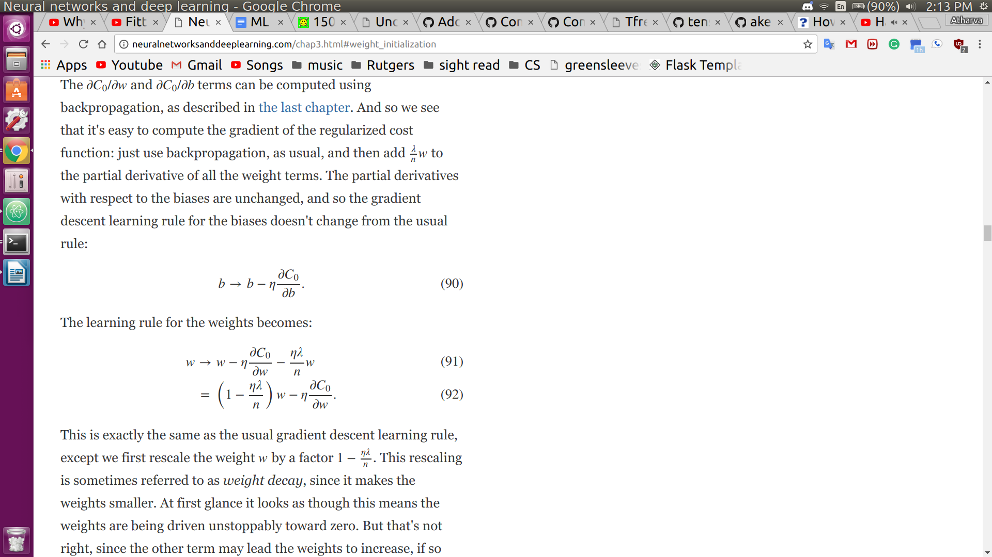
partial derivatives of cost w.r.t weight and bias

  - bias update is the same as without regularization

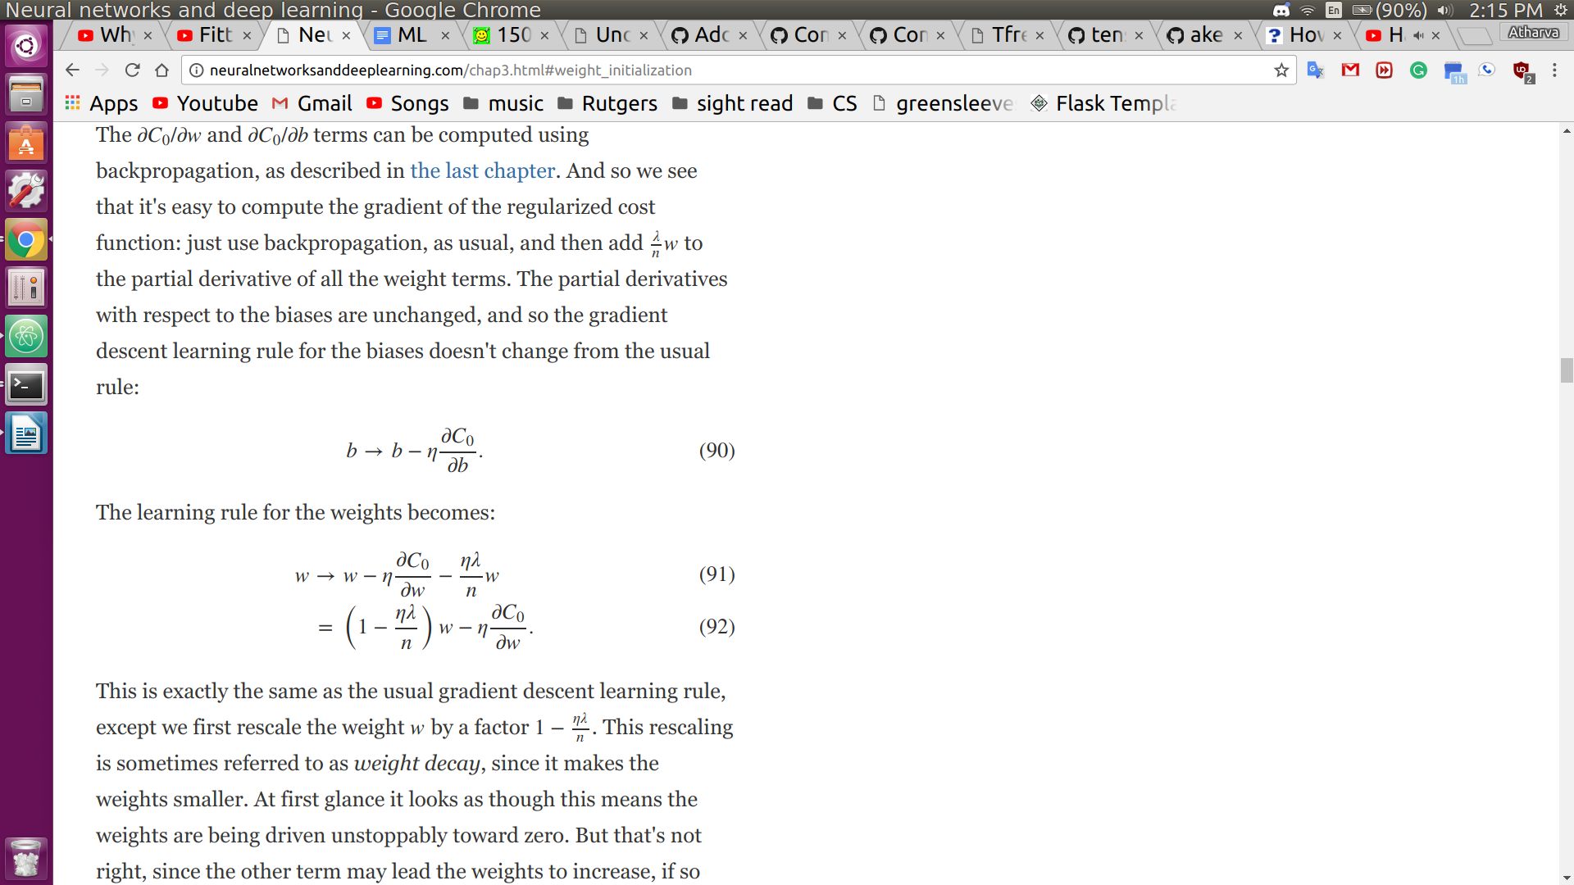
  - weight update is the same as without reg, but now we also scale by (1- ηλ/n)

    - The (1- ηλ/n) is called weight decay, since makes weights smaller
  - Sometimes, unregularized models get stuck in local minima
    - Results from regularized models are more consistent
  - If cost function is unregularized, weight vectors can get extremely large, and gradient descent usually only makes small changes

L1 Regularization

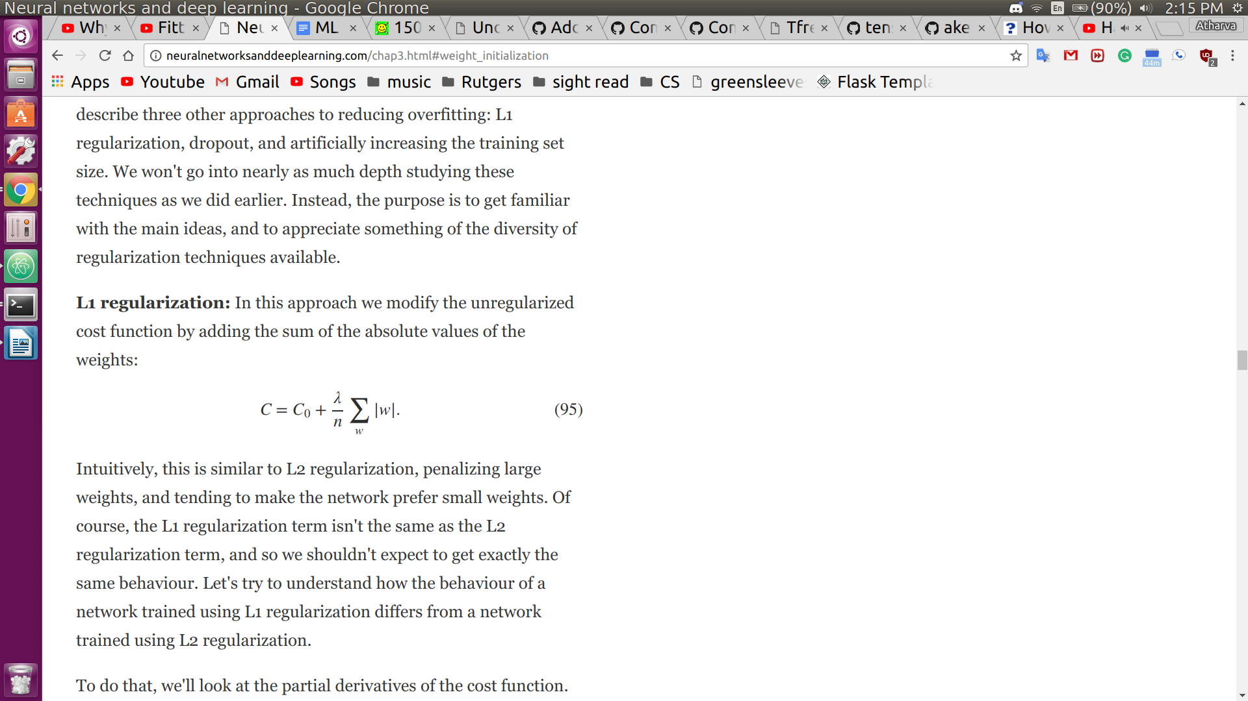
- Adds sum of abs value of all weights

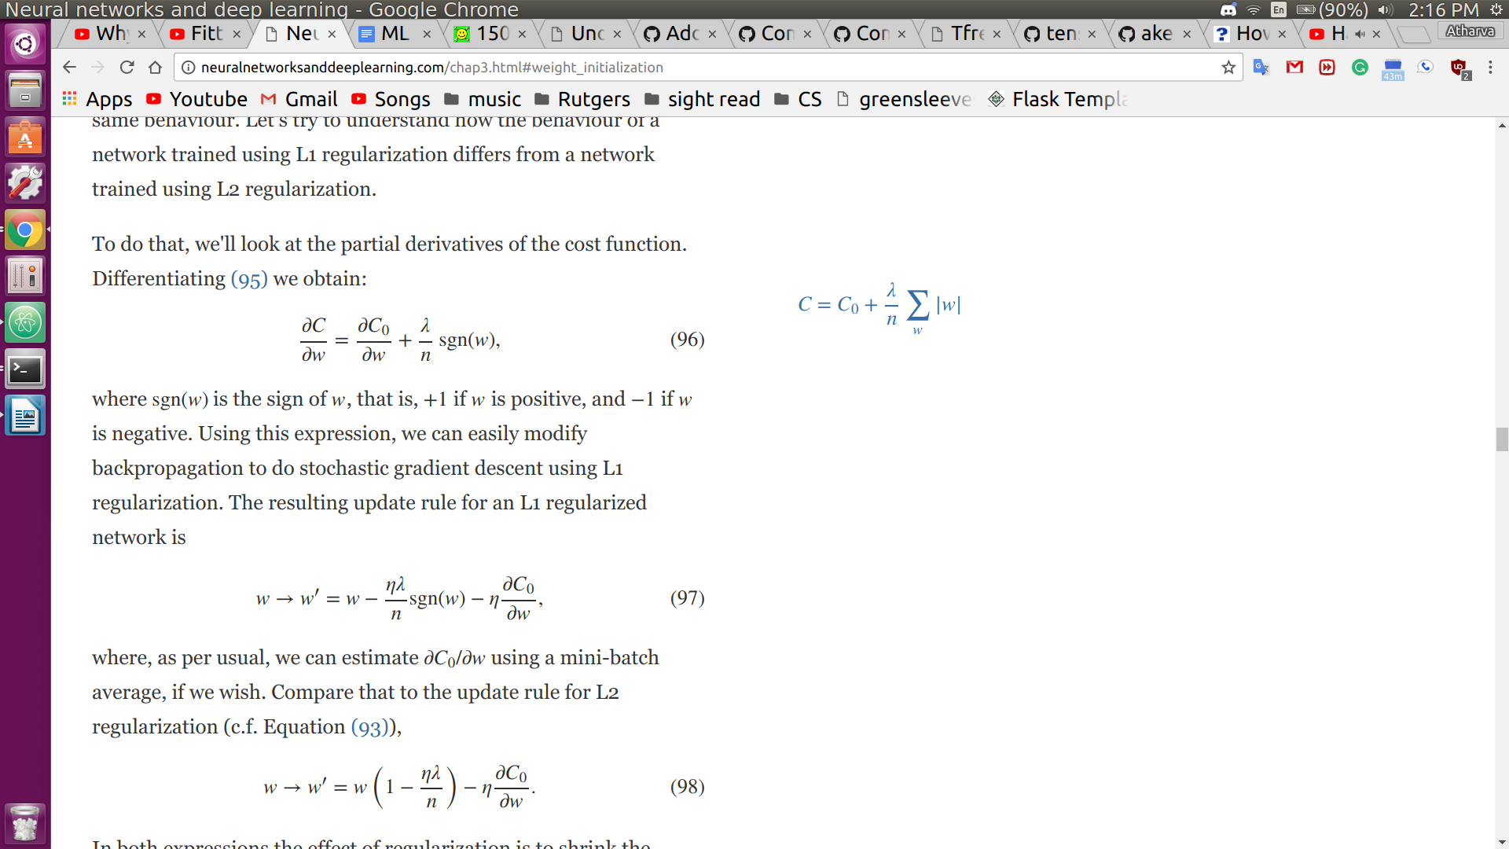
partial deriv of cost wrt weight, where sgn(w) is + if w > 0 and - if w < 0

- In L1 Reg, the weights shift by a constant amount towards 0, whereas in L2 reg, we scale by a number which is proportional to the weight
- Example:
  - If |w| is large
    - L1 reg lowers the weight by much less than L2 reg
  - If |w| is small
    - L2 reg lowers weight by more

