# Serena Deployment Automation plugin for JIRA Issues (REST)

The JIRA Issues plugin allows you to create, edit, transition and add comments to JIRA issues as part of a process. Although there is already an SDA plugin for JIRA – that plugin uses the deprecated SOAP API. This plugin uses the JIRA REST API and adds in a few more plugin steps as follows:

* **Add Comments**   
  Add comments to one or more Issues in JIRA.
* **Check Component Exists**   
  Check if one or more Components exist in JIRA.
* **Check Issue Exists**   
  Check if one or more Issues exist in JIRA.
* **Check Project Exists**   
  Check if one or more Projects exist in JIRA.
* **Check Status**   
  Check the current status of one or more Issues in JIRA.
* **Check Version Exists**   
  Check if one or more Versions exist in JIRA.
* **Create Component**   
  Create a new Component in a JIRA.  
  Sets the value of the property "componentId" to the id of the component created.
* **Create Issue**   
  Create a new Issue in a JIRA.
* **Create Version**   
  Create a new Version in a JIRA  
  Sets the value of the property "versionId" to the id of the version created.
* **Edit Issues**   
  Edit one or more Issues in JIRA, adding comments if required.
* **Get Issue Status**   
  Gets the status of an Issue.  
  Sets the value of the property "issueStatus" to the result.
* **Transition Issues**   
  Transition one or more Issues in JIRA, adding comments if required.

A number of the steps have a “Fail Mode” property, this is typically used where multiple Issues are being updated/transitioned etc. Its value can be set to achieve the following:

* WARN_ONLY  
  ignore any errors
* FAIL_FAST  
  when an issue (in a list of issues) cannot be edited etc, fail immediately and do no try any more issues.
* FAIL_ON_NO_UPDATES  
  if no issues (in a list of issues) were edited etc then fail
* FAIL_ON_ANY_FAILURE  
  if any issues (in a list of issues) were edited etc then fail

An example process is shown below:

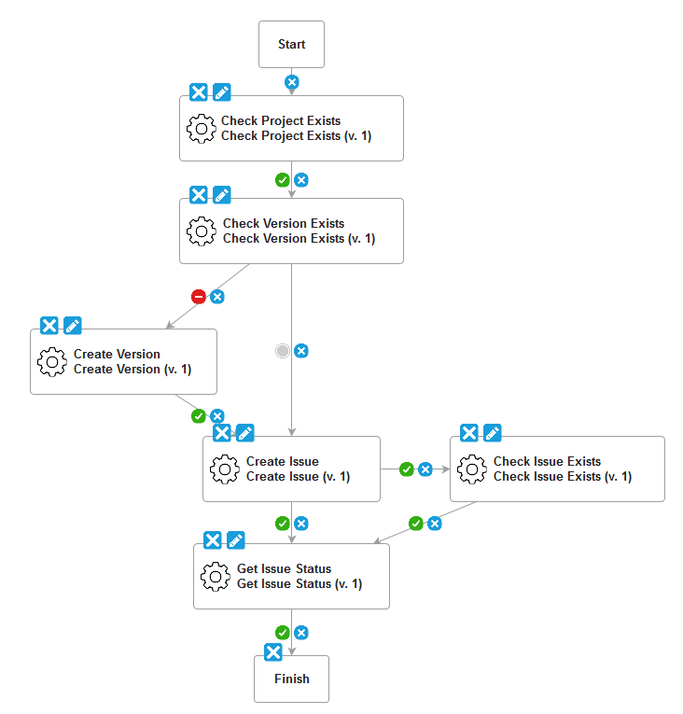

Some typical use cases for the plugin include:

* Creating an Issue (Bug) on deployment failure
* Adding Comments to Issues in a deployment
* Transitioning Issues in a deployment
* Checking the status of an Issue to see if deployment can start

The list of Issues to be edited/transitioned etc can either be entered at deployment time or associated with the versions that are being deployed. To do the latter create a new Version Property definition for each component of name “jira.issueIds” or similar:

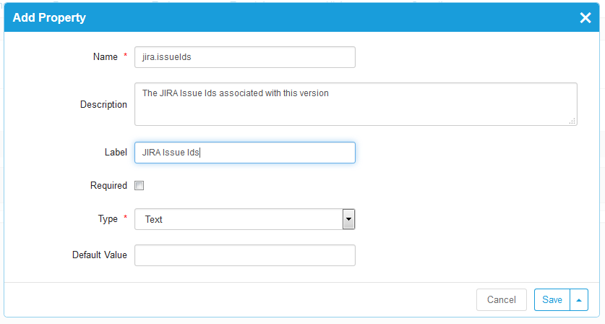

The issues ids on each version can then be populated manually, or better automatically from a build tool or separate plugin.