# Serena Deployment Automation plugin for ServiceNow (REST)

The ServiceNow plugin allows you to create, edit, transition and check the status of Change Requests and Tasks as part of a process. Although there is already an SDA plugin for ServiceNow – that plugin uses the SOAP API and needs to be re-built for each new version of ServiceNow. This plugin uses the ServiceNow versioned REST API and adds in a few more plugin steps as follows:

* **Check Change Request Approval**  
  Check the current approval status of one or more Change Requests in ServiceNow.
* **Check Change Request Status**  
  Check the current status of one or more Change Requests in ServiceNow.
* **Check Change Requests Child Task Status**  
  Check the current status of one or more Change Request's Child Tasks in ServiceNow.
* **Check Change Requests Exist**  
  Checks if one or more Change Requests exist in ServiceNow.
* **Create Change Request**  
  Create a new Change Request in ServiceNow, sets the properties "changeId" and "sysId" to the Change Request "number" and "sys_id".
* **Create Incident**  
  Create a new Incident in ServiceNow, sets the properties "incidentId" and "sysId" to the Incident "number" and "sys_id".
* **Get Change Requests Child Tasks**  
  Gets the Child Tasks for a Change Request in ServiceNow, sets the property "changeTaskIds" to a comma separated list of the numbers for the Change Tasks.
* **Set Change Request Approval**  
  Set the current approval status of one or more Change Requests in ServiceNow.
* **Set Change Request Status**  
  Set the current status of one or more Change Requests in ServiceNow.
* **Set Change Task Status**  
  Set the current status of one or more Change Tasks in ServiceNow.

A number of the steps have a “Fail Mode” property, this is typically used where multiple Change Requests are being updated/transitioned etc. Its value can be set to achieve the following:

* WARN_ONLY  
  ignore any errors
* FAIL_FAST  
  when a change request (in a list of change requests) cannot be edited etc, fail immediately and do no try any more change requests.
* FAIL_ON_NO_UPDATES  
  if no change requests (in a list of change requests) were edited etc then fail
* FAIL_ON_ANY_FAILURE  
  if any change requests (in a list of change requests) were edited etc then fail

An example process is shown below:

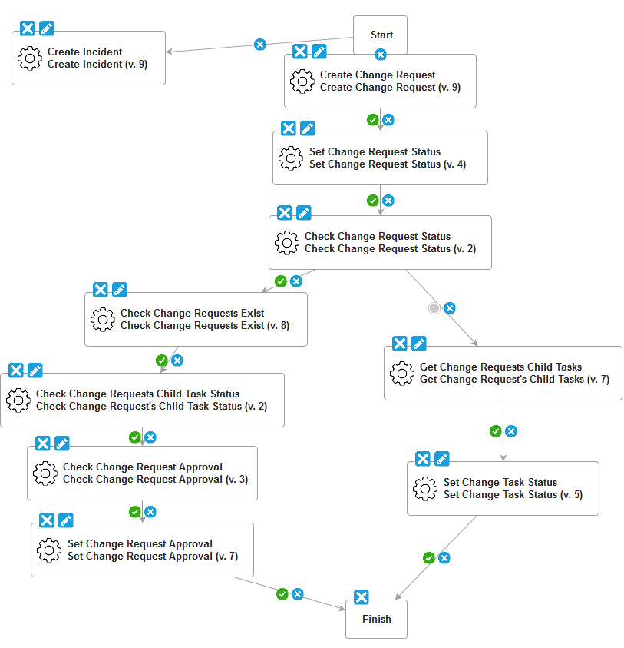

Some typical use cases for the plugin include:

* Check the Approval status of a Change Request to see if deployment can start
* Transitioning Change Requests to different state on successful deployment
* Checking if all Change Request tasks have been completed
* Creating a new Incident on a failed deployment

The list of Change Requests to be edited/transitioned etc can either be entered at deployment time or associated with the versions that are being deployed. To do the latter create a new Version Property definition for each component of name “snow.changeIds” or similar:

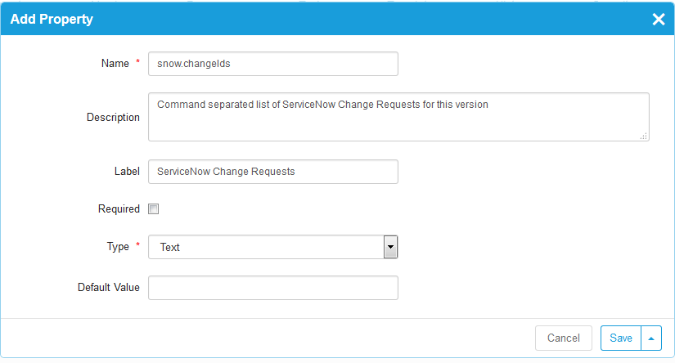

The change ids on each version can then be populated manually, or better automatically from a build tool or separate plugin.