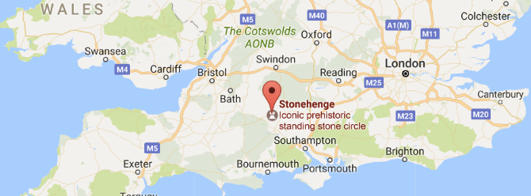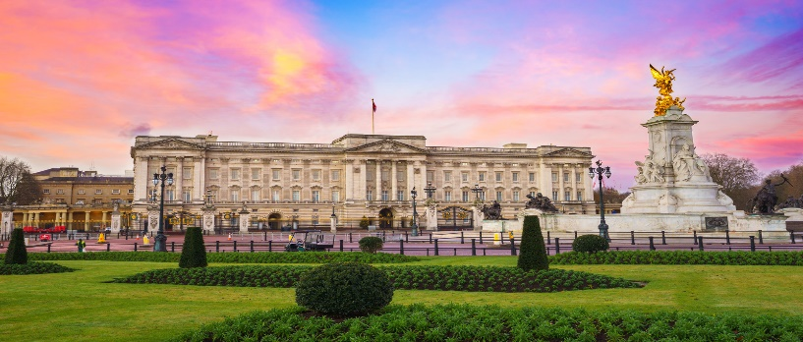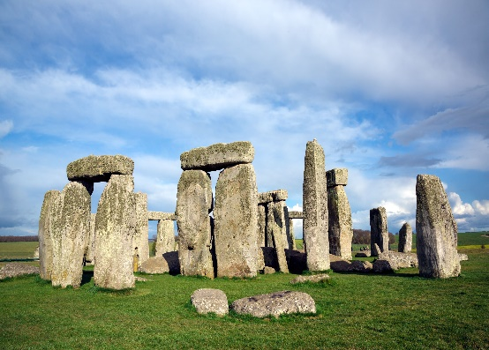

***Buckingham Palace***

***Stonehenge***

Stonehenge is a natural human attraction built in the Stone age era, they have been around for centuries. It’s an open space of land with impressive rocks. They date back so far in time to around 3000 BC and they signify the Stone age. The area used to be able to help with daily things like telling the time. Stonehenge opens at 9:30am and closes at 5:00pm. For a child to visit it would cost £12.00 to get in and for an adult it costs £20.00.

***Buckingham Palace*** is a human attraction with some of the finest things in the UK. To get into Buckingham palace you need to buy a ticket the ticket can cost £26.50 for adults and £24.00 for students. This ticket is for the grounds and the massive cultural house. The cost to get there depends on if you live near or far away .You could go in a car, but the easiest route would be by train. This would cost around £20.00 per person, depending if you are just going by yourself or if all the whole family are going. It could cost quite a lot for a large family!

TOP THREE  
 Landmarks in the UNITED KINGDOM

**Geography Leaflet Level 2**

***The White Cliffs of Dover***

The white cliffs of dover are a physical attraction and they are natural beauty spot. It is on the coast of Dover facing south towards France. It is free to get in, but it is £10.00 to park for all day and £5.00 for 3 hours. The White Cliffs of Dover is owned by the National Trust and is an amazing piece of natural erosion next to the sea.

