# Serena Deployment Automation plugin for Teamcity

* Install the SerenaDeploy.zip in to TeamCity using the Administration menu
* Go to an existing Build Configuration and add a new Build Step selecting Serena Deploy plugin.
* Enter the parameters for SDA (see screenshots as an example).
* In SDA, select None as the source type for the component you are uploading to as the plugin resides in TeamCity
* The plugin will optionally upload a new version into SDA using the built artefacts.
* The plugin will optionally create component version properties to the uploaded version.
* The plugin will optionally apply a status to the uploaded version.
* The plugin will optionally execute a process to deploy it.
* A parameter can be passed to the plugin to determine if publishing should occur. For example create a parameter "PublishToSDA" as below and then in the plugin parameter "Publish Version if" reference this parameter, i.e. %PublishToSDA%.

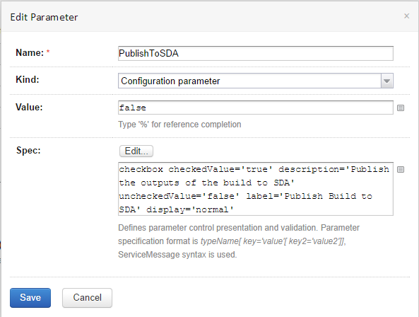

* A parameter can be passed to the plugin to determine if deployment should occur. For example create a parameter "DeployFromSDA" as below and then in the plugin parameter "Deploy to Version if" reference this parameter, i.e. %DeployFromSDA%.

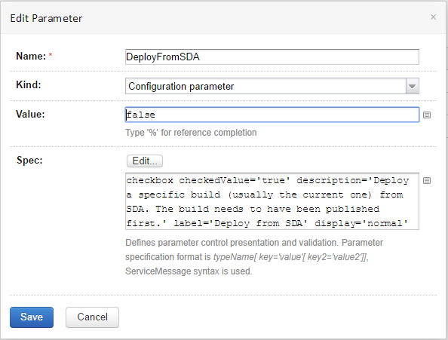

* Deployment can be carried out in a separate step if required, however the component name and version name need to be set to ensure that deployment is initiated.

## Example Setup (1/2):

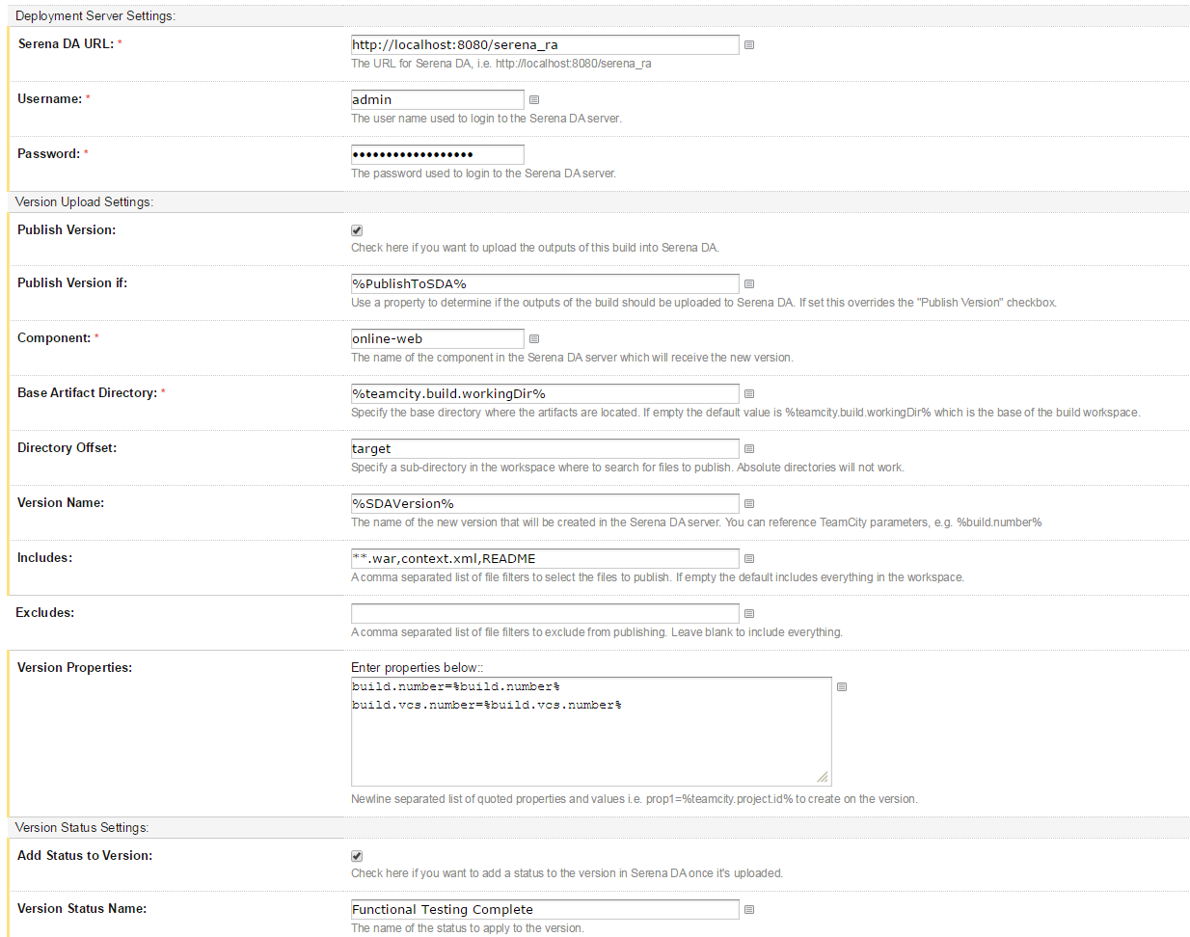

## Example Setup (2/2):

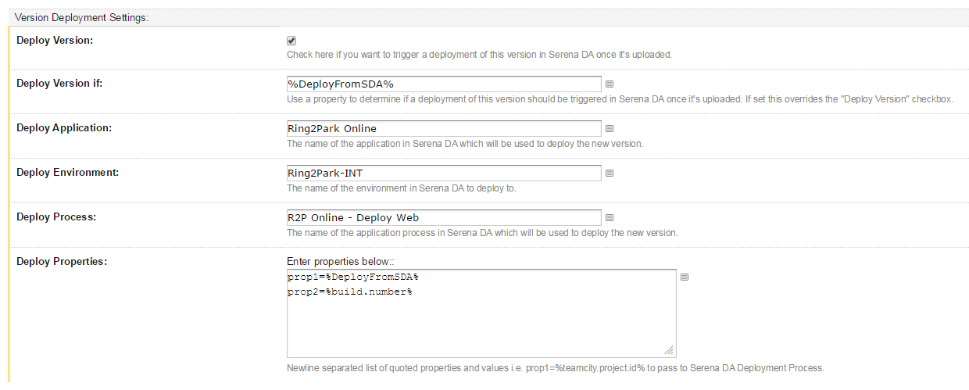

## Example Successful Build Output:

