

**BUDAPEST UNIVERSITY OF TECHNOLOGY AND ECONOMICS**

**Control Engineering and Image Processing Laboratory**

**After Experiment Report**

**Akif ALIÇ**

**QILMRM**

1. **Introduction**

Filtering is a technique for modifying or enhancing an image. For example, you can filter an image to emphasize certain features or remove other features. Image processing operations implemented with filtering include smoothing, sharpening, and edge enhancement.

Filtering is a *neighborhood operation,* in which the value of any given pixel in the output image is determined by applying some algorithm to the values of the pixels in the neighborhood of the corresponding input pixel. A pixel's neighborhood is some set of pixels, defined by their locations relative to that pixel.

*Linear filtering* is filtering in which the value of an output pixel is a linear combination of the values of the pixels in the input pixel's neighborhood.

Linear filtering of an image is accomplished through an operation called convolution. Convolution is a neighborhood operation in which each output pixel is the weighted sum of neighboring input pixels. The matrix of weights is called the convolution kernel, also known as the filter.

**2. Experiments**

**2.1 Kernels Filters**

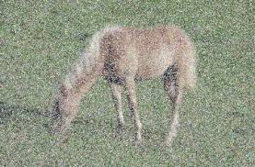

**Figure 1. original image**

In this experiment, we used different filters for image filtering. We use kernel filters with 4 different types of kernel matrix and FFT filter (Fast Fourier Transformation) with low pass and high pass methods based on the noised image which is above can be seen in Figure 1. If we check the original image we can easily see noises which is called salt and pepper type noise. The image might be clear for human perception however for computer algorithm it is really hard to capture. Therefore we should do this filtering process to eliminate the noise and make the image better vision for computer. By using this filters it will be quite easy for computer to find the horse in the image. The first method we used is kernels filter with the implementation of different kernel matrixes, the result is shown as follows.

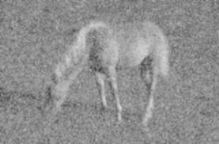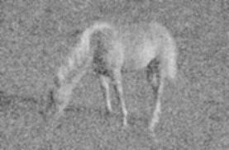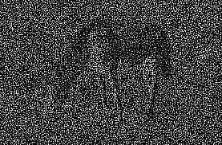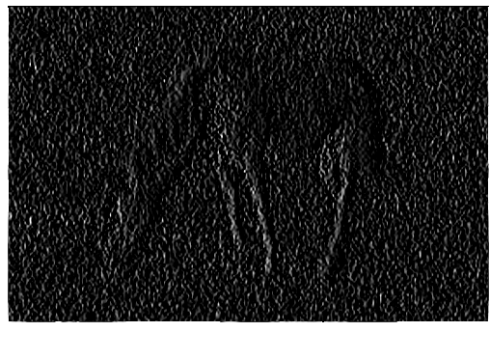

**Figure2. kernels filter image with 4 kernel matrixes**

we use different kernel matrix whose size is 3x3 in the kernels filter and implement it in this original image, after that we get the figure 2. As we can see from figure 2, the sequence of the picture in figure 2 from left and top is picture 1, 2, 3, 4, which are corresponding to the kernel matrixes 1, 2, 3, 4 respectively and the specific value of these matrixes is as follows:

|  |  |  |
| --- | --- | --- |
| 1 | 1 | 1 |
| 1 | 1 | 1 |
| 1 | 1 | 1 |
| 0.3 | 0.5 | 0.3 |
| 0.5 | 1 | 0.5 |
| 0.3 | 0.5 | 0.3 |

Kernel 1 Kernel 2

|  |  |  |
| --- | --- | --- |
| 1 | 1 | 1 |
| 1 | -8 | 1 |
| 1 | 1 | 1 |
| -1 | 0 | 1 |
| -1 | 0 | 1 |
| -1 | 0 | 1 |

Kernel 3 Kernel 4

If we applied the corresponding kernels the given image then results are shown above. If we check the results, one can easily see that the first image is blurry version of original image and filter is called blur filter which simply create a new image which has new pixel value from its neighboring pixels. The second one is called Gaussian filter which is known as smoothing filter and as we can see from image above the result is smooth version of original image.

And the kernels filter 3 and 4 can be said as edges kernel filters according to its function, so which means we can extract the edges information from the image through this filter. The specialty of this filter is that matrix sum equal to zero. And more specifically, the third kernel filter is point filter and the fourth filter is line filter in a vertical way. By doing this operation, computer can detect the lines which image has.

**2.2 FFT Filters with low pass**

It is also one of the image enhancement method. A low pass filter is the basis for most smoothing methods. An image is smoothed by decreasing the disparity between pixel values by averaging nearby pixels. Using a low pass filter tends to retain the low frequency information within an image while reducing the high frequency information. FFT filter is to transform processing data into the frequency domain, and the advantage of this is computing faster to perform 2-dimensional image than performing a convolution in the spatial domain. Figure 3 and 4 are example of FFT low pass filter results. In this experiment we implement FFT filter with the different level of a low pass one is really low and the other one is relatively high. And it indicates that we can get less noise and blurry image if we implement lower level of a low pass from this consequence, so in order to get the best effective image, it is essential to find a balanced point which could make the reduction of noise in this image and clear for the objects as well. The influence of this method is quite similar to the first method that is kernels filter. The key point is trying to find the best variables for each method and get the best image.

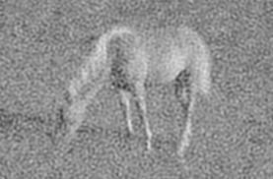 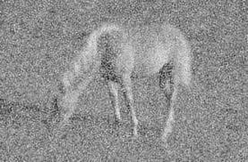

**Figure3. Low pass FFT filter image with 5% Figure4. FFT filter image with 20% low pass**

**2.3 FFT Filters with high pass**

High pass filter will increase the contrast between bright and dark pixel to produce a sharper image and Figure 4 and 6 shows the result which we implement FFT filter with the different lever of a high pass in this experiment. And it indicates that we can extract the shape of the objects in this image with high pass, as the level of the high pass increases, the edges of the objects are blurrier and only frequency noise appears. When we set the level which is above 20%, we even could not see anything, its function is similar to the kernel filters 3 and 4. The kernel of the high pass filter is designed to increase the brightness of the center pixel relative to neighboring pixels.

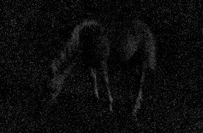 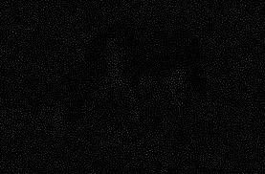

**Figure 5. FFT filter image with 5% high pass Figure 6. High pass FFT filter image with high**

1. **Conclusion**

In this experiment we asked for to use different filters to enhance an image and extracts some features. And we used 4 different kernel in the first experiments and we evaluate the results above. In short, by using kernels we can get some important feature of an image which can help computer algorithm to get the needed information from image. What we worked on was a noisy image which is quite hard for computer to get needed information. Even in this case some early filtering methods will help a lot us to get better image for computer algorithms.

The second experiment aim to understand the frequency contents of an image and get a results based on images frequency content which might be very useful information for some case be like if the noise is high frequency noise which image include, then it will be easy to clear it from image by using frequency filters. As we done in this second experiment we can easily see that in high frequency only noise appears. Therefore one can say image contents close the zero. In short, the experimental results show that, high pass filter preserves the edge details and low pass filter denoises the image by preserving details, therefore high pass and low pass filters are basic filters used in the image transformations

The experiment and results has been evaluated and final word is that in image processing, there are some early work to be able to process image to get better results. This process is called filtering in bit images. It might be really useful for some case especially when the image content include noises and some other unwanted contents.