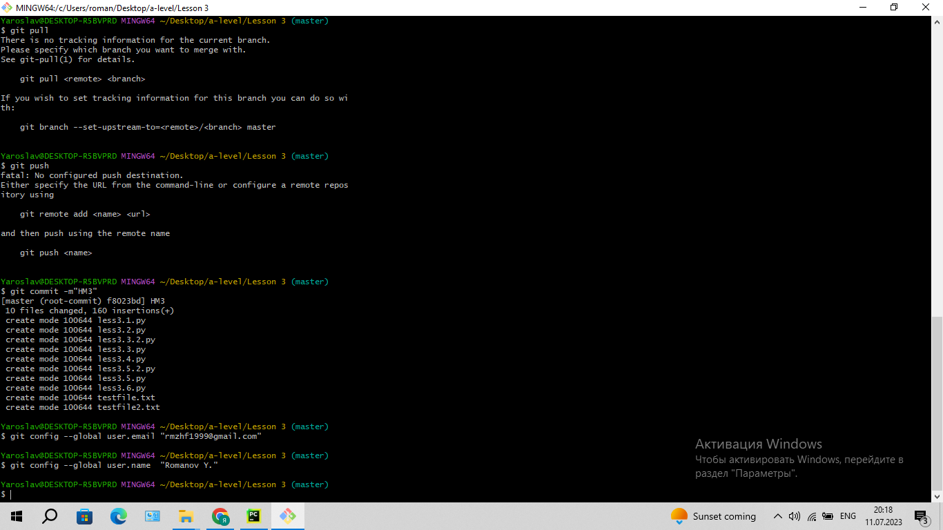

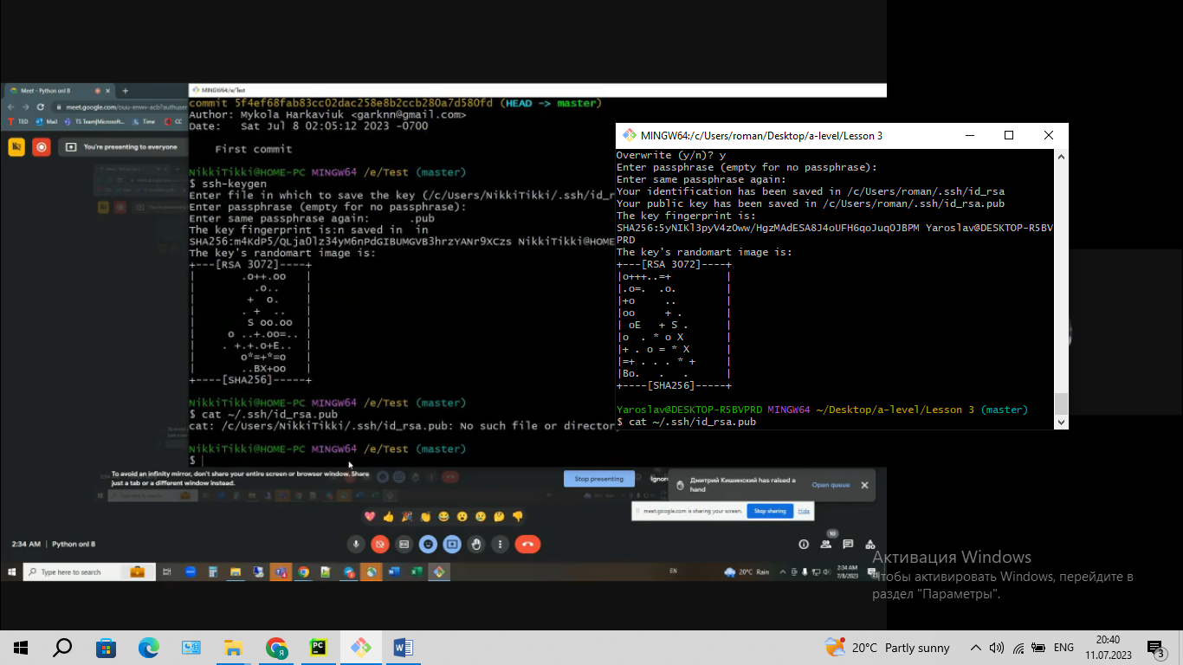

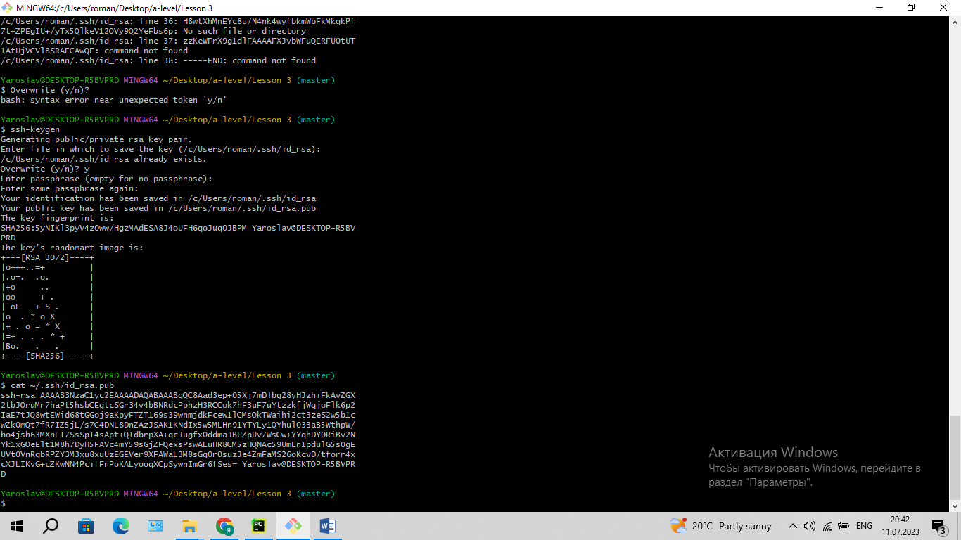

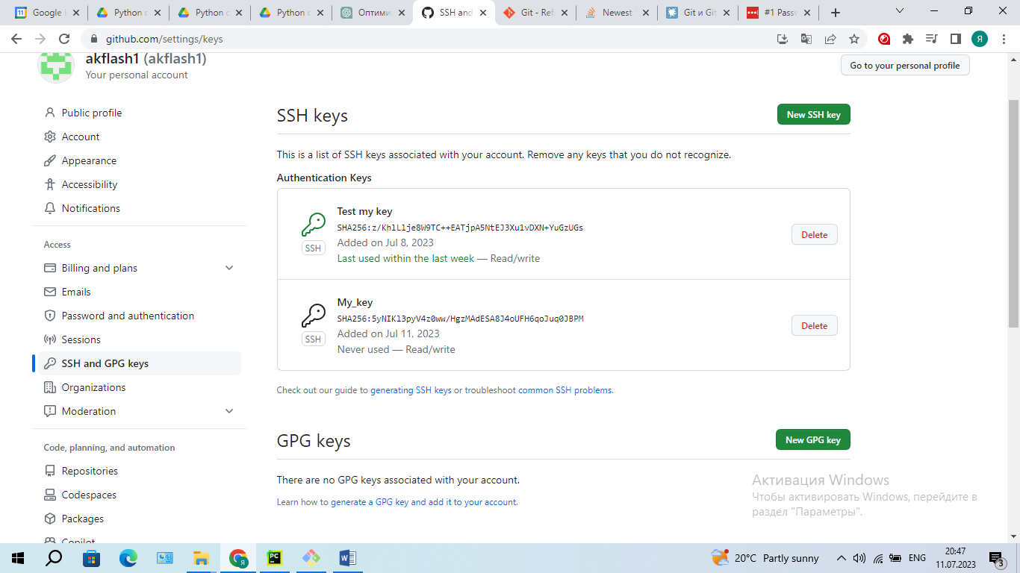

git pull origin master

From github.com:akflash1/My-HM-a-level

* branch master -> FETCH_HEAD

fatal: refusing to merge unrelated histories

git push -u origin master

To github.com:akflash1/My-HM-a-level.git

! [rejected] master -> master (non-fast-forward)

error: failed to push some refs to 'github.com:akflash1/My-HM-a-level.git'

hint: Updates were rejected because the tip of your current branch is behind

hint: its remote counterpart. Integrate the remote changes (e.g.

hint: 'git pull ...') before pushing again.

hint: See the 'Note about fast-forwards' in 'git push --help' for details.

git pull origin master --allow-unrelated-histories