Documentation for Snake V1.0

README:

Snake is a Python powered Game script designed for Beginners to learn python game programming.The source code has meaningful comments which

lets the programmer know about the working of different functions in pygame modeule.You can freely modify the source code and make

advancements to the game.I have also putted some challenges in the code(Some code is not working ),You can fix that too.

Logic For The Game:

The snake eats the apple and its size is getting bigger.If you collide with the boundaries you will Die...Thats it Simple.

Instructions :

1. Use Arrow keys(Up,Down,Right or Left) to navigate the snake.

2. Other keys as directed by the message.

Requirements :

1. Any Python IDE(like Pycharm,VScode,Coding blocks etc.)

2. Pyhton installed on your machine(You can download it at www.python.org)

3. Pygame Module installed (You can install it Either by command pip install pygame on cmd OR by installing it in interpreter)

Modification in Code :

You can modify it freely,But after modifying please let me know about the modification.You can Mention me in your instagram story

by Mention @abhaygupta1609 . I will appreciate you and it makes me happy.

Contact Us :

Instagram - @abhaygupta1609

Facebook - fb.com/akgupta077

Email - Akgupta0777@gmail.com

Whatsapp - +919354942524

Raise an issue on my github if you are stuck at something.

Date Created On :- 31 August 2019

For Those who are complaining error about Module not found Pygame...Just follow these steps:

Open Pycharm IDE

Just go to file tab

Then settings

There is a project folder there

Click on it

Then click on project interpreter

Then click + sign

Search pygame and install package.

Pictures that may help you

1. 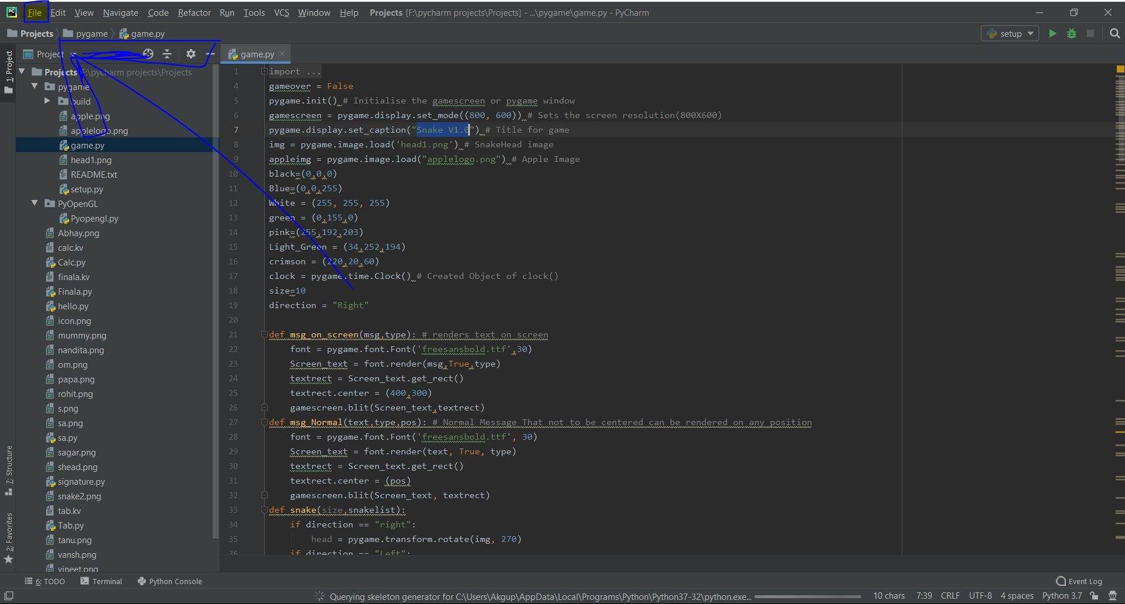
2. 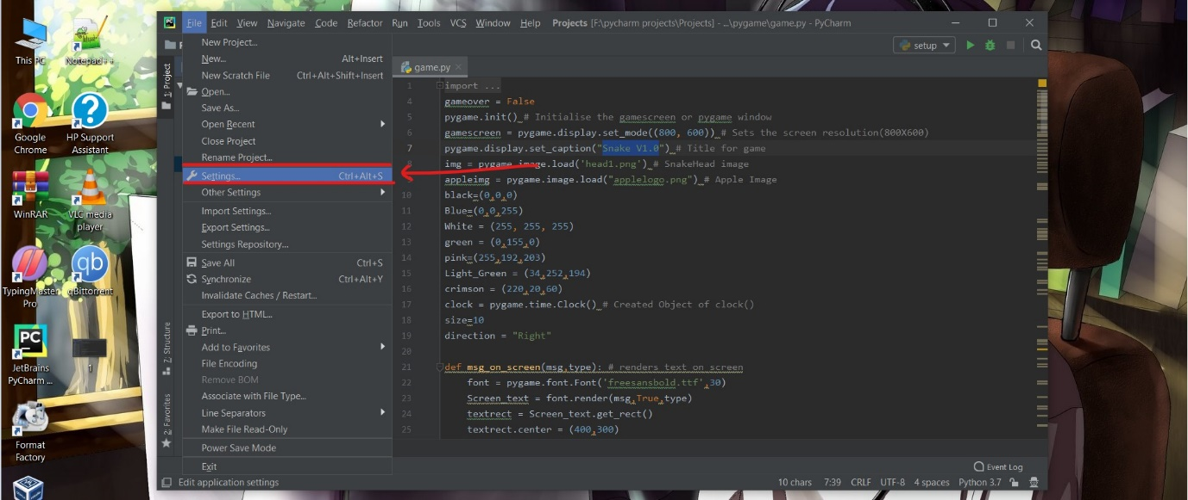
3. 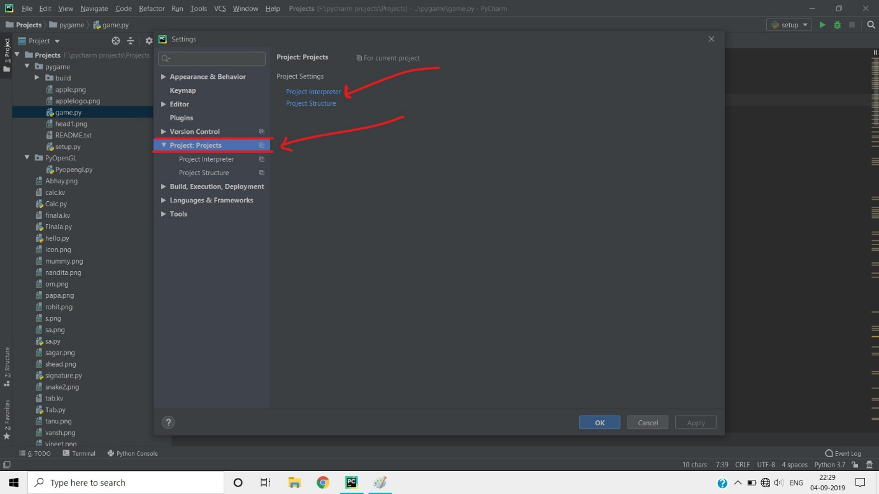
4. 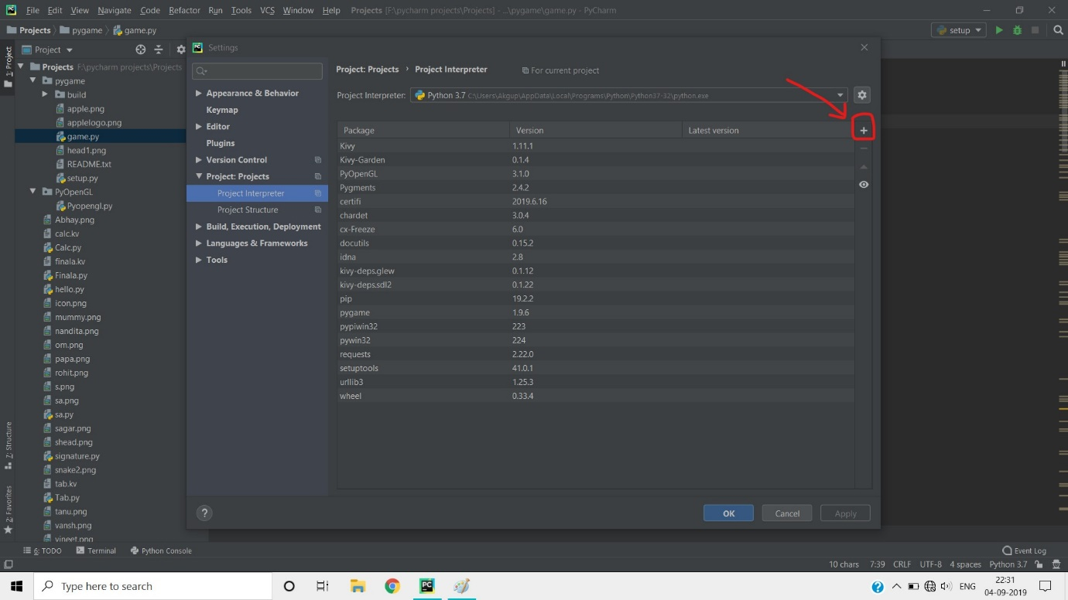
5. 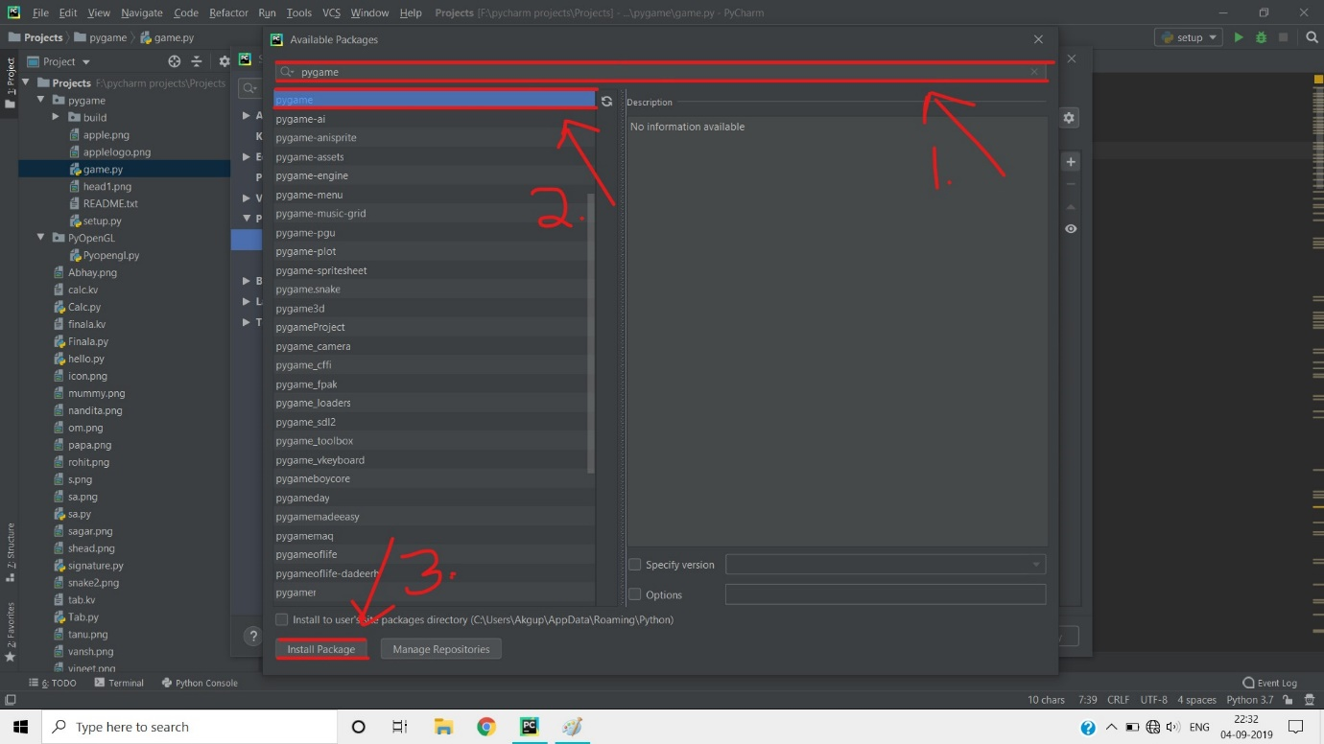

That’s it you are done with Pygame installation.