Assignment 5

Restaurant Automation System (RAS)

Software Analysis and design

Group 39

1. Gaurav Kumar

2. Ankit kumar gupta

Contents

1.0. Introduction ……………………………………………………………………………………………3

1.1. Purpose .................................................................................................3

1.2. About the software .................................................................................................. 3

1.3. Feasibility Study ..................................................................................................... 3

2.0. Software Analysis and Design……………………………………………………………………………………..4

2.1 class diagram …………………………………………………………………………………………………………..4

2.2 sequence diagram ………………………………………………………………………………………………………….5

3.0 conclusion ………………………………………………………………………………………………………………………

**1. Introduction**

**1.1. Purpose**

The purpose of this document is to provide the detailed design specifications of Restaurant Automation System (RAS) . It analyses the problem and explains different design viewpoints using various diagrams and thus elaborates the planned implementation that needs to be carried out.

**1.2**. **About the software**

This software is meant for computerize order processing, billing, and accounting activities in restaurant. Major goal of this computerization is to make supply ordering more accurate so that the problem of excess inventory is avoided as well as the problem of non-availability of ingredients required to satisfy orders for some popular items is minimized.

**1.3. Feasibility Study**

**1.3.1. The Problem**

The problem is to develop software for restaurant owner to computerise order processing, billing, and accounting activities in restaurant. Major goal of this computerization is to make supply ordering more accurate so that the problem of excess inventory is avoided as well as the problem of non-availability of ingredients required to satisfy orders for some popular items is minimized. This will help in increase in profit and reduce food wastage. The computer will calculate the threshold value for each item based on the average consumption of this ingredient for the past three days and assuming that a minimum of two days stock must be maintained for all ingredients.

The problem may be broken into some sub problem:

**1. Identifying stakeholder:**

These are key user who interacts with the software most of the time. In this software the stakeholder are sales clerk and manager. Whenever any item is sold, the sales clerk would enter the item code and the quantity sold. Manager can change the prices of items and he can also generate Monthly sales receipt and expenses data.

Accessibility Rights has been given to manager and sales clerk and owner of the restaurant.

**2. Generation of statistics:**

The computer will generate statistical report about sales of different items whenever owner of the restaurant wants to see them.

**3. Calculating the threshold value**:

On the basis of average consumption of this ingredient for the past three days computer will calculate threshold value.

**2. Software Analysis and Design**

**2.1 class diagram**

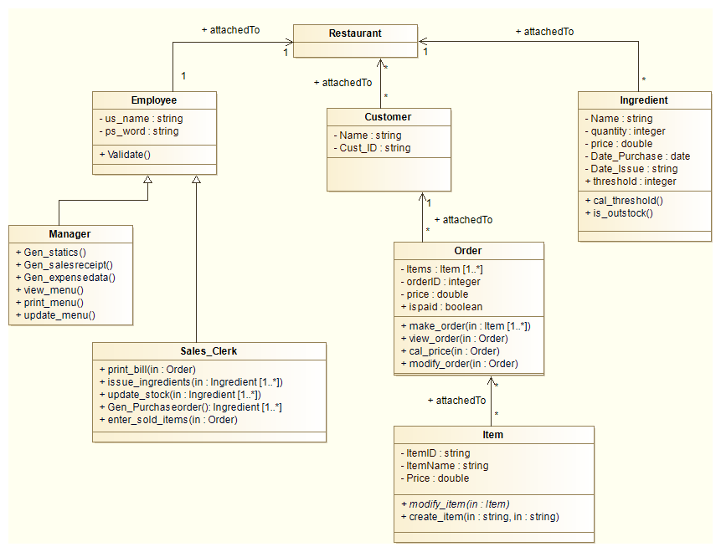

1 .Employee consists of stakeholder member who works at the restaurant. It contains special attributes of employee like username (us_name) and password (ps_word).

2. Manager class is inherited from employee class so it contains special attributes of username and password. It contains methods which is use to generate statistics, generate sales receipts, view and update menu.

3. Sales clerk class also inherited from employee class so it also contains special attributes of username and password. This class has methods which are used to generate bills, issue ingredients, and update stock.

4. Customer class contains two special attributes name and cust_ID (customer id).It is base class for order class.

5. Order class contains special attributes of items array which contains list of menu items which has been ordered by customer. It also contains the special attributes order id and price. Make order method has an argument of array of items. View_order contains the ordered items. Cal_price calculates the total price.

6. Item class has three special attributes namely itemID, ItemName, itemPrice.

7. Ingredient class has special attributes of name, quantity, price, date of issue of ingredients. Cla_threshold method calculates the threshold value for each ingredients on the basis of uses of items formed by the ingredients in past three days.

**2.2 Sequence diagram**

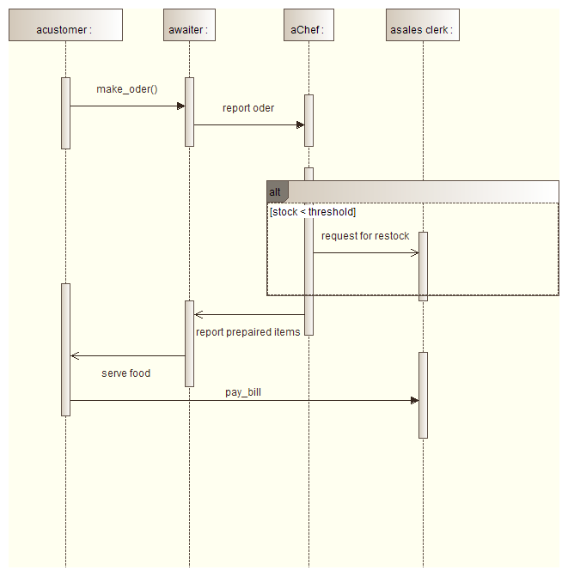

1. The first step is to take order from the customer

2. The order is taken by waiter, who convey message to the chef for preparation of the food.

3. Chef check the stock, if the stock is less than the threshold value he request for restocking to the sales clerk.

4. Then chef prepare the food and waiter serves it to the customer.

5. Then customer pay the required bill.

**3.0 conclusion**:

This document describes the software analysis and design of the restaurant automation system. It describes class diagram, sequence diagram. It makes to understand software easily. It is purely based on object oriented programing.