**Software Requirement**

**Specifications**

**(Version 1.0)**

FOR

**Restaurant**

**Automation System**

**Ankit kumar Gupta and Gaurav Kumar**

**Group 39**

***Table of Contents***

**Table of Contents**....................................................................................................................................... ii

**1.0. Purpose**.................................................................................................................................................. **1**

1.1. Introduction............................................................................................................................................ 1

1.2. Scope........................................................................................................................................................1

1.3. Glossary....................................................................................................................................................1

1.4. References.................................................................................................................................................1

1.5. Document Overview..................................................................................................................................2

**2.0. Over all Description**............................................................................................................................... **3**

2.1. Project Perspectives............................................................................................................................... ...3

2.2. Project Features.........................................................................................................................................3

2.3. Use Cases...................................................................................................................................................3

2.3.1 *Use Case: Place order….*........................................................................................................................4

2.3.2 *Use Case: cook food*...........................................................................................................................…4

2.3.3 *Use Case: serve food*................................................................................................. …………………………7

2.3.4 *Use Case: pay bill*.................................................................................................................................. 8

2.3.5 *Use Case: view menu…………………………………………………………………………………………………………………..*

2.3.6 *Use Case: print menu…………………………………………………………………………………………………………………..*

2.3.7 *Use Case: update menu………………………………………………………………………………………………………………*

2.3.8 *Use Case: Generate sales receipt report……………………………………………………………………………………*

2.3.9 *Use Case Generate expense data report ……………………………………………………………………………...*

2.3.9 *Use Case Generate sales statics report ……………………………………………………………………………………*

2.3.11 *Use Case: login ……………………………………………………………………………………………………………………..*

2.3.12 *Use Case: Generate purchase order………………………………………………………………………………………..*

2.3.13 *Use Case: Enter invoice of purchase ………………………………………………………………………………………*

2.4. User Characteristics............................................................................................................................... 9

2.5. Operating Environment......................................................................................................................... 9

2.6. Design and Implementation Constraints.............................................................................................. 10

2.7. Assumption and Dependencies........................................................................................................... 10

**3.0. Requirement Specifications**.............................................................................................................. **10**

3.1. External Interface Requirements.......................................................................................................... 10

3.2. Functional Requirements..................................................................................................................... 10

3.2.1. Set Initial Configuration................................................................................................................ 10

3.2.2. Configure....................................................................................................................................... 11

3.2.3. View Normal Simulation............................................................................................................... 11

3.2.4. View Graphical Simulation........................................................................................................... 12

3.2.5. View Optimal Number of Adjusters............................................................................................. 12

3.3. Detailed Non- Functional Requirements............................................................................................. 13

3.4. System Evolution................................................................................................................................ 13

**4.0. Other Requirements**......................................................................................................................... **11**

**1. Purpose**

***1.1 Introduction***

This Software Requirements Specification provides a complete description of all the functions and specifications of the Restaurant Automation System Software.

The expected audience of this document is the Restaurant owner, especially the HR department employing our software.

***1.2 Scope***

The Restaurant Automation System Software is designed as a Stand-Alone application to be installed on the system of the the members of the Management Department of Restaurant.

A major goal of this software is to make supply ordering more accurate so that the problem of excess inventory is avoided as well as the problem of non-availability of ingredients required to satisfy orders for some popular items is minimized.

This Software can be used by any restaurant.

***1.3. Glossary***

RAS: Restaurant Automation System

***1.4 References***

1. [IEEE] the applicable IEEE standards are published in “IEEE Standards

2001 edition.

2. “Fundamentals of Software Engineering” by Rajib Mall.

3. www.wikipedia.org

***1.5 Document Overview***

The remaining document is divided into two chapters, the first providing the full description of project. This chapter also lists the functions provided by our software. It contains the overall description and features of our product. The final chapter concerns details of each of the system functions and actions in full for the software developers’ assistance. These two sections are cross-referenced by topic; to increase understanding by both groups involved.

**2. Overall Description**

***2.1. Project Perspectives***

The origin this software product is the need of computerization of order processing, billing, and accounting activities in restaurant. Major goal of this computerization is to make supply ordering more accurate so that the problem of excess inventory is avoided as well as the problem of non-availability of ingredients required to satisfy orders for some popular items is minimized.

This software is especially useful for those restaurants whose business is growing rapidly. So they need to increase their production for which they require proper utilization and maintenance of their ingredients to prepare food and this software will be extremely beneficial to them maintaining their ingredients stock.

***2.2. Project Features***

As mentioned before, the RAS allows the following things to be done:

1. This software allows the manager to see statistical report about sales of different items.
2. It also allows the manager to generate monthly sales receipt and expenses data.
3. The manager can update menu and print menu card.
4. The Sales clerk can generate purchase order on daily basis.
5. The sales clerk can enter details items sold such as item code, prices etc. and he can also generate invoice of this transition.
6. The sales clerk can enter details of ingredients issued for preparation of food.

***2.3. USE CASES***

RAS has only three primary actors the manager and the Sales clerk and customer. And it also has waiter, chef, Store staff and printer as secondary actors.

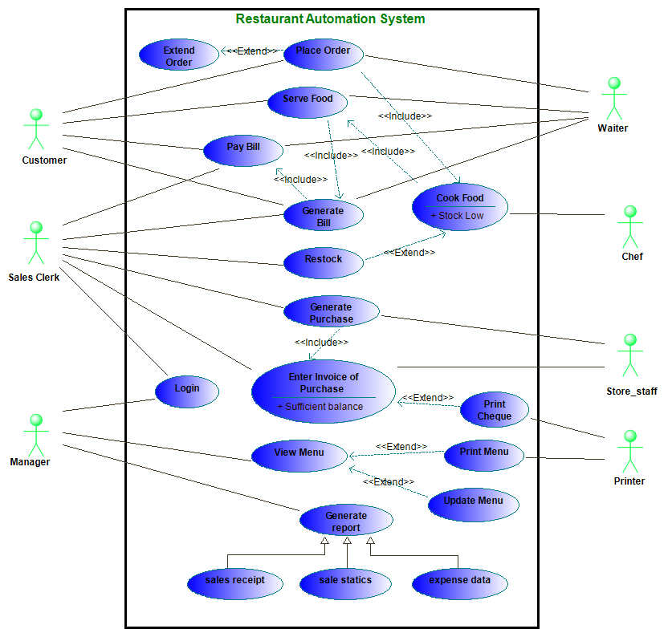

2.3.1 ***Use Case: Place order***

**Brief Description:**

Customer after viewing menu can place order to waiter. This can be extend to extend order whenever customer wants to extend his order.

**Initial Step by Step Description:**

1. Firstly customer will ask waiter for menu and waiter will provide him menu.
2. After viewing menu customer will place order items which he wants to eat.

2.3.2 ***Use Case: cook food***

**Brief Description:**

Cook after receiving order will cook place food. This can be extend to restock of ingredients in which cook can demand for ingredients. This can only be extended only if stock is not sufficient to prepare food for the received order.

**Initial Step by Step Description:**

1. Waiter will inform cook about order.
2. Cook will prepare food for the order and he can request for ingredients in case enough ingredients are not available foe preparation of food.

2.3.3 ***Use Case: serve food***

**Brief Description:**

Waiter will serve food to customer after cook prepares food.

**Initial Step by Step Description**

1. Waiter will receive food from cook after he prepare food and serves it to the customer and customer eats food.

2.3.4 ***Use Case: pay bill***

**Brief Description:**

After eating customer pays bill.

**Initial Step by Step Description**

1. After eating food customer will ask waiter for bill. Waiter will receive bill from sales clerk after producing details of order.
2. After waiter produces bill customer will make payment and waiter will collect payment.
3. After collecting payment waiter will deposit it to the sales clerk.

2.3.5 ***Use Case: view menu***

**Brief Description:**

Manager can view menu whenever he wants to do so.

**Initial Step by Step Description:**

1. Whenever manager request for view menu will be displayed.
2. This can be extened to print menu and update menu.

2.3.6 ***Use Case: print menu***

**Brief Description:**

Manager can print menu whenever he wants to do so.

**Initial Step by Step Description :**

1. Whenever manager request for view menu will be displayed . he can extend view menu to print menu.
2. The computer will be print a menu card containing the menu items and their prices.

2.3.7 ***Use Case: update menu***

**Brief Description:**

Manager can update menu whenever he wants to do so.

**Initial Step by Step Description :**

1. Whenever manager request for view menu will be displayed . he can extend view menu to print menu.
2. Manager can update menu .he can change price of items he want to. He can also add new items to menu.

2.3.8 ***Use Case: Generate sales receipt report***

**Brief Description:**

Manager can generate monthly sales receipt whenever he wants to do so.

**Initial Step by Step Description:**

1. Whenever manager request for generation of *sales receipt report* *monthly sales receipt report* will be displayed .
2. Which can be used by manager to get idea of which items are sold most and how much is sold in that particular month.

2.3.9 ***Use Case Generate expense data report***

**Brief Description:**

Manager can generate monthly expense report whenever he wants to do so.

**Initial Step by Step Description :**

1. Whenever manager request for generation of *expenses data report* *monthly expense data report* will be displayed .
2. Which can be used by manager to get idea of which items are sold most and how much is sold in that particular month.

2.3.10 ***Use Case: print menu***

**Brief Description:**

Manager can print menu whenever he wants to do so.

**Initial Step by Step Description :**

1. Whenever manager request for view menu will be displayed . he can extend view menu to print menu.
2. The computer will be print a menu card containing the menu items and their prices.

2.3.11 ***Use Case: login***

**Brief Description:**

Employees are required to be login to use software.

**Initial Step by Step Description**

1. In order to login an employee need to produce his user name and login password.
2. After employee clicks submit button user name and login password will be verified.
3. If employee successfully login then he will be redirected to his account where he can do things assigned to him.

2.3.12 ***Use Case: Generate purchase order***

**Brief Description:**

Purchase can be generated on daily basis for the purchase of ingredients.

**Initial Step by Step Description**

1. Sales clerks can generate purchase order for the purchase of ingredients.
2. The computer will check for the ingredient whose current stock is less than there threshold value. If it founds so it will generate purchase order for that item.
3. For the purchase order generated store staff will purchase required ingredients according to purchase order.

2.3.13 ***Use Case: Enter invoice of purchase***

**Brief Description:**

Details of purchase will be entered to the system example date of purchase , price, ingredients purchased .

**Initial Step by Step Description**

1. After store staff purchases ingredients as generated by purchase order. He will report it to the sales clerk and sales clerk will enter invoice of the purchase and will update ingredients stock.
2. If sufficient cash balance is available in restaurant accout then a cheque will be generated against this invoice.

***2.4. User Characteristics***

For the manager and the sales clerk the UI is very easy to understand and the Service Manager only needs to know the basic handling of software. For Graphical Simulation, the Service Manager should know how to interpret Graphs. In order to print the results, the Service Manager should know how to handle print jobs.

***2.5. Operating Environment***

This software is tested on windows 8 but it will work on any operating System.

***2.6. Design and Implementation Constraints***

The Software has been designed with English as the only available language. History of previous simulations is maintained in a single database. The data is hence prone to loss due to digital and physical calamities

***2.7. Assumptions and Dependencies***

No *Assumptions and Dependencies.*

**3. Requirement Specifications**

***3.1. External Interface Requirements***

The only link to the external system is the use of Printer. We use the printer in the use cases “View Normal Simulation” and “View Graphical Simulation” where the user can select the option to print the obtained results. On selecting the print option, the Print Dialog Box appears which adds a job to the printer.

***3.2. Functional requirements***

None.

**4. Other Requirements**

**Legal Requirements:**

RAS has a license agreement according to which use or distribution without prior permission of the developer is punishable by law.