**Use java 1.8 for running this project**

The project is designed using simple approach of Model, View, and Controller. This solutions implements all the requirements of the problem.

HomeworkApplication.java acts as controller and acts on Model User.java and its view UserView.java.

The main function is run TestDemo.java. I am using helperfunction.java to sort the Map that contains the itemID and its rating. Sorting is done using the averageOverallRating.

As the solution demands acting as client side only, I have not used any restful API such as Jersey or RestEasy.

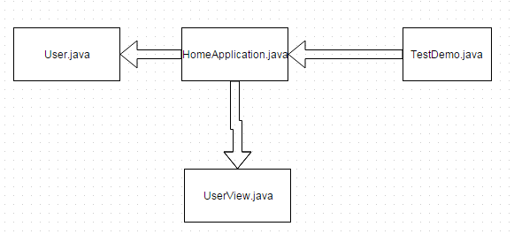

**Product Search API:** Response is received in xml and first product ID is used after parsing.

**Product Recommendation API:** The xml format does not work in this API. Even after giving format=xml in API Walmart Server always returns json format. I tried formatting using simple json and Google GSON. Even though my approach is correct and I am able to format various other json files, it does not work on the json format returned by this API. I have therefore used regex to extract the product ID from the response of this API. I should be able to parse the json file using simpleJson or Google Gson if I dig deeper but unfortunately time does not permit that.

**Review API:** I have stores the top 10 product ID given by the previous API in ArrayList and use them to call Review API one by one. The xml is parsed and product ID and its rating is stores in HashMap. I sort the HashMap using the comparator in Helper function and display the result accordingly. All other variables are assigned as well. Only the top results are displayed with different ratings. If two product have same rating then only the first product is shown.

**How to run the solution:**

1. **Running the jar file in command line**

I have attached a jar file in the attachment that is runnable. **Use java 1.8 for running the solution**. I have attached json-simple jar in the attachment. On windows system use following:

Java –jar final.jar **dell**

Here **dell** is the product String. You can use any string such as hp, moto etc.

1. **Running the solution from the eclipse folder.**

* Download the project and unzip.
* In the Eclipse File->Import->General->FileSystem->Next->Choose the Walmart solution directory->Check Box on Walmart-> Enter the name “Walmart” in “Into Folder” -> Finish
* Right Click Walmart in project explorer->Build Path-> Configure Build Path->Libraries->Add External Library-> Choose json-simple-1.1.jar that I have attached along with the project in github-> Apply. OK.
* Eclipse->Run->Run Configuration->Arguments-> Enter the product String (Ex dell, hp. etc) in “Program arguments”->Apply->Run.

Use Java 1.8.

Please let me know if you face any problem and I will be able to help.

For any other question please let me know at akuma118@asu.edu or 4807879938.

Have a great day!!

Thank you.