**Department Invited Speakers Do Not Reflect Trainee Diversity**

Running title: Invited Speaker Diversity Does Not Reflect Trainee Diversity

Ada K. Hagan, Ph.D., Rebecca M. Pollet, Ph.D., and Josie Libertucci, Ph.D.

To whom correspondence should be addressed: [akhagan@umich.edu](mailto:akhagan@umich.edu) or [libertj@mcmaster.ca](mailto:libertj@mcmaster.ca)

1. Department of Microbiology & Immunology, University of Michigan, Ann Arbor, Michigan

2. Department of Medicine, McMaster University, Hamilton, Ontario, Canada

Figures: 1

Tables: 1

Supplemental:

## Abstract

## Keywords

inclusion, diversity, invited speakers, academia, graduate programs

## Background

500 words

Representation of white women and historically underrepresented minorities (HURM) in science, technology, engineering, and math (STEM) in the workforce remains low despite equal enrollment in undergraduate STEM majors. Longitudinal data indicates that these discrepancies might be partially explained by low retention of women and URM in undergraduate STEM programs where academic performance is a key predictor of retention. A growing body of evidence suggests that women and URM under-perform in introductory science courses compared to their white male colleagues, even when representation is equal. Additionally, there is evidence to suggest that women and URM participate less in class, which could inhibit the learning process and subsequent success. A prevailing hypothesis to explain achievement gaps and a lack of participation in class for women and URM is that, many students have an unconscious fear of being seen as a negative stereotype, termed stereotype threat. This is prevalent in fields that have historically been dominated by white males, such as in STEM. In order to retain a diverse population of students in STEM, in an effort to ensure all students have equal opportunities and resources to be successful, under-performance and a lack of participation in introductory science courses needs to be addressed. One mechanism to address the issue is through the use of inclusive teaching practices –teaching methods that promote the full participation, learning, and success of all students.

* introduce invited speaker series - what are the goals, who attends, etc.
* previous examinations have focused on conferences and panels, large number of people in a short period of time – easy to make comparisons & see trends
* more difficult to see trends over long time period – asked cumulative trends of speakers over 5 year period, “normative” to trainees in the department

## Methods

Each academic year, each faculty member in the Department of Microbiology and Immunology at the University of Michigan has the opportunity to invite one speaker per year for a weekly seminar series. Some of these seminar slots are dedicated to named lectureships, which are decided by committee, and three trainee-invited speakers. We analyzed the demographics of invited speakers and faculty hosts for five academic years (Fall 2014 - Spring 2019), and compared them to the current trainees when the data were analyzed (Spring 2019). Each speaker was only counted once and those listed as departmental faculty members or as a “host” at any point could not also be considered “invited speakers”. The list of faculty hosts was used as a proxy for faculty demographics since as hosts, these faculty members are visible representatives of the department. The trainee lists were obtained from department listservs that included masters students, doctoral students, and post-doctoral fellows.

We hand-coded demographics using personal knowledge, photos, and CVs. The presenting gender of each individual was assigned using a binary system (man/woman). Diversity definitions vary according to the goals and population in question. However, in the United States, there is an inclination to consider both together. We believe that it is important to distinguish between individuals of historically under-represented minority (HURM) and international backgrounds since each face different issues in the US and the academy and thus require different support systems. For instance, international scientists must contend with visa issues while HURMs have the trauma associated with living in a country who systematically shuts them out (despite an infrastructure that was built on their historical land and labor). For this reason, other assigned demographics included Caucasian, Historically Under-represented Minority (HURM), and International, each with a binary (yes/no) possibilty. Caucasian was assigned using the current U.S. Census definition where those of Middle Eastern, European, and Russian descent are included. HURM individuals were restricted to those with African-American, Indigenous and/or Hispanic heritage while International individuals were either visiting the US at the time of their seminar, or immigrated to the US as an adult.

## Results

To understand the representation of women, we compared the proportion of women in each academic role. At the trainee level, more than half of students and postdoctoral fellows were women. That dropped to 46.77% of faculty hosts and 38.73% of the invited speakers (Fig. 1A). Of 27 lectureships over the five year period, 37.04% were awarded to women. The proportion of women as faculty hosts and speakers is equivalent to global estimates that 40% of microbiologists are women (Elseiver), with a slightly lower representation of women in lectureships.

Our analysis identified an over-representation of Caucasian individuals as hosting faculty and invited speakers, relative to the proportion of Caucasian trainees (Fig. 1B). We also observed declines in the representation of HURM and international faculty and speakers relative to the trainees, particularly postdocs (Fig 1B). Caucasian scientists also dominated lectureships, comprising 81.48% of those awarded (Fig. 1C). Three and six lectureships were awarded to HURM and International scientists, respectively. Because the intersection of identities can compound biases and outcomes, we further examined the more prestigous lectureships by gender and Caucasian status. Caucasian men and women accounted for 44.44% and 37.04% of the lectureships, respectively, compared to 18.52% non-Caucasian men and zero non-Caucasian women (Fig. 1D).

## Discussion

Several papers have investigated the representation of women at scientific conferences, however, we have only identified one that focused on invited speakers at universities (Nittrouer, 2018). In their study, Nittrouer et. al., examined 3,652 talks at 50 U.S. institutions in 2013 - 2014 and found that women faculty are less likely to be invited speakers, despite similar acceptance rates. These results suggest that women faculty are less often invited as speakers, a decision that may be negatively impacted by assumptions about competency and dedication. The dedication of women who have children to their work is perceived to be less than that of their colleagues, i.e., men who also have children. The perceived prioritization and commitments of women to family over work may cause faculty to doubt their acceptance of a speaking invitation (despite the prestigious nature of these invitations and evidence to the contrary). As a result, the faculty member invites a different colleague who they feel is more likely to agree (and is a man). Departments have different processes and criteria for selecting invited speakers, but it is a matter of pride to bring the best scientists possible. It may be that the definition of “best” poses a problem to women, who need three-times as many publications as their men colleges to be considered equally competent. Some departments only invite tenured faculty, which severely limits the number of potential women speakers. Another scenario is that pre-tenure faculty members invite prestigious, tenured faculty in their field to network and secure letters for their own tenure package. The increased burden of women to prove competency decreases their likelihood to be considered for either tenure or as possible source of tenure letters.

We have not been able to identify any other publications examining scientific speaker diversity beyond gender. This seems to be the first. This is concerning since conclusions drawn from gender-based studies are often framed, and considered, to be applicable to other marginalized groups (e.g., HURM). This is a flawed assumption. While there is no doubt some overlap, each group remains marginalized due to a complex set of factors that are unique to each group and cannot always be solved by gender-based solutions. US-serving institutions, such as the University of Michigan have a particular responsibility to the historically suppressed populations included in our definition of HURMs. We therefore implore US institutions to apply this framing to their discussions and research.

Our data support the advancement of social role theory, which states that to improve retention of white women & HURMs, each group needs equivalent representation to counteract biases and improve self-efficacy. Implict biases that affect perceptions of marginalized groups are the primary issue, but we must acknowledge that it is not always possible to identify members of historically under-served communities. For instance, after data analysis, we learned that at least one speaker in our data set is a member of a HURM group, but it wasn’t readily apparent from their internet presence or CV. This limitation makes two important points: that perspective is often as, if not more, important than self-identification with regards to biased outcomes, and that we need better tools to identify members of marginalized groups.

## Building Diversify

To help address this issue, we make some suggestions (Table 1) and have developed a resource to identify scientists who are members of marginalized and/or historically under-served groups. Motivated by a lack of such resources and inspired by similar resources–DiversifyEEB and DiversifyChemistry–we created DiversifyMicrobiology and DiversifyImmunology. These resources are a tool for symposium organziers, award committees, search committees and other scientists to identify individuals to diversify their pools. Additionally, we have built these as a tool for use by other fields and organizations to create their own lists. Importantly, since these lists are compiled by self-nomination, we can ensure that only scientists comfortable revealing their marginalized identities are included.

* Development of Diversify tools
  + describe maintenance of lists (Rebecca)

The website provides an interface to the Google forms and spreadsheets with template pages for viewing the list, adding a name to the list, and finding additional resources. Importantly, our website creation tool is hosted for free by GitHub, which provides a free website for each GitHub organization (citation). Basic tools and skills required to set up a Diversify site include knowledge of, or experience with, the version control tool git, the webtool GitHub, and a text editor. A tutorial in the DiversifyMicrobiology repository on GitHub provides links to these resources and instructions for adapting the tool to your own field.

## Conclusion

To increase the retention of white women and HURMS in STEM, they must also be represented as experts. However, the invited speaker diversity at one department does not represent the diversity of trainees. There is a lack of research on invited speakers examining factors other than gender. To facilite the identification and recruitment of individuals in these historically under-served groups, we have built a tool to create self-nominated, field-specific lists.

## Acknowledgements

We thank Dr. Harry Mobley and the Department of Microbiology & Immunology, University of Michigan for their input and financial support that enabled publication of our manuscript. We would also like to acknowledge Nick Lesniak and Dr. Ariangela Kozick for their comments and suggestions.

## Author Contributions

A.K.H. collected the data, assigned demographics, analyzed the data, and created the website. R.M.P. created the Google lists, forms, and website content and the description of their maintenance. J.L. wrote the introduction and provided conceptual advice. All authors contributed to the final manuscript.

## Code and data availability

The anonymized data, code for all analysis steps, and an Rmarkdown version of this manuscript is available at <https://github.com/akhagan/Hagan_Libertucci_SpeakerDiversity_XXXX_2019/>. Template and complete instructions for generating a field-specific Diversity website are available at <https://github.com/diversifymicrobiology/DiversifyMicrobiology.github.io/>.

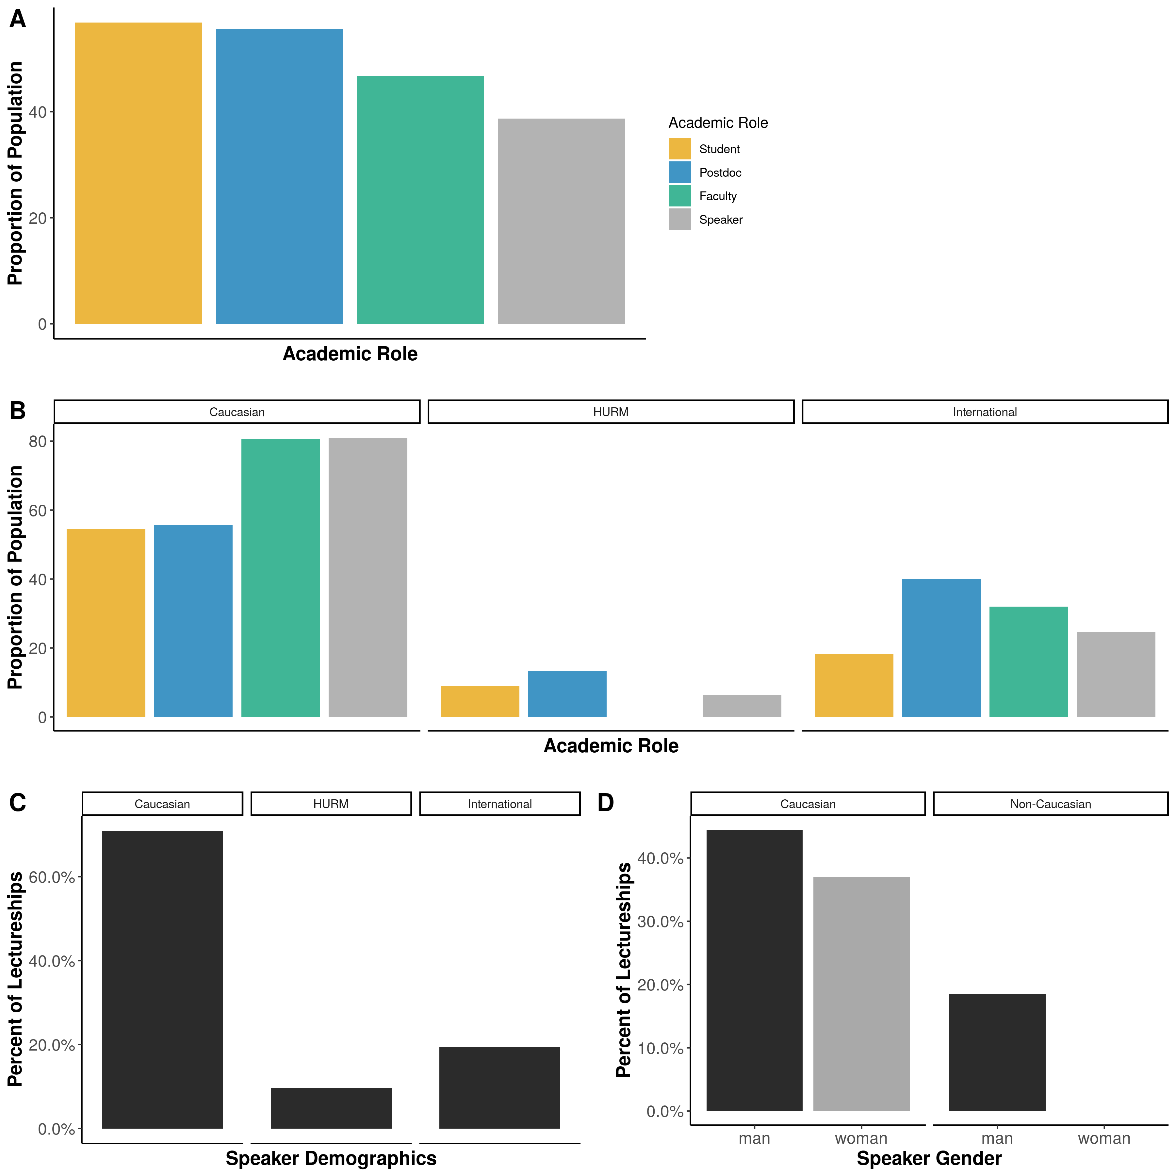

Figure 1. **The demographics of invited speakers, hosting faculty, and trainees.** A) The proportion of women in each academic role. B) The proportion of each academic role represented by individuals that are Caucasian (left), Historically Underrepresented Minorities (HURM, center) or International (right). C-D)The percent of lectureships awarded to individuals that are C) Caucasian, HURM, International or D) Caucasian or Non-Caucasian by gender.

## References