Option #1: Department Invited Speakers Do Not Reflect Trainee Diversity

Option #2: Moving towards a more inclusive climate in STEM by changing department invited speaker series demographics

Option #3: Moving towards a more inclusive climate in STEM by changing department invited speaker series demographics to better reflect trainee demographics

Option #4: Changing department invited speaker series demographics to better reflect trainee demographics

Option#5: Department invited speaker demographic disparities compared to trainee demographics

Running title: Invited Speaker Diversity Does Not Reflect Trainee Diversity

Ada K. Hagan, Ph.D. ${}^{1}†$, Rebecca M. Pollet, Ph.D. ${}^{1}$, and Josie Libertucci, Ph.D. ${}^{2}†$

$†$ To whom correspondence should be addressed: [akhagan@umich.edu](mailto:akhagan@umich.edu) or [libertj@mcmaster.ca](mailto:libertj@mcmaster.ca)

1. Department of Microbiology & Immunology, University of Michigan, Ann Arbor, Michigan

2. Department of Medicine, McMaster University, Hamilton, Ontario, Canada

Figures: 1

Tables: 1

Supplemental:

Abstract

## Keywords

inclusion, diversity, invited speakers, academia, graduate programs

## Background

Long-standing systemic bias, sexism, and racism have contributed to the underrepresentation of many racial and ethnic groups, as well as women, in science, technology, engineering, and math (STEM) fields (NIH 2015 report, Measuring DEI 2016, Colloquy on minority Males in STEM 2012). Organization climate and culture that supports inclusion of all individuals is essential to support the retention of historically underrepresented minorities (HURM) in the U.S., as well as non-Caucasian individuals, and women in STEM fields (Schneider, 2013). Inclusive organization culture will not suffice in retaining HURM, non-Caucasian individuals, and women without organization policy changes that support their values and goals (Coe 2019, Lancet issue).

A long-standing issue within STEM fields, specifically within academia, has been a lack of diverse representation of scientists for trainees (graduate students and postdoctoral fellows). In order to maintain retention of HURM, non-Caucasian individuals, and women in STEM fields, it is important for trainees to have visual representations of themselves as scientists. The importance of representation in retaining a diverse group of individuals in STEM fields is supported by social role theory (Eagly and Steffen, 1984). Individuals tend to make inferences about characteristics that are needed to be successful in a given role by examining individuals that most occupy that role (Eagly and Steffen, 1984 and Carter et al., 2018 PlosOne). Therefore, trainees who do not see representation of themselves in senior scientific positions, or in this case as senior faculty members, may decide that they do not possess the characteristics that are required to succeed. In an attempt to make science a more inclusive environment, many individuals have attempted to address this issue by promoting the inclusion of more women speakers at conferences (refs, Ada used one below but there are probably others). However, no study to date has addressed invited speaker seminar series diversity within their own institution.

Within the Department of Microbiology and Immunology at the University of Michigan (Ann Arbor, MI, USA), each year from September to June, faculty members have the opportunity to invite scientists from other institutions to give a one-hour seminar in which all department members attend. The invited seminar speaker also has the opportunity to meet with current department faculty members and trainees. Scientists who are invited to give seminars are widely regarded as successful and the top in their field. Thus, if trainees are constantly being exposed to “the top scientist in their field”, according to social role theory, it is imperative that the selected seminar speakers represent a diverse group of individuals.

In this study, we examine and compare the proportion of HURM, non-Caucasian/non-HURM, and women invited speakers to white males in the Department of Microbiology and Immunology. Additionally, we compare invited-speaker demographics to the current trainee demographics as a means to gauge if trainee demographics are being represented accordingly throughout the seminar series. Following our investigation, we proposed a policy change to the Department of Microbiology and Immunology in how invited speakers are selected as a means to promote inclusion in our department and reduce stereotype threat, microaggressions, and unconscious bias. In order to facilitate inviting a more diverse group of scientists, we developed a set of resources that allow scientists, within the field of microbiology, to self-identify as an HURM, non-Caucasian/non-HURM, or a woman. These resources will promote inclusion and diversity by providing greater representation of all scientists and will provide hosts an opportunity to invite a more diverse group of scientists.

## Methods

Each academic year, each faculty member in the Department of Microbiology and Immunology at the University of Michigan has the opportunity to invite one speaker per year for a weekly seminar series. Some of these seminar slots are dedicated to named lectureships, which are decided by committee, and three trainee-invited speakers. We analyzed the demographics of invited speakers and faculty hosts for five academic years (Fall 2014 - Spring 2019), and compared them to the current trainees when the data were analyzed (Spring 2019). Each speaker was only counted once and those listed as departmental faculty members or as a “host” at any point could not also be considered “invited speakers”. The list of faculty hosts was used as a proxy for faculty demographics since as hosts, these faculty members are visible representatives of the department. The trainee lists were obtained from department listservs that included masters students, doctoral students, and post-doctoral fellows.

We hand-coded demographics using personal knowledge, photos, and CVs. The presenting gender of each individual was assigned using a binary system (man/woman). Diversity definitions vary according to the goals and population in question. However, in the United States, there is an inclination to consider both together. We believe that it is important to distinguish between individuals of historically under-represented minority (HURM) and international backgrounds since each face different issues in the US and the academy and thus require different support systems. For instance, international scientists must contend with visa issues while HURMs have the trauma associated with living in a country who systematically shuts them out (despite an infrastructure that was built on their historical land and labor). For this reason, other assigned demographics included Caucasian, Historically Under-represented Minority (HURM), and International, each with a binary (yes/no) possibilty. Caucasian was assigned using the current U.S. Census definition where those of Middle Eastern, European, and Russian descent are included. HURM individuals were restricted to those with African-American, Indigenous and/or Hispanic heritage while International individuals were either visiting the US at the time of their seminar, or immigrated to the US as an adult.

## Results

To understand the representation of women, we compared the proportion of women in each academic role. At the trainee level, more than half of students and postdoctoral fellows were women. That dropped to 46.77% of faculty hosts and 38.73% of the invited speakers (Fig. 1A). Of 27 lectureships over the five year period, 37.04% were awarded to women. The proportion of women as faculty hosts and speakers is equivalent to global estimates that 40% of microbiologists are women (Elseiver), with a slightly lower representation of women in lectureships.

Our analysis identified an over-representation of Caucasian individuals as hosting faculty and invited speakers, relative to the proportion of Caucasian trainees (Fig. 1B). We also observed declines in the representation of HURM and international faculty and speakers relative to the trainees, particularly postdocs (Fig 1B). Caucasian scientists also dominated lectureships, comprising 81.48% of those awarded (Fig. 1C). Three and six lectureships were awarded to HURM and International scientists, respectively. Because the intersection of identities can compound biases and outcomes, we further examined the more prestigous lectureships by gender and Caucasian status. Caucasian men and women accounted for 44.44% and 37.04% of the lectureships, respectively, compared to 18.52% non-Caucasian men and zero non-Caucasian women (Fig. 1D).

## Discussion

Several papers have investigated the representation of women at scientific conferences, however, we have only identified one that focused on invited speakers at universities (Nittrouer, 2018). In their study, Nittrouer et. al., examined 3,652 talks at 50 U.S. institutions in 2013 - 2014 and found that women faculty are less likely to be invited speakers, despite similar acceptance rates. These results suggest that women faculty are less often invited as speakers, a decision that may be negatively impacted by assumptions about competency and dedication. The dedication of women who have children to their work is perceived to be less than that of their colleagues, i.e., men who also have children. The perceived prioritization and commitments of women to family over work may cause faculty to doubt their acceptance of a speaking invitation (despite the prestigious nature of these invitations and evidence to the contrary). As a result, the faculty member invites a different colleague who they feel is more likely to agree (and is a man). Departments have different processes and criteria for selecting invited speakers, but it is a matter of pride to bring the best scientists possible. It may be that the definition of “best” poses a problem to women, who need three-times as many publications as their men colleges to be considered equally competent. Some departments only invite tenured faculty, which severely limits the number of potential women speakers. Another scenario is that pre-tenure faculty members invite prestigious, tenured faculty in their field to network and secure letters for their own tenure package. The increased burden of women to prove competency decreases their likelihood to be considered for either tenure or as possible source of tenure letters.

The desire to invite the “best” scientist to these seminar series also poses a problem for HURM and NCNH scientists. A large portion of the NCNH cohort in our sample are Asian/Asian American individuals. Although Asian scientists are well-represented in the US scientific workforce, they face significant bias and barriers to inclusion in society and academia ([http://dx.doi.org/10.1037/1099-9809.14.4.326](https://psycnet.apa.org/doi/10.1037/1099-9809.14.4.326" \t "_blank), <https://doi.org/10.1080/01419870.2019.1579920>). Both men and women who identify as HURM and Asian reported having to work harder than white men to be perceived as legitimate scholars (doi: 10.17226/18556). This expectation of higher productivity may result in fewer HURM and NCNH individuals being invited as seminar speakers. This is particularly striking in the low number of NCNH individuals in the more prestigious lectureships of our sample despite the higher employment rate of Asian scientists.

While HURM and NCNH share some experiences, differences including varying rates of hiring and tenure promotion mean unique considerations are important for inclusion of each group (doi:10.1001/jama.284.9.1085). For instance, the proportion of HURM faculty at the Assistant and Associate Professor level is currently higher than the Full Professor level so it will be difficult to increase speaker diversity if early-career researchers are not being considered (PMID: [26240521](https://www.ncbi.nlm.nih.gov/pubmed/26240521)). Increased performance expectations and patterns of exclusions are consistent themes in studies characterizing the HURM faculty experience (DOI: [10.1007/s11606-010-1478-7](https://doi.org/10.1007/s11606-010-1478-7" \t "_blank), doi: [10.3402/meo.v19.24768](https://dx.doi.org/10.3402%2Fmeo.v19.24768" \t "pmc_ext)). Therefore, inclusion of HURM faculty in seminar series is likely essential to increasing the number of HURM Associate and Full Professors. More significantly, a major barrier to inclusion of HURM faculty at similar proportions to HURM trainees is the low transition rate of scientists from HURM backgrounds to faculty positions and the associated low proportion of HURM faculty (<https://doi.org/10.7554/eLife.21393.001>). Even when HURM speaker rates match the proportion of HURM faculty employment, HURM trainees will be represented at a significantly higher proportion. Inclusion of HURM faculty in these seminar series is just one aspect of larger institutional change that is needed.

We have not been able to identify any other publications examining scientific speaker diversity beyond gender. This seems to be the first. This is concerning since conclusions drawn from gender-based studies are often framed, and considered, to be applicable to other marginalized groups (e.g., HURM). This is a flawed assumption. While there is no doubt some overlap, each group remains marginalized due to a complex set of factors that are unique to each group and cannot always be solved by gender-based solutions. US-serving institutions, such as the University of Michigan have a particular responsibility to the historically suppressed populations included in our definition of HURMs. We therefore implore US institutions to apply this framing to their discussions and research.

Our data support the advancement of social role theory, which states that to improve retention of white women & HURMs, each group needs equivalent representation to counteract biases and improve self-efficacy. Implict biases that affect perceptions of marginalized groups are the primary issue, but we must acknowledge that it is not always possible to identify members of historically under-served communities. For instance, after data analysis, we learned that at least one speaker in our data set is a member of a HURM group, but it wasn’t readily apparent from their internet presence or CV. This limitation makes two important points: that perspective is often as, if not more, important than self-identification with regards to biased outcomes, and that we need better tools to identify members of marginalized groups.

Instituting policy change within the Department of Microbiology and Immunology

In an attempt to promote inclusion within the Dept. M&I these data were presented to faculty members and the dept chair (Harry Mobley). Since, trainee demographics were not represented within seminar speaker demographics over the past 5 years, we proposed a policy change as to how seminar speakers were being invited. This policy change included switching from PI invited to lab invited in an attempt to allow trainees to choose a speaker that best represented themselves. In addition to this we also created resources which allowed scientists to self-identify and provide host faculty with more diverse choices.

## Building Diversify

To help address this issue, we make some suggestions (Table 1) and have developed a resource to identify scientists who are members of marginalized and/or historically under-served groups. Motivated by a lack of such resources and inspired by similar resources–DiversifyEEB and DiversifyChemistry–we created DiversifyMicrobiology and DiversifyImmunology. These resources are a tool for symposium organziers, award committees, search committees and other scientists to identify individuals to diversify their pools. Additionally, we have built these as a tool for use by other fields and organizations to create their own lists. Importantly, since these lists are compiled by self-nomination, we can ensure that only scientists comfortable revealing their marginalized identities are included.

The self-nomination form is a Google Form with entries logged in a private Google Sheet. This form is embedded within the website and can be linked to directly. The use of a Google Forms allows us to maintain this database at no cost and gives us the flexibility to add questions or change response options without disrupting previous responses. Entries are logged in a private spreadsheet so that entries can be screened before being added to the public database. This screening currently includes two steps: 1. Confirming that each person is listed in the database only once. 2. Verifying that the submitted website is a professional website for the person being listed. If a person has not been listed in the database previously and passes step 2, a new entry is added to the public database spreadsheet. If a person is already listed in the database, their information is updated to the most recent submission.

* This public spreadsheet is embedded in the website and can be open separately as a locked (uneditable) Google Sheet. Importantly, this allows the list to be easily searched. We have chosen to list individuals’ academic information first in the spreadsheet to encourage a focus on academic achievement rather than tokenization of marginalized identities. Currently the database lists individuals in order of self-nomination but future versions will be re-sorted based on name and/or academic field to varying the individuals who may receive more attention for simply being at the top of the list. Development of Diversify tools
  + describe maintenance of lists (Rebecca)

The website provides an interface to the Google forms and spreadsheets with template pages for viewing the list, adding a name to the list, and finding additional resources. Importantly, our website creation tool is hosted for free by GitHub, which provides a free website for each GitHub organization (citation). Basic tools and skills required to set up a Diversify site include knowledge of, or experience with, the version control tool git, the webtool GitHub, and a text editor. A tutorial in the DiversifyMicrobiology repository on GitHub provides links to these resources and instructions for adapting the tool to your own field.

## Conclusion

To increase the retention of white women and HURMS in STEM, they must also be represented as experts. However, the invited speaker diversity at one department does not represent the diversity of trainees. There is a lack of research on invited speakers examining factors other than gender. To facilite the identification and recruitment of individuals in these historically under-served groups, we have built a tool to create self-nominated, field-specific lists.

## Acknowledgements

We thank Dr. Harry Mobley and the Department of Microbiology & Immunology, University of Michigan for their input and financial support that enabled publication of our manuscript. We would also like to acknowledge Nick Lesniak and Dr. Ariangela Kozick for their comments and suggestions.

## Author Contributions

A.K.H. collected the data, assigned demographics, analyzed the data, and created the website. R.M.P. created the Google lists, forms, and website content and the description of their maintenance. J.L. wrote the introduction and provided conceptual advice. All authors contributed to preparing the final manuscript.

## Code and data availability

The anonymized data, code for all analysis steps, and an Rmarkdown version of this manuscript is available at <https://github.com/akhagan/Hagan_Libertucci_SpeakerDiversity_XXXX_2019/>. Template and complete instructions for generating a field-specific Diversity website are available at <https://github.com/diversifymicrobiology/DiversifyMicrobiology.github.io/>.

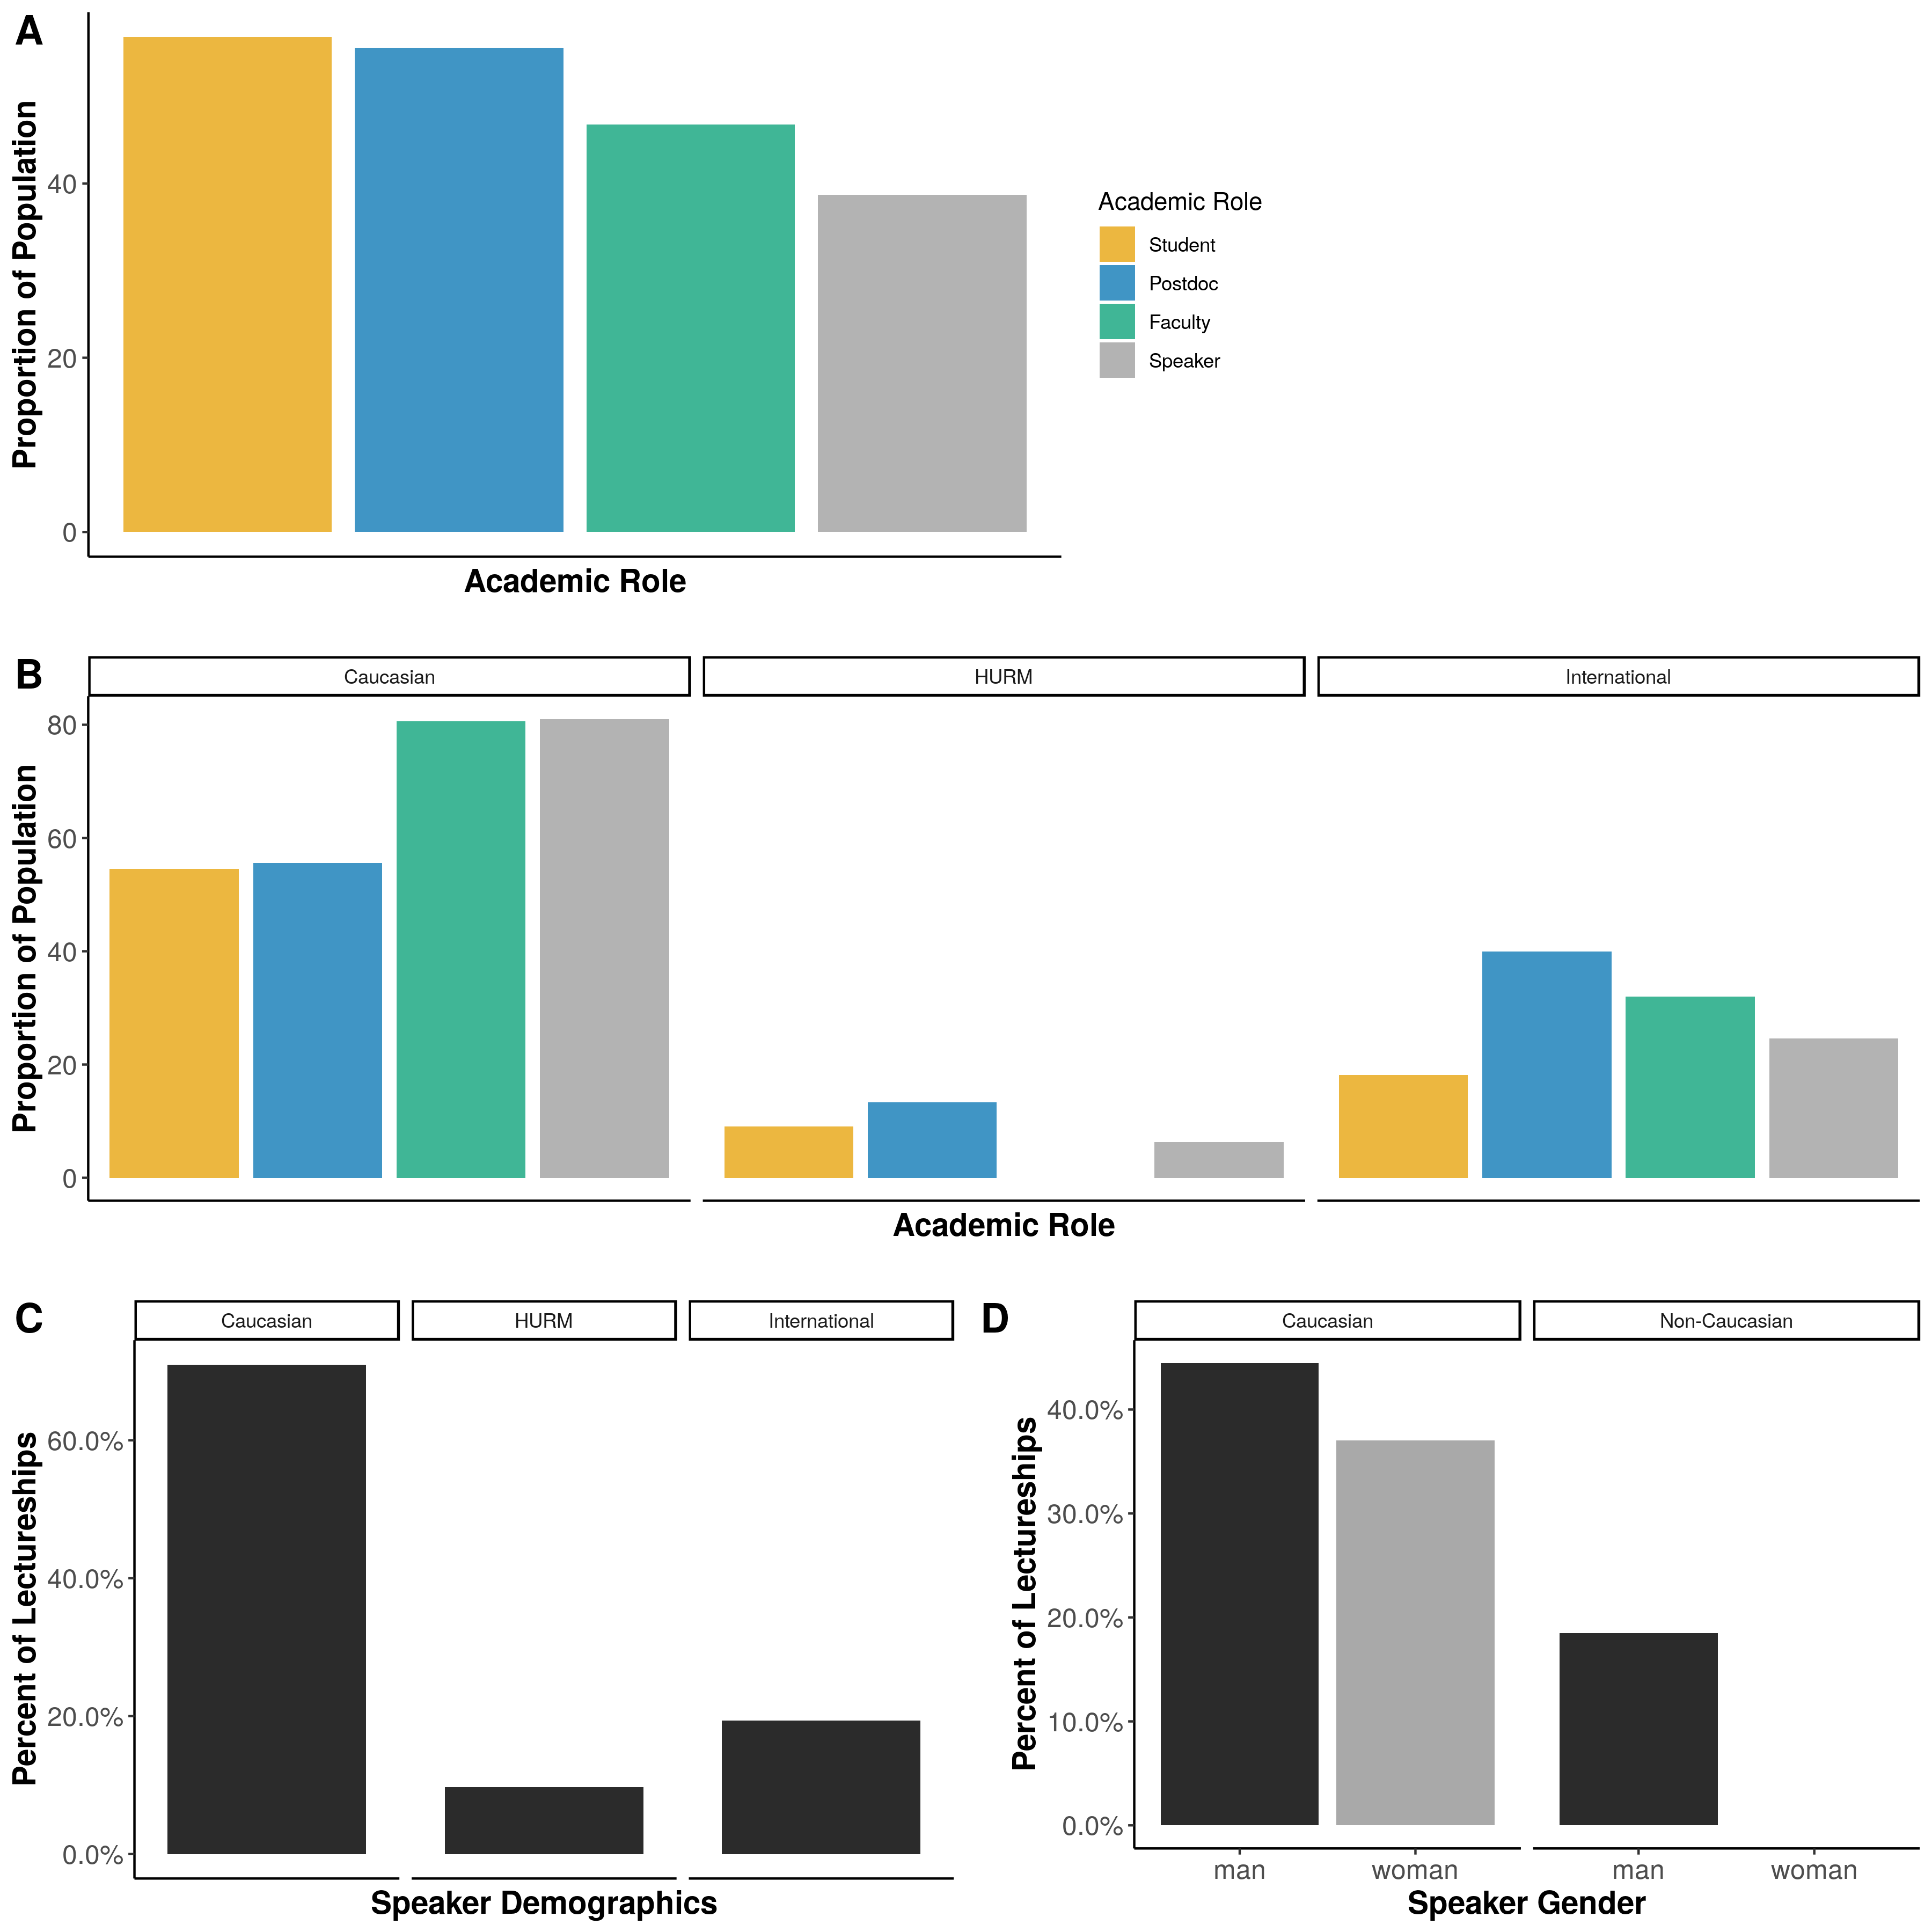

Figure 1.

## References