|  |
| --- |
|  |
| Functional Specification Document |
|  |
|  |
| **Version 1.0** |
| **7/9/2018** |

# Change History

# New Functionalities

|  |  |  |
| --- | --- | --- |
| **Date** | **Page** | **Functionality** |
| 11/20/2013 | Global Page - Header | Breadcrumb  Capgemini – Application should navigate to capgemini.com  Need to configure in Site Preference – Custom Preference |
| 11/20/2013 | Global Page – Footer | Email Registration  On Submitting the Email id, address should be added to the Email Subscription in Custom Object. |
| 11/20/2013 | Global Page - Category drop down | Drop down  First three Sub Categories’ first product details (Image, Name and Price) should be displayed |
| 11/20/2013 | Home Page | Message should be listed / saved in Testimonial Custom object  Only selected 5 messages should be displayed in the Home page |
| 11/25/2013 | Personalization Overlay | Personalization overlay with Message field. |
| 11/25/2013 | Wish List Page | By default, only 1 quantity should be added to Wish list page  Update link – to Update the quantity and add the product to the cart |
| 11/25/2013 | Payment Details | Displaying Saved Billing Address section  Displaying Billing address in Address Book page |
| 11/25/2013 | Edit / Add Payment Details | Billing address section is added |
| 11/25/2013 | Order History – Guest User | Added Phone number field |
| 11/25/2013 | Mini Cart | Should display Personalized message |
| 11/25/2013 | Shopping bag | Edit functionality at the item level |
| 11/26/2013 | Sub Category and Search Results page | Added extra Search Refine attribute – ‘Brand’  Tag the product as ‘New’  On / Off hover, product image should change  Displaying Grid View link |
| 11/26/2013 | Product Detail page | Added Recommendation section  Logic for Enabling & Disabling attributes along with message display for Add to Bag button  Personalization functionality |

Table of Contents

[To update the table of contents, right click the message below and select Update Field (F9 on PC, ⌥⌘U on Mac).]

Change History 2

New Functionalities 2

Global Page - Header 2

Global Page – Footer 2

Global Page - Category drop down 2

Drop down 2

First three Sub Categories’ first product details (Image, Name and Price) should be displayed 2

Personalization Overlay 3

Wish List Page 3

Payment Details 3

Edit / Add Payment Details 3

Order History – Guest User 3

Mini Cart 3

Shopping bag 3

Sub Category and Search Results page 3

Product Detail page 3

1.0. Global Page - Header 15

1.0.1. User Interface 15

1.0.2. Widget Table 15

1.0.3. Developer Notes 16

1.1. Global Page - Header for Registered User 17

1.1.1. User Interface 17

1.1.2. Widget Table 17

1.2. Global Page – Footer 17

1.2.1 User Interface 17

1.2.2. Widget Table 18

1.2.2. Developer Notes 18

1.3. Global Page - Category drop down 19

1.3.1. User Interface 19

1.3.2. Widget Table 19

1.3.3. Developer Notes 20

1.4. Home Page 20

1.4.1. User Interface 21

1.4.2. Widget Table 22

1.4.3. Developer Notes 22

1.5. Home Page – Testimonial Form 23

1.5.1. User Interface 23

1.5.2. Widget Table 23

1.6. Category Landing Page 24

1.6.1. User Interface 24

1.6.2. Widget Table 25

1.7. Sub Category Landing Page 26

1.7.1. User Interface 26

1.7.2. Widget Table 27

1.7.3. Developer Notes 27

1.8. Search Result page 28

1.8.1. User Interface 28

1.9. No Search Results page – Retain same as SG 28

1.10. Product Detail Page 29

1.10.1. User Interface 29

1.10.2. Widget Table 30

1.9.3. Developer Notes 32

1.11. Product Details 32

1.11.1. User Interface 32

1.12. Size Guide 33

1.12.1 User Interface 33

1.13. Send to Friend 33

1.13.1. User Interface 33

1.13.2 User Interface – Confirmation overlay 33

1.13.3. Widget Table 33

1.14. Personalization 35

1.14.1.User Interface 35

1.14.2. Widget Table 35

1.15. Wish List Page 36

1.15.1. User Interface 36

1.15.2. Widget Table 36

1.16. Email Wish List 38

1.16.1. User Interface 38

1.16.2. Widget Table 39

1.17. Sign In Overlay – Retain SG functionality 40

1.18. Create your Account 40

1.18.1. User Interface 40

1.18.2. Widget Table 40

1.19. Error - Create your Account 43

1.19.1. User Interface 43

1.19.2. Widget Table 44

1.20. Forgot Password Overlay – Retain SG functionality 44

1.21. My Account - Home Page 44

1.21.1. User Interface 44

1.21.2. Widget Table 44

1.22. My Account - Edit Details 46

1.22.1. User Interface 46

1.22.2. Widget Table 47

1.22.3. Developer Notes 47

1.23. My Account - Edit Email Address 48

1.23.1. User Interface 48

1.23.2. Widget Table 49

1.23.3. Developer Notes 49

1.24. My Account - Change Password 50

1.24.1. User Interface 50

1.24.2. Widget Table 51

1.25. Address Book 52

1.25.1. User Interface 52

1.25.2. Widget Table 52

1.26. Edit / Add Address Book 53

1.26.1. User Interface 53

1.26.2. Widget Table 54

1.26.3. Developer Notes 55

1.27. Delete Overlay 55

1.27.1. User Interface 55

1.28. Payment Details 56

1.28.1. User Interface 56

1.28.2. Widget Table 56

1.29. Payment Details – Add / Edit 58

1.29.1. User Interface 58

1.29.2. Widget Table 59

1.30. Order History 61

1.30.1. User Interface 61

1.30.2. Widget Table 62

1.31. Order History – Guest User 63

1.31.1. User Interface 63

1.31.2. Widgets 63

1.32. Mini Cart 64

1.32.1 User Interface 64

1.32.2. Widget Table 64

1.33. Shopping Bag 65

1.33.1. User Interface 65

1.33.2. Widget 66

* 1. Global Page - Header
     1. User Interface

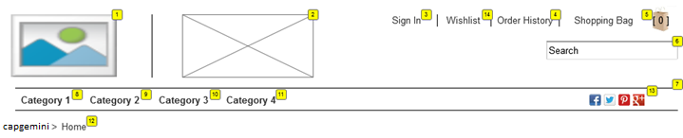

* + 1. Widget Table

|  |  |  |  |  |
| --- | --- | --- | --- | --- |
| **Footnote** | **Label** | **Field Type** | **Data Source** | **UI Interaction** |
| 1 | Company Logo | Content Slot | HomePage-Logo | On click – Navigates to Home page. |
| 2 | Promotional Banner | Content Slot | Header-PromoBanner |  |
| 3 | Sign In link | Form field |  | Sign In – Opens Login Overlay |
| 4 | Order History link | Form field |  | Navigates to the Order History page as a Guest user |
| 5 | Shopping Bag link | Form field |  | Should display number of products added to the cart on the Shopping icon.  On hover – Display mini cart overlay  On click – Navigates to Shopping Bag / Cart page. |
| 6 | Search Text Field | Form field |  | On enter – Navigates to Search Results Page  Note – On enter without entering keyword stays on the same page. |
| 7 | Category menu Bar | Object attribute |  | On Hover – Sub category drop down will be displayed.  On click – Navigates to appropriate category page.  Max of 8 Category to be configured.  Dynamically driven by category |
| 8 | Category 1 | Object attribute |  |  |
| 9 | Category 2 | Object attribute |  |  |
| 10 | Category 3 | Object attribute |  |  |
| 11 | Category 4 | Object attribute |  |  |
| 12 | Breadcrumb | Form field |  | On click – Navigates to appropriate page  Capgemini – Application should navigate to capgemini.com  Home – Should be a Static text |
| 13 | Social Media | Content Asset | Header-Social Media | On click – Navigates to appropriate page  FB – facebook.com  Twitter – twitter.com  Pinterest - pinterest.com  Google+ - accounts.google.com/Login |
| 14 | Wish List | Form field |  | On click – Navigates to My Wish List Page.  Note – If user is not signed in then, open Login Overlay. |

* + 1. Developer Notes

|  |  |  |
| --- | --- | --- |
| **Footnote** | **Label** | **Additional Info** |
| 7 | Category Menu | Dynamically driven by category. |
| 12 | Breadcrumb | Capgemini link -  Need to configure in Site Preference – Custom Preference |
|  |  |  |

* 1. Global Page - Header for Registered User
     1. User Interface

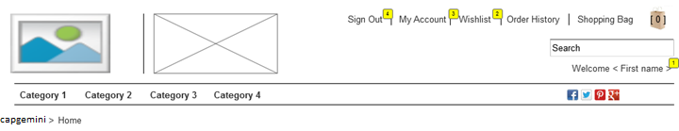

* + 1. Widget Table

|  |  |  |  |  |
| --- | --- | --- | --- | --- |
| **Footnote** | **Label** | **Field Type** | **Data source** | **UI Interactions** |
| 1 | Welcome Message | Form field |  | Static message: Welcome <First Name> displayed below Search text box |
| 2 | Wish List | Form field |  | Navigates to the Wish List page |
| 3 | My Account | Form field |  | Navigates to My Account – Home page |
| 4 | Sign Out | Form field |  | Logs Off the user |

* 1. Global Page – Footer
     1. User Interface

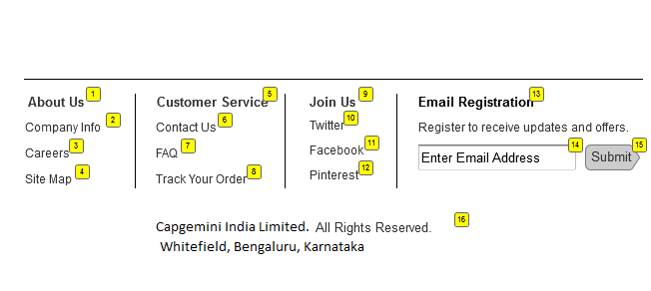

1.2.2. Widget Table

|  |  |  |  |  |
| --- | --- | --- | --- | --- |
| **Footnote** | **Label** | **Field Type** | **Data Source** | **UI Interaction** |
| 1 | About Us | Content slot | footer-content slot | Navigates to the About Us page |
| 2 | Company Info |  |  | Navigates to the Company Info page |
| 3 | Careers |  |  | Navigates to the Careers page |
| 4 | Site Map |  |  | Navigates to the Site Map page |
| 5 | Customer Service | Content slot | footer-content slot | Navigates to the Customer Service page |
| 6 | Delivery Schedule |  |  | Navigates to the Delivery Schedule page |
| 7 | FAQ |  |  | Navigates to the FAQ page |
| 8 | Track Your Order |  |  | Navigates to the Order History page |
| 9 | Join Us | Content slot | footer-content slot |  |
| 10 | Twitter |  |  | Navigates to twitter.com |
| 11 | Facebook |  |  | Navigates to facebook.com |
| 12 | Pinterest |  |  | Navigates to the pinterest.com |
| 13 | Email Registration | Form field |  |  |
| 14 | Email address | Form field |  | On submitting valid email address - ‘Thank You’ message should be displayed below the input field  If the email address is invalid, ‘Please enter valid email address’ should be displayed  If the email address is already in DB,  ‘Email Id is in records, Thank You.’ |
| 15 | Submit | Form field |  | On Submitting the email address, regular updates need to be received by the User |
| 16 | Disclaimer | Content slot | Footer-disclaimer |  |

1.2.2. Developer Notes

|  |  |  |
| --- | --- | --- |
| **Footnote** | **Label** | **Additional Info** |
| 13 | Email Registration | On Submitting the Email id, address should be added to the Email Subscription in Custom Object. |
| 1, 5, 9 & 13 | Content Slot | On click, navigates to the appropriate page as configured in content asset |

* 1. Global Page - Category drop down
     1. User Interface

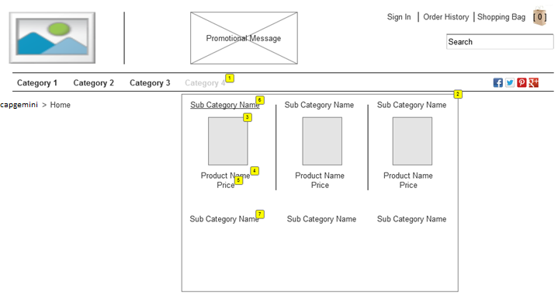

* + 1. Widget Table

|  |  |  |  |  |
| --- | --- | --- | --- | --- |
| **Footnote** | **Label** | **Field Type** | **Data Source** | **UI Interactions** |
| 1 | Category |  |  | Hovering on the Category link in category menu, respective Sub Category drop down will be displayed |
| 2 | Drop Down |  |  | Should display Sub Categories tied to the Respective Category.  First three Sub Categories’ first product details (Image, Name and Price) should be displayed |
| 3 | Product Image | Object attribute |  | On click – navigates to respective product detail page |
| 4 | Product Name | Object attribute |  | On click – navigates to respective product detail page |
| 5 | Price | Object attribute |  | List price |
| 6 | Sub Category name link | Object attribute |  | On click – navigates to respective Sub Category landing page |
| 7 | Sub Category Name | Object attribute |  | On click – navigates to respective Sub Category landing page |

1.3.3. Developer Notes

|  |  |  |
| --- | --- | --- |
| **Footnote** | **Label** | **Additional Info** |
| 2 | Drop down | First three Sub Categories’ first product details (Image, Name and Price) should be displayed |

* 1. Home Page
     1. User Interface

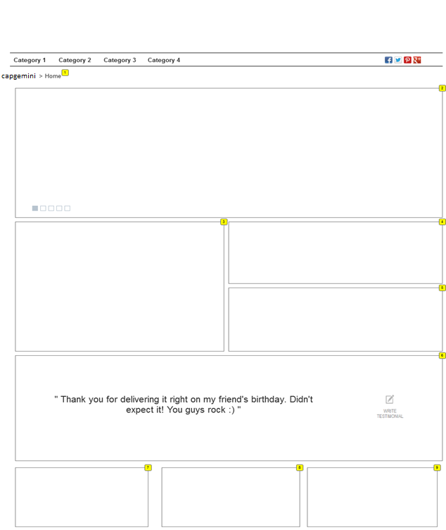

* + 1. Widget Table

|  |  |  |  |  |
| --- | --- | --- | --- | --- |
| **Footnote** | **Label** | **Field Type** | **Data Source** | **UI Interactions** |
| 1 | Breadcrumb | Breadcrumb |  | On click – Navigates to appropriate page  Capgemini – Application should navigate to capgemini.com  Home – Should be a Static text |
| 2 | Hero Flash Image | Content Slot | Home-flash slot | Should contain 5 flash images |
| 3 | Content Slot 1 |  | home-main slot1 | On Click – navigates to appropriate page as configured in Content asset |
| 4 | Content Slot 2 |  | home-slot2 | On Click – navigates to appropriate page as configured in Content asset |
| 5 | Content Slot 3 |  | home-slot3 | Video to be configured  On click – video should be played in the Overlay |
| 6 | Testimonial | Form Field |  | Previously written Testimonials should be displayed one after the other (as a flash message)  On Click - Write Testimonial – Testimonial form should be displayed |
| 7 | Content Slot 4 |  | home- slot4 | On Click – navigates to appropriate page as configured in Content asset |
| 8 | Content Slot 5 |  | home- slot5 | On Click – navigates to appropriate page as configured in Content asset |
| 9 | Content Slot 6 |  | home- slot6 | On Click – navigates to appropriate page as configured in Content asset |

1.4.3. Developer Notes

|  |  |  |
| --- | --- | --- |
| **Footnote** | **Label** | **Additional Info** |
| 6 | Testimonial | Message should be listed / saved in Testimonial Custom object  Only selected 5 messages should be displayed in the Home page |

* 1. Home Page – Testimonial Form
     1. User Interface

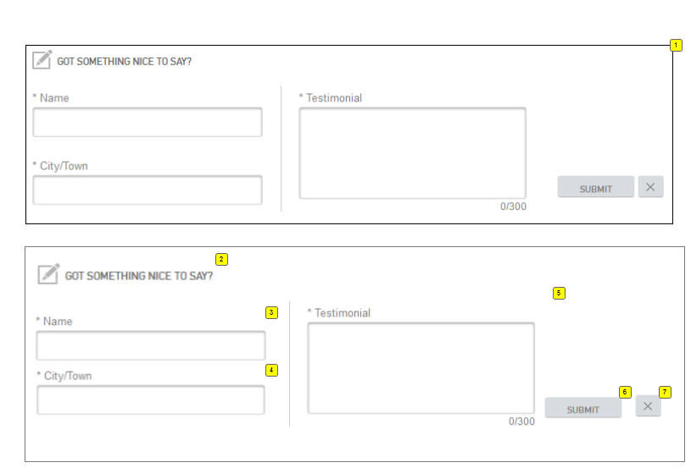

* + 1. Widget Table

|  |  |  |  |  |
| --- | --- | --- | --- | --- |
| **Footnote** | **Label** | **Field Type** | **Data Source** | **UI Interactions** |
| 1 | Testimonial form | Form Field |  |  |
| 2 | Static Message |  |  |  |
| 3 | Name | Form Field |  | First and Last Name |
| 4 | City / Town | Form Field |  |  |
| 5 | Message | Form Field |  | Enter the testimonial message.  Max of 300 characters including alphabets, special characters and numbers |
| 6 | Submit | Form Field |  | On Submit – Entered testimonial should be saved in BM and should be displayed in Testimonial as a flash message |
| 7 | Close Icon | Form Field |  | Closes the testimonial form field and displays Testimonial flash message in Home page |

* 1. Category Landing Page
     1. User Interface

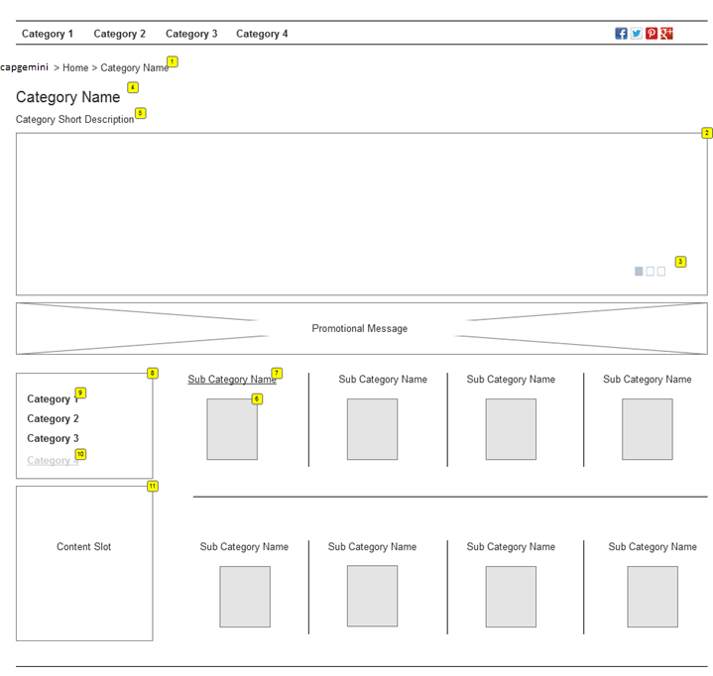

* + 1. Widget Table

|  |  |  |  |  |
| --- | --- | --- | --- | --- |
| **Footnote** | **Label** | **Field Type** | **Data Source** | **UI Interaction** |
| 1 | Breadcrumb | Form Field |  | On click – Navigates to appropriate page  Capgemini – Application should navigate to capgemini.com  Home – on click, application should navigate to the Home page  Category – Static text |
| 2 | Flash Hero Image | Content Slot | category-flash slot | 3 flash images should be displayed |
| 3 | Flash image indicator |  |  | Indicates which image is displayed out of 3 |
| 4 | Category Name | Form Field |  |  |
| 5 | Category Short Description | Form Field |  |  |
| 6 | Sub Category Image | Form Field |  | On click – navigates to respective Sub category landing page  Should display 4 Sub categories in a row  And can be N no of rows as per configuration |
| 7 | Sub Category name link | Form Field |  | On click – navigates to respective Sub category landing page  Should display 4 Sub categories in a row  And can be N no of rows as per configuration |
| 8 | Category Left Nav |  |  | Contains Category and Sub category links |
| 9 | Category Link |  |  | On click – Navigates to the respective category landing page  On Hover – Respective category link should be shaded / grayed out |
| 10 | Category Link |  |  | Selected Category link should underlined |
| 11 | Content slot |  | category main-slot | No interaction should take place – on click nor on hover |
| 12 | Promotional Message |  |  | Static image |

* 1. Sub Category Landing Page
     1. User Interface

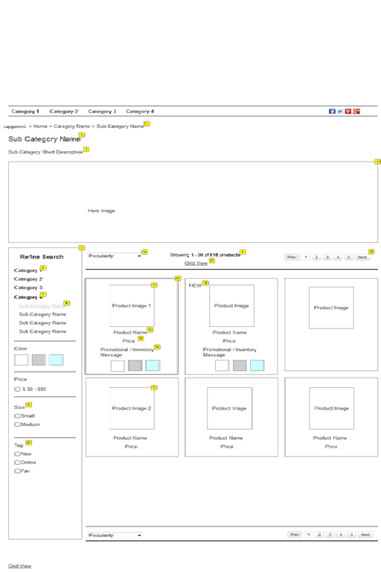

* + 1. Widget Table

|  |  |  |  |  |
| --- | --- | --- | --- | --- |
| **Footnote** | **Label** | **Field Type** | **Data Source** | **UI Interaction** |
| 1 | Breadcrumb | Form Field |  | On click – Navigates to appropriate page  Capgemini – Application should navigate to capgemini.com  Home – On click, application should navigate to the Home page  Category – On click, application should navigate to the respective category landing page  Sub Category – Static text |
| 2 | Category Name |  |  |  |
| 3 | Category Short Description |  |  |  |
| 4 | Hero Image |  |  |  |
| 5, 6, 7, 8, 19 & 20 | Refine Search |  |  | Search refinements – Categories, Color, Price and Brand  On Click – respective category page should be displayed  On Hover – Category or Sub category link should be grayed out  On Selection - Category or Sub category link should be underlined |
| 9 | Results |  |  | Displays dynamic results “Showing xx-xx out of xx products” |
| 10 | Sort By |  |  | Values to be displayed as configured in BM |
| 11 | Product Image |  |  | On click – Navigates respective product detail page |
| 12 | Product Name |  |  | On click – Navigates respective product detail page |
| 13 | Product Price |  |  | Displays ‘List’ price and Sale price if configured |
| 14 | Product detail |  |  |  |
| 15 | Promotional / Inventory message Message |  |  | Promotional / Inventory message placeholder |
| 16 | Pagination |  |  | 12 products per page, if more display in next page.  Contains buttons ‘Previous’ – navigates to the previous page and ‘Next’ – Navigates to the next page |
| 17 | Product Image 2 |  |  | Have to configure 2 images for the product  Without hover – first image should be displayed  On hover – second image should be displayed |
| 18 | Tag – New / Fav / Online only |  |  | Attribute to be selected in BM |
| 21 | Grid View |  |  | On Click, in the product tile don’t display colors |

1.7.3. Developer Notes

|  |  |  |
| --- | --- | --- |
| **Footnote** | **Label** | **Additional Info** |
| 20 | Inventory status | In Stock – No message displays on the site.  Out of Stock – Display “Out of Stock” and hide “Add to Cart” if inventory status = out of stock and available date is null.  Back order – Display item ship date/message if inventory status = out of stock and available date is future date. |

* 1. Search Result page
     1. User Interface

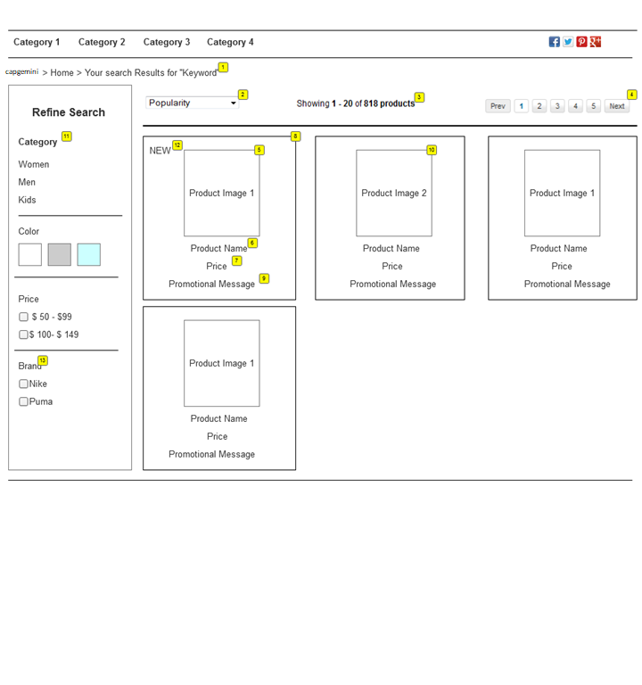

|  |  |  |  |  |
| --- | --- | --- | --- | --- |
| **Footnote** | **Label** | **Field Type** | **Data Source** | **UI Interaction** |
| 1 | Breadcrumb |  |  | On click – Navigates to appropriate page  Capgemini – Application should navigate to capgemini.com  Home – On click, application should navigate to the Home page  Keyword – Static text |

Note: 1. Annotation same as Sub Category landing page

* 1. No Search Results page – Retain same as SG
  2. Product Detail Page
     1. User Interface

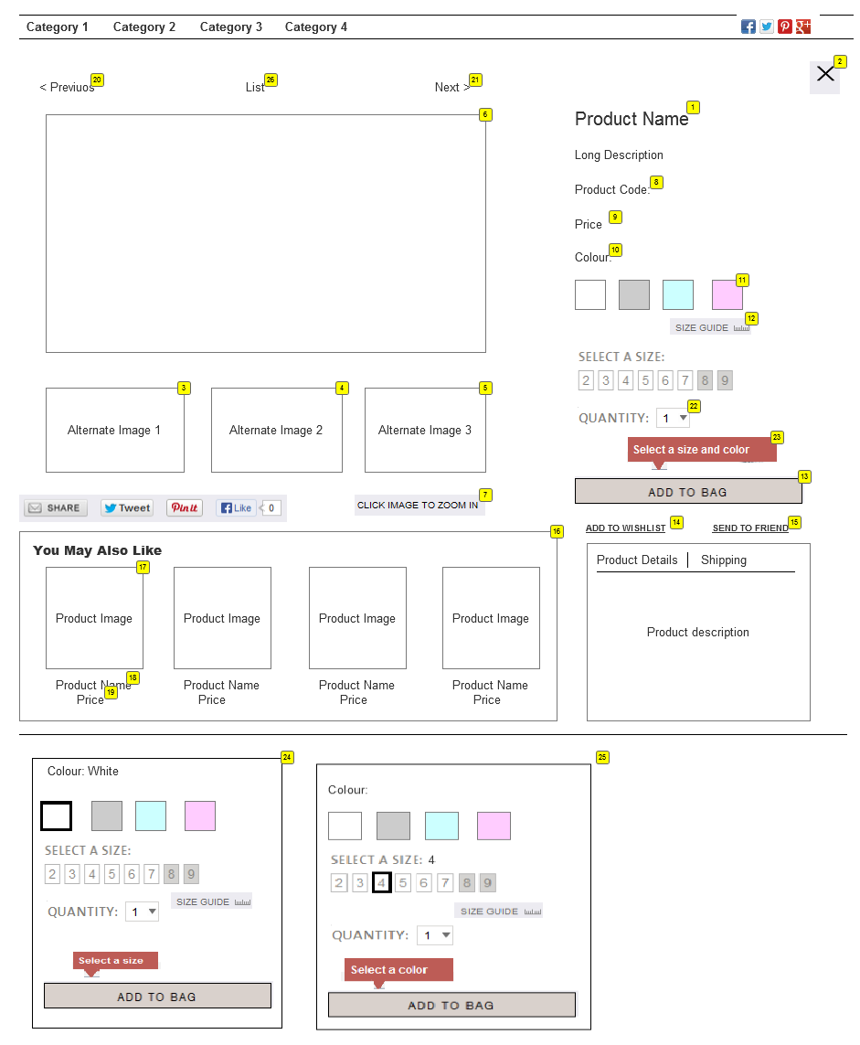

* + 1. Widget Table

|  |  |  |  |  |
| --- | --- | --- | --- | --- |
| **Footnote** | **Label** | **Field Type** | **Data source** | **UI Interaction** |
| 1 | Product Name | Object Attribute |  |  |
| 2 | Close icon | Form Field |  | Product detail page should be closed and should navigate back to Previous page from where Detail page was navigate to (Category drop down / Sub Category / Search Results page ) |
| 3 | Alternate Image 1 | Object Attribute |  | On click – should display product large image |
| 4 | Alternate Image 2 | Object Attribute |  | On click – should display product large image  If the image is not configured, then the space should be left blank |
| 5 | Alternate Image 3 | Object Attribute |  | On click – should display product large image |
| 6 | Hero Image | Object Attribute |  |  |
| 7 | Zoom Functionality |  |  | On Click, Hero image should be zoomed.  Only the main image should be zoomed not the alternate images |
|  | Long Description | Object Attribute |  |  |
| 8 | Product Code |  |  | Unique product id |
| 9 | Price |  |  |  |
| 10 | Color |  |  | Color name should be displayed when selected as well as when Hovered |
| 11 | Color Swatches |  |  | User should have the option to select from the swatches  Swatches should be highlighted on selection |
| 12 | Size Guide | Content Slot | size-guide | Refer 1.10.1 User Interface |
| 13, 24 & 25 | Add to bag button | Form Field |  | 1. Sku attributes (color n size) should be selected / highlighted on page load, if set default in BM  - Add to Bag button should be enabled (No text message should be displayed on hovered)  2. Sku attribute (color n size) should not be selected / highlighted on page load, if not set default in BM  - Add to Cart button should be disabled  - 'Select Size and Color' message should be displayed on hovering Add to bag button  - On selection, attributes should be highlighted and Add to Bag button should be enabled  3. In any one Sku attribute is set default in BM, that respective option should be selected / highlighted and  - Add to Cart button should be disabled  - 'Select Size / Color' message should be displayed on hovering Add to bag button  - On selection, attributes should be highlighted and Add to Bag button should be enabled  4. Swatches should be greyed out, if 'Not Available', tool tip message should be displayed  - Color not available  - Size not available  On Click, If the product is personalized, then Personalization overlay should be displayed |
| 14 | Add to Wish list link | Form Field |  | On selection of the Size, Color and quantity, Add to Wish list link should be enabled.  Product should be added to the Wish list  Max of 3 products can be added to the Wish list page |
| 15 | Send to Friend | Form Field |  | Send to Friend overlay should be displayed |
| 16 | Recommendations –You May Also Like |  |  | Max of 4 recommended products should be displayed for a product  On click – Application should navigate to respective product detail page |
| 17 | Product Image | Form Field |  | On hover of the image, product name should be displayed |
| 18 | Product name | Form Field |  | On click. Respective product detail page should be displayed |
| 19 | Price | Form Field |  |  |
| 20 | Previous link | Form Field |  | On click – navigates to previous product in that category or previous item from search results page based on how user arrived on this page. |
| 21 | Next link | Form Field |  | On click – navigates to next product in that category or next item from search results page based on how user arrived on this page. |
| 22 | Quantity drop down | Form Field |  | By default, 1 should be displayed on page load |
| 23 | Tool tip message | Form Field |  | ‘Select a size and color’ when hovered on Add to bag button |
| 26 | List link | Form Field |  | On click – navigates to gallery page or search results page based on how user arrived on this page. |
| 27 | Product Details |  |  | Dynamic tabs display a variation of product data: Product Details (product short  Description) and the Shipping details |

1.9.3. Developer Notes

|  |  |  |
| --- | --- | --- |
| **Footnote** | **Label** | **Additional Info** |
| 13 | Add to bag | If the product is checked for personalization option (custom attribute in BM) then personalization overlay should be displayed else proceed the normal flow |
|  | Inventory status | In Stock – No message displays on the site.  Out of Stock – Display “Out of Stock” and hide “Add to Cart” if inventory status = out of stock and available date is null.  Back order – Display item ship date/message if inventory status = out of stock and available date is future date. |

* 1. Product Details
     1. User Interface

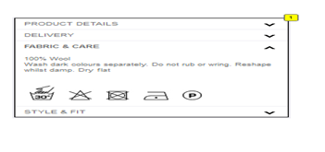

* 1. Size Guide

1.10.1 User Interface

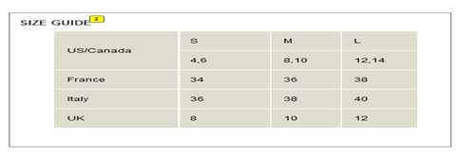

* 1. Send to Friend
     1. User Interface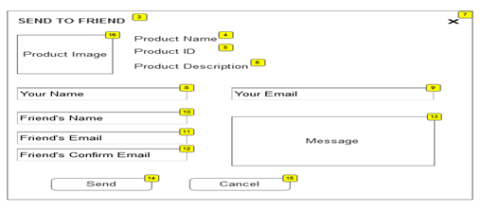

1.11.2 User Interface – Confirmation overlay



* + 1. Widget Table

|  |  |  |  |  |
| --- | --- | --- | --- | --- |
| **Footnote** | **Label** | **Field Type** | **Data source** | **UI Interaction** |
| 1 | Product Details expanded | Form Field |  | Clicking on down arrow, product details should be enlarged / extended.  On expansion, arrow mark should be pointing to upwards. |
| 2 | Size guide Title | Content slot |  |  |
| 3 | Send to Friend | Form Field |  | On Click – Send to friend overlay should be displayed |
| 4 | Product Name | Form Field |  |  |
| 5 | Product ID | Form Field |  |  |
| 6 | Product Description | Form Field |  |  |
| 7 | Close Icon |  |  | On Click – Send to friend overlay should get closed, PD page should be displayed |
| 8 | Your Name | Form Field |  | Required Field  Error Msg: Please Enter Your Name |
| 9 | Your Email | Form Field |  | Required Field  Error Msg: Please Enter Your Email |
| 10 | Friend Name | Form Field |  | Required Field  Error Msg: Please Enter Friend Name |
| 11 | Friend Email | Form Field |  | Required Field  Error Msg: Please Enter Friend Email |
| 12 | Friend Confirm Email | Form Field |  | Required Field  Error Msg: Please Enter Friend Confirm Email |
| 13 | Message | Form Field |  | Optional Field  Max of 300 characters  Above 300 characters, user should not be allowed to enter. |
| 14 | Send |  |  | Confirmation message should be displayed in an overlay  Email should be sent to the Friend’s Email id |
| 15 | Cancel |  |  | Send to Friend overlay should get closed  Email should not be sent |
| 16 | Product Image |  |  | Static image |
| 17 | Confirmation Message |  |  | Click on Send button - Confirmation message should be displayed in an overlay with close icon |
| 18 | Close Icon |  |  | Confirmation message should be displayed |

* 1. Personalization
     1. . User Interface

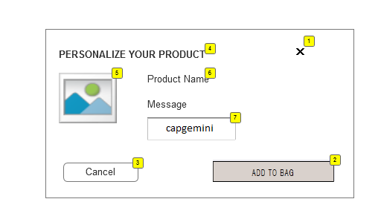

1.13.2. Widget Table

|  |  |  |  |  |
| --- | --- | --- | --- | --- |
| **Footnote** | **Label** | **Field Type** | **Data source** | **UI Interaction** |
| 1 | Close Icon |  |  | Closes the Personalization overlay  PD page is displayed |
| 2 | Add to Bag |  |  | Adds to the product to cart with personalization details |
| 3 | Cancel |  |  | Cancels personalization options  PD page is displayed |
| 4 | Title |  |  | Personalize your product |
| 5 | Product image |  |  | Static image |
| 6 | Product Name |  |  | Static text |
| 7 | Personalize Message |  |  | Required field  Message to be printed on the product  Error message: Please enter your personalized message  Max of 10 characters |

* 1. Wish List Page
     1. User Interface

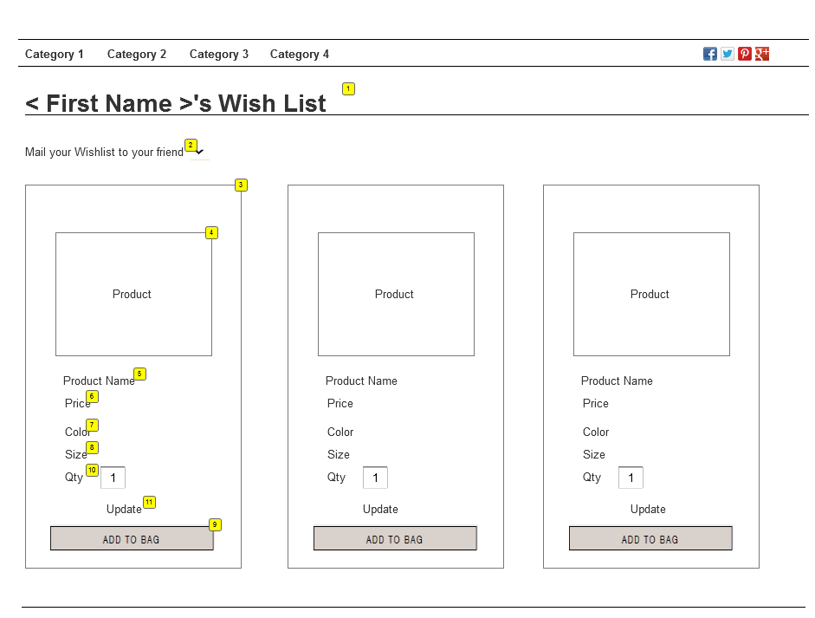

* + 1. Widget Table

|  |  |  |  |  |
| --- | --- | --- | --- | --- |
| **Footnote** | **Label** | **Field Type** | **Data source** | **UI Interaction** |
| 1 | Wish List title | Form Field |  | <First Name >’s Wish list should be displayed |
| 2 | Wish List Mail | Form Field |  | On click - Email Wish list form should be expanded. Refer 1.13.1 User Interface |
| 3 | Product Details |  |  |  |
| 4 | Product Image | Form Field |  | Application should navigate to respective product detail page |
| 5 | Product Name | Form Field |  | Application should navigate to respective product detail page |
| 6 | Price | Form Field |  |  |
| 7 | Color | Form Field |  |  |
| 8 | Size | Form Field |  |  |
| 9 | Add to Bag | Form Field |  | On click – Respective product should be added to the cart |
| 10 | Quantity | Form Field |  | Product with 1 qty should be added to wish list irrespective of the qty added in PD page |
| 11 | Update link | Form Field |  | User should be allowed to update the qty and add the product to the cart w.r.t the qty |

* 1. Email Wish List
     1. User Interface

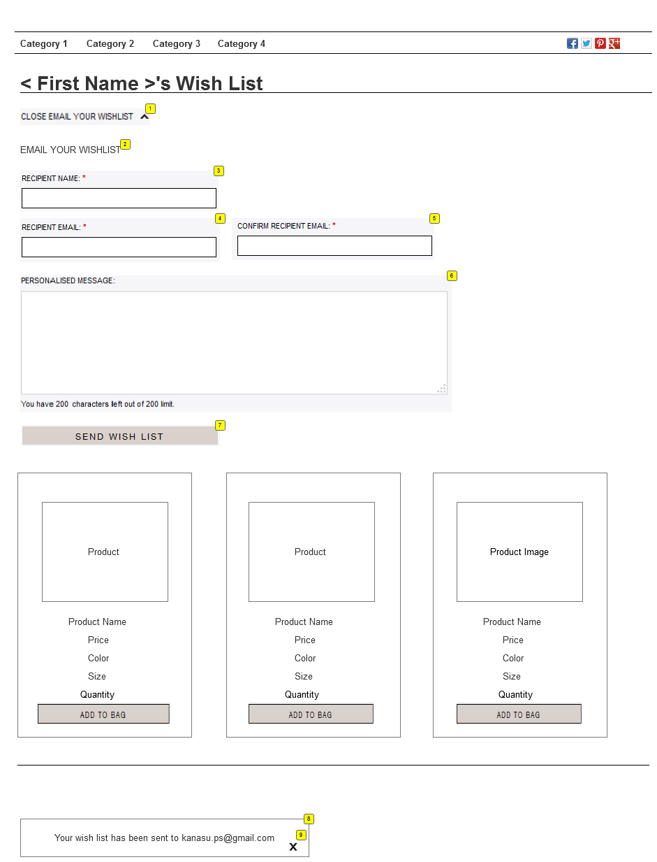

* + 1. Widget Table

|  |  |  |  |  |
| --- | --- | --- | --- | --- |
| **Footnote** | **Label** | **Field Type** | **Data source** | **UI Interaction** |
| 1 | Close Wish List | Form Field |  | On Click – Email Wish list closes / contracts |
| 2 | Email text | Form Field |  | Static text |
| 3 | Recipient name | Form Field |  | Required Field  Error Message: Please enter Recipient Name |
| 4 | Recipient Email | Form Field |  | Required Field  Error Message: Please enter Recipient Email |
| 5 | Confirm Recipient Email | Form Field |  | Required Field  Error Message: Please enter Confirm Recipient Email |
| 6 | Personal Message | Form Field |  | Optional Field  Max of 300 Characters  Above 300 characters, user should not be allowed to enter. |
| 7 | Send Wish list button | Form Field |  | Email Wish list confirmation message overlay should be displayed  Email should be sent to Recipient Email Id |
| 8 | Confirmation Message | Form Field |  | Message “Your wish list has been sent to Recipient Email Id” should be displayed |
| 9 | Close Icon | Form Field |  | Overlay should get closed and User should remain in Wish list page |

* 1. Sign In Overlay – Retain SG functionality
  2. Create your Account
     1. User Interface

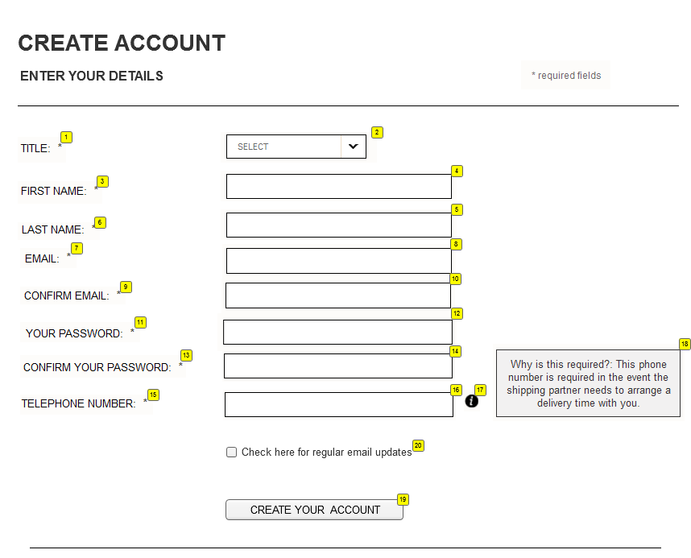

* + 1. Widget Table

|  |  |  |  |  |
| --- | --- | --- | --- | --- |
| **Footnote** | **Label** | **Field Type** | **Data source** | **UI Interaction** |
| 1 | Title | Form Field |  |  |
| 2 | Title drop down | Form Field |  | Drop down Values – Mr., Mrs., Miss, Master, Dr, Sir etc. |
| 3 | First Name | Form Field |  |  |
| 4 | First Name input field | Form Field |  | Required Field  Error Msg: Please Enter Your Name |
| 5 | Last Name input field | Form Field |  | Required Field  Error Msg: Please Enter Your Name |
| 6 | Last Name | Form Field |  |  |
| 7 | Email | Form Field |  |  |
| 8 | Email input field | Form Field |  | Required Field  Error message: Please Enter Your Email id  Format: xx@xx.com / xx@xx.co.in |
| 9 | Confirm Email | Form Field |  |  |
| 10 | Confirm Email input field | Form Field |  | Required Field  Error message: Please Enter Your Confirm Email id  Format: xx@xx.com / xx@xx.co.in |
| 11 | Password | Form Field |  |  |
| 12 | Password input field | Form Field |  | Required Field  Error message: Please Enter your password  Entered password should be masked |
| 13 | Confirm Password | Form Field |  |  |
| 14 | Confirm Password input field | Form Field |  | Required Field  Error message: Please Enter your password  Entered password should be masked |
| 15 | Telephone number | Form Field |  |  |
| 16 | Text Field | Form Field |  | Required Field  Only Numbers should be allowed  Error message: Please Enter your Telephone number |
| 17 | Tool tip | Content Slot |  | On hover, message should be displayed as configured in BM - Content slot |
| 18 | Content slot |  |  |  |
| 19 | Create Your Account button |  |  | Button should be enabled only when all the fields are entered  On click – Account should be created successfully, and user should be navigated to My Account – Home page should be displayed |
| 20 | Email Registration Checkbox | Form Field |  | On selecting the email address, regular updates need to be received by the User |

* 1. Error - Create your Account
     1. User Interface

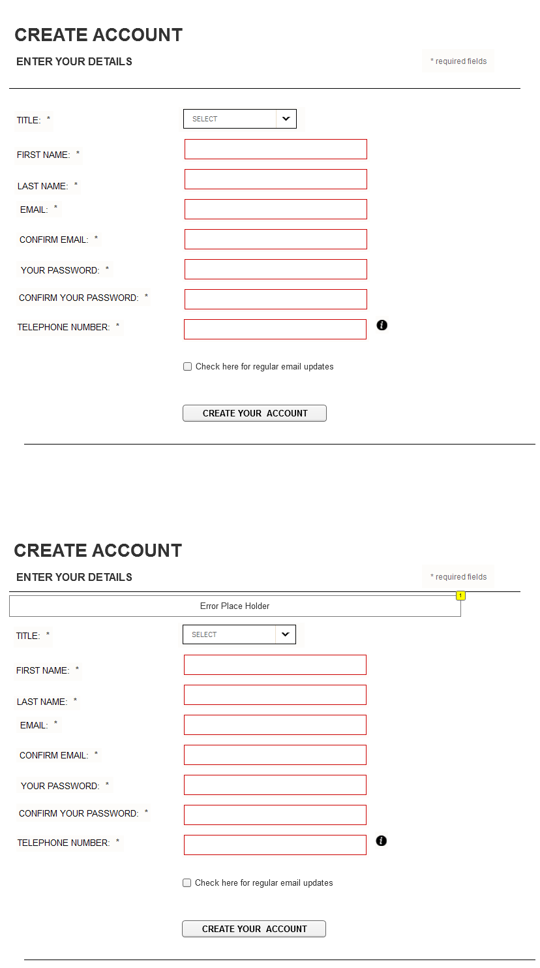

* + 1. Widget Table

|  |  |  |  |  |
| --- | --- | --- | --- | --- |
| **Footnote** | **Label** | **Field Type** | **Data source** | **UI Interaction** |
| 1 | Error Place Holder | Form Field |  | Error message should be displayed |

* 1. Forgot Password Overlay – Retain SG functionality
  2. My Account - Home Page
     1. User Interface

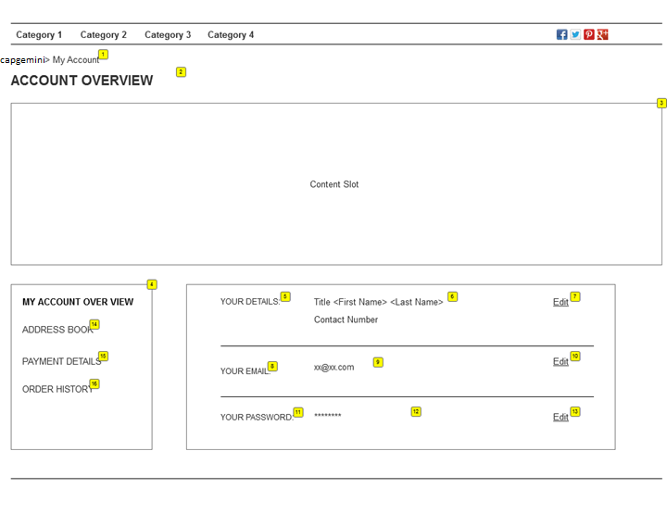

* + 1. Widget Table

|  |  |  |  |  |
| --- | --- | --- | --- | --- |
| **Footnote** | **Label** | **Field Type** | **Data source** | **UI Interaction** |
| 1 | Breadcrumb | Form Field |  | Click on Capgemini – Application should navigate to capgemini.com  My Account should be static text |
| 2 | Title |  |  |  |
| 3 | Content Slot |  |  |  |
| 4 | Left Navigation |  |  | Present page link should be highlighted  E.g.: If User is in ‘My Account’ page, link in left nav should be highlighted (Bold)  Application should navigate to respective page when clicked on other links like Address book, Payment details or Order History |
| 5 | Your Details | Form Field |  |  |
| 6 | First and Last name | Form Field |  | User’s Full name should be displayed |
| 7 | Edit link | Form Field |  | “Your Details” section should be expanded  Refer 1.18.1 User Interface |
| 8 | Your email |  |  |  |
| 9 | Email address | Form Field |  | User’s email id should be displayed |
| 10 | Edit | Form Field |  | “Your Email” section should be expanded  Refer 1.19.1 User Interface |
| 11 | Password |  |  |  |
| 12 | Masked password | Form Field |  | Entered password should be masked |
| 13 | Edit | Form Field |  | Password section should be expanded |
| 14 | Address Book | Form Field |  | Link in Left Nav.  On click - Application navigates to Address book page |
| 15 | Payment Details | Form Field |  | Link in Left Nav.  On click - Application navigates to Payment details page |
| 16 | Order History | Form Field |  | Link in Left Nav.  On click - Application navigates to Order History page |

* 1. My Account - Edit Details
     1. User Interface

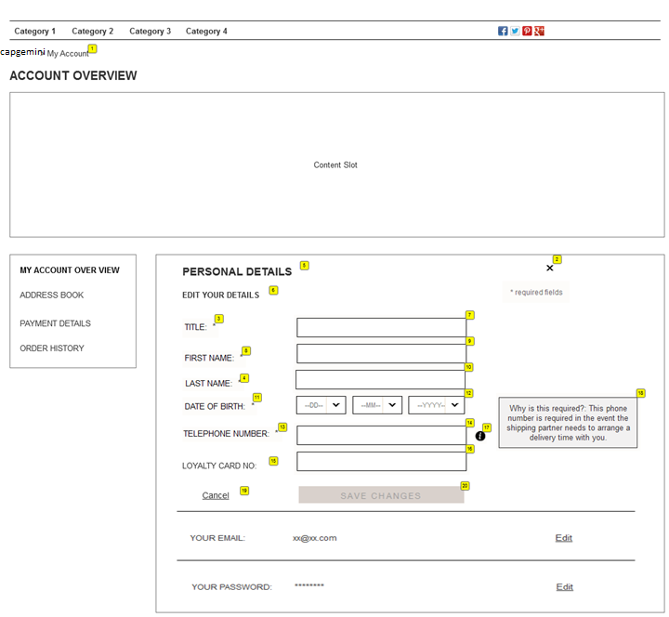

* + 1. Widget Table

|  |  |  |  |  |
| --- | --- | --- | --- | --- |
| **Footnote** | **Label** | **Field Type** | **Data source** | **UI Interaction** |
| 1 | Breadcrumb | Form Field |  | Click on Capgemini – Application should navigate to capgemini.com  My Account should be static text |
| 2 | Close Icon | Form Field |  | Personal details section should get closed |
| 3 | Title | Form Field |  | Should be drop down |
| 4 | Last Name | Form Field |  |  |
| 5 | Personal Details | Form Field |  | Page title |
| 6 | Static Text | Form Field |  | “Edit your Details” |
| 7 | Title drop down | Form Field |  | Drop down Values – Mr, Mrs, Miss, Master, Dr, Sir etc |
| 8 | First Name | Form Field |  |  |
| 9 | First Name input field | Form Field |  | Required Field  Error Msg: Please Enter Your Name |
| 10 | Last Name Input Field | Form Field |  | Required Field  Error Msg: Please Enter Your Name |
| 11 | DOB | Form Field |  | Drop down |
| 12 | DOB drop down | Form Field |  | Optional field  Format: DD//MM/ YYYY  Error Msg: Please select the DOB |
| 13 | Telephone Number | Form Field |  |  |
| 14 | Telephone input Field | Form Field |  | Optional field.  Format: xxx-xxx-xxxx. |
| 15 | Loyalty card | Form Field |  |  |
| 16 | Loyalty card input field | Form Field |  | Optional field.  On entering, registered user receives discount on the order. |
| 17 | Tool tip | Content Slot |  |  |
| 18 | Content slot message |  |  |  |
| 19 | Cancel | Form Field |  | Personal details section closes. |
| 20 | Save Changes button | Form Field |  | Save Changes button is enabled only when all the required fields are entered.  On click - Edited details are saved successfully. |

* + 1. Developer Notes

|  |  |  |
| --- | --- | --- |
| **Footnote** | **Label** | **Additional Info** |
| 6 |  | Pre-populate details from profile for edit mode |

* 1. My Account - Edit Email Address
     1. User Interface

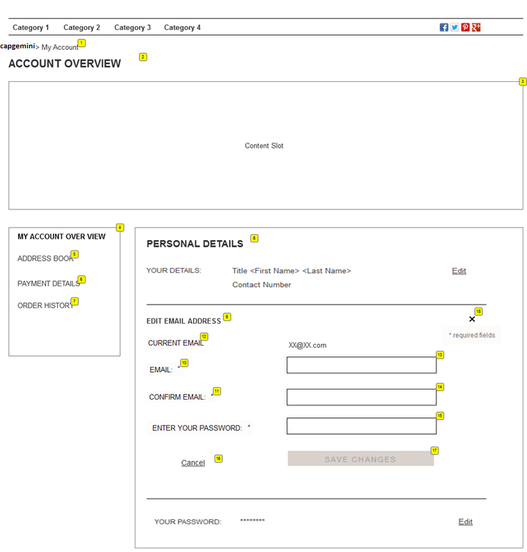

* + 1. Widget Table

|  |  |  |  |  |
| --- | --- | --- | --- | --- |
| **Footnote** | **Label** | **Field Type** | **Data source** | **UI Interaction** |
| 1 | Breadcrumb | Form Field |  | Click on Capgemini – Application should navigate to capgemini.com  My Account should be static text |
| 2 | Heading | Form Field |  |  |
| 3 | Content Slot | Content Slot |  |  |
| 4 | Left Navigation | Form Field |  |  |
| 5 | Address Book | Form Field |  |  |
| 6 | Payment Details | Form Field |  |  |
| 7 | Order History | Form Field |  |  |
| 8 | Personal Details | Form Field |  |  |
| 9 | Title | Form Field |  | “Edit Email address” static text |
| 10 | Email | Form Field |  |  |
| 11 | Confirm Email | Form Field |  |  |
| 12 | Current Email | Form Field |  | User’s email id |
| 13 | Email input field | Form Field |  | Required Field  Error message: Please Enter Your Email id  Format: xx@xx.com / xx@xx.co.in |
| 14 | Confirm Email input field | Form Field |  | Required Field  Error message: Please Reenter Your Email id  Format: xx@xx.com / xx@xx.co.in |
| 15 | Password input field | Form Field |  | Required Field  Entered password should be masked |
| 16 | Cancel | Form Field |  | Edit email section closes |
| 17 | Save Changes button | Form Field |  | Save Changes button is enabled only when all the required fields are entered.  On click - Edited details are saved successfully. |
| 18 | Close Icon | Form Field |  | Close the email section |

* + 1. Developer Notes

|  |  |  |
| --- | --- | --- |
| **Footnote** | **Label** | **Additional Info** |
| 9 | Edit email address | Pre-populate details from profile for edit mode |

* 1. My Account - Change Password
     1. User Interface

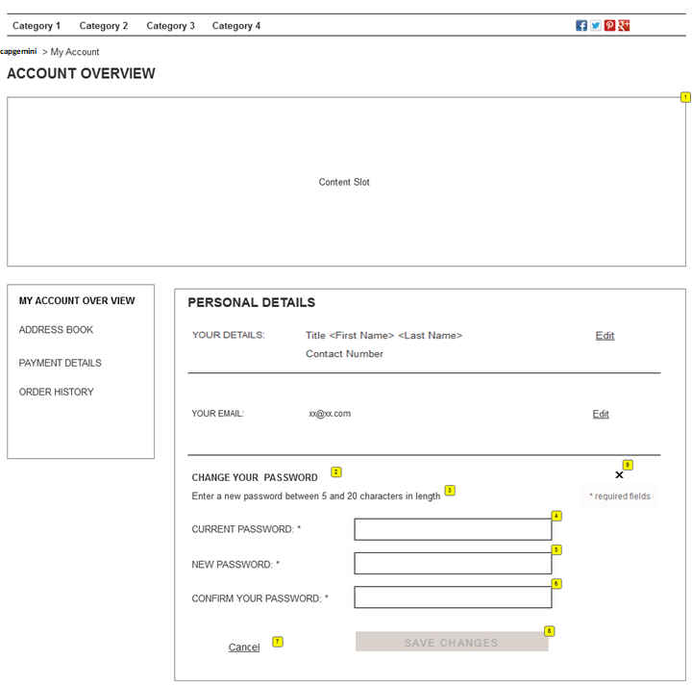

* + 1. Widget Table

|  |  |  |  |  |
| --- | --- | --- | --- | --- |
| **Footnote** | **Label** | **Field Type** | **Data source** | **UI Interaction** |
| 1 | Content Slot |  |  |  |
| 2 | Title | Form Field |  | Change your password |
| 3 | sub title | Form Field |  | Static text |
| 4 | Current password | Form Field |  | User’s masked password should |
| 5 | New password | Form Field |  | Required Field  Entered password should be masked |
| 6 | Confirm your password | Form Field |  | Required Field  Entered password should be masked |
| 7 | Cancel | Form Field |  | Close the password section |
| 8 | Save Changes button | Form Field |  | Save Changes button is enabled only when all the required fields are entered.  On click - Edited details are saved successfully. |
| 9 | Close Icon | Form Field |  | Close the password section |

* 1. Address Book
     1. User Interface

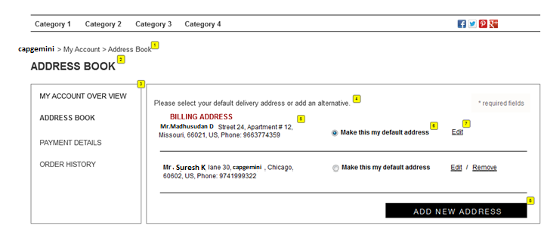

* + 1. Widget Table

|  |  |  |  |  |
| --- | --- | --- | --- | --- |
| **Footnote** | **Label** | **Field Type** | **Data source** | **UI Interaction** |
| 1 | Breadcrumb |  |  | Click on Capgemini – Application should navigate to capgemini.com  My Account – Application should navigate to My Account home page  Address Book- Should be static text |
| 2 | Address Book Title |  |  |  |
| 3 | Left nav |  |  | Present page link should be highlighted  Eg: If User is in ‘Address Book’ page, link in left nav should be highlighted (Bold)  Application should navigate to respective page when clicked on other links like My Account Home, Payment details or Order History pages |
| 4 | Static Text |  |  | Message |
| 5 | Entered Address |  |  | Saved address - <Title Full name>, Address 1 & 2, City, State, Country and Phone number |
| 6 | Default Address |  |  | Radio button – By default first entered / saved address should be selected |
| 7 | Edit link |  |  | ‘Edit Address Book’ section should be displayed  Refer 1.22.1 User Interface |
| 8 | Remove Link |  |  | Address should be removed  Remove link should be displayed only for Shipping address (Not Billing address) |
| 9 | Add New Address button |  |  | Add address book section should be displayed.  Refer 1.22.1 User Interface |

* 1. Edit / Add Address Book
     1. User Interface

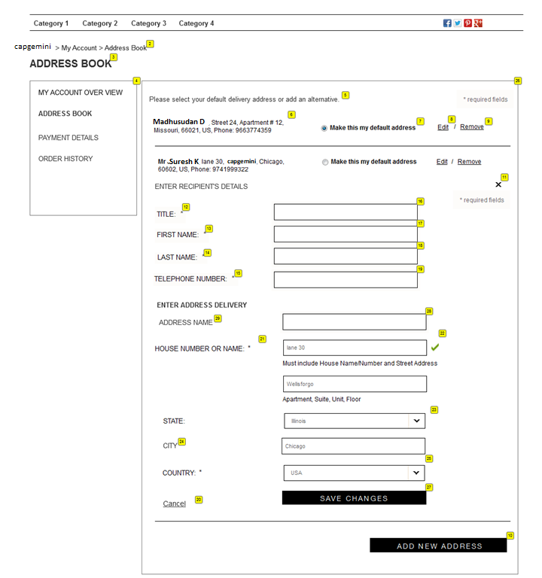

* + 1. Widget Table

|  |  |  |  |  |
| --- | --- | --- | --- | --- |
| **Footnote** | **Label** | **Field Type** | **Data source** | **UI Interaction** |
| 2 | Breadcrumb | Form field |  | Click on Capgemini – Application should navigate to capgemini.com  My Account – Application should navigate to My Account home page  Address Book- Should be static text |
| 3 | Address Book Title | Form field |  |  |
| 4 | Left nav |  |  | Present page link should be highlighted  Eg: If User is in ‘Address Book’ page, link in left nav should be highlighted (Bold)  Application should navigate to respective page when clicked on other links like My Account Home, Payment details or Order History pages |
| 5 | Static Text |  |  |  |
| 6 | Entered Address |  |  | Saved address |
| 7 | Default Address |  |  | Radio button – By default first entered / saved address should be selected |
| 8 | Edit link |  |  | ‘Edit Address Book’ section should be displayed  Refer 1.22.1 User Interface |
| 9 | Remove Link |  |  | Delete overlay should be displayed |
| 10 | Add New Address button |  |  | Add address book section should be displayed.  Refer 1.22.1 User Interface |
| 11 | Close Icon |  |  | Closes the Edit / Add New Address section |
| 12 | Title input Field |  |  | Drop down Values – Mr., Mrs., Miss, Master, Dr, Sir etc |
| 13 | First Name |  |  |  |
| 14 | Last Name |  |  |  |
| 15 | Telephone Number |  |  |  |
| 16 | Title |  |  |  |
| 17 | First name Input field |  |  | Required Field  Error Msg: Please Enter Your First Name |
| 18 | Last name input Field |  |  | Required Field  Error Msg: Please Enter Your Last Name |
| 19 | Telephone input Field |  |  | Optional field  Format: xxx-xxx-xxxx |
| 20 | Cancel |  |  | Closes the address section |
| 21 | Label of the address field |  |  |  |
| 22 | Address 1 & 2 |  |  | Required Field  Format: Address1  Address 2  Allow special characters, alphabets and numbers |
| 23 | State drop down |  |  | Should contain all the state values |
| 24 | City |  |  | Based on the selected State, City options should be displayed |
| 25 | Country |  |  | United States text should be displayed by default |
| 26 | Cancel |  |  | Closes the Edit / Add New Address section |
| 27 | Save Changes button |  |  | Save Changes button is enabled only when all the required fields are entered.  On click - Edited / Entered details are saved successfully. |

* + 1. Developer Notes

|  |  |  |
| --- | --- | --- |
| **Footnote** | **Label** | **Additional Info** |
| 12-25 |  | Pre-populate details from profile for edit mode |

* 1. Delete Overlay
     1. User Interface

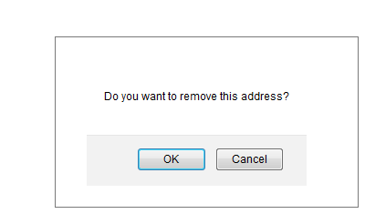

|  |  |  |  |  |
| --- | --- | --- | --- | --- |
| **Footnote** | **Label** | **Field Type** | **Data source** | **UI Interaction** |
| 1 | Delete Overlay |  |  | Click on Remove link, Delete overlay should be displayed |
| 2 | Static text | Form Field |  | ‘Do you want to remove this address’ |
| 3 | OK button | Form Field |  | Selected Address will be removed |
| 4 | Cancel button | Form Field |  | Delete overlay should be closed and User stays on same (address book / payment details) page |

* 1. Payment Details
     1. User Interface

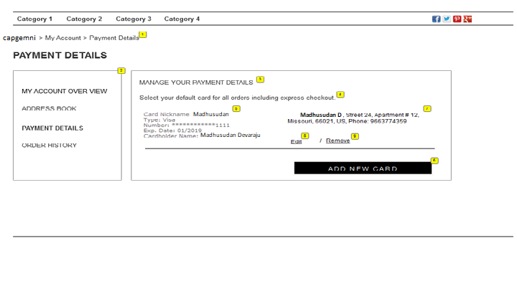

* + 1. Widget Table

|  |  |  |  |  |
| --- | --- | --- | --- | --- |
| **Footnote** | **Label** | **Field Type** | **Data source** | **UI Interaction** |
| 1 | Breadcrumb |  |  | Click on Capgemini – Application should navigate to capgemini.com  My Account – Application should navigate to My Account home page  Payment Details - Should be static text |
| 2 | Left nav |  |  | Present page link should be highlighted  E.g.: If User is in ‘Payment details ‘page, link in left nav should be highlighted (Bold)  Application should navigate to respective page when clicked on other links like My Account Home, Payment details or Order History pages |
| 3 | Title |  |  | Manage your payment details |
| 4 | Static text |  |  |  |
| 5 | Saved Card details | Form Field |  | Card nickname, card type, number (masked except last 4 digits), exp date and card holder name |
| 6 | Add New Card button | Form Field |  | Payment Details – Add / Edit section should be displayed |
| 7 | Saved Address |  |  | Billing address should be displayed |
| 8 | Edit | Form Field |  | Payment Details – Add / Edit section should be displayed  Edited address should be saved in payment setting and address book page |
| 9 | Remove | Form Field |  | Delete overlay should be displayed |

* 1. Payment Details – Add / Edit
     1. User Interface

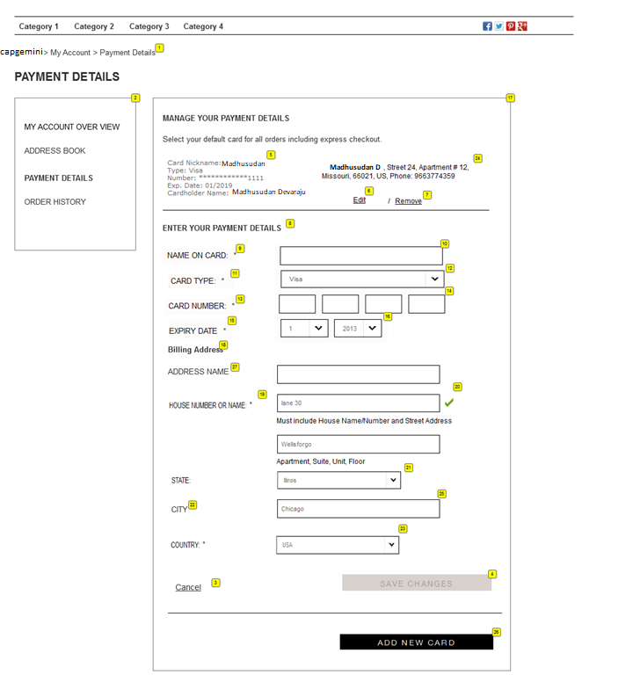

* + 1. Widget Table

|  |  |  |  |  |
| --- | --- | --- | --- | --- |
| **Footnote** | **Label** | **Field Type** | **Data source** | **UI Interaction** |
| 1 | Breadcrumb |  |  | Click on Capgemini – Application should navigate to capgemini.com  My Account – Application should navigate to My Account home page  Payment Details - Should be static text |
| 2 | Left nav |  |  | Present page link should be highlighted  Eg: If User is in ‘Payment details ‘page, link in left nav should be highlighted (Bold)  Application should navigate to respective page when clicked on other links like My Account Home, Payment details or Order History pages |
| 3 | Cancel |  |  | Closes the payment details section |
| 4 | Save Changes button |  |  | Save Changes button is enabled only when all the required fields are entered.  On click - Edited / Entered details are saved successfully. |
| 5 | Saved Card details |  |  | Card nickname, card type, number (masked except last 4 digits), exp date and card holder name |
| 6 | Edit link |  |  | Payment Details – Add / Edit section should be displayed |
| 7 | Remove Link |  |  | Delete overlay should be displayed |
| 8 | Static Text |  |  |  |
| 9 | Name on the card |  |  | Required field  Error message: Please enter your name on the card |
| 10 | Card name Input Text Field |  |  |  |
| 11 | Card Type |  |  | Required field  Should be a drop down |
| 12 | Card type drop down |  |  | Drop down values – Visa, American express, Discover, Master card etc |
| 13 | Card Number |  |  | Required field  Error message: Please enter valid card number |
| 14 | Card number Field |  |  | Card validation |
| 15 | Expiry Date |  |  | Drop down  Format: MM/ YYYY |
| 16 | MM/ YYYY |  |  | Error message: Please select a proper expiry date |
| 17 | Add New Card |  |  | Enter payment details section should be displayed |
| 18 | Billing address details | Label |  |  |
| 20 | Address 1 & 2 |  |  | Required Field  Format: Address1  Address 2  Allow special characters, alphabets and numbers |
| 21 | State drop down |  |  | Should contain all the state values |
| 22 | City |  |  | Based on the selected State, City options should be displayed |
| 23 | Country drop down |  |  | United States text should be displayed by default |
| 24 | Entered Address |  |  | Saved address |
| 26 | Add New Card button |  |  | User should be allowed to enter new Credit card |

* 1. Order History
     1. User Interface

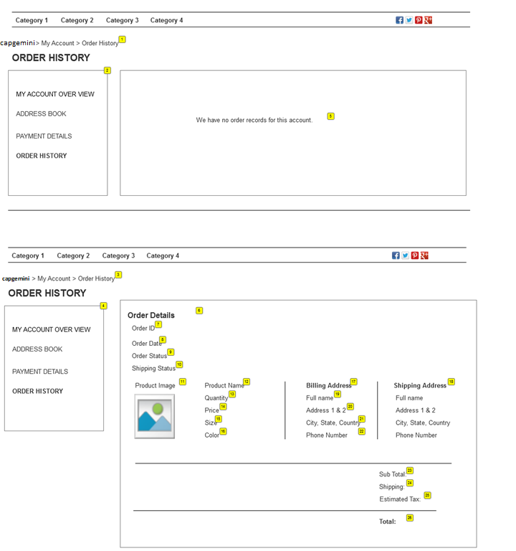

* + 1. Widget Table

|  |  |  |  |  |
| --- | --- | --- | --- | --- |
| **Footnote** | **Label** | **Field Type** | **Data source** | **UI Interaction** |
| 1 | Breadcrumb |  |  | Click on Capgemini – Application should navigate to capgemini.com  My Account – Application should navigate to Account home page  Order History – Static text |
| 2 | Left nav |  |  | Present page link should be highlighted  Eg: If User is in ‘Payment details’page, link in left nav should be highlighted (Bold)  Application should navigate to respective page when clicked on other links like My Account Home, Payment details or Order History pages |
| 3 | Breadcrumb |  |  |  |
| 4 | Left nav |  |  |  |
| 5 | No Orders Message |  |  | Message ‘We have no orders for this account’ should be displayed when user has not placed orders |
| 6 | Title |  |  | Order Details |
| 7 | Order Id | Form field |  |  |
| 8 | Date | Form field |  | Format: MM/DD/YYYY |
| 9 | Order Status |  |  | Either one of the status  Not shipped, Shipped and Cancelled |
| 10 | Shipping Status |  |  | Either one of the status  Not shipped, Shipped, |
| 11 | Product Image |  |  | On Click – Application should navigate to respective product detail page |
| 12 | Product Name |  |  | On Click – Application should navigate to respective product detail page |
| 13 | Quantity |  |  | qty of products, the order was placed |
| 14 | Price |  |  | Price of the product |
| 15 | Size |  |  | Sku attributes |
| 16 | Color |  |  | Sku attributes |
| 17 | Billing Address |  |  | Address entered to Bill the order |
| 18 | Shipping Address |  |  | Address entered to Ship the order |
| 19 | Full Name |  |  |  |
| 20 | Address 1 & 2 |  |  |  |
| 21 | City, State, Country |  |  |  |
| 22 | Phone Number |  |  |  |
| 23 | Sub total |  |  | Sub Total or the order should be displayed |
| 24 | Shipping charge |  |  | Shipping charge applicable to the Order should be displayed |
| 25 | Estimated Tax |  |  | Tax applicable to the Order should be displayed |
| 26 | Total |  |  | Total = Subtotal + Shipping charge + Tax |

* 1. Order History – Guest User
     1. User Interface

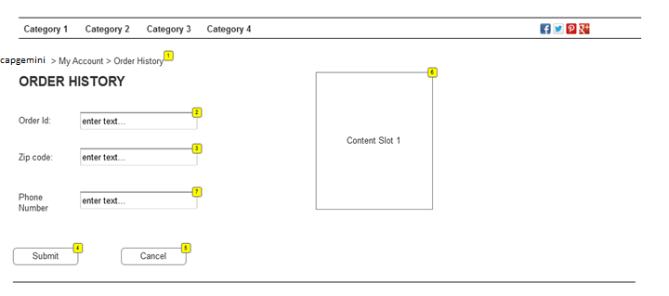

* + 1. Widgets

|  |  |  |  |  |
| --- | --- | --- | --- | --- |
| **Footnote** | **Label** | **Field Type** | **Data source** | **UI Interaction** |
| 1 | Breadcrumb |  |  | Click on Capgemini – Application should navigate to capgemini.com  My Account – Application should navigate to Account home page  Order History – Static text |
| 2 | Order ID | Form Field |  | Required Field  ‘Please enter a valid Order ID’  ‘Order ID does not exist in the records’ |
| 3 | Zip Code | Form Field |  | Required Field  ‘Please enter a valid Zip code’ |
| 4 | Submit | Form Field |  | On entering valid Order ID, Zip code and Phone number, User should be able to search for the Order Details as a Guest User  Order Details section should be displayed  Left Nav should not be displayed |
| 5 | Cancel | Form Field |  | On Cancel, Application should navigate to Home page |
| 6 | Content Slot 1 |  | order-history guest user |  |
| 7 | Phone Number | Form Field |  | Option field |

* 1. Mini Cart

1.32.1 User Interface

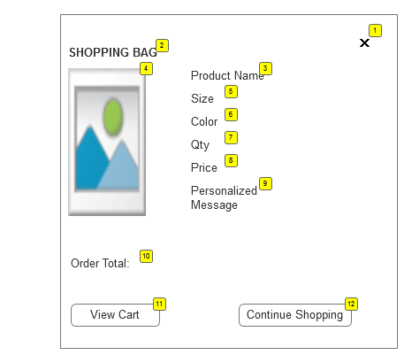

* + 1. Widget Table

|  |  |  |  |  |
| --- | --- | --- | --- | --- |
| **Footnote** | **Label** | **Field Type** | **Data source** | **UI Interaction** |
| 1 | Close Icon |  |  | Closes the Mini cart |
| 2 | Shopping bag title |  |  |  |
| 3 | Product Name |  |  | On Click – Application navigates to the respective product detail page |
| 4 | Product Image |  |  | On Click – Application navigates to the respective product detail page |
| 5 | Size |  |  | Selected Size of the product should be displayed |
| 6 | Color |  |  | Selected color of the product should be displayed |
| 7 | Qty |  |  | Qty selected should be displayed |
| 8 | Price |  |  | Price of the product |
| 9 | Personalized Message |  |  | Message (if entered by User) |
| 10 | Order total |  |  | Qty * Price |
| 11 | View Cart |  |  | Application navigates to Cart page |
| 12 | Continue Shopping |  |  | Application closes the mini cart and navigates to the Home page |

* 1. Shopping Bag

1.33.1. User Interface

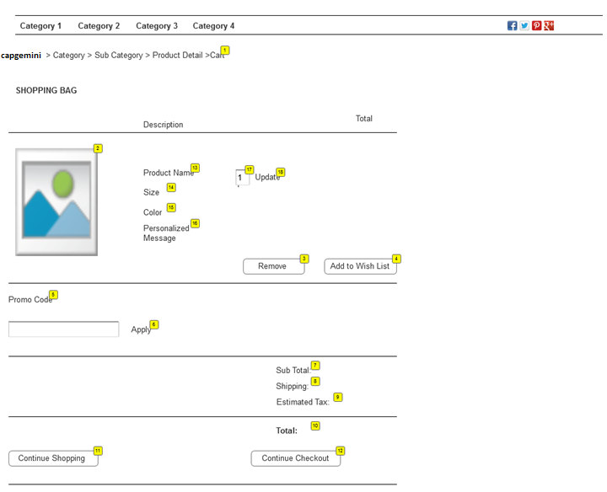

* + 1. Widget

|  |  |  |  |  |
| --- | --- | --- | --- | --- |
| **Footnote** | **Label** | **Field Type** | **Data source** | **UI Interaction** |
| 1 | Breadcrumb |  |  | On click – Navigates to appropriate page  Capgemini – Application should navigate to capgemini.com  Home – On click, application should navigate to the Home page  Cart – Static text  Path: Capgemini > Home > Cart |
| 2 | Product Image |  |  | On Click – Application navigates to the respective product detail page |
| 3 | Remove |  |  | Delete overlay should be displayed |
| 4 | Add to Wish List |  |  | Product should be added to Wish list page if the User is logged in else Sign in Overlay should be displayed |
| 13 | Product name |  |  | On Click – Application navigates to the respective product detail page |
| 14 | Size |  |  | Selected product’s size should be displayed |
| 15 | Color |  |  | Selected product’s color should be displayed |
| 16 | Personalized Message |  |  | Personalized message should be displayed |
| 17 | Quantity |  |  | Selected Quantity should be displayed in the Text field |
| 18 | Update |  |  | User should be allowed to update the quantity |
| 5 | Promo Code |  |  | Promotional – Order, Shipping and Product level promotion can be applied |
| 6 | Apply |  |  | On click, promotion should be applied |
| 7 | Sub total |  |  | Sub Total or the order should be displayed |
| 8 | Shipping charge |  |  | Shipping charge applicable to the Order should be displayed |
| 9 | Estimated Tax |  |  | Tax applicable to the Order should be displayed |
| 10 | Total |  |  | Total = Subtotal + Shipping charge + Tax |
| 11 | Continue Shopping |  |  | On Click – Application navigates to the Home page |
| 12 | Continue Checkout |  |  | On Click – Application navigates to the Checkout page |