Installing Kubernete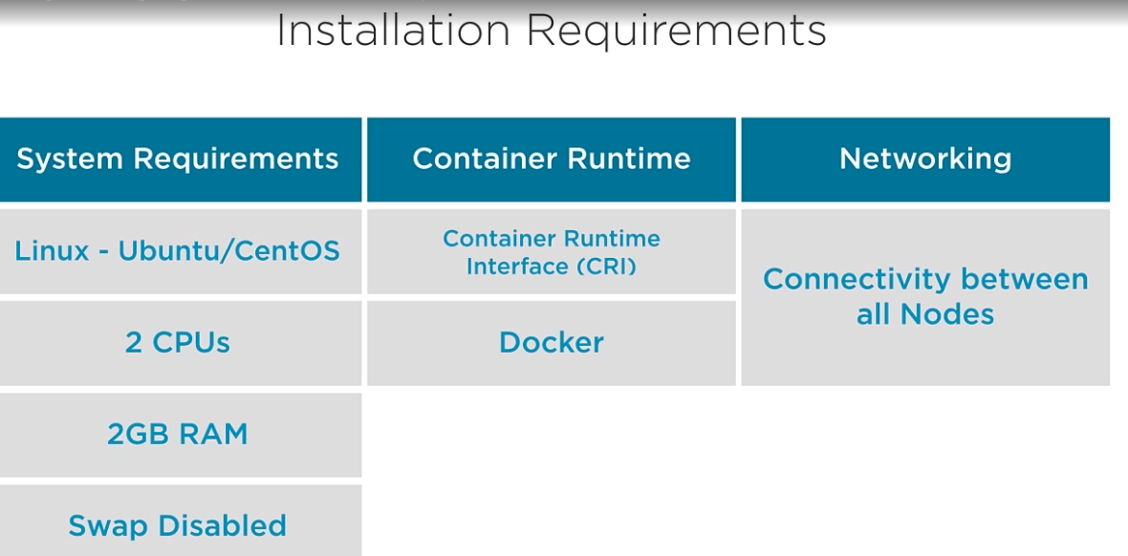

* Installation Methods:
  + Desktop
  + Kubeadm
  + Scratch – great way of learning the working behind the scenes.
  + Cloud Scenarios
* Cluster Network Ports

|  |  |  |
| --- | --- | --- |
| **Component** | **Ports** | **Used By** |
| API server | 6443 | All |
| Etcd | 2379-2380 | Etcd/API server |
| Scheduler | 10251 | Self (localhost) |
| Controller Manager | 10252 | Self (localhost) |
| Kubelet | 10250 | Control plane |
| Node Port Service | 30000-32767 | ALL |

* Node Port is the service which exposes our services on ports hosted on individual nodes.

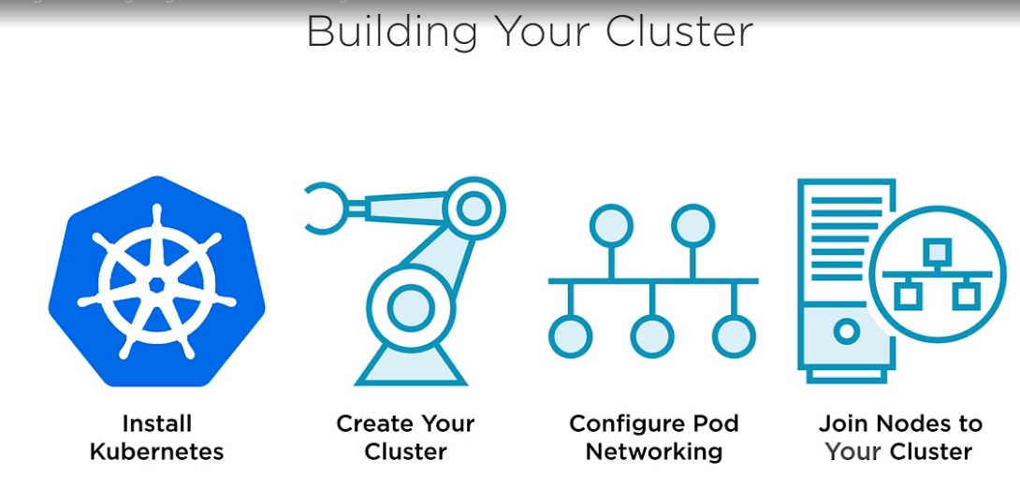

* 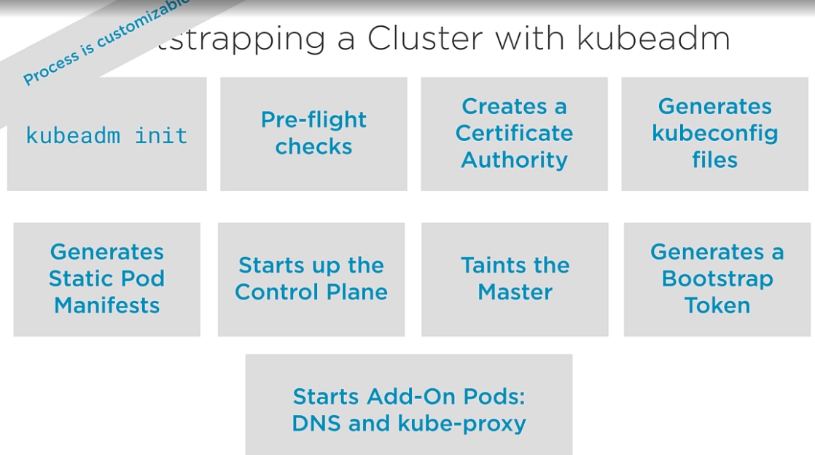
* Installing as kubeadm:
  + Required Packages:
    - Kubelet
    - Kubeadm
    - Kubectl
    - Container Runtime
  + Operating System: CentOs , Cloud Provider : GCP
  + Open the network ports in firewall rules on the cloud.
  + sudo su #switch to root user

swap off –a #turn swap off

setenforcing 0 #enforcing mode for selinux

vi /etc/sysconfig/selinux #mark SELINUX=disabled

or sed -i --follow-symlinks 's/SELINUX=enforcing/SELINUX=disabled/g' /etc/sysconfig/selinux

reboot #restart the machine

#open the ports on the master

firewall-cmd --permanent --add-port=6433/tcp #port for API server

firewall-cmd --permanent --add-port=2379-2380/tcp #port for etcd  
firewall-cmd --permanent --add-port=10250/tcp #port for kubelet

firewall-cmd --permanent --add-port=10251/tcp #port for scheduler

firewall-cmd --permanent --add-port=10252/tcp #port for controller

firewall-cmd --permanent --add-port=30000-32767/tcp #port for node

firewall-cmd –reload #reloads the firewall

modprobe br_netfilter #add the netfilter module required for communication for pods between cluster

echo '1' > /proc/sys/net/bridge/bridge-nf-call-iptables  
#configure kubernetes repo on the machine.

sudo vi /etc/yum.repo.d/kubernetes.repo

#insert below in the file

[kubernetes]

name=Kubernetes

baseurl=https://packages.cloud.google.com/yum/repos/kubernetes-el7-x86_64

enabled=1

gpgcheck=1

repo_gpgcheck=1

gpgkey=https://packages.cloud.google.com/yum/doc/yum-key.gpg

https://packages.cloud.google.com/yum/doc/rpm-package-key.gp

#or run below cat command and enter values one by one

cat <<EOF > /etc/yum.repos.d/kubernetes.repo

> [kubernetes]

> name=Kubernetes

> baseurl=https://packages.cloud.google.com/yum/repos/kubernetes-el7-x86_64

> enabled=1

> gpgcheck=1

> repo_gpgcheck=1

> gpgkey=https://packages.cloud.google.com/yum/doc/yum-key.gpg

> https://packages.cloud.google.com/yum/doc/rpm-package-key.gpg

> EOF

* + Next is to install kubeadm and docker on the machine

yum -y install docker kubeadm  
systemctl restart docker && systemctl enable docker  
systemctl restart kubelet && systemctl enable kubelet

kubeadm init #initialize kubernetes

mkdir -p $HOME/.kube #create .kube directory

sudo cp -i /etc/kubernetes/admin.conf $HOME/.kube/config #copy admin config file , required for interacting with kubectl

sudo chown $(id -u):$(id -g) $HOME/.kube/config #change owenership if kubernetes to be used as a non-root user

for configuring the networking , we will use weavenet(there are different add-ons available for configure the networking)

export kubever=$(kubectl version |base64)

kubectl apply -f "https://cloud.weave.works/k8s/net?k8s-version=$kubever"

kubectl get pods --all-namespaces

Configure Worker Nodes:

setenforce 0

vi /etc/sysconfig/selinux

getenforce

reboot

firewall-cmd --permanent --add-port 10250/tcp

firewall-cmd --permanent --add-port 10251/tcp

firewall-cmd --permanent --add-port=30000-32767/tcp

firewall-cmd --permanent --add-port=6783/tcp

firewall-cmd --reload

cat /proc/sys/net/bridge/bridge-nf-call-iptables

modprobe br_netfilter

echo '1' > /proc/sys/net/bridge/bridge-nf-call-iptables

cat <<EOF > /etc/yum.repos.d/kubernetes.repo

[kubernetes]

name=Kubernetes

baseurl=https://packages.cloud.google.com/yum/repos/kubernetes-el7-x86_64

enabled=1

gpgcheck=1

repo_gpgcheck=1

gpgkey=https://packages.cloud.google.com/yum/doc/yum-key.gpg

https://packages.cloud.google.com/yum/doc/rpm-package-key.gpg

EOF

yum -y install kubeadm docker

systemctl restart docker && systemctl enable docker

kubeadm join 10.128.0.3:6443 --token b7qj7v.hurghfjrpkmrvybo --discovery-token-ca-cert-hash sha256:f5d773c2f9ba1fb620f61265e9a4ba5451d02a415dc2157aff580ba029a9482c