
Over all thank you sir for practical project. This can help me to learn both mern stack and power bi their linking with next js and react components how the navigate between the pages by never reloading the website
ASSIGNEMT NUMBER # 2

NAME: MUHAMMAD ANUS SALEM
ENROLLMENT NUMBER: 03-134231-038
BAHRIA UNIVERCITY LAHORE CAMPUS
PHONE NUMBER: 031061537,03136195065
DATE SUBMITIED : 15/10/2025

Task number 1:
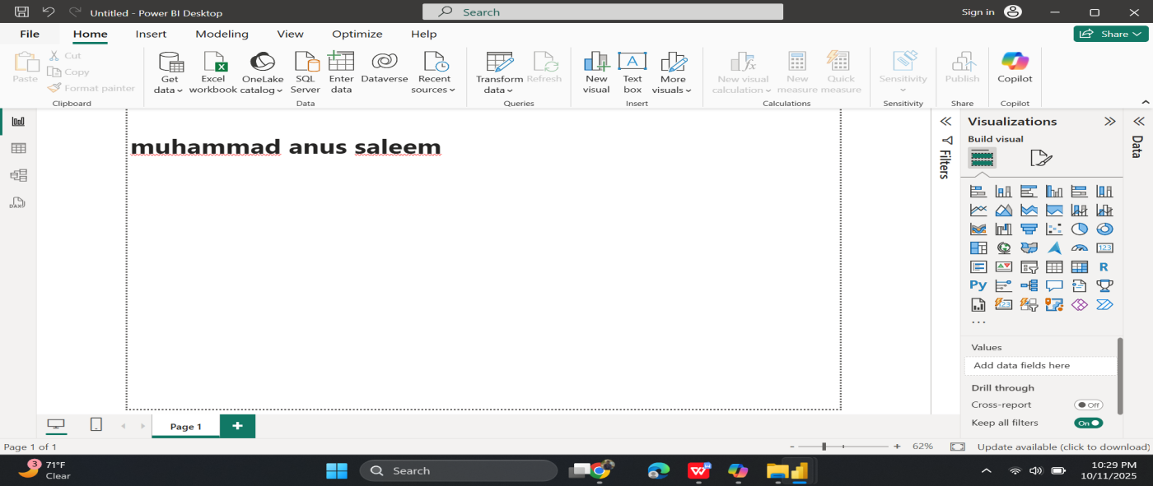
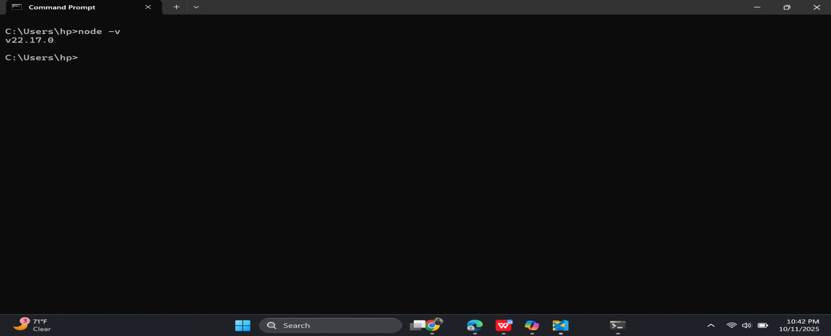
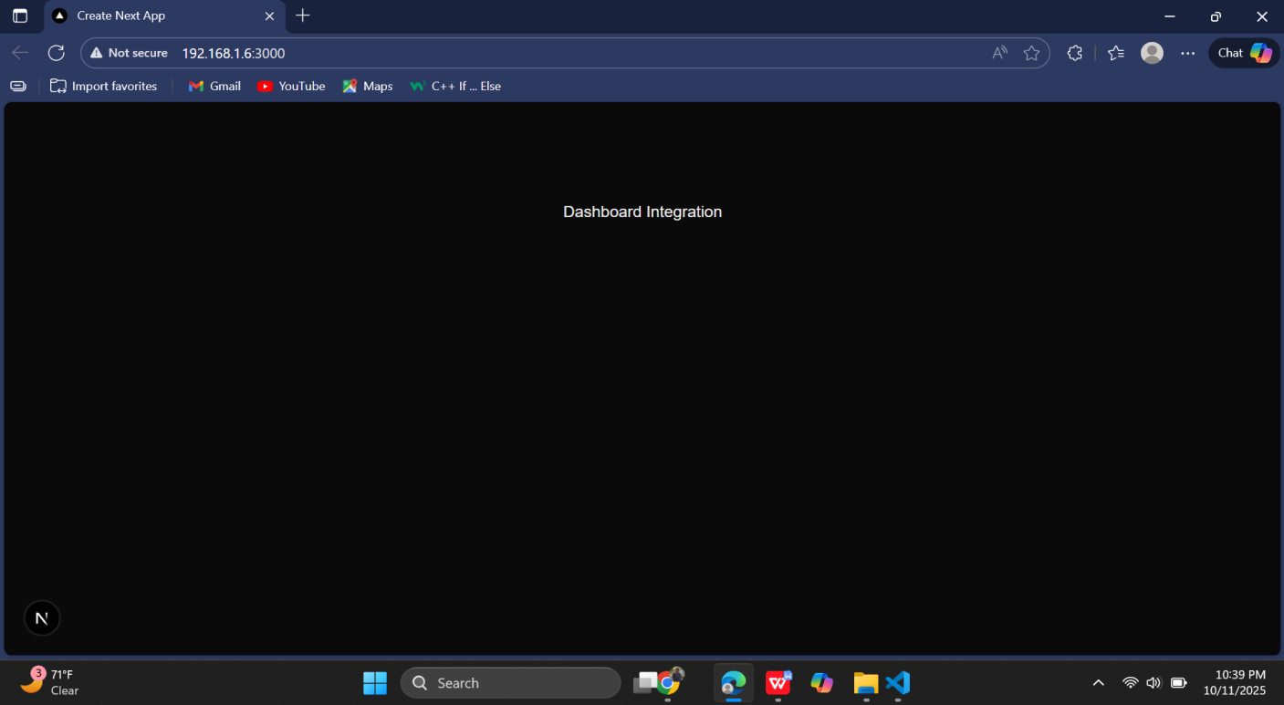

Task number # 02

💰 3️⃣ Total Profit by Individual (Bar Chart)

📈 4️⃣ Clustered Column Chart – Project Manager Metrics

Three separate visuals
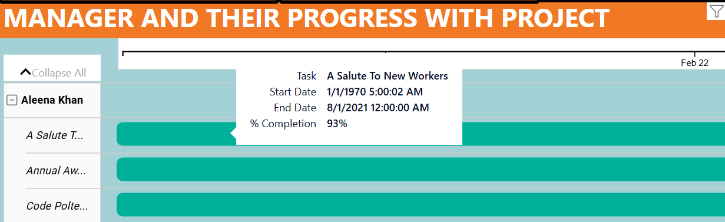
Explanation:
This shows all the tasks given to Aleena Khan on a timeline.
Each task is shown as a horizontal bar, showing how long it takes from start to end.
One of her tasks, “A Salute To New Workers”, is 93% complete, which shows she is almost done with it.
The timeline helps see progress clearly and makes it easy to check how the manager is performing over time.

Visuall number 2:
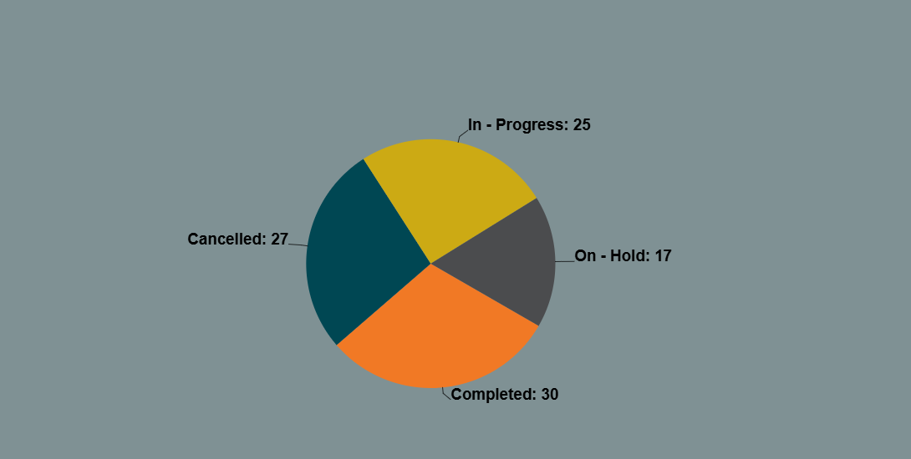

Explanation:
This chart shows how all the tasks are divided into four parts.
There are 30 completed tasks, 25 in progress, 27 cancelled, and 17 on hold.
By looking at this chart, I can easily see how my project is going. It shows which parts are doing fine and where there are problems or delays. It quickly gives an idea of the overall project health.

Visuall number 3 :
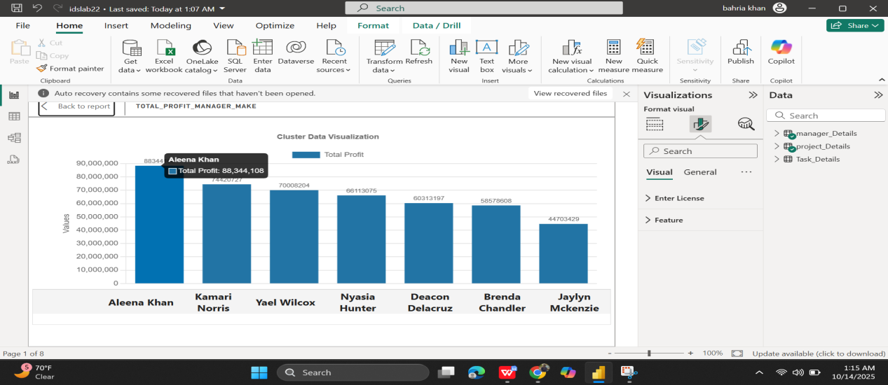

Explanation:
This bar chart compares how much profit each person made.
Aleena Khan is leading with around 88344108, while Kamari Norris and Yoel Wilcox are close behind with around 800 each.
Jaylyn Mckenzie has the lowest, about 4470.
This chart helps me understand who is contributing more financially and who might need improvement.

Visuall number 4:
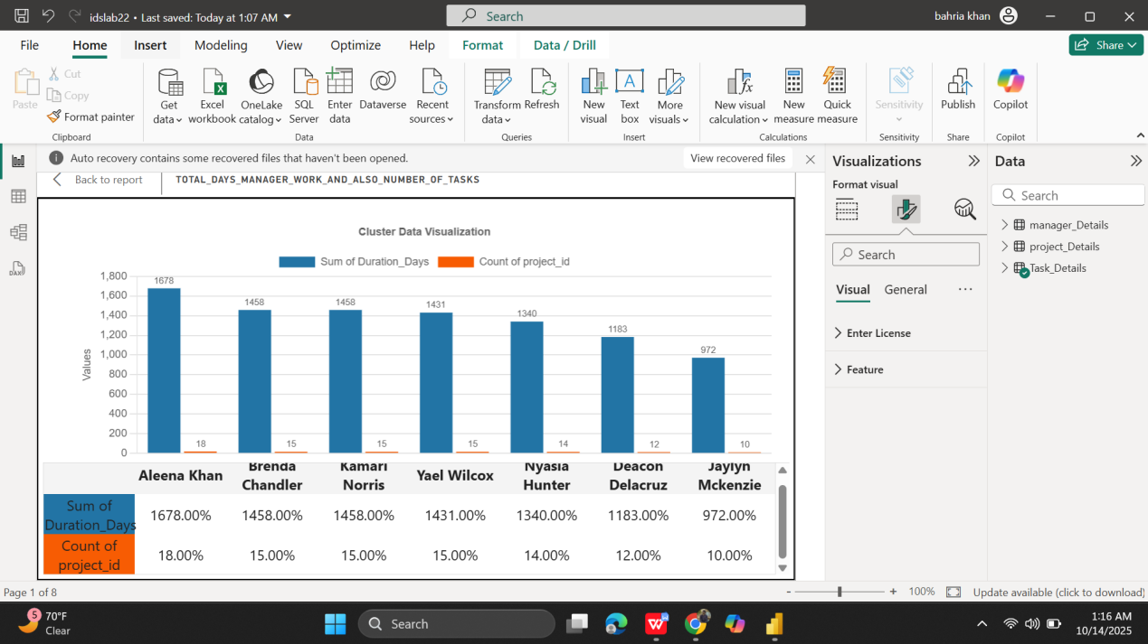
This chart compares all the project managers using three metrics:
Sum of Duration_Days (blue): how many total days each worked
Count of project_id (orange): how many projects they handled
percentage of Count of project_id (gray): their workload percentage
All the managers have almost the same workload percentage, but Aleena Khan has the highest total duration.
It clearly shows who is handling more work and spending more time on projects.

Explanation:

Slicers :

Gernal overveiw:
It shows the main stats that help understand how the organization is built and performing.
Total project: 99
→ This shows the total number of project in all departments combined. And when you hover on that you get unique informations
Department Size: 5
Tool tip:
DEPARTMENT

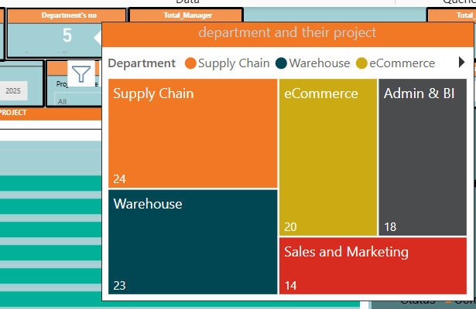

NEW PAGE
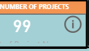

BY CLICKING THE BACK BUTTON ONCE YOU REACED THE DESTINATION MAKE YOU RETURN THE SAME PAGE

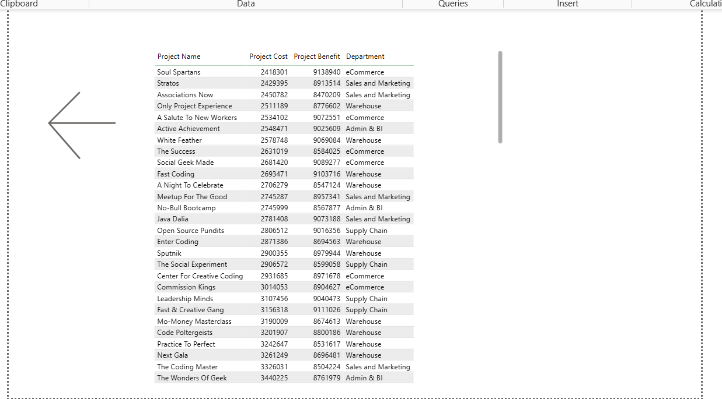
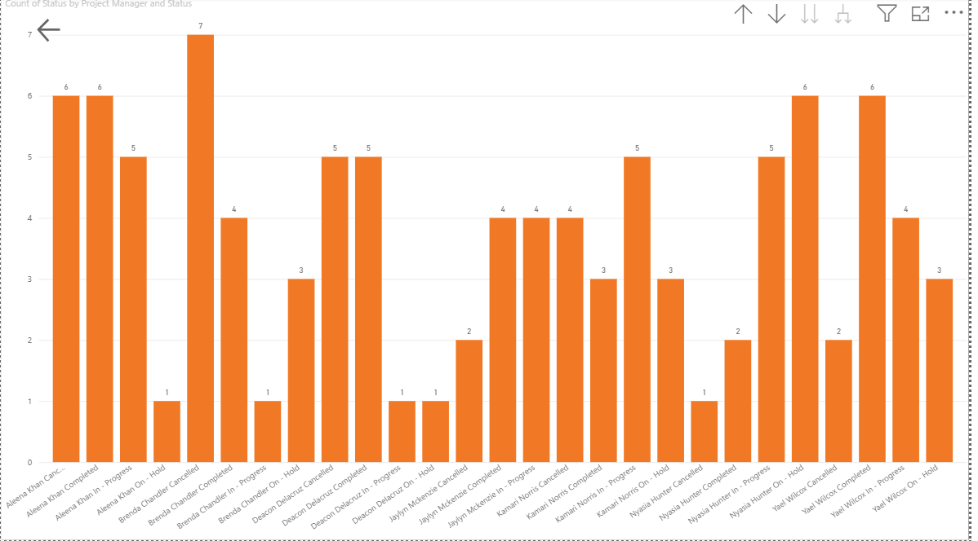
Showing detail information of managers and their success with project total number of faliure projects and so on .

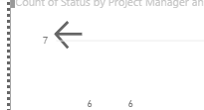

Can make you go back

COMPLETE DASHBORAD
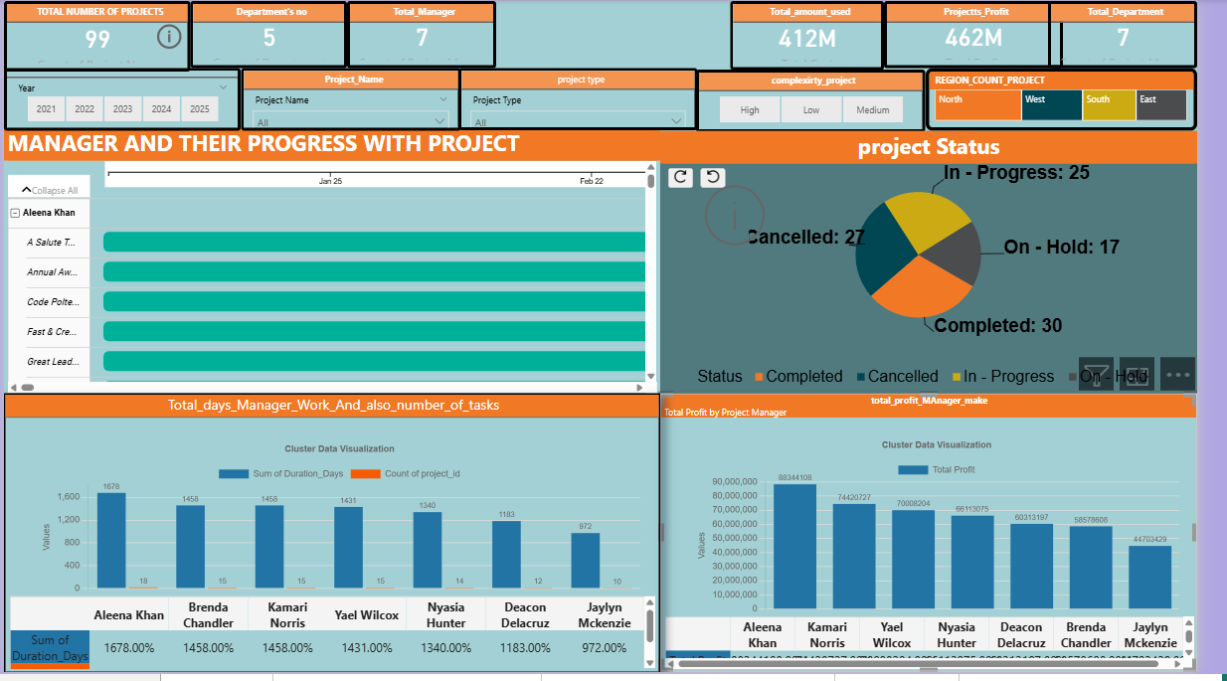

TASK NUMBER 3:
SIR YOU ALREADY MENTIONED THAT WE USE THE SAME DATASET SO HERE THE SOLOUTION IS :
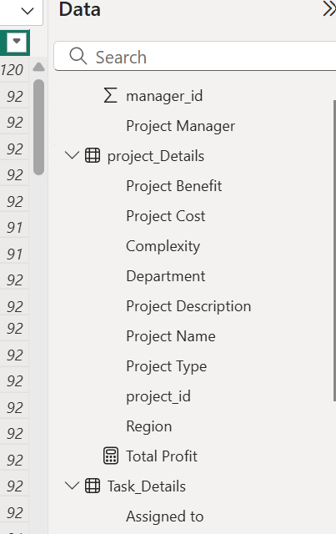 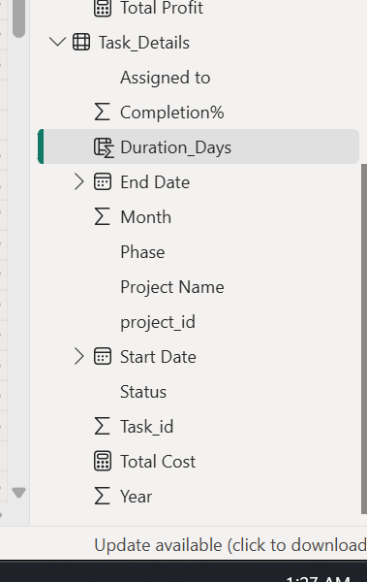\

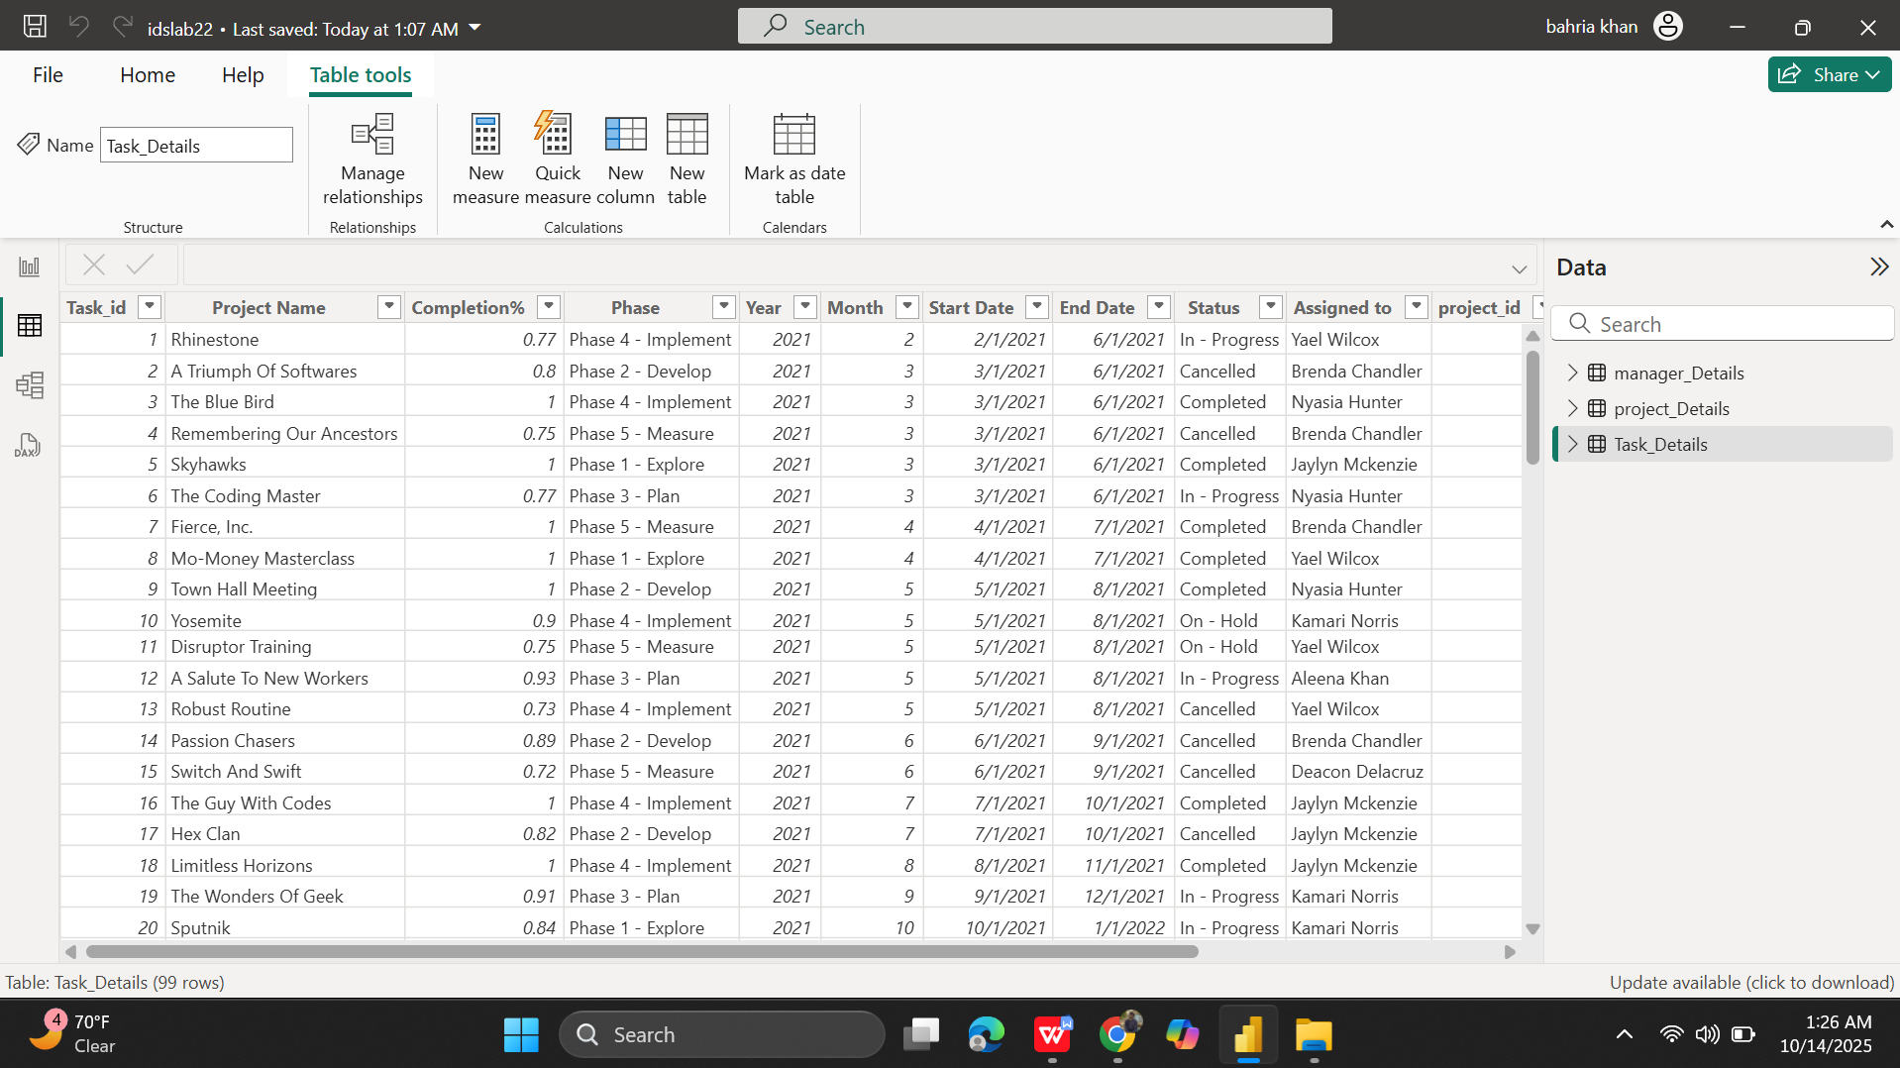
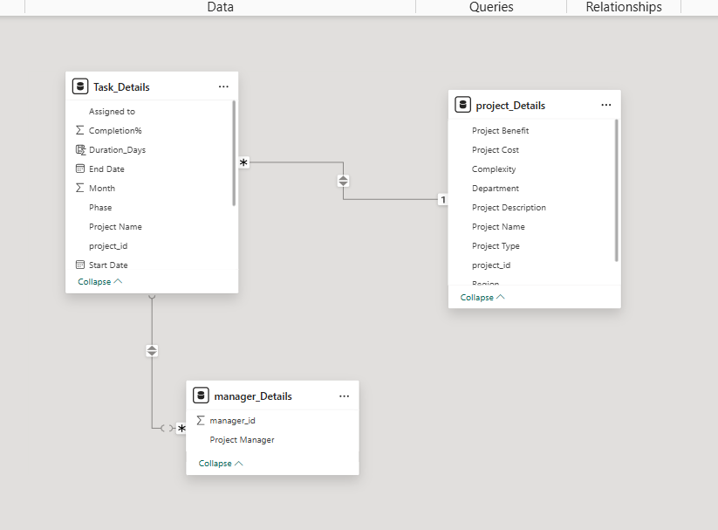
Also make the relation in both dirrection
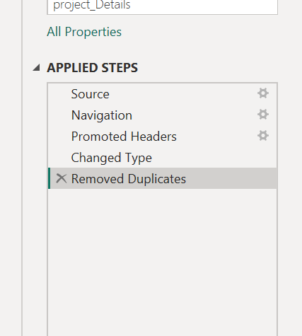

Already the data is enough and unique I don’t need to do calculations on that EXCEPT THE MANAGER TABLE WHERE I REMOVE DUPLIACTED DATA ON THE BASIS OF MANAGER KEY AND GOT THE UNIQUE DATA ON THAT COLUMN

Part 4: Embed Power BI in Next.js App

Total three components I made one for dashborad one for navbar and one for footer

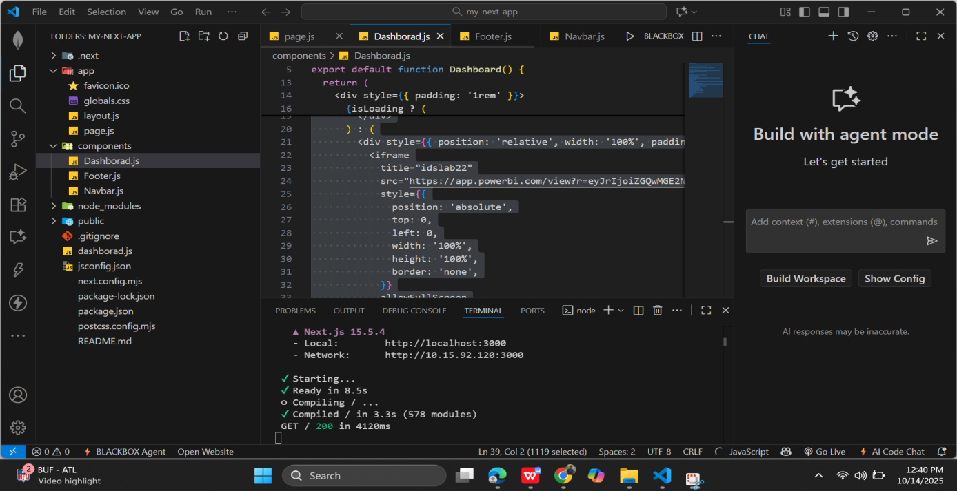

Components

Navbar code :
'use client';

import React from 'react';

export default function Navbar() {
return (
<nav style={{
backgroundColor: '#1e293b', // dark slate
color: '#ffffff',
padding: '1rem 2rem',
display: 'flex',
justifyContent: 'space-between',
alignItems: 'center',
fontFamily: 'Arial, sans-serif',
fontSize: '1rem',
boxShadow: '0 2px 4px rgba(0,0,0,0.1)',
}}>
<div style={{ fontWeight: 'bold', letterSpacing: '0.5px' }}>
Student Name:
<span style={{ marginLeft: '0.5rem', textTransform: 'uppercase' }}>
MUHAMMAD ANUS SALEEM
</span>
</div>
<div style={{ fontWeight: 'bold', letterSpacing: '0.5px' }}>
Enrollment:
<span style={{ marginLeft: '0.5rem' }}>
03-134231-038
</span>
</div>
</nav>
);
}

Dashborad code :
'use client';

import { useEffect, useState } from 'react';

export default function Dashboard() {
const [isLoading, setIsLoading] = useState(true);

useEffect(() => {
const timer = setTimeout(() => setIsLoading(false), 2000);
return () => clearTimeout(timer);
}, []);

return (
<div style={{ padding: '1rem' }}>
{isLoading ? (
<div style={{ textAlign: 'center', padding: '2rem' }}>
<p>Loading dashboard...</p>
</div>
) : (
<div
style={{
position: 'relative',
width: '100%',
overflow: 'hidden',
height: '80vh', // Make this large enough so content shows
}}
>
<div
style={{
transform: 'scale(0.44)', // Zoom level
transformOrigin: 'top left',
width: `${100 / 0.44}%`,
height: `${100 / 0.44}%`,
position: 'absolute',
top: 0,
left: 0,
}}
>
<iframe
title="powerbi-dashboard"
src="https://app.powerbi.com/view?r=eyJrIjoiYjYzOTkxNjctMzM2NS00MjJmLWIzM2EtZDYwMGQ1MmM3N2NjIiwidCI6IjFmYzhkNGZiLWQyMmEtNDY3Zi1iYzA0LWFiOGFjYmFjZWFkYiIsImMiOjl9"
style={{
width: '100%',
height: '100%',
border: 'none',
}}
allowFullScreen
/>
</div>
</div>
)}
</div>
);
}

Footer code:

'use client';

import React from 'react';

export default function Footer() {
return (
<footer style={{
backgroundColor: '#1e293b', // dark slate
color: '#ffffff',
padding: '1rem 2rem',
textAlign: 'center',
fontFamily: 'Arial, sans-serif',
fontSize: '0.9rem',
marginTop: '2rem',
borderTop: '1px solid #334155',
}}>
<p>
© {new Date().getFullYear()} MUHAMMAD ANUS SALEEM — Enrollment: 03-134231-038
</p>
<p style={{ marginTop: '0.5rem', fontStyle: 'italic', color: '#cbd5e1' }}>
“Learning never exhausts the mind — it only ignites it.”
</p>
</footer>
);
}

App/page.js code:
import Head from "next/head";
import Dashboard from "@/components/Dashborad";
import Navbar from "@/components/Navbar";
import Footer from "@/components/Footer";

export default function Home() {
return (
<>
<Head>
<title>Dashboard</title>
<meta name="description" content="Student Dashboard for Muhammad Anus Saleem" />
</Head>

<main>
<Navbar />
<Dashboard />
<Footer />
</main>
</>
);
}

Dyanmic rezing also covered in it :

Indifferent resolutions: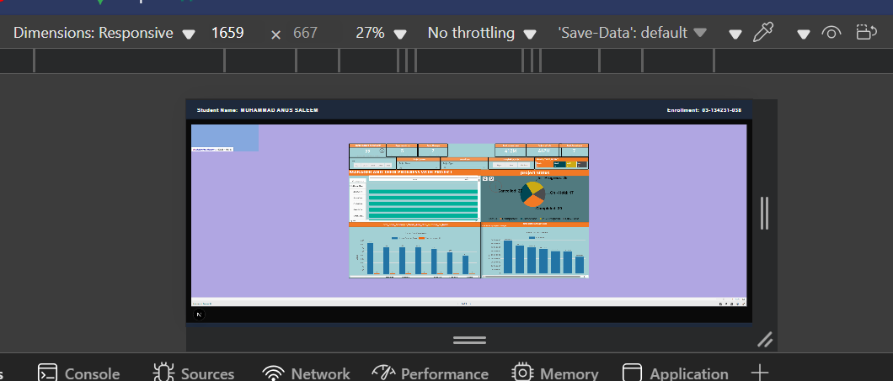

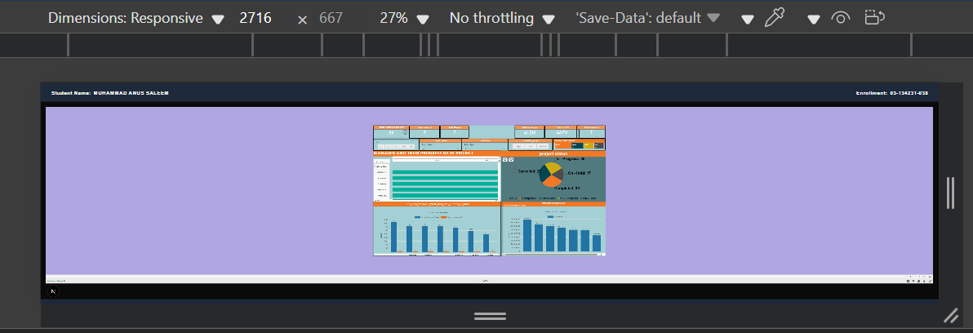

Loding state:

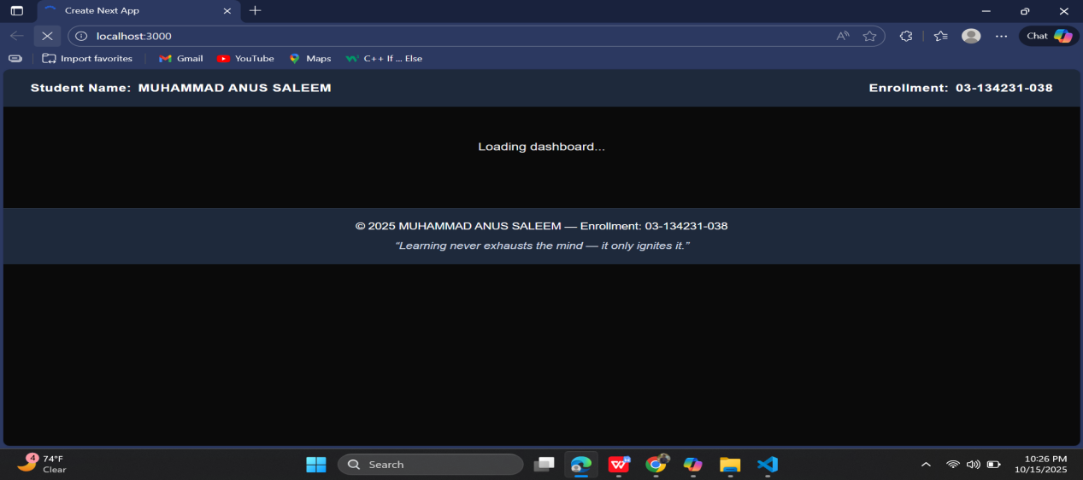

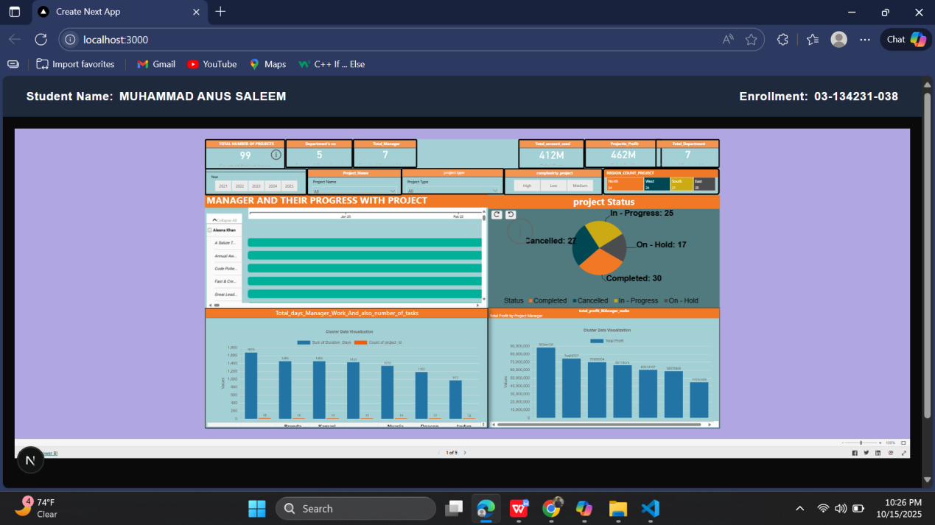

Also in project I don’t upload the node module file because according to project every one download it know I about node_modules/ — it's huge and can be regenerated.
Instead, include package-lock.json or yarn.lock for reproducibility.
To run it, I do this:
npm install
npm run dev
Then I open my browser and go to http://localhost:3000 to see my dashboard live.
Every time I make changes in code or update the Power BI link, I just restart it with npm run dev, and it shows the latest version.

Part 5:

I already make the gif in folder you can easily find

1: Update or Replace the Power BI Dashboard
I connected Power BI with my Next.js app so it shows the dashboard properly.
When I want to update or replace it, I do it like this:
- I open Power BI Service and go to my dashboard.
- Click File → Publish to web (embed) and copy the new link.
- Then I open my Next.js file (Dashboard.js) and replace the old link inside the iframe like this:
<iframe
width="100%"
height="600"
src="https://app.powerbi.com/view?r=NEW_EMBED_LINK"
frameBorder="0"
allowFullScreen
></iframe>
Save it and run the project again — and my new dashboard shows up instantly.
At first it was confusing, but now it’s easy for me because I understand how Power BI connects with the web app.

2: Add New Data Sources to Power BI
This one took some effort too because I had to make sure everything connects properly.
Here’s how I do it:
- I open my .pbix file in Power BI Desktop.
- Click Get Data, pick the source (like Excel, CSV, or SQL), and load it.
- Go to Model View and connect new tables with existing ones using relationships.
- Refresh the data and check if visuals are updating correctly.
- Then I re-publish and copy the new embed link again for my app.
After some testing, it worked smoothly. I learned how to handle multiple data sources without breaking the visuals.

3:Run the Next.js App Locally
I only run my app locally, not deployed online.
To run it, I do this:
npm install
npm run dev
Then I open my browser and go to http://localhost:3000 to see my dashboard live.
Every time I make changes in code or update the Power BI link, I just restart it with npm run dev, and it shows the latest version.

Part 6:
- When I started embedding Power BI inside my Next.js app, it looked easy at first, but it wasn’t. The main problem I faced was making the dashboard show properly through the iframe. Sometimes it didn’t load, or it messed up the size and layout. I had to keep testing the code again and again to make it fit perfectly. Also, whenever I updated my Power BI report, I had to replace the embed link in my code manually — that part took some time to understand.
- During this project, I learned a lot about frontend development. I worked with React components, learned how Next.js helps to handle pages and routing easily, and how Node.js runs the app locally. It made me understand how frontend and backend connect together. Before this, I didn’t know much about how React components are structured, but now I can create, update, and reuse them properly. Running the app using npm run dev and seeing my Power BI dashboard appear live felt amazing 🔥.
- I also worked on linking Power BI with my web app. Understanding how to connect visuals from Power BI into a Next.js page was new for me. It took me some effort to make it smooth and look good on the frontend. I also learned a bit about Power BI data relationships — how different tables can connect so visuals stay updated — but my main focus was on the frontend and embedding part.
- About iframe vs SDK, I used iframe because it’s simple and quick. You just copy the link and paste it into your React component, and it works. The SDK gives more control and interactivity, but it’s more advanced and needs setup with Power BI APIs. Maybe later, when I get better with Node.js and APIs, I’ll try that method too.
- Overall, this project taught me real development flow — connecting React, Next.js, Node.js, and Power BI all together.

