

# Methodology

1. **The benchmarking exercise clusters an array of well-established institutional indicators into nine institutional families**. There is no agreed theoretical framework that could guide the categorization process. The categorization process faces a trade-off between aggregation and narrowness, where the categories have to be broad enough to comprehensively capture the main indicators and policy spaces but also focused enough to guide an in-depth qualitative analysis as well as a productive dialogue in the country. The proposed categories, described in more detail in Appendix A, are based on an effort to balance this trade-off and capture key functions that different institutions perform (Figure 1): Anticorruption, transparency, and accountability; Business environment and trade; Financial market; Labor market; Justice; Political; Public sector; Social; and SOE corporate governance. The institutional benchmarking uses more than 80 indicators collected from a variety of data sources in order to provide a snapshot of governance and institutions according to the latest available international indicators, as of 2020. Details on the indicators used for the institutional benchmarking are provided in Appendix B.

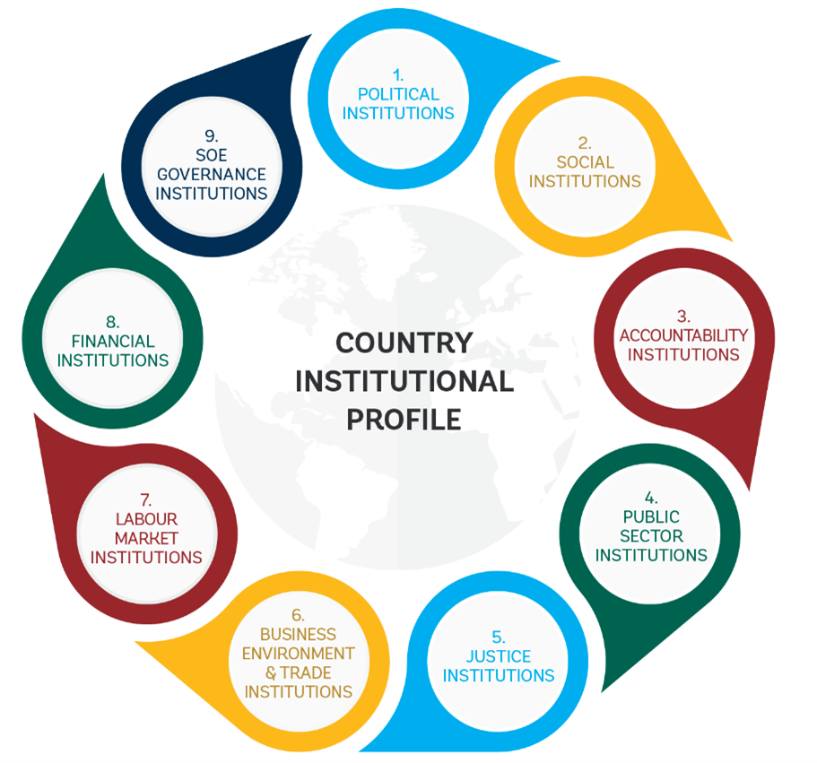

Institutional families

1. **The benchmarking exercise employs the “closeness to frontier” (CTF) methodology to standardize and compare a wide range of institutional indicators**. The CTF methodology facilitates the assessment of a country’s performance across institutional indicators by comparing it with the “global frontier,” which corresponds to the world’s best performer. For each indicator, a country’s performance is rescaled on a 0–1 scale using a linear transformation (worst–y)/(worst–frontier), where 1 represents the best performer and 0 the worst performer. The higher the score, the closer a country is to the best performer and the lower the score, the closer a country is to the worst performer, and more distant to the frontier. The best and worst performers are identified using available data from the global sample (i.e., considering all countries for which data are available) across the last five years. In the case of Algeria, we use indicators for 2014–20 (or a shorter period if data are not available). Next, for each institutional category, the CTF scores obtained for each indicator are aggregated through simple averaging into one aggregated CTF score. This captures the overall performance for a category relative to the “global frontier.” Performance across the indicators will help identify priority areas for institutional strengthening.
2. **Relative institutional weaknesses and strengths are defined based on the percentile in which the specific indicator belongs, relative to the set of comparator countries**. Traffic light coloring indicates where the largest institutional gaps exist relative to the comparator countries, based on the following categories (Figure 2): “weak institution” (bottom 25 percent—red), “emerging institution” (25–50 percent—yellow), and “advanced institution” (top 50 percent—green). For Algeria, the chosen set of comparator countries include: Bahrain, Egypt, Iraq, Jordan, Kuwait, Lebanon, Libya, Mauritania, Morocco, Oman, Qatar, Saudi Arabia, Somalia, Sudan, Syria, Tunisia, United Arab Emirates, Yemen The comparators were chosen based on **[… FOR TEAMS TO COMPLETE]**.

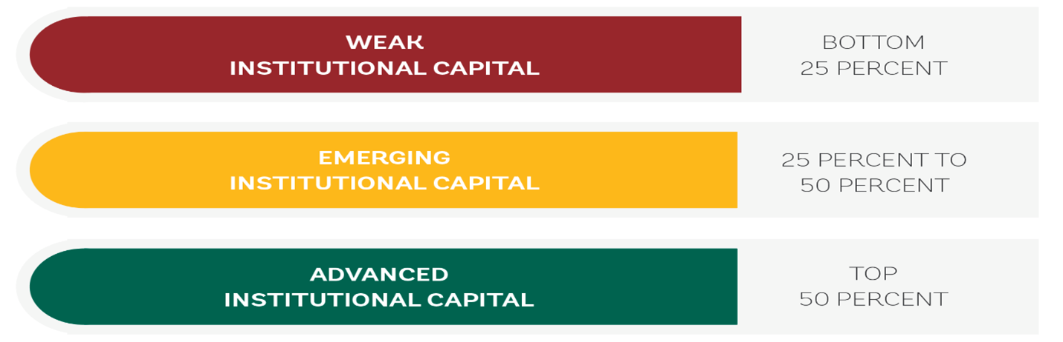

Traffic light coloring, as used in the institutional benchmarking exercise

# Country overview

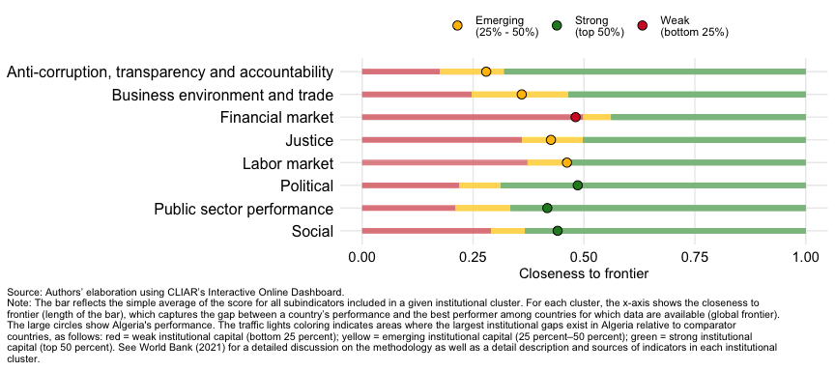

# Institutional families

## Strong institutional capital: Political, Social, Public sector performance

### Political

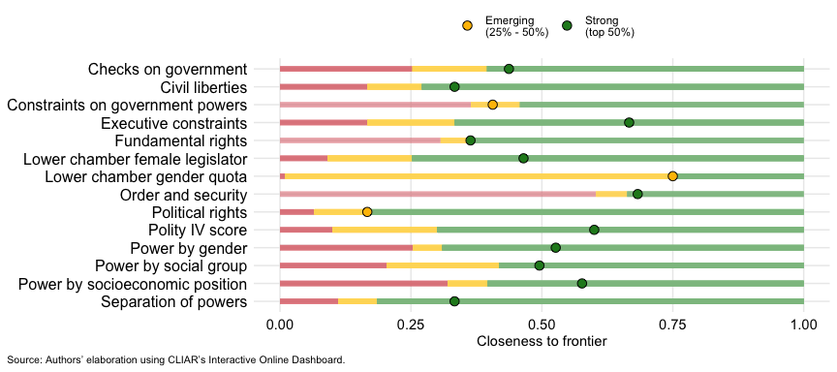

### Social

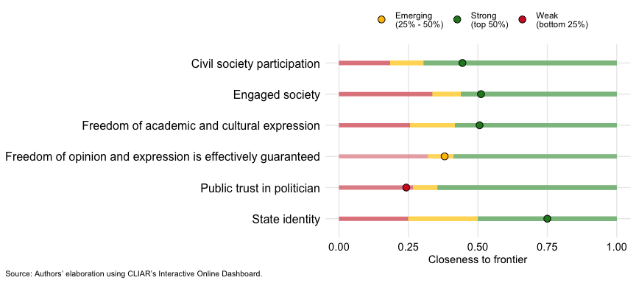

### Public sector performance

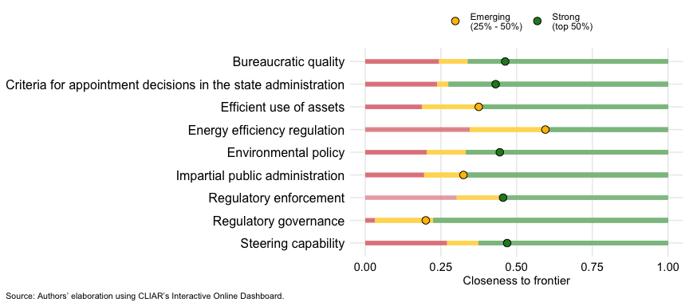

## Emerging institutional capital: Anti-corruption, transparency and accountability, Justice, Labor market, Business environment and trade

### Anti-corruption, transparency and accountability

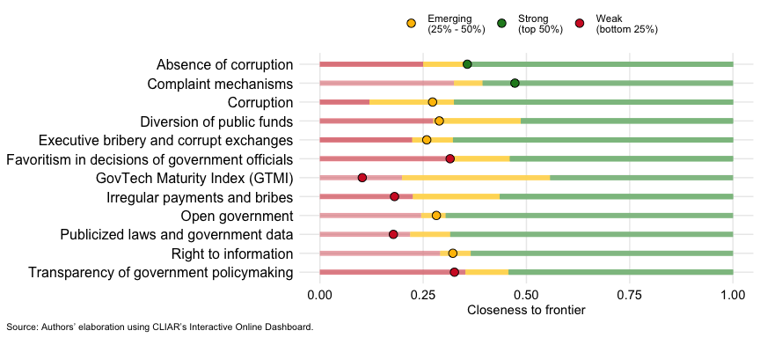

### Justice

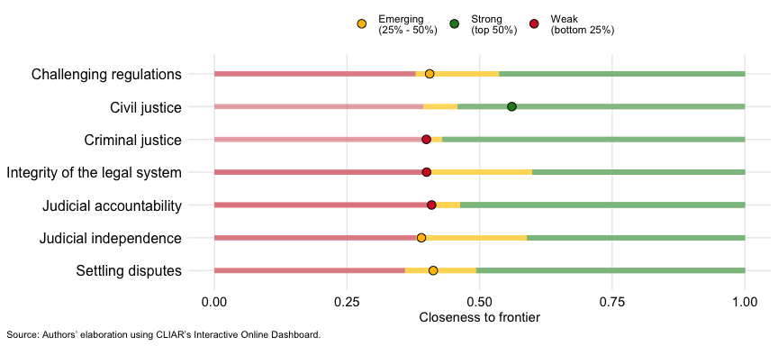

### Labor market

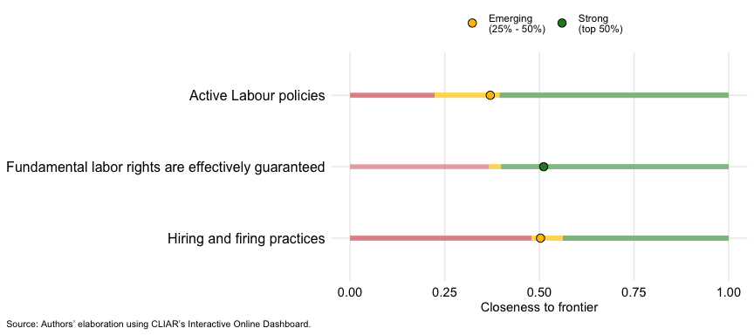

### Business environment and trade

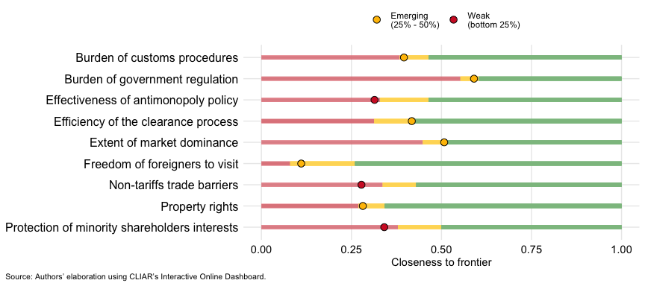

## Weak institutional capital: Financial market

### Financial market

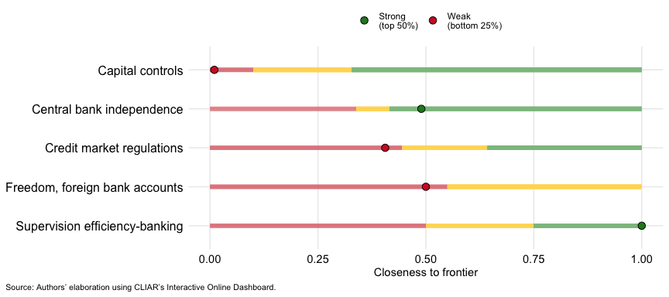

# Appendix A - Institutional families

**Political institutions** relate to the political regime and mechanisms that regulate relationships between different parts of the government (electoral rules, political parties, and rules that delineate the functions of a government), including institutions that facilitate participation of vulnerable groups (such as ethnic representation and gender quotas). The indicators included in this category assess the extent to which certain institutional functions and mechanisms are in place, including constraints on government powers, political stability, voting rights, political competition, civil liberties and fundamental rights, and distribution of political powers across gender, social groups, and socioeconomic positions. Social institutions refer to concepts such as social norms, beliefs, trust, and civic cooperation, and coincide largely with informal institutions. The literature on social institutions also studies social capital, civic engagement, and social networks.

**Anti-corruption, transparency, and accountability institutions** capture whether the existing institutional setting is effective in holding public actors accountable, promoting integrity across the public administration, and curbing corruption. These include e-government and Open Data initiatives, citizens’ access to information, and the government’s efforts, as well as citizens’ active participation in the fight against corruption.

**Public sector institutions** correspond to laws, regulations, and policies that deal with the design, implementation, and enforcement of regulations that organize and guide state and public service delivery. Government effectiveness can be compromised by limited coordination among agencies, the weak role of regulatory agencies, competing legislation, lack of monitoring activities, or poor internal management capacity. “Center of government” refers to the institution or group of institutions that supports a country’s chief executive (president or prime minister) in leading the political and technical coordination of critical government actions, strategic planning, monitoring of performance, promoting innovation, and communicating on the government’s decisions and achievements. These institutions are becoming increasingly relevant in a context where an increasing number of cross-cutting issues demand “whole-of-government” approaches and coherent responses. Justice institutions vary from public- or state-devised institutions, to private institutions, which are realized through contracts. Justice institutions are important across a vast range of issues, including property rights, enforcement of legislation, the effectiveness and independence of the judicial system, and impartial enforcement of laws by courts and other actors.

**Business environment and trade institutions** overlap — in part — with justice institutions and refer to rules that govern the market, such as the legal system, enforcement of property rights, trade and firm regulations, regulatory governance, credit markets, business and labor market regulations, and so on. Indirectly, indicators included in this cluster (such as measures burden on custom procedures, nontariff trade barriers, and business regulations) provide an interesting proxy for the extent to which institutions are “captured” by narrow interests.

**Labor market institutions** describe the laws and regulations and organizations that shape the labor market and the relationships between workers and employers, including employment security for permanent and temporary workers, employees covered by collective agreements, organization of workers into unions, and the legislative mandate on minimum wages.

**Financial market institutions** refer to the rules governing the banking and financial sectors as well as the oversight and monitoring of these sectors by public bodies, including credit market regulations, the banking and financial market supervisory authorities, or regulation of competition. This cluster also considers the constraints faced by private actors, such as limitations to ownership of foreign bank accounts and barriers to access to credit, and the degree of state intervention, for example, through direct or indirect public ownership of banks and other financial firms.

**Governance of state-owned enterprises (SOEs)** captures whether the state has a predominant role in service delivery through SOEs, such as in the utility sectors. Rather than passing judgement on whether state intervention in service delivery is a desirable feature or not, it considers whether the state operates according to market rules and in equal terms relative to other private actors in the same market. The quality of these types of institutions depends on how tariffs are set, whether there are laws and regulations that limit competition, the degree of SOEs’ autonomy in making market-related decisions, and whether SOEs are required to provide clear and transparent information to customers on tariffs and consumption.

# Appendix B - Indicator definitions

## Anti-corruption, transparency and accountability

| Indicator | Description | Source |
| --- | --- | --- |
| Absence of corruption | Government officials in the executive branch do not use public office for private gain; Government officials in the judicial branch do not use public office for private gain; Government officials in the police & the military do not use public office for private gain; Government officials in the legislative branch do not use public office for private gain. | World Justice Project, Rule of Law |
| Open government | Publicized laws & government data; Right to information; Civic participation; Complaint mechanisms. | World Justice Project, Rule of Law |
| Complaint mechanisms | Measures whether people are able to bring specific complaints to the government about the provision of public services or the performance of government officers in carrying out their legal duties in practice, and how government officials respond to such complaints. Coded from 0 to 1, with higher scores indicating stronger mechanisms. | World Justice Project - Rule of Law |
| Publicized laws and government data | Measures whether basic laws and information on legal rights |  |

are publicly available, presented in plain language, and made accessible in all languages used in the country or jurisdiction. It also measures the quality and accessibility of information published by the government in print or online, and whether administrative regulations, drafts of legislation, and high court decisions are made accessible to the public in a timely manner |World Justice Project - Rule of Law | |Right to information |Measures whether requests for information held by a government agency are granted, whether these requests are granted within a reasonable time period, if the information provided is pertinent and complete, and if requests for information are granted at a reasonable cost and without having to pay a bribe. It also measures whether people are aware of their right to information, and whether relevant records are accessible to the public upon request. Coded from 0 to 1, with higher scores indicating stronger rights. |World Justice Project - Rule of Law | |Irregular payments and bribes |In your country, how common is it for firms to make undocumented extra payments or bribes connected with (a) imports and exports; (b) public utilities; (c) annual tax payments; (d) awarding of public contracts and licenses; (e) obtaining favorable judicial decisions? [1 = very common; 7 = never occurs]. |World Economic Forum Global Competitiveness Index | |Transparency of government policymaking |In your country, how easy is it for businesses to obtain information about changes in government policies and regulations affecting their activities? [1 = extremely difficult; 7 = extremely easy] |World Economic Forum Global Competitiveness Index | |Favoritism in decisions of government officials |In your country, to what extent do government officials show favoritism to well-connected firms and individuals when deciding upon policies and contracts? [1 = show favoritism to a great extent; 7 = do not show favoritism at all] |World Economic Forum Global Competitiveness Index | |GovTech Maturity Index (GTMI) |Measures key aspects in the four focus areas of digital transformation in the public sector: core government systems, public service delivery, citizen engagement, and GovTech enablers. |World Bank | |Corruption |This is an assessment of corruption within the political system. _x000B_The most common form of corruption met directly by business is financial corruption in the form of demands for special payments and bribes connected with import and export licences, exchange controls, tax assessments, police protection or loans. _x000B_Although this measure takes such corruption into account, it is more concerned with actual or potential corruption in the form of excessive patronage, nepotism, job reservations, favour-for-favours , secret party funding and suspiciously close ties between politics and business. |V-Dem, Variety of Democracy database | |Executive bribery and corrupt exchanges |Wide and independent public deliberations when important policy changes are being considered. 0 represents countries where public deliberation is never, or almost never allowed; 5 represents countries where a large numbers of non-elite groups as well as ordinary people tend to discuss major policies among themselves, in the media, in associations or neighborhoods, or in the streets, and grass-roots deliberation is common and unconstrained. |V-Dem, Variety of Democracy database | |Budget documentation |PI-5 Budget Documentation. |Public Expenditure Financial Accontability | |External audit |PI-30 External audit. Based on Audit coverage and standards, Submission of audit reports to the legislature, External audit follow-up, Supreme Audit Institution, independence |Public Expenditure Financial Accontability | |Public access to information |PI-9 Public access to information. |Public Expenditure Financial Accontability | |Open Data Barometer |It measures how governments are publishing and using open data for accountability, innovation and social impact (readiness and impact). |Open Data Barometer and World Wide Web Foundation | |Diversion of public funds |In your country, how common is diversion of public funds to companies, individuals, or groups due to corruption? [1 = very commonly occurs; 7 = never occurs] |Global State of Democracy | |Global corruption barometer |Transparency International’s Global Corruption Barometer (TIGBC) is the largest world-wide public opinion survey on corruption. It addresses people’s direct experiences with bribery and details their views on corruption in the main institutions in their countries. Significantly, the Barometer also provides insights into how willing and ready people are to act to stop corruption. |Global Corruption Barometer | |Corruption as a major constraint |Percentage of firms identifying corruption as a “major” or “very severe” obstacle. |Enterprise Surveys |

## Justice

| Indicator | Description | Source |
| --- | --- | --- |
| Civil justice | People can access & afford civil justice; Civil justice is free of discrimination; Civil justice is free of corruption; Civil justice is free of improper government influence; Civil justice is not subject to unreasonable delay; Civil justice is effectively enforced; Alternative dispute resolution mechanisms are accessible, impartial, and effective. | World Justice Project, Rule of Law |
| Criminal justice | Criminal investigation system is effective; Criminal adjudication system is timely and effective; Correctional system is effective in reducing criminal behavior; Criminal justice system is impartial; Criminal justice system is free of corruption; Criminal justice system is free of improper government influence; Due process of the law & rights of the accused. | World Justice Project, Rule of Law |
| Judicial independence | In your country, to what extent is the judiciary independent from influences of members of government, citizens, or firms? [1 = heavily influenced; 7 = entirely independent] | World Economic Forum Global Competitiveness Index |
| Challenging regulations | In your country, how easy is it for private businesses to challenge government actions and/or regulations through the legal system? [1 = extremely difficult; 7 = extremely easy] | World Economic Forum Global Competitiveness Index |
| Settling disputes | In your country, how efficient is the legal framework for private businesses in settling disputes? [1 = extremely inefficient; 7 = extremely efficient] | World Economic Forum Global Competitiveness Index |
| Judicial accountability | 0 represents countries where judges found responsible for serious misconduct, are never removed from their posts or otherwise disciplined; 4 represents countries where judges found responsible for serious misconduct, are always removed from their posts or otherwise disciplined. | V-Dem, Variety of Democracy database |
| Integrity of the legal system | It assesses the strength and impartiality of the legal system, and the popular observance of the law (based on the International Country Risk Guide Political Risk Component I for Law and Order). | Fraser Institute |
| Courts system as a major constraint | Percent of firms identifying the courts system as a major constraint | Enterprise Surveys |

## Political

| Indicator | Description | Source |
| --- | --- | --- |
| Constraints on government powers | Government powers are effectively limited by the legislature; Government powers are effectively limited by the judiciary; Government powers are effectively limited by independent auditing and review; Government officials are sanctioned for misconduct; Government powers are subject to non-governmental checks; Transition of power is subject to the law. | World Justice Project, Rule of Law |
| Fundamental rights | Equal treatment & absence of discrimination; The right to life & security of the person is effectively guaranteed; Due process of the law and rights of the accused; Freedom of opinion & expression is effectively guaranteed; Freedom of belief & religion is effectively guaranteed; Freedom from arbitrary interference with privacy is effectively guaranteed; Freedom of assembly & association is effectively guaranteed; Fundamental labor rights are effectively guaranteed. | World Justice Project, Rule of Law |
| Order and security | Crime is effectively controlled; Civil conflict is effectively limited; People do not resort to violence to redress personal grievances. | World Justice Project, Rule of Law |
| Checks on government | Besides regular elections, the exercise of political power needs to be continuously subjected to scrutiny. If the other branches of government (the legislature and the judiciary) or a critical and pluralistic press do not check executive power, they are more prone to be abused for private gain and to biased political decision-making and implementation. Vertical accountability through elections should be supplemented by horizontal accountability between elections. The three subattributes were aggregated into the checks on government index using BFA. | V-Dem, Variety of Democracy database |
| Executive constraints | Question: How routinely do members of the executive (the head of state, the head of government and cabinet ministers) or their agents grant favours in exchange for bribes or other material inducements? Responses: 0: It is routine and expected._x000B_ 1: It happens more often than not in dealings with the executive._x000B_ 2: It happens but is unpredictable; those dealing with the executive find it hard to predict when an inducement will be required. 3: It happens occasionally but is not expected._x000B_ 4: It never, or hardly ever, happens. | V-Dem, Variety of Democracy database |
| Lower chamber female legislator | Share of female representatives in the lower (or unicameral) chamber of the legislature. | V-Dem, Variety of Democracy database |
| Lower chamber gender quota | 0 represents countries with no national level gender quota and 4 represents countries where there are reserved seats in the legislature for women. | V-Dem, Variety of Democracy database |
| Power by gender | 0 represents countries where men have a near-monopoly on political power and 4 represents countries where men and women have roughly equal political power. | V-Dem, Variety of Democracy database |
| Power by social group | Social group is differentiated within a country by caste, ethnicity, language, race, region, religion, or some combination thereof. It does not include identities grounded in sexual orientation or socioeconomic status. 0 represents countries where political power is monopolized by one social group comprising a minority of the population, and 4 represents countries where all social groups have roughly equal political power or there are no strong ethnic, caste, linguistic, racial, religious, or regional differences to speak of. | V-Dem, Variety of Democracy database |
| Power by socioeconomic position | 0 represent countries where wealthy people enjoy a virtual monopoly on political power and average and poorer people have almost no influence and 4 represents countries where wealthy people have no more political power than those whose economic status is average or poor and political power is more or less equally distributed across economic groups. | V-Dem, Variety of Democracy database |
| Party Financing | To what extent is private and public party financing and electoral campaign financing transparent, effectively monitored and in case of infringement of rules subject to proportionate and dissuasive sanction? | Sustainable Governance Indicators |
| Legislative scrutiny of budgets | PI-18 Legislative scrutiny of budgets. | Public Expenditure Financial Accontability |
| Polity IV score | The Autocracy indicator and the Democracy indicator range between 0 and 10. Autocracy is defined operationally in terms of the presence of a distinctive set of political characteristics: restriction or suppression of competitive political participation; chief executives chosen in a regularized process of selection within the political elite; few institutional constraints on the executive. The Democracy indicator is derived from codings of the competitiveness of political participation (PARCOMP), the openness and competitiveness of executive recruitment (XROPEN and XRCOMP), and constraints on the chief executive (XCONST). | Polity IV |
| Civil liberties | Freedom House is an independent watchdog organization dedicated to the expansion of freedom and democracy around the world. The report Freedom in the World is produced each year by a team of in-house and external analysts and expert advisers from the academic, think tank, and human rights communities. The data used in that report is shown here. Civil Liberties is measured on a one-to-seven scale, with one representing the highest degree of Freedom and seven the lowest | Freedom House |
| Political rights | Freedom House is an independent watchdog organization dedicated to the expansion of freedom and democracy around the world. The report Freedom in the World is produced each year by a team of in-house and external analysts and expert advisers from the academic, think tank, and human rights communities. The data used in that report is shown here. Political Rights is measured on a one-to-seven scale, with one representing the highest degree of Freedom and seven the lowest | Freedom House |
| Separation of powers | To what extent is there a working separation of powers (checks and balances)? | Bertelsmann Transformation Index |

## Social

| Indicator | Description | Source |
| --- | --- | --- |
| Freedom of opinion and expression is effectively guaranteed | Measures whether an independent media, civil society organizations, political parties, and individuals are free to report and comment on government policies without fear of retaliation. Coded from 0 to 1, with higher scores indicating more freedom. | World Justice Project, Rule of Law |
| Public trust in politician | In your country, how do you rate the ethical standards of politicians? [1 = extremely low; 7 = extremely high] | 2016–17 weighted average | World Economic Forum Global Competitiveness Index |
| Civil society participation | Major CSOs are routinely consulted by policymakers (v2cscnsult); Extent of the involvement of people in CSOs (v2csprtcpt); Women prevented from participating in CSOs (v2csgender); Legislative candidate nomination within party organization highly decentralized or made through party primaries (v2pscnslnl). | V-Dem, Variety of Democracy database |
| CSO entry and exit | Question: To what extent does the government achieve control over entry and exit by civil society organizations (CSOs) into public life? Responses: 0: Monopolistic control. The government exercises an explicit monopoly over CSOs. The only organizations allowed to engage in political activity, such as endorsing parties or politicians, sponsoring public issues forums, organizing rallies or demonstrations, engaging in strikes or publicly commenting on public officials and policies, are government-sponsored organizations. The government actively represses those who attempt to defy its monopoly on political activity. 1: Substantial control. The government licenses all CSOs and uses political criteria to bar organizations that are likely to oppose the government. There are at least some citizen-based organizations that play a limited role in politics independent of the government. The government actively represses those who attempt to flout its political criteria and bars them from any political activity. 2: Moderate control. Whether the government ban on independent CSOs is partial or full, some prohibited organizations manage to play an active political role. Despite its ban on organizations of this sort, the government does not or cannot repress them, due to either its weakness or political expediency. 3: Minimal control. Regardless of whether the government licenses CSOs, constitutional provisions exist that allow the government to ban organizations or movements that have a history of anti-democratic action (e.g. the banning of neo-fascist or communist organizations in the Federal Republic of Germany). Such bans take place within the rule of law and conditions of judicial independence. 4: Unconstrained. Regardless of whether the government licenses CSOs, the government does not impede their formation and operation unless they are engaged in activities that seek to violently overthrow the government. | V-Dem, Variety of Democracy database |
| Engaged society | Wide and independent public deliberations when important policy changes are being considered. 0 represents countries where public deliberation is never, or almost never allowed; 5 represents countries where a large numbers of non-elite groups as well as ordinary people tend to discuss major policies among themselves, in the media, in associations or neighborhoods, or in the streets, and grass-roots deliberation is common and unconstrained. | V-Dem, Variety of Democracy database |
| Freedom of academic and cultural expression | A measure on whether “there is academic freedom and freedom of cultural expression related to political issues.” Coded Responses: 0: Not respected by public authorities. Censorship and intimidation are frequent. Academic activities and cultural expressions are severely restricted or controlled by the government. 1: Weakly respected by public authorities. Academic freedom and freedom of cultural expression are practiced occasionally, but direct criticism of the government is mostly met with repression. 2: Somewhat respected by public authorities. Academic freedom and freedom of cultural expression are practiced routinely, but strong criticism of the government is sometimes met with repression. 3: Mostly respected by public authorities. There are few limitations on academic freedom |  |
| and freedom of cultural expression, and resulting sanctions tend to be infrequent and soft. 4: Fully respected by public authorities. There are no restrictions on academic freedom or cultural expression. Scale: Ordinal, converted to interval by the measurement model. | V-Dem, Variety of Democracy database |  |
| State identity | To what extent do all relevant groups in society agree about citizenship and accept the nation-state as legitimate? | Bertelsmann Transformation Index |

## Public sector performance

| Indicator | Description | Source |
| --- | --- | --- |
| Regulatory enforcement | Government regulations are effectively enforced; Government regulations are applied & enforced without improper influence; Administrative proceedings are conducted without unreasonable delay; Due process is respected in administrative proceedings; The government does not expropriate without lawful process & adequate compensation. | World Justice Project, Rule of Law |
| Energy efficiency regulation | Assesses a country’s policies and regulations to promote energy efficiency energy. The score ranges from 0 (not conducive) to 100 (very conducive) | World Economic Forum Global Competitiveness Index |
| Renewable energy regulation | Assesses a country’s policies and regulations to promote renewable energies. The score ranges from 0 (not conducive) to 100 (very conducive) | World Economic Forum Global Competitiveness Index |
| Regulatory governance | It captures how policymakers interact with stakeholders when shaping regulations affecting business communities. It considers: publication of forward regulatory plans; consultation on proposed regulations; report back on the results of that consultation process; conduct regulatory impact assessment; laws are made publicly accessible. | World Bank, Global Indicators of Regulatory Governance database |
| Criteria for appointment decisions in the state administration | Question: To what extent are appointment decisions in the state administration based on personal and political connections, as opposed to skills and merit? Clarification: Appointment decisions include hiring, firing and promotion in the state administration. Note that the question refers to the typical de facto (rather than de jure) situation obtaining in the state administration, excluding the armed forces. If there are large differences between different branches of the state administration or between top and lower level state administrators please try to consider the average when answering the question. Responses: from 0: All appointment decisions in the state administration are based on personal or political connections, to 4: None of the appointment decisions in the state administration are based on personal or political connections. All are based on skills and merit. Scale: Ordinal. Cross-coder aggregation: Bayesian item response theory measurement model (see V-Dem Methodology). | V-Dem, Variety of Democracy database |
| Impartial public administration | Question: Are public officials rigorous and impartial in the performance of their duties? Responses: 0: The law is not respected by public officials. Arbitrary or biased administration of the law is rampant. 1: The law is weakly respected by public officials. Arbitrary or biased administration of the law is widespread. 2: The law is modestly respected by public officials. Arbitrary or biased administration of the law is moderate. 3: The law is mostly respected by public officials. Arbitrary or biased administration of the law is limited. 4: The law is generally fully respected by the public officials. Arbitrary or biased administration of the law is rare. Clarification This question focuses on the extent to which public officials generally abide by the law and treat like cases alike; or, conversely, the extent to which public administration is characterized by arbitrariness and bias (i.e. nepotism, cronyism or discrimination). The question covers the public officials who handle the cases of ordinary people. If no functioning public administration exists, the lowest score (0) applies. | V-Dem, Variety of Democracy database |
| Debt management | PI-13 Debt management. Based on Recording and reporting of debt and guarantees, Approval of debt and guarantees, and Debt management strategy | Public Expenditure Financial Accontability |
| Fiscal strategy | PI-15 Fiscal strategy. Based on the Fiscal impact of policy proposals, and the Fiscal strategy adoption. | Public Expenditure Financial Accontability |
| Monitoring of public corporations | Monitoring of public corporations. | Public Expenditure Financial Accontability |
| Procurement | PI-24. Based on Procurement monitoring, Procurement methods, Public access to procurement information, and Procurement complaints management. | Public Expenditure Financial Accontability |
| Public asset management | PI-12 Public asset management. Based on Financial asset monitoring, Nonfinancial asset monitoring, and Transparency of asset disposal. | Public Expenditure Financial Accontability |
| Revenue administration | PI-19 Revenue administration. Based on Rights and obligations for revenue measures, Revenue risk management, Revenue audit and investigation, Revenue arrears monitoring. | Public Expenditure Financial Accontability |
| Centre of government, influence | Indicators on whether the center of government has full or shared responsibility over a series of functions: Preparation of Cabinet meetings; Policy coordination; Relations with parliament; Communication of government messages; Government programme; Monitoring of government policy; PolicyÂ formulation; Strategic planning; Designing and implementing reform; Risk anticipation and foresight; Human resources strategy; Relations with sub-levels of government; International coordination; Policy analysis; Regulatory policy. | OECD Survey on Centre of Government |
| Bureaucratic quality | The institutional strength and quality of the bureaucracy is another shock absorber that tends to minimize revisions of policy when governments change. Therefore, high points are given to countries where the bureaucracy has the strength and expertise to govern without drastic changes in policy or interruptions in government services. In these low-risk countries, the bureaucracy tends to be somewhat autonomous from political pressure and to have an established mechanism for recruitment and training. Countries that lack the cushioning effect of a strong bureaucracy receive low points because a change in government tends to be traumatic in terms of policy formulation and day-to-day administrative functions. | Global State of Democracy (GSoD) Indices |
| Tax administration as a major constraint | Percentage of firms identifying tax administration as a “major” or “very severe” obstacle. | Enterprise Surveys |
| Efficient use of assets | To what extent does the government make efficient use of available human, financial and organizational resources? | Bertelsmann Transformation Index |
| Environmental policy | To what extent are environmental concerns effectively taken into account? | Bertelsmann Transformation Index |
| Steering capability | To what extent does the government manages reforms effectively and can achieve its policy priorities? | Bertelsmann Transformation Index |

## Labor market

| Indicator | Description | Source |
| --- | --- | --- |
| Fundamental labor rights are effectively guaranteed | Measures the effective enforcement of fundamental labor rights, including freedom of association and the right to collective bargaining, the absence of discrimination with respect to employment, and freedom from forced labor and child labor. | World Justice Project - Rule of Law |
| Hiring and firing practices | In your country, how would you characterize the hiring and firing of workers? [1 = heavily impeded by regulations; 7 = extremely flexible] | World Economic Forum Global Competitiveness Index |
| Active Labour policies | In your country, to what extent do Labour market policies help unemployed people to reskill and find new employment (including skills matching, retraining, etc.)? [1 = not at all; 7 = to a great extent] | World Economic Forum Global Competitiveness Index |
| Collective bargaining coverage | Number of employees whose pay and/or conditions of employment are determined by one or more collective agreement(s) as a percentage of the total number of employees. Collective bargaining coverage includes, to the extent possible, workers covered by collective agreements in virtue of their extension. | ILO |
| Employment protection, regular | Composite indicator of Employment protection legislation governing regular contracts, individual dismissals. | ILO |
| Employment protection, temporary | Composite indicator of Employment protection legislation governing temporary contracts, individual dismissals. | ILO |
| Minimum to mean wage ratio | Ratio of minimum to mean wages. | ILO |
| Union density | Number of union members who are employees as a percentage of the total number of employees. For the purpose of this indicator in particular, trade union membership excludes union members who are not in paid employment (self-employed, unemployed, retired, etc.). | ILO |
| Labor regulations as a major constraint | Percentage of firms identifying labor regulations as a “major” or “very severe” obstacle. | Enterprise Surveys |

## Business environment and trade

| Indicator | Description | Source |
| --- | --- | --- |
| Property rights | In your country, to what extent are property rights, including financial assets, protected? [1 = not at all; 7 = to a great extent] | World Economic Forum, Global Competitiveness Report |
| Non-tariffs trade barriers | In your country, to what extent do non-tariff barriers (e.g., health and product standards, technical and labeling requirements, etc.) limit the ability of imported goods to compete in the domestic market? [1 = strongly limit; 7 = do not limit at all] | World Economic Forum, Global Competitiveness Report |
| Extent of market dominance | In your country, how do you characterize corporate activity? [1 = dominated by a few business groups; 7 = spread among many firms]. | World Economic Forum Global Competitiveness Index |
| Effectiveness of antimonopoly policy | In your country, how effective are anti-monopoly policies at ensuring fair competition? | World Economic Forum Global Competitiveness Index |
| Protection of minority shareholders interests | In your country, to what extent are the interests of minority shareholders protected by the legal system? [1 = not protected at all; 7 = fully protected] | World Economic Forum Global Competitiveness Index |
| Burden of customs procedures | It measures business executives perceptions of their countrys efficiency of customs procedures. | World Economic Forum Global Competitiveness Index |
| Efficiency of the clearance process | Efficiency of customs clearance processes (i.e. speed, simplicity and predictability of formalities) by border control agencies, including customs | WB International LPI |
| Admin burdens on start-ups | Simple average of three components: (i) Administrative burdens on creating a public limited company, (ii) Administrative burdens on creating an individual enterprise, (iii) Entry barriers in professional services, freight transport services and retail distribution. | OECD Product Market Regulation Database |
| Protection of incumbents | Simple average of three components: (i) Pervasiveness of barriers to entry in 30 business sectors as a share of sectors in which there are explicit legal limitations on the number of competitors, (ii) Scope of exemptions from competition law for public enterprises, (iii) Entry barriers in 8 network sectors (gas, electricity, water, rail transport, air transport, road freight transport, postal services and telecommunication) and degree of vertical separation in 3 network sectors (gas, electricity and rail transport). | OECD Product Market Regulation Database |
| Other barriers to trade | Simple average of two components: (i) Discrimination of foreign firms with respect to taxes and subsidies, public procurement, entry regulation and appeal and procedure, (ii) Recognition of foreign regulations, use of international standards and international transparency of domestic regulation. | OECD Product Market Regulation Database |
| Explicit barriers to trade | Simple average of two components: (i) Restrictiveness of a countrys FDI rules in 22 sectors in terms of foreign equity limitations, screening or approval mechanisms, restrictions on the employment of foreigners as key personnel and operational restrictions (e.g. restrictions on branching and on capital repatriation or on land ownership), (ii) Simple cross-product average of effectively applied tariffs. | OECD Product Market Regulation Database |
| Complex regulatory procedures | Simple average of two components: (i) Use of one-stop-shops and the silence is consent rule for issuing licenses and accepting notifications, (ii) The governments communication strategy and efforts to reduce and simplify the administrative burden of interacting with the government. | OECD Product Market Regulation Database |
| Freedom of foreigners to visit | Freedom of foreigners to visit (Robert Lawson and Jayme Lemke (2012) | Fraser Institute, Lawson and Lemke (2012) |
| Business licensing and permits as a major constraint | Percentage of firms identifying business licensing and permits as “major” or “very severe” obstacle. | Enterprise Surveys |
| Customs and trade regulations as a major constraint | Percentage of firms identifying customs and trade regulations as a “major” or “very severe” obstacle. | Enterprise Surveys |
| Burden of government regulation | In your country, how burdensome is it for companies to comply with public administrations requirements (e.g. permits, regulations, reporting)? | NA |

## Other

| Indicator | Description | Source |
| --- | --- | --- |
| GDP per capita, PPP | GDP per capita based on purchasing power parity (PPP). PPP GDP is gross domestic product converted to international dollars using purchasing power parity rates. An international dollar has the same purchasing power over GDP as the U.S. dollar has in the United States. GDP at purchaser’s prices is the sum of gross value added by all resident producers in the economy plus any product taxes and minus any subsidies not included in the value of the products. It is calculated without making deductions for depreciation of fabricated assets or for depletion and degradation of natural resources. Data are in constant 2011 international dollars. Weighted average. | World Development Indicators |

## Financial market

| Indicator | Description | Source |
| --- | --- | --- |
| Foreign currency regulations | Extent to which regulations over foreign currency is one of the most pressing obstacles for business | WEF GCI Most Problematic Factors |
| Capital controls | The zero-to-10 rating is the percentage of capital controls not levied as a share of the total number of capital controls listed, multiplied by 10. Source: International Monetary Fund, Annual Report on Exchange Arrangements and Exchange Restrictions. Higher values indicate higher capital mobility (i.e., fewer controls). | International Monetary Fund |
| Competition regulation | Competition regulation in the Financial Sector. Perception data collected through questionnaires. Answers range from 0 (minimum score) to 4 (maximum score). | Institutional Profiles Database |
| Supervision efficiency-banking | Efficiency of the banking supervisory authority. Perception data collected through questionnaires. Answers range from 0 (minimum score) to 4 (maximum score). | Institutional Profiles Database |
| Supervision efficiency-financial | Efficiency of the financial market supervisory authority. Perception data collected through questionnaires. Answers range from 0 (minimum score) to 4 (maximum score). | Institutional Profiles Database |
| Central bank independence | Index of de jure Central Bank Indepedence. Values range from 0 (minimum score) to 1 (maximum score). Method based in Cukierman, Webb, and Neyapty (1992). | Garriga (2016) |
| Credit market regulations | Regulations on Ownership of banks, Private sector credit, Interest rate controls/negative real interest rates. | Fraser Institute |
| Freedom, foreign bank accounts | 0 represents countries where foreign currency bank accounts are restricted both domestically and abroad; 10 represents countries where foreign currency bank accounts are permissible without any restrictions both domestically and abroad. | Fraser Institute |
| Access to finance as a major constraint | Percentage of firms identifying access/cost of finance as a “major” or “very severe” obstacle. | Enterprise Surveys |

## SOE corporate governance

| Indicator | Description | Source |
| --- | --- | --- |
| Governance of state-owned enterprises | It captures how policymakers interact with stakeholders when shaping regulations affecting business communities. It considers: publication of forward regulatory plans; consultation on proposed regulations; report back on the results of that consultation process; conduct regulatory impact assessment; laws are made publicly accessible. | OECD Product Market Regulation Database |
| Use of command & control regulation | It measures the degree of autonomy of SOEs for taking market-related decisions, such as opening hours for retail distribution, if taxis are allowed to offer ride-sharing to customers, if air companies are free to choose which routes to serve, etc. It also measures whether SOEs (for utilities) are required to provide clear and transparent information to customers on tariffs and consumption. Higher values mean worse performance. | OECD Product Market Regulation Database |
| Direct control over business enterprises | It measures the existence of special voting rights by the government in privately owned firms and constraints to the sale of government stakes in publicly controlled firms. | OECD Product Market Regulation Database |
| Government involvement in network sectors | It measures the size of the government’s stake in the largest firm in key network sectors. | OECD Product Market Regulation Database |
| Price controls | It measures whether tariffs are regulated and whether there are laws and regulations that limit competition. Higher values mean worse performance. | OECD Product Market Regulation Database |
| Scope of state-owned enterprises | It measures whether the government controls at least one firm in a number of business sectors, with a higher weight given to the key network sectors on which the PMR exercise focuses. | OECD Product Market Regulation Database |

# Appendix C - The risks and limitations of the benchmarking analysis

**Data coverage.** Ultimately, the quality of a benchmarking exercise is a function of the quality and availability of the indicators used for the analysis. The cross-country indicators used can have significant limitations and might fail to capture important information relative to the institutional functions under analysis. They may also not be updated regularly and/or not be available for the whole set of countries of interest. There is also a risk in focusing only on what is known from the international media and official government sources, which are often the main sources of cross-country expert assessments but do not necessarily reflect the perception and views of ordinary citizens and local actors on the ground (World Bank, 2020). Finally, important functional areas worth exploring are simply not subject to a benchmarking analysis due do the lack of international benchmarking indicators. A clear example of this is the governance of climate change, where there is a clear gap in quantitative data available both in terms of spatial and temporal coverage. While this limits the scope of the benchmarking exercise, new indicators are being constantly developed and produced, requiring a process to regularly update the selection of indicators considered for the institutional benchmarking and—possibly—revise the organization of the institutional clusters.

**Form vs. function.** Many governance and institutional indicators have a normative bias and reflect specific institutional forms more than they capture performance relative to a given function. This bias reflects the notion that development could be accelerated through transplanting institutional forms and laws developed in high-income countries which would in turn facilitate institutional and functional convergence (Andrews et al 2017). In contrast, being able to assess institutional functions can help to make sense of the multiple historical trajectories of institutional change around the world and the role that institutions and governance play in policy effectiveness (World Bank 2017). For the institutional benchmarking exercise, the team prioritized, whenever possible, institutional indicators capturing functions rather than forms, but this choice was limited by the quality of data.

**Expert assessments vs. objective measures.** Some indicators are based on expert assessments or perception surveys. While there have been efforts to complement expert assessments with alternative measurement methods, the objective measurement of some dimensions is hindered by their hidden or complex nature (such as corruption, or the quality of the legal system) and the fact that—when available—such granular data are not comparable across countries. Some dimensions of institutional performance identified in this methodological note are necessarily subjective, such as those related to trust and values captured by public opinion surveys. These are critical elements that shape social cohesion and influence the business climate in a country, with significant implications for growth, poverty, and inequality. That said, this subjective element needs to be considered when interpreting results and, where possible, such findings need to be complemented and corroborated with country-specific sources and additional qualitative analysis.

**Processes vs. outcomes.** The choice of the proposed indicators for the institutional analysis seeks to distinguish institutional processes (laws, regulations, norms) from development outcomes. For example, the CLIAR is not concerned with the unemployment rate in the country but rather labor market institutions, such as employment regulations, that affect unemployment rates. While this distinction is clear in some domains, it is debatable in others. For example, corruption can be perceived as an intermediate outcome, being the product of transparency, accountability, independence of the judiciary, and cultural norms and, at the same time, having implications on the business climate, attractiveness of foreign investments, and the overall economy of a country.

**Normative bias.** In the CTF methodology, the frontier is — by definition — the highest possible value (“monotonicity assumption”). While this is not problematic for indicators like “political stability,” for other types of indicators this interpretation can raise some doubts. For example, strong labor market regulations and employment protection can pose some trade-offs between economic and social policy objectives. While it is desirable to protect workers from unfair dismissals and guarantee a respectable minimum income, strong labor market regulations can discourage firms or incentivize the informal economy. Identifying the optimal strength of labor market regulations is ultimately a normative and political choice that requires balancing these trade-offs and considering the costs and benefits for all social groups in a country-specific setting. This goes beyond the scope of this analysis, and therefore, for the sake of simplicity and transparency, we adopt the monotonicity assumption for all institutional dimensions considered in the analysis. This limitation needs be considered, however, when interpreting the results of the empirical analysis.

**Formal vs. informal institutions.** Given the challenges associated with the effort to capture empirically informal institutions and the limited availability of cross-country data in this regard, the benchmarking exercise tends to be biased toward formal institutions. An important exception is the category of social institutions, which captures important manifestations of informal institutions such as social norms, beliefs, and social capital and trust. This bias toward formal institutions is an additional limitation of the quantitative analysis, as in many countries informal institutions often play an important role in shaping actors’ expectations and behavior. The qualitative analysis is intended to address—at least in part—this shortcoming and is addressed specifically.

**The limitations outlined above suggest that the benchmarking exercise is — at best — an “exercise of approximation.”** It is not intended as an exhaustive and comprehensive analysis of the specific institutional constraints of each country and may not authoritatively identify all key institutional shortcomings. The tool should therefore be used only as an initial effort to bring well-structured evidence into the discussion of institutional challenges, as a basis for customizing it to the best extent possible to the country context. Most importantly, this is only the first step of the CLIAR, which provides an opportunity to address limitations and gaps experienced in the benchmarking with the qualitive analysis that follows.