برای خواندن محتویات یک صفحه از ویکی پدیا دستور زیر نوشته شد:
import requests
from bs4 import BeautifulSoup

def get_wikipedia_body(name):
# Construct the Wikipedia URL for the given name
url = f"https://en.wikipedia.org/wiki/{name}"

# Send an HTTP request to the URL
response = requests.get(url)

# Check if the request was successful (status code 200)
if response.status_code == 200:
# Parse the HTML content of the page using BeautifulSoup
soup = BeautifulSoup(response.text, 'html.parser')

# Find the main content of the Wikipedia page
content_div = soup.find('div', {'id': 'mw-content-text'})

# Extract and return the text content within the main content div
if content_div:
paragraphs = content_div.find_all('p') # Extract all paragraphs
body_text = "\n".join([paragraph.get_text() for paragraph in paragraphs])
return body_text
else:
return f"No content found for {name} on Wikipedia."
else:
return f"Failed to retrieve page for {name}. Status code: {response.status_code}"

# Example usage
name_to_search = "Albert_Einstein"
result = get_wikipedia_body(name_to_search)
print(result)

به طور مثال خروجی برای صفحهای با نام آلبرت انیشتین به صورت زیر میباشد:
Albert Einstein (/ˈaɪnstaɪn/ EYEN-styne;[4] German: [ˈalbɛɐt ˈʔaɪnʃtaɪn] ⓘ; 14 March 1879 – 18 April 1955) was a German-born theoretical physicist who is widely held to be one of the greatest and most influential scientists of all time. Best known for developing the theory of relativity, Einstein also made important contributions to quantum mechanics, and was thus a central figure in the revolutionary reshaping of the scientific understanding of nature that modern physics accomplished in the first decades of the twentieth century.[1][5] His mass–energy equivalence formula E = mc2, which arises from relativity theory, has been called "the world's most famous equation".[6] He received the 1921 Nobel Prize in Physics "for his services to theoretical physics, and especially for his discovery of the law of the photoelectric effect",[7] a pivotal step in the development of quantum theory. His work is also known for its influence on the philosophy of science.[8][9] In a 1999 poll of 130 leading physicists worldwide by the British journal Physics World, Einstein was ranked the greatest physicist of all time.[10] His intellectual achievements and originality have made the word Einstein broadly synonymous with genius.[11]
...
برای پیش پردازش برنامه زیر نوشته شد:
import string
from nltk.corpus import stopwords
from nltk.stem import PorterStemmer, WordNetLemmatizer
import nltk
nltk.download('stopwords')
nltk.download('wordnet')
def preprocess_text(text):
# Remove punctuation
def remove_punctuation(text):
punctuation_free = "".join([" " if char in string.punctuation else char for char in text])
return punctuation_free
# Convert to lowercase
text = text.lower()
cleaned_text=text
# Remove stopwords
stop_words_list = set(stopwords.words('english'))
words = text.split()
meaningful_words = [word for word in words if word.lower() not in stop_words_list]
text = " ".join(meaningful_words)
no_stop_text=text
# Apply stemming
porter_stemmer = PorterStemmer()
words = text.split()
stem_text = [porter_stemmer.stem(word) for word in words]
text = " ".join(stem_text)
stemmed_text=text
# Apply lemmatization
wordnet_lemmatizer = WordNetLemmatizer()
words = no_stop_text.split()
lemm_text = [wordnet_lemmatizer.lemmatize(word) for word in words]
text = " ".join(lemm_text)

return cleaned_text, no_stop_text, stemmed_text, text
در این برنامه باتدا punctations حذف میشوند و سپس تمام حروف کوچک میشوند خروجی این بخش با نام cleaned_text اماده میشود سپس stop word ها پاک میشوند و خروجی no_stop_word ایجاد میشود. سپس استمینگ و لمتیزیشن انجام شده و در نهایت خروجیهای آنها ایجاد میشود. متن نهایی پیش پردازش شده خروجی مرحله lemmatization است. در زیر یک نمونه از مراحل را میتوان دید:
متن اصلی:
This is an example sentence with punctuation, stopwords, and various words.
متن پاک سازی شده و نرمال شده:
this is an example sentence with punctuation, stopwords, and various words.
حذف استاپ وردها:
example sentence punctuation, stopwords, various words.
خروجی استمینگ:
exampl sentenc punctuation, stopwords, variou words.
بعد از لمتیزیشن:
example sentence punctuation, stopwords, various words.
برای توکنایز کردن متن از کد زیر استفاده شد:
import nltk
from nltk.tokenize import word_tokenize

nltk.download('punkt') # Download the punkt tokenizer data if not already downloaded

def tokenize_text(text):
# Use nltk's word_tokenize to tokenize the text
tokens = word_tokenize(text)
return tokens

نتیجه توکنایز کردن متن پیش پردازش شدهی مثال:
Tokenized Text: ['example', 'sentence', 'punctuation', ',', 'stopwords', ',', 'various', 'words', '.']
برای ترسیم درخت پارسینگ از کد زیر استفاده شد:
import spacy
from spacy import displacy

nlp = spacy.load('en_core_web_sm')

def generate_parse_tree(text):
doc = nlp(text)
return doc

# Example usage
example_text = "This is an example sentence with a parse tree."

parse_tree = generate_parse_tree(example_text)

# Visualize the parse tree using spaCy's displacy module
displacy.render(parse_tree, style='dep', jupyter=True)

مثال:
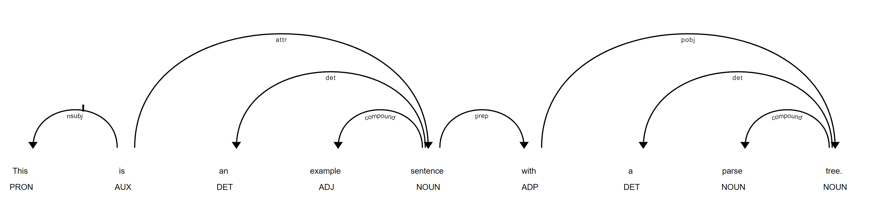
در مرحله بعد تابعی برای POS tagging نوشته شد:
import spacy

nlp = spacy.load('en_core_web_sm')

def pos_tagging(text):
doc = nlp(text)
pos_tags = [(token.text, token.pos_) for token in doc]
return pos_tags

# Example usage
example_text = "This is an example sentence for POS tagging."
مثال:
[('This', 'PRON'), ('is', 'AUX'), ('an', 'DET'), ('example', 'NOUN'), ('sentence', 'NOUN'), ('for', 'ADP'), ('POS', 'PROPN'), ('tagging', 'NOUN'), ('.', 'PUNCT')]

سپس برای استخراج موجودیت ها از کد زیر استفاده شد:
import spacy

nlp = spacy.load('en_core_web_sm')

def named_entity_recognition(text):
doc = nlp(text)
entities = [(ent.text, ent.label_) for ent in doc.ents]
return entities
مثال:
# Example usage
example_text = "Apple Inc. was founded by Steve Jobs in Cupertino. Elon Musk is the CEO of Tesla, Inc."

ner_entities = named_entity_recognition(example_text)
print(ner_entities)

[('Apple Inc.', 'ORG'), ('Steve Jobs', 'PERSON'), ('Cupertino', 'GPE'), ('Elon Musk', 'PERSON'), ('Tesla, Inc.', 'ORG')]

برای فاصله سمنتیک بین دو واژه بر اساس متن از کد زیر استفاده شد:
from nltk.corpus import wordnet
from nltk.corpus import stopwords
from nltk.tokenize import word_tokenize

import nltk
nltk.download('wordnet')
nltk.download('stopwords')

def semantic_distance_between_words(word1, word2, text):
stop_words = set(stopwords.words('english'))

def get_wordnet_pos(tag):
if tag.startswith('N'):
return wordnet.NOUN
elif tag.startswith('V'):
return wordnet.VERB
elif tag.startswith('R'):
return wordnet.ADV
elif tag.startswith('J'):
return wordnet.ADJ
else:
return None

def shortest_path_length(word1, word2):
synsets1 = wordnet.synsets(word1)
synsets2 = wordnet.synsets(word2)

shortest_distance = float('inf')

for synset1 in synsets1:
for synset2 in synsets2:
path_length = synset1.shortest_path_distance(synset2)
if path_length is not None and path_length < shortest_distance:
shortest_distance = path_length

if shortest_distance == float('inf'):
return None
else:
return shortest_distance

tokens = word_tokenize(text.lower())
pos_tags = nltk.pos_tag(tokens)
pos_tags = [(word, pos) for word, pos in pos_tags if word not in stop_words]

wordnet_pos1 = get_wordnet_pos(pos_tags[0][1])
wordnet_pos2 = get_wordnet_pos(pos_tags[1][1])

if wordnet_pos1 is not None and wordnet_pos2 is not None:
distance = shortest_path_length(word1, word2)
return distance
else:
return None

همچنین برای شباهت سمنتیک از کد زیر:
from nltk.corpus import wordnet
from nltk.corpus import stopwords
from nltk.tokenize import word_tokenize

import nltk
nltk.download('wordnet')
nltk.download('stopwords')

def get_wordnet_pos(tag):
if tag.startswith('N'):
return wordnet.NOUN
elif tag.startswith('V'):
return wordnet.VERB
elif tag.startswith('R'):
return wordnet.ADV
elif tag.startswith('J'):
return wordnet.ADJ
else:
return None

def word_similarity_between_words(word1, word2, text):
stop_words = set(stopwords.words('english'))

def word_similarity(word1, word2):
synsets1 = wordnet.synsets(word1)
synsets2 = wordnet.synsets(word2)

max_similarity = 0.0

for synset1 in synsets1:
for synset2 in synsets2:
similarity = synset1.wup_similarity(synset2)
if similarity is not None and similarity > max_similarity:
max_similarity = similarity

return max_similarity

tokens = word_tokenize(text.lower())
pos_tags = nltk.pos_tag(tokens)
pos_tags = [(word, pos) for word, pos in pos_tags if word not in stop_words]

wordnet_pos1 = get_wordnet_pos(pos_tags[0][1])
wordnet_pos2 = get_wordnet_pos(pos_tags[1][1])

if wordnet_pos1 is not None and wordnet_pos2 is not None:
similarity = word_similarity(word1, word2)
return similarity
else:
return None

نتایج:
نمایش 100 کارکتر نخست متن با سطوح مختلف پیش پردازش:
print("Original Text:\n", text[:200])
print('********************')
print("Cleaned Text Text:\n", cleaned_text[:200])
print('********************')
print("Without Stop Word Text:\n", no_stop_text[:200])
print('********************')
print("Stemmed Text:\n", stemmed_text[:200])
print('********************')
print("After Lemmatizer Text:\n", preprocessed_text[:200])

Original Text:

Albert Einstein (/ˈaɪnstaɪn/ EYEN-styne;[4] German: [ˈalbɛɐt ˈʔaɪnʃtaɪn] ⓘ; 14 March 1879 – 18 April 1955) was a German-born theoretical physicist who is widely held to be one of the greatest and mo
********************
Cleaned Text Text:

albert einstein (/ˈaɪnstaɪn/ eyen-styne;[4] german: [ˈalbɛɐt ˈʔaɪnʃtaɪn] ⓘ; 14 march 1879 – 18 april 1955) was a german-born theoretical physicist who is widely held to be one of the greatest and mo
********************
Without Stop Word Text:
albert einstein (/ˈaɪnstaɪn/ eyen-styne;[4] german: [ˈalbɛɐt ˈʔaɪnʃtaɪn] ⓘ; 14 march 1879 – 18 april 1955) german-born theoretical physicist widely held one greatest influential scientists time. best
********************
Stemmed Text:
albert einstein (/ˈaɪnstaɪn/ eyen-styne;[4] german: [ˈalbɛɐt ˈʔaɪnʃtaɪn] ⓘ; 14 march 1879 – 18 april 1955) german-born theoret physicist wide held one greatest influenti scientist time. best known dev
********************
After Lemmatizer Text:
albert einstein (/ˈaɪnstaɪn/ eyen-styne;[4] german: [ˈalbɛɐt ˈʔaɪnʃtaɪn] ⓘ; 14 march 1879 – 18 april 1955) german-born theoretical physicist widely held one greatest influential scientist time. best k
توکنایز کردن:
نمایش تنها 100 کارکتر نخست:
tokenized_text = tokenize_text(preprocessed_text)
print("Tokenized Text:", tokenized_text[:100])

Tokenized Text: ['albert', 'einstein', '(', '/ˈaɪnstaɪn/', 'eyen-styne', ';', '[', '4', ']', 'german', ':', '[', 'ˈalbɛɐt', 'ˈʔaɪnʃtaɪn', ']', 'ⓘ', ';', '14', 'march', '1879', '–', '18', 'april', '1955', ')', 'german-born', 'theoretical', 'physicist', 'widely', 'held', 'one', 'greatest', 'influential', 'scientist', 'time', '.', 'best', 'known', 'developing', 'theory', 'relativity', ',', 'einstein', 'also', 'made', 'important', 'contribution', 'quantum', 'mechanics', ',', 'thus', 'central', 'figure', 'revolutionary', 'reshaping', 'scientific', 'understanding', 'nature', 'modern', 'physic', 'accomplished', 'first', 'decade', 'twentieth', 'century', '.', '[', '1', ']', '[', '5', ']', 'mass–energy', 'equivalence', 'formula', 'e', '=', 'mc2', ',', 'arises', 'relativity', 'theory', ',', 'called', '``', 'the', 'world', "'s", 'famous', 'equation', "''", '.', '[', '6', ']', 'received', '1921', 'nobel', 'prize', 'physic']

نمایش درخت پارسینگ:
parse_tree = generate_parse_tree(preprocessed_text)

# Visualize the parse tree using spaCy's displacy module
displacy.render(parse_tree, style='dep', jupyter=True)

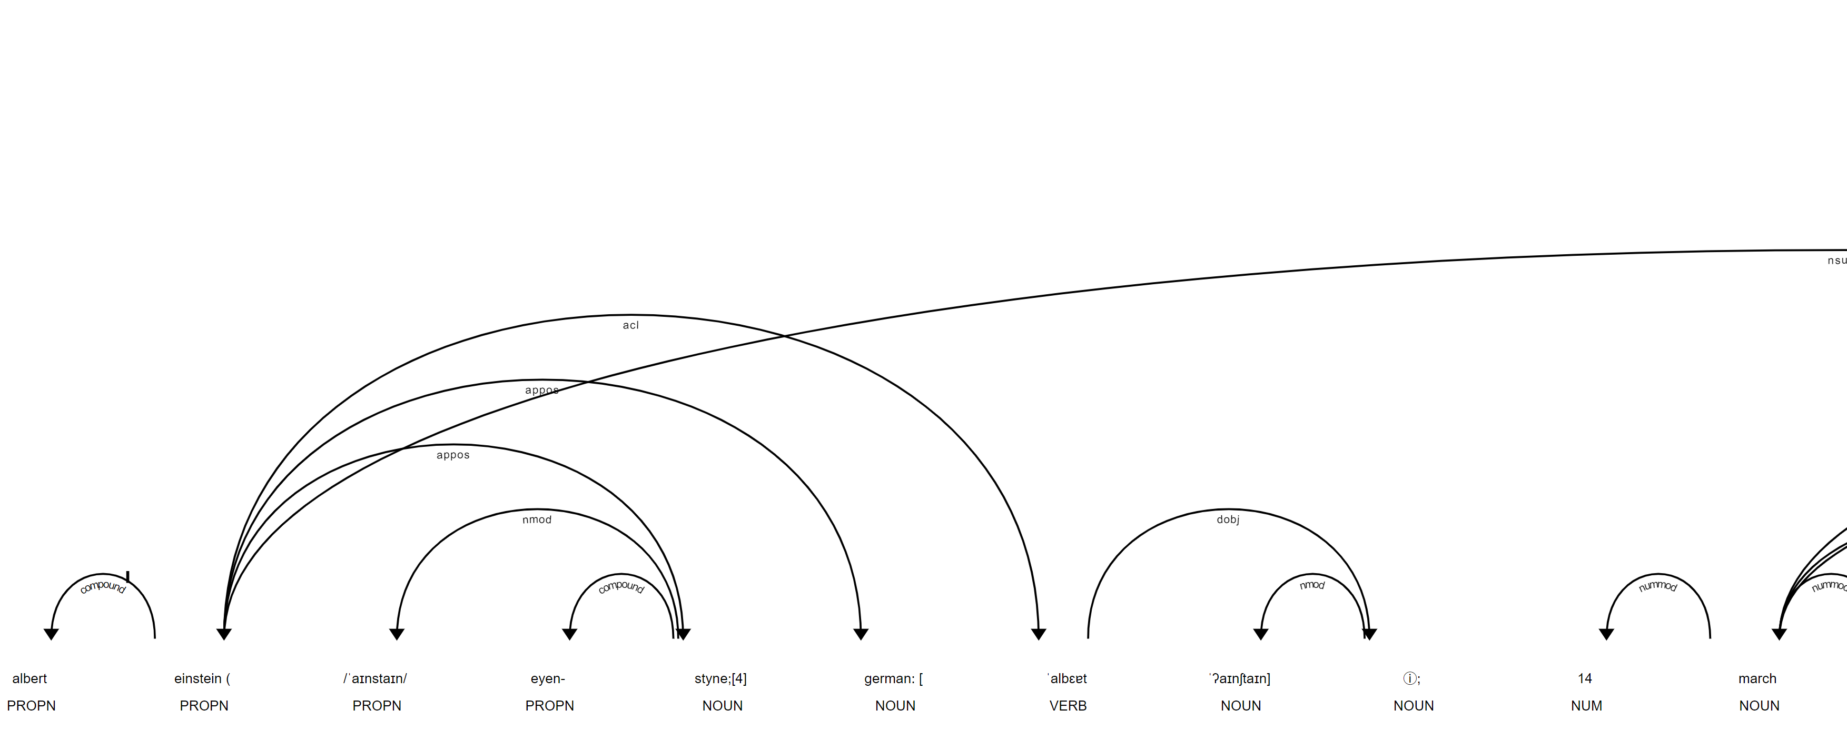
برای مشاهده کامل به فایل کد مراجعه شود:
نمایش POS Tagging:
pos_tags = pos_tagging(text)
print(pos_tags)
[('\n\n', 'SPACE'), ('Albert', 'PROPN'), ('Einstein', 'PROPN'), ('(', 'PUNCT'), ('/ˈaɪnstaɪn/', 'PROPN'), ('EYEN', 'PROPN'), ('-', 'PUNCT'),...]
نمایش موجودیتها:
ner_entities = named_entity_recognition(text)
print(ner_entities)
[('Albert Einstein', 'PERSON'), ('German', 'NORP'), ('14 March 1879', 'DATE'),...]
یافتن هم معنی هر کلمه:
synonyms_result = get_synonyms(text)
for word, synonyms in synonyms_result.items():
print(f"Synonyms for '{word}': {synonyms}")

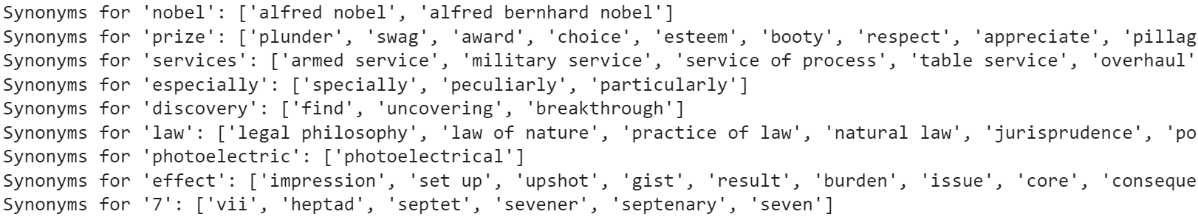
تنها بخش کوچکی از نتایج در بالا نمایش داده شده است.
یافتن هایپونیم و هایپرنیم در دنباله کلمات:
relations_result = get_relations(text)
for word, relations in relations_result.items():
print(f"Relations for '{word}':")
print(f" Synonyms: {relations['synonyms']}")
print(f" Hypernyms: {relations['hypernyms']}")
print(f" Hyponyms: {relations['hyponyms']}")
print()
نمایش بخشی از نتایج:
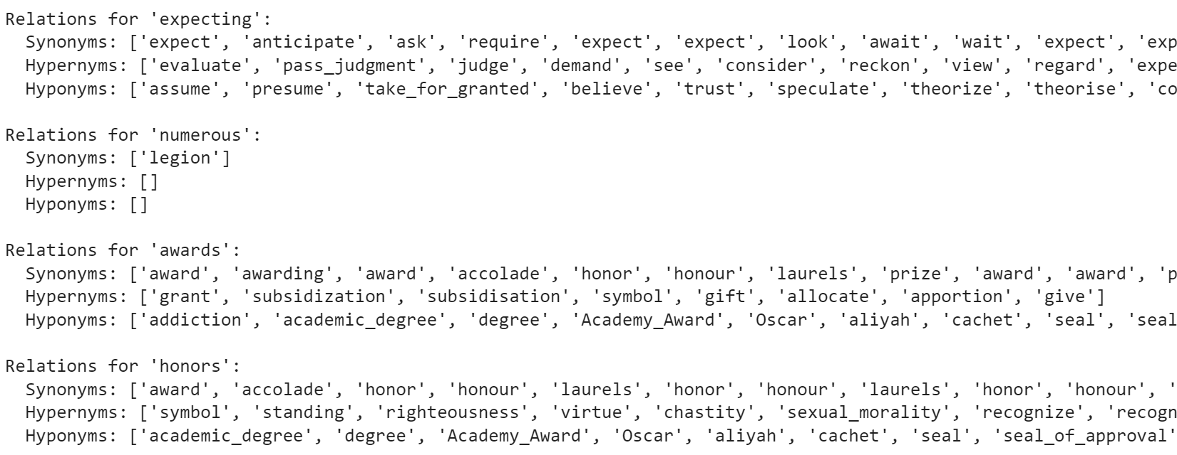
یافتن فاصله بین دو کلمه:
word1 = "theory"
word2 = "relativity"
semantic_distance_result = semantic_distance_between_words(word1, word2, text)
print(f"Semantic distance between '{word1}' and '{word2}': {semantic_distance_result}")

Semantic distance between 'theory' and 'relativity': 2

word1 = "albert"
word2 = "einstein"
semantic_distance_result = semantic_distance_between_words(word1, word2, text)
print(f"Semantic distance between '{word1}' and '{word2}': {semantic_distance_result}")

Semantic distance between 'albert' and 'einstein': 7
word1 = "albert"
word2 = "physics"

semantic_distance_result = semantic_distance_between_words(word1, word2, text)
print(f"Semantic distance between '{word1}' and '{word2}': {semantic_distance_result}")

Semantic distance between 'albert' and 'physics': 10

word1 = "albert"
word2 = "islam"

semantic_distance_result = semantic_distance_between_words(word1, word2, text)
print(f"Semantic distance between '{word1}' and '{word2}': {semantic_distance_result}")

Semantic distance between 'albert' and 'islam': 14

همانطور که دیده میشود تئوری و نسبیت کمترین فاصله یعنی 2 را دارند سپس فاصله بین البرت و انیشتین 7 به دست آمده است که مشخص است پی به ارتباط آن دو برده شده است. در ادامه فاصله آلبرت و فیزیک 10 محاسبه شده است در صورتی که فاصله آلبرت و اسلام 14 است پس میتوان متوجه شد که ارتباط شغل فیزیکدان بودن با شخص آلبت انشتین کشف شده است.
محاسبه شباهت معنایی:
word1 = "theory"
word2 = "relativity"

result = word_similarity_between_words(word1, word2, text)
print(f"Semantic similarity between '{word1}' and '{word2}': {result}")

Semantic similarity between 'theory' and 'relativity': 0.9

word1 = "albert"
word2 = "einstein"

result = word_similarity_between_words(word1, word2, text)
print(f"Semantic similarity between '{word1}' and '{word2}': {result}")

Semantic similarity between 'albert' and 'einstein': 0.5714285714285714

word1 = "albert"
word2 = "physics"

result = word_similarity_between_words(word1, word2, text)
print(f"Semantic similarity between '{word1}' and '{word2}': {result}")

Semantic similarity between 'albert' and 'physics': 0.375

word1 = "albert"
word2 = "islam"

result = word_similarity_between_words(word1, word2, text)
print(f"Semantic similarity between '{word1}' and '{word2}': {result}")

Semantic similarity between 'albert' and 'islam': 0.125

با محاسبه شباهت معنایی طبق بالا مشاهده میشود که به طور عکس با فاصله معنایی، کلمات دارای شباهت معنایی هستند و به طور مثال البرت و اسلام که بیشترین فاصله معنایی را داشتند دارای بیشترین شباهت معنایی هستند.

