RSP Certificates and Authentication
eIM • SM-DP+ • eUICC — implementation guide for the ConnectX simulator suite

Specifications: GSMA SGP.22 v3 (RSP) • GSMA SGP.26 v3 (test certificates) • GSMA SGP.32 v1.2 (M2M extensions)

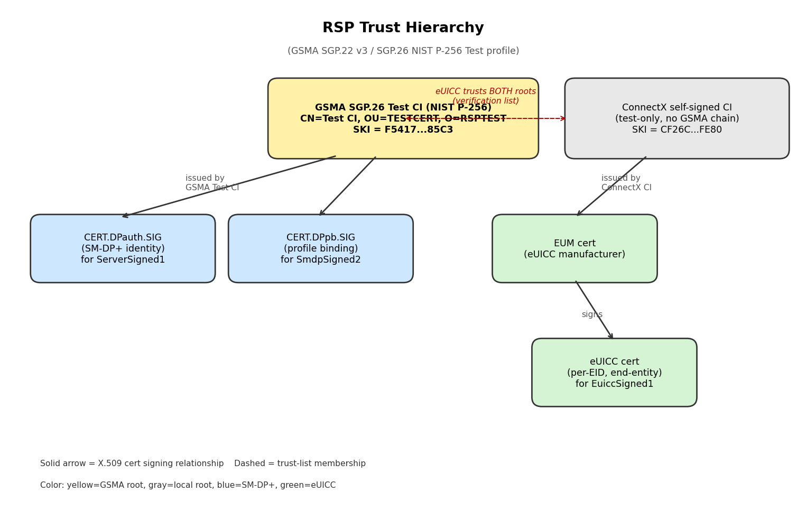

1. Overview
Remote SIM Provisioning (RSP) requires three actors — the eIM (eSIM IoT Manager), the SM-DP+ (Subscription Manager — Data Preparation +) and the eUICC (the chip in the device) — to mutually authenticate using ECDSA signatures and X.509 certificate chains. This document describes which certificates and keys each actor holds, where the trust anchors live, and how the cryptographic flow plays out across the ESipa, ES9+ and ES10b interfaces.
Everything in this guide is implemented and verified end-to-end in the ConnectX simulator suite. Profile downloads, enable/disable/delete operations and ESipa-routed PSMO/eCO commands all complete with full SGP.22 v3 wire conformance — no test-mode bypasses.

2. Certificates per actor
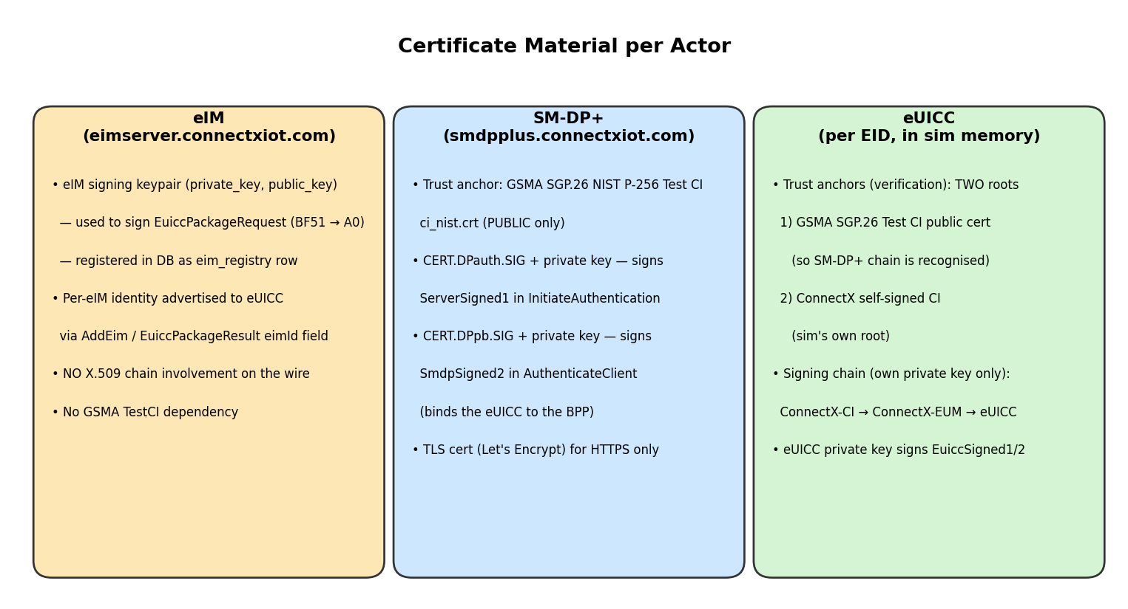

2.1 SM-DP+ (smdpplus.connectxiot.com)
The SM-DP+ acts as the profile preparation server. It must prove its identity to every eUICC that downloads a profile, and it does so with end-entity certificates issued under a public test CI.
Asset | Purpose | File / location | Algorithm
Trust anchor (CI public) | Verifies its own DPauth/DPpb certs were issued under the GSMA Test CI. | ci_nist.crt | ECDSA P-256
CERT.DPauth.SIG + private key | Signs ServerSigned1 in ES9+.InitiateAuthentication (step 3). | smdp_dpauth.crt + .key | ECDSA P-256
CERT.DPpb.SIG + private key | Signs SmdpSigned2 in ES9+.AuthenticateClient (step 5). Binds the BPP to a specific eUICC. | smdp_dpbp.crt + .key | ECDSA P-256
TLS cert | HTTPS only. Independent of RSP signing. | /etc/letsencrypt/... | Let's Encrypt
Trust-anchor details — GSMA SGP.26 RSP2 NIST P-256 Test CI:
Subject: CN=Test CI, OU=TESTCERT, O=RSPTEST, C=IT
Self-signed: yes (root)
SubjectKeyId: F5:41:72:BD:F9:8A:95:D6:5C:BE:B8:8A:38:A1:C1:1D:80:0A:85:C3
Curve / hash: NIST P-256 (prime256v1) / SHA-256
Source: GSMA SGP.26 v3 test certificate package (osmo-smdpp upstream)
Notes: The PRIVATE key is intentionally not on this box — it lives only with whoever
issues new DPauth/DPpb certs. We have only the public cert here.

2.2 eUICC simulator (per-EID, in-process)
Each virtual eUICC carries its own three-tier cert chain plus a list of trusted CI roots that it will accept on the SM-DP+ side. Both sets are independent — the trust list controls verification, the private key controls signing.
Asset | Purpose | Source
Trusted CI #1 — GSMA Test CI | Lets the eUICC verify any SM-DP+ chain rooted in the public GSMA SGP.26 NIST P-256 CI. Public-only. | Copied to certs/_trusted_cis/gsma_test_ci_nist.crt at sim provisioning
Trusted CI #2 — ConnectX self-signed CI | The simulator's own CI (full keypair). Allows offline cert issuance for sim-only chains. | Generated per-deployment at certs/<EID>/ci_*.pem
EUM cert (intermediate) | Represents the eUICC manufacturer. Issued by the ConnectX CI. | certs/<EID>/eum_cert.pem
eUICC end-entity cert + private key | The per-device cert. Used to sign EuiccSigned1 / EuiccSigned2. | certs/<EID>/euicc_{cert,private}.pem
Key list returned to SM-DP+ in EUICCInfo1.euiccCiPKIdListForVerification:
[ F54172BDF98A95D65CBEB88A38A1C11D800A85C3, -- GSMA Test CI (NIST P-256)
CF26CF596C453B64AD88C10F18C473118857FE80 ] -- ConnectX self-signed CI
Both SKIs are advertised. The SM-DP+ picks one (usually the GSMA TestCI, as that is its DPauth root) via the euiccCiPKIdToBeUsed field of the InitiateAuthentication response.

2.3 eIM (eimserver.connectxiot.com)
Unlike the SM-DP+, the eIM does NOT participate in any X.509 trust chain on the wire. It identifies itself to the eUICC by an opaque eimId string and a per-association counter (replay protection). The eIM operator's public key (raw EC) is stored on the eUICC at AddEim time; subsequent requests are signed with the matching private key.
Asset | Purpose | File / location
eIM signing keypair (raw EC P-256, no X.509) | Signs every EuiccPackageRequest sent over ESipa. | /var/www/eim/storage/app/eim/keys/<eimId>_private.pem
eim_registry row (database) | Stores eim_id, eim_id_hmac (for multi-tenant lookup), public-key bytes, counter, supported_protocol. | MySQL table eim_db.eim_registry
No CA cert / no GSMA chain | The eIM identity is verified by counter + signature only, not by a cert chain. | —

3. Authentication flow (profile download)
The 8-step profile-download flow exercises every ECDSA signature, every cert chain validation, and every key-exchange path in RSP. The sequence below is what our simulator suite executes verbatim against an SGP.22 v3 SM-DP+. Each labelled phase corresponds to one or more spec sections (SGP.22 §5.6 for ES9+, §5.7 for ES10b).
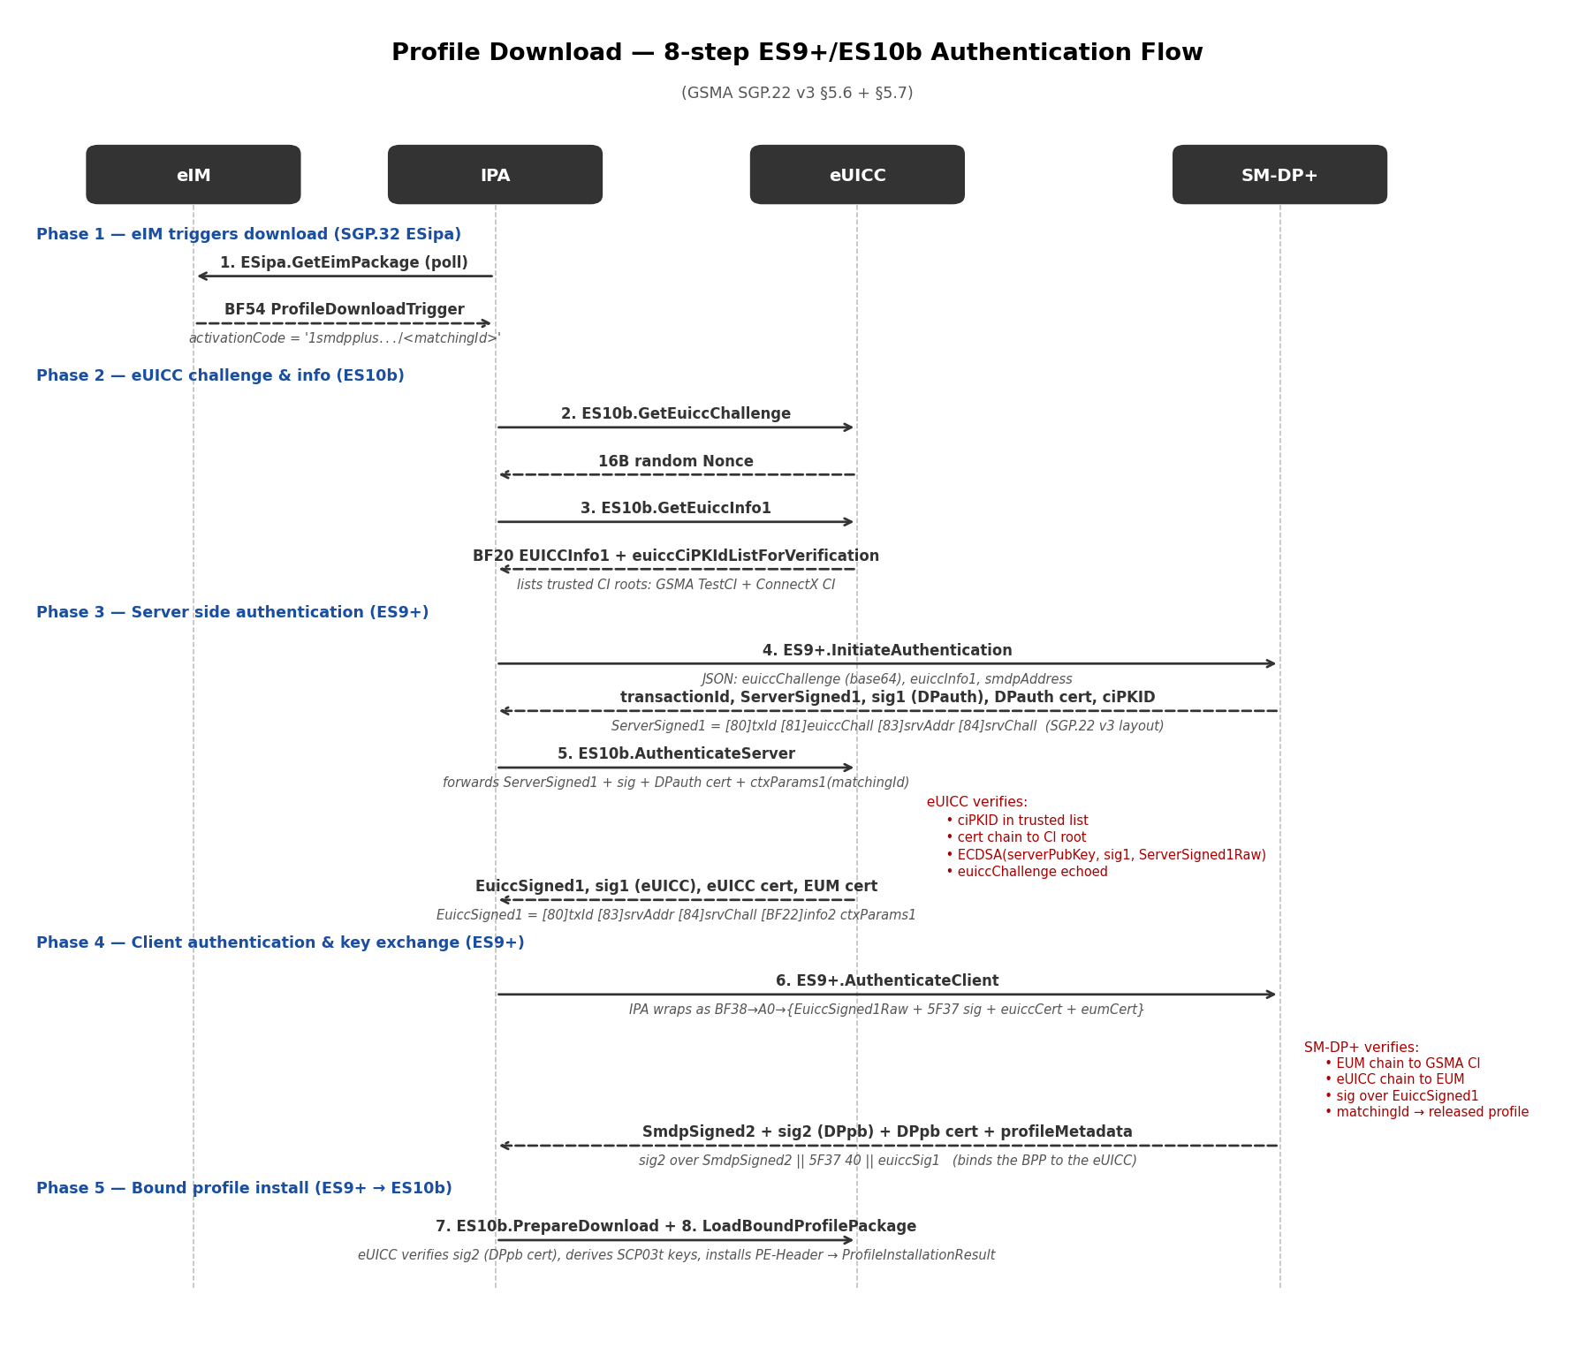

3.1 Step-by-step explanation

Step 1 — GetEuiccChallenge (ES10b)
The IPA asks the eUICC for a fresh 16-byte random challenge. This Nonce is the eUICC's session-binding token; the SM-DP+ must echo it back signed with CERT.DPauth.SIG to prove freshness.

Step 2 — GetEuiccInfo1 (ES10b)
The eUICC returns BF20 EUICCInfo1 carrying euiccCiPKIdListForVerification (the SKIs of every CI root the eUICC trusts) and euiccCiPKIdListForSigning. The SM-DP+ uses these to decide which of its DPauth certs to use for the signature.

Step 3 — ES9+.InitiateAuthentication (IPA → SM-DP+)
The IPA forwards the challenge, info1 and the SM-DP+ FQDN. The SM-DP+ responds with: transactionId, ServerSigned1 (a SEQUENCE with txId/euiccChallenge/serverAddress/serverChallenge), the 5F37-wrapped serverSignature1 (made with CERT.DPauth.SIG over the canonical DER bytes of ServerSigned1), the DPauth cert, and the chosen euiccCiPKIdToBeUsed (DER-OCTET-STRING wrapped as 04 14 <SKI>).

Step 4 — ES10b.AuthenticateServer (eUICC verifies SM-DP+)
The IPA strips the 04 14 wrapper from euiccCiPKIdToBeUsed, parses the ServerSigned1 base64 into fields, strips the 5F37 40 wrapper from the signature, then forwards everything plus the original ServerSigned1 raw DER bytes to the eUICC. The eUICC checks: (a) ciPKID is in its trust list, (b) the SM-DP+'s cert chain validates to that CI, (c) ECDSA(serverPubKey, signature, ServerSigned1Raw) verifies, (d) the euiccChallenge in ServerSigned1 matches the one issued in step 1. On success the eUICC returns EuiccSigned1 + euiccSignature1 + its own cert + the EUM cert. EuiccSigned1 carries ctxParams1 echoing the matchingId from the activation code.

Step 5 — ES9+.AuthenticateClient (IPA → SM-DP+)
The IPA hand-rolls the AuthenticateServerResponse outer wrapper at the byte level: BF38 → A0 → {EuiccSigned1Raw + 5F37+sig + euiccCert + eumCert}, base64-encodes it, and POSTs to the SM-DP+. The SM-DP+ verifies the eUICC's cert chain (eUICC → EUM → CI) and the signature over EuiccSigned1, then looks up a released profile by matchingId. It returns SmdpSigned2 + a 5F37-wrapped smdpSignature2 + the CERT.DPpb.SIG + profile metadata. Critically, smdpSignature2 is computed over SmdpSigned2 || 5F37 40 || euiccSignature1 — the SM-DP+ binds its response to the eUICC's prior signature so it can't be replayed against a different session.

Step 6 — ES10b.PrepareDownload (eUICC verifies SM-DP+ profile-binding)
The eUICC validates the DPpb cert chain (separately from DPauth), then verifies smdpSignature2 against SmdpSigned2 || 5F37 40 || euiccSignature1 using the DPpb public key. It generates its one-time public/private keypair (otpk), derives SCP03t session keys via ECDH against the SM-DP+'s ephemeral key, and returns EuiccSigned2 + a 5F37-wrapped euiccSignature2.

Step 7 — ES9+.GetBoundProfilePackage
The IPA forwards EuiccSigned2 + signature back to the SM-DP+. The SM-DP+ verifies that euiccSig2 was made by the same eUICC that authenticated in step 5, then encrypts the actual profile elements with the derived SCP03t keys and returns the BoundProfilePackage (BF36 envelope).

Step 8 — ES10b.LoadBoundProfilePackage
The eUICC walks the BF36 TLV tree, decrypts each profile element with SCP03t (CMAC-verified), instantiates an ISD-P, installs the profile, and returns a ProfileInstallationResult. Profile is now stored on the eUICC in the disabled state, ready to be enabled via a separate ESipa command.

4. Signature layouts — what gets signed
Every ECDSA signature in RSP is over canonical DER bytes — exact, byte-for-byte. Any re-encoding ambiguity (length-form, AUTOMATIC TAGS edge case) breaks the signature. The simulator passes the original DER through verbatim for verification; never re-encodes between hops.
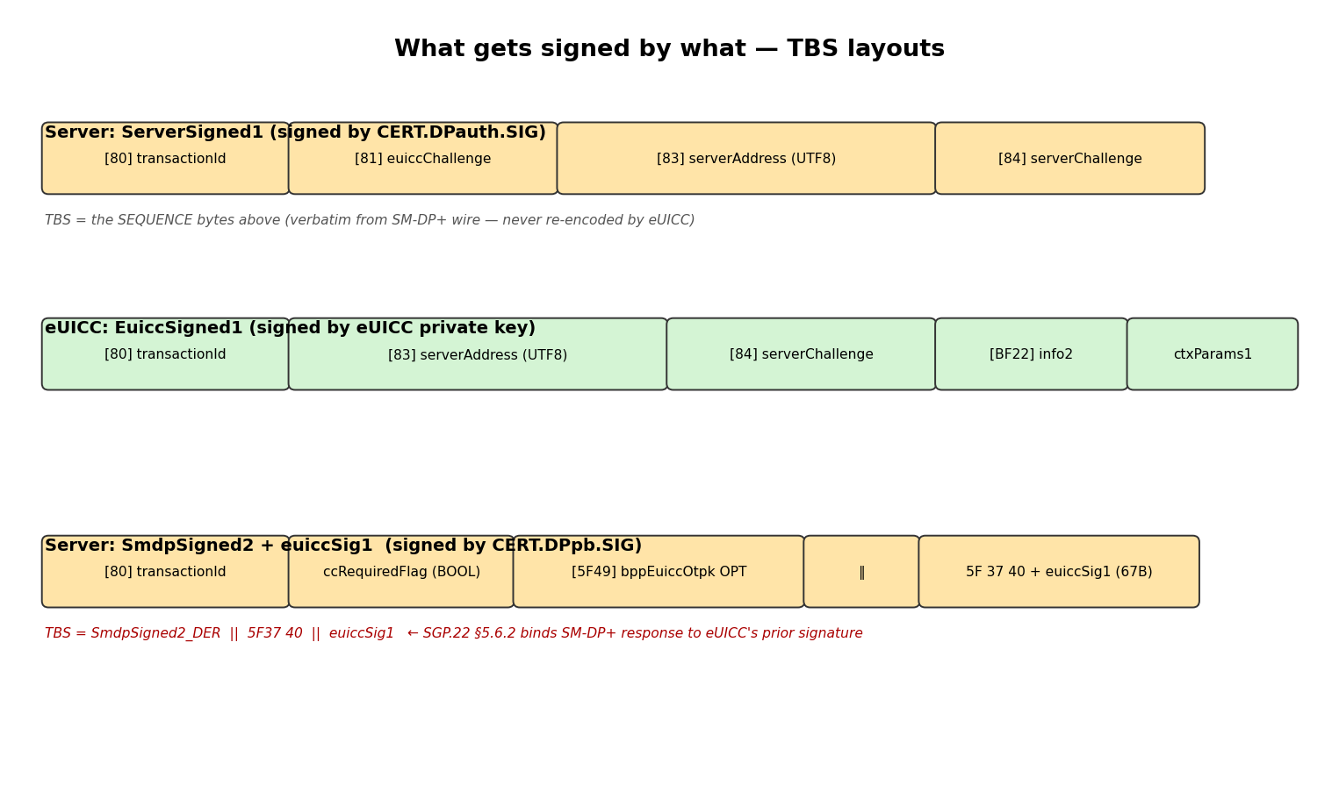

4.1 Tag layouts that matter (canonical SGP.22 v3)
Type | Tag layout | Notes
ServerSigned1 | SEQUENCE { [0] txId, [1] euiccChallenge, [3] serverAddress, [4] serverChallenge } | Tags [2] reserved. Re-encoding with [0][1][2][3] produces different DER bytes → sig fails.
EuiccSigned1 | SEQUENCE { [0] txId, [3] serverAddress, [4] serverChallenge, [34] euiccInfo2, ctxParams1 } | ctxParams1 is mandatory in v3, an untagged CHOICE (matchingId carried inside).
SmdpSigned2 | SEQUENCE { [0] txId, ccRequiredFlag (BOOL), [APPLICATION 73] bppEuiccOtpk OPT } | ccRequiredFlag is untagged BOOLEAN. The OTPK uses [APPLICATION 73] = 5F49 wire tag.
EuiccSigned2 | SEQUENCE { [0] txId, [APPLICATION 73] euiccOtpk, hashCc OPT } | Same APPLICATION-tag pattern; hashCc untagged when present.
AuthenticateResponseOk | SEQUENCE { EuiccSigned1, [APPLICATION 55] euiccSig1, euiccCert, eumCert } | Outer wrapped in BF38 → A0 (CHOICE alternative 0).

5. ESipa relay (eIM → eUICC PSMO / eCO commands)
Profile state operations (enable / disable / delete / listProfileInfo, etc.) and eIM configuration operations (addEim / deleteEim / listEim) are not direct ES10b commands. They flow through ESipa: the eIM packages them as signed BF51 EuiccPackageRequest messages, the IPA polls and relays them to the eUICC, and results return to the eIM as BF50 ProvideEimPackageResult.
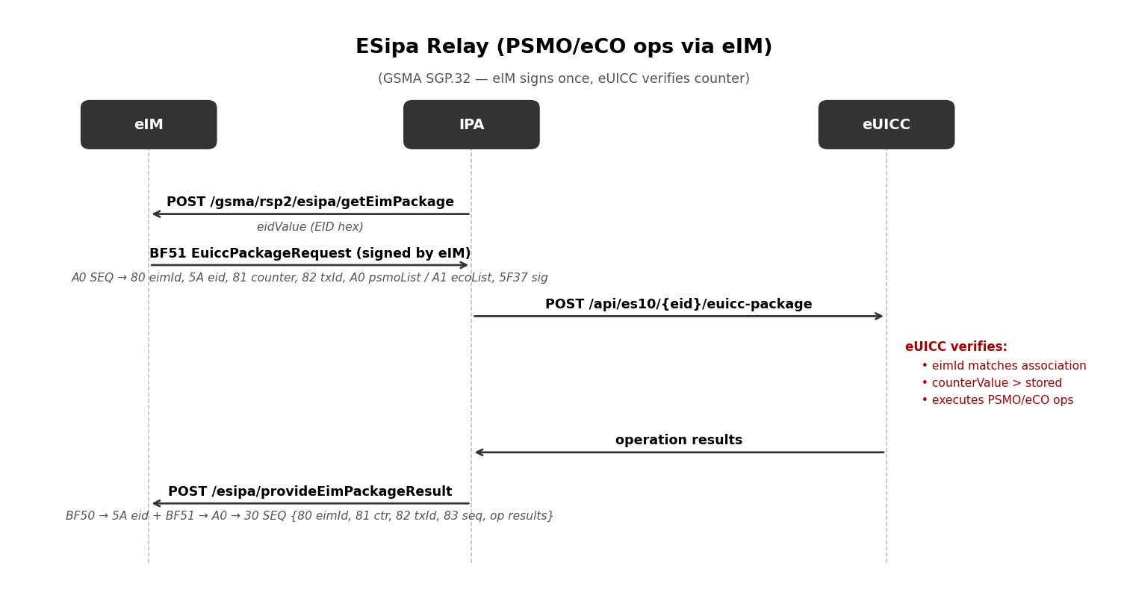

5.1 EuiccPackageRequest — what the eIM actually signs
BF51 <len>
30 <len> -- EuiccPackageSigned
80 <len> <eimId UTF-8> -- the eIM's identifier
5A 10 <eid 16B> -- target EID
81 <len> <counterValue> -- replay protection
82 10 <transactionId 16B> -- session ID (optional)
A0 <len> <psmoList content> | A1 <len> <ecoList content>
5F37 40 <signature 64B> -- ECDSA(eIM private key)
PSMO action tags (inside A0):
A3 enable A4 disable A5 delete A6 getRAT
A7 configureImmediateEnable A8 setFallbackAttribute A9 unsetFallbackAttribute
BF2D listProfileInfo BF65 setDefaultDpAddress
eCO action tags (inside A1):
A8 addEim A9 deleteEim AA updateEim AB listEim

5.2 ProvideEimPackageResult — what the eUICC returns
BF50 <len> -- ProvideEimPackageResult outer
5A 10 <eid> -- REQUIRED for finishQueueItem in eIM
BF51 <len> -- euiccPackageResult
A0 <len> -- euiccPackageResultSigned (constructed)
30 <len> -- SEQUENCE
80 <eimId> 81 <counter> 82 <txId> 83 <seqNumber>
<op result tags>
Op-result tags read by the eIM:
0x83 / 0xA3 enable result 0x84 / 0xA4 disable 0x85 / 0xA5 delete
0xA8 addEim result (constructed) 0x89 / 0xA9 deleteEim
0xBF2D listProfileInfo result wraps E3 ProfileInfo entries (5A iccid, 9F70 state, 9F12 name).

6. Interoperability with third-party RSP servers
Direction | Requirement | ConnectX status
SM-DP+ → eUICC (verify SM-DP+ chain) | eUICC must trust the SM-DP+'s CI root. | ✓ eUICC trusts GSMA Test CI as additional root → accepts any SM-DP+ rooted there
eUICC → SM-DP+ (verify eUICC chain) | SM-DP+ must trust the eUICC's CI root (real production: GSMA Test CI). | Partial — works against our SM-DP+ today; for strict third parties the eUICC's EUM + eUICC certs need re-issuing under GSMA Test CI (requires its private key from SGP.26 v3 test pack).
Sig math byte equivalence | TBS bytes must match canonical SGP.22 v3 layout exactly. | ✓ Schema fully aligned (see §4.1).

6.1 How to upgrade to full third-party interop
1. Obtain GSMA SGP.26 v3 test pack (gsma.com → click-through license). Look for SK_CI_ECDSA_NIST.pem.
2. Drop the file into a known location on the deployment box.
3. Run the cert regeneration script (~30 min): create a new EUM cert signed by SK_CI_ECDSA_NIST, then per-EID issue eUICC certs signed by the new EUM. Replace the contents of certs/<EID>/eum_*.pem and certs/<EID>/euicc_*.pem.
4. Sim restart picks up the new chain. The eUICC's euiccCiPKIdListForSigning now reports the GSMA TestCI SKI; any SGP.22 v3 SM-DP+ that trusts that root will accept our eUICC.

7. Appendix — files and tools
File / location | Purpose
smdpplus/scripts/lib/asn1/rsp/rsp.asn | Canonical SGP.22 v3 ASN.1 schema (osmo-smdpp upstream)
{euicc,ipa}-simulator/asn1_schemas/rsp_definitions.asn | Simulator-side schema — must match the canonical above
euicc-simulator/app/crypto/certificates.py | Per-EID cert chain provisioning + multi-CI trust list
euicc-simulator/app/crypto/cert_validator.py | X.509 chain validation against any of the trusted CIs
euicc-simulator/app/es10/es10b.py | AuthenticateServer / PrepareDownload signature math
ipa-simulator/app/clients/smdp_client.py | ServerSigned1 / SmdpSigned2 wire parsers; hand-rolled AuthenticateServerResponse builder
smdpplus/storage/app/certs/ | DPauth + DPpb cert + private key + GSMA Test CI public cert
euicc-simulator/certs/_trusted_cis/ | Additional trust anchors (GSMA Test CI public)
euicc-simulator/certs/<EID>/ | Per-EID self-signed CI + EUM + eUICC chain

Verification checklist:
• Schema byte-equivalence: parse a captured Comprion AuthenticateClient request and diff its EuiccSigned1 tag tree against ours (same tag layout, different values).
• ECDSA signature: feed our SM-DP+'s ServerSigned1 + sig + DPauth cert to es10b.authenticate_server() and confirm verified=true.
• End-to-end: run /transactions/N for any tx with operation = retrieve_eim_package and a downstream profile_download — every step in §3 should appear with status 200.

