Ringkasan Hasil Analisis   
2018-08-01 s/d 2019-01-01

# Pie chart persebaran gangguan

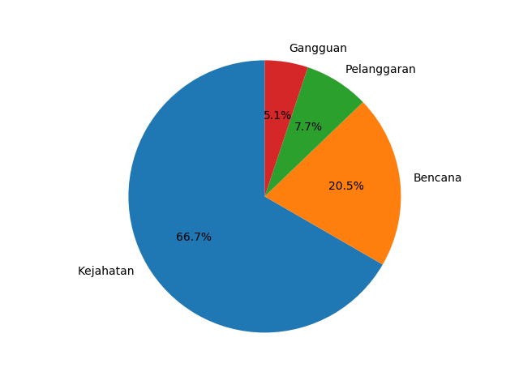

# Line chart persebaran gangguan

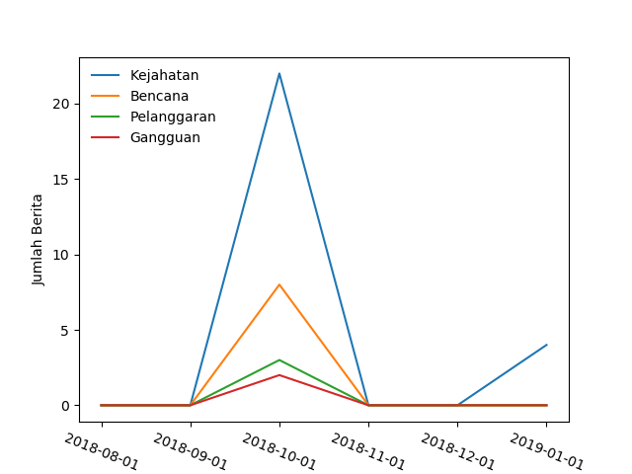

# Tabel persebaran gangguan

