Course Name: | Web Programming Laboratory (216U01L501) | Semester: | V
Date of Performance: | 27z/ 09 / 2026 | DIV/ Batch No: | A2
Student Name: | Abhishek D. Khedekar | Roll No: | 16014024029

Experiment No: 2
Title To apply CSS3 style sheets to an existing HTML5-based Web Portal in order to enhance layout, responsiveness, visual aesthetics, and user interaction using modern CSS3 features.

Aim and Objective of the Experiment:
- Implement different CSS3 styling techniques
- Design responsive layouts using Flexbox and media queries
- Enhance user interaction using animations
- Maintain separation of content and presentation

COs to be achieved:
CO2:

Problem Statement:
Task 1: Apply Basic Page Styling
Use Case: Improve overall page look.
Requirements:
Set background color of page
Change font family for entire portal
Set text alignment for header and footer
Add margin and padding to body
CSS Concepts: element selector, properties, global styling

Task 2: Style the Header and Footer
Use Case: Make portal banner attractive.
Requirements:
Background color for header and footer
Change text color to white
Increase header font size
Add padding
CSS Concepts: element styling, color, padding

Task 3: Design Horizontal Navigation Bar
Use Case: Convert links into navigation menu.
Requirements:
Remove underline from links
Display links horizontally
Add spacing between links
Change link color on hover
CSS Concepts: nav a, text-decoration, display, :hover

Task 4:
Requirements:
Add border and rounded corners
Add box shadow
Center the card on page
Add background color
CSS Concepts: class selector, box model, shadow

Task 5: Style Lists
Use Case: Improve stock list readability.
Requirements:
Change ordered list style
Add spacing between list items
Change color of item names
Style description list background
CSS Concepts: list styling, spacing, colors

Task 6: Create Consistent Layout for All Pages
Use Case: Maintain uniform design across portal.
Requirements:
Provide common margins for main content
Ensure footer stays at bottom
Maintain consistent font and color theme
Reuse same CSS file for all pages
CSS Concepts: layout consistency, reusable CSS

Deliverable: create style.css and external link it.

HTML tags used:
Task 1 (Basic Setup & Styling): <!DOCTYPE html>, <html>, <head>, <meta>, <title>, <link>, <body>, <main>, <p>
Task 2 (Header & Footer): <header>, <footer>, <h1>, <span>
Task 3 (Navigation Bar): <nav>, <a>
Task 4 (Card Component): <section>, <div>, <h2>
Task 5 (Style Lists): <ol>, <li>, <dl>, <dt>, <dd>
Task 6 (Layout Consistency & Forms): <main class="main-container">, <form>, <label>, <input>, <button>

Code:
Task 1 –

Style.css
/* ASTRA Runway Ultra-Aesthetic Engine */
@import url('https://googleapis.com');

/* ==========================================
TASK 1: GLOBAL STYLING & FONT FAMILY
========================================== */
* {
margin: 0;
padding: 0;
box-sizing: border-box;
font-family: 'Montserrat', Arial, sans-serif; /* ✅ Requirement: Font family for entire portal */
text-decoration: none;
color: #000;
}

/* ==========================================
TASK 1: PAGE BACKGROUND, MARGIN & PADDING
========================================== */
body {
background-color: #f4f4f4; /* ✅ Requirement: Set background color of page */
margin: 10px; /* ✅ Requirement: Added margin to body */
padding: 20px; /* ✅ Requirement: Added padding to body */
min-height: 100vh;
display: flex;
flex-direction: column;
}

/* ==========================================
TASK 1: TEXT ALIGNMENT FOR HEADER & FOOTER
========================================== */
header, footer {
text-align: center; /* ✅ Requirement: Text alignment for header and footer */
}

/* Navigation Bar with Clickable Left Logo */
header {
display: flex;
justify-content: space-between;
align-items: center;
padding: 30px 5%;
background: #fff;
border-bottom: 1px solid #f2f2f2;
position: sticky;
top: 0;
z-index: 100;
}

.logo { font-family: 'Bodoni Moda', serif; font-size: 26px; font-weight: 600; letter-spacing: 6px; cursor: pointer; display: inline-block; }
nav a { margin-left: 30px; font-size: 11px; text-transform: uppercase; letter-spacing: 2px; font-weight: 300; transition: opacity 0.3s; }
nav a:hover { opacity: 0.5; }

/* Hero Banner Layout */
.hero { height: 75vh; background: #f6f5f3; display: flex; flex-direction: column; justify-content: center; align-items: center; text-align: center; border-bottom: 1px solid #f2f2f2; padding: 0 20px; }
.hero h1 { font-family: 'Bodoni Moda', serif; font-size: clamp(32px, 5vw, 55px); font-weight: 400; letter-spacing: 8px; margin-bottom: 25px; text-transform: uppercase; }

/* Pure CSS Graphic Grid Layout Framework */
.grid { display: grid; grid-template-columns: repeat(auto-fit, minmax(320px, 1fr)); gap: 50px 30px; padding: 8% 5%; max-width: 1400px; margin: 0 auto; width: 100%; }
.card { display: flex; flex-direction: column; background: #fff; }

/* Premium Layout Grid Canvas Blocks */
.img-wrap { width: 100%; height: 480px; overflow: hidden; position: relative; display: flex; align-items: center; justify-content: center; transition: all 0.5s ease; border-radius: 2px; }
.card:hover .img-wrap { transform: translateY(-4px); box-shadow: 0 15px 30px rgba(0,0,0,0.04); }

/* Luxury Presentation Hues (Zara Minimalist Style) */
.item-1 .img-wrap { background: linear-gradient(180deg, #dcd9d4 0%, #ece9e6 100%); }
.item-2 .img-wrap { background: linear-gradient(180deg, #ebdcd5 0%, #f6ebe6 100%); }
.item-3 .img-wrap { background: linear-gradient(180deg, #dfdad3 0%, #f0ede9 100%); }
.item-4 .img-wrap { background: linear-gradient(180deg, #cfd3d6 0%, #eef1f5 100%); }
.item-5 .img-wrap { background: linear-gradient(180deg, #dcd7cf 0%, #ebe7e0 100%); }
.item-6 .img-wrap { background: linear-gradient(180deg, #d2cbd4 0%, #e7e2e8 100%); }
.item-7 .img-wrap { background: linear-gradient(180deg, #cbd4d2 0%, #e2e8e7 100%); }
.item-8 .img-wrap { background: linear-gradient(180deg, #ece9e6 0%, #ffffff 100%); }
.item-9 .img-wrap { background: linear-gradient(180deg, #dad6d1 0%, #f1eee9 100%); }

.img-wrap::after { content: 'ASTRA PREMIUM'; font-size: 10px; letter-spacing: 5px; color: #7f7a70; font-weight: 300; text-transform: uppercase; }

/* Form Graphics Configuration */
.form-bg { background: #f6f5f3; flex: 1; display: flex; justify-content: center; align-items: center; padding: 60px 20px; }
.form-box { background: #fff; border: 1px solid #e5e5e5; padding: 50px 40px; width: 100%; max-width: 460px; box-shadow: 0 10px 30px rgba(0,0,0,0.01); }
.form-box h2 { font-family: 'Bodoni Moda', serif; font-size: 24px; font-weight: 400; letter-spacing: 4px; margin-bottom: 35px; text-align: center; text-transform: uppercase; }
input, select, textarea { width: 100%; padding: 14px; margin-bottom: 20px; border: 1px solid #e5e5e5; font-size: 13px; font-weight: 300; background: #fff; }
input:focus, select:focus, textarea:focus { border-color: #000; outline: none; }
.form-box a { display: block; text-align: center; font-size: 11px; letter-spacing: 1px; text-transform: uppercase; margin-top: 15px; color: #777; }

/* Core Card Microcopy Elements */
.details { padding-top: 20px; text-align: left; }
.card h3 { font-size: 14px; font-weight: 400; letter-spacing: 1px; text-transform: uppercase; margin-bottom: 6px; }
.card .cat { font-size: 11px; color: #777; text-transform: uppercase; letter-spacing: 1px; margin-bottom: 8px; display: block; }
.card p.price { font-size: 14px; font-weight: 500; margin-bottom: 15px; }
.btn { display: block; width: 100%; padding: 15px; background: #000; color: #fff; text-align: center; font-size: 11px; text-transform: uppercase; letter-spacing: 2px; border: 1px solid #000; transition: all 0.3s ease; cursor: pointer; }
.btn:hover { background: #fff; color: #000; }

footer { margin-top: auto; padding: 40px; text-align: center; font-size: 11px; text-transform: uppercase; letter-spacing: 2px; color: #777; border-top: 1px solid #f2f2f2; background: #fff; }
@media (max-width: 768px) { header { flex-direction: column; gap: 15px; } nav a { margin: 0 10px; } }

Task 2

Style.css
/* ASTRA Runway Ultra-Aesthetic Engine */
@import url('https://googleapis.com');

/* Task 1 Global Rules */
* {
margin: 0;
padding: 0;
box-sizing: border-box;
font-family: 'Montserrat', Arial, sans-serif;
text-decoration: none;
}

body {
background-color: #f4f4f4;
margin: 10px;
padding: 20px;
min-height: 100vh;
display: flex;
flex-direction: column;
}

/* ==========================================
TASK 2: HEADER & FOOTER STYLING
========================================== */
header, footer {
background-color: #111111; /* ✅ Requirement: Background color for header & footer */
color: #ffffff; /* ✅ Requirement: Change text color to white */
text-align: center;
}

/* Navigation Bar */
header {
display: flex;
justify-content: space-between;
align-items: center;
padding: 35px 5%; /* ✅ Requirement: Added padding */
position: sticky;
top: 0;
z-index: 100;
}

.logo {
font-family: 'Bodoni Moda', serif;
font-size: 32px; /* ✅ Requirement: Increased header font size */
font-weight: 600;
letter-spacing: 6px;
cursor: pointer;
display: inline-block;
color: #ffffff; /* ✅ Requirement: Change text color to white */
}

nav a {
margin-left: 30px;
font-size: 13px; /* ✅ Requirement: Increased font size for nav links */
text-transform: uppercase;
letter-spacing: 2px;
font-weight: 400;
color: #ffffff; /* ✅ Requirement: Change text color to white */
transition: opacity 0.3s;
}
nav a:hover { opacity: 0.6; }

/* Hero Banner Layout */
.hero { height: 75vh; background: #f6f5f3; display: flex; flex-direction: column; justify-content: center; align-items: center; text-align: center; border-bottom: 1px solid #f2f2f2; padding: 0 20px; }
.hero h1 { font-family: 'Bodoni Moda', serif; font-size: clamp(32px, 5vw, 55px); font-weight: 400; letter-spacing: 8px; margin-bottom: 25px; text-transform: uppercase; color: #000; }

/* Pure CSS Graphic Grid Layout Framework */
.grid { display: grid; grid-template-columns: repeat(auto-fit, minmax(320px, 1fr)); gap: 50px 30px; padding: 8% 5%; max-width: 1400px; margin: 0 auto; width: 100%; }
.card { display: flex; flex-direction: column; background: #fff; }

/* Premium Layout Grid Canvas Blocks */
.img-wrap { width: 100%; height: 480px; overflow: hidden; position: relative; display: flex; align-items: center; justify-content: center; transition: all 0.5s ease; border-radius: 2px; }
.card:hover .img-wrap { transform: translateY(-4px); box-shadow: 0 15px 30px rgba(0,0,0,0.04); }

/* Luxury Presentation Hues (Zara Minimalist Style) */
.item-1 .img-wrap { background: linear-gradient(180deg, #dcd9d4 0%, #ece9e6 100%); }
.item-2 .img-wrap { background: linear-gradient(180deg, #ebdcd5 0%, #f6ebe6 100%); }
.item-3 .img-wrap { background: linear-gradient(180deg, #dfdad3 0%, #f0ede9 100%); }
.item-4 .img-wrap { background: linear-gradient(180deg, #cfd3d6 0%, #eef1f5 100%); }
.item-5 .img-wrap { background: linear-gradient(180deg, #dcd7cf 0%, #ebe7e0 100%); }
.item-6 .img-wrap { background: linear-gradient(180deg, #d2cbd4 0%, #e7e2e8 100%); }
.item-7 .img-wrap { background: linear-gradient(180deg, #cbd4d2 0%, #e2e8e7 100%); }
.item-8 .img-wrap { background: linear-gradient(180deg, #ece9e6 0%, #ffffff 100%); }
.item-9 .img-wrap { background: linear-gradient(180deg, #dad6d1 0%, #f1eee9 100%); }

.img-wrap::after { content: 'ASTRA PREMIUM'; font-size: 10px; letter-spacing: 5px; color: #7f7a70; font-weight: 300; text-transform: uppercase; }

/* Form Graphics Configuration */
.form-bg { background: #f6f5f3; flex: 1; display: flex; justify-content: center; align-items: center; padding: 60px 20px; }
.form-box { background: #fff; border: 1px solid #e5e5e5; padding: 50px 40px; width: 100%; max-width: 460px; box-shadow: 0 10px 30px rgba(0,0,0,0.01); }
.form-box h2 { font-family: 'Bodoni Moda', serif; font-size: 24px; font-weight: 400; letter-spacing: 4px; margin-bottom: 35px; text-align: center; text-transform: uppercase; color: #000; }
input, select, textarea { width: 100%; padding: 14px; margin-bottom: 20px; border: 1px solid #e5e5e5; font-size: 13px; font-weight: 300; background: #fff; color: #000; }
input:focus, select:focus, textarea:focus { border-color: #000; outline: none; }
.form-box a { display: block; text-align: center; font-size: 11px; letter-spacing: 1px; text-transform: uppercase; margin-top: 15px; color: #777; }

/* Core Card Microcopy Elements */
.details { padding-top: 20px; text-align: left; }
.card h3 { font-size: 14px; font-weight: 400; letter-spacing: 1px; text-transform: uppercase; margin-bottom: 6px; color: #000; }
.card .cat { font-size: 11px; color: #777; text-transform: uppercase; letter-spacing: 1px; margin-bottom: 8px; display: block; }
.card p.price { font-size: 14px; font-weight: 500; margin-bottom: 15px; color: #000; }
.btn { display: block; width: 100%; padding: 15px; background: #000; color: #fff; text-align: center; font-size: 11px; text-transform: uppercase; letter-spacing: 2px; border: 1px solid #000; transition: all 0.3s ease; cursor: pointer; }
.btn:hover { background: #fff; color: #000; }

/* Footer Styling */
footer {
margin-top: auto;
padding: 30px 20px; /* ✅ Requirement: Added padding */
font-size: 12px;
text-transform: uppercase;
letter-spacing: 2px;
color: #ffffff; /* ✅ Requirement: Change text color to white */
background-color: #111111; /* ✅ Requirement: Background color for header & footer */
}

@media (max-width: 768px) { header { flex-direction: column; gap: 15px; } nav a { margin: 0 10px; } }

Task 3-

Style.css
/* ASTRA Runway Ultra-Aesthetic Engine */
@import url('https://googleapis.com');

/* Task 1: Global Rules */
* {
margin: 0;
padding: 0;
box-sizing: border-box;
font-family: 'Montserrat', Arial, sans-serif;
}

body {
background-color: #f4f4f4;
margin: 10px;
padding: 20px;
min-height: 100vh;
display: flex;
flex-direction: column;
}

/* Task 2: Header & Footer Base Rules */
header, footer {
background-color: #111111;
color: #ffffff;
text-align: center;
}

header {
display: flex;
justify-content: space-between;
align-items: center;
padding: 35px 5%;
position: sticky;
top: 0;
z-index: 100;
}

.logo {
font-family: 'Bodoni Moda', serif;
font-size: 32px;
font-weight: 600;
letter-spacing: 6px;
cursor: pointer;
display: inline-block;
color: #ffffff;
text-decoration: none; /* 👈 Add this line to clean up the logo */
}
/* ==========================================
TASK 3: DESIGN HORIZONTAL NAVIGATION BAR
========================================== */

/* 1. Horizontal display, no underline, spacing between links */
nav a {
display: inline-block; /* ✅ Requirement: Display links horizontally */
text-decoration: none; /* ✅ Requirement: Remove underline from links */
color: #ffffff; /* Initial link color */
margin-left: 30px; /* ✅ Requirement: Add spacing between links */
font-size: 13px;
text-transform: uppercase;
letter-spacing: 2px;
font-weight: 400;
transition: color 0.3s ease; /* Smooth color transition */
}

/* 2. Link color change on hover */
nav a:hover {
color: #cccccc; /* ✅ Requirement: Change link color on hover */
}

/* Hero Banner Layout */
.hero { height: 75vh; background: #f6f5f3; display: flex; flex-direction: column; justify-content: center; align-items: center; text-align: center; border-bottom: 1px solid #f2f2f2; padding: 0 20px; }
.hero h1 { font-family: 'Bodoni Moda', serif; font-size: clamp(32px, 5vw, 55px); font-weight: 400; letter-spacing: 8px; margin-bottom: 25px; text-transform: uppercase; color: #000; }

/* Pure CSS Graphic Grid Layout Framework */
.grid { display: grid; grid-template-columns: repeat(auto-fit, minmax(320px, 1fr)); gap: 50px 30px; padding: 8% 5%; max-width: 1400px; margin: 0 auto; width: 100%; }
.card { display: flex; flex-direction: column; background: #fff; }

/* Premium Layout Grid Canvas Blocks */
.img-wrap { width: 100%; height: 480px; overflow: hidden; position: relative; display: flex; align-items: center; justify-content: center; transition: all 0.5s ease; border-radius: 2px; }
.card:hover .img-wrap { transform: translateY(-4px); box-shadow: 0 15px 30px rgba(0,0,0,0.04); }

/* Luxury Presentation Hues (Zara Minimalist Style) */
.item-1 .img-wrap { background: linear-gradient(180deg, #dcd9d4 0%, #ece9e6 100%); }
.item-2 .img-wrap { background: linear-gradient(180deg, #ebdcd5 0%, #f6ebe6 100%); }
.item-3 .img-wrap { background: linear-gradient(180deg, #dfdad3 0%, #f0ede9 100%); }
.item-4 .img-wrap { background: linear-gradient(180deg, #cfd3d6 0%, #eef1f5 100%); }
.item-5 .img-wrap { background: linear-gradient(180deg, #dcd7cf 0%, #ebe7e0 100%); }
.item-6 .img-wrap { background: linear-gradient(180deg, #d2cbd4 0%, #e7e2e8 100%); }
.item-7 .img-wrap { background: linear-gradient(180deg, #cbd4d2 0%, #e2e8e7 100%); }
.item-8 .img-wrap { background: linear-gradient(180deg, #ece9e6 0%, #ffffff 100%); }
.item-9 .img-wrap { background: linear-gradient(180deg, #dad6d1 0%, #f1eee9 100%); }

.img-wrap::after { content: 'ASTRA PREMIUM'; font-size: 10px; letter-spacing: 5px; color: #7f7a70; font-weight: 300; text-transform: uppercase; }

/* Form Graphics Configuration */
.form-bg { background: #f6f5f3; flex: 1; display: flex; justify-content: center; align-items: center; padding: 60px 20px; }
.form-box { background: #fff; border: 1px solid #e5e5e5; padding: 50px 40px; width: 100%; max-width: 460px; box-shadow: 0 10px 30px rgba(0,0,0,0.01); }
.form-box h2 { font-family: 'Bodoni Moda', serif; font-size: 24px; font-weight: 400; letter-spacing: 4px; margin-bottom: 35px; text-align: center; text-transform: uppercase; color: #000; }
input, select, textarea { width: 100%; padding: 14px; margin-bottom: 20px; border: 1px solid #e5e5e5; font-size: 13px; font-weight: 300; background: #fff; color: #000; }
input:focus, select:focus, textarea:focus { border-color: #000; outline: none; }
.form-box a { display: block; text-align: center; font-size: 11px; letter-spacing: 1px; text-transform: uppercase; margin-top: 15px; color: #777; }

/* Core Card Microcopy Elements */
.details { padding-top: 20px; text-align: left; }
.card h3 { font-size: 14px; font-weight: 400; letter-spacing: 1px; text-transform: uppercase; margin-bottom: 6px; color: #000; }
.card .cat { font-size: 11px; color: #777; text-transform: uppercase; letter-spacing: 1px; margin-bottom: 8px; display: block; }
.card p.price { font-size: 14px; font-weight: 500; margin-bottom: 15px; color: #000; }
.btn { display: block; width: 100%; padding: 15px; background: #000; color: #fff; text-align: center; font-size: 11px; text-transform: uppercase; letter-spacing: 2px; border: 1px solid #000; transition: all 0.3s ease; cursor: pointer; }
.btn:hover { background: #fff; color: #000; }

/* Footer Styling */
footer {
margin-top: auto;
padding: 30px 20px;
font-size: 12px;
text-transform: uppercase;
letter-spacing: 2px;
color: #ffffff;
background-color: #111111;
}

@media (max-width: 768px) { header { flex-direction: column; gap: 15px; } nav a { margin: 0 10px; } }

Task 4-

Style.css
/* ASTRA Runway Ultra-Aesthetic Engine */
@import url('https://googleapis.com');

/* Task 1: Global Rules */
* {
margin: 0;
padding: 0;
box-sizing: border-box;
font-family: 'Montserrat', Arial, sans-serif;
}

body {
background-color: #f4f4f4;
margin: 10px;
padding: 20px;
min-height: 100vh;
display: flex;
flex-direction: column;
}

/* Task 2: Header & Footer Base Rules */
header, footer {
background-color: #111111;
color: #ffffff;
text-align: center;
}

header {
display: flex;
justify-content: space-between;
align-items: center;
padding: 35px 5%;
position: sticky;
top: 0;
z-index: 100;
}

.logo {
font-family: 'Bodoni Moda', serif;
font-size: 32px;
font-weight: 600;
letter-spacing: 6px;
cursor: pointer;
display: inline-block;
color: #ffffff;
text-decoration: none;
}

/* Task 3: Design Horizontal Navigation Bar */
nav a {
display: inline-block;
text-decoration: none;
color: #ffffff;
margin-left: 30px;
font-size: 13px;
text-transform: uppercase;
letter-spacing: 2px;
font-weight: 400;
transition: color 0.3s ease;
}

nav a:hover {
color: #cccccc;
}

/* Hero Banner Layout */
.hero { height: 75vh; background: #f6f5f3; display: flex; flex-direction: column; justify-content: center; align-items: center; text-align: center; border-bottom: 1px solid #f2f2f2; padding: 0 20px; }
.hero h1 { font-family: 'Bodoni Moda', serif; font-size: clamp(32px, 5vw, 55px); font-weight: 400; letter-spacing: 8px; margin-bottom: 25px; text-transform: uppercase; color: #000; }

/* Pure CSS Graphic Grid Layout Framework */
.grid { display: grid; grid-template-columns: repeat(auto-fit, minmax(320px, 1fr)); gap: 50px 30px; padding: 8% 5%; max-width: 1400px; margin: 0 auto; width: 100%; }

/* ==========================================
TASK 4: CARD STYLING (CLASS SELECTOR)
========================================== */
.card {
display: flex;
flex-direction: column;
background-color: #ffffff; /* ✅ Requirement: Add background color */
border: 1px solid #e2e8f0; /* ✅ Requirement: Add border */
border-radius: 12px; /* ✅ Requirement: Add rounded corners */
box-shadow: 0 10px 25px rgba(0,0,0,0.08); /* ✅ Requirement: Add box shadow */
overflow: hidden; /* Clips image to rounded corners */
margin: 0 auto; /* ✅ Requirement: Center the card on page */
width: 100%;
max-width: 380px;
transition: transform 0.3s ease, box-shadow 0.3s ease;
}

.card:hover {
transform: translateY(-5px);
box-shadow: 0 15px 35px rgba(0,0,0,0.12);
}

/* Premium Layout Grid Canvas Blocks */
.img-wrap { width: 100%; height: 480px; overflow: hidden; position: relative; display: flex; align-items: center; justify-content: center; transition: all 0.5s ease; }

/* Luxury Presentation Hues (Zara Minimalist Style) */
.item-1 .img-wrap { background: linear-gradient(180deg, #dcd9d4 0%, #ece9e6 100%); }
.item-2 .img-wrap { background: linear-gradient(180deg, #ebdcd5 0%, #f6ebe6 100%); }
.item-3 .img-wrap { background: linear-gradient(180deg, #dfdad3 0%, #f0ede9 100%); }
.item-4 .img-wrap { background: linear-gradient(180deg, #cfd3d6 0%, #eef1f5 100%); }
.item-5 .img-wrap { background: linear-gradient(180deg, #dcd7cf 0%, #ebe7e0 100%); }
.item-6 .img-wrap { background: linear-gradient(180deg, #d2cbd4 0%, #e7e2e8 100%); }
.item-7 .img-wrap { background: linear-gradient(180deg, #cbd4d2 0%, #e2e8e7 100%); }
.item-8 .img-wrap { background: linear-gradient(180deg, #ece9e6 0%, #ffffff 100%); }
.item-9 .img-wrap { background: linear-gradient(180deg, #dad6d1 0%, #f1eee9 100%); }

.img-wrap::after { content: 'ASTRA PREMIUM'; font-size: 10px; letter-spacing: 5px; color: #7f7a70; font-weight: 300; text-transform: uppercase; }

/* Form Graphics Configuration */
.form-bg { background: #f6f5f3; flex: 1; display: flex; justify-content: center; align-items: center; padding: 60px 20px; }
.form-box { background: #fff; border: 1px solid #e5e5e5; padding: 50px 40px; width: 100%; max-width: 460px; box-shadow: 0 10px 30px rgba(0,0,0,0.01); border-radius: 8px; }
.form-box h2 { font-family: 'Bodoni Moda', serif; font-size: 24px; font-weight: 400; letter-spacing: 4px; margin-bottom: 35px; text-align: center; text-transform: uppercase; color: #000; }
input, select, textarea { width: 100%; padding: 14px; margin-bottom: 20px; border: 1px solid #e5e5e5; font-size: 13px; font-weight: 300; background: #fff; color: #000; }
input:focus, select:focus, textarea:focus { border-color: #000; outline: none; }
.form-box a { display: block; text-align: center; font-size: 11px; letter-spacing: 1px; text-transform: uppercase; margin-top: 15px; color: #777; }

/* Core Card Microcopy Elements */
.details { padding: 20px; text-align: left; }
.card h3 { font-size: 14px; font-weight: 400; letter-spacing: 1px; text-transform: uppercase; margin-bottom: 6px; color: #000; }
.card .cat { font-size: 11px; color: #777; text-transform: uppercase; letter-spacing: 1px; margin-bottom: 8px; display: block; }
.card p.price { font-size: 14px; font-weight: 500; margin-bottom: 15px; color: #000; }
.btn { display: block; width: 100%; padding: 15px; background: #000; color: #fff; text-align: center; font-size: 11px; text-transform: uppercase; letter-spacing: 2px; border: 1px solid #000; transition: all 0.3s ease; cursor: pointer; border-radius: 4px; }
.btn:hover { background: #fff; color: #000; }

/* Footer Styling */
footer {
margin-top: auto;
padding: 30px 20px;
font-size: 12px;
text-transform: uppercase;
letter-spacing: 2px;
color: #ffffff;
background-color: #111111;
}

@media (max-width: 768px) { header { flex-direction: column; gap: 15px; } nav a { margin: 0 10px; } }

Task 5 –
Index.html
<!DOCTYPE html>
<html lang="en">
<head>
<meta charset="UTF-8">
<meta name="viewport" content="width=device-width, initial-scale=1.0">
<title>ASTRA | Home</title>
<link rel="stylesheet" href="style.css">
</head>
<body>
<header>
<a href="index.html" class="logo">ASTRA</a>
<nav>
<a href="index.html">Home</a>
<a href="catalogue.html">Shop</a>
<a href="login.html">Login</a>
<a href="register.html">Register</a>
</nav>
</header>

<section class="hero">
<h1>NEW COLLECTION 2026</h1>
<a href="catalogue.html" class="btn" style="width:auto; padding:15px 40px;">Discover Runway</a>
</section>

<main class="grid">
<div class="card item-1">
<div class="img-wrap"></div>
<div class="details">
<h3>Brioni Tailored Suit</h3>
<p class="price">₹1,45,000</p>
<a href="catalogue.html" class="btn">Shop Now</a>
</div>
</div>
<div class="card item-2">
<div class="img-wrap"></div>
<div class="details">
<h3>Luxury Silk Dress</h3>
<p class="price">₹45,500</p>
<a href="catalogue.html" class="btn">Shop Now</a>
</div>
</div>
<div class="card item-3">
<div class="img-wrap"></div>
<div class="details">
<h3>Minimalist Linen Shirt</h3>
<p class="price">₹8,900</p>
<a href="catalogue.html" class="btn">Shop Now</a>
</div>
</div>
</main>

<!-- TASK 5: STOCK LIST & SPECIFICATIONS -->
<section style="padding: 40px; max-width: 900px; margin: 40px auto; background: #ffffff; border-radius: 12px; box-shadow: 0 10px 25px rgba(0,0,0,0.08);">
<h2 style="font-family: 'Bodoni Moda', serif; letter-spacing: 3px; font-weight: 400; text-transform: uppercase; margin-bottom: 20px; color: #000;">Stock Availability</h2>

<!-- Requirement: Ordered List -->
<ol>
<li><strong class="item-name">Brioni Tailored Suit</strong> — 15 units in stock</li>
<li><strong class="item-name">Luxury Silk Dress</strong> — 8 units in stock</li>
<li><strong class="item-name">Minimalist Linen Shirt</strong> — 24 units in stock</li>
</ol>

<h2 style="font-family: 'Bodoni Moda', serif; letter-spacing: 3px; font-weight: 400; text-transform: uppercase; margin: 30px 0 20px; color: #000;">Product Specifications</h2>

<!-- Requirement: Description List -->
<dl>
<dt>Brioni Tailored Suit</dt>
<dd>100% Italian virgin wool with silk lining. Dry clean only.</dd>

<dt>Luxury Silk Dress</dt>
<dd>Pure mulberry silk, champagne tint, bias-cut silhouette.</dd>
</dl>
</section>

<footer>&copy; 2026 ASTRA Haute Couture &bull; Sustainability &bull; Stores</footer>
</body>
</html>

Style.css
/* ASTRA Runway Engine */
@import url('https://googleapis.com');

/* Task 1: Global Rules */
* {
margin: 0;
padding: 0;
box-sizing: border-box;
font-family: 'Montserrat', Arial, sans-serif;
}

body {
background-color: #f4f4f4;
margin: 10px;
padding: 20px;
min-height: 100vh;
display: flex;
flex-direction: column;
}

/* Task 2: Header & Footer Base Rules */
header, footer {
background-color: #111111;
color: #ffffff;
text-align: center;
}

header {
display: flex;
justify-content: space-between;
align-items: center;
padding: 35px 5%;
position: sticky;
top: 0;
z-index: 100;
}

.logo {
font-family: 'Bodoni Moda', serif;
font-size: 32px;
font-weight: 600;
letter-spacing: 6px;
cursor: pointer;
display: inline-block;
color: #ffffff;
text-decoration: none;
}

/* Task 3: Design Horizontal Navigation Bar */
nav a {
display: inline-block;
text-decoration: none;
color: #ffffff;
margin-left: 30px;
font-size: 13px;
text-transform: uppercase;
letter-spacing: 2px;
font-weight: 400;
transition: color 0.3s ease;
}

nav a:hover {
color: #cccccc;
}

/* Hero Banner Layout */
.hero { height: 75vh; background: #f6f5f3; display: flex; flex-direction: column; justify-content: center; align-items: center; text-align: center; border-bottom: 1px solid #f2f2f2; padding: 0 20px; }
.hero h1 { font-family: 'Bodoni Moda', serif; font-size: clamp(32px, 5vw, 55px); font-weight: 400; letter-spacing: 8px; margin-bottom: 25px; text-transform: uppercase; color: #000; }

/* Pure CSS Graphic Grid Layout Framework */
.grid { display: grid; grid-template-columns: repeat(auto-fit, minmax(320px, 1fr)); gap: 50px 30px; padding: 8% 5%; max-width: 1400px; margin: 0 auto; width: 100%; }

/* Task 4: Card Styling (Class Selector) */
.card {
display: flex;
flex-direction: column;
background-color: #ffffff;
border: 1px solid #e2e8f0;
border-radius: 12px;
box-shadow: 0 10px 25px rgba(0,0,0,0.08);
overflow: hidden;
margin: 0 auto;
width: 100%;
max-width: 380px;
transition: transform 0.3s ease, box-shadow 0.3s ease;
}

.card:hover {
transform: translateY(-5px);
box-shadow: 0 15px 35px rgba(0,0,0,0.12);
}

/* Presentation Grid Canvas Blocks */
.img-wrap { width: 100%; height: 480px; overflow: hidden; position: relative; display: flex; align-items: center; justify-content: center; transition: all 0.5s ease; }

.item-1 .img-wrap { background: linear-gradient(180deg, #dcd9d4 0%, #ece9e6 100%); }
.item-2 .img-wrap { background: linear-gradient(180deg, #ebdcd5 0%, #f6ebe6 100%); }
.item-3 .img-wrap { background: linear-gradient(180deg, #dfdad3 0%, #f0ede9 100%); }

.img-wrap::after { content: 'ASTRA PREMIUM'; font-size: 10px; letter-spacing: 5px; color: #7f7a70; font-weight: 300; text-transform: uppercase; }

/* ==========================================
TASK 5: STYLE LISTS
========================================== */

/* Ordered List Customization */
ol {
list-style-type: decimal-leading-zero;
padding-left: 25px;
margin: 20px 0;
}

ol li {
margin-bottom: 14px;
font-size: 14px;
color: #444444;
}

ol li strong,
ol li .item-name {
color: #111111;
font-weight: 600;
}

/* Description List Customization */
dl {
background-color: #f9f9f8;
border: 1px solid #e8e8e8;
border-radius: 8px;
padding: 24px;
margin: 25px 0;
}

dt {
color: #000000;
font-weight: 600;
text-transform: uppercase;
letter-spacing: 1px;
font-size: 13px;
margin-top: 10px;
}

dd {
margin-left: 0;
margin-bottom: 12px;
color: #666666;
font-size: 13px;
line-height: 1.5;
}

/* Core Card Microcopy Elements */
.details { padding: 20px; text-align: left; }
.card h3 { font-size: 14px; font-weight: 400; letter-spacing: 1px; text-transform: uppercase; margin-bottom: 6px; color: #000; }
.card .cat { font-size: 11px; color: #777; text-transform: uppercase; letter-spacing: 1px; margin-bottom: 8px; display: block; }
.card p.price { font-size: 14px; font-weight: 500; margin-bottom: 15px; color: #000; }
.btn { display: block; width: 100%; padding: 15px; background: #000; color: #fff; text-align: center; font-size: 11px; text-transform: uppercase; letter-spacing: 2px; border: 1px solid #000; transition: all 0.3s ease; cursor: pointer; border-radius: 4px; }
.btn:hover { background: #fff; color: #000; }

/* Footer Styling */
footer {
margin-top: auto;
padding: 30px 20px;
font-size: 12px;
text-transform: uppercase;
letter-spacing: 2px;
color: #ffffff;
background-color: #111111;
}

@media (max-width: 768px) { header { flex-direction: column; gap: 15px; } nav a { margin: 0 10px; } }

Task 6 –

Index.html
<!DOCTYPE html>
<html lang="en">
<head>
<meta charset="UTF-8">
<meta name="viewport" content="width=device-width, initial-scale=1.0">
<title>ASTRA | Home</title>
<!-- Task 6: External stylesheet linking -->
<link rel="stylesheet" href="style.css">
</head>
<body>
<header>
<a href="index.html" class="logo">ASTRA</a>
<nav>
<a href="index.html" class="active">Home</a>
<a href="catalogue.html">Shop</a>
<a href="login.html">Login</a>
<a href="register.html">Register</a>
</nav>
</header>

<section class="hero">
<h1>NEW COLLECTION 2026</h1>
<a href="catalogue.html" class="btn" style="width:auto; padding:15px 40px;">Discover Runway</a>
</section>

<!-- Task 6: Consistent main container -->
<main class="main-container">
<h2 class="page-title">Featured Pieces</h2>

<div class="grid">
<div class="card item-1">
<div class="img-wrap"></div>
<div class="details">
<h3>Brioni Tailored Suit</h3>
<p class="price">₹1,45,000</p>
<a href="catalogue.html" class="btn">Shop Now</a>
</div>
</div>
<div class="card item-2">
<div class="img-wrap"></div>
<div class="details">
<h3>Luxury Silk Dress</h3>
<p class="price">₹45,500</p>
<a href="catalogue.html" class="btn">Shop Now</a>
</div>
</div>
<div class="card item-3">
<div class="img-wrap"></div>
<div class="details">
<h3>Minimalist Linen Shirt</h3>
<p class="price">₹8,900</p>
<a href="catalogue.html" class="btn">Shop Now</a>
</div>
</div>
</div>

<!-- Task 5 Lists section -->
<section style="margin-top: 60px; background: #ffffff; padding: 35px; border-radius: 12px; box-shadow: 0 10px 25px rgba(0,0,0,0.06);">
<h2 style="font-family: 'Bodoni Moda', serif; letter-spacing: 3px; font-weight: 400; text-transform: uppercase; margin-bottom: 20px;">Stock Availability</h2>
<ol>
<li><strong class="item-name">Brioni Tailored Suit</strong> — 15 units in stock</li>
<li><strong class="item-name">Luxury Silk Dress</strong> — 8 units in stock</li>
<li><strong class="item-name">Minimalist Linen Shirt</strong> — 24 units in stock</li>
</ol>

<h2 style="font-family: 'Bodoni Moda', serif; letter-spacing: 3px; font-weight: 400; text-transform: uppercase; margin: 30px 0 20px;">Product Specifications</h2>
<dl>
<dt>Brioni Tailored Suit</dt>
<dd>100% Italian virgin wool with silk lining. Dry clean only.</dd>
<dt>Luxury Silk Dress</dt>
<dd>Pure mulberry silk, champagne tint, bias-cut silhouette.</dd>
</dl>
</section>
</main>

<footer>&copy; 2026 ASTRA Haute Couture &bull; Sustainability &bull; Stores</footer>
</body>
</html>

Style.css
/* ==========================================
ASTRA HAUTE COUTURE - MASTER STYLESHEET
========================================== */

@import url('https://fonts.googleapis.com/css2?family=Bodoni+Moda:ital,opsz,wght@0,6..96,400..900;1,6..96,400..900&family=Montserrat:ital,wght@0,100..900;1,100..900&display=swap');

/* --- TASK 1: GLOBAL RESETS & THEME UNIFORMITY --- */
* {
margin: 0;
padding: 0;
box-sizing: border-box;
font-family: 'Montserrat', Arial, sans-serif;
}

/* --- TASK 6: FLEXBOX STICKY FOOTER WRAPPER --- */
body {
background-color: #f4f4f4;
color: #111111;
min-height: 100vh;
display: flex;
flex-direction: column;
}

/* --- TASK 2 & 6: HEADER & STICKY NAVIGATION --- */
header {
background-color: #111111;
color: #ffffff;
display: flex;
justify-content: space-between;
align-items: center;
padding: 25px 5%;
position: sticky;
top: 0;
z-index: 100;
}

.logo {
font-family: 'Bodoni Moda', serif;
font-size: 30px;
font-weight: 600;
letter-spacing: 6px;
cursor: pointer;
display: inline-block;
color: #ffffff;
text-decoration: none;
}

/* --- TASK 3: NAVIGATION BAR --- */
nav a {
display: inline-block;
text-decoration: none;
color: #ffffff;
margin-left: 25px;
font-size: 12px;
text-transform: uppercase;
letter-spacing: 2px;
font-weight: 400;
transition: color 0.3s ease;
}

nav a:hover, nav a.active {
color: #cccccc;
}

/* --- TASK 6: COMMON MARGINS & MAIN CONTAINER --- */
main, .main-container {
flex: 1 0 auto; /* Pushes footer to bottom on sparse pages */
width: 100%;
max-width: 1200px; /* Uniform max width */
margin: 40px auto; /* Common outer margins */
padding: 0 20px; /* Uniform side padding */
}

/* Page Titles */
.page-title {
font-family: 'Bodoni Moda', serif;
font-size: 32px;
font-weight: 400;
letter-spacing: 4px;
text-transform: uppercase;
text-align: center;
margin-bottom: 30px;
}

/* --- HERO BANNER LAYOUT --- */
.hero {
height: 60vh;
background: #f6f5f3;
display: flex;
flex-direction: column;
justify-content: center;
align-items: center;
text-align: center;
border-bottom: 1px solid #e8e8e8;
padding: 0 20px;
margin-bottom: 20px;
}

.hero h1 {
font-family: 'Bodoni Moda', serif;
font-size: clamp(32px, 5vw, 52px);
font-weight: 400;
letter-spacing: 8px;
margin-bottom: 25px;
text-transform: uppercase;
color: #000000;
}

/* --- TASK 4: GRID & CARD STYLING --- */
.grid {
display: grid;
grid-template-columns: repeat(auto-fit, minmax(300px, 1fr));
gap: 40px 30px;
width: 100%;
}

.card {
display: flex;
flex-direction: column;
background-color: #ffffff;
border: 1px solid #e2e8f0;
border-radius: 12px;
box-shadow: 0 10px 25px rgba(0,0,0,0.08);
overflow: hidden;
width: 100%;
transition: transform 0.3s ease, box-shadow 0.3s ease;
}

.card:hover {
transform: translateY(-5px);
box-shadow: 0 15px 35px rgba(0,0,0,0.12);
}

.img-wrap {
width: 100%;
height: 380px;
overflow: hidden;
position: relative;
display: flex;
align-items: center;
justify-content: center;
}

.item-1 .img-wrap { background: linear-gradient(180deg, #dcd9d4 0%, #ece9e6 100%); }
.item-2 .img-wrap { background: linear-gradient(180deg, #ebdcd5 0%, #f6ebe6 100%); }
.item-3 .img-wrap { background: linear-gradient(180deg, #dfdad3 0%, #f0ede9 100%); }

.img-wrap::after {
content: 'ASTRA PREMIUM';
font-size: 10px;
letter-spacing: 5px;
color: #7f7a70;
font-weight: 300;
text-transform: uppercase;
}

.details { padding: 20px; text-align: left; }
.card h3 { font-size: 14px; font-weight: 400; letter-spacing: 1px; text-transform: uppercase; margin-bottom: 6px; color: #000; }
.card p.price { font-size: 14px; font-weight: 500; margin-bottom: 15px; color: #000; }

.btn {
display: block;
width: 100%;
padding: 14px;
background: #000000;
color: #ffffff;
text-align: center;
font-size: 11px;
text-transform: uppercase;
letter-spacing: 2px;
border: 1px solid #000000;
transition: all 0.3s ease;
cursor: pointer;
border-radius: 4px;
text-decoration: none;
}

.btn:hover { background: #ffffff; color: #000000; }

/* --- TASK 5: LIST STYLING --- */
ol {
list-style-type: decimal-leading-zero;
padding-left: 25px;
margin: 20px 0;
}

ol li {
margin-bottom: 14px;
font-size: 14px;
color: #444444;
}

ol li strong, ol li .item-name {
color: #111111;
font-weight: 600;
}

dl {
background-color: #f9f9f8;
border: 1px solid #e8e8e8;
border-radius: 8px;
padding: 24px;
margin: 25px 0;
}

dt {
color: #000000;
font-weight: 600;
text-transform: uppercase;
letter-spacing: 1px;
font-size: 13px;
margin-top: 10px;
}

dd {
margin-left: 0;
margin-bottom: 12px;
color: #666666;
font-size: 13px;
line-height: 1.5;
}

/* --- UNIFORM FORM CONTAINER STYLING --- */
.form-box {
max-width: 450px;
margin: 40px auto;
background: #ffffff;
padding: 35px;
border-radius: 12px;
border: 1px solid #e2e8f0;
box-shadow: 0 10px 25px rgba(0,0,0,0.06);
}

.form-group {
margin-bottom: 20px;
}

.form-group label {
display: block;
font-size: 12px;
text-transform: uppercase;
letter-spacing: 1px;
margin-bottom: 8px;
color: #333333;
}

.form-group input {
width: 100%;
padding: 12px 15px;
border: 1px solid #cccccc;
border-radius: 6px;
font-size: 14px;
outline: none;
transition: border-color 0.3s ease;
}

.form-group input:focus {
border-color: #000000;
}

/* --- TASK 2 & 6: FOOTER GUARANTEED AT BOTTOM --- */
footer {
margin-top: auto;
padding: 30px 20px;
font-size: 12px;
text-transform: uppercase;
letter-spacing: 2px;
color: #ffffff;
background-color: #111111;
text-align: center;
}

@media (max-width: 768px) {
header { flex-direction: column; gap: 15px; }
nav a { margin: 0 10px; }
}

Stepwise-Procedure / Algorithm:
Step 1: Setup: Create style.css with imported Google Fonts (Bodoni Moda & Montserrat) and link it in the <head> of all pages (index.html, catalogue.html, login.html, register.html).
Step 2: HTML Structure: Build the portal layout using semantic tags (<header>, <nav>, <main>, <section>, <form>, <footer>).
Step 3: Global Styling: Apply CSS reset (* { margin:0; padding:0; box-sizing:border-box; }), global typography, and background color palette.
Step 4: Header, Footer & Nav: Style dark-themed header and footer (#111111) with a flex-aligned navigation menu featuring active and hover transitions.
Step 5: Cards, Forms & Lists: Implement centered product cards, interactive form components (<input>, <button>), and styled inventory/specification lists (<ol>, <dl>).
Step 6: Site-wide Layout & Test: Enforce full-height viewport Flexbox (min-height: 100vh with margin-top: auto on footer) across all portal pages to ensure consistent margins and a sticky footer.

Output
Task 1-
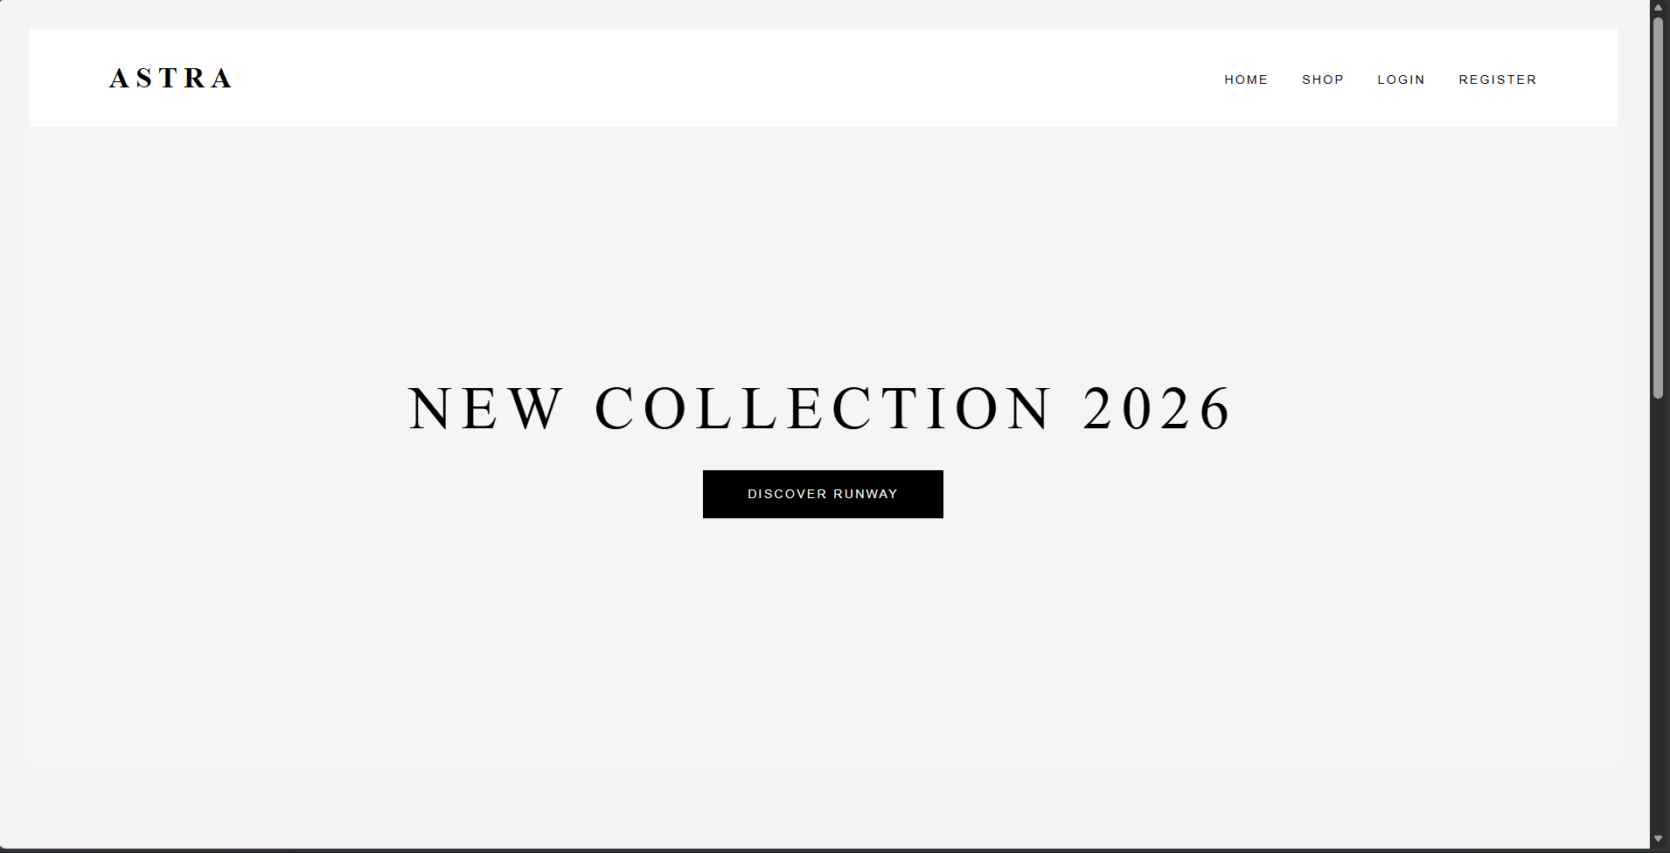

Task 2-

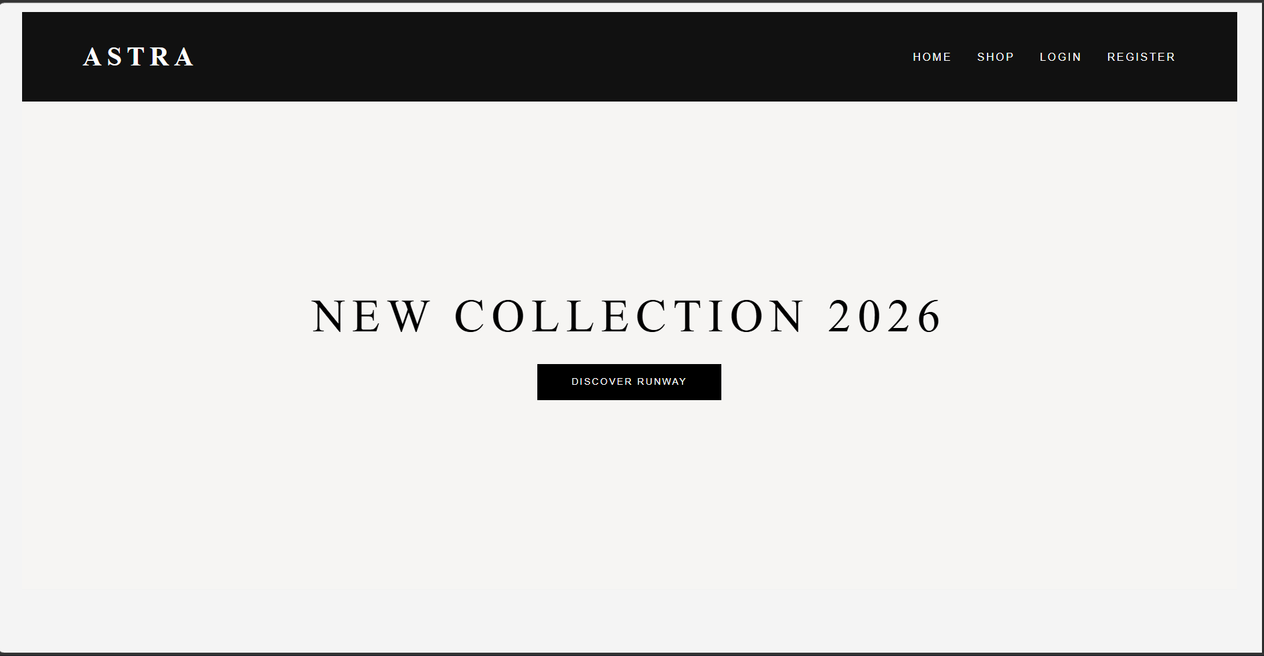

Task 3-
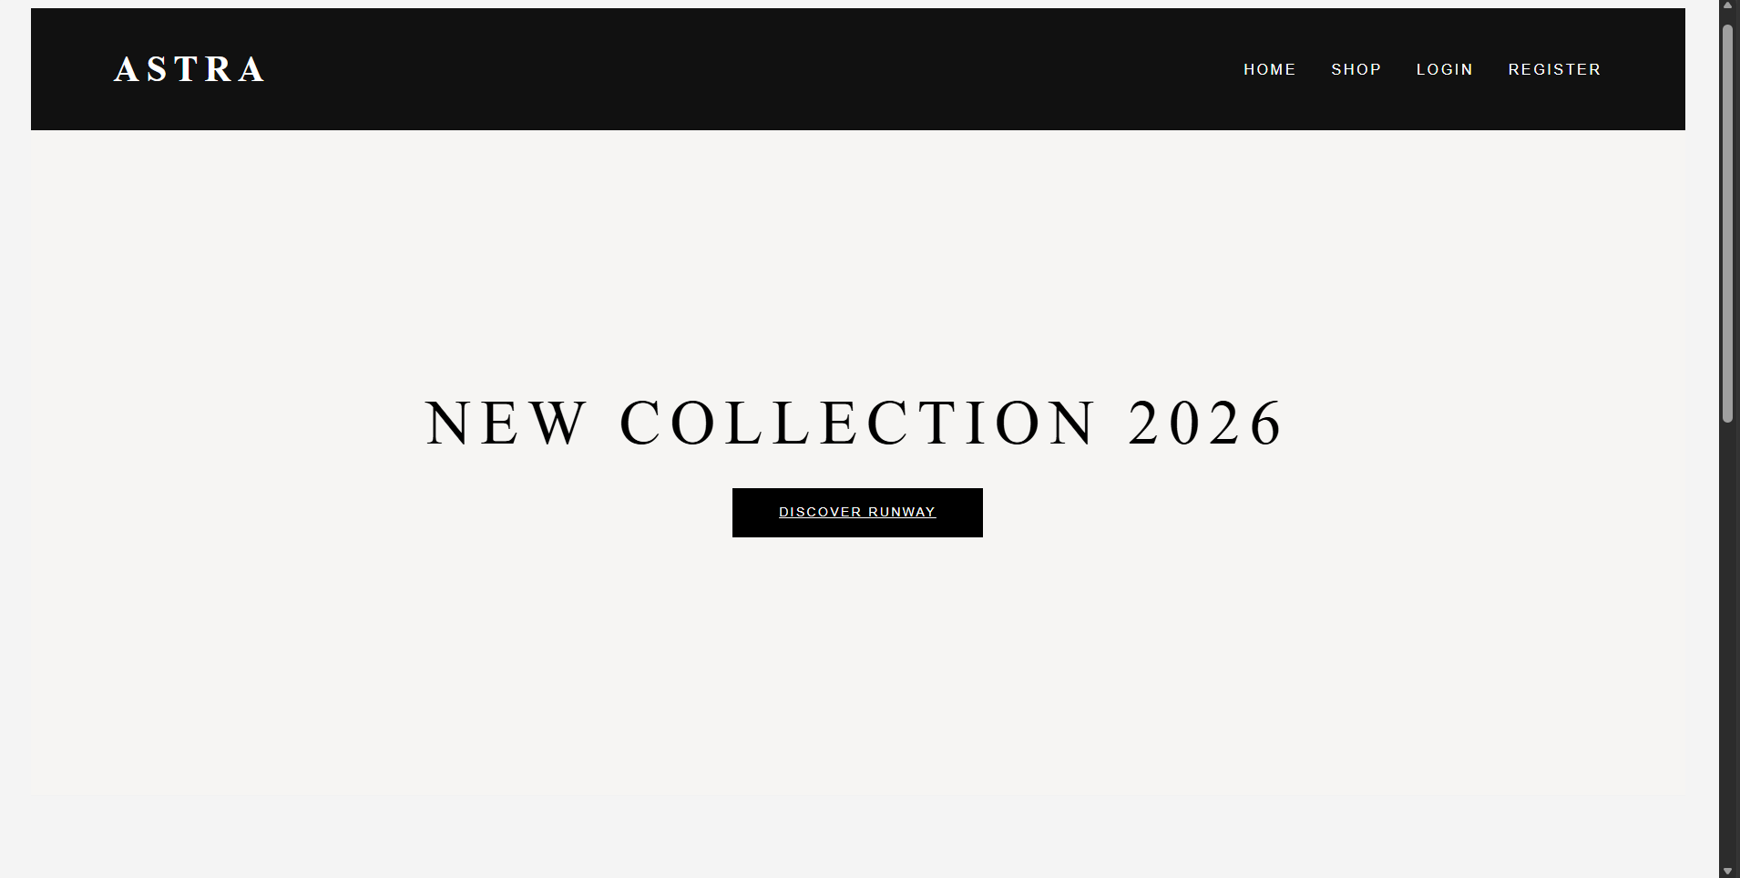

Task 4-
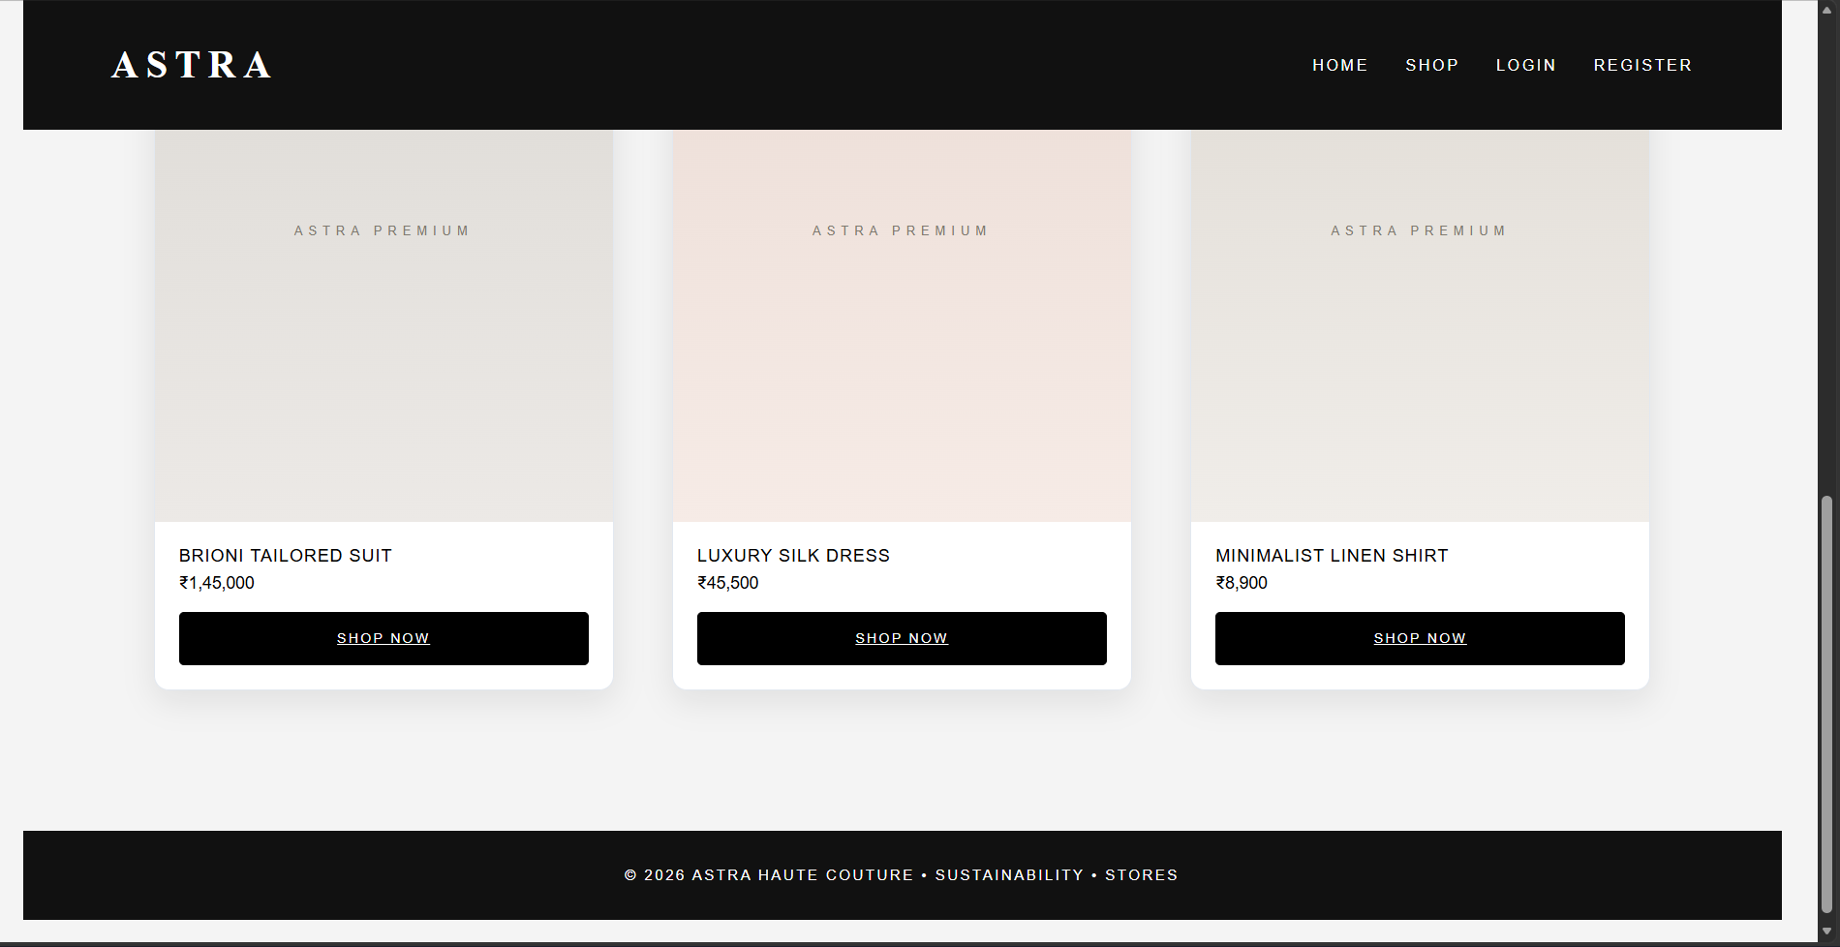

Task 5 –
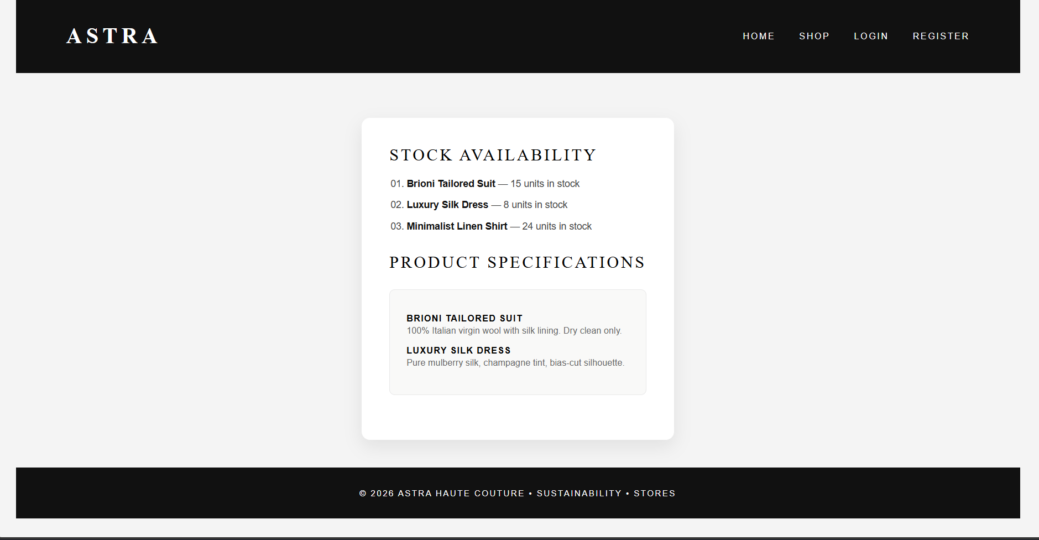

Task 6-
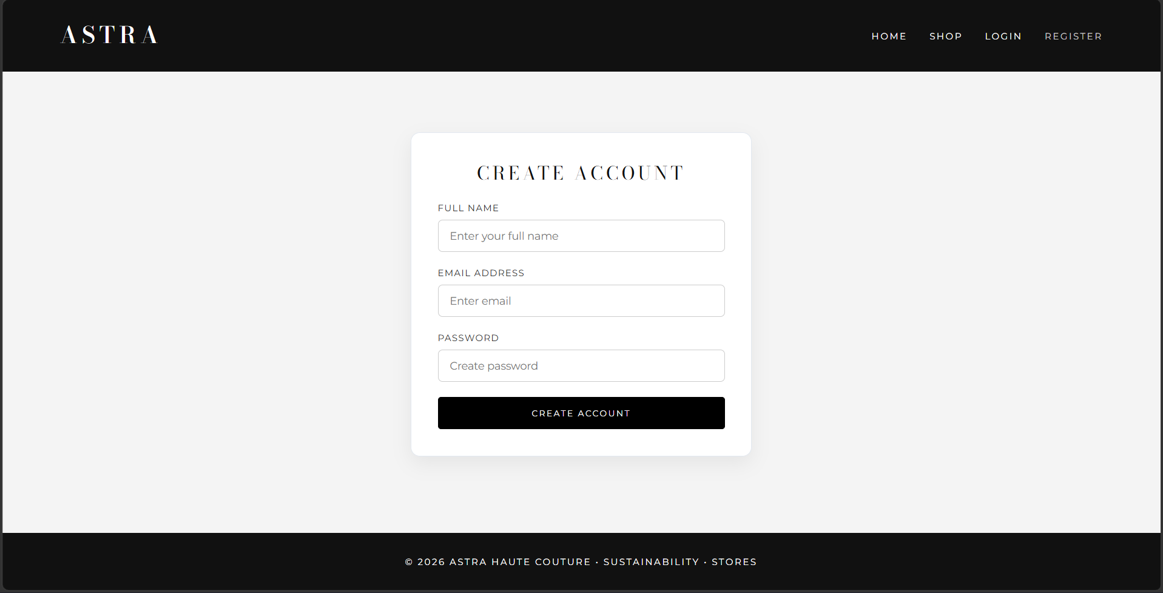

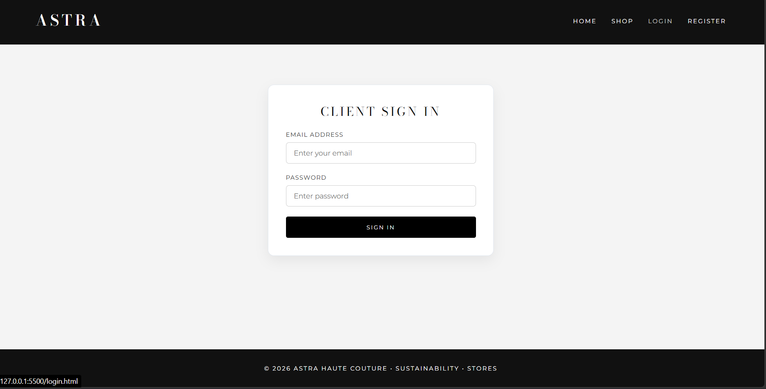

Link of the Generated website

Post Lab Subjective/Objective type Questions:
1. Write CSS code to create a responsive layout using Flexbox.
CSS
/* Responsive Flexbox Layout */
.flex-container {
display: flex;
flex-wrap: wrap;
gap: 20px;
padding: 20px;
}

.flex-item {
/*
flex: flex-grow flex-shrink flex-basis;
Allows items to grow, shrink, and maintain a baseline width of 300px
*/
flex: 1 1 300px;
background-color: #f1f5f9;
padding: 20px;
border-radius: 8px;
}
2. Write a media query for screens smaller than 768px.
CSS
/* Styles targeting viewports narrower than 768px */
@media screen and (max-width: 767px) {
body {
font-size: 14px;
}

.sidebar {
display: none; /* Example layout adjustment for mobile */
}
}
3. Justify the use of CSS animations in user interfaces.
CSS animations serve several vital UX and technical purposes:
- Improves User Feedback & Micro-interactions: Provides immediate visual confirmation for user actions (e.g., button presses, form submissions, page loading states).
- Guides User Attention: Directs the user's eye to high-priority elements, such as Call-to-Action (CTA) buttons, notifications, or errors.
- Reduces Cognitive Load: Smooth transitions between UI states (like sliding menus or expanding cards) help users maintain context, preventing abrupt context switching.
- High Performance & GPU Acceleration: CSS animations run off the main JavaScript thread and leverage hardware acceleration (using properties like transform and opacity), keeping the frame rate smooth (60fps) without degrading web performance.
4. Design a CSS animation for a call-to-action button.
HTML
<button class="cta-button">Get Started</button>
CSS
.cta-button {
background-color: #2563eb;
color: #ffffff;
font-size: 1rem;
font-weight: bold;
padding: 12px 28px;
border: none;
border-radius: 6px;
cursor: pointer;
/* Apply continuous pulse animation */
animation: pulse 2s infinite;
transition: transform 0.2s ease, background-color 0.2s ease;
}

/* Hover effect */
.cta-button:hover {
background-color: #1d4ed8;
transform: scale(1.05);
}

/* Pulse animation keyframes */
@keyframes pulse {
0% {
box-shadow: 0 0 0 0 rgba(37, 99, 235, 0.7);
}
70% {
box-shadow: 0 0 0 12px rgba(37, 99, 235, 0);
}
100% {
box-shadow: 0 0 0 0 rgba(37, 99, 235, 0);
}
}
5. Create a responsive navigation menu using Flexbox and media queries.
HTML
HTML
<nav class="navbar">
<div class="logo">MyBrand</div>
<ul class="nav-links">
<li><a href="#">Home</a></li>
<li><a href="#">About</a></li>
<li><a href="#">Services</a></li>
<li><a href="#">Contact</a></li>
</ul>
</nav>
CSS
CSS
/* Desktop / Base Styles */
.navbar {
display: flex;
justify-content: space-between;
align-items: center;
background-color: #0f172a;
padding: 15px 30px;
}

.logo {
color: #ffffff;
font-size: 1.5rem;
font-weight: bold;
}

.nav-links {
display: flex;
list-style: none;
gap: 20px;
margin: 0;
padding: 0;
}

.nav-links a {
color: #ffffff;
text-decoration: none;
font-weight: 500;
transition: color 0.3s ease;
}

.nav-links a:hover {
color: #38bdf8;
}

/* Mobile Media Query (< 768px) */
@media screen and (max-width: 767px) {
.navbar {
flex-direction: column;
align-items: flex-start;
gap: 15px;
}

.nav-links {
flex-direction: column; /* Stack menu items vertically */
width: 100%;
gap: 10px;
}

.nav-links li a {
display: block;
padding: 8px 0;
border-bottom: 1px solid #1e293b;
}
}

Conclusion:
In Experiment No. 2, the ASTRA E-Commerce portal was successfully developed using semantic HTML5 and centralized external CSS (style.css). Site-wide layout consistency was achieved across all portal pages (index.html, catalogue.html, login.html, and register.html) utilizing Flexbox sticky footer logic (min-height: 100vh), uniform main containers (max-width: 1200px), custom luxury typography (Bodoni Moda & Montserrat), and styled form controls to deliver a clean, modern user interface.

Signature of faculty in-charge with Date:

