Course Name: | Web Programming Laboratory (216U01L501) | Semester: | V
Date of Performance: | ___ / ___ / ______ | DIV/ Batch No: | A2
Student Name: | Abhishek D. Khedekar | Roll No: | 16014024029

Experiment No: 1
Title: Design the static web pages with the help of HTML5

Aim and Objective of the Experiment:
Design the static web pages with the help of HTML5.
Example: Need to change the application
A) Design the following static web pages required for your WPL Mini Project
For Example Online Book store website.
1) HOME PAGE:
2) LOGIN PAGE:
3) CATOLOGUE PAGE: The catalogue page should contain the details of all the Books available in the website in a table.
4) REGISTRATION PAGE
B) Create a table to show your class timetable.

COs to be achieved:
CO1

Problem Statement:
- Develop structured and semantic HTML5 documents
- Create interactive and media-rich web pages
- Apply real-world problem context to web development
- Build a basic but complete front-end web portal

HTML tags used:
<!DOCTYPE>, <a>, <body, <button>, <div>, <footer>, <form>, <h1>, <h2>, <h3>, <head>, <header>, <html>, <input>, <link>, <main>, <meta>, <nav>, <option>, <p>, <section>, <select>, <span>, <textarea>, <title>.

Code:
Index.html:-
<!DOCTYPE html>
<html lang="en">
<head>
<meta charset="UTF-8"><meta name="viewport" content="width=device-width, initial-scale=1.0">
<title>ASTRA | Home</title><link rel="stylesheet" href="style.css">
</head>
<body>
<header>
<a href="index.html" class="logo">ASTRA</a>
<nav><a href="index.html">Home</a><a href="catalogue.html">Shop</a><a href="login.html">Login</a><a href="register.html">Register</a></nav>
</header>
<section class="hero">
<h1>NEW COLLECTION 2026</h1>
<a href="catalogue.html" class="btn" style="width:auto; padding:15px 40px;">Discover Runway</a>
</section>
<main class="grid">
<div class="card item-1"><div class="img-wrap"></div><div class="details"><h3>Brioni Tailored Suit</h3><p class="price">₹1,45,000</p><a href="catalogue.html" class="btn">Shop Now</a></div></div>
<div class="card item-2"><div class="img-wrap"></div><div class="details"><h3>Luxury Silk Dress</h3><p class="price">₹45,500</p><a href="catalogue.html" class="btn">Shop Now</a></div></div>
<div class="card item-3"><div class="img-wrap"></div><div class="details"><h3>Minimalist Linen Shirt</h3><p class="price">₹8,900</p><a href="catalogue.html" class="btn">Shop Now</a></div></div>
</main>
<footer>&copy; 2026 ASTRA Haute Couture &bull; Sustainability &bull; Stores</footer>
</body>
</html>

Catalogue.html:-
<!DOCTYPE html>
<html lang="en">
<head>
<meta charset="UTF-8"><meta name="viewport" content="width=device-width, initial-scale=1.0">
<title>Shop Collection | ASTRA</title><link rel="stylesheet" href="style.css">
</head>
<body>
<header>
<a href="index.html" class="logo">ASTRA</a>
<nav><a href="index.html">Home</a><a href="catalogue.html">Shop</a><a href="login.html">Login</a><a href="register.html">Register</a></nav>
</header>
<main class="grid">
<div class="card item-1"><div class="img-wrap"></div><div class="details"><h3>Brioni Tailored Suit</h3><span class="cat">Suiting</span><p class="price">₹1,45,000</p><button class="btn">Buy</button></div></div>
<div class="card item-2"><div class="img-wrap"></div><div class="details"><h3>Silk Midi Dress</h3><span class="cat">Dresses</span><p class="price">₹45,500</p><button class="btn">Buy</button></div></div>
<div class="card item-3"><div class="img-wrap"></div><div class="details"><h3>Linen Resort Shirt</h3><span class="cat">Tops</span><p class="price">₹8,900</p><button class="btn">Buy</button></div></div>
<div class="card item-4"><div class="img-wrap"></div><div class="details"><h3>Wide Leg Trousers</h3><span class="cat">Bottoms</span><p class="price">₹14,200</p><button class="btn">Buy</button></div></div>
<div class="card item-5"><div class="img-wrap"></div><div class="details"><h3>Premium Leather Boots</h3><span class="cat">Shoes</span><p class="price">₹32,000</p><button class="btn">Buy</button></div></div>
<div class="card item-6"><div class="img-wrap"></div><div class="details"><h3>Suede Bomber Jacket</h3><span class="cat">Outerwear</span><p class="price">₹56,000</p><button class="btn">Buy</button></div></div>
<div class="card item-7"><div class="img-wrap"></div><div class="details"><h3>Selvedge Denim Jacket</h3><span class="cat">Outerwear</span><p class="price">₹18,500</p><button class="btn">Buy</button></div></div>
<div class="card item-8"><div class="img-wrap"></div><div class="details"><h3>Asymmetric Pleated Skirt</h3><span class="cat">Bottoms</span><p class="price">₹11,900</p><button class="btn">Buy</button></div></div>
<div class="card item-9"><div class="img-wrap"></div><div class="details"><h3>Classic Chunky Loafers</h3><span class="cat">Shoes</span><p class="price">₹24,000</p><button class="btn">Buy</button></div></div>
</main>
<footer>&copy; 2026 ASTRA Haute Couture</footer>
</body>
</html>

Login.html:-
<!DOCTYPE html>
<html lang="en">
<head>
<meta charset="UTF-8"><meta name="viewport" content="width=device-width, initial-scale=1.0">
<title>Sign In | ASTRA</title><link rel="stylesheet" href="style.css">
</head>
<body>
<header>
<a href="index.html" class="logo">ASTRA</a>
<nav><a href="index.html">Home</a><a href="catalogue.html">Shop</a><a href="login.html">Login</a><a href="register.html">Register</a></nav>
</header>
<div class="form-bg">
<div class="form-box">
<h2>SIGN IN</h2>
<form><input type="email" placeholder="Email Address" required><input type="password" placeholder="Password" required><button type="submit" class="btn">Access Account</button></form>
<a href="#">Forgot Password?</a>
</div>
</div>
<footer>&copy; 2026 ASTRA Haute Couture</footer>
</body>
</html>

Register.html:-
<!DOCTYPE html>
<html lang="en">
<head>
<meta charset="UTF-8"><meta name="viewport" content="width=device-width, initial-scale=1.0">
<title>Create Profile | ASTRA</title><link rel="stylesheet" href="style.css">
</head>
<body>
<header>
<a href="index.html" class="logo">ASTRA</a>
<nav><a href="index.html">Home</a><a href="catalogue.html">Shop</a><a href="login.html">Login</a><a href="register.html">Register</a></nav>
</header>
<div class="form-bg">
<div class="form-box" style="max-width: 540px;">
<h2>CREATE PROFILE</h2>
<form>
<input type="text" placeholder="Full Name" required><input type="email" placeholder="Email Address" required>
<input type="tel" placeholder="Mobile Number" required><input type="password" placeholder="Password" required>
<input type="password" placeholder="Confirm Password" required>
<select required><option value="">Select Gender</option><option>Female</option><option>Male</option><option>Non-Binary</option></select>
<textarea placeholder="Delivery Address" rows="2" required></textarea>
<button type="submit" class="btn">Register Account</button>
</form>
</div>
</div>
<footer>&copy; 2026 ASTRA Haute Couture</footer>
</body>
</html>

Style.css:-
/* ASTRA Runway Ultra-Aesthetic Engine */
@import url('https://googleapis.com');
* { margin: 0; padding: 0; box-sizing: border-box; font-family: 'Montserrat', sans-serif; text-decoration: none; color: #000; }
body { background: #ffffff; min-height: 100vh; display: flex; flex-direction: column; }

/* Navigation Bar with Clickable Left Logo */
header { display: flex; justify-content: space-between; align-items: center; padding: 30px 5%; background: #fff; border-bottom: 1px solid #f2f2f2; position: sticky; top: 0; z-index: 100; }
.logo { font-family: 'Bodoni Moda', serif; font-size: 26px; font-weight: 600; letter-spacing: 6px; cursor: pointer; display: inline-block; }
nav a { margin-left: 30px; font-size: 11px; text-transform: uppercase; letter-spacing: 2px; font-weight: 300; transition: opacity 0.3s; }
nav a:hover { opacity: 0.5; }

/* Hero Banner Layout */
.hero { height: 75vh; background: #f6f5f3; display: flex; flex-direction: column; justify-content: center; align-items: center; text-align: center; border-bottom: 1px solid #f2f2f2; padding: 0 20px; }
.hero h1 { font-family: 'Bodoni Moda', serif; font-size: clamp(32px, 5vw, 55px); font-weight: 400; letter-spacing: 8px; margin-bottom: 25px; text-transform: uppercase; }

/* Pure CSS Graphic Grid Layout Framework */
.grid { display: grid; grid-template-columns: repeat(auto-fit, minmax(320px, 1fr)); gap: 50px 30px; padding: 8% 5%; max-width: 1400px; margin: 0 auto; width: 100%; }
.card { display: flex; flex-direction: column; background: #fff; }

/* Premium Layout Grid Canvas Blocks */
.img-wrap { width: 100%; height: 480px; overflow: hidden; position: relative; display: flex; align-items: center; justify-content: center; transition: all 0.5s ease; border-radius: 2px; }
.card:hover .img-wrap { transform: translateY(-4px); box-shadow: 0 15px 30px rgba(0,0,0,0.04); }

/* Luxury Presentation Hues (Zara Minimalist Style) */
.item-1 .img-wrap { background: linear-gradient(180deg, #dcd9d4 0%, #ece9e6 100%); }
.item-2 .img-wrap { background: linear-gradient(180deg, #ebdcd5 0%, #f6ebe6 100%); }
.item-3 .img-wrap { background: linear-gradient(180deg, #dfdad3 0%, #f0ede9 100%); }
.item-4 .img-wrap { background: linear-gradient(180deg, #cfd3d6 0%, #eef1f5 100%); }
.item-5 .img-wrap { background: linear-gradient(180deg, #dcd7cf 0%, #ebe7e0 100%); }
.item-6 .img-wrap { background: linear-gradient(180deg, #d2cbd4 0%, #e7e2e8 100%); }
.item-7 .img-wrap { background: linear-gradient(180deg, #cbd4d2 0%, #e2e8e7 100%); }
.item-8 .img-wrap { background: linear-gradient(180deg, #ece9e6 0%, #ffffff 100%); }
.item-9 .img-wrap { background: linear-gradient(180deg, #dad6d1 0%, #f1eee9 100%); }

.img-wrap::after { content: 'ASTRA PREMIUM'; font-size: 10px; letter-spacing: 5px; color: #7f7a70; font-weight: 300; text-transform: uppercase; }

/* Form Graphics Configuration */
.form-bg { background: #f6f5f3; flex: 1; display: flex; justify-content: center; align-items: center; padding: 60px 20px; }
.form-box { background: #fff; border: 1px solid #e5e5e5; padding: 50px 40px; width: 100%; max-width: 460px; box-shadow: 0 10px 30px rgba(0,0,0,0.01); }
.form-box h2 { font-family: 'Bodoni Moda', serif; font-size: 24px; font-weight: 400; letter-spacing: 4px; margin-bottom: 35px; text-align: center; text-transform: uppercase; }
input, select, textarea { width: 100%; padding: 14px; margin-bottom: 20px; border: 1px solid #e5e5e5; font-size: 13px; font-weight: 300; background: #fff; }
input:focus, select:focus, textarea:focus { border-color: #000; outline: none; }
.form-box a { display: block; text-align: center; font-size: 11px; letter-spacing: 1px; text-transform: uppercase; margin-top: 15px; color: #777; }

/* Core Card Microcopy Elements */
.details { padding-top: 20px; text-align: left; }
.card h3 { font-size: 14px; font-weight: 400; letter-spacing: 1px; text-transform: uppercase; margin-bottom: 6px; }
.card .cat { font-size: 11px; color: #777; text-transform: uppercase; letter-spacing: 1px; margin-bottom: 8px; display: block; }
.card p.price { font-size: 14px; font-weight: 500; margin-bottom: 15px; }
.btn { display: block; width: 100%; padding: 15px; background: #000; color: #fff; text-align: center; font-size: 11px; text-transform: uppercase; letter-spacing: 2px; border: 1px solid #000; transition: all 0.3s ease; cursor: pointer; }
.btn:hover { background: #fff; color: #000; }

footer { margin-top: auto; padding: 40px; text-align: center; font-size: 11px; text-transform: uppercase; letter-spacing: 2px; color: #777; border-top: 1px solid #f2f2f2; background: #fff; }
@media (max-width: 768px) { header { flex-direction: column; gap: 15px; } nav a { margin: 0 10px; } }

Stepwise-Procedure / Algorithm:
1. • Initialize Project Setup
- Create a project directory and set up the five required source files: index.html, catalogue.html, login.html, register.html, and style.css.
• Develop the Home Page (index.html)
- Define the HTML5 document layout (<!DOCTYPE html>, <html>, <head>, <body>).
- Link the external stylesheet (style.css) inside the <head> section.
- Add a sticky <header> with the brand logo and navigation links (<nav>) pointing to all site pages.
- Add a <section class="hero"> containing a main headline (<h1>) and a call-to-action link button (<a>).
- Create a grid container (<main class="grid">) displaying top featured product cards, including product image placeholders, titles, prices, and buttons.
- Add the <footer> section with copyright and company details.
• Develop the Shop Catalogue Page (catalogue.html)
- Maintain design consistency by including the identical <header> navigation and <footer> sections.
- Build an expanded product grid inside <main class="grid"> containing product items (item-1 through item-9).
- Add product details within each card: category label (<span class="cat">), title (<h3>), price (<p>), and a "Buy" button (<button>).
• Develop the Login Page (login.html)
- Reuse the global <header> and <footer>.
- Create a form container (<div class="form-box">) inside a centered background wrapper (<div class="form-bg">).
- Build the sign-in form with required inputs for email and password, a "Submit" button, and a "Forgot Password?" hyperlink.
• Develop the Registration Page (register.html)
- Reuse the global <header> and <footer>.
- Create a wider form container (<div class="form-box">) to accommodate user details.
- Include input fields for Full Name (text), Email (email), Mobile Number (tel), Password (password), Confirm Password (password), Gender (<select> dropdown), and Delivery Address (<textarea>).
• Style and Layout the Website (style.css)
- CSS Reset & Fonts: Reset padding/margin globally (*) and set font families (Montserrat and Bodoni Moda).
- Navigation & Hero: Style the header to stick to the top (position: sticky) and align navigation links.
- CSS Grid Layout: Apply display: grid with grid-template-columns: repeat(auto-fit, minmax(320px, 1fr)) to create a responsive product grid.
- Aesthetics & Cards: Add soft linear-gradient background colors (.item-1 to .item-9) for product image wraps and implement hover animation effects (transform: translateY(-4px)).
- Forms & Controls: Style inputs, select fields, textareas, and buttons (.btn) with sleek border transitions and focus states.
- Responsiveness: Add media queries (@media (max-width: 768px)) to stack header elements vertically on smaller screens.
• Test & Verify
- Open index.html in a web browser to ensure seamless navigation across links, proper form validation (required attributes), and responsive visual layout.

Output
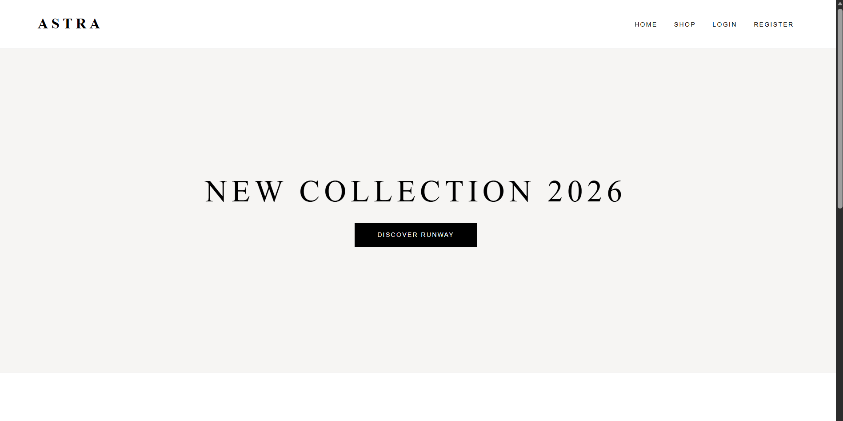

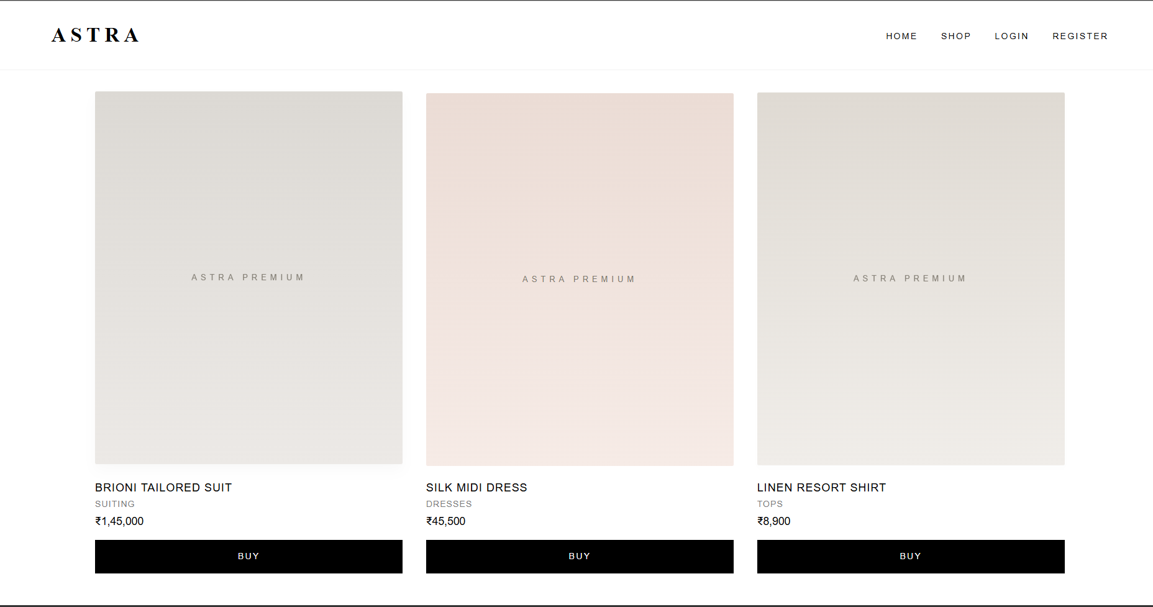

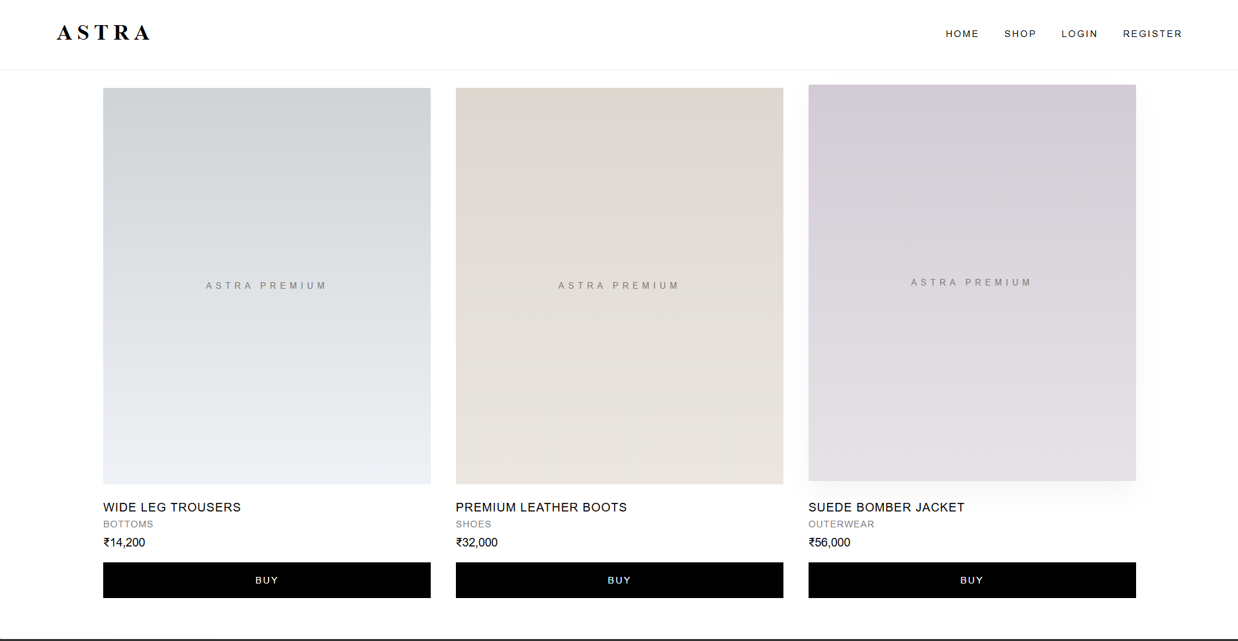

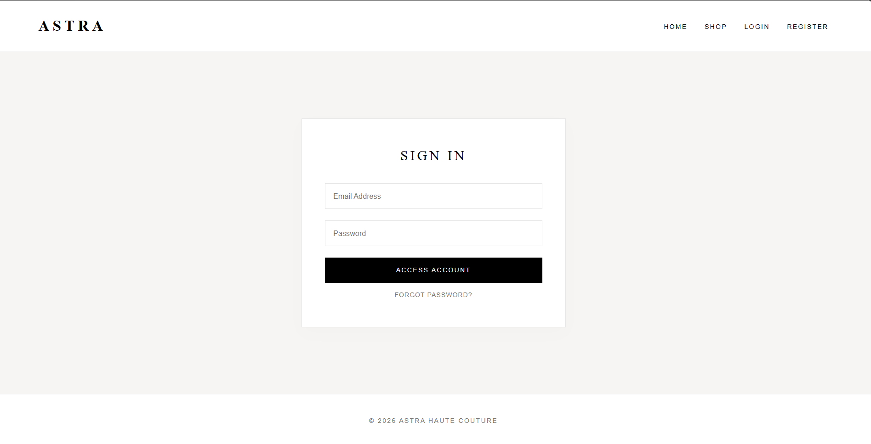

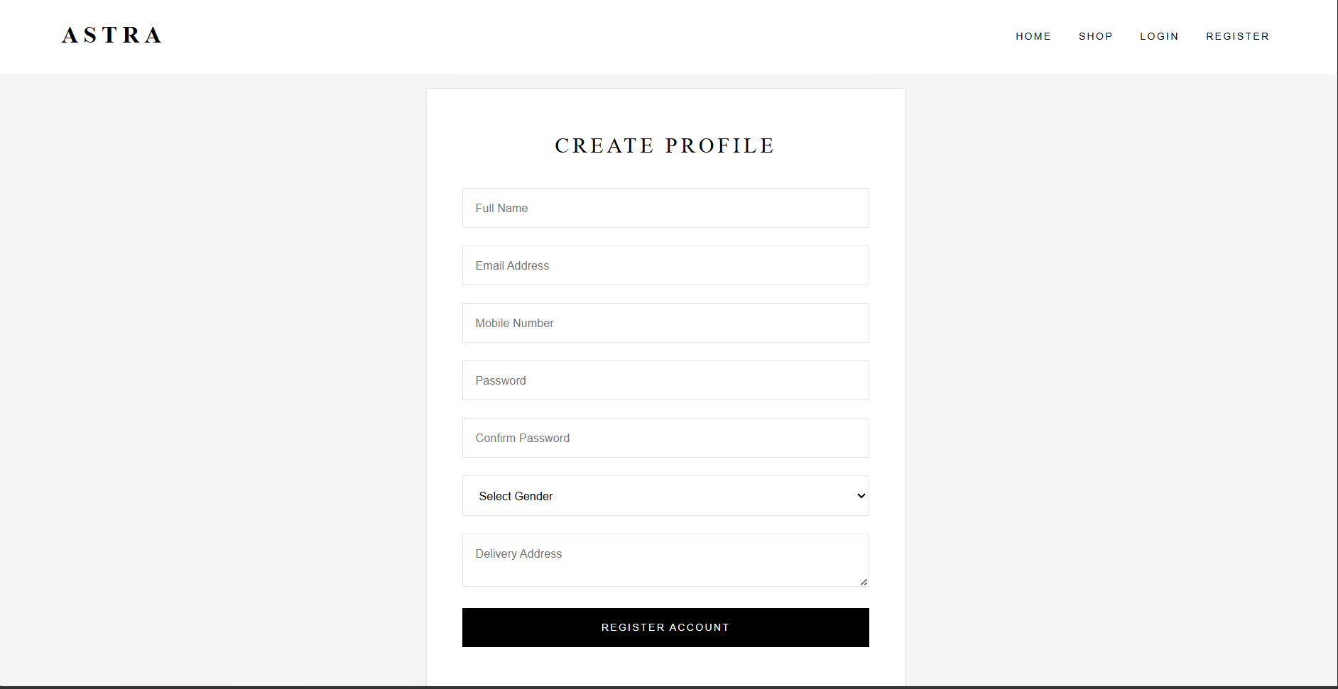

Link of the Generated website
ASTRA | Home

Post Lab Subjective/Objective type Questions:
- Write HTML code to create a hyperlink that opens in a new tab.
Ans <a href="https://example.com" target="_blank" rel="noopener noreferrer"> Explore Collection </a>
- Differentiate between block-level and inline elements with examples.
Ans
Feature | Block-Level Elements | Inline Elements
Line Behavior | Always starts on a new line. | Renders inline without forcing a new line.
Width / Height | Takes up the full available width of its parent container unless styled otherwise. | Takes up only as much width as necessary for its content.
Margin / Padding | Top, bottom, left, and right margins/padding are fully respected. | Top and bottom margins/padding are mostly ignored; left and right are respected.
Examples | <div>, <p>, <h1>-<h6>, <header>, <main>, <section>, <footer> | <span>, <a>, <strong>, <em>, <img>, <label>

- Why are semantic tags preferred over <div> tags?
Ans While <div> elements are non-semantic containers that offer no structural context, semantic tags (<header>, <nav>, <main>, <article>, <section>, <footer>) clearly describe their meaning to both the browser and developer.
- Accessibility (a11y): Screen readers use semantic landmarks to help visually impaired users navigate directly to main content, headers, or menus.
- SEO Optimization: Search engines process semantic markup more effectively, indexing page structure and prioritizing core content.
- Code Maintainability: Semantic code avoids "div soup," making layouts far easier to read, debug, and maintain across development teams.

- Why is <iframe> preferred over <frame> in modern HTML?
Ans • Deprecation: The <frame> and <frameset> tags were deprecated in HTML4 and completely removed in HTML5. Modern browsers no longer support multi-frame window layouts.
• Document Flow Integration: <iframe> (Inline Frame) embeds external content directly within a standard single-document DOM, allowing normal scrolling, layout control, and responsive styling via CSS.
• Security & Control: <iframe> supports modern HTML5 security attributes like sandbox and allow to restrict untrusted external content.
• Mobile & Responsive Friendliness: Framesets break layout responsiveness, bookmarking, and screen navigation on mobile devices, whereas <iframe> fits seamlessly into modern flexible layouts.

- Evaluate the importance of using alt attribute in images.
Ans The alt (alternative text) attribute provides a textual fallback for images:
- Accessibility: Assists users with visual impairments by allowing screen readers to describe the image content aloud.
- Broken Asset Fallback: Displays descriptive text if an image fails to load due to poor connectivity, broken file paths, or blocked content.
- Image Search Engine Optimization (SEO): Helps web crawlers contextualize images, improving rankings in Google Images and visual search results.

Suggest two additional features that can improve the given web portal and explain how HTML5 supports them
• Feature 1: Fashion Runway Video Preview
- HTML5 Support: Utilizes the native <video> element (with <source>) to seamlessly play background video clips of runway shows directly in the browser without third-party plugins like Flash.
• Feature 2: Product Search Autocomplete
- HTML5 Support: Utilizes <input type="search"> combined with the <datalist> element to provide native, instant search suggestions as users type item names, reducing the need for external JavaScript libraries.

Conclusion:
Building a modern, responsive web portal like ASTRA relies on clean, accessible, and standards-compliant HTML5.
By leveraging modern web standards—such as utilizing semantic elements for structured code, adhering to accessibility standards via the alt attribute, transitioning away from deprecated legacy tags like <frame>, and integrating native HTML5 tools like <video> and <datalist>—developers can craft web applications that excel in performance, search engine visibility (SEO), and user experience. Adopting these fundamental principles ensures that web applications remain scalable, maintainable, and inclusive for all users.

Signature of faculty in-charge with Date:

