Course Name: | Web Programming Laboratory (216U01L501) | Semester: | V
Date of Performance: | ___ / ___ / ______ | DIV/ Batch No: | A2
Student Name: | Abhishek D. Khedekar | Roll No: | 16014024029

Experiment No: 3
Title To design and develop a responsive, component-rich Web Portal using the Bootstrap
framework, incorporating grids, layouts, navigation, alerts, input groups, pagination, and custombstyled components.

Aim and Objective of the Experiment:
- Implement Responsive Containers: Use Bootstrap container classes to manage margins,
- paddings, and responsive layout behavior across different viewport sizes.
- Design a flexible, mobile-first multi-column layout using rows and responsive column classes.
- Integrate Key Bootstrap Components: Implement user-friendly elements including navigation bars, input groups with icons, dropdowns, alerts, and pagination.

COs to be achieved:
CO2:

Problem Statement:
Task 1: Layout &amp; Container Setup

Use Case: Set up a clean webpage layout with responsive margins.
Requirements:
• .container
• .container-fluid
• Breakpoint constraints using a Bootstrap container to manage margin alignment.

Task 2: Responsive Grid Layout

Use Case: Present contents dynamically side-by-side on desktop and stacked on mobile devices.
Requirements:
• Build a grid utilizing rows and column definitions (e.g.,.col-md-4, .col-sm-12).

• Grid system
• .row
• .col-*

Task 3: Navigation &amp;Search Bar

Use Case: Provide accessible menu routes and global site search.
Requirements:
• Create a responsive navbar with links/dropdown.
• Insert search input-group featuring a search icon.
• .navbar
• .input-group
• Iconography (Glyphicon/Bootstrap Icons)

Task 4: Circle Image Shaping

Use Case: Style images or profile avatars in an elegant layout.
Requirements:
• Add layout image and style it into a clean circle using utility classes.
• .rounded-circle
• Responsive image helpers

Task 5: Alerts &amp; Pagination Use Case: Notify users of statuses and provide paging layout navigation.
Requirements:
• Include interactive alert messages.
• Implement standard paginated navigation at bottom.
• .alert, .alert-dismissible
• .pagination
• .page-item, .page-link

HTML tags used:
<header>, <nav>, <main>, <footer>, <div>, <h1>, <h2>, <h3>, <p>, <a>, <span>, <button>, <input>, <form>, <img>, <ul>, <li>

Code:
Index.html
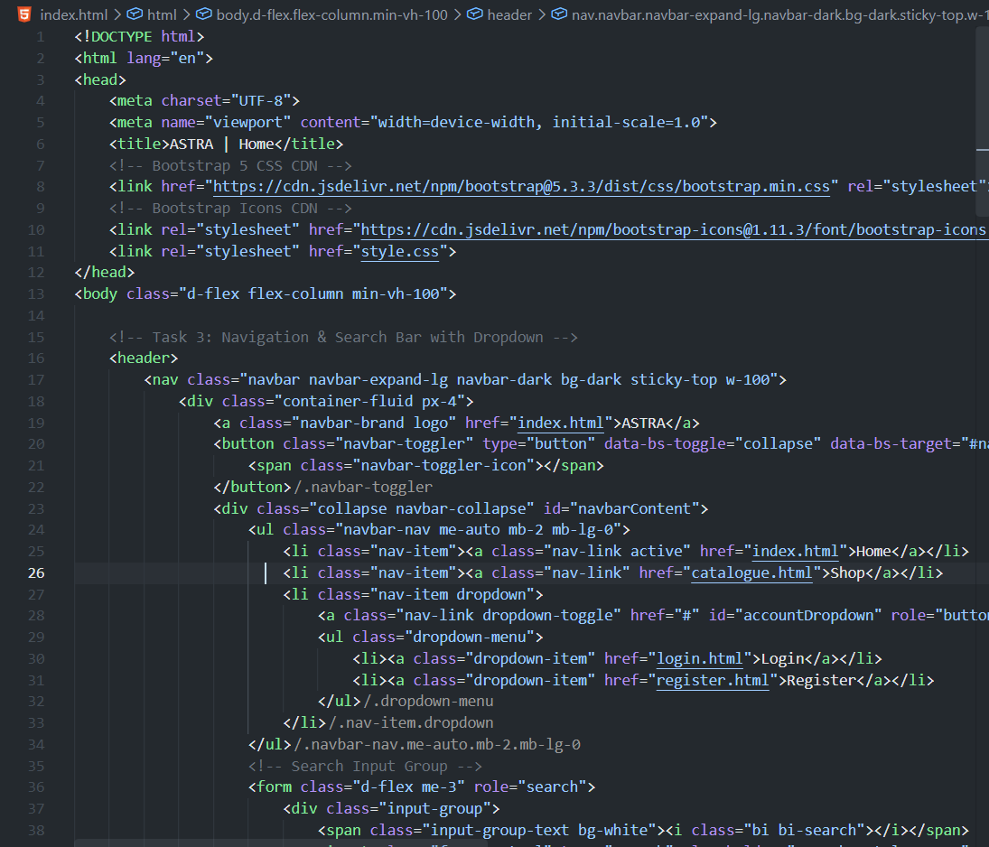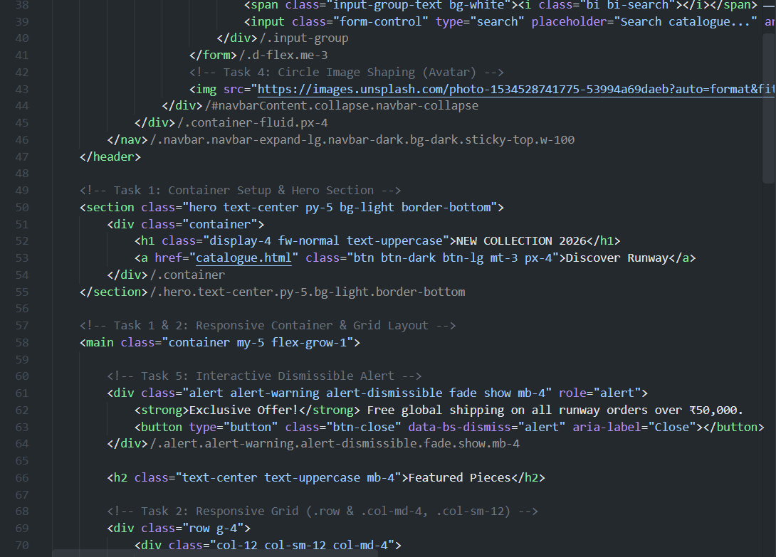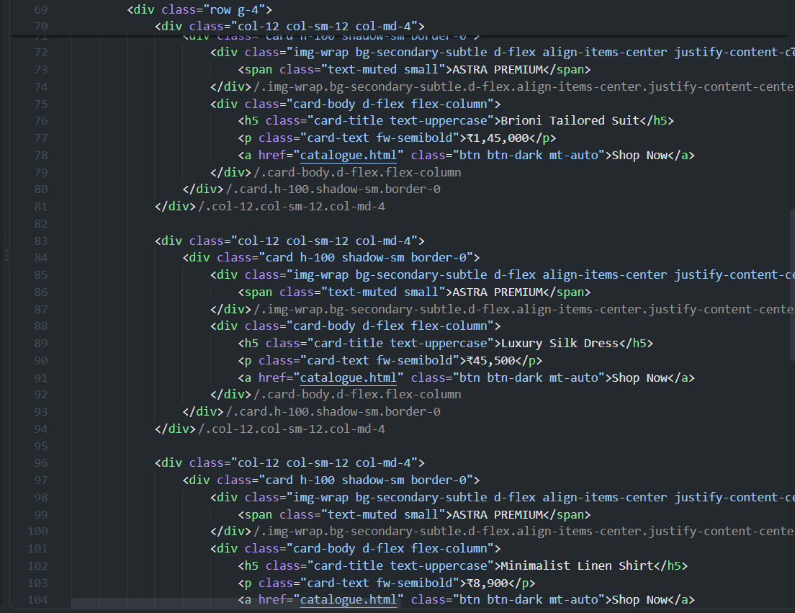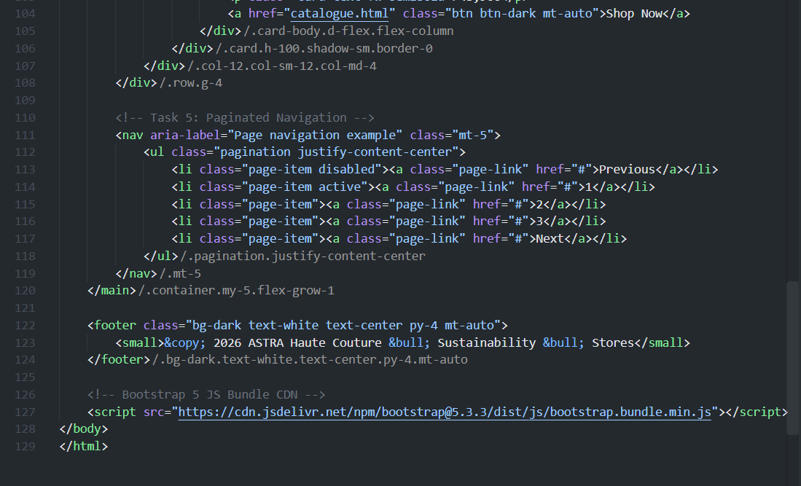

Cataloge.html
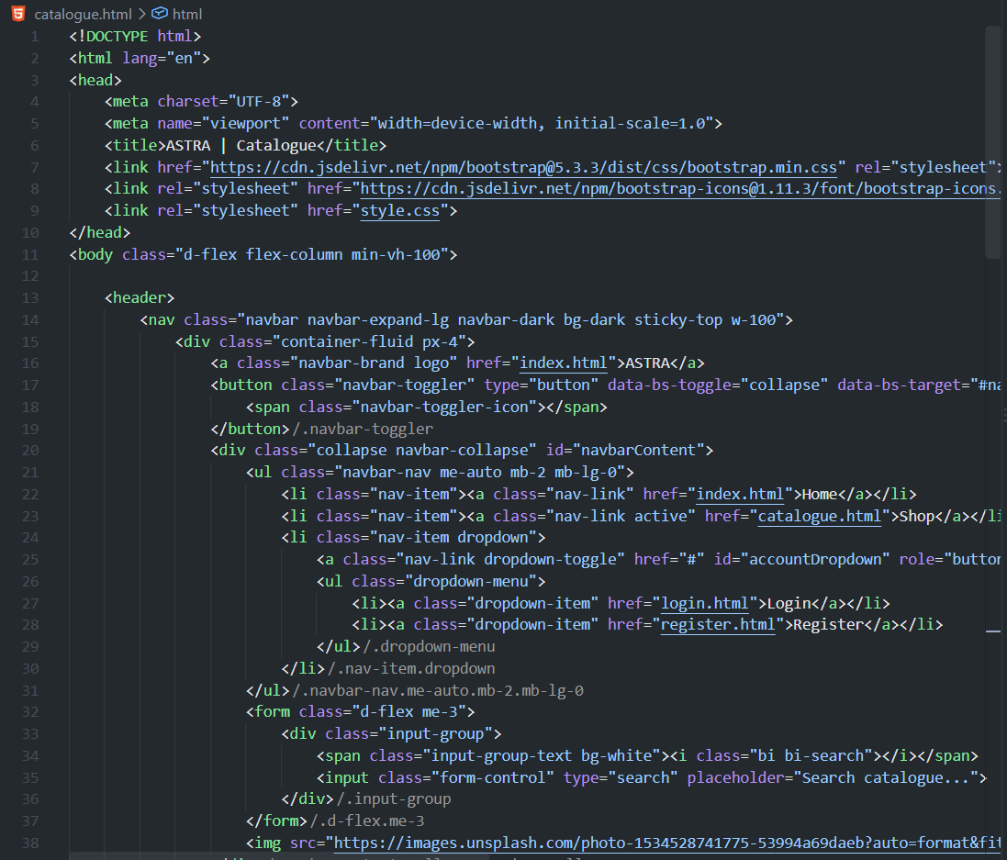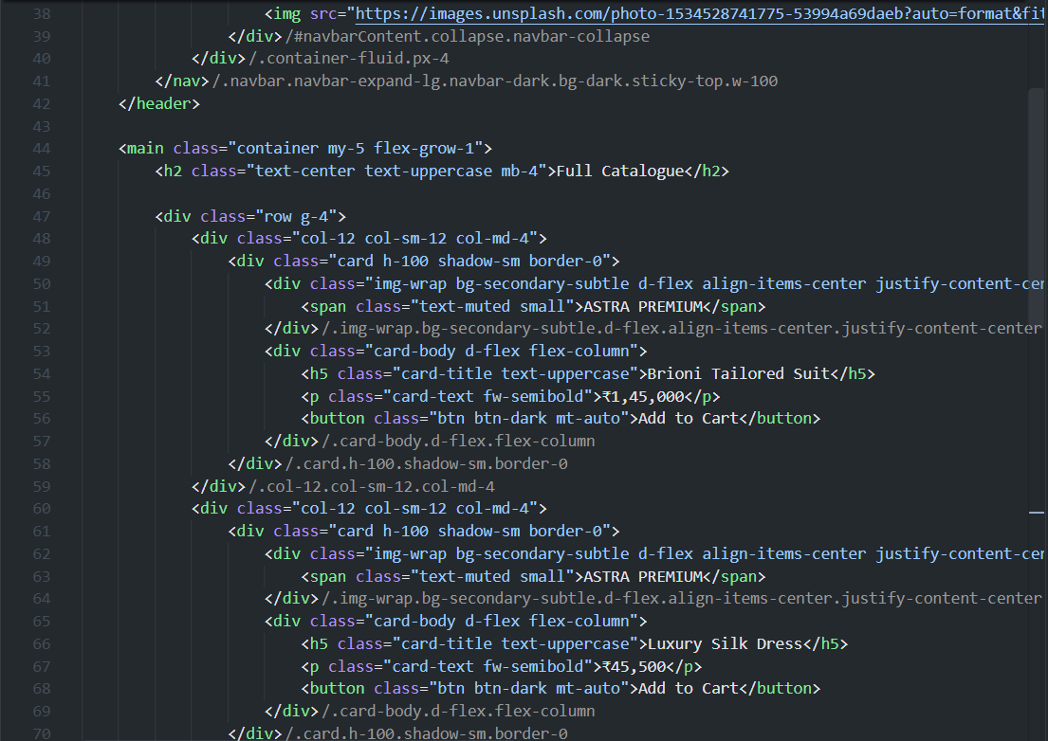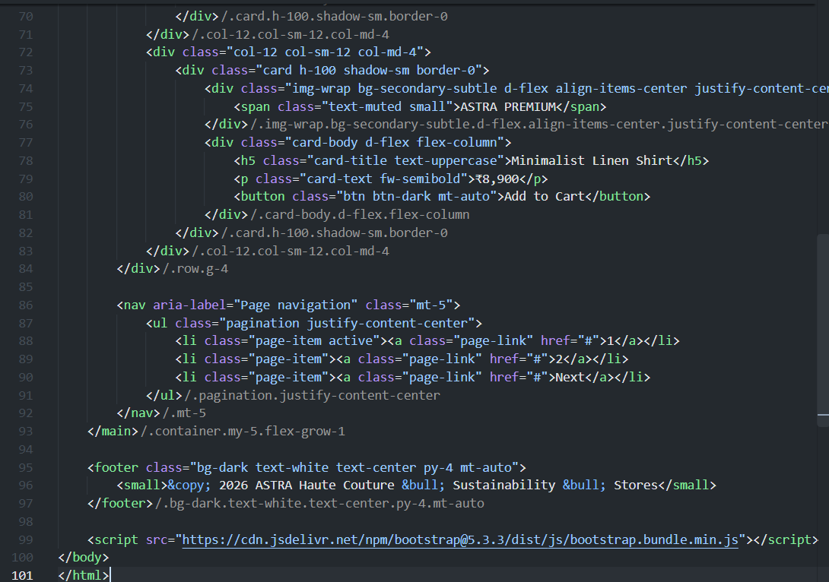

Login.html
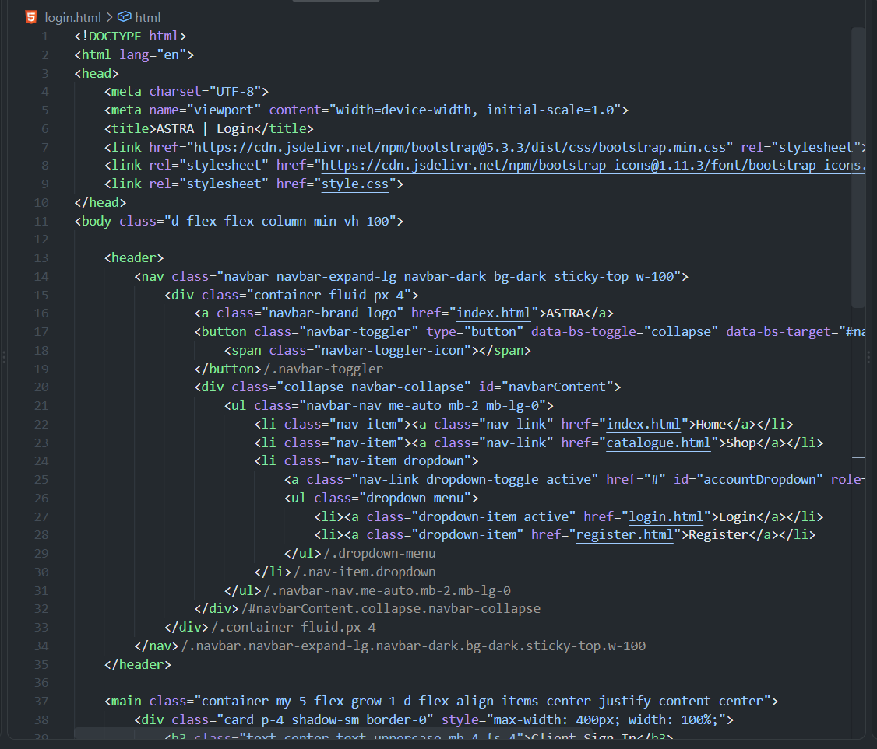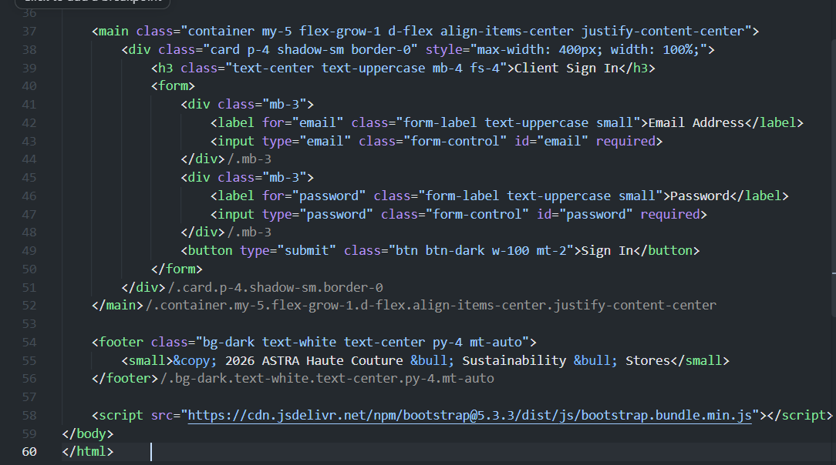

Register.html
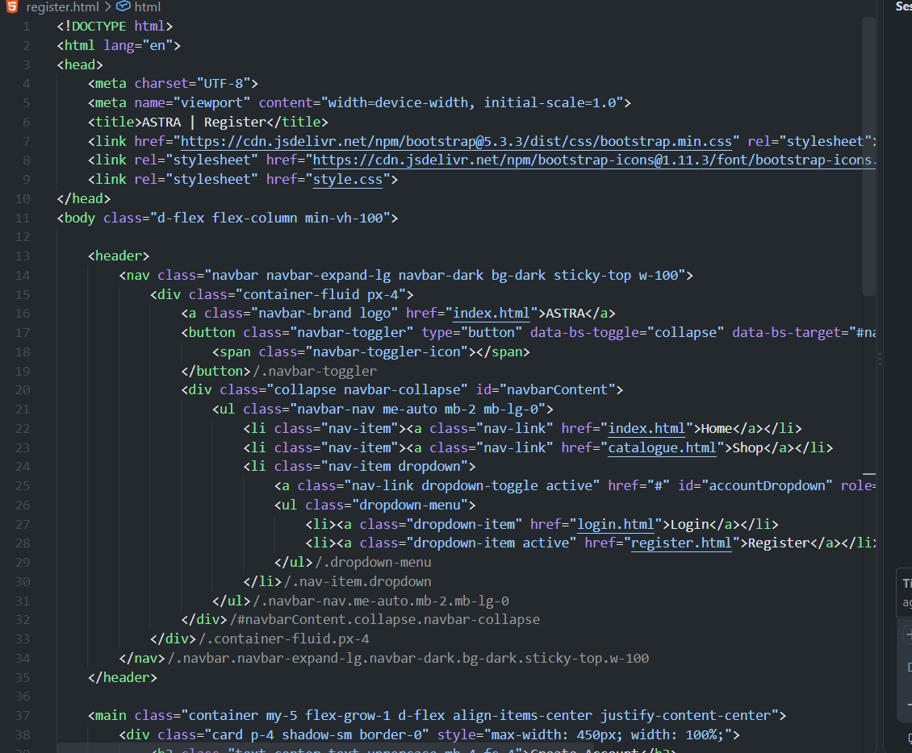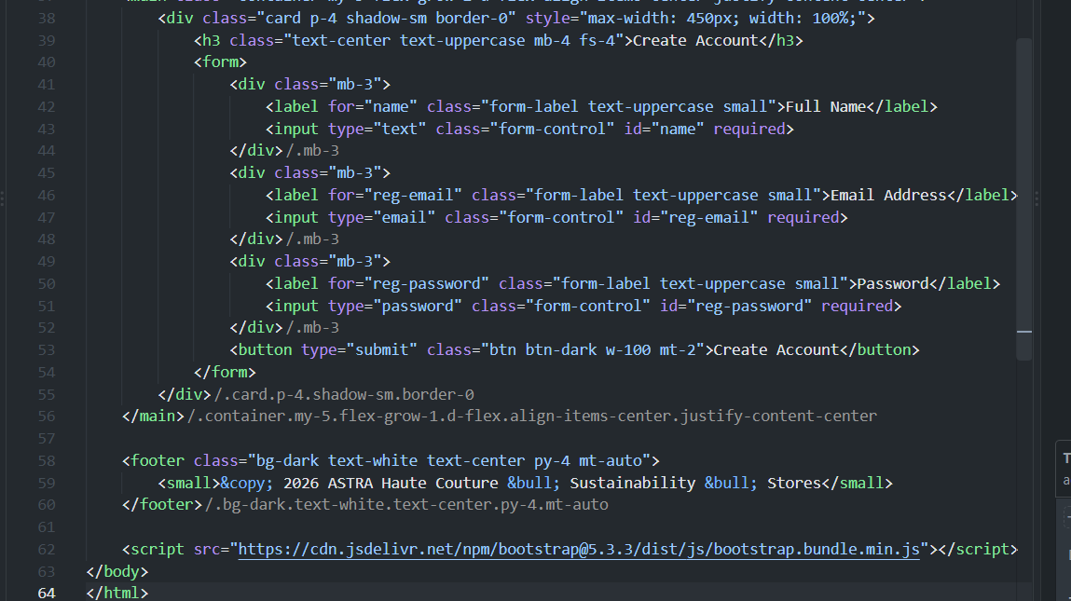

Style.css
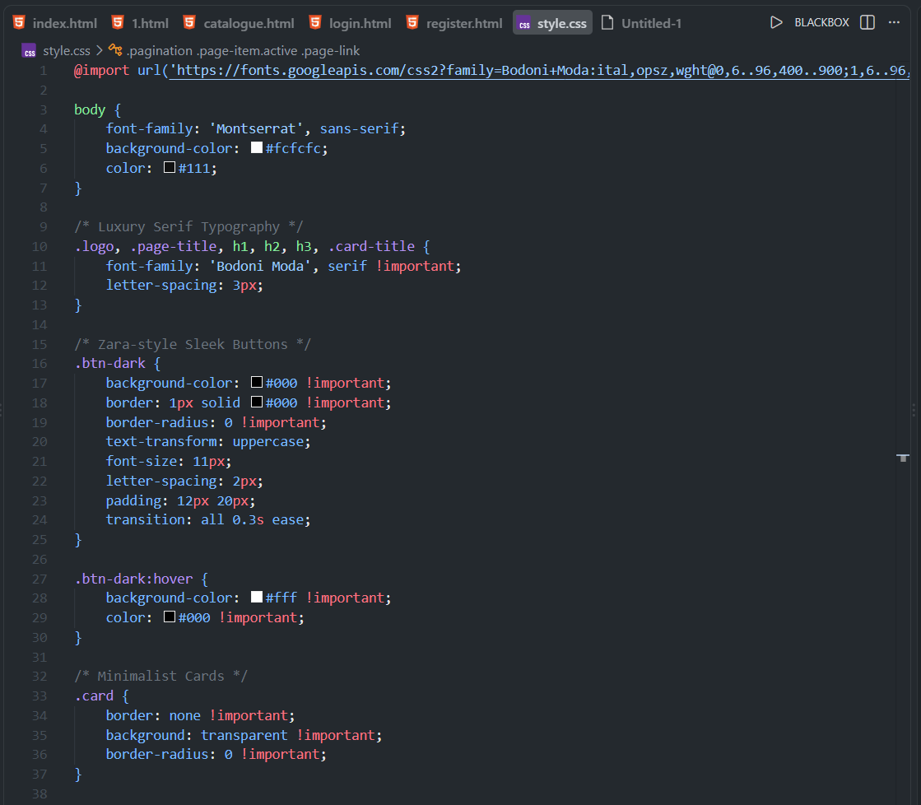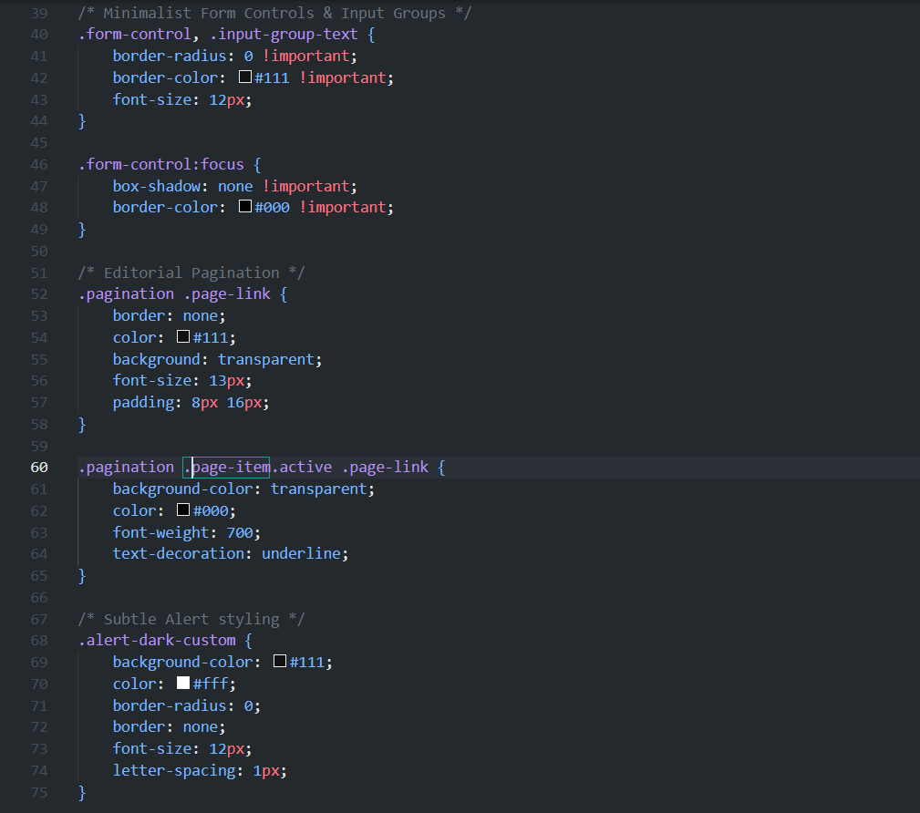

Stepwise-Procedure / Algorithm:
1. Setup Environment: Link the Bootstrap 5 CSS CDN in the <head> and JS Bundle before the closing </body> tag.
Layout Setup: Build a responsive top navigation bar (.navbar) wrapped in .container-fluid and center main page content inside .container.
Navbar & Inputs: Implement an .input-group search bar with icon and a circular profile avatar using .rounded-circle.
Responsive Grid: Create a product catalog grid using .row and breakpoint column classes (.col-12 .col-sm-12 .col-md-4) for mobile/desktop layout switching.
Interactive Components: Add a top banner using .alert-dismissible with a close button and bottom navigation using .pagination

Output
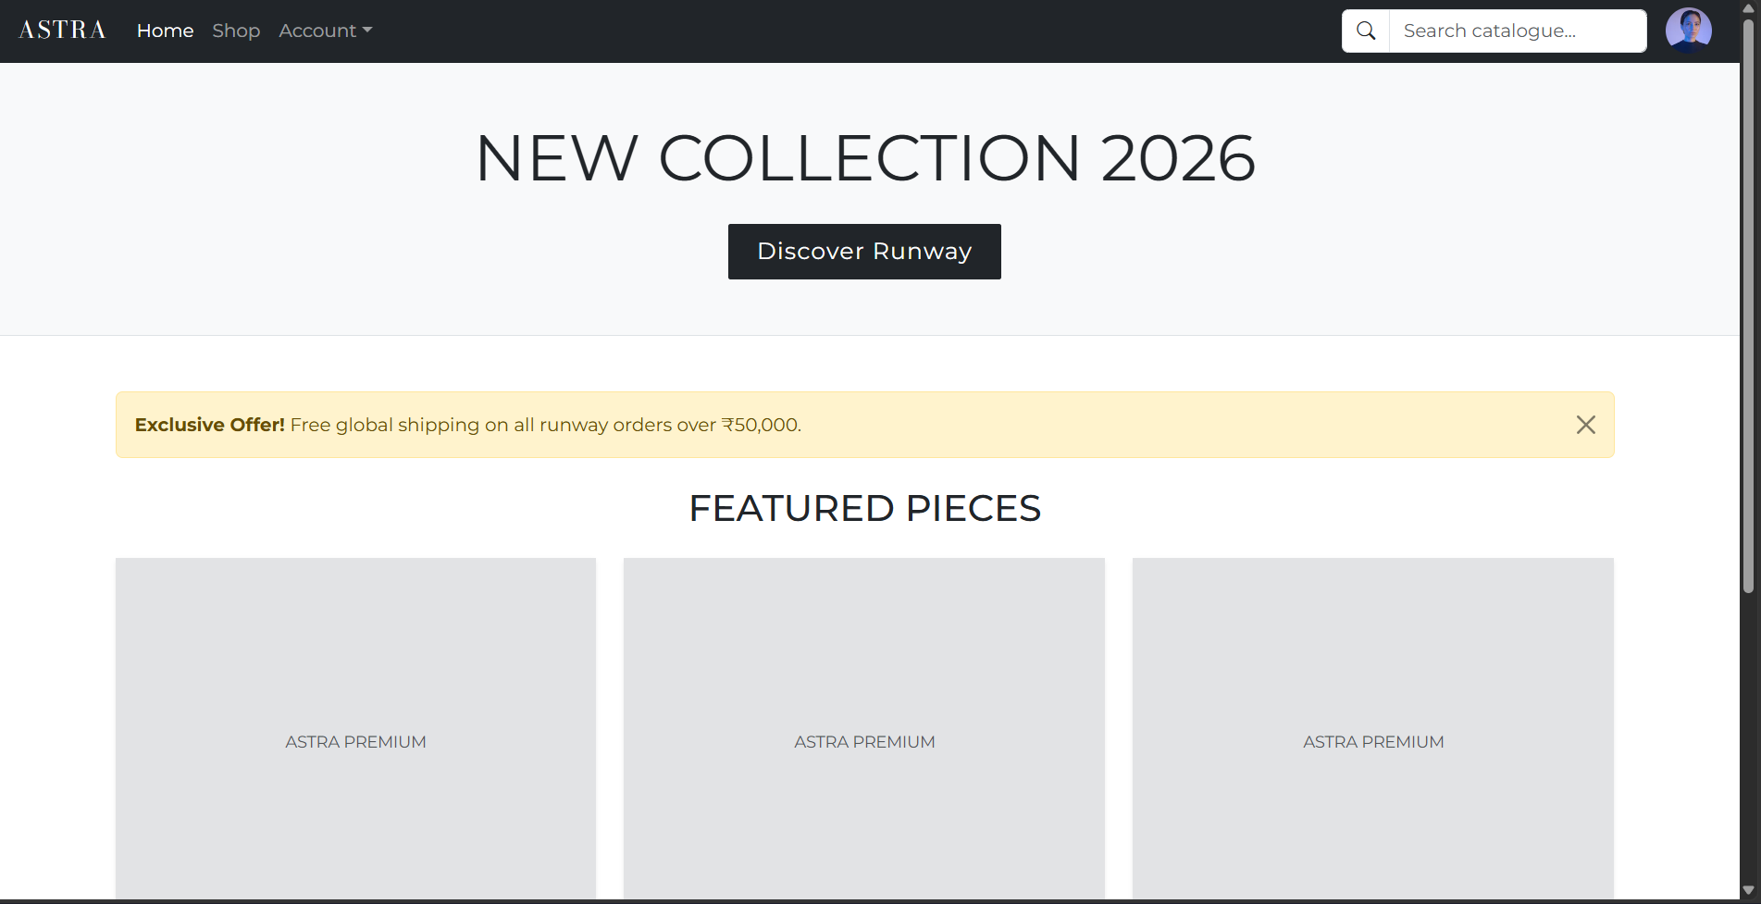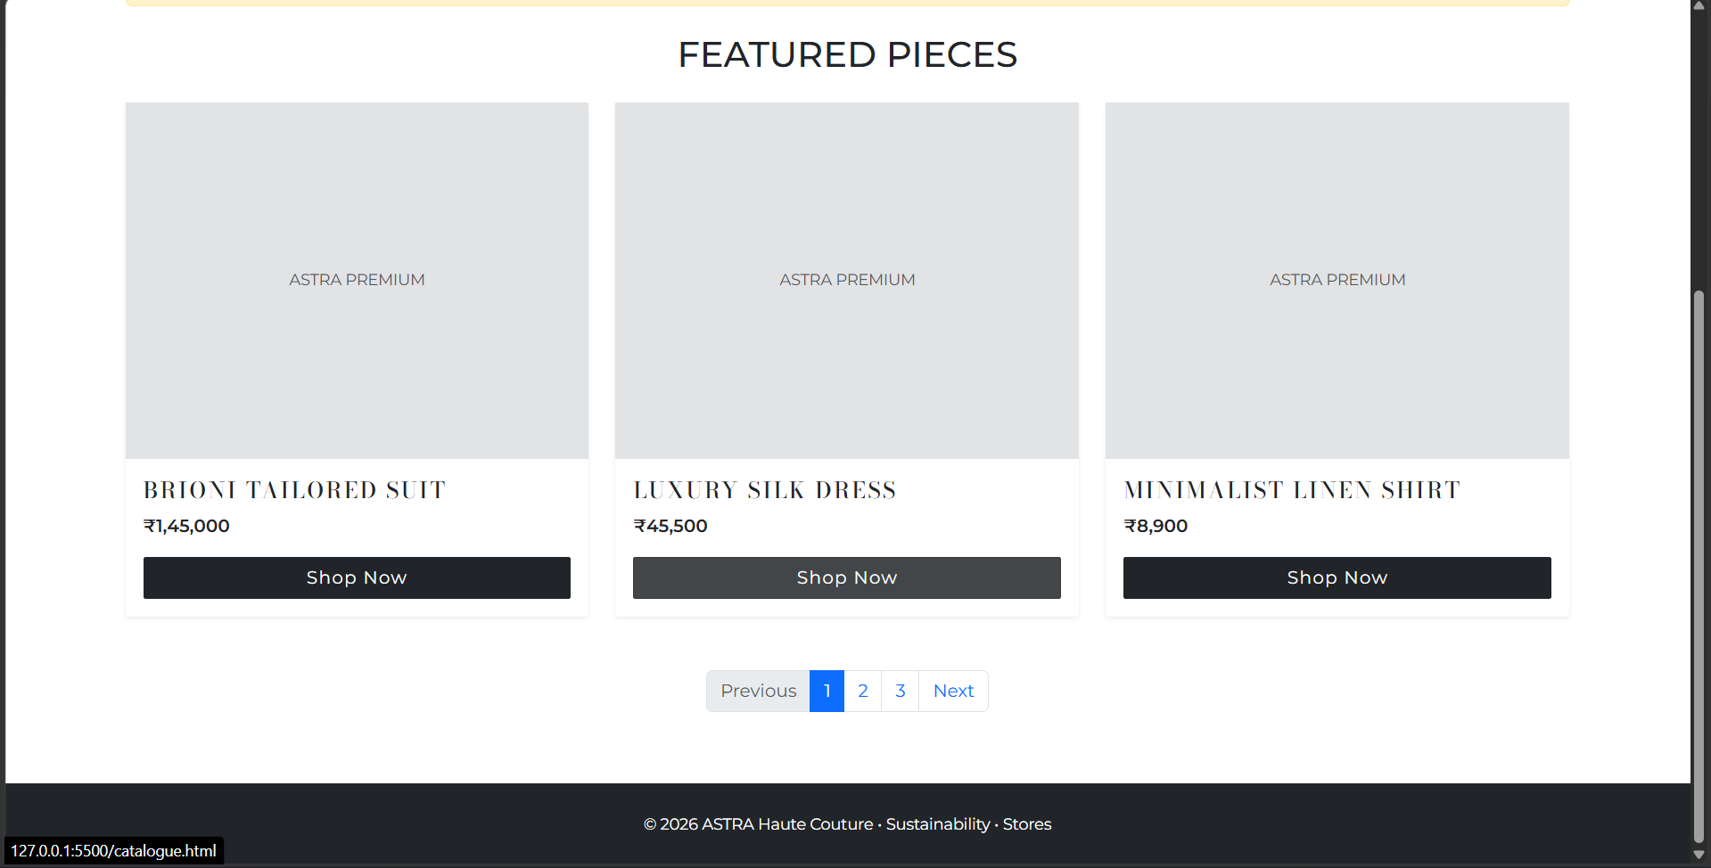

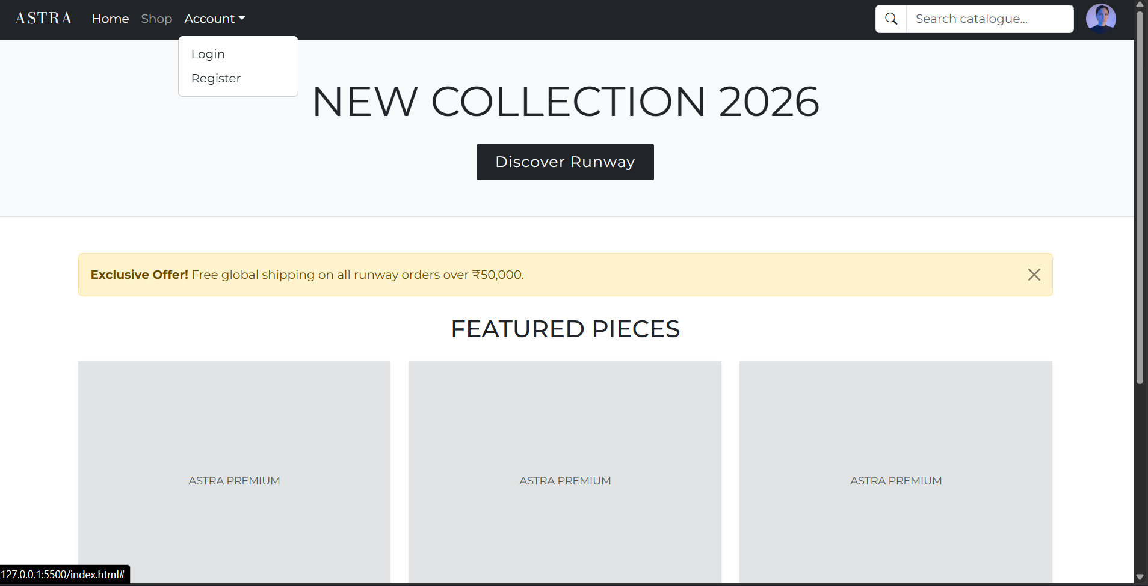


Link of the Generated website
ASTRA | Home

Post Lab Subjective/Objective type Questions:
- What is the use of containers in bootstrap? Explain in detail.
• Purpose: Centers and pads page content. Acts as the required parent wrapper for the grid system.
• Types:
- .container: Fixed width that changes at specific screen breakpoints.
- .container-fluid: 100% full-width across all screen sizes.
- .container-{breakpoint}: Full-width until reaching a specific breakpoint (e.g., .container-md).

- Name the classes to achieve the different button styles in bootstrap.
• Base Class: .btn (mandatory for basic padding and alignment)
• Colors (Solid): .btn-primary, .btn-secondary, .btn-success, .btn-danger, .btn-warning, .btn-info, .btn-light, .btn-dark, .btn-link
• Outlines: .btn-outline-primary, .btn-outline-dark, etc.
• Sizes: .btn-lg (Large), .btn-sm (Small)

- Write details about the Bootstrap Grid system.
• Structure: A 12-column layout using Container $→$ .row $→$ .col-*.
• 12-Column Rule: Column sizes in a row must add up to 12 (e.g., .col-6 + .col-6).
• Breakpoints:
- .col- (< 576px)
- .col-sm- ($≥$ 576px)
- .col-md- ($≥$ 768px)
- .col-lg- ($≥$ 992px)
- .col-xl- ($≥$ 1200px)

Conclusion:
The experiment was successfully executed to build a responsive, multi-page e-commerce layout using Bootstrap 5. Core features including containers, the 12-column flexbox grid system, navbar search groups, utility classes (.rounded-circle), dismissible alerts, and paginated controls were implemented and verified across different screen sizes.

Signature of faculty in-charge with Date:

