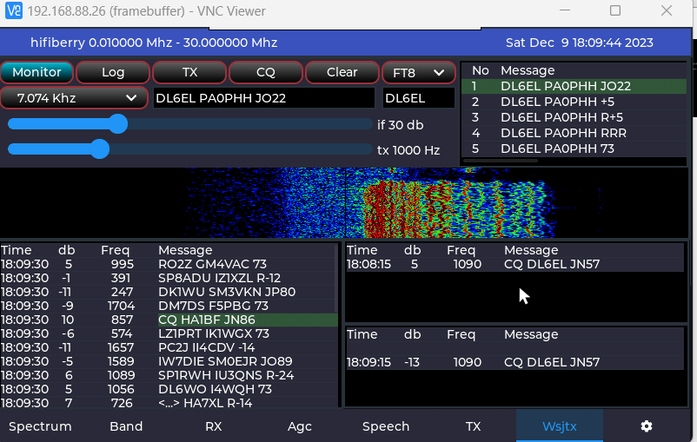

Steps CQ

|  |  |  |  |
| --- | --- | --- | --- |
| Step | Description | Status | Receive list |
| 1 | Monitor | Monitor | Allow click in receive pane on cq’s to be copied to qso pane and message pane |
| 2 | Send CQ | Cq | Do not allow click event on cq’s to be copied, don’t change message content |
| 3 | Receive response | Cq | Update qso pane with response |
| 4a | Log | Monitor | Log to csv file + clear panes (qso, cq and message) |
| 4b | Clear | Monitor | clear panes (qso, cq and message) |

Steps Respond to a CQ

|  |  |  |  |
| --- | --- | --- | --- |
| Step | Description | Status | Receive list |
| 1 | Monitor | Monitor | Allow click in receive pane on cq’s to be copied to qso pane and message pane |
| 2 | Click on CQ Message | Monitor | Allow click in receive pane on cq’s to be copied to qso pane and message pane |
| 3 | Press TX to send response | Respond | Do not allow click event on cq’s to be copied, don’t change message content |
|  |  |  |  |
| 4a | Receive response | Respond | Do not allow click event on cq’s to be copied, don’t change message content |
| 4a | Receive new CQ of status which was selected | Respond | Do not allow click event on cq’s to be copied, don’t change message content,  Copy CQ message to cq pane |
| 5a | Log | Monitor | Log to csv file + clear panes (qso, cq and message) |
| 5b | Clear | Monitor | clear panes (qso, cq and message) |