Md.Akheruzzaman
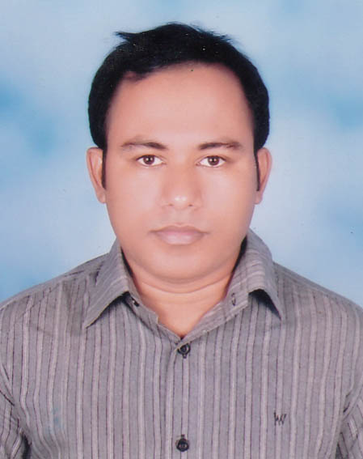
House #33,Road #13,
D.I.T Project,Merul Badda.
Badda, Dhaka-1212
+880 1912297684
akher.ice07@gmail.com
Objectives
 | Looking for a position in Software Company where I can utilize my ability and knowledge and to enhance career in the field of IT and Software Engineering.
Technical Skills
Languages
- Programming Language Proficiency:
- Object Oriented Programming(OOP) Concept with SOLID and design pattern
- C#.NET and ADO.NET
- ASP.NET ,Unit testing and TDD
- EF6 with LINQ
- MVC5
- Web API2,Web service ,SignalR
- SSRS 2012
- Crystal Report
- Java
- Android Application Development
- Web Design:
- HTML
- CSS
- JavaScrip
- jQuery
- Ajax
- JSON
- Knockoutjs
- Backbonejs

- Database Administration
- Knowledge in SQL
- Microsoft SQL Server 2012 R2
- SQLite

Summery
More than 2 years of programming and application development experience.
Experience
 |  | Programmer : |  | Jan, 2013 – Aug
ITRRC, IU [Under HEQEP Project]
Design & development of Examination Result Processing System for Islamic University using C#.NET and Microsoft SQL Server 2008 R2
Project:
- Design & Development of Library Management System using C#.NET and Microsoft SQL Server 2008 R2.
- University Course & Result Management System using ASP.NET(C#), SQL server 2008 R2.
Natural Language Processing(NLP):
- Adapting Rule-Based Voice-to-Text from English to Bangla for android Platform For 4th year final Project.

 |  | Trainer :  SARENG TECHNOLOGY | Aug, 2012 To Dec 2012
 |  | Training Program on Object Oriented Programming(OOP)-ASP.NET(C#).
Emplacement History
- Soft code (Jun 2014 to till date )
- Garment ERP (HRM ,Payroll ,Accounting, Merchandising etc)
- Computer Services Limited (Sep,2013 to May 2014)
- CSL_ERP with MVC4
Education
Examination | Board/University | Group/Subject | Result (Scale) | Passing Year
S.S.C | Comilla Board | Science | 3.56 (5.00) | 2004
H.S.C | Comilla Board | Science | 4.70 (5.00) | 2007
B.Sc. (Hon’s) | Islamic University, Kushtia | Information & Communication Engineering | 3.43(4.00)(Position: 2nd) | 2011

Achievements
- Training Program on Object Oriented Programming(OOP)-ASP.NET(C#) Track(34 Batch) from Basis.
Roll No: OOP-34-14
Result( GPA) : B Grade
- Software Design and Architecture organized by Hi-Tech Park/IT park project
personal information
Name | : | Md.Akheruzzaman
Father Name | : | Md.Khalilur Rahmn
Mother Name | : | Nazmin Nahar
Permanent Address | : | Vill- Chandpara, P.O: Sacher, P.S: Kachua, Dist:Chandpur,Bangladesh.
Present Address | : | House #33,Road #13, D.I.T Project,Merul Badda.  Badda, Dhaka-1212
Date of Birth | : | 18-04-1988
Nationality | : | Bangladeshi
Religion | : | Islam
Voter ID NO | : | 1315815411685

Interests
- Reading the Books
- Watching Movie [English,Bangla]
- Travelling
elf certification
- Ready to take challenge
- Hard Working
- Helpful

References
- Dr. Md. Tariquzzaman
- Associate Professor, Dept. of Information & Communication Engineering (ICE), Islamic University, Kushtia
- Contact: +8801730441974
- Email: tareq_ict_iu@yahoo.com, mtareq@ice.iu.ac.bd

- Soft Code Dhaka office
- T:+88028317240,9346944
- F:+88029347851
- E :akher.ice07@gmail.com
- Unit-502,Concord Tower , 113,Kazi Nazrul Islam avenue ,Dhaka-100
- Soft Code UK office
- T:+4411434 87742
- E:softcode.uk@gmail.com
- M:+447587000411 , Gainsford Road ,Sheffield ,S9 4RJ,UK

Declaration: I do hereby declare that all the above information is true and correct to the best of my knowledge.


-----------------------------
Md.Akheruzzaman
House #33,Road #13,
D.I.T Project,Merul Badda.
Badda, Dhaka-1212
+880 1912297684
akher.ice07@gmail.com

