1. Get Books (default records in Db)

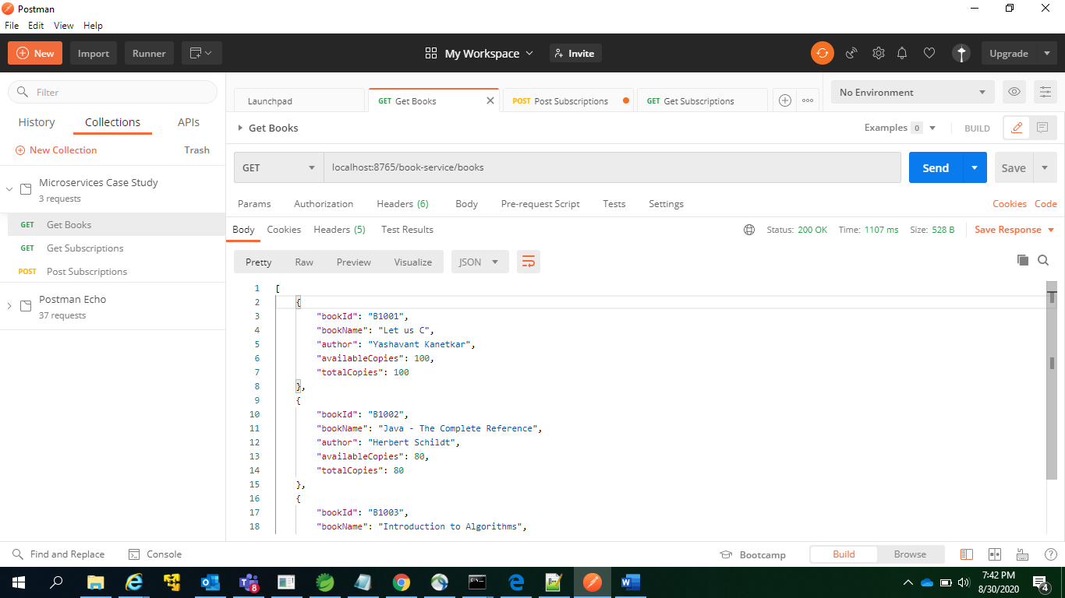

1. Get Subscription (default records in Db)

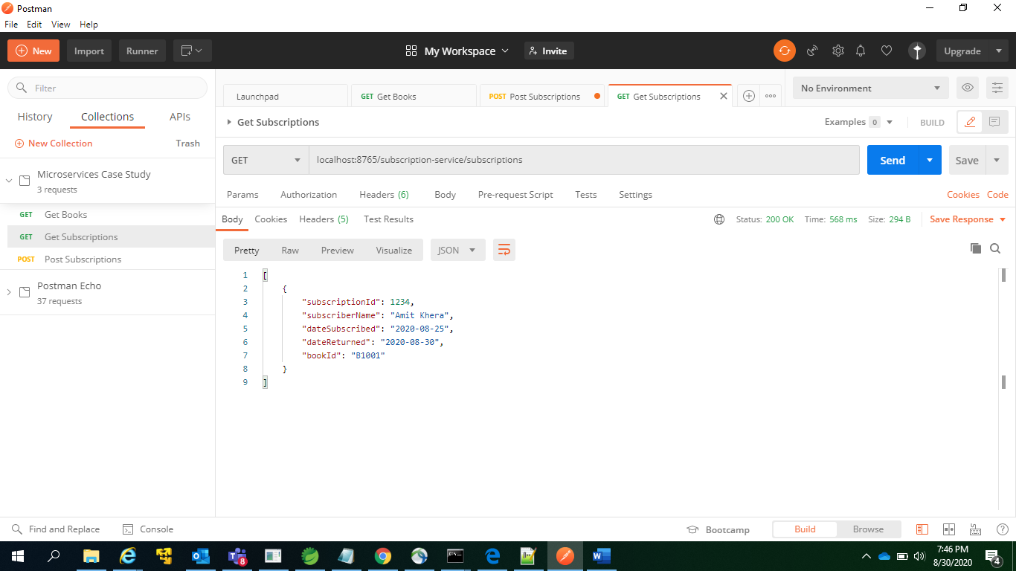

1. Post Subscription (success case)

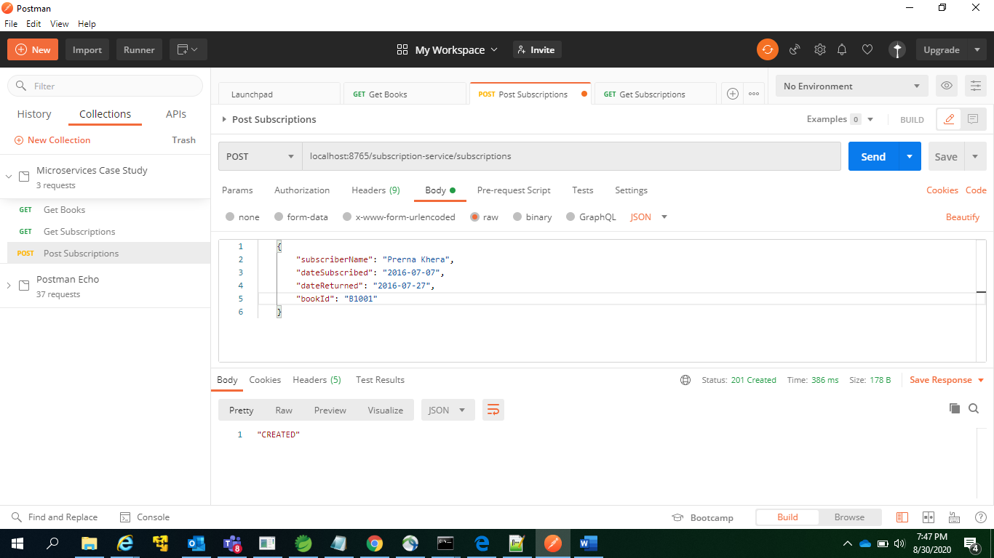

* 1. Get Books after successful post subscription (availableCount for Book_Id = B1001 decremented by 1)

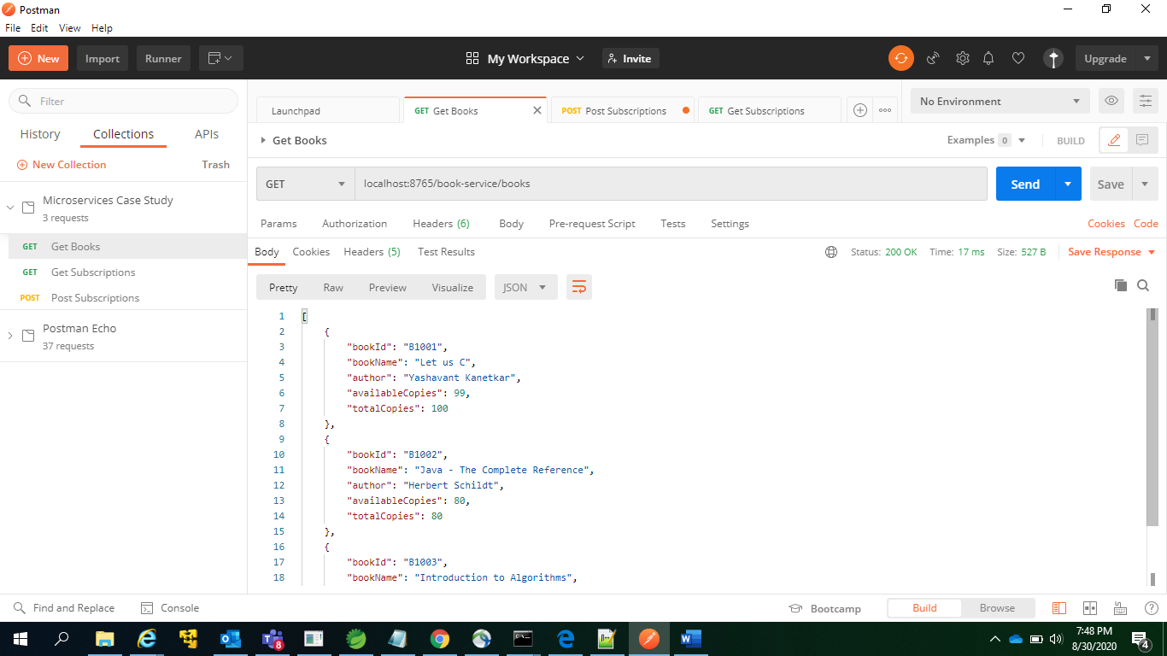

* 1. Get Subscription after successful post subscription (new subscription present)

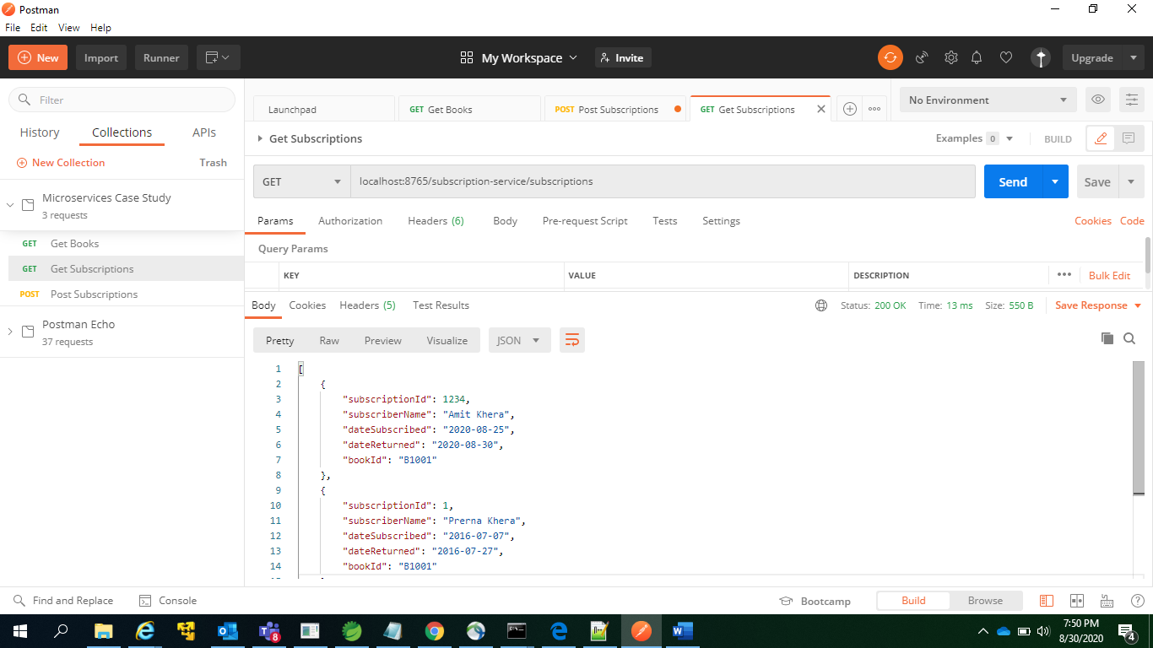

1. Post Subscription (book_Id = B1009 doesn’t exist)

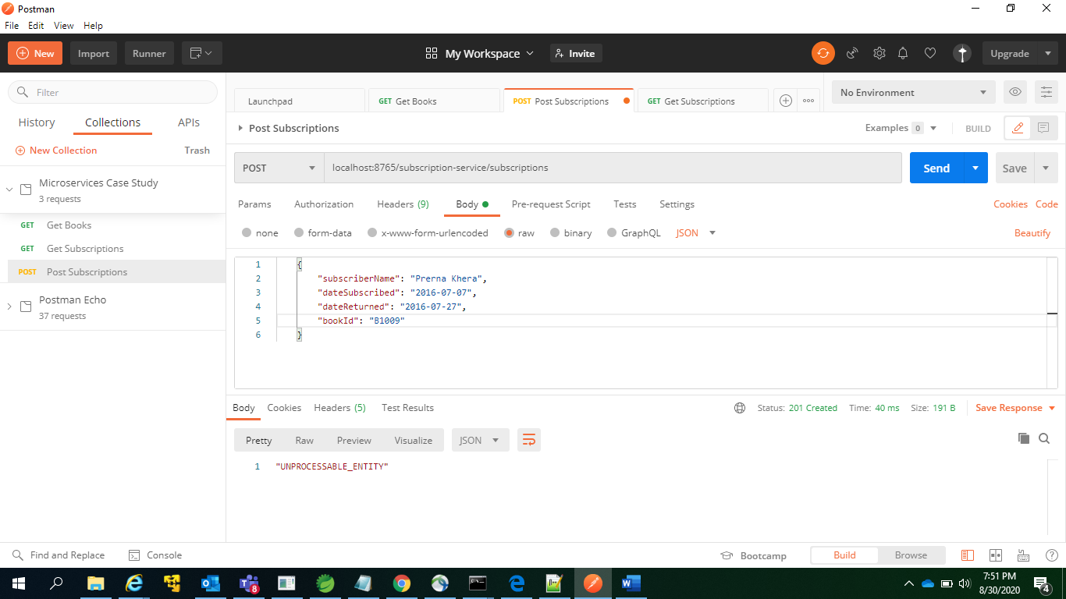

1. Post Subscription (book availableCount = 0 for Book_Id = B1001)

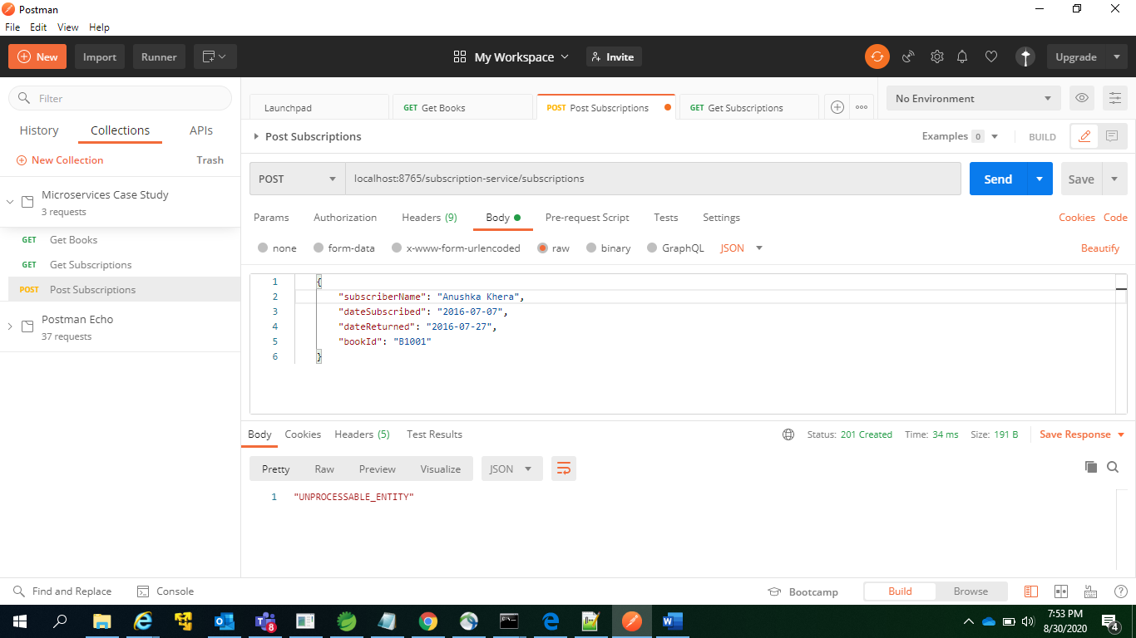

* 1. Get Books showing availableCount = 0 for Book_Id = B1001.

