**Admin Login**

**Module Name: Academic**

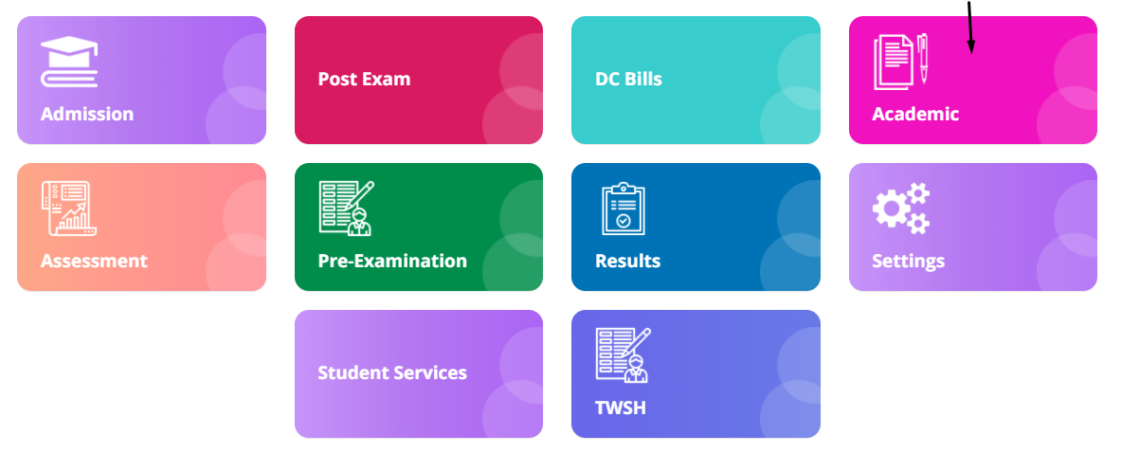

**Module Description:**

**Academic** module consists sub-modules namely **Mark 6th sem report, Semester date settings, Feedback report, Mapping report, Syllabus Coverage, Promotional fee list, Elective mapping report, Subject master, Student promotion and Academic year settings**

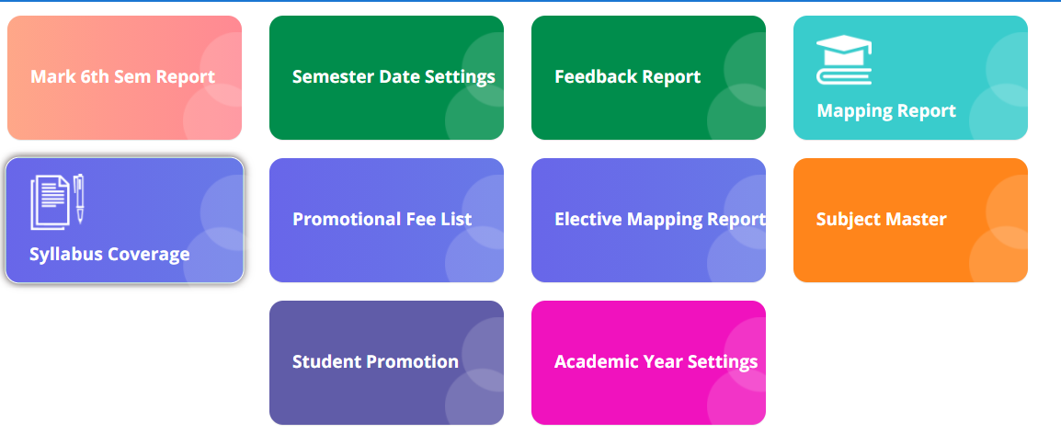

**1) Sub module name: Mapping Reports**

**Description:**

This sub module is used get the fee payment reports

**Navigation steps**

**Step1: Open Mapping Reports**

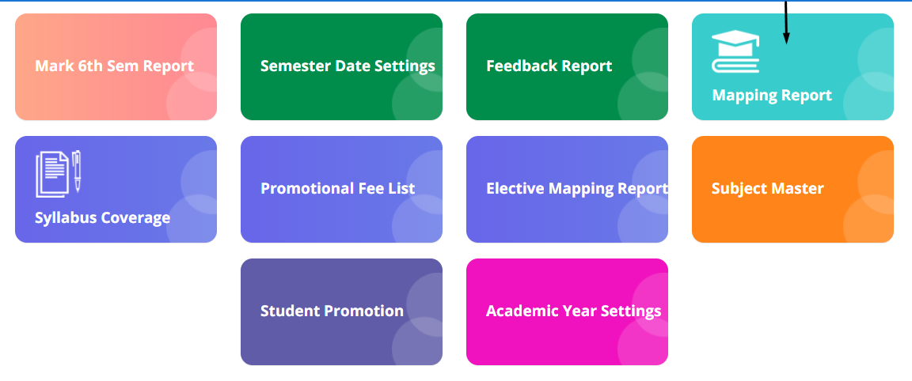

**Step2: Select the scheme and shift to get the mapping reports of the branches for different semesters.**

**Click on Show Results**

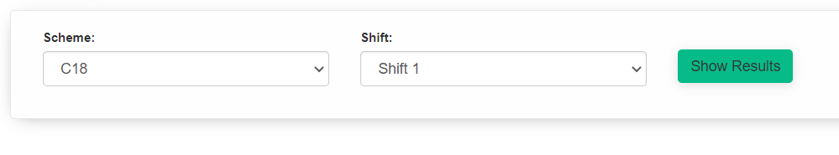

**Step3: The results will be displayed.**

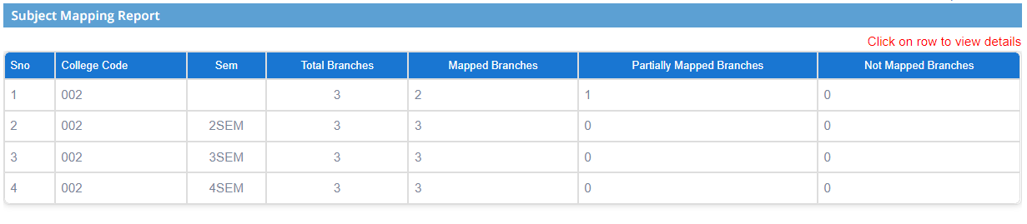

**Step4: By clicking on the row, we can get the details of non-mapped subjects and branches if any colleges are partially mapped(i.e if it is 1)**









**Step5: The results can also be downloaded in excel format.**

**Click on Export to Excel. The excel will be downloaded as is shown in the second image.**

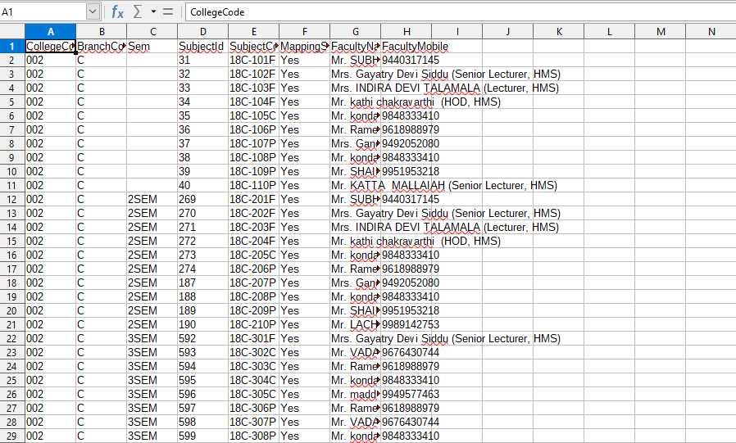

**2) Sub module name: Syllabus coverage**

**Description:**

This sub module is used get the report of the syllabus covered by the colleges for different courses

**Navigation steps**

**Step1: Open Syllabus coverage**

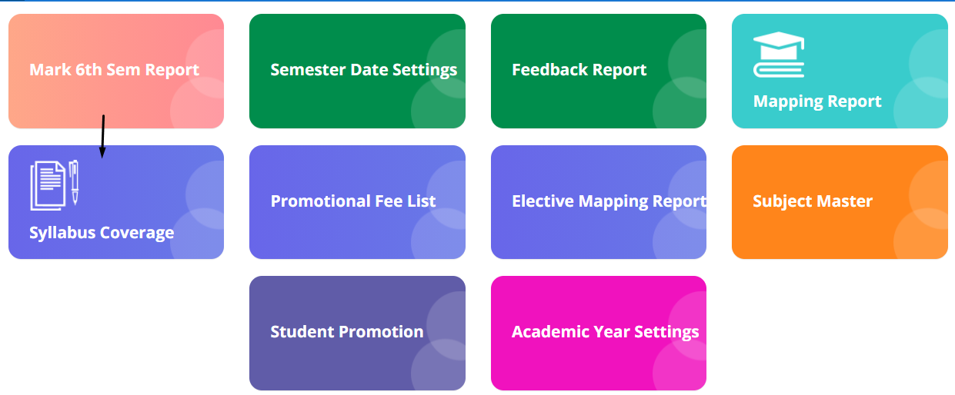

**Step2: Select the shift from the dropdown and click on submit.**

**The overall syllabus reports with all the details will be displayed.**

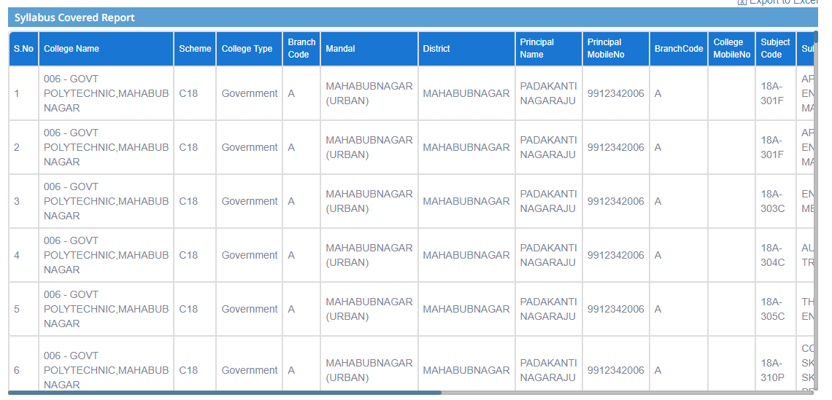

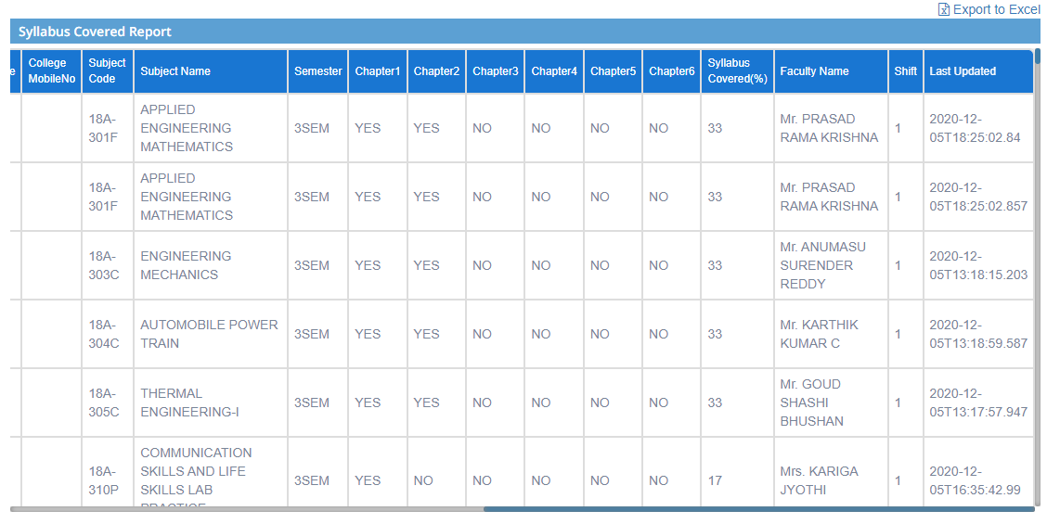

**Step3: The report can also be downloaded in excel format.**

**Click on Export to Excel. The file will be downloaded.**

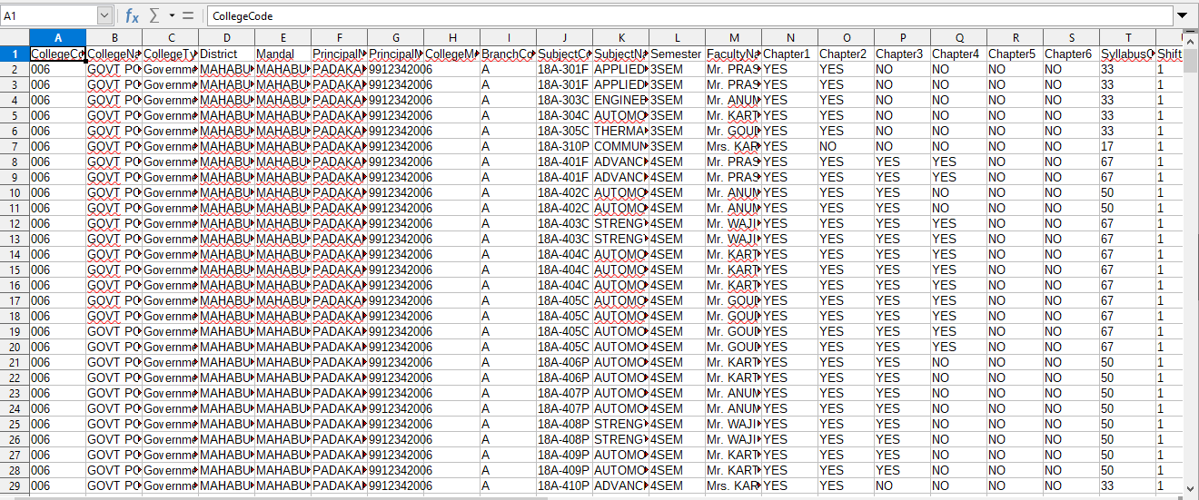

**3) Sub module name: Subject Master**

**Description:**

This sub module is used to retrieve the complete data of the scheme and the subjects.

**Navigation steps**

**Step1: Open Subject Master**

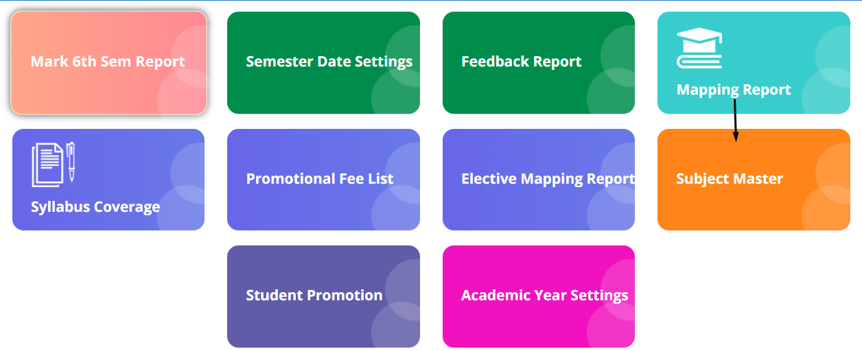

**Step2: Search the data which need to be retrieved. The list will be displayed.**

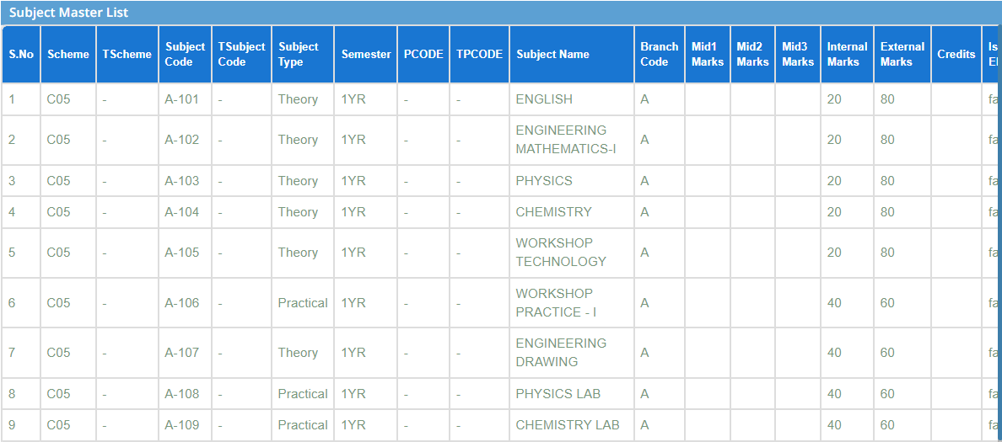

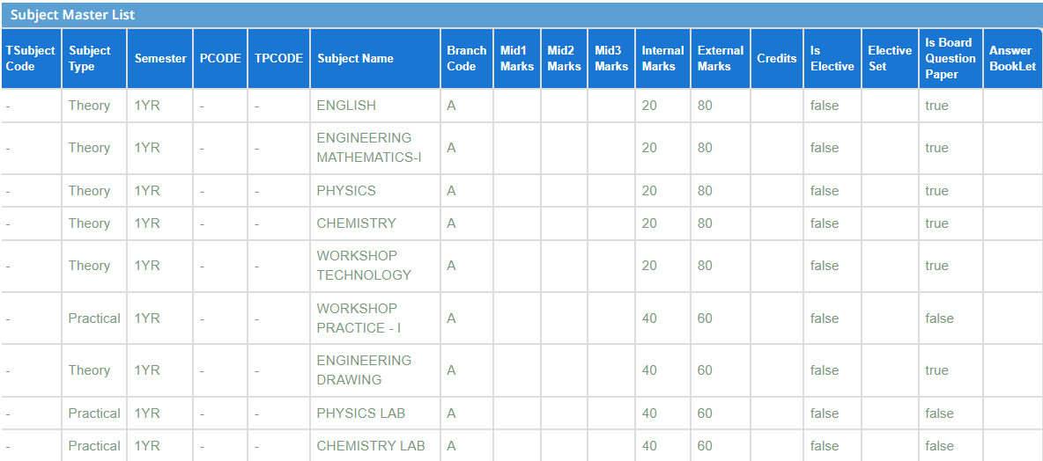

**Step3: To edit the changes click on Edit subject master data.**

* **Provide the scheme and subject code then click on Get details.**
* **Particular detail will be displayed.**
* **Click on Edit to update the changes.**

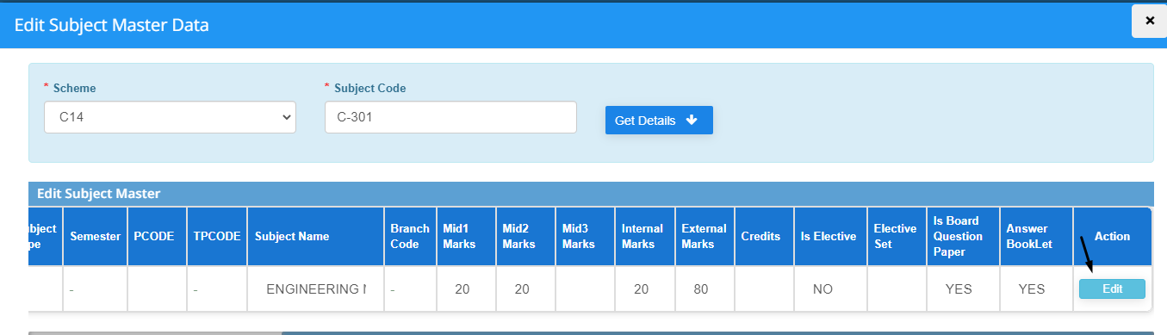

**Step4: Files can also be downloaded in excel format. Sample files are as shown below.**

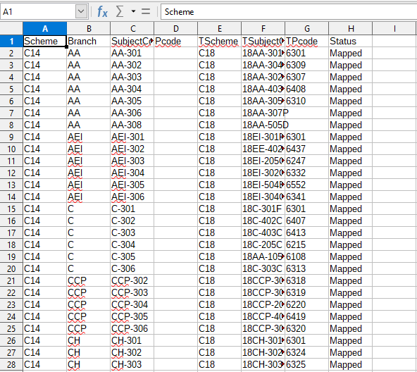

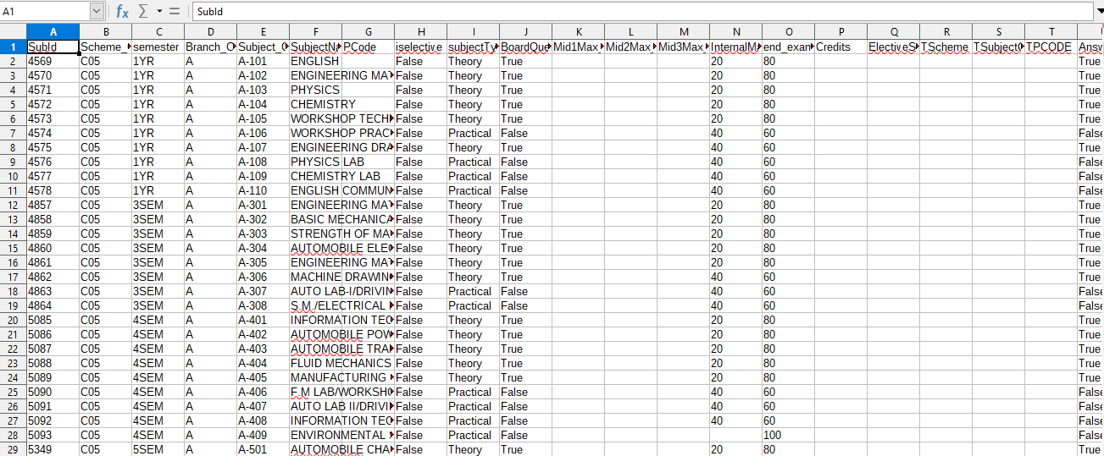

**4) Sub module name: Student promotion**

**Description:**

This sub module is used to get the details of the promoted students in particular year.

**Navigation steps**

**Step1: Open Student promotion**

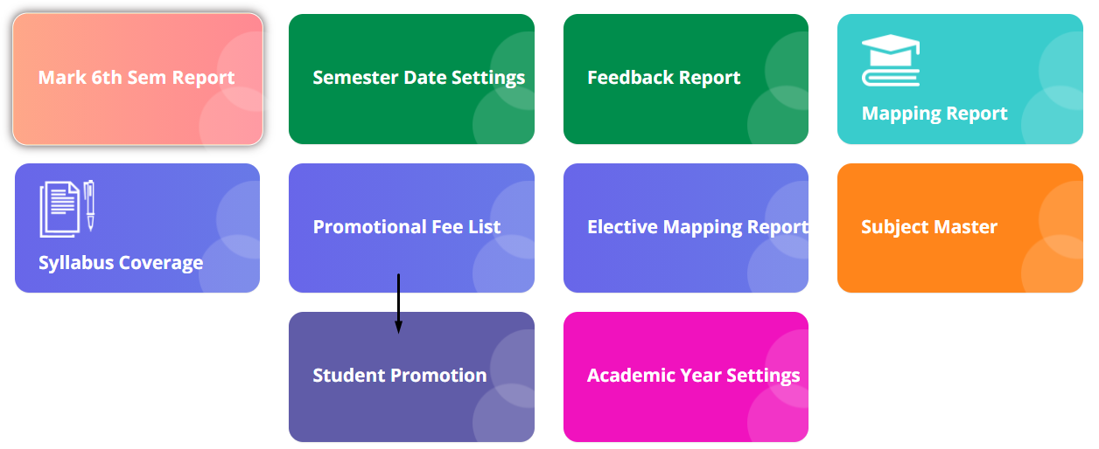

**Step2: Goto Student promotion:**

* **Select Academic year and click on Submit button**
* **The list of the promotion list with their respective semester will be displayed**

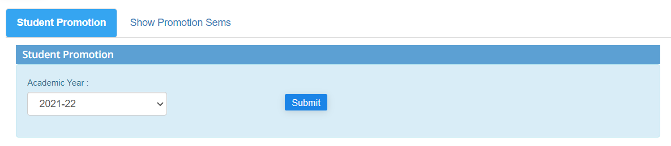

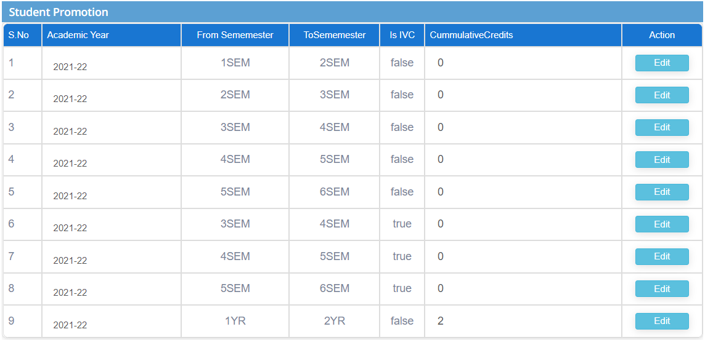

**Step3: To edit the changes click on Edit in the list and update the changes**

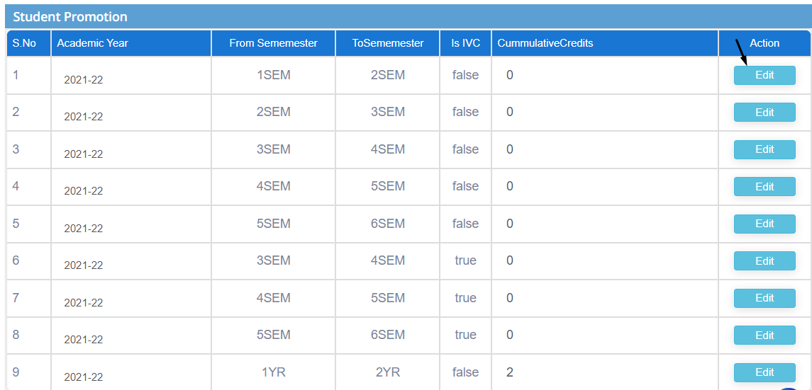

**Step4: Goto Student promotion:**

* **Select semester**
* **Click on submit button**
* **Report will be displayed based on semesters.**

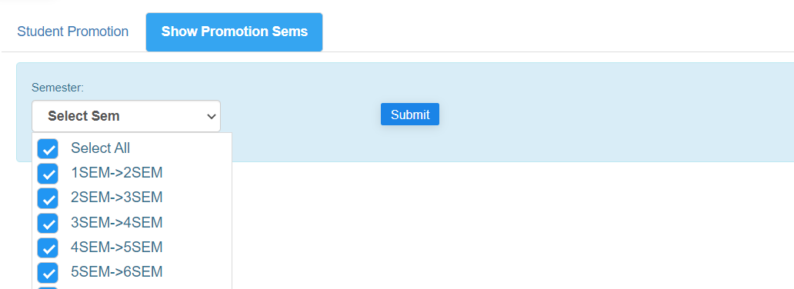

**5) Sub module name: Promotional Fee List**

**Description:**

This sub module is used to retrieve the list of students who have got promoted.

**Navigation steps**

**Step1: Open Promotional Fee List**

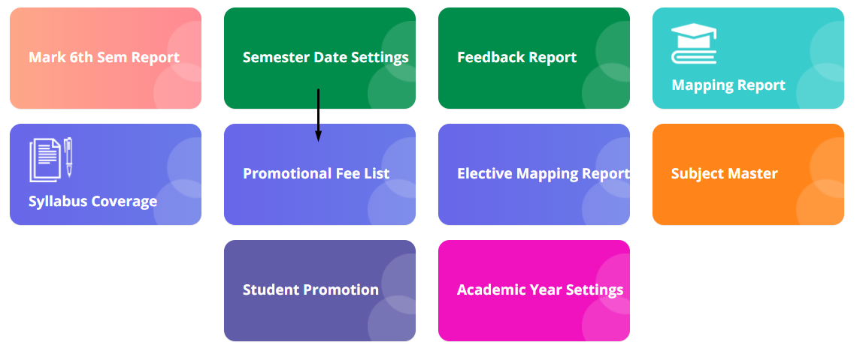

**Step2: Click on Download promotional list**

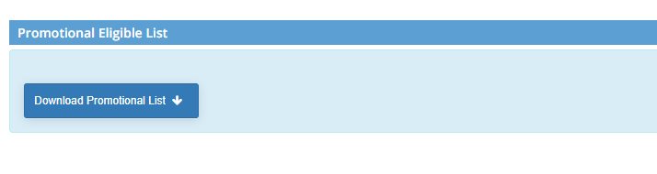

**Step3: The list is downloaded in the form of excel sheet and is displayed as shown below**

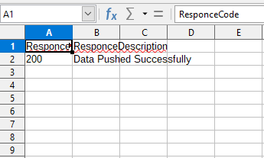

**6) Sub module name: Academic Year Setting**

**Description:**

This sub module is used to set the current academic year

**Navigation steps**

**Step1: Open Academic Year Setting**

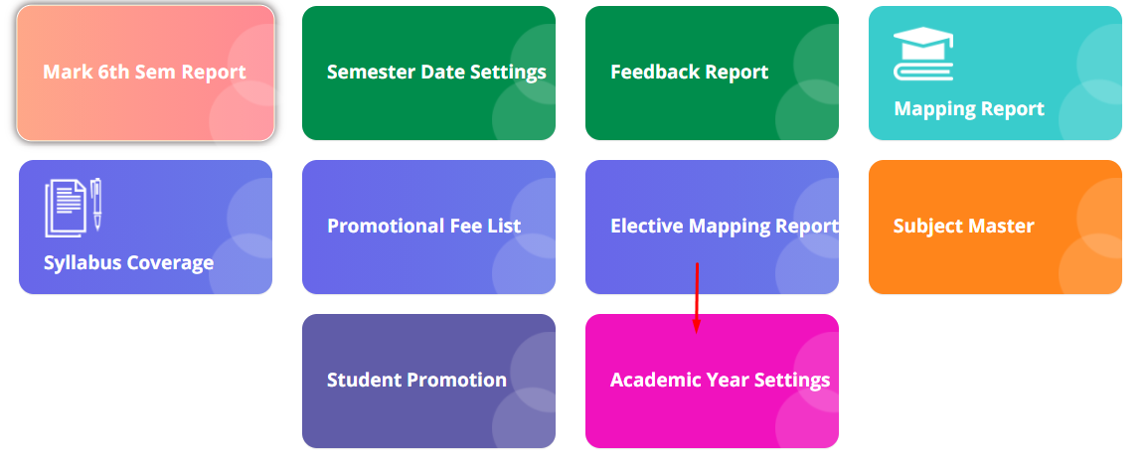

**Step2: Fill the academic start year, start date and end date to get the details.**

**Academic year will be automatically taken.**

**Click on create**

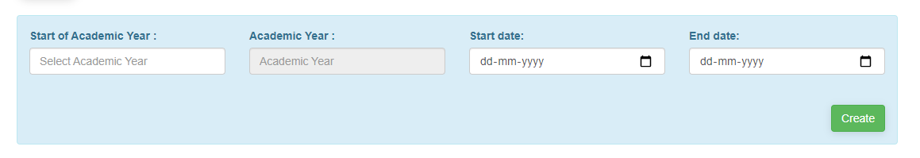

**Step3: The academic year will be created and by default it will be selected in current academic year**

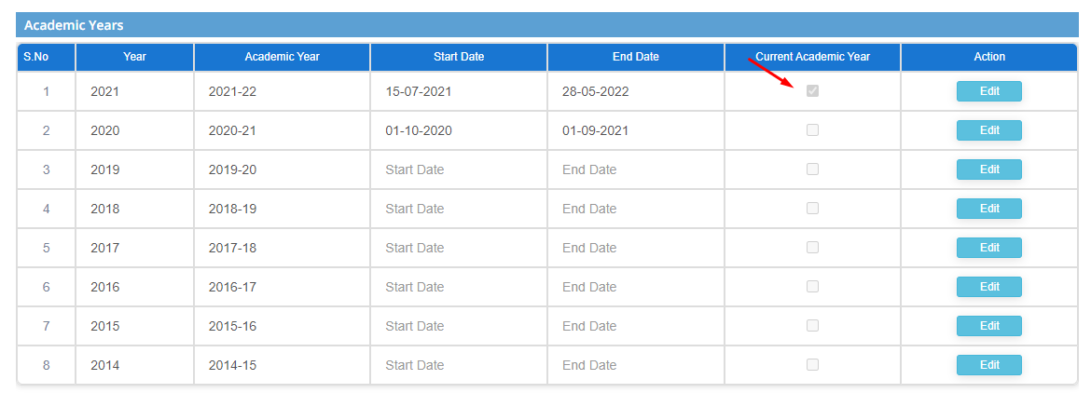

**Step4: The data can be edited and updated by clicking on Edit button in Action column**

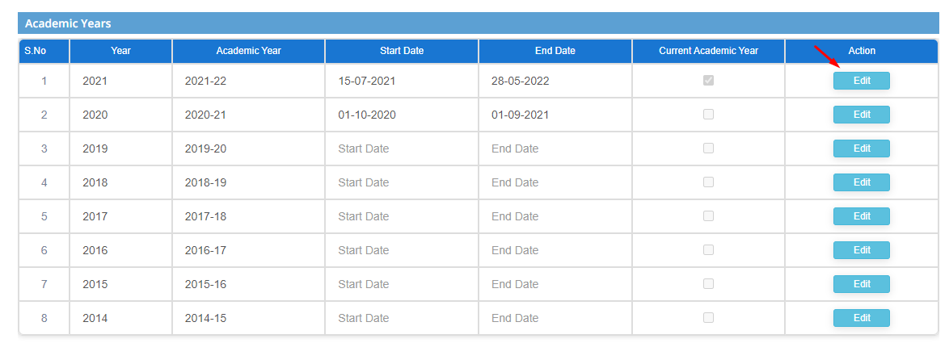

**7) Sub module name: Mark 6th sem report**

**Description:**

This sub module is used to get the report of the colleges which have promoted students to 6th sem

**Navigation steps**

**Step1: Open Mark 6th sem report**

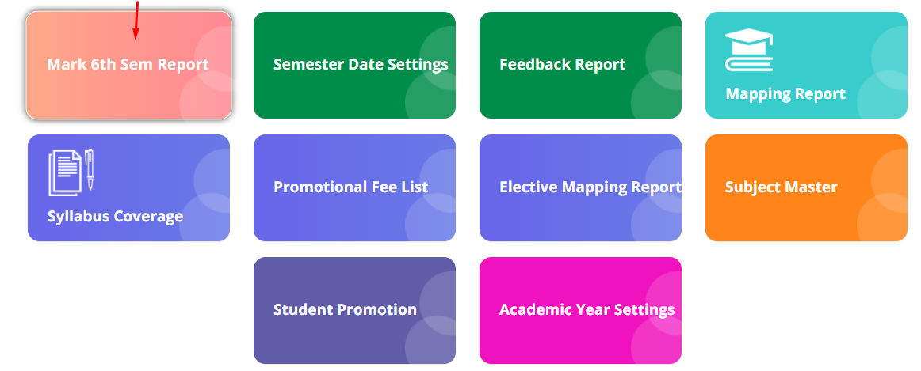

**Step2: The list contains list of colleges and number of students who are promoted directly to 6th sem**

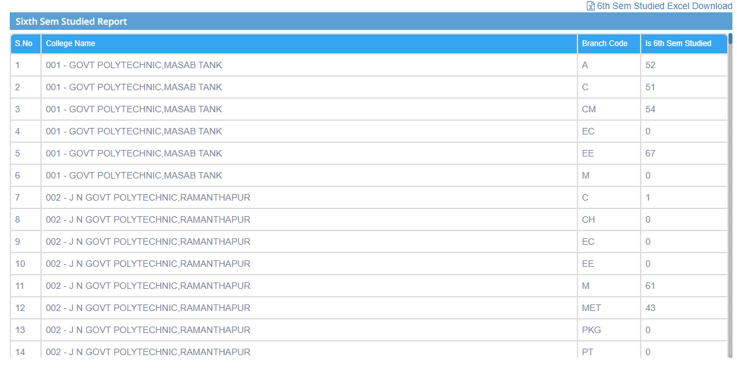

**Step3:**   
**To download the report in excel format click on Export to Excel**

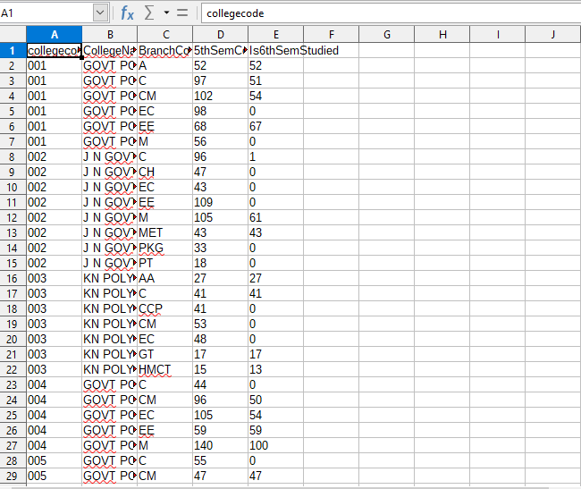

**7) Sub module name: Semester Date Settings**

**Description:**

This sub module is used to set the semester details for different scheme

**Navigation steps**

**Step1: Open Semester Date Settings**

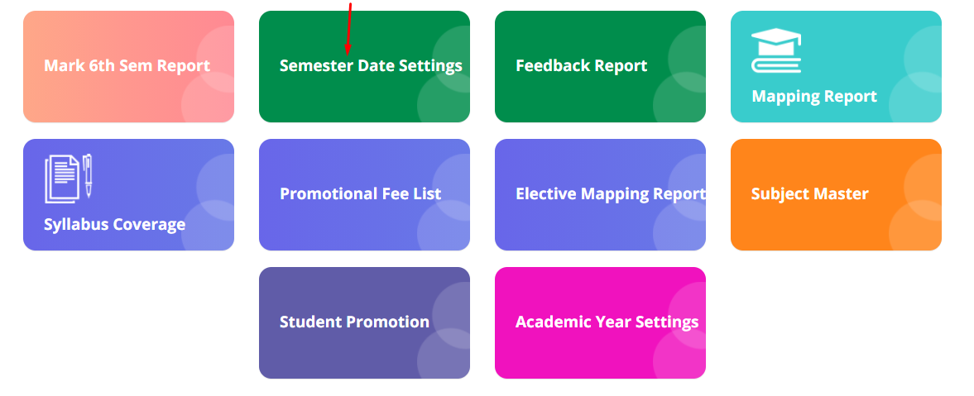

**Step2: Enter academic year and session to get the semester details.**

**Click on Get Details**

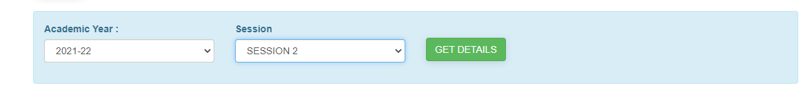

**Step3: The details are displayed as follows**

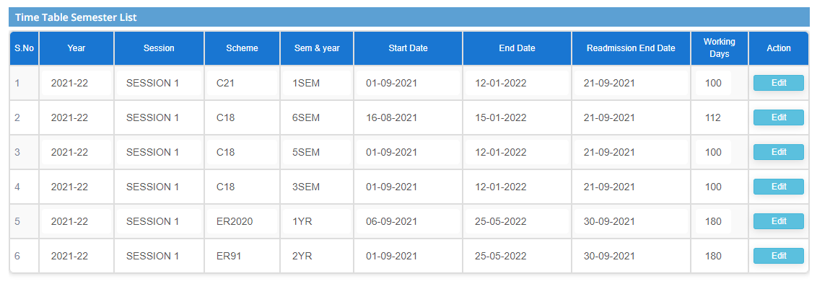

**Step4: To add new semester dates select ADD. Fill the mandatory details and click on ADD**

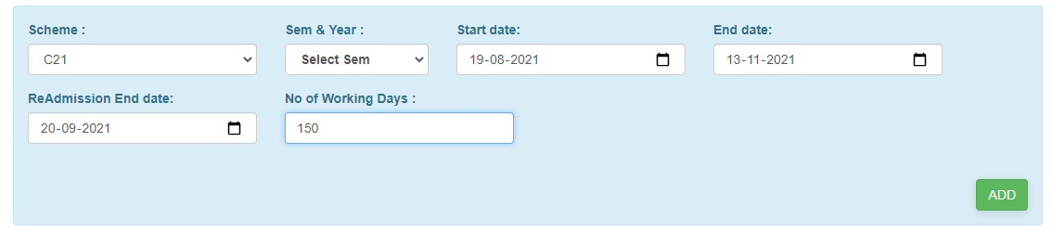

**Step5: To edit and update the details click on Edit button**

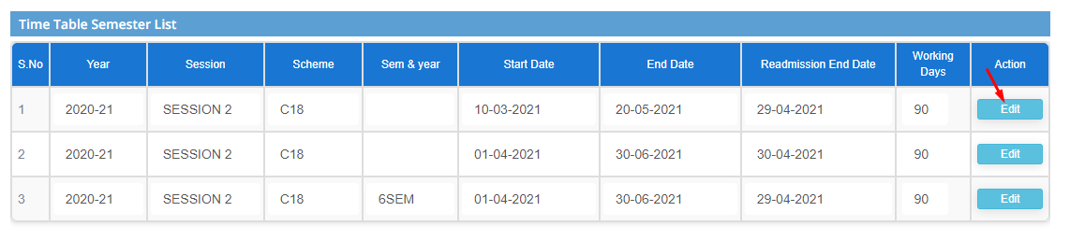

**8) Sub module name: Feedback report**

**Description:**

This sub module is used to get the feedback reports from students

**Navigation steps**

**Step1: Open Feedback report**

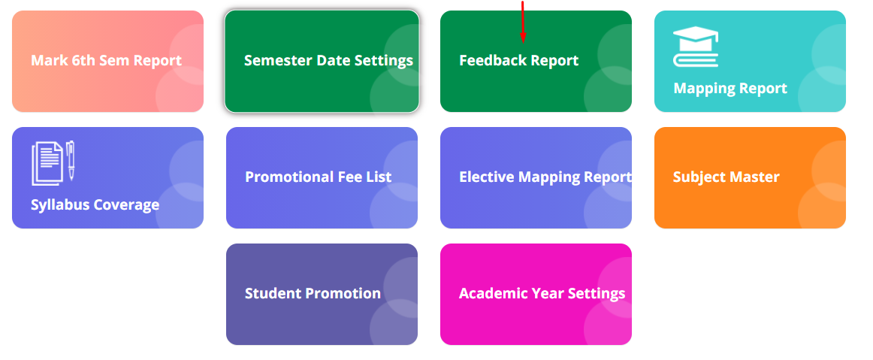

**Step2: Fill in all the details from the dropdown and click on Get details**

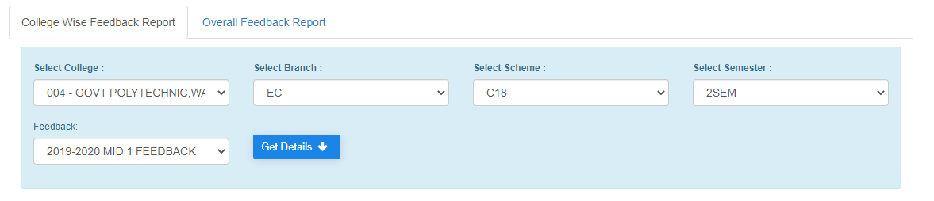

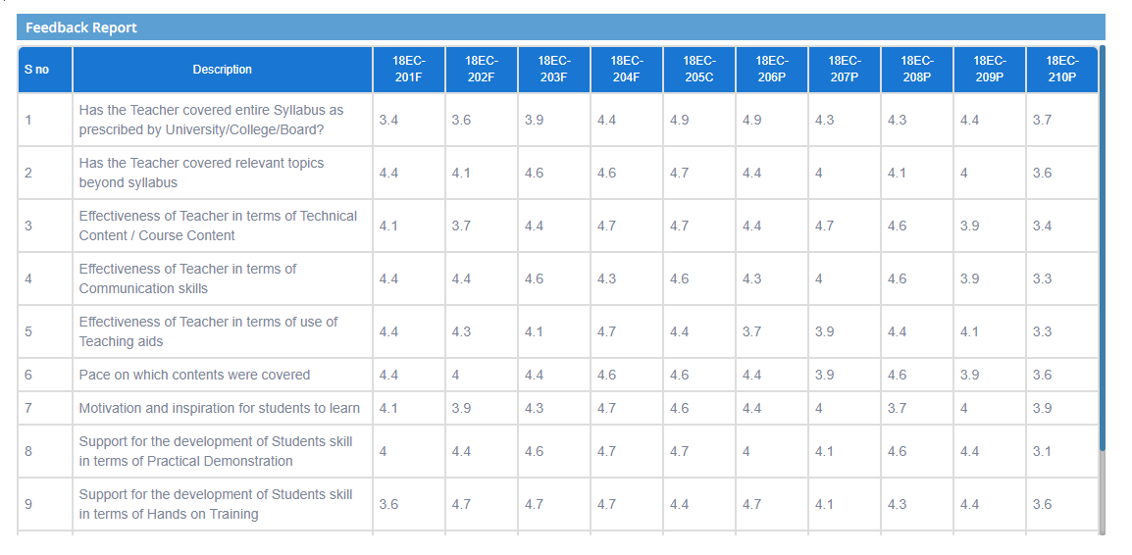

**Step3: Data can also be imported as excel by clicking on Export to Excel**

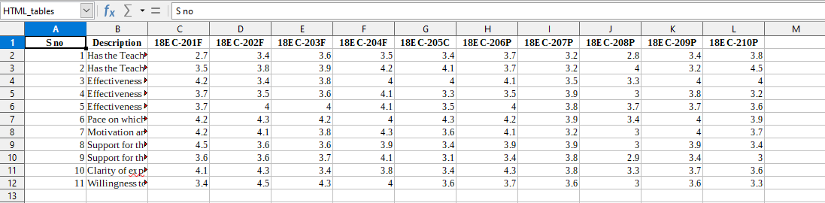

**Step4: To get overall feedback report, Goto Overall feedback report**

**Select feedback name and click on download feedback report. An excel file will be downloaded.**

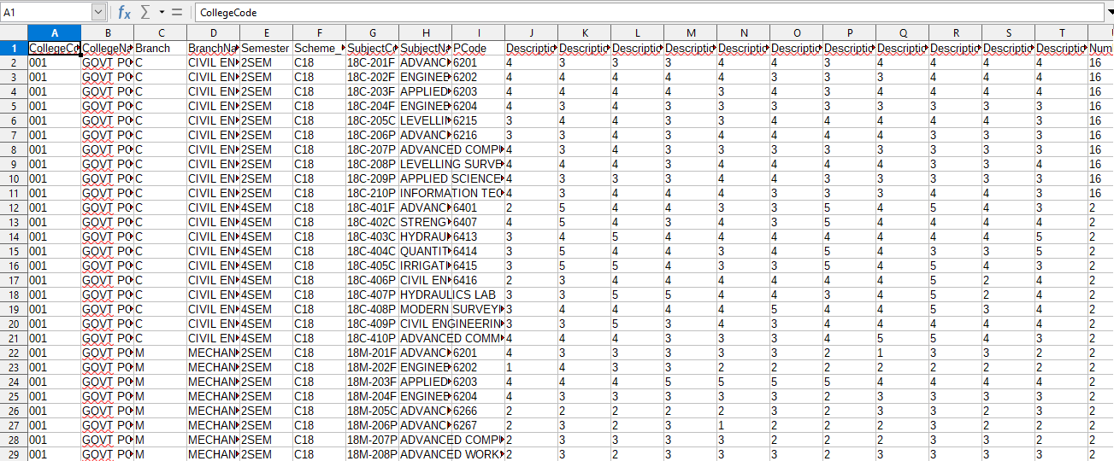

**9) Sub module name: Elective Mapping report**

**Description:**

This sub module is used to retrieve the report of colleges which have taken elective subject

**Navigation steps**

**Step1: Open Elective Mapping report**

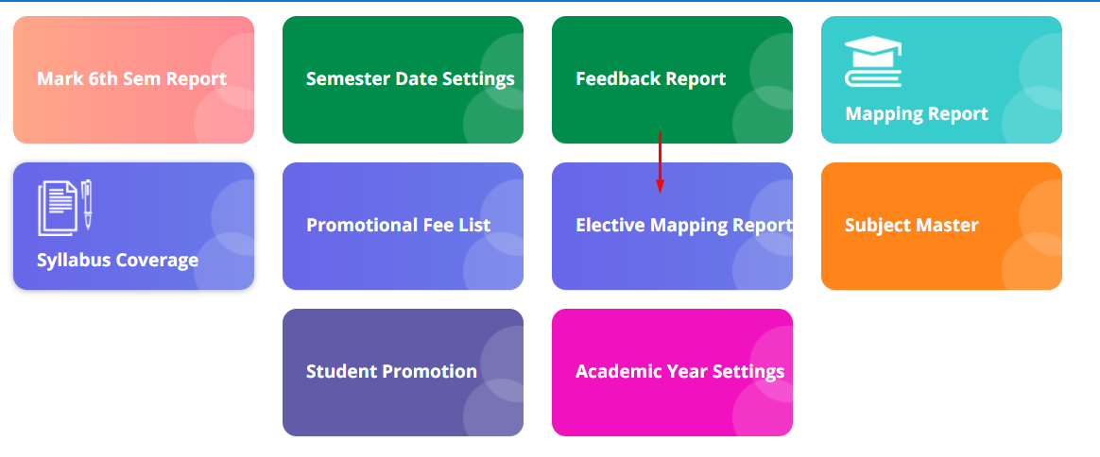

**Step2: The mapped and non-mapped details are displayed.**

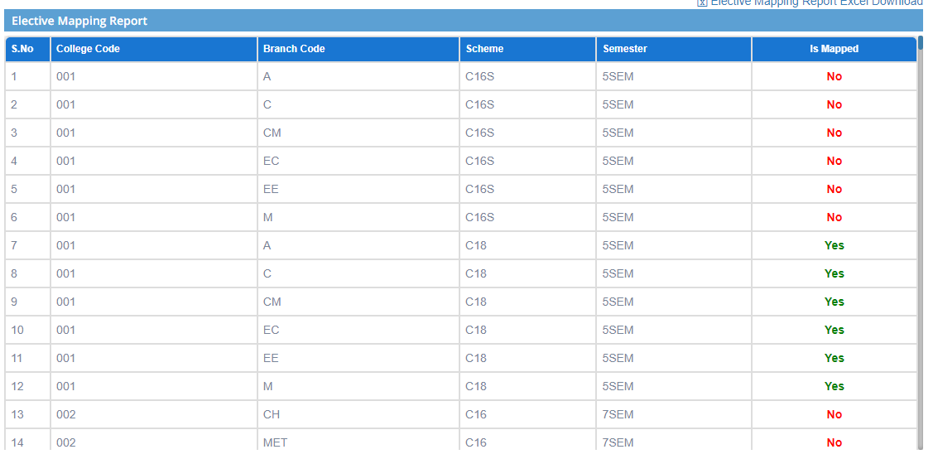

**Step3: If the college is not taken any elective subject it is printed as NO.**   
**To get the subject code click on the particular row which is not mapped it redirects to another page showing the subject code**

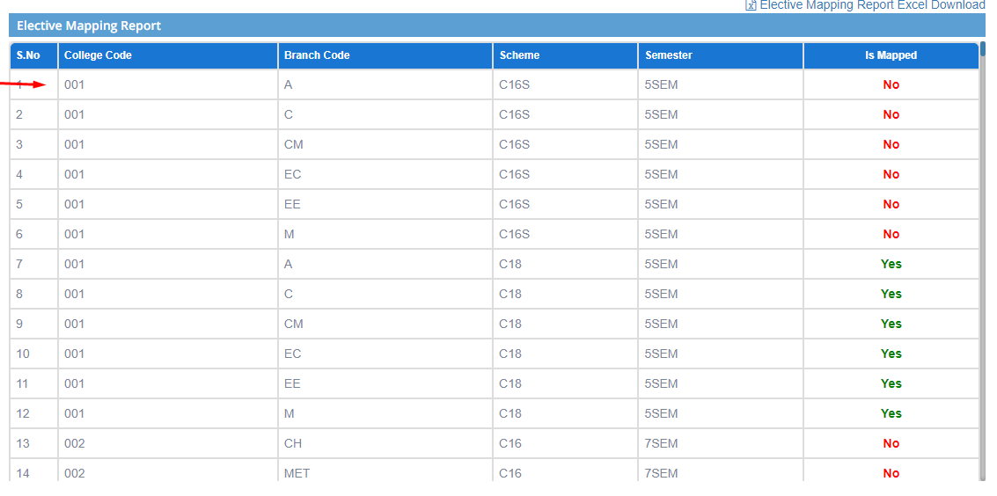

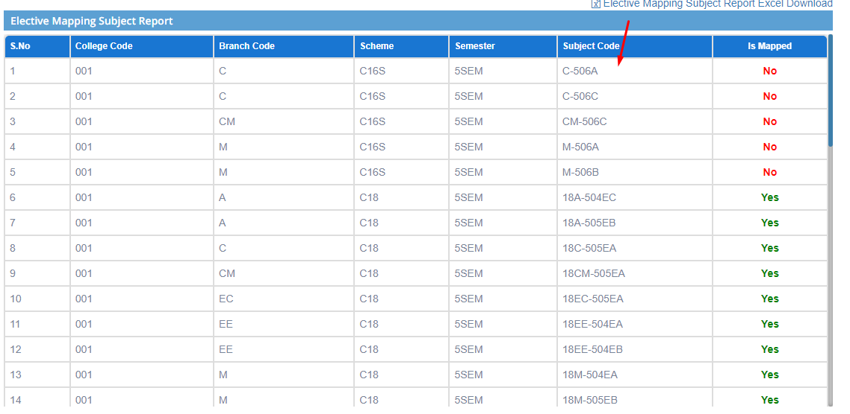

**Step4: The data can also be retrieved in the excel form. Click on Elective Mapping report Excel download**

