**Admin Login**

**Admin Home page contains 8 modules. They are**

1. **Admission**
2. **Post Exam**
3. **DC Bills**
4. **Academic**
5. **Assessment**
6. **Pre-Examination**
7. **Results**
8. **Settings**
9. **Student Services**
10. **TWSH**

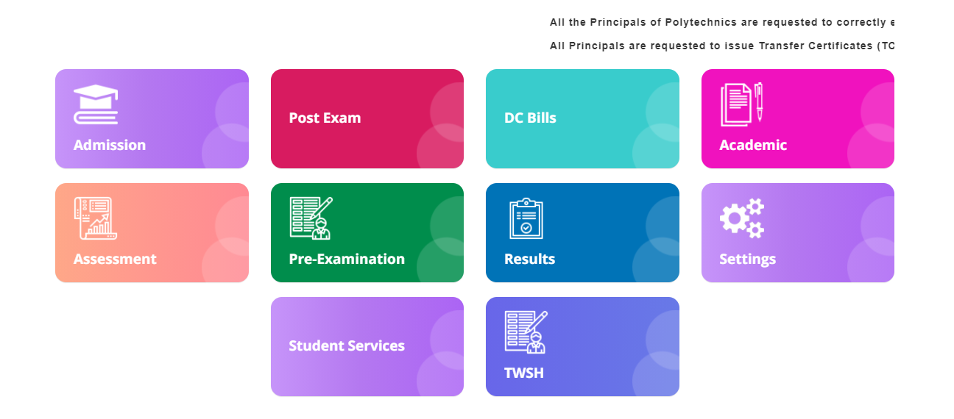

**1)Module Name: Admission**

**Module Description:**

Admission Module contains Admission Reports ,Polycet Exam Centers, Register, Attendance, Category Reports, Upload Polycet data, Pin Report, Transfer Student, Student Search, Release Aadhar and Transfer Report Modules.

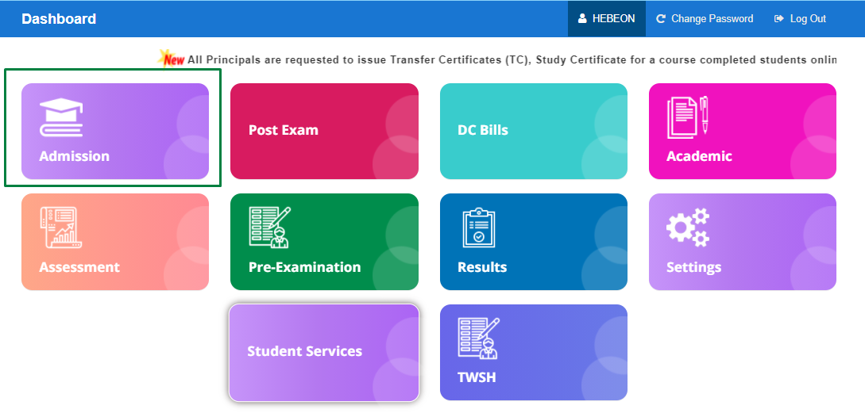

**Navigation steps to Admission:**

STEP 1: Click on Admission Module

STEP 2: User can view the list of modules as mentioned in above description.

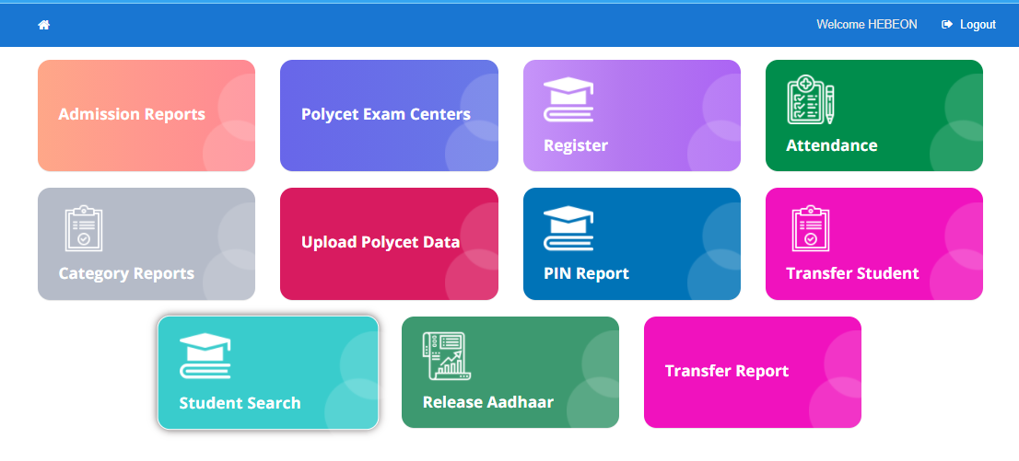

**1)Module Name: Upload Polycet Data**

**Module Description:**

Upload Polycet Data Module is used for uploading the student data in the form excel sheet.

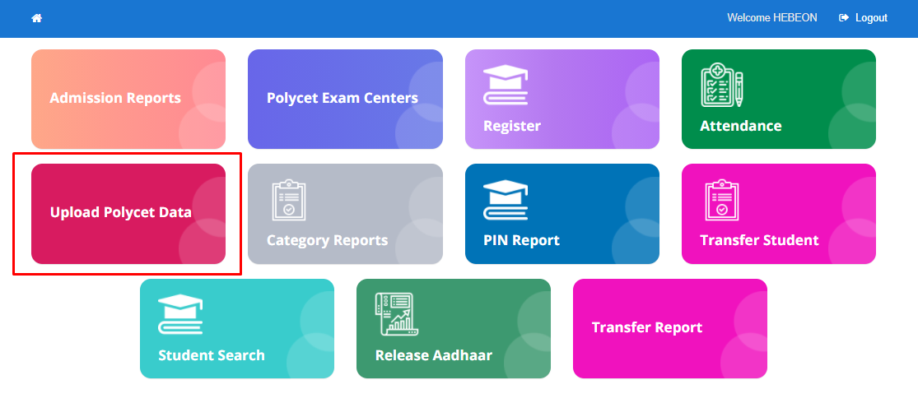

**Navigation steps to Upload Polycet Data:**

STEP 1: Click on Upload Polycet Data Module

STEP 2: Select the data from the dropdown and then download the sample format by clicking on **“Download Sample Data”.**

STEP 3: Insert the data into the excel and upload the file

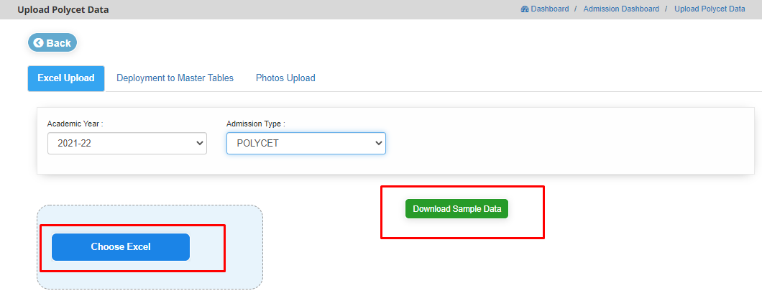

STEP 4: Data will be uploaded.

**2)Module Name: Registration**

**Module Description:**

Registration module is used to get the student current academic data of all the colleges.

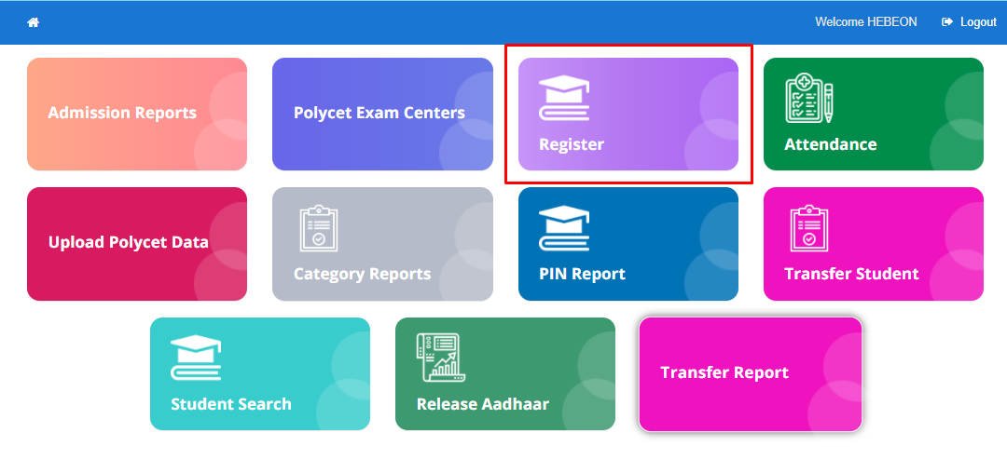

**Navigation steps to Registration:**

STEP 1: Click on Registration Module.

STEP 2: User can able to view data of college code, College name, Alloted(total), On Roll(allocated), Kyc pending and No Attendance Id.

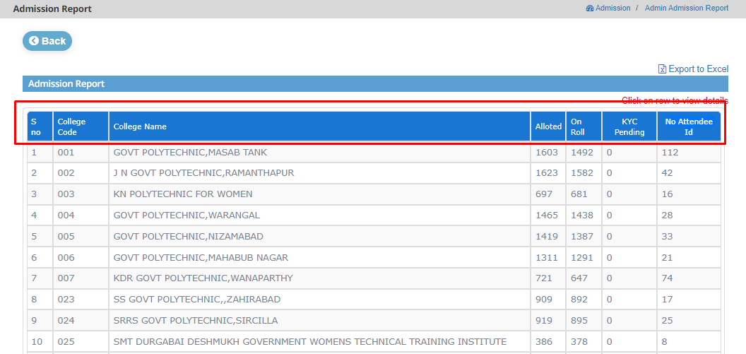

STEP 3: To get each college data including college details, student details user should click on that particular row.

STEP 4: College details includes college name followed by college code, Address, Bank details, Phone number, College email and College Established Date.

STEP 5: Student Details includes Scheme, Semester, Branch, Allotted, On Roll, Data Not Updated, Aadhar Not Verified, AttendeeId Not Generated, Pin Not Generated.

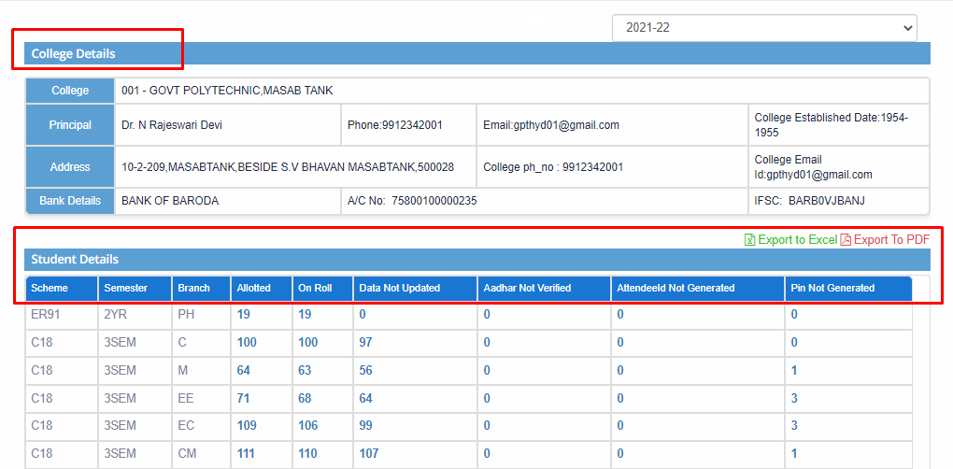

STEP 6: To get each row details click on that particular row. The data includes PIN, AttendeeId, Student Name, Birth Date, Admission Type, Aadhaar Status and Generate Pin.

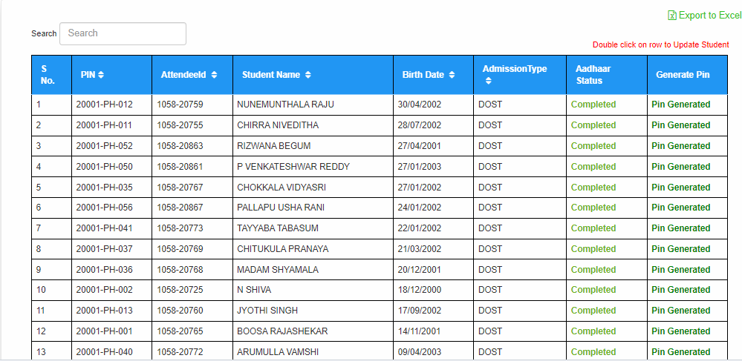

STEP 7: To Update the Student details user should double-click on that particular row.

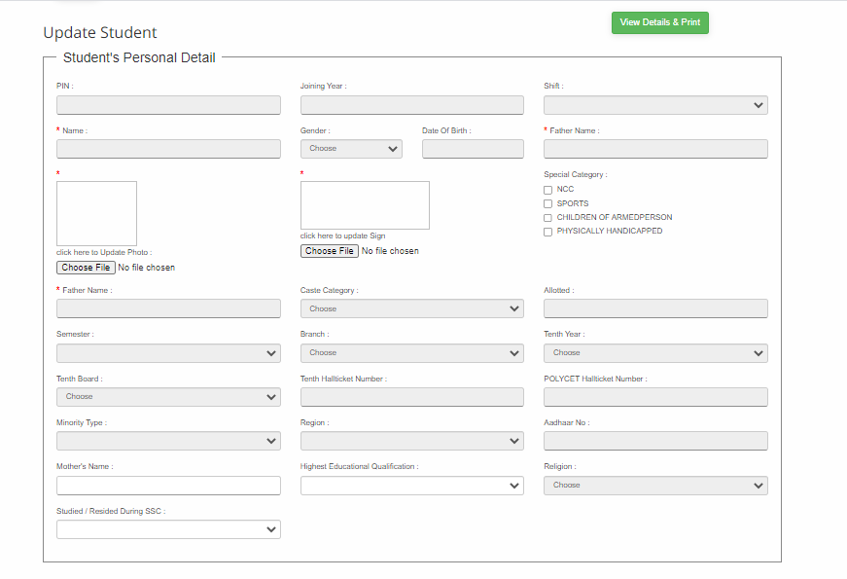

STEP 8: Click on **Update Student Details** which will be present at the bottom after updating the student details

STEP 9: User can download the report in the form of excel by clicking on **Import to Excels/Import to Pdf.**

**3)Module Name: Admission Reports**

**Module Description:**

Admission Reports Module is used to get the report of all the colleges of all the academic years

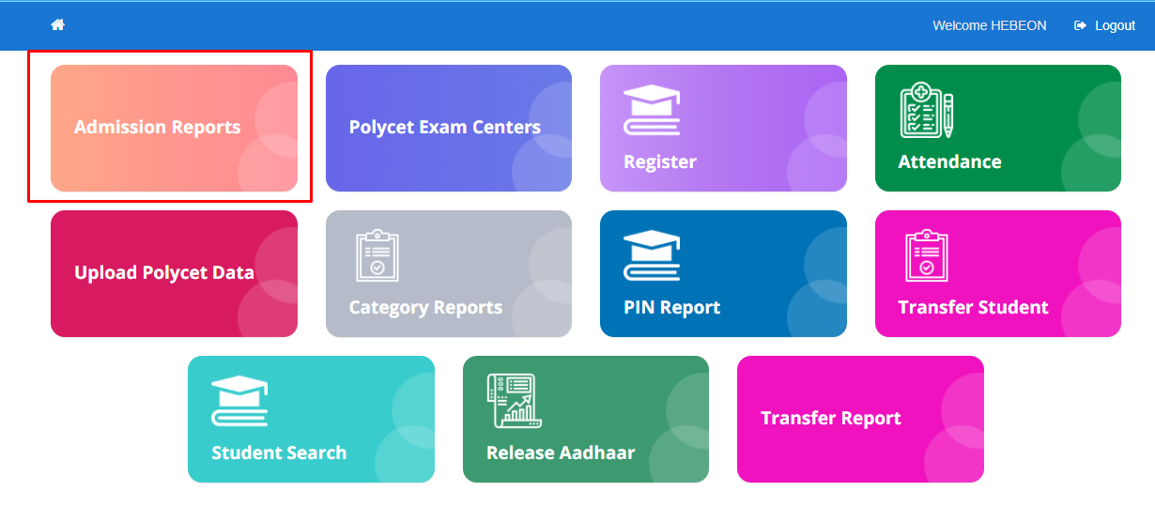

**Navigation Steps to Admission Report:**

STEP 1: Click on Admission Report Module.

STEP 2: Choose the data from drop down as per requirement.

STEP 3: Click on Get Report.

STEP 4: Report containing the College Name, On Roll, Allotted, Kyce pending and No AttendeeId.

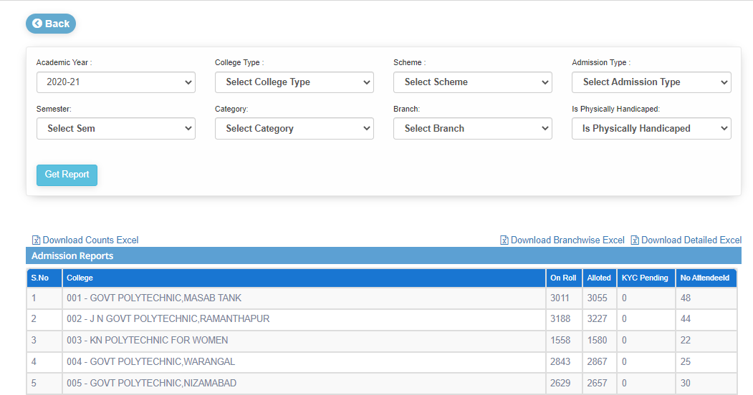

STEP 4: Click on Download Excels the kind of data user want to download

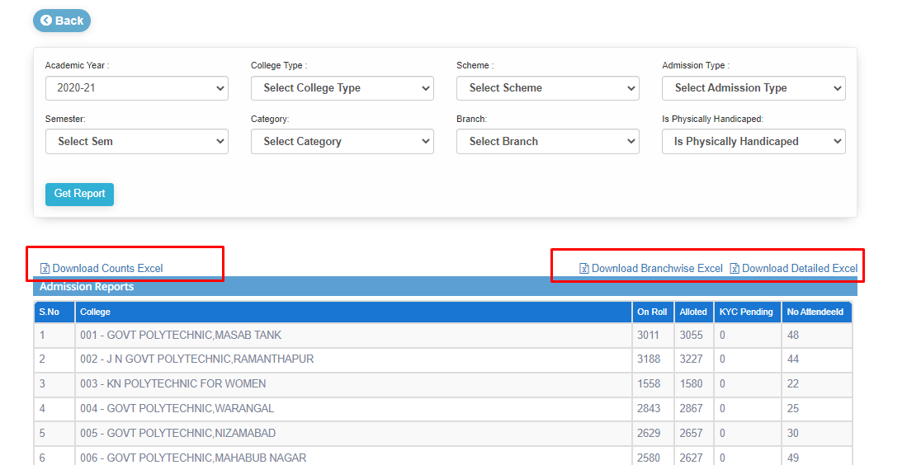

STEP 6: To get the in details about college user need to click on that particular row. The details contain college and student details.

STEP 7: College details includes college name followed by college code, Address, Bank details, Phone number, College email and College Established Date.

STEP 8: Student Details includes Scheme, Semester, Branch, Allotted, On Roll, Data Not Updated, Aadhar Not Verified, AttendeeId Not Generated, Pin Not Generated.

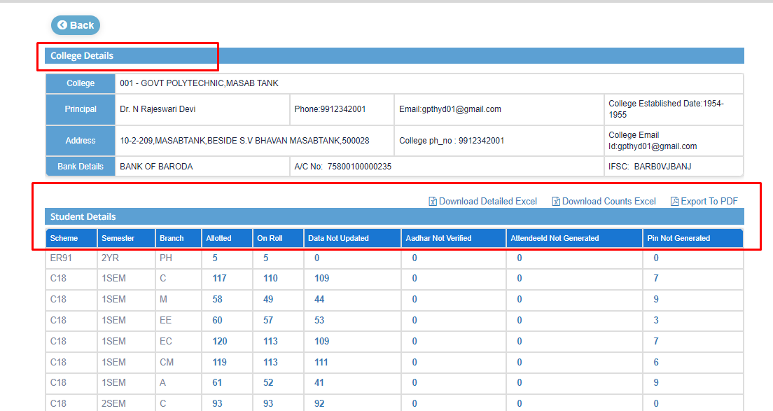

STEP 9: Click on Download Excel that user want to download.

STEP 10: To get each row details click on that particular row. The data includes PIN, AttendeeId, Student Name, Birth Date, Admission Type, Aadhaar Status and Generate Pin.

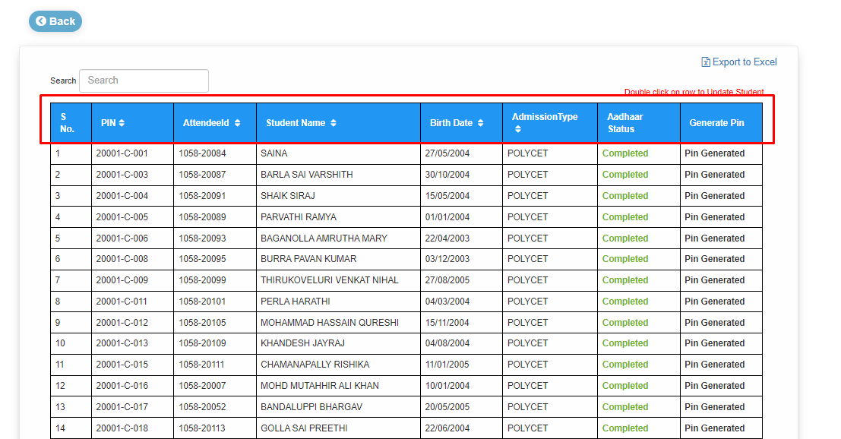

**Note: If Aadhaar status is in pending click on that particular data. user can view the Aadhar e-kyc popup. Select the software and enter the data into Aadhaar number field and click on Approve. Then status will be change from pending to completed.**

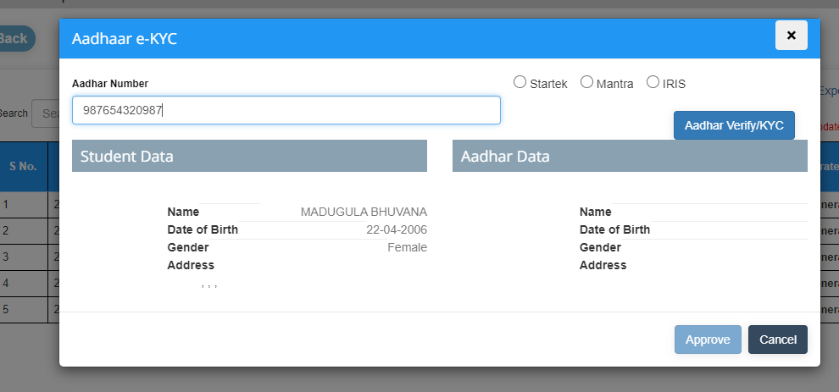

STEP 11: To update the student details user should double-click on that particular row.

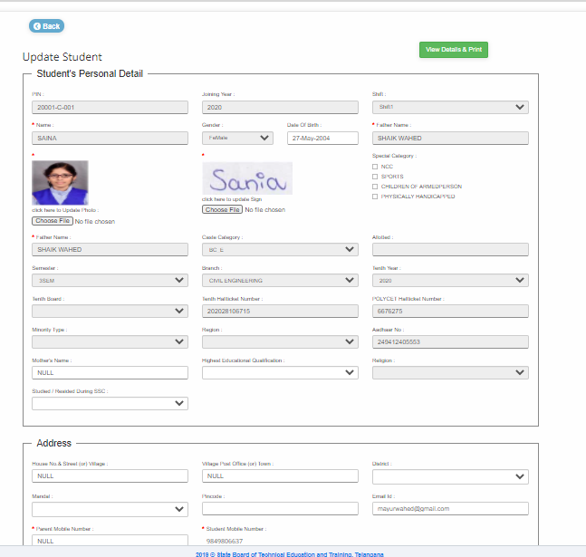

STEP 12: Click on **Update Student Details** which will be present at the bottom after updating the student details.

STEP 13: User can download the report in the form of excel by clicking on **Import to Excels/Import to Pdf.**

**4)Module Name: Attendance**

**Module Description:**

Attendance Module is used for, to get the overall attendance percentage of all the colleges.

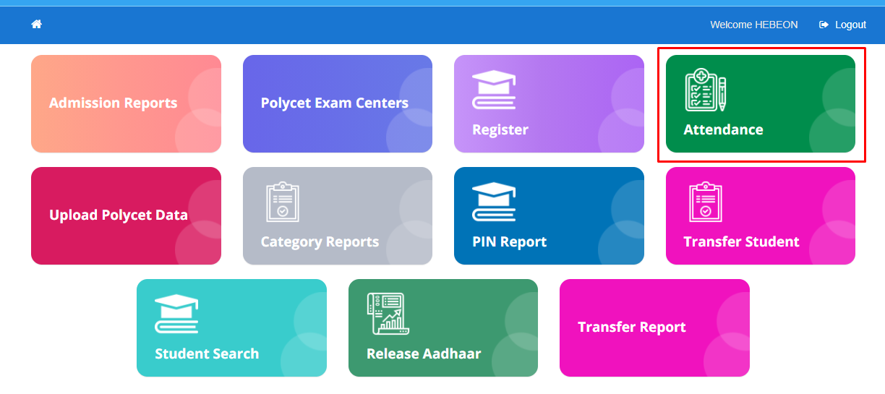

**Navigation Steps to Attendance:**

STEP 1: Click on Attendance Module

STEP 2: User can view the data of all the colleges

STEP 3: The data contains College Code, College Name, On Roll, the overall attendance percentage of students which is <65%, 65% to 75% and >75%.

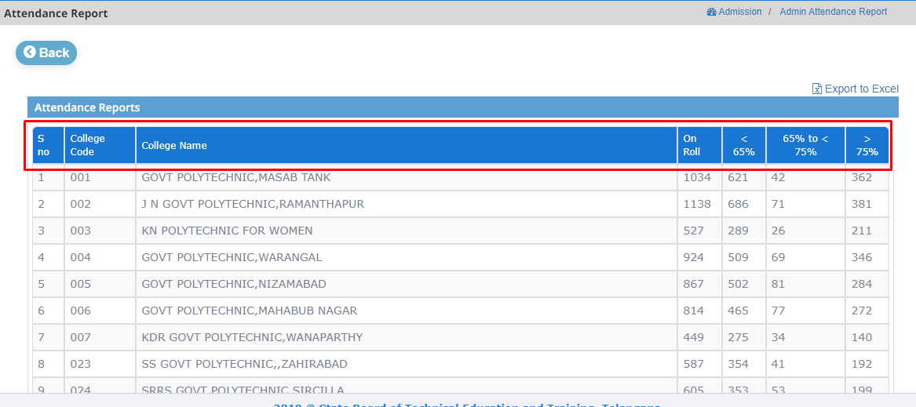

STEP 4: To get the in detail about college, user need to click on that particular row. It contains the data of Scheme, Semester, Branch, On Roll and the overall attendance percentage of students which is <65%, 65% to 75% and >75%.

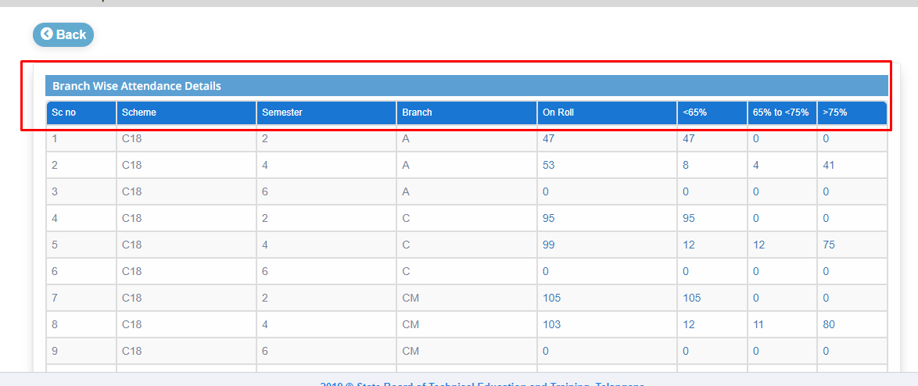

STEP 5: To get the attendance details of students click on that particular row who are having <65%, 65% to 75% and >75. The data contains Pin, Name, Working days, Present and overall percentage.

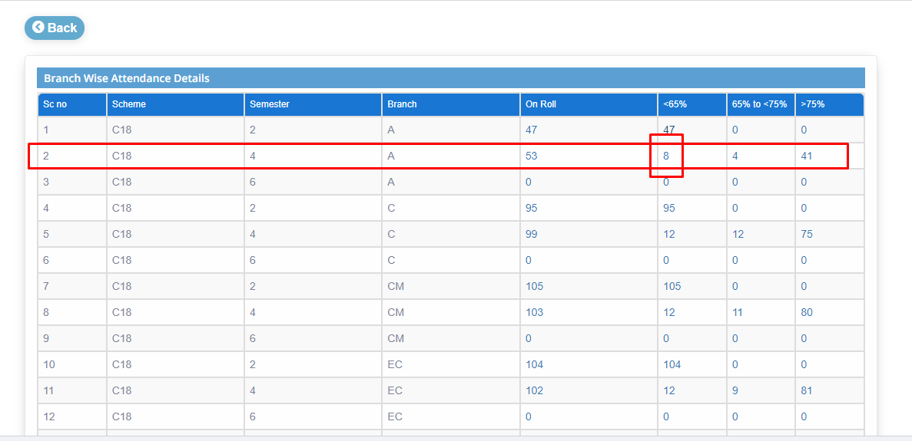

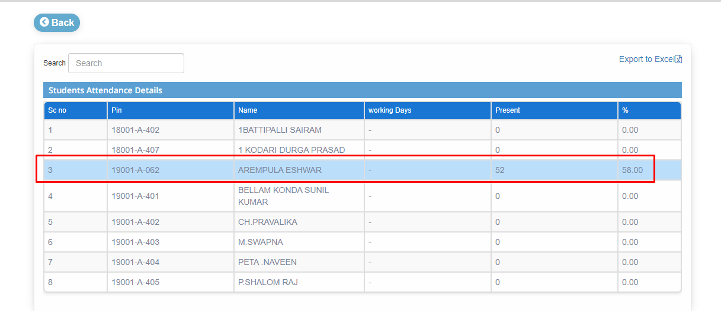

STEP 6: To get attendance of each student by month and date, click on that particular row.

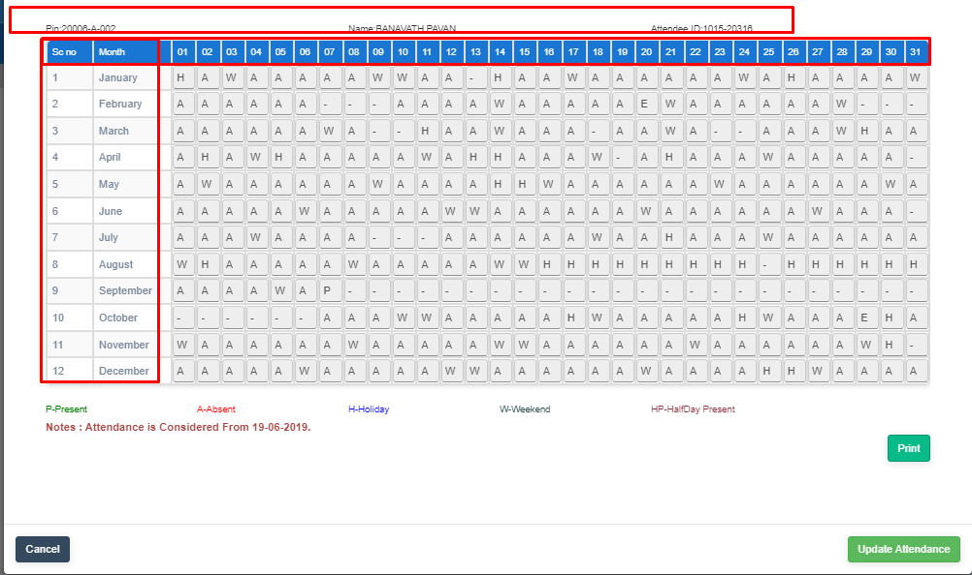

STEP 7: User can update the attendance of any student by editing and then Update Attendance

**NOTE: Admin user has right to edit the attendance of any student.**

**5)Module Name: Category Reports**

**Module Description:**

Category Reports is used to get the report by category of all the colleges.

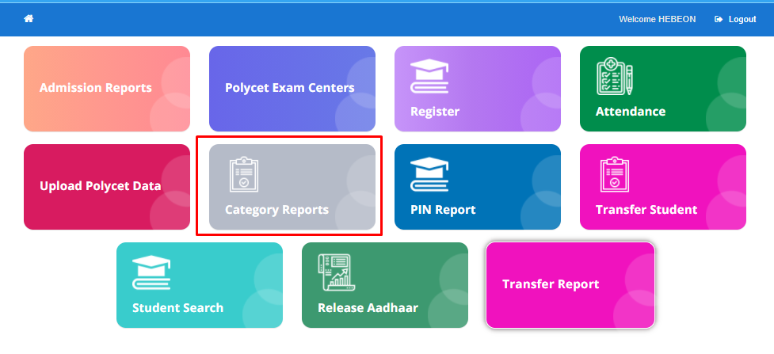

**Navigation steps to Category Reports:**

STEP 1: Click on Category Reports Module

STEP 2: User can view the report by category of all the colleges.

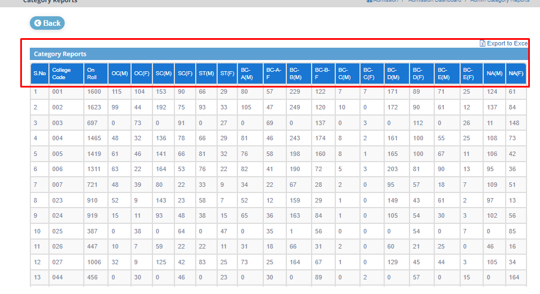

STEP 3: To get details of college click on that particular row.

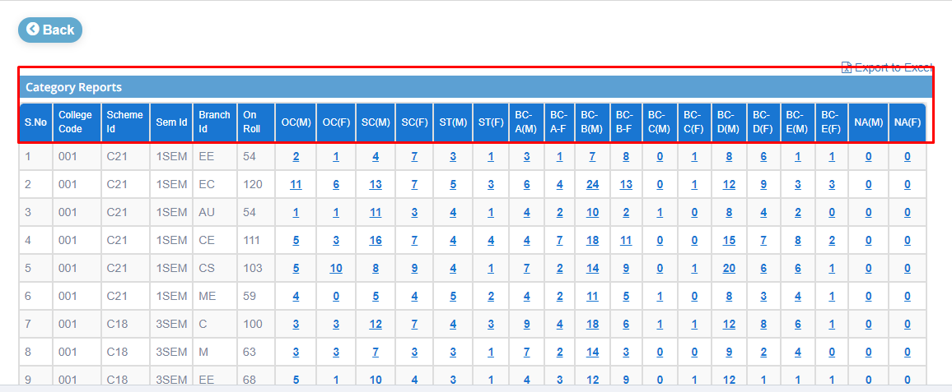

STEP 4: To get in-detail about student click on that particular row. User can view the student name, pin and category.

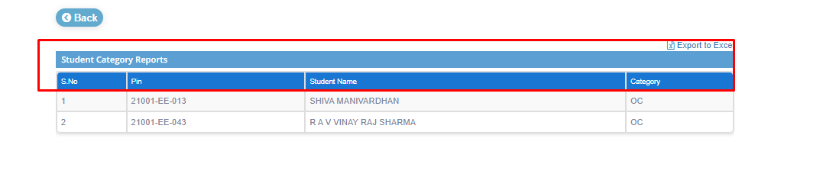

STEP 5: User can download the report in the form of excel by clicking on **Import to Excel.**

**6)Module Name: PIN Reports**

**Module Description:**

Pin Report Module is used for, to display the pin generated information of all the colleges.

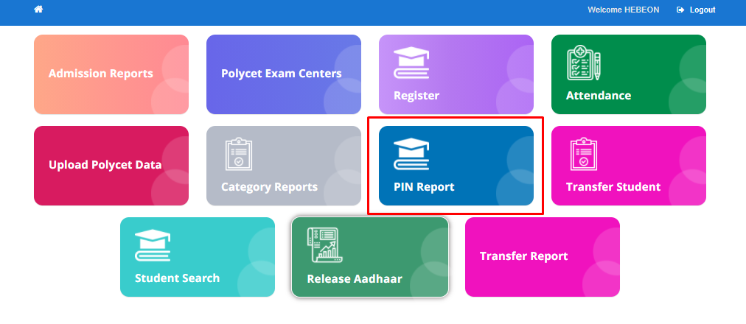

**Navigation steps to PIN Reports:**

STEP 1: Click on PIN Report Module.

STEP 2: User can view the data of all the colleges. The data includes College Code, College Name, Intake, Allotted, Pin Generated, Pin Generated Percentage, AttendeeId Not Generated, Principal phone number and College Phone Number.

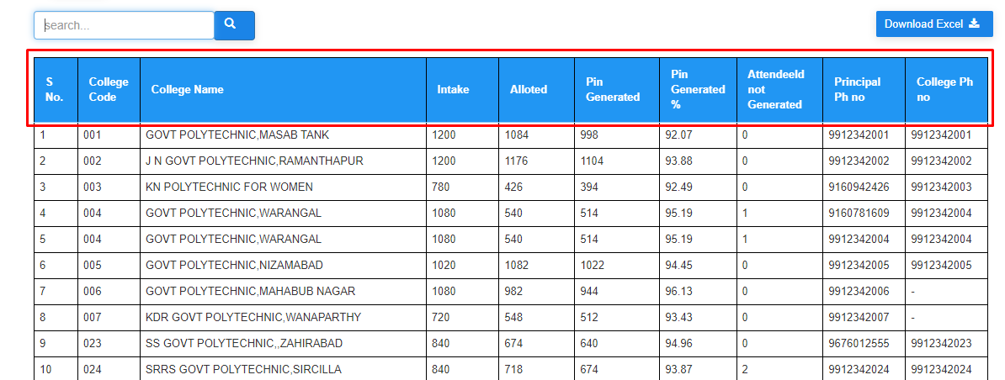

STEP 3: User can download the report in the form of excel by clicking on **Import to Excel.**

**7)Module Name: Transfer Student**

**Module Description:**

Transfer Student Module is used for to transfer the student from one college to other college.

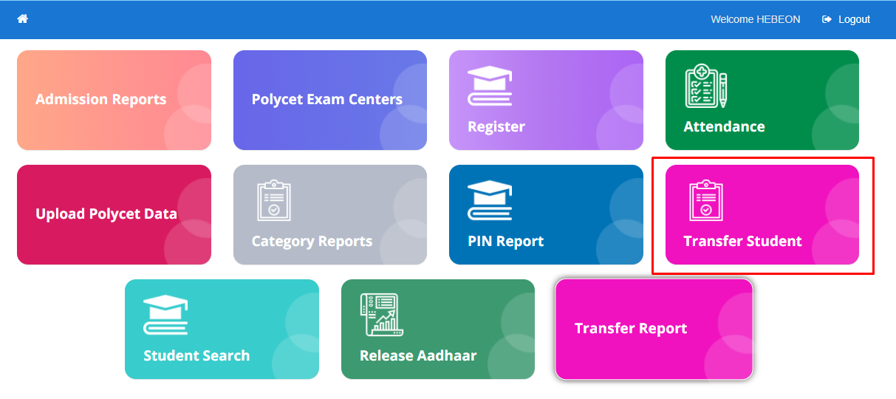

**Navigation steps to Transfer Student:**

STEP 1: Click on Transfer Student Module

STEP 2: Enter the data into the PIN field and click on Get Details.

STEP 3: User can view the data of that particular PIN number.

STEP 4: Select the college to transfer the student from the dropdown.

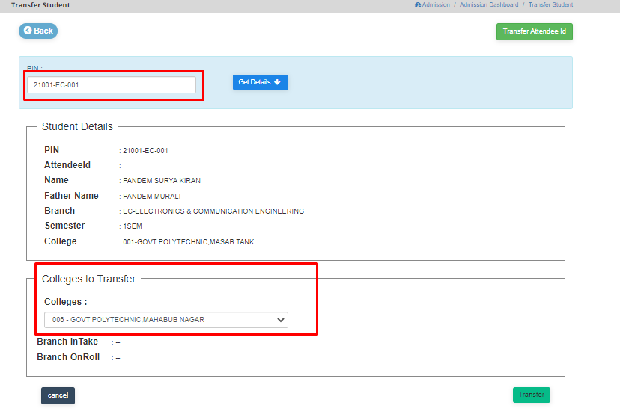

STEP 5: Click on Transfer. User will get a popup to verify the details to proceed

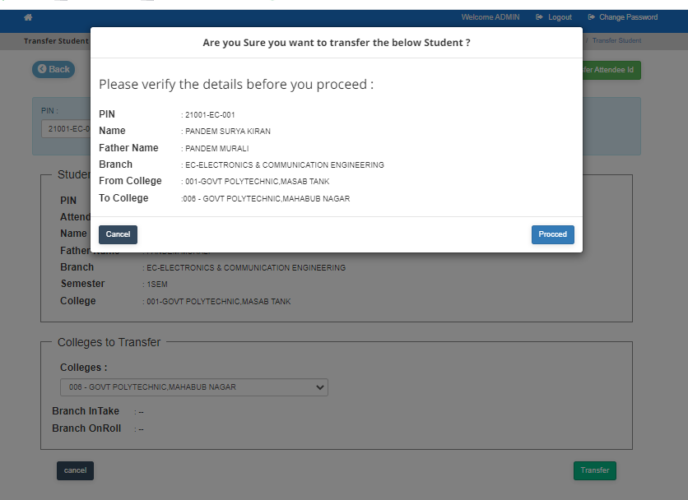

STEP 6: Click on proceed.

**8)Module Name: Transfer Report**

**Module Description:**

Transfer Report Module is used to get the information about the students who were transferred from one college to other.

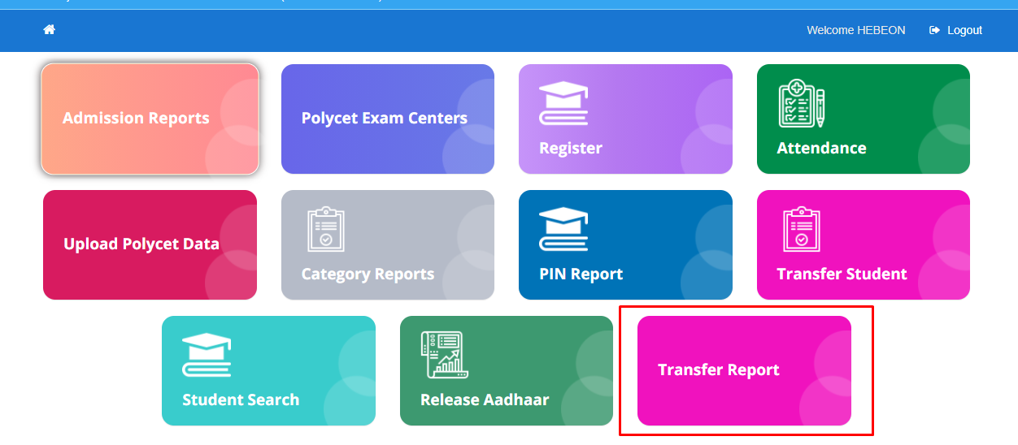

**Navigation steps to Transfer Report:**

STEP 1: Select the data from the dropdown as per requirement

STEP 2: Click on Get Report

STEP 3: User can view the data of students who transferred from one college to other.

STEP 4: The data contains New College Name, Old College Name, Scheme, Branch, Current Semester and Students Transferred.

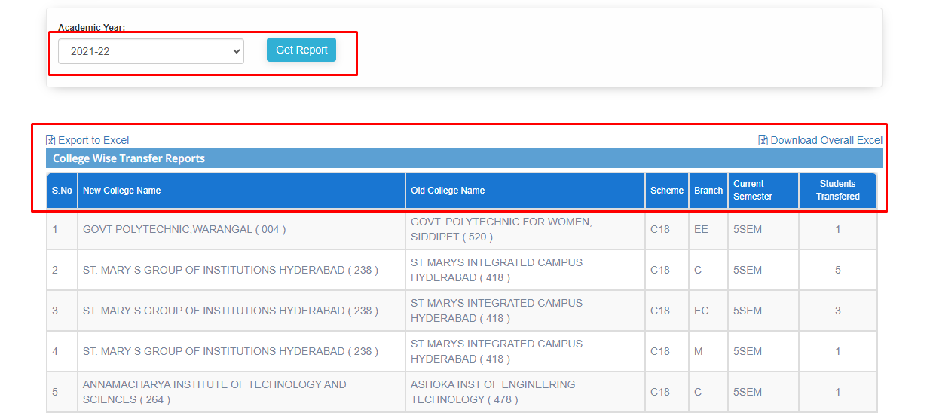

STEP 5: To get more about college click on that particular row. The data contains New College Name, Old College Name, Scheme, Branch, Semester and Transferred Count.

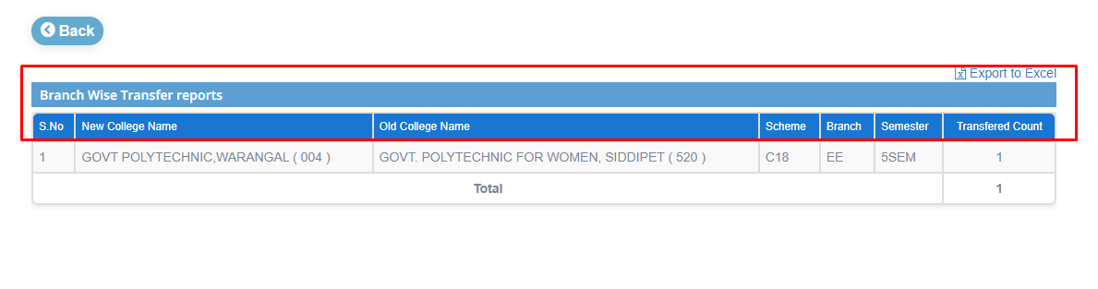

STEP 6: To get transferred count details click on that particular count. The data contains New College Code, Old College Code, Branch, Scheme, Semester, Pin and Name.

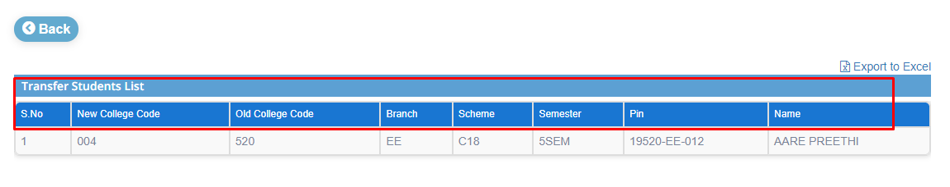

**9)Module Name: Student Search**

**Module Description:**

Student Search Module is used to get the information about Assessment, Attendance and Admission of any student.

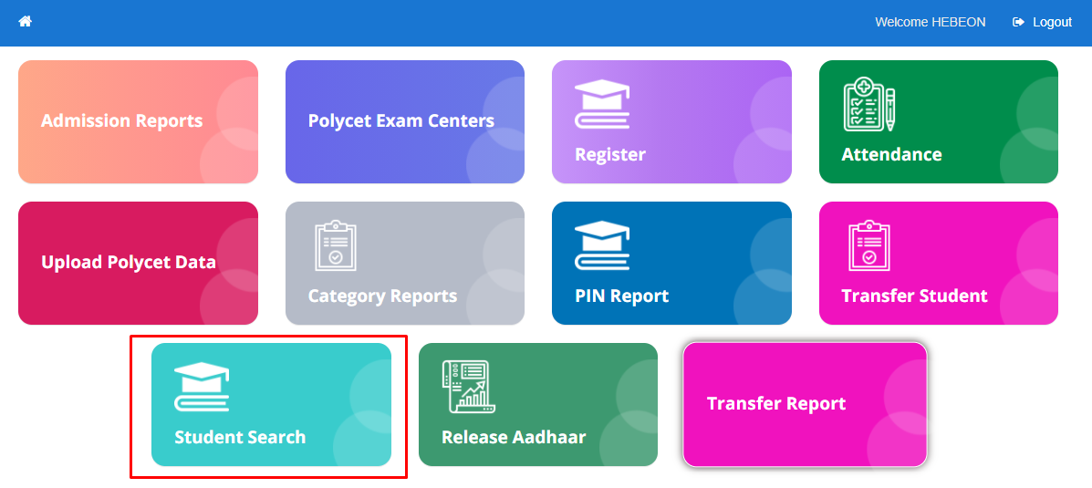

**Navigation steps to Student Search:**

STEP 1: Select the option (pin or attendee id (or) Aadhaar number) to search the student.

STEP 2: User can view the Assessment details i.e., Scheme Code, SemId, Branch Code, Pin, Subject Code, Is Elective, Mid 1 Max Marks, Mid 1, Mid 1 Date, Mid 1 Is Submitted, Mid 2 Max Marks, Mid 2, Mid 2 Date, Mid 2 Is Submitted, Internal Marks, Internal, Internal Date, Internal Is Submitted, End Exam Marks, End exam, End Exam Date and End Is Submitted.

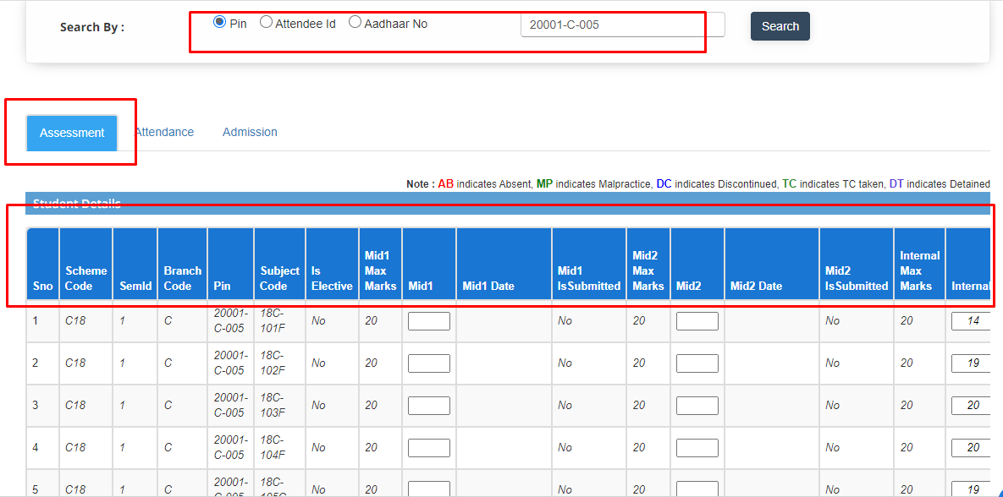

STEP 3: In Attendance tab details user can view the PIN, Attendee Id, Name, College Code, Semester, Branch Code, Working Days, Attendance Percentage, Days Present, Updated Date and Is Transferred.

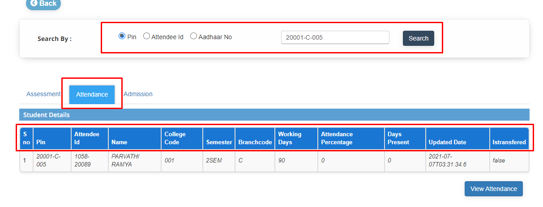

STEP 4: If user want to view the attendance by month and date of student. Click on View Attendance.

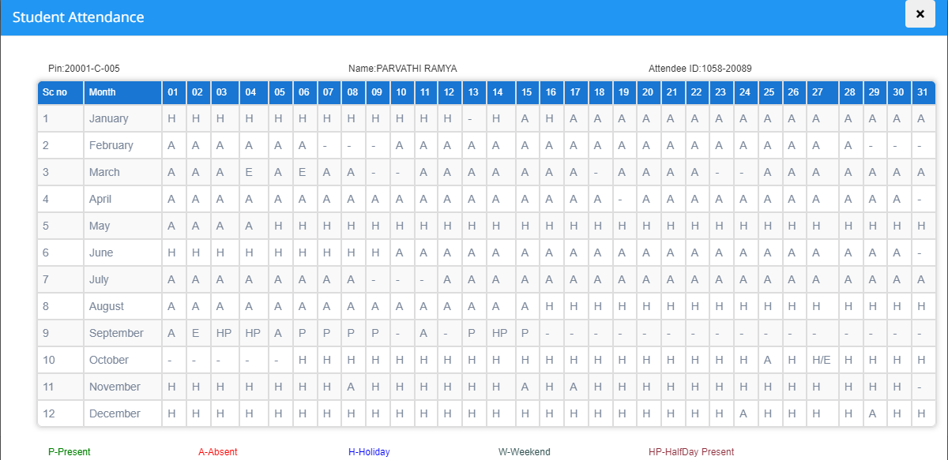

STEP 5: In Admission tab details user can view the student details.

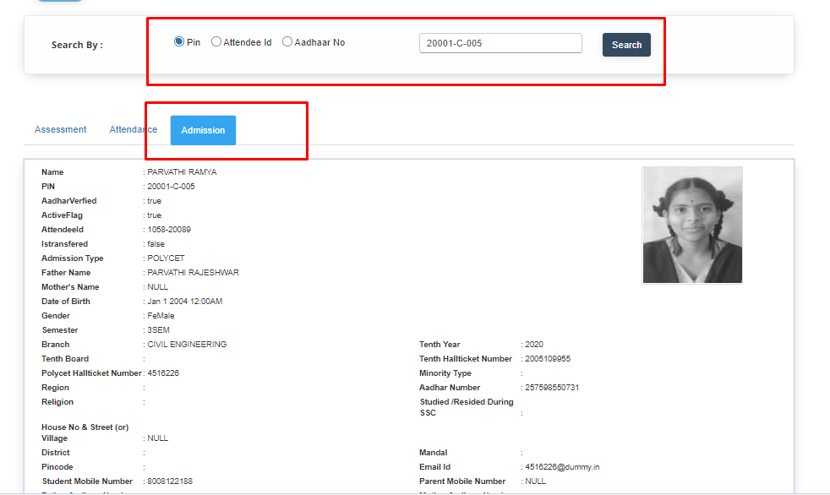

**10)Module Name: Release Aadhaar**

**Module Description:**

Release Aadhaar Module is used for clearing the Aadhaar number of student.

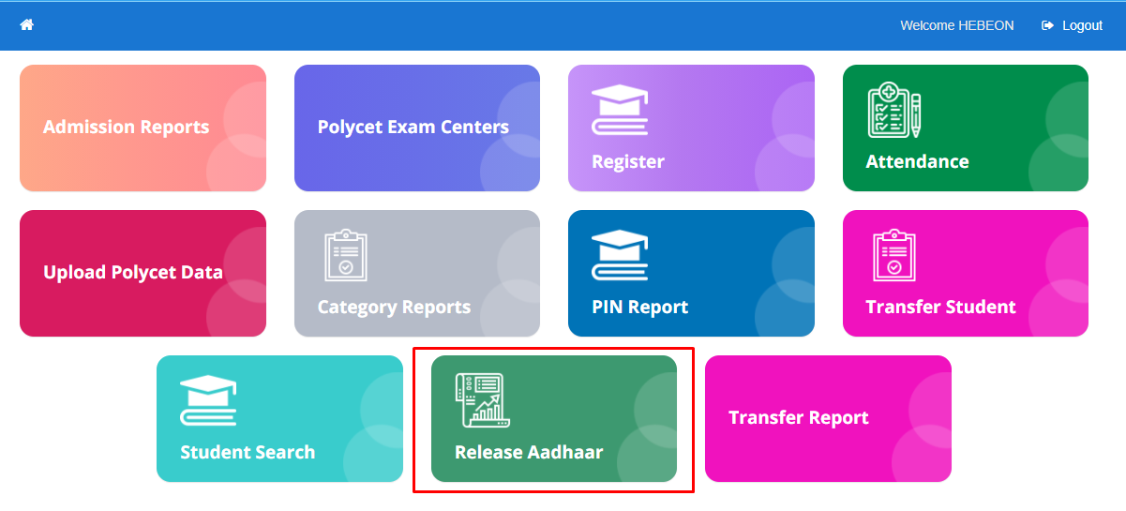

**Navigation steps to Release Aadhar:**

STEP 1: Click on Release Aadhaar Module.

STEP 2: Enter the data into the student pin number field

STEP 3: Click on Release Aadhaar.

STEP 4: User can view the pop that “Are you sure you want to Release Aadhaar”.

STEP 5: Click on OK.

