**Module Name: Assessment**

**Module Description:**

Assessment module is a place where it contains Reports, Set dates, Statistical Reports, Search PIN, Release Marks Entry and Backlog Marks Entry Sub-Modules

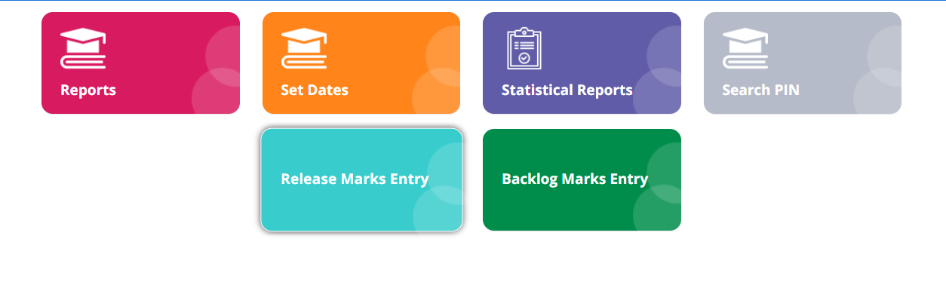

**1)Name of the Module: Set Date**

**Module Description:**

This module is used to set the date for marks entry of students by the HOD logins.

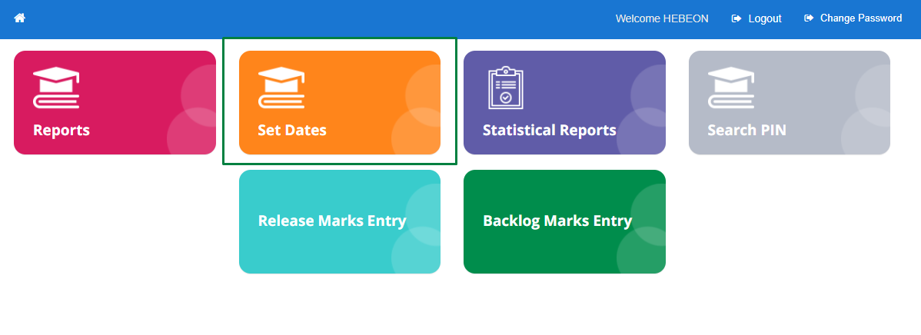

**Navigation steps to Set the Date:**

STEP 1: Login to Admin page

STEP 2: Click on Assessment Module

STEP 3: Click on Set Date Module

STEP 4: Choose the data from the dropdown as per requirement

STEP 5: Click on set

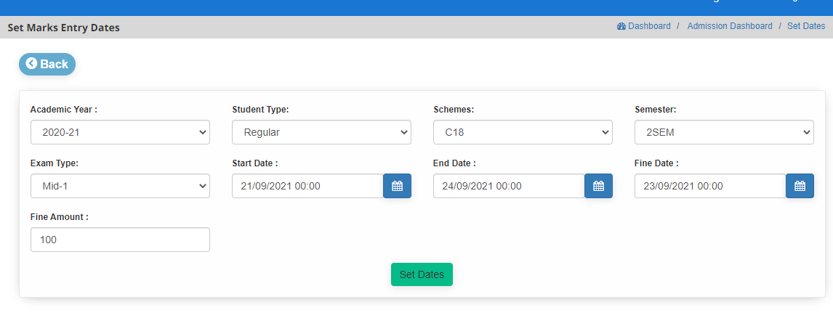

**NOTE: --**

To view the data in dropdown, admin has to create them in respective module.

**2)Name of the Module: Reports**

**Module Description:**

Reports module is a place where user can see the entry of marks of each academic year along with each college

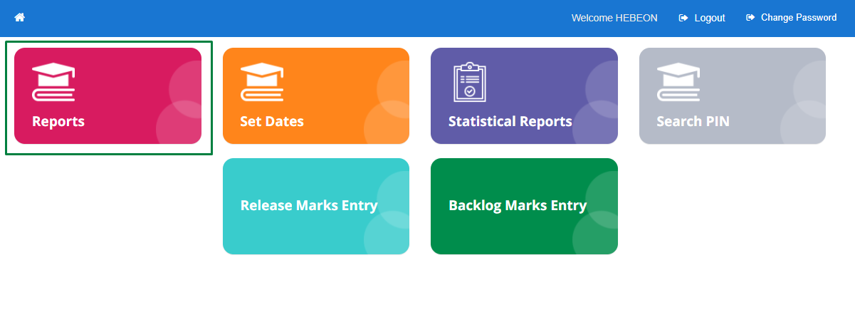

**Navigation steps to Reports:**

STEP 1: Click on Reports module Module.

STEP 2: Choose the data from the drop down as per user requirement.

STEP 3: Report contains each college of data followed by total number of students, not posted I.e., the count of students whose marks were not entered, Absent, Malpractice, Detained, Discontinued and TC Taken of choosed data from the dropdown.

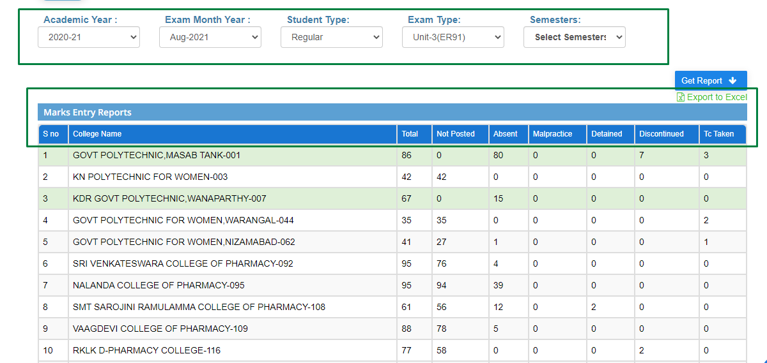

STEP 4: List of colleges were highlighted where not posted count is zero.

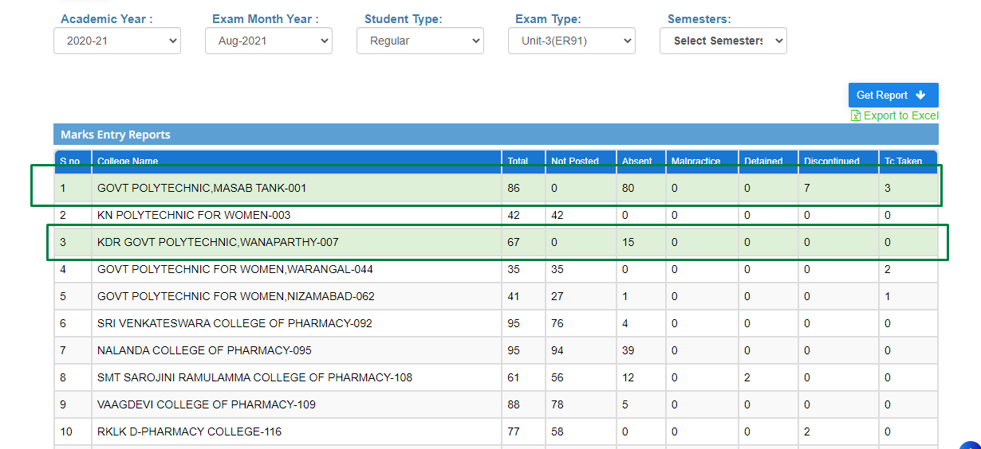

STEP 5: User can view in-detail about of each college I.e., Scheme, College code, Branch code, Semester, Subject code, Total, Not Posted, Absent, Malpractice, Detained, Discontinued and TC Taken in marks entry reports when clicking on each row.

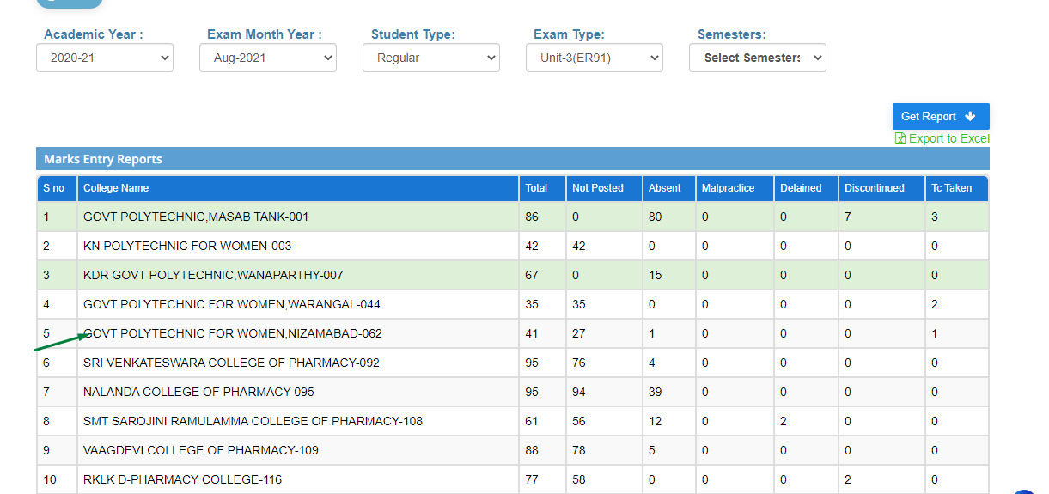

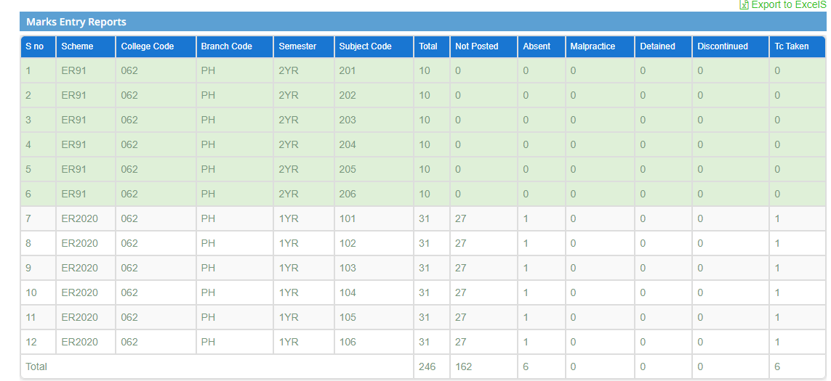

STEP 6: Click on each row to get more details. Data contains Scheme, College Code, Semester, Subject Code, Pin, Marks Entered Date and Marks.

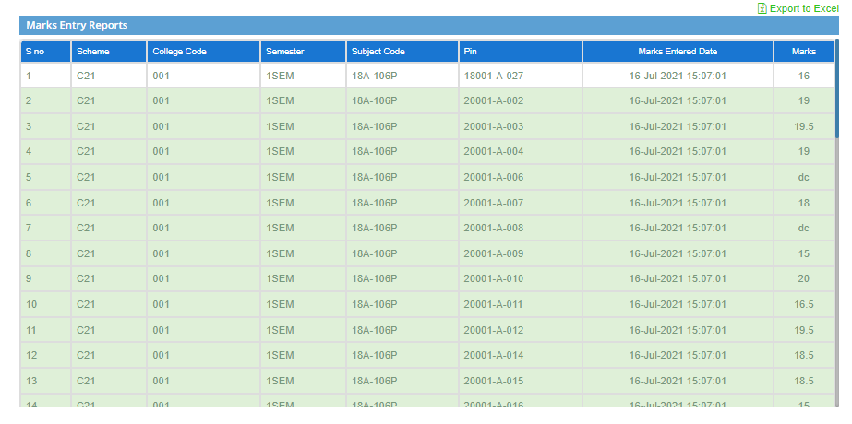

STEP 7: User can download the report in the form of excel while clicking on **Import to Excels** which is present at top right.

**NOTE:**

To view the marks entry reports user has to entry the marks of each student by the HOD

**3)Name of the Module: Release Marks Entry**

**Module Description:**

Release Marks Entry module is used for, to give the provision for HOD logins to edit the marks of students.

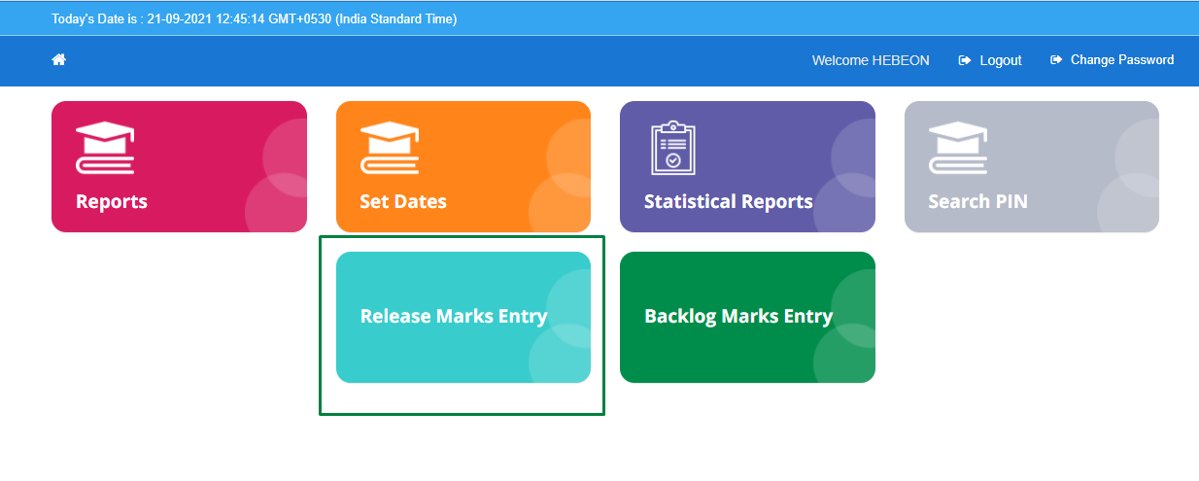

**Navigation steps to Release Marks Entry:**

STEP 1: Click on Release Marks Entry Module

STEP 2: Choose the Data from dropdowns, To which user want to give permission to edit the marks of student.

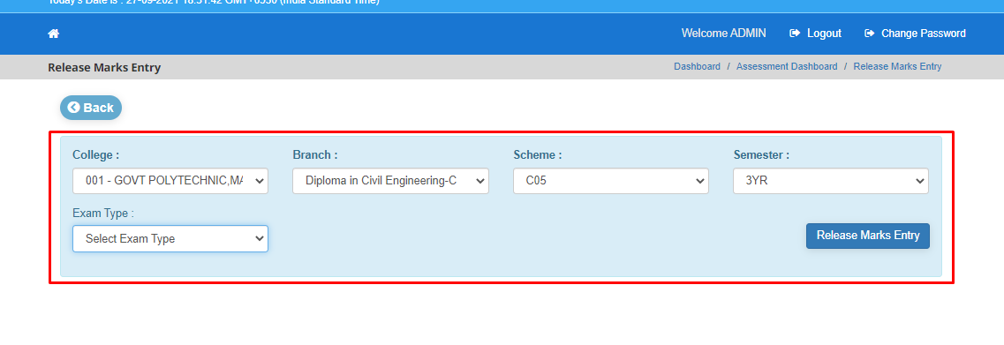

STEP 3: Click on Release Marks Entry.

STEP 4: So, user can edit the student marks in HOD logins

**4)Name of the Module: Backlog Marks Entry**

**Module Description:**

Backlog Marks Entry module is used for editing the marks of students in the case of where students were absent and detained of all the colleges.

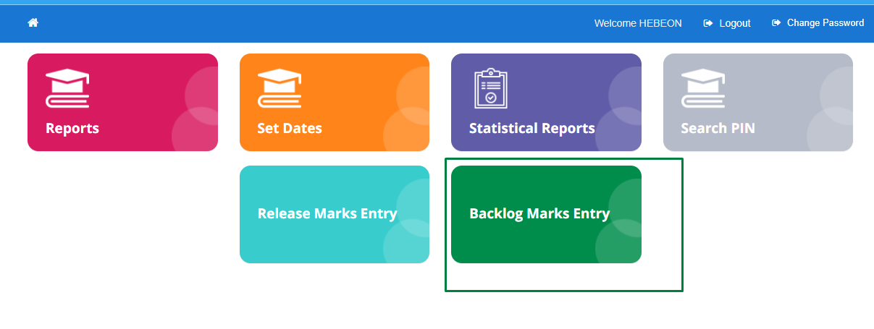

**Navigation steps to Backlog Marks Entry:**

STEP 1: Click on Backlog Marks Entry Module

STEP 2: Choose the data from dropdown as per requirement

STEP 3: Click on Get data

STEP 4: User can view the details of choosed data from down. So, in the details user can edit the marks.

