**Admin Login**

**Module Name: DC Bills**

**Module Description:**

DC Bills module contains Detailed Expenditure, Abstract, Set Exam Charges.

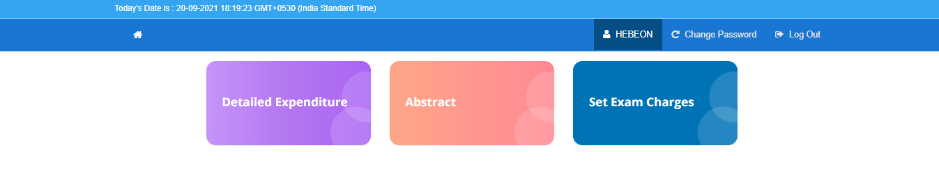

**1) Sub module name: Set Exam Charges**

**Description:**

This sub module is used to set all the exam expenditures.

**Navigation steps:**

**Step1:** Open set exam charges



**Step 2:** Select exam month and year and click on Get Exam Charges as attached below

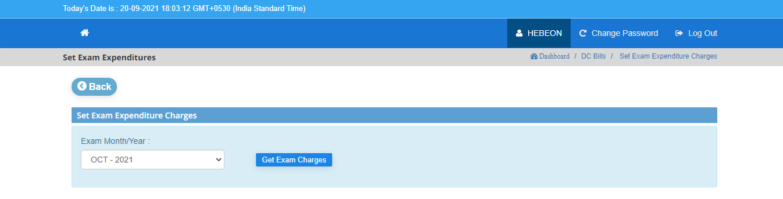

**Step 3:** When we click on **Get exam Charges** the details of Session expenditure were displayed as below which are categorized to Theoretical, Practical and Practical Viva Charges. 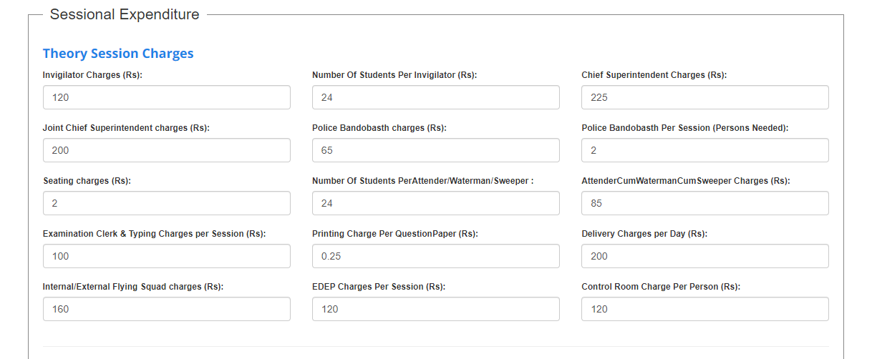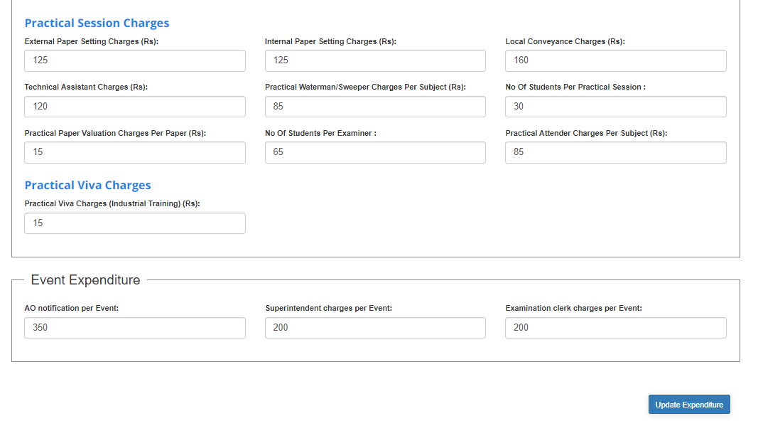

**Note:** Here The values that are displayed in the above are given by default. If any deviation occurred among those, we can re-enter the values and click on update expenditure so that the existed values are updated.

**2) Sub module name: Detail Expenditure**

**Description:**

This sub module is used to displays the detailed amount of each expenditure.

**Navigation steps:**

**Step1:** Open **Detail Expenditure**.  
  
**Step-2:** Select Academic Year, Month of Exam/Year and click on  **Get Details**

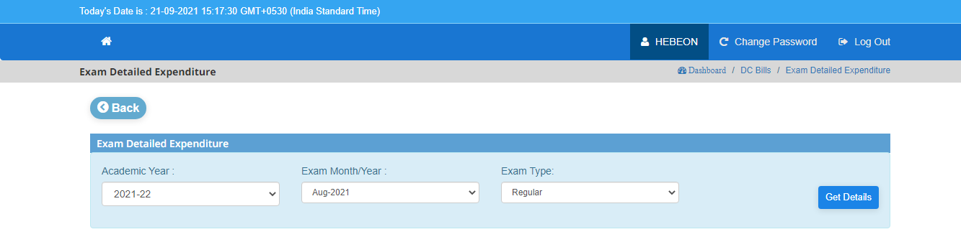

**Step-3:** While clicking on **Get Details the** expenditure is categorized to three ways.  
 At first the Theoretical Expenditure information is displayed

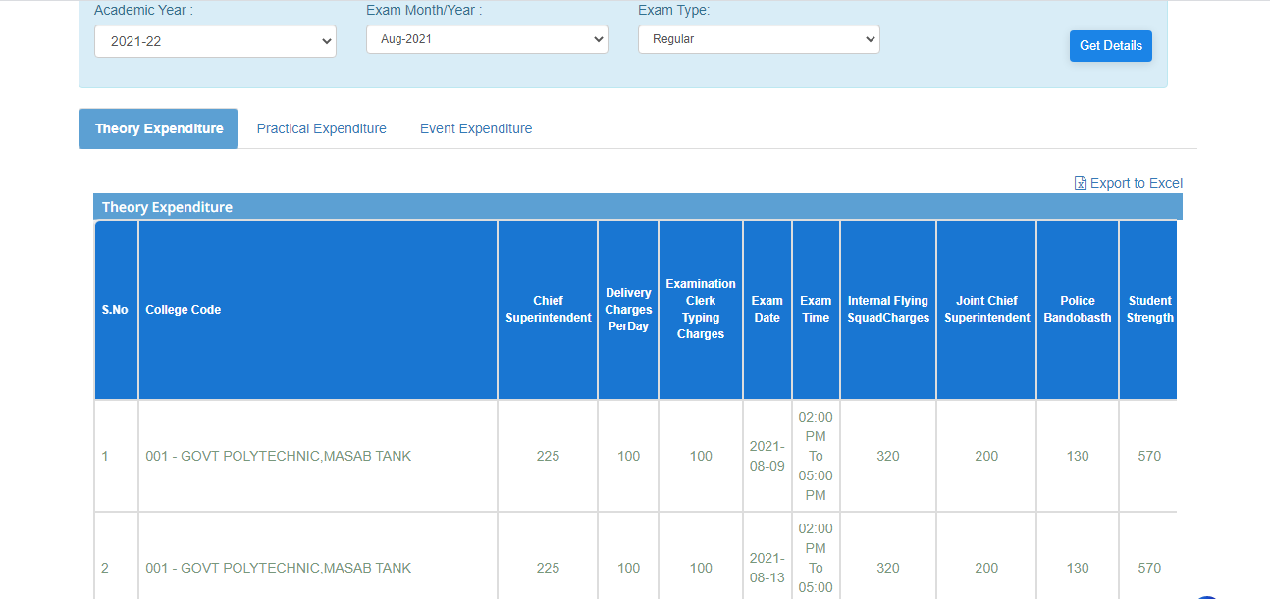

* Click on **Export to Excel** to download and generate the Theoretical expenditures through Excel Format.

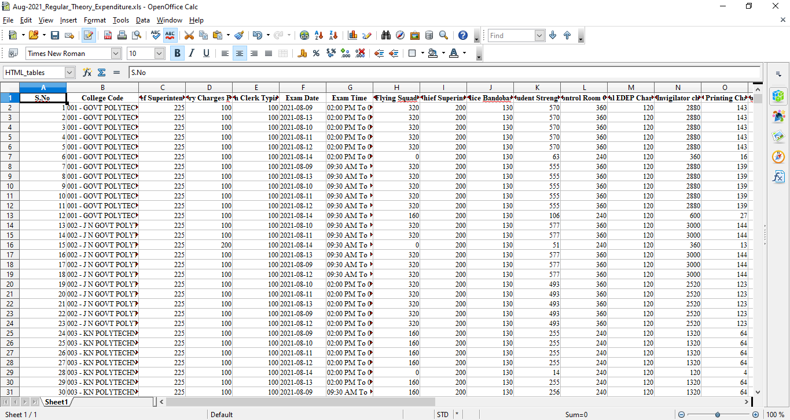

**Step-4:** Next, click on the Practical Expenditure to get all details on practical related.

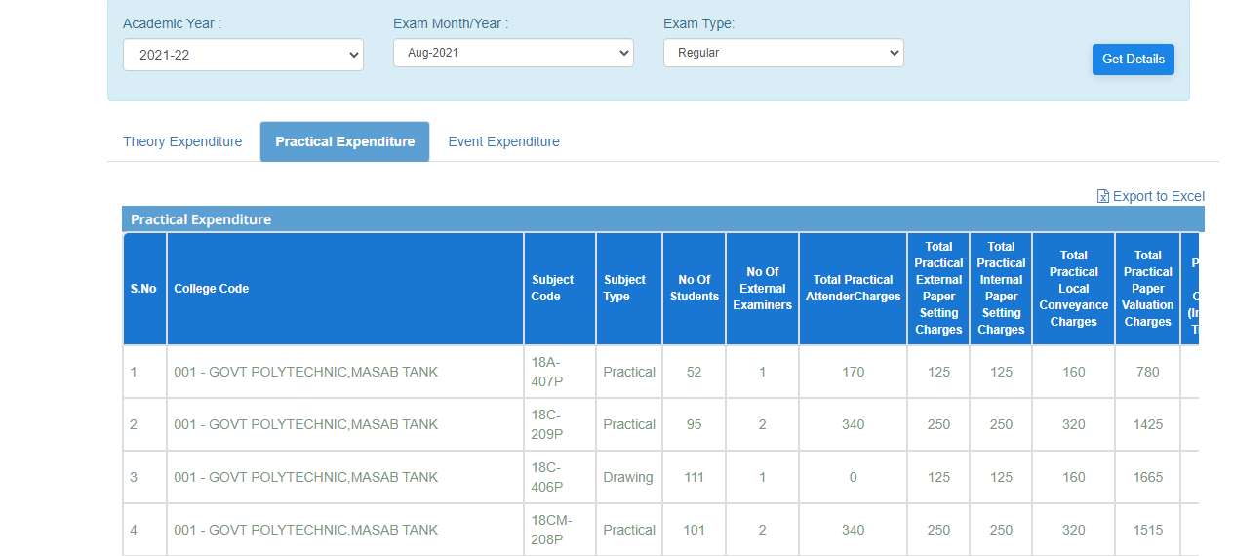

* Click on **Export to Excel** to download and generate the Practical expenditures through Excel Format.

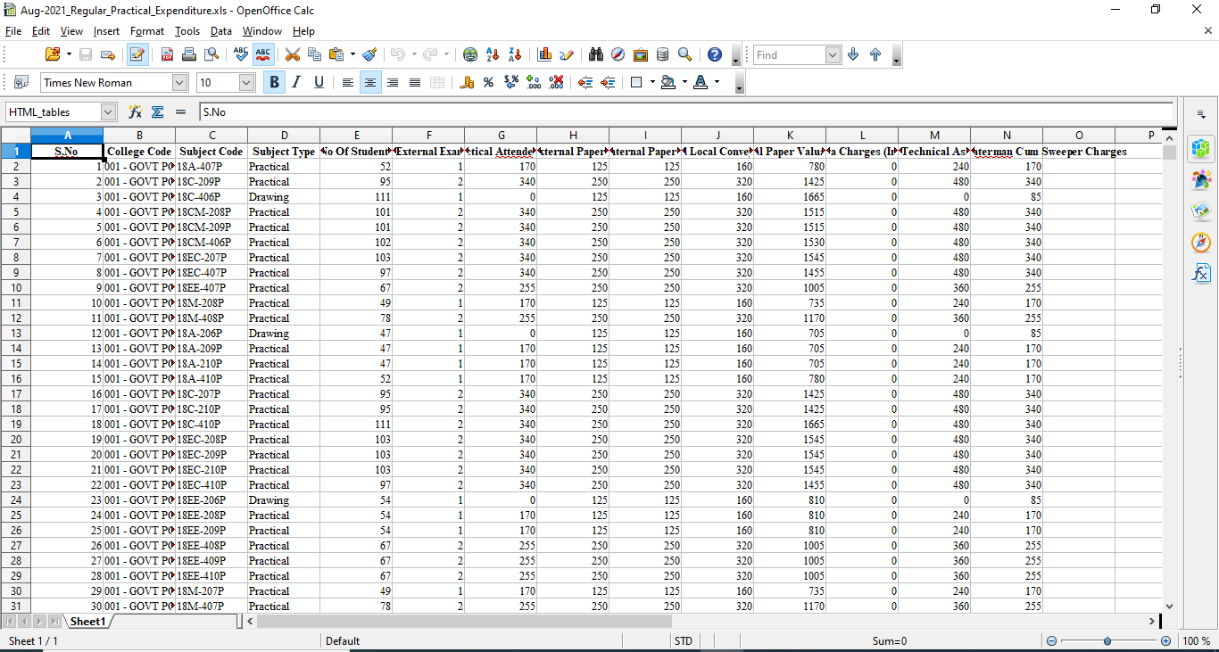

**Step-5:** At last, click on the Event Expenditure that display all details regarding on an event.

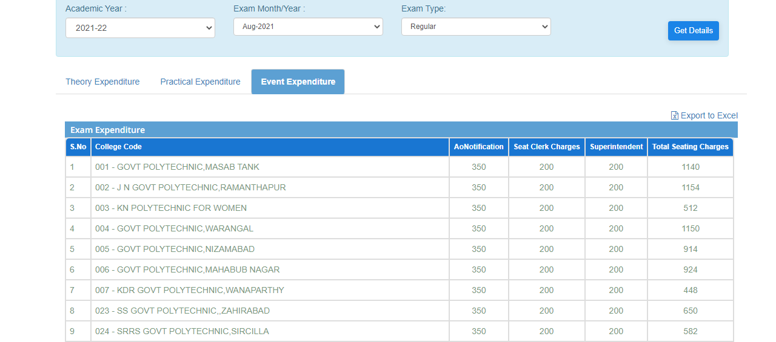

* Click on **Export to Exce**l to download and generate the Event expenditures through Excel Format.

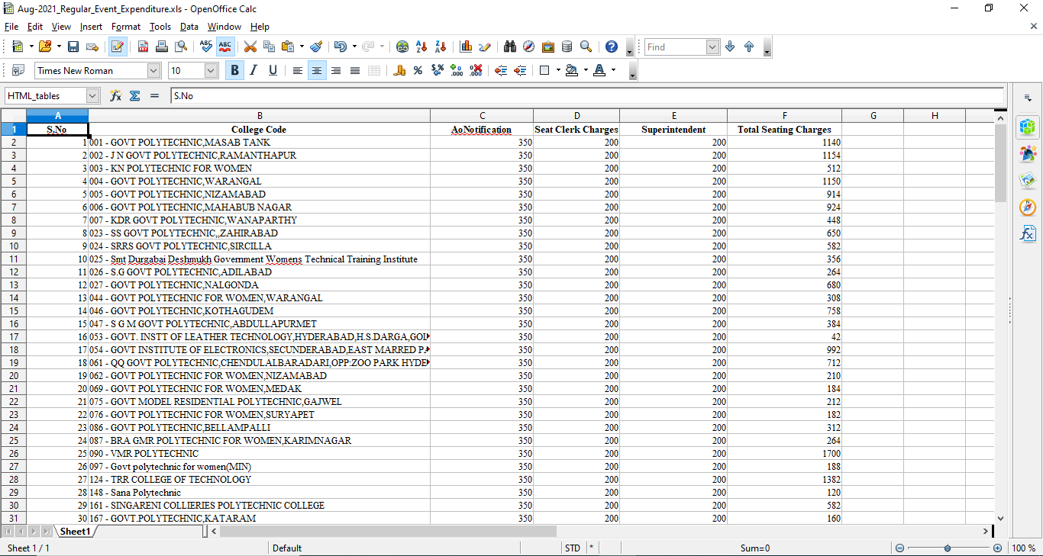

**3) Sub module name: Abstract**

**Description:**

This sub module is used to get brief review on expenditure details.

**Navigation steps:**

**Step 1:** Open **Abstract**  
  
**Step 2:** Select Academic month and year, exam month and year and type of exam after that click on **Get Details.**

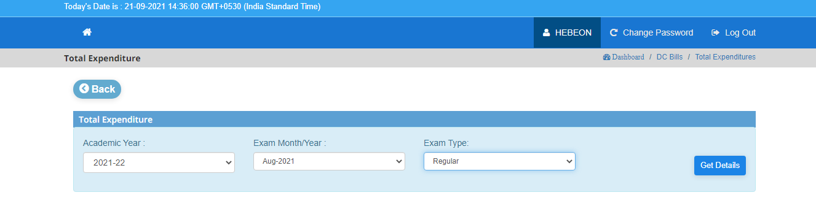

**Step 3:** While clicking on Get Details, we will get **Total Exam Expenditures** of the list of colleges. If we want to fetch how much expenditure of a particular college, we can search as displayed in the search bar.

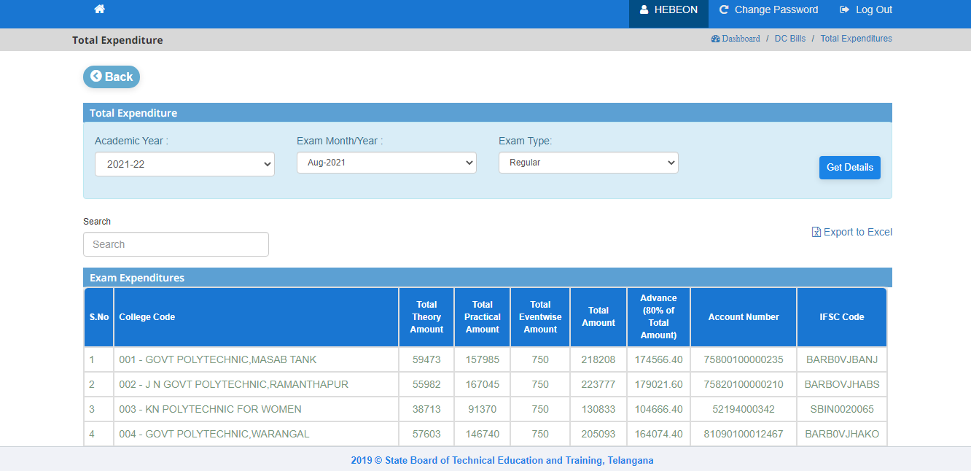

* Click on Export to Excel to download and generate the expenditures data through Excel Format such that how much amount is to be released for a college is given in detail

