**Module Name: Post Exam**

**Module Description:**

Results module consists of Results Reports, Generate Memo Data, NBA Reports, Backlog PIN List, Ambedkar Reports, ODC Tr Sheet, Wantings Report, Generate C18 Memos, Results Automation, 3BL IND TRG Report, Generate ODC, Certificate Approval, NC, C-90,96,00 Approvals, Memo Tr Sheets, RVRC Results.

**1) Sub module name: Results Reports**

**Description:**

This sub module is used to display the report of the overall results of a student

**Navigation steps:**

**Step1:** Open **Results Reports**

**Step2:** Select College. Semester, Branch and click on **Get Report**

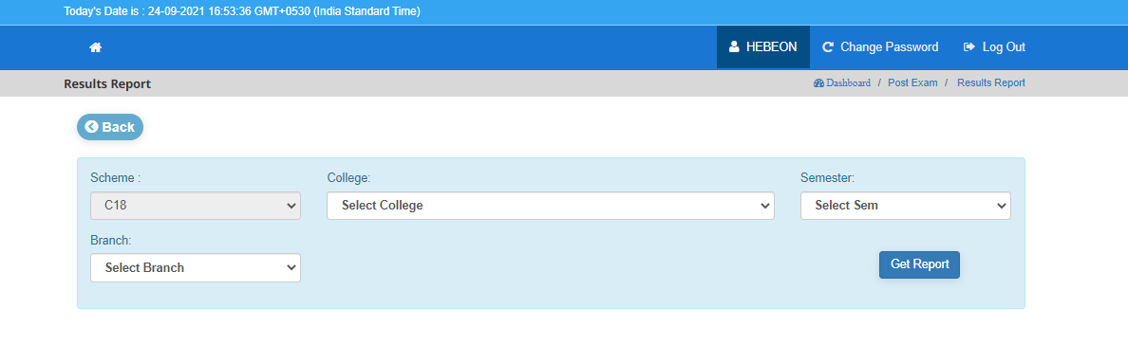

**Step 3:** When we click on **Get Report,** the Results Report is displayed of all students which are related to those college name, branch and semester that generates result data of all semesters, name of branch, college code, SGPA, and CGPA is displayed in excel format.

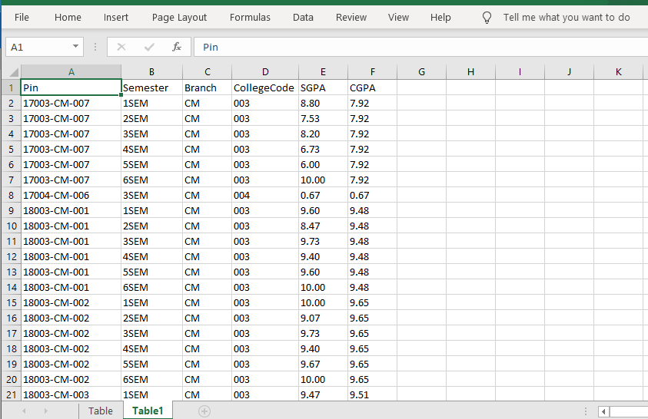

**2) Sub module name: Generate Memo Data**

**Description:**

This sub module is used to get memos data of a student.

**Navigation steps:**

**Step 1:** Open **Generate Memo Data.**  
  
**Step 2:** Enter Scheme, Exam Type, Select Date and click on **Get Report.**

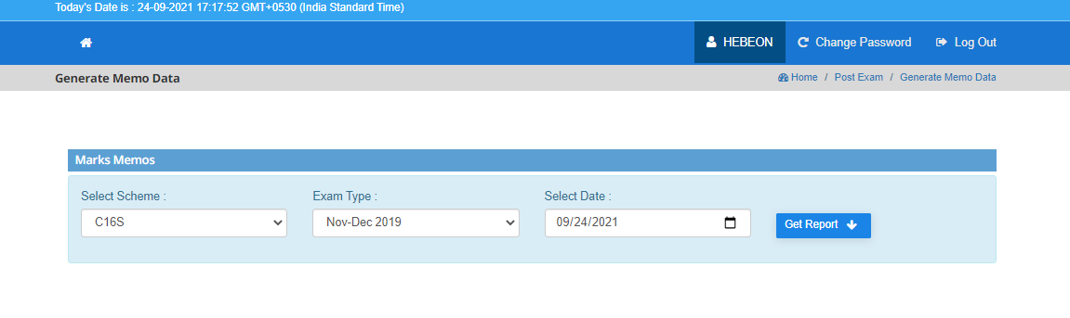

**Step 3:** When we click on **Get Report,** all the marks memos will be generated to the predecessor of the selected Exam type. Based on that we select the particular date on which the marks memos to be downloaded.

**3) Sub module name: NBA Reports**

**Description:**

This sub module is used to get different ways of NBA Reports.

**Navigation steps:**

**Step 1:** Open **NBA Reports.**

**Step 2:** Here we can see that there are 4 various ways of an NBA Report. We can directly download all the reports as attached below.

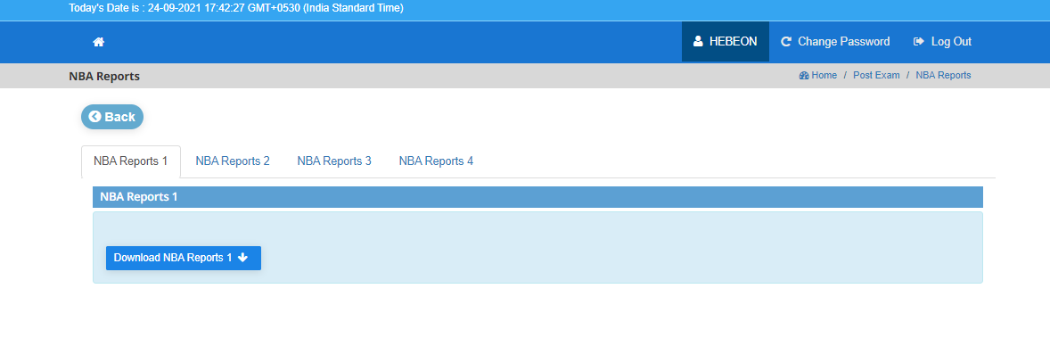

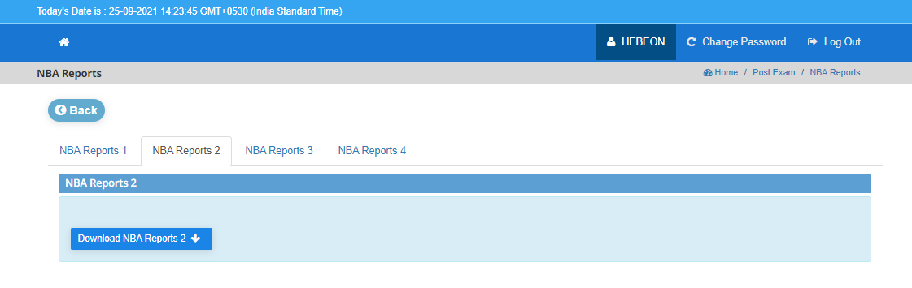

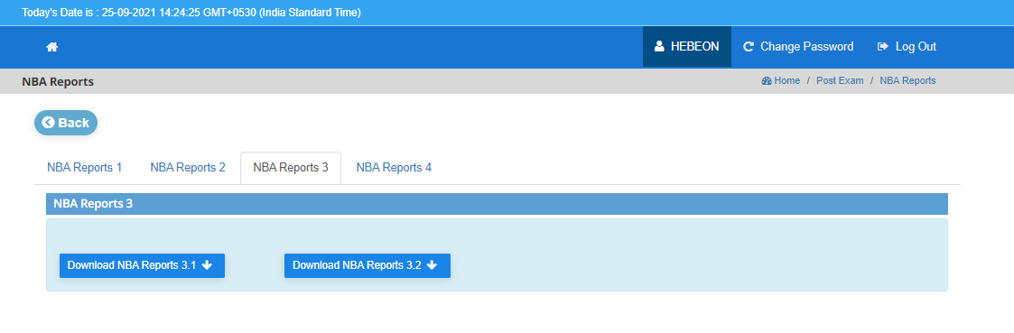

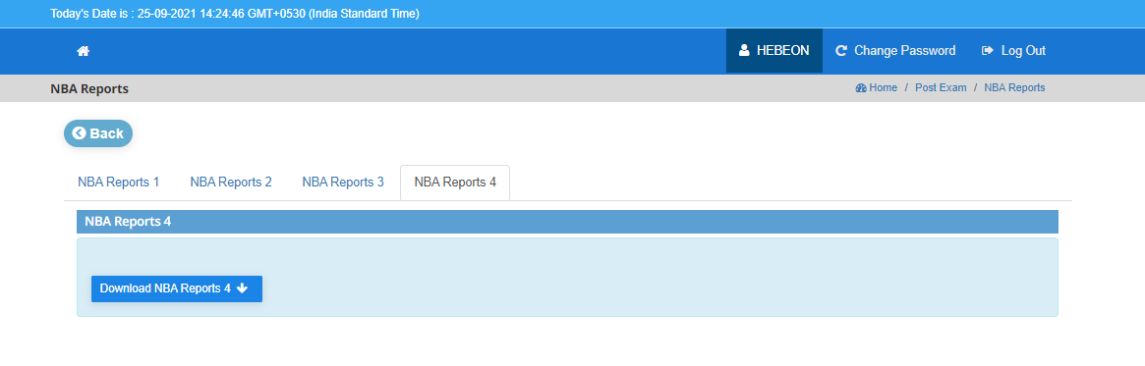

**4) Sub module name: Backlog PIN List**

**Description:**

This sub module is used to get result list of all backlog students.

**Navigation steps:**

**Step 1:** Open **Backlog PIN List.**  
  
**Step 2:** Select Scheme and click on **Get Report.**

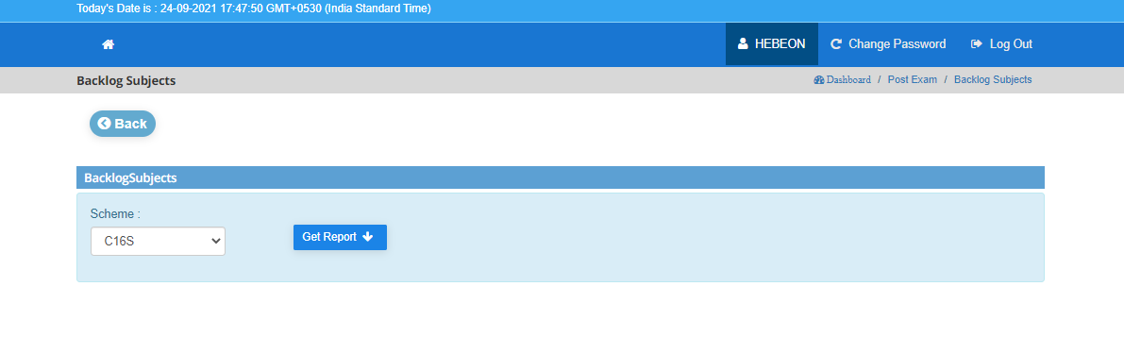

**Step 3:** When we click on **Get Report,**

* The Failed count of backlog subjects is given in Table1. Here the exemption is given for only less than 3 backlogs. If the failed count is less than or equal to 3, they are eligible to pay the fee to get certificate. Otherwise, we should clear all backlogs and met the criteria as mentioned.

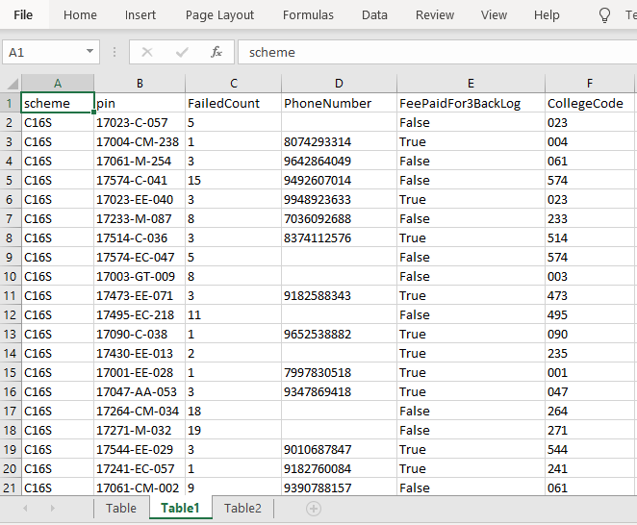

* We can observe in Table2 the backlog result report is given more precise way by giving the student scheme, Exam month/year, pin, subject code, subject name with subject type whether it is theoretical or practical.

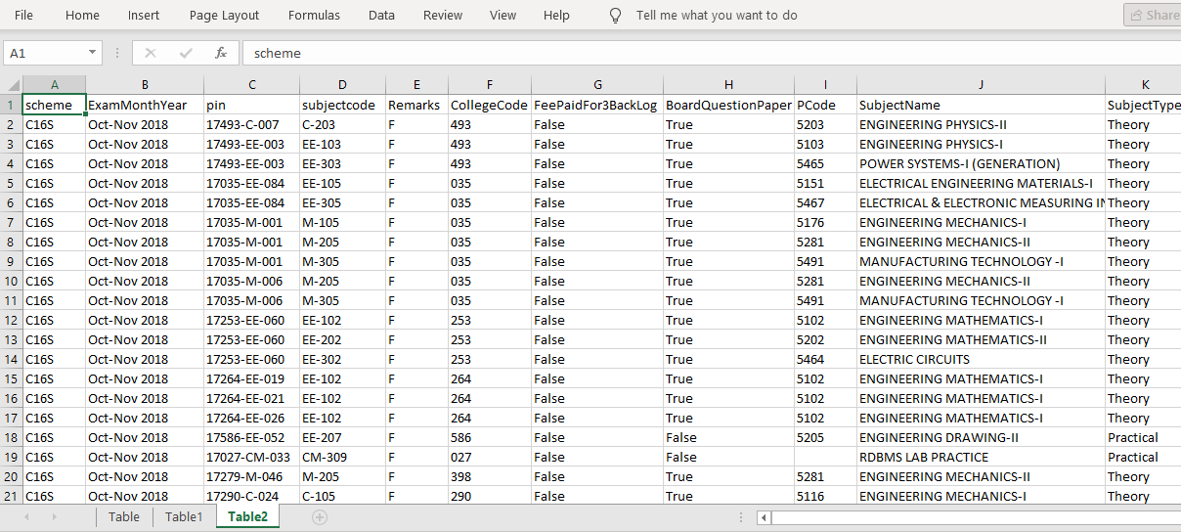

**5) Sub module name: Ambedkar Reports**

**Description:**

This sub module is used to get Ambedkar report.  
  
**Navigation steps:**

**Step 1:** Open **Ambedkar Reports**.  
  
**Step 2:** Select Scheme and click on **Get Report.**

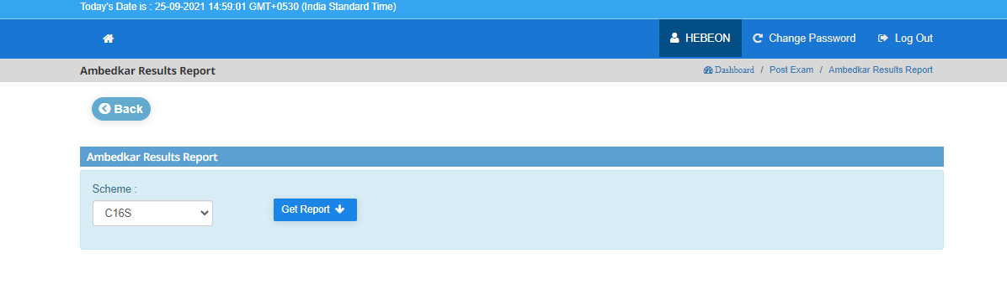

**Step 3:** When we click on **Get Report,** the Ambedkar report will be generated which consists of all student data such as Name of student, Branch name, PIN, College name, Course duration, Month & year etc.,

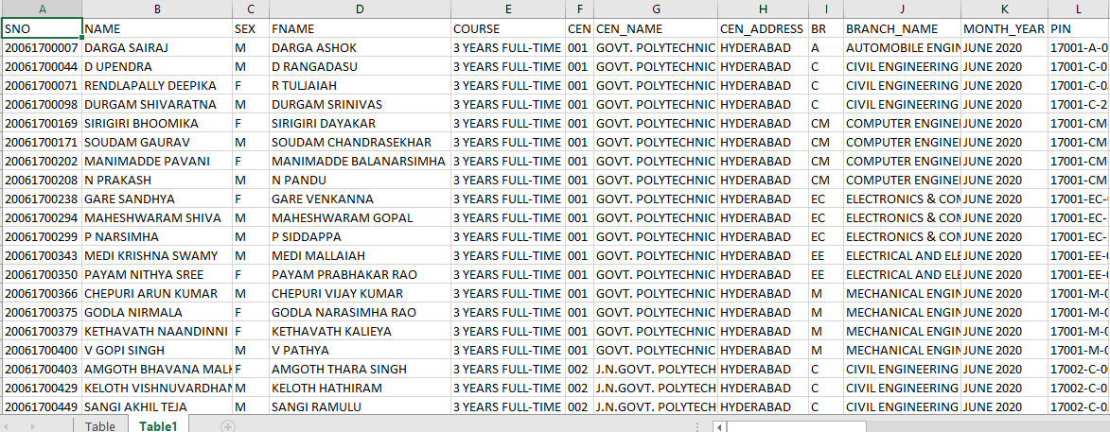

**6) Sub module name: Generate C18 Reports**

**Description:**

This sub module is used to get reports on the scheme based on C18.

**Navigation steps:**

**Step 1:** Open **Generate C18 Reports.**

**Step 2:** Select Exam Month Year, Credits earned, Day, Month & year and click on submit.

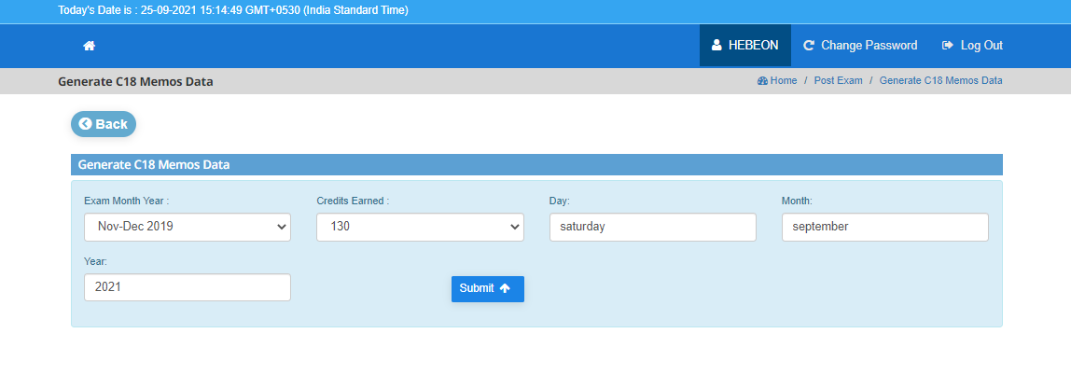

**Step 3:** When we click on **Submit,** the student memos and ODC details will be fetched and displayed up to the previous of Selected Exam Month Year as per C18 scheme report.

**7) Sub module name: 3BL IND TRG Report**

**Description:**

This sub module is used to generate reports those who are failed in Industrial project whose backlogs are less than 3

**Navigation steps:**

**Step 1:** Open **3BL IND TRG Report.**

**Step 2:** Select Scheme click on **Get Report.**

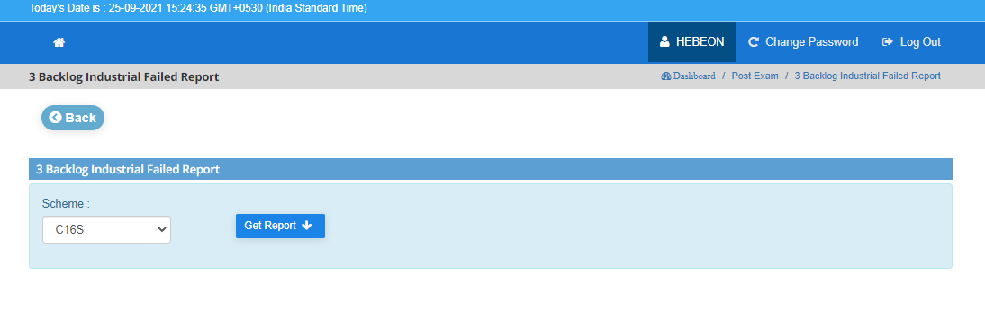

**Step 3:** When we click on **Get Report,** the report is generated as for the students whose backlogs are less than 3 but failed in industrial project those details are categorized as failed. So, if we want to fetch those data the subject code is also given to get the resultant report of a student.

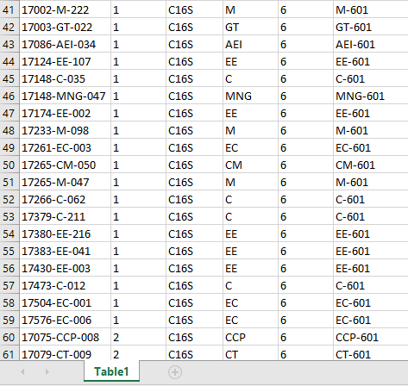

**8) Sub module name: Wantings Report**

**Description:**

This sub module is used to for admin to check if any student marks need to be entered in the report we(admin) can re-enter the data for those particular.  
  
**Navigation steps:**

**Step 1:** Open **Wantings Report.**

**Step 2:** Download directly on **Get Wantings Report.**

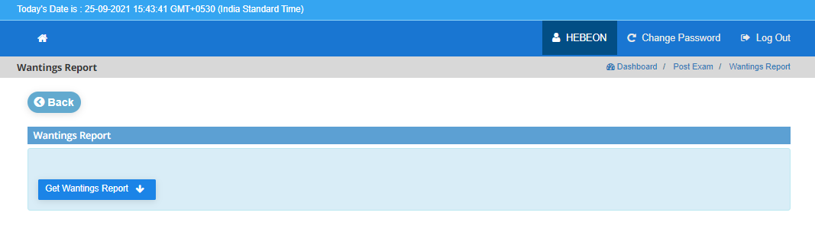

**Step 3:** When we click on **Get Wantings Report.** the student report is generated as per the month year along with mid, semester, subject code, Internal, Subject total, End Exam and Remarks.

* Here the End Exam is generated with some grades as

W - Withheld  
 DC – Discontinued  
 DT – Detained

* So based on above grades if the we(admin) want to re-enter any data, the data is displayed here and can update the data.

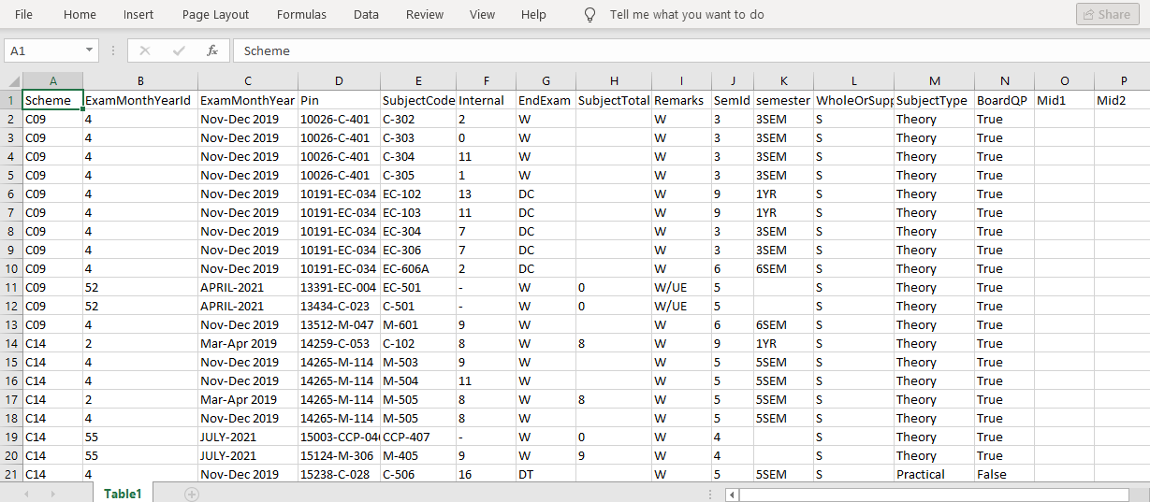

**9) Sub module name: ODC Tr Sheets**

**Description:**

This sub module is used to for admin to check if any student marks need to be entered in the report, we(admin) can re-enter the data for those particular.  
  
**Navigation steps:**

**Step 1:** Open **ODC Tr Sheets.**

**Step 2:** Select Exam type and click on **Get Report.**

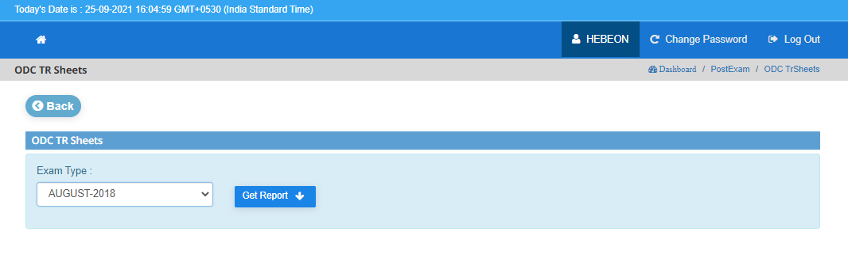

**Step 3:** When we click on **Get Report,** ODC Results Report which is already generated is downloaded based on selected exam type.

**10) Sub module name: Generate ODC**

**Description:**

This sub module is used to generate ODC report.  
  
**Navigation steps:**

**Step 1:** Open **Generate ODC**

* We can observe that 3 different options are given as follows

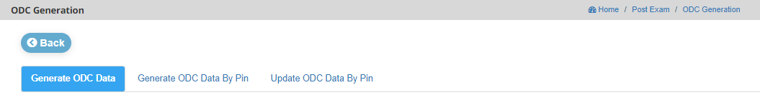

**Step 2:** When we click on **Generate ODC Data**, we need to enter Exam month year, day, month, year and click on **submit** which generates the ODC data up to the previous year data of selected Exam month year.

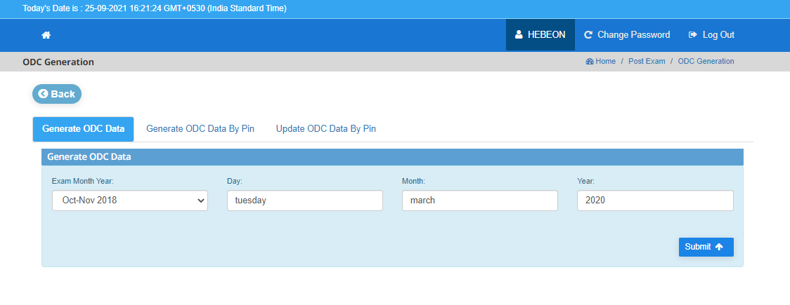

**Step 3:** When we click on **Generate ODC Data By PIN**, enter PIN no and click on **submit** which generates the ODC Report for that particular PIN number.

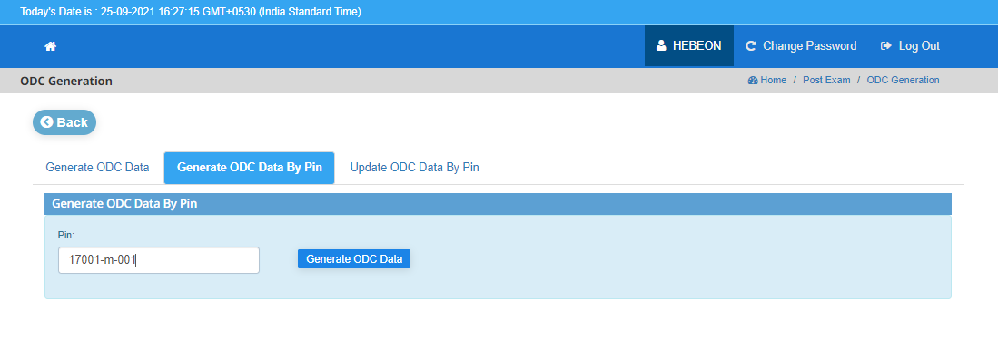

**Step 4:** When we click on **Upload ODC Data By PIN**, enter PIN no and click on **Get Details** it will perform that if anyone requires our data using our pin, we can directly enter our PIN and get ODC Report of that student.

* The overall process we can observe that if any company requires our data, if they missed our PIN number, first they will generate PIN number, and next by using that PIN they will generate ODC. As the ODC no is unique number they will update ODC data by using ODC no and linked to the PIN number and last will generate the ODC report.

**11) Sub module name: Certificate Approval**

**Description:**

This sub module is used to display the report those certificates are approved

**Navigation steps:**

**Step 1:** Open **Certificate Approval.**

**Step 2:** When clicking on it will display the student list for Approvals list whose backlogs are less than 3.

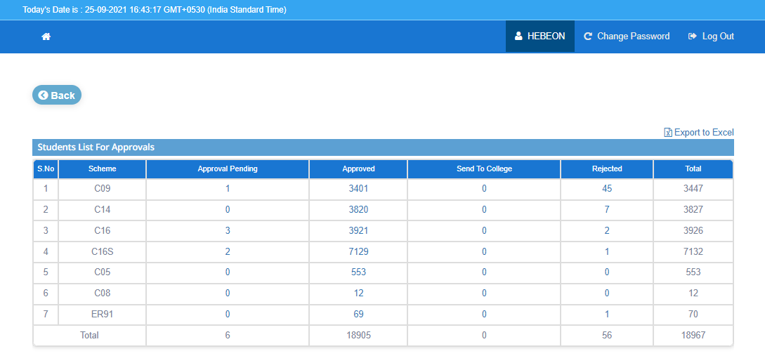

* Here, we need to observe that based on scheme the approval pendings, approved and rejected data. When we click on Approved, we get the list of students download the certificate those who are rejected they need to meet the criteria of <3 backlogs to download certificate.

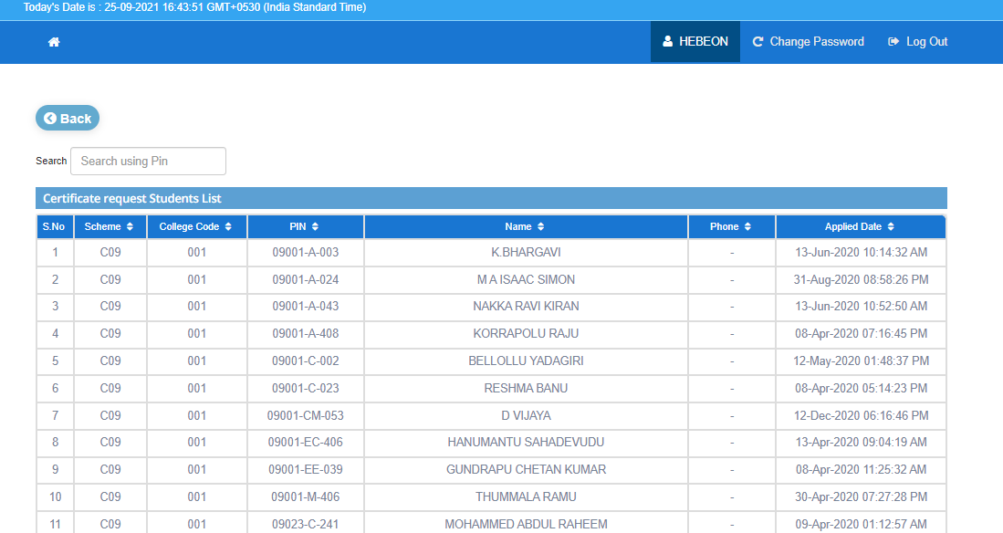

**12) Sub module name: NC, C-90,96,00 Approvals**

**Description:**

This sub module is used to display the report those certificates are approved

**Navigation steps:**

**Step 1:** Open NC, C-90,96,00 Approvals.

**Step 2:** When clicking on it will display the student list for Approvals list.

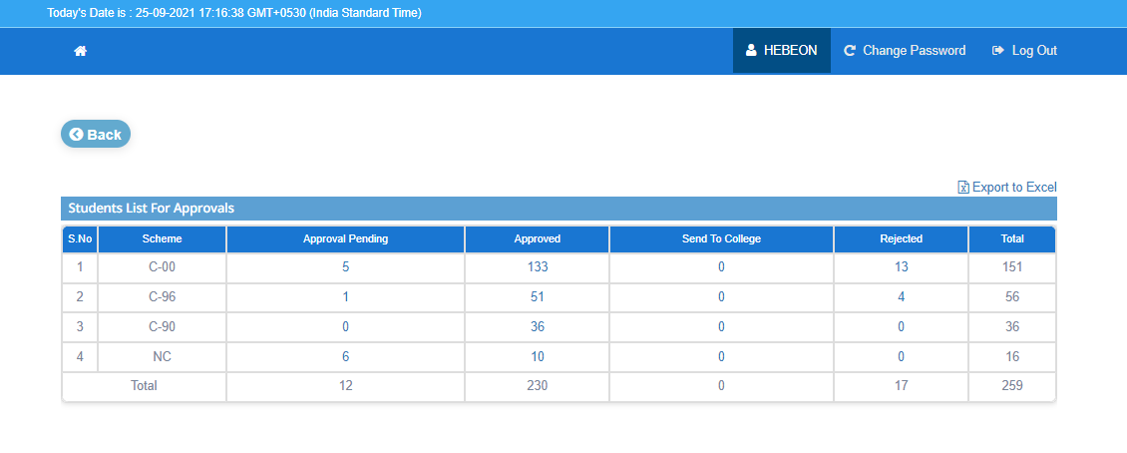

* Here, we need to observe that based on scheme the approval pendings, approved and rejected data. When we click on Approved, we get the list of students download the certificate those who are rejected they need to meet the criteria of <3 backlogs to download certificate.

**13) Sub module name: Memo Tr Sheets**

**Description:**

This sub module is used to display memos data of a student.

**Navigation steps:**

**Step 1:** Open **Generate Memo Data.**  
  
**Step 2:** Enter Scheme, Exam Type, Select Date and click on **Get Report.**



**Step 3:** When we click on **Get Report,** all the marks memos will be generated to the predecessor of the selected Exam type. Based on that we select the particular date on which the marks memos to be downloaded.

**14) Sub module name: RVRC Automation**

**Description:**

This sub module is used to display memos data of a student.

**Navigation steps:**

**Step 1:** Open **RVRC Automation.**

* We can observe that 4 different options are given as follows

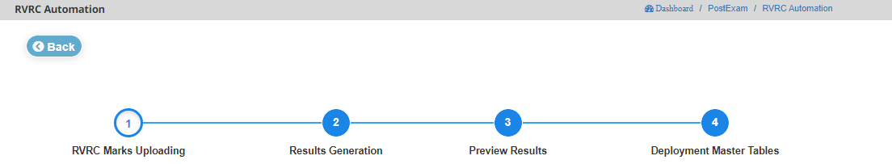

**Step 2:** When we click on Enter Scheme, Scheme, Student type and click on **submit** that displays the report of upload marks.

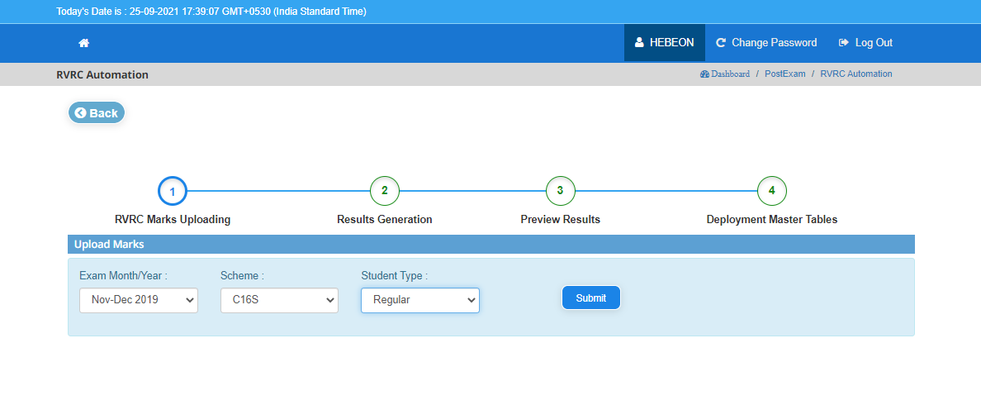

**Step 3:** When we click on Enter Scheme, Scheme, Student type and click on **submit** that generates the result

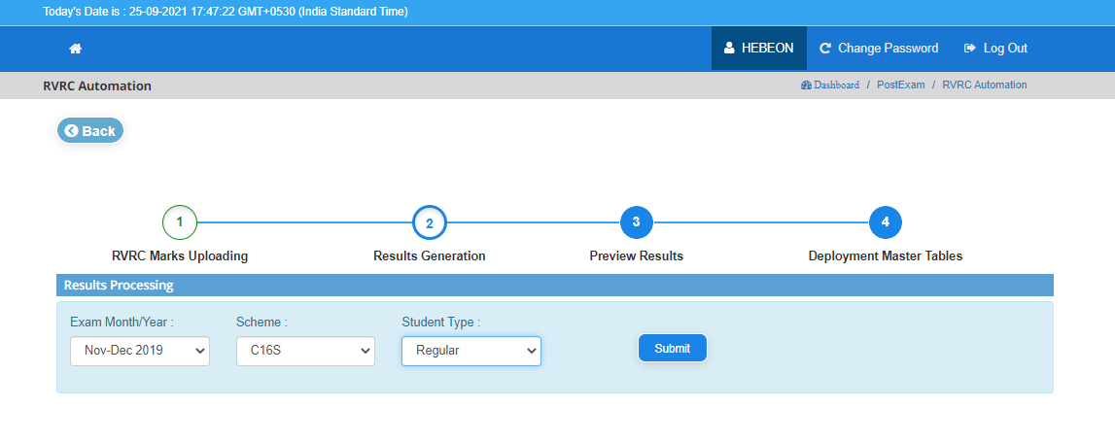

**Step 4:** When we click on Enter Scheme, Scheme, Student type, PIN no and click on **submit** that previews the result based on details given.

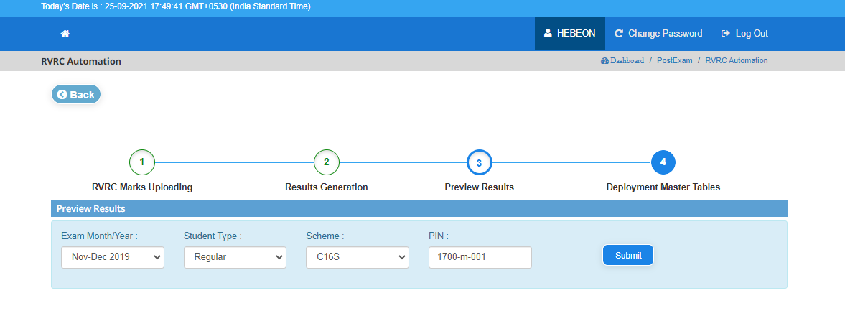

**Step 5:** When we click on Enter Scheme, Scheme, Student type and click on **submit** that deploy the master tables based on given data.

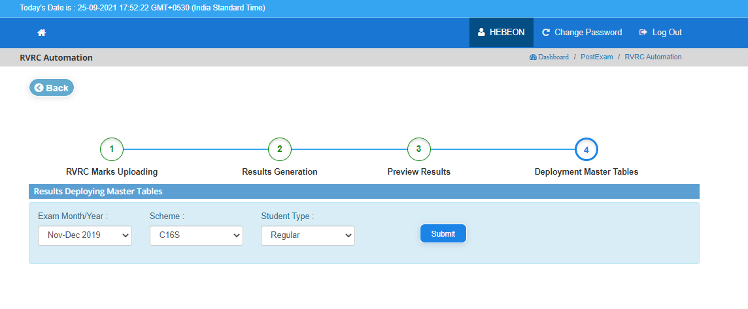

**15) Sub module name: Results Automation**

**Description:**

This sub module is used to generate results automation.

**Navigation steps:**

**Step 1:** Open **Results Automation**.

* We can observe that 7 different options are given as follows

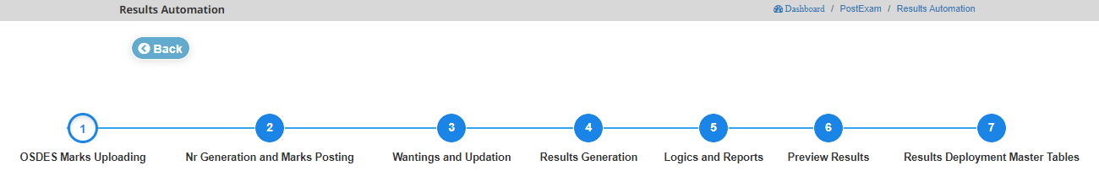

**Step 2:** Select Exam Month year, scheme, student type, exam type and click on **submit** which display the downloads the sample data by clicking on **Download Sample Data.** After downloaded click on **Choose Excel**

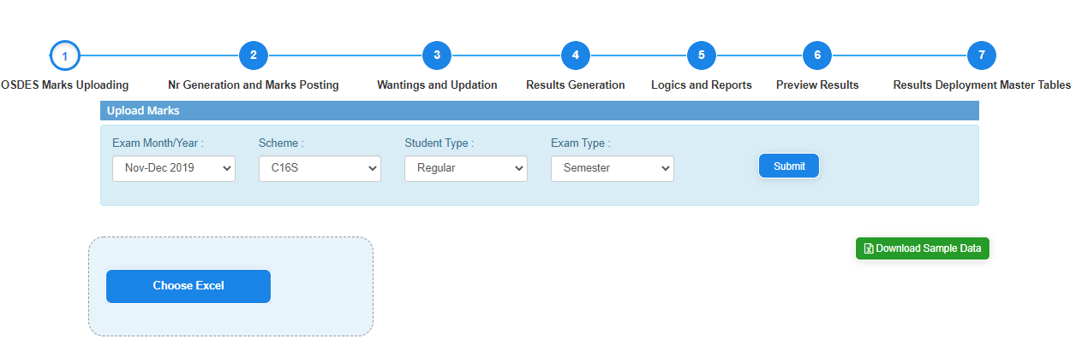

**Step 3:** After that go to Nr generation and marks posting which displays 2 fields. Select Exam Month year, scheme, student type, exam type from **Nr Generation** and **Marks Posting in NR** and click on **submit** which display those who pay fees and generate results.

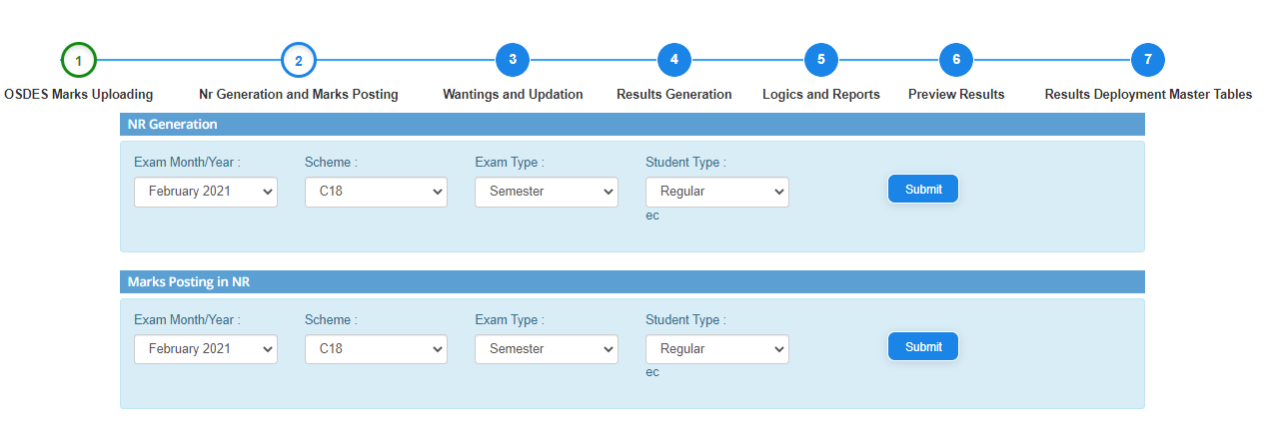

**Step 4:** After that click on Wantings and Updation which displays 2 fields. Select Exam Month year, scheme, student type, exam type from **Generate Warnings** and **Upload Wantings** and click on **submit** which generates and uploads the wantings by clicking on   
**Download Sample Data.** After downloaded click on **Choose Excel.**

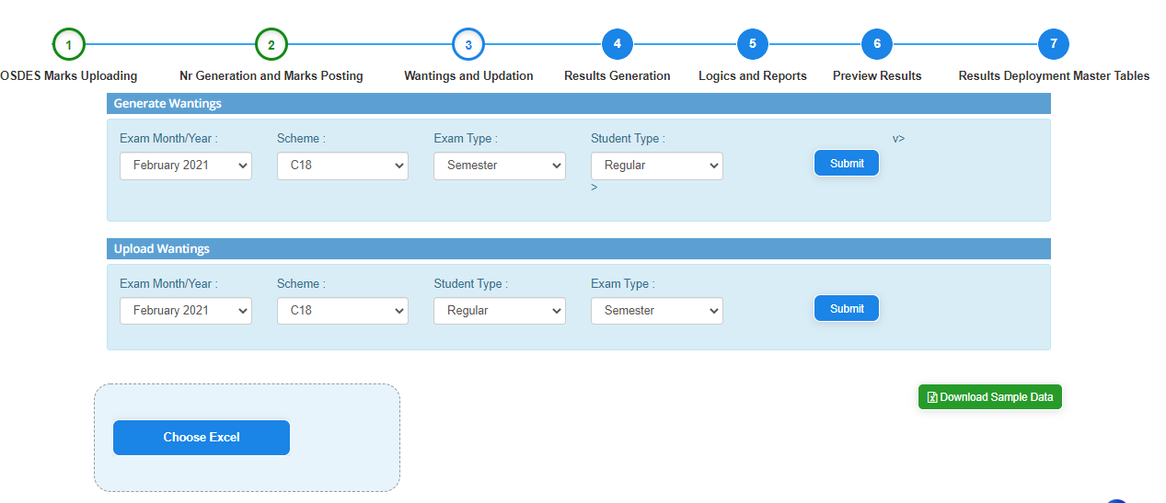

**Step 5:** After that click on **Results Generation.** Select Exam Month year, scheme, student type, exam type, academic year and click on submit that display the Results Generated report by clicking on **submit**

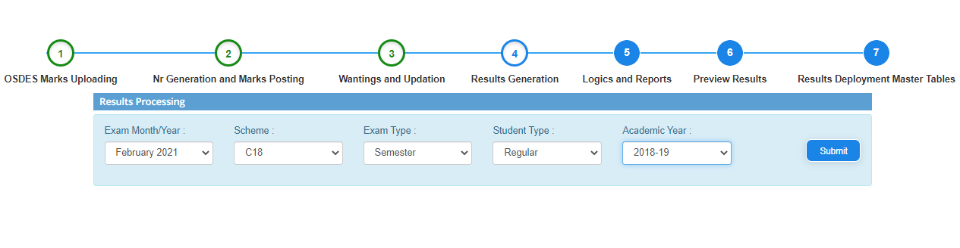

**Step 6:** After that click on **Logics and Reports.** Select Exam Month year, scheme, student type, exam type, academic year and click on **submit** that display the Results report logically based on the subjects.

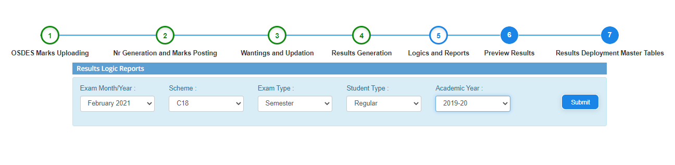

**Step 7:** After that click on **Preview Results.** Select scheme, student type, PIN and click on **submit** that generates the results report.

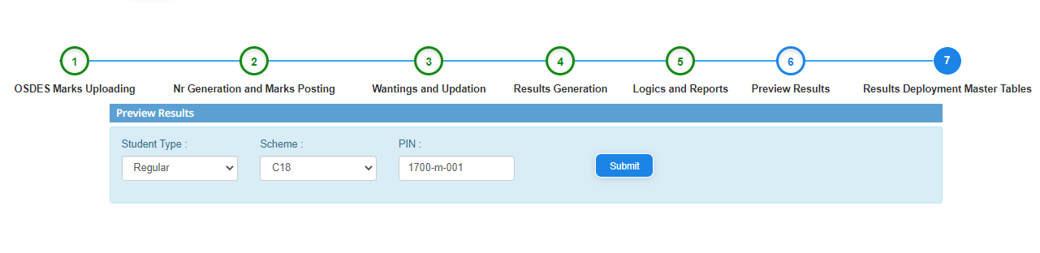

**Step 8:** Finally, click on **Result Deployment Master Tables.** Select Exam month year, scheme, exam type, student type and click on **submit** that will publishes the results for all students overall statewide.

