**Module Name: Results**

**Module Description:**

Results module consists of Consolidate Result, Result History, Branch Results, Student Results.

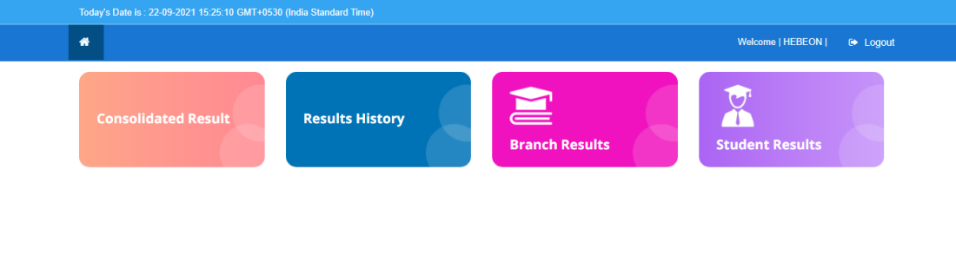

**1) Sub module name: Consolidate Result**

**Description:**

This sub module is used to display the overall result.

**Navigation steps:**

**Step1:** Open Consolidate Result

**Step2:** Select Scheme. Enter PIN and captcha given and click on **Get Report**

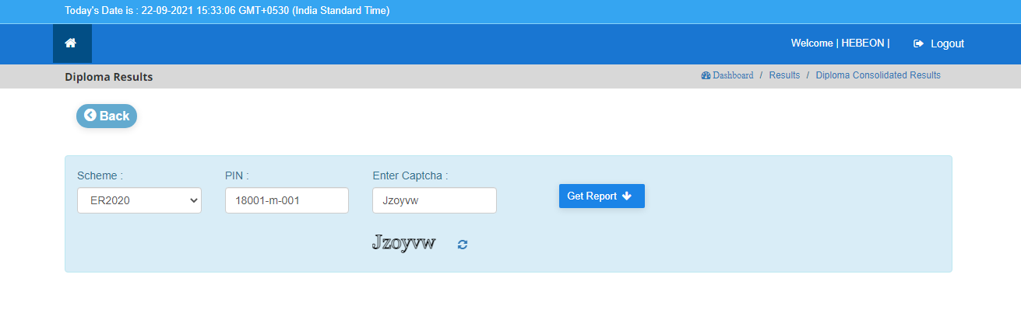

**Step 3:** When we click on **Get Report** the **Result History Marks Card** is displayed as per the given PIN No and scheme.

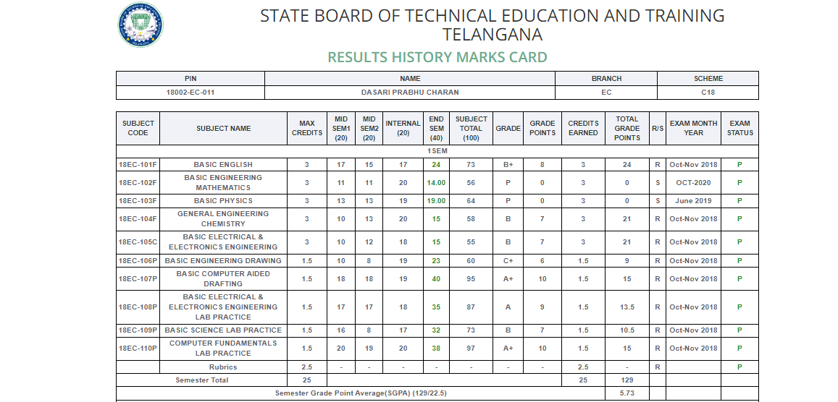

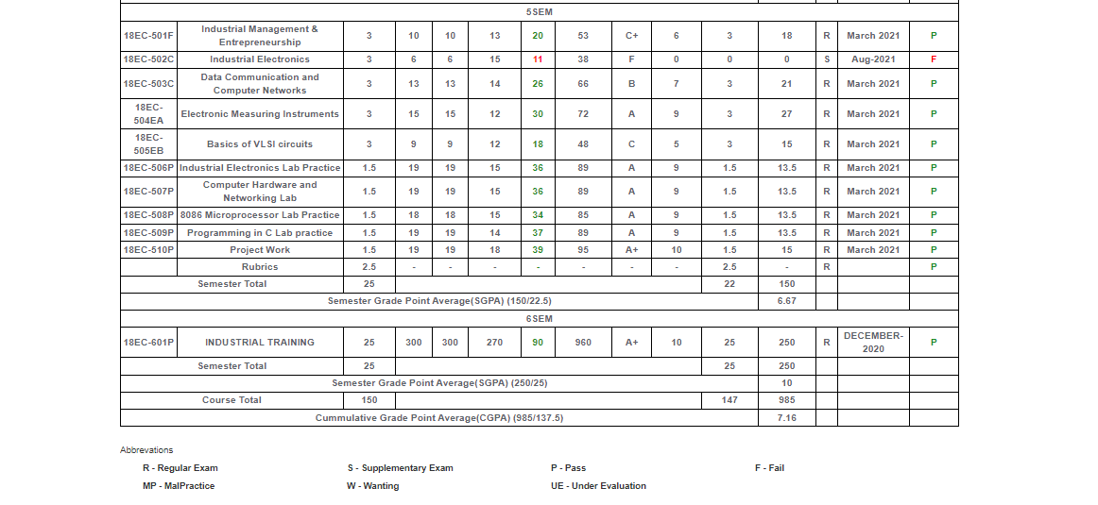

* Here we can see the fields as

1. Semester wise subject code
2. Subjects
3. Credits based on subject
4. Mid, Internal and External marks
5. Grade and Grade points that we got
6. Credits that we earned
7. Overall Result - (R/S)   
    R – Regular  
    S – Supplementary
8. Total grade points
9. Exam month & year
10. Exam Status - (P/F)  
     P – Pass  
     F – Fail

* The Semester Wise Grade Point Average (SGPA) was to be given for each semester.
* At the last semester the overall Cumulative Grade Point Average (CGPA) was given totally.
* We also get the total grade points to the credits user earned.

**2) Sub module name: Results History**

**Description:**

This sub module is used to get consolidated marks sheet.

**Navigation steps:**

**Step 1:** Open **Results History.**  
  
**Step 2:** Enter PIN and click on **Get Report**

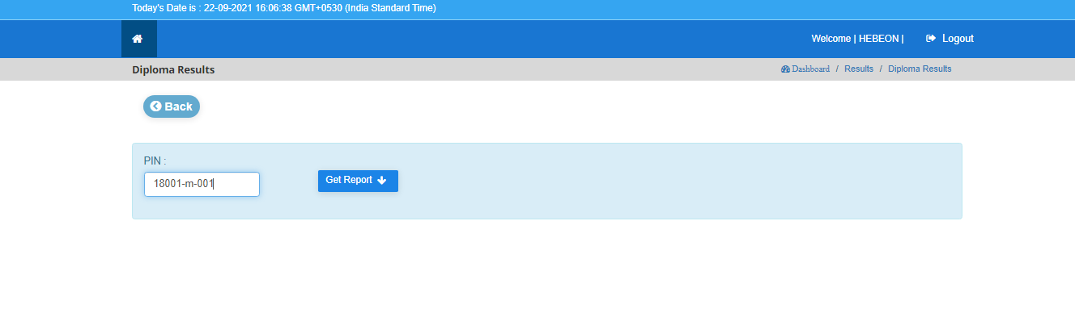

**Step 3:** When we click on **Get Report** the **Consolidated Marks Card** is displayed as per the given PIN No.

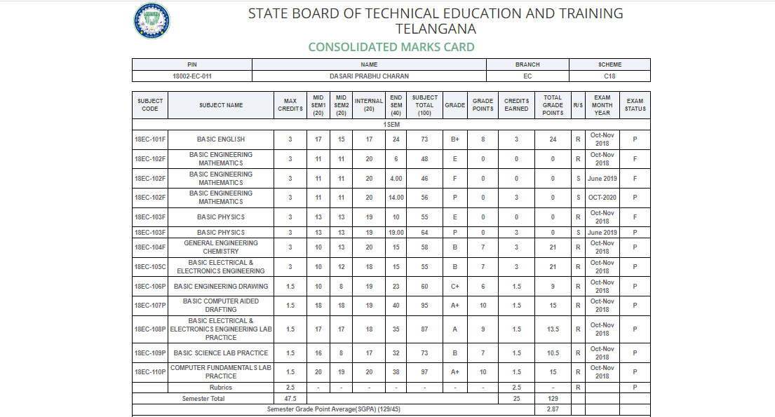

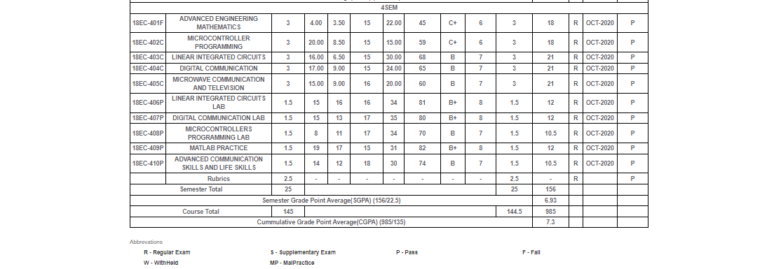

**3) Sub module name: Branch Results**

**Description:**

This sub module is used to displays the result based on branch wise.

**Navigation steps:**

**Step1:** Open **Branch Results.**  
  
**Step-2:** Select College, Scheme, Exam Month/Year, Sem & Year, Exam, Branch and click on  **Get Results**

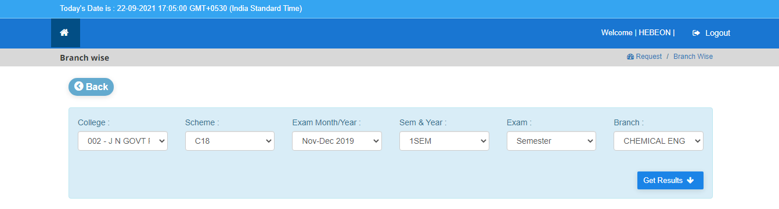

**Step 3:** When we click on **Get Results** the results of the student mid –1 and mid-2 marks with grades and total marks of all students were displayed according to the branch code, scheme, college name and semester.

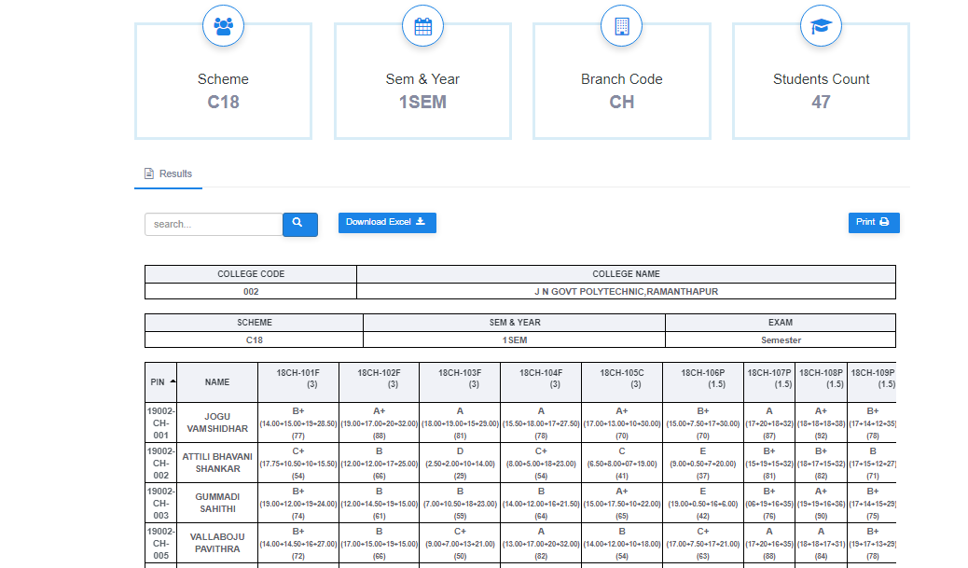

**4) Sub module name: Student Results**

**Description:**

This sub module is used to displays the result based on branch wise.

**Navigation steps:**

**Step 1:** Open Student Results.

**Step 2:** Select College, Scheme, Exam Pass Type, Sem & Year, Exam, Exam Month/Year, Pin Number and click on  **Get Report.**

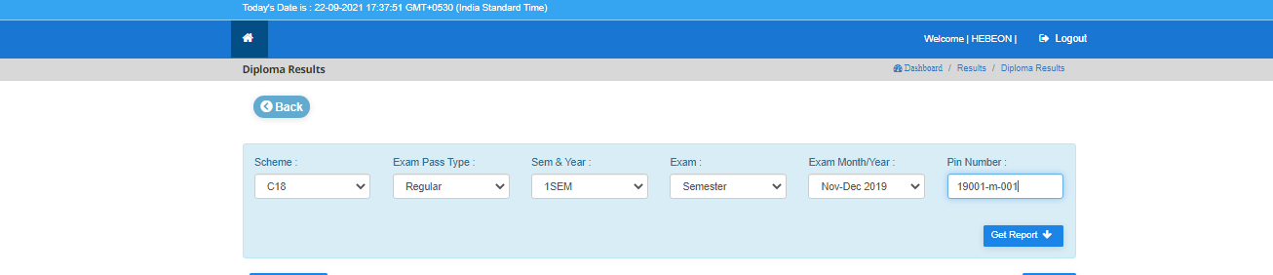

**Step 3:** When we click on **Get Report** the marks card were displayed according to the PIN number, branch, scheme, college name and semester.

