**Admin Login**

**Module Name: Settings**

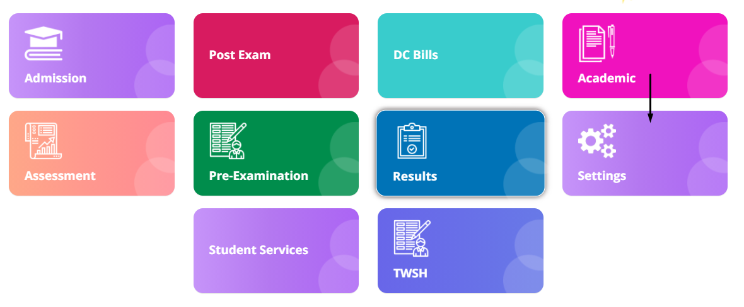

**Module Description:**

**Settings** module consists sub-modules namely **Tenders, Staff info, Circulars, Downloads, Module settings, Website feedback, Datesheet month year, Datesheet timeslot, Attendance settings, Notifications**

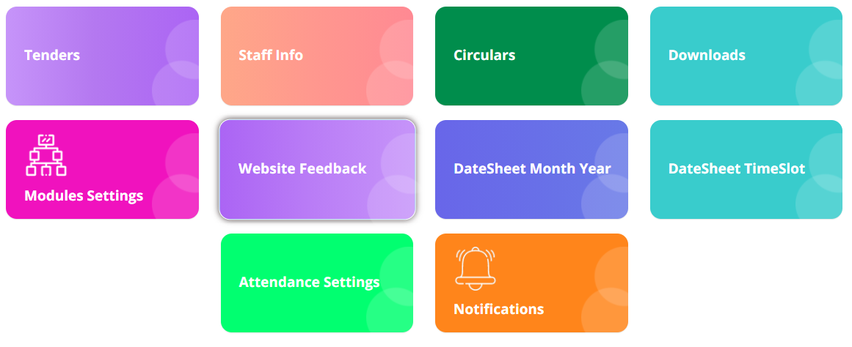

**NOTE**: You can even find the data for Notifications, Tenders and Downloads in **MORE** section from Home page

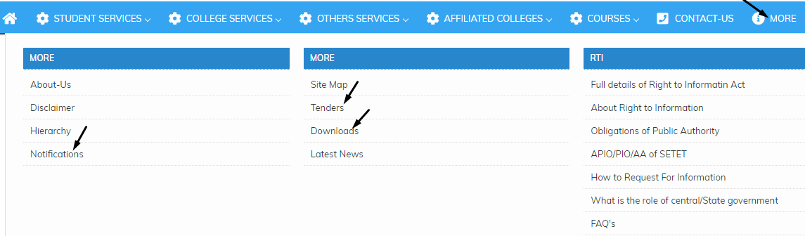

**1) Sub module name: Tenders**

**Description:**

This sub module is used to get the list of new requirements from the clients

**Navigation steps**

**Step1: Open Tenders**

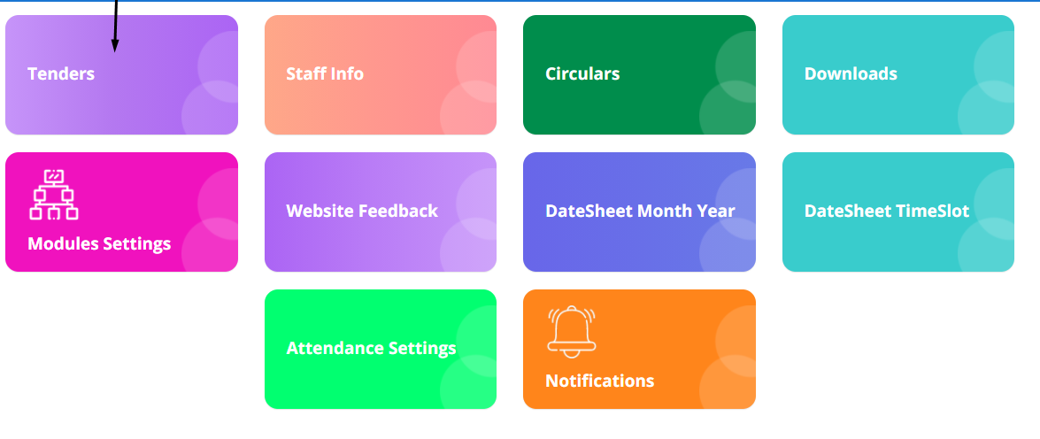

**Step2: Enter the mandatory details add new requirements as shown in the image.**

**Upload the image by choosing the file**

**Click on Submit button**

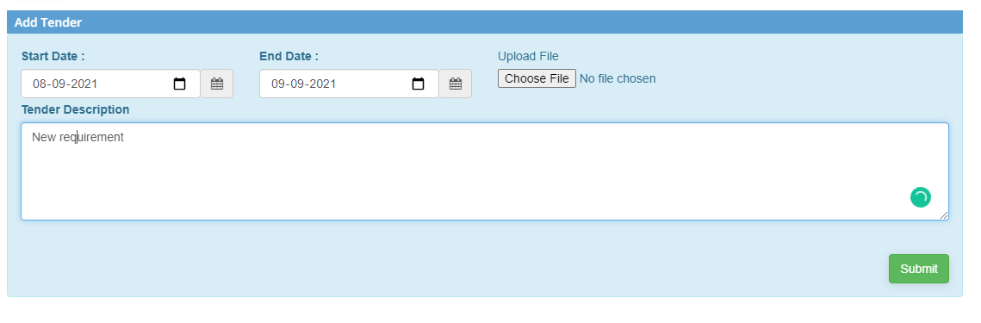

**Step3: The list of requirements added is displayed as shown below**

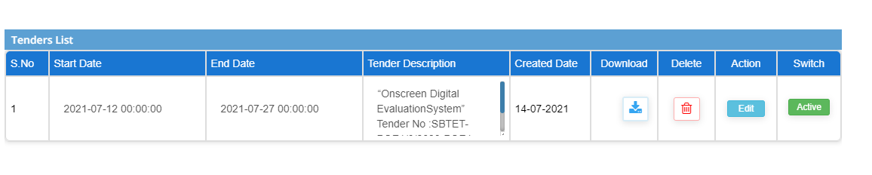

**Step3: There are 4 operations that can be performed to the list for changes:**

1. **Download –** downloads the particular tender list
2. **Delete –** removes the row if the tender is not needed
3. **Action –** edits and updates the details
4. **Switch –** activates or inactivates the tender

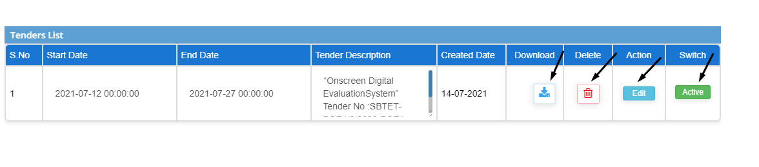

**2) Sub module name: Staff info**

**Description:**

This sub module is used to add and retrieve the staff details

**Navigation steps**

**Step1: Open Staff info**

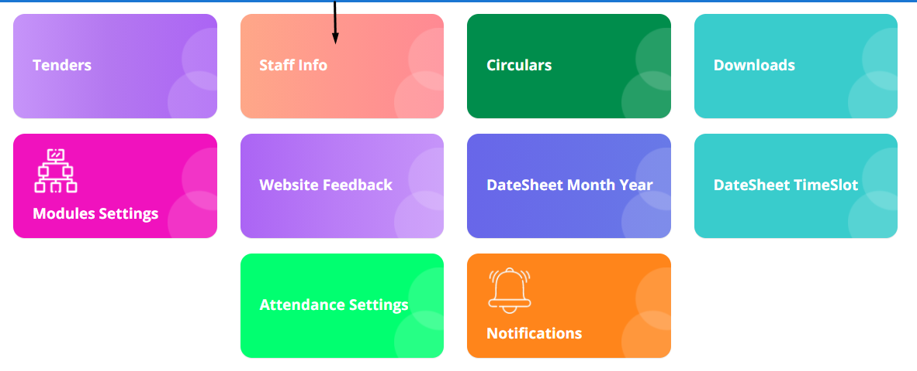

**Step2: Fill up the details of the staff in the given blocks.**

**Upload the image and Click on Submit button**

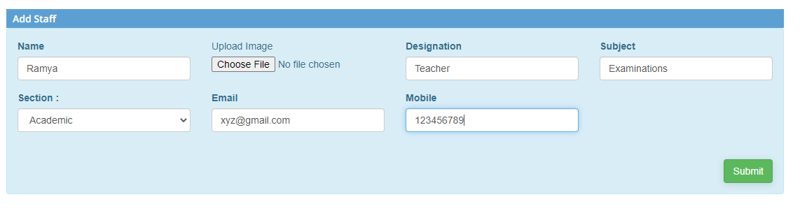

**Step3: The submitted lists are displayed in the table**

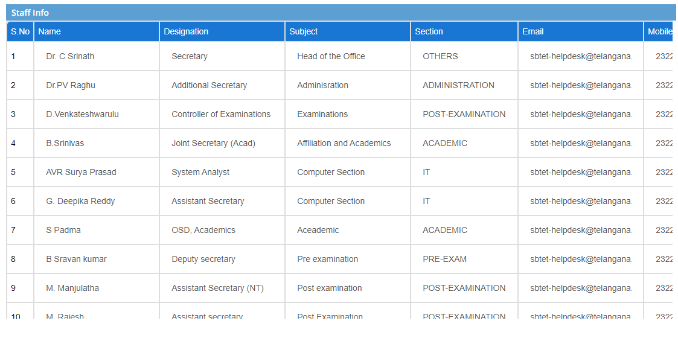

**Step4: There are 4 operations that can be performed to the list for changes:**

1. **Photo –** downloads the particular staff details
2. **Delete –** removes the row if the staff is not needed
3. **Action –** edits and updates the details
4. **Switch –** activates or inactivates the tender

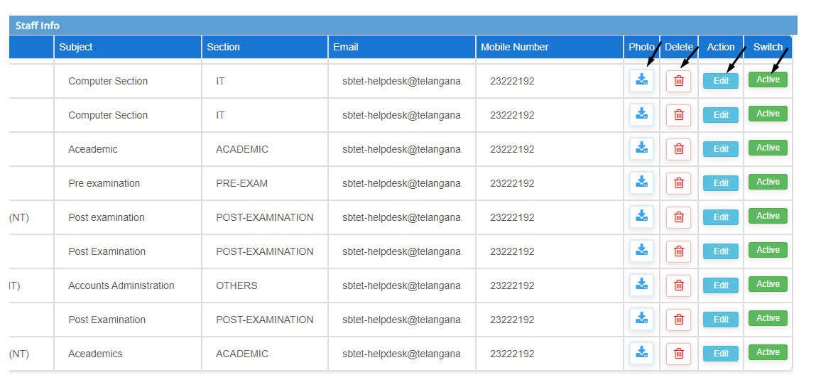

**3) Sub module name: Circulars**

**Description:**

This sub module is used to distribute the advertisements

**Navigation steps**

**Step1: Open Circulars**

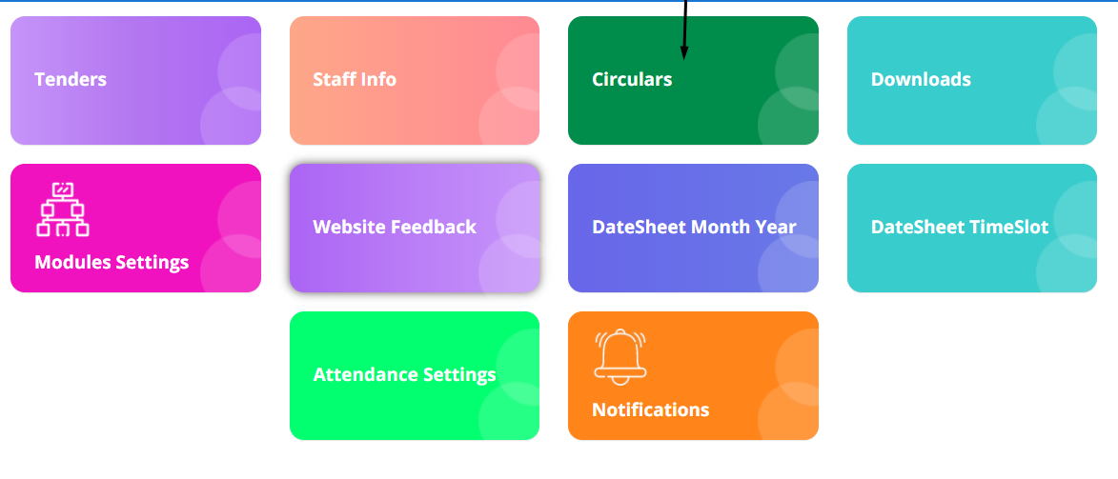

**Step2: Fill in the given details and upload the file which has to be displayed**

**Click on Submit button**

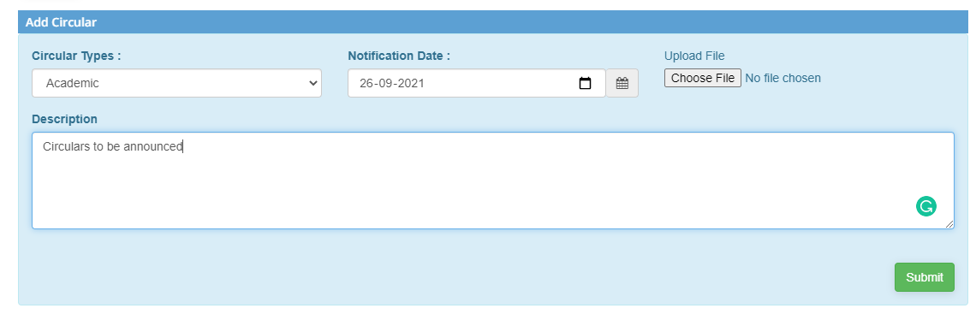

**Step3: The created circular lists is shown below**

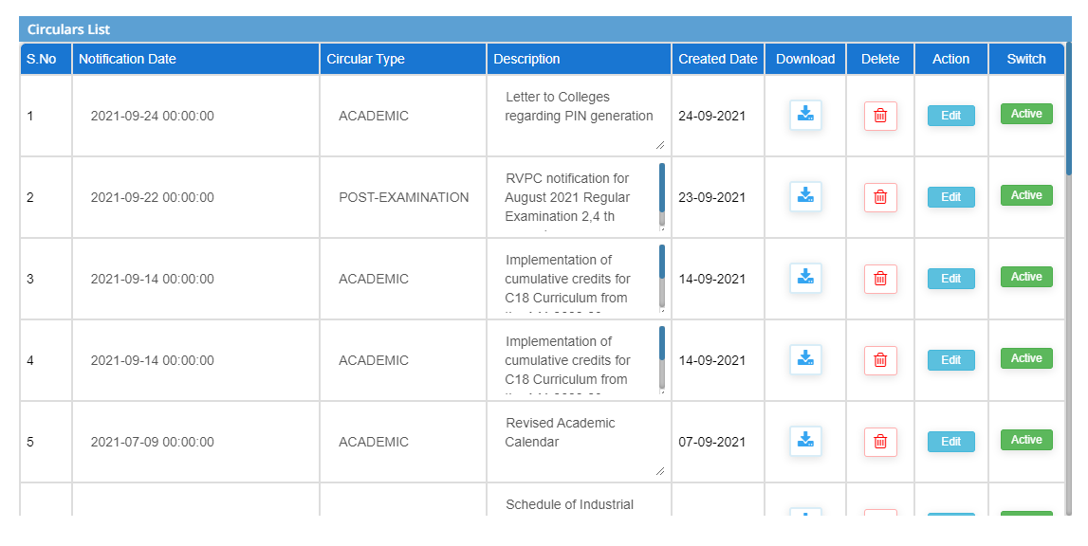

**Step4: There are 4 operations that can be performed to the list for changes:**

1. **Download –** downloads the particular circular list
2. **Delete –** removes the row if the circular is not needed
3. **Action –** edits and updates the details
4. **Switch –** activates or inactivates the circular

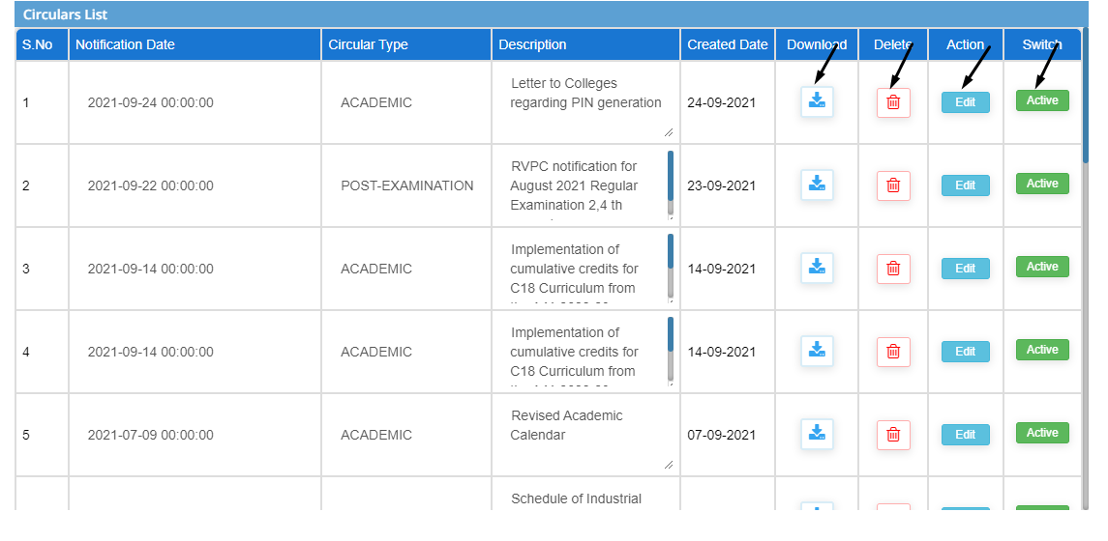

**4) Sub module name: Downloads**

**Description:**

This sub module is used to download the files

**Navigation steps**

**Step1: Open Downloads**

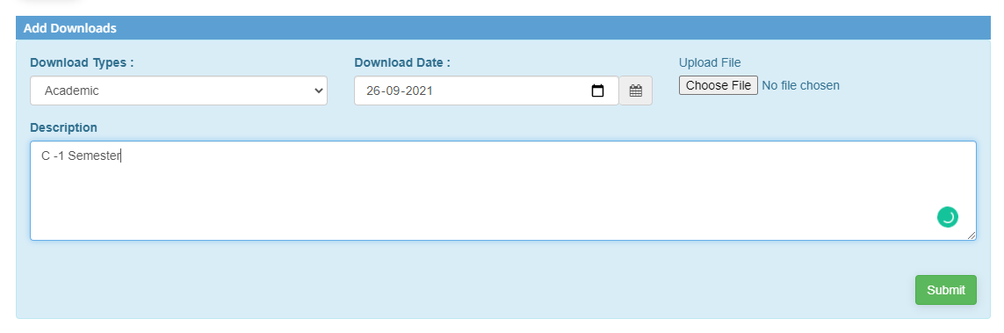

**Step2: The downloads lists is shown below**

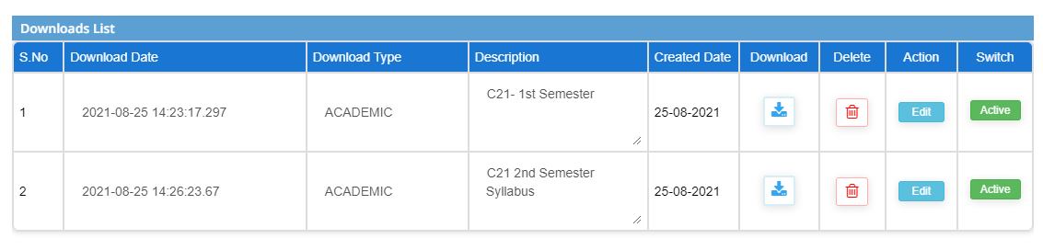

**Step3: There are 4 operations that can be performed to the list for changes:**

1. **Download –** downloads the particular list
2. **Delete –** removes the row if the list is not needed
3. **Action –** edits and updates the details
4. **Switch –** activates or inactivates the list

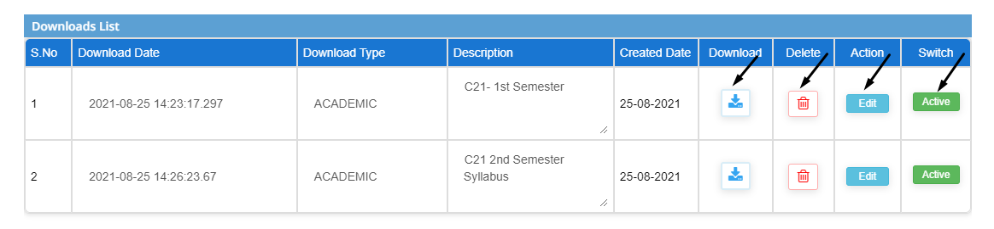

**5) Sub module name: Website Feedback**

**Description:**

This sub module is used to get the feedback reports given by students

**Navigation steps**

**Step1: Open Website Feedback**

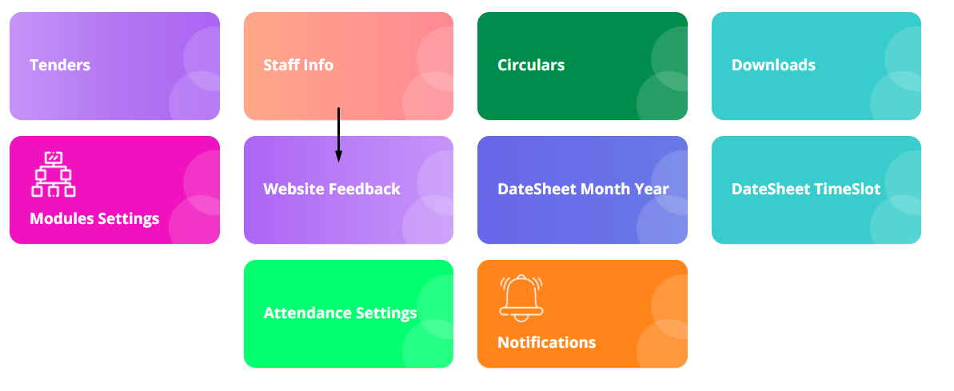

**Step2: Search the feedback to retrieve the details**   
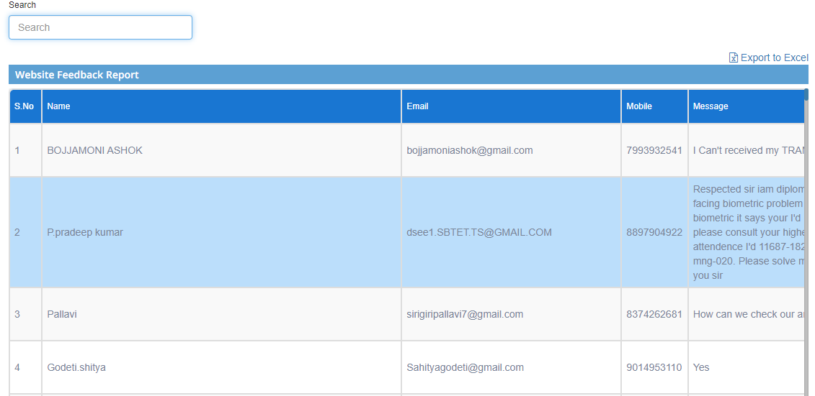

**Step3: The feedback report is retrieved**

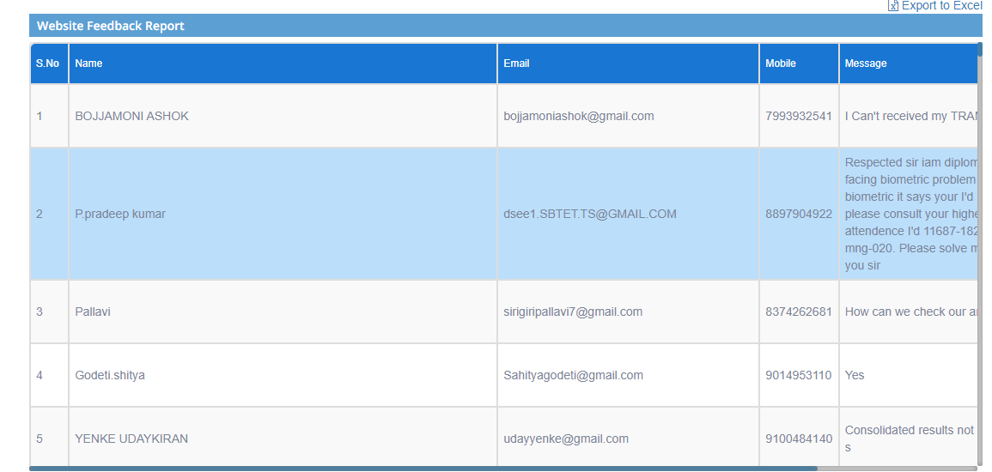

**Step4: Report can also be downloaded in excel format by clicking on Export to excel**

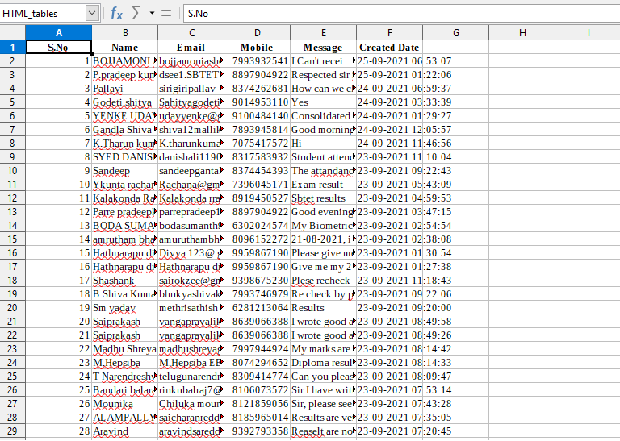

**6) Sub module name: Datasheet month year**

**Description:**

This sub module is used to get the exam timetable for particular student type

**Navigation steps**

**Step1: Open Datasheet month year**

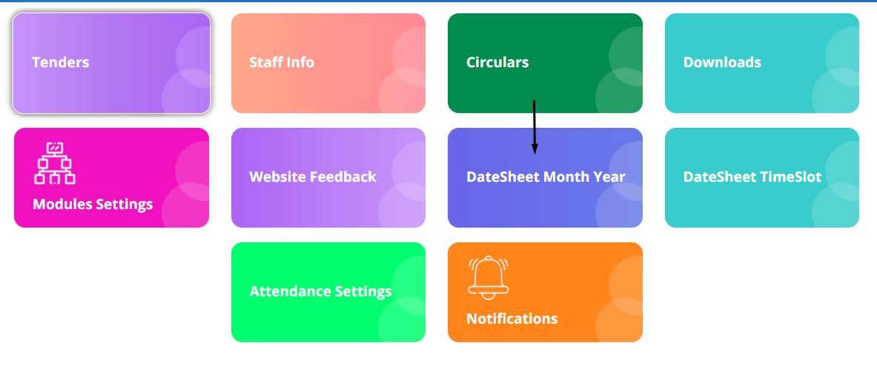

**Step2: Fill up the details from dropdown list**

**Click on Get details**

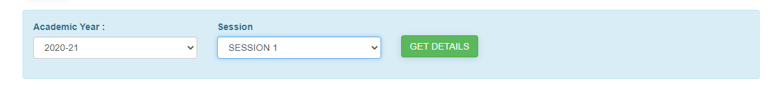

**Step3: The list will be displayed**

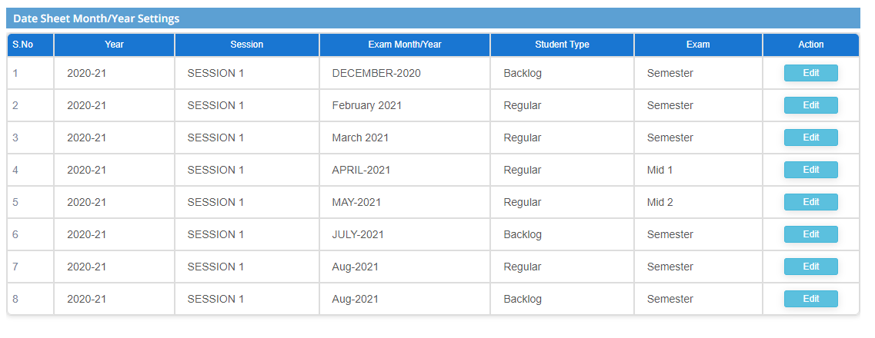

**Step4: Select ADD for creating new date sheet**

**Complete the details by filling from dropdown list.**

**Click on Add button**

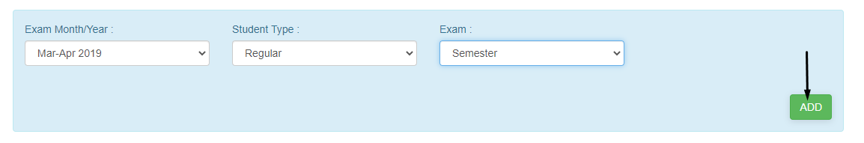

**Step5: Click on Edit button to change and update any details**

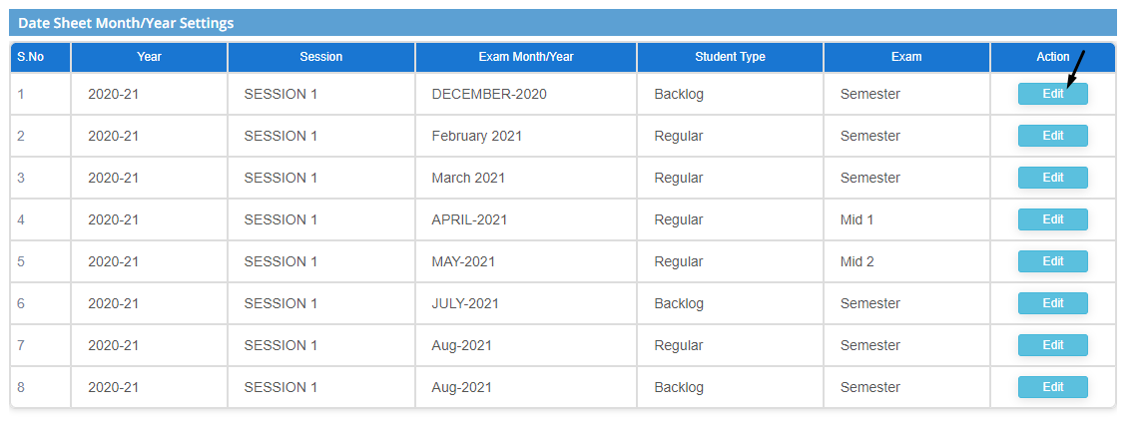

**7) Sub module name: Datesheet Timeslot**

**Description:**

This sub module is used to get the complete details of the timetable

**Navigation steps**

**Step1: Open Datesheet Timeslot**

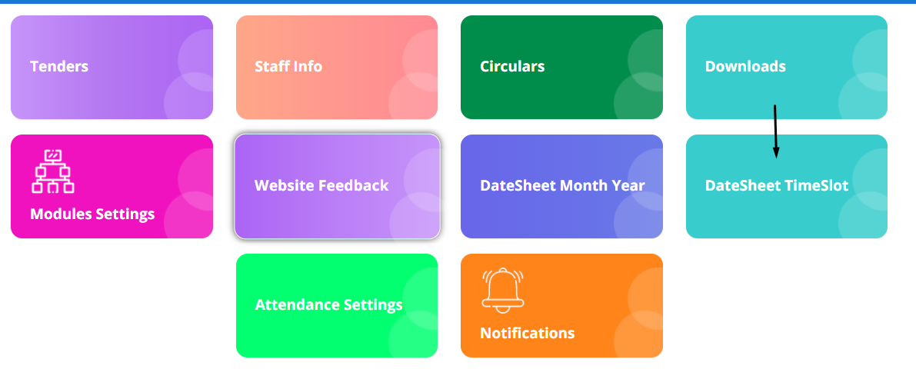

**Step2: Give the academic year and session name to retrieve the details**

**Click on Get details**

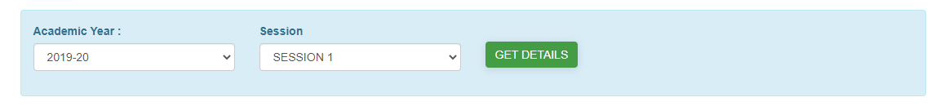

**Step3: The list is shown below**

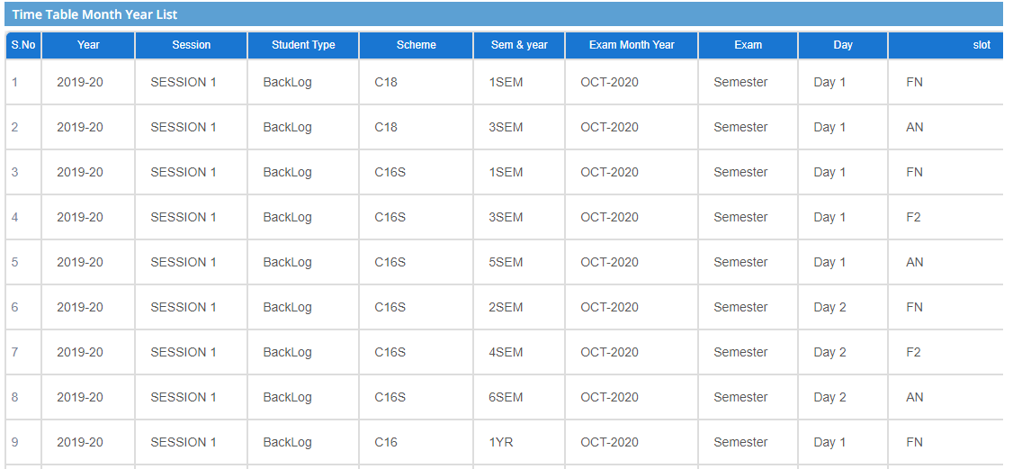

**Step4: To create new timetable for a student click on ADD session**

**Then fill up the details in the given blocks**

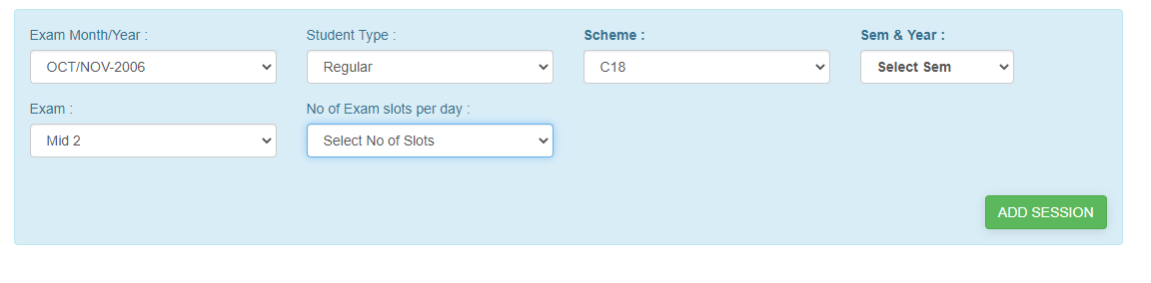

**Step5: When you select the number of exam slots needed, time slots should be mentioned either AN/FN/FN1**

1. **After selecting the timeslot:**
2. **The start and end time will be set by default according to the timetable**
3. **Select the order**
4. **If any change of time is needed, then select from the dropdown**

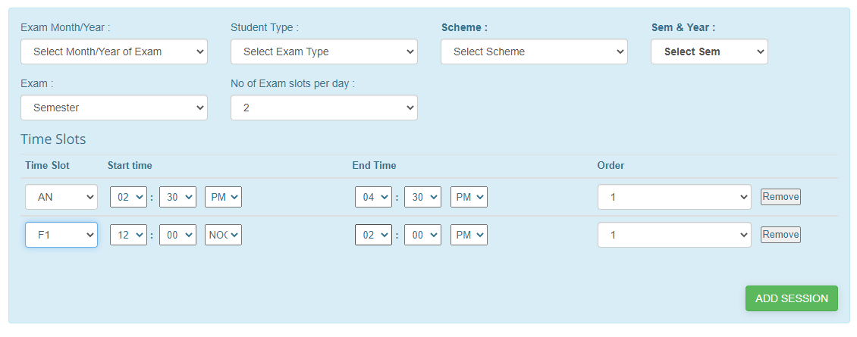

**Note:**  
**Any number of slots can be selected and any order can be mentioned**

**8) Sub module name: Attendance settings**

**Description:**

This sub module is used to retrieve attendance data and set changes if required

**Navigation steps**

**Step1: Open Attendance settings**

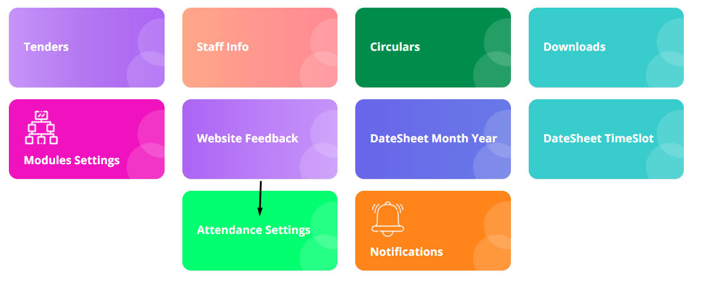

**Step2: Select the exam month/ year and enter the pin the which is generated and sent to the registered number**

**Click on Get details**

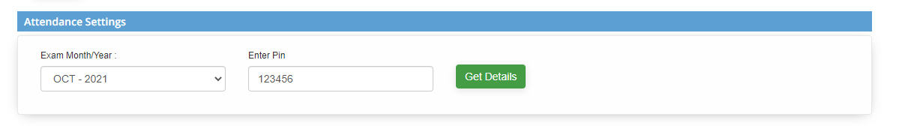

**Step3: The attendance details of the student will be displayed**

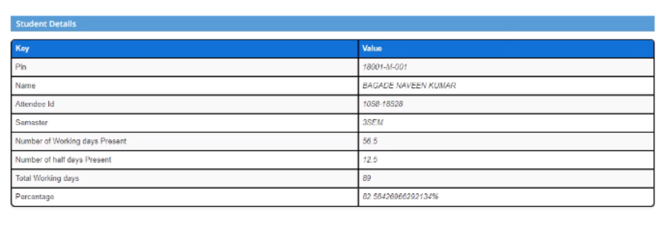

**Step4: If any changes are to be made, select update attendance**  
**Select the number days and click on update**  
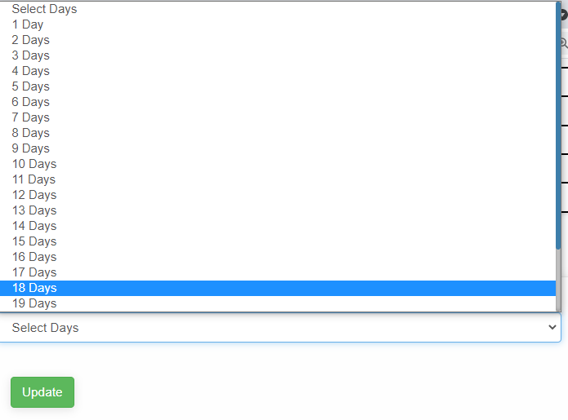

**9) Sub module name: Notifications**

**Description:**

This sub module is used to get the notifications in the home page

**Navigation steps**

**Step1: Open Notifications**

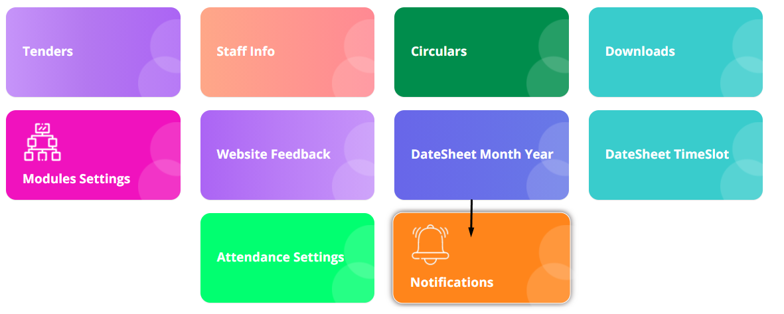

**Step2: Fill the mandatory details**

1. **Select the user type**
2. **Pick the start and end date**
3. **Write the notification message which should be displayed**
4. **Click on Submit button**

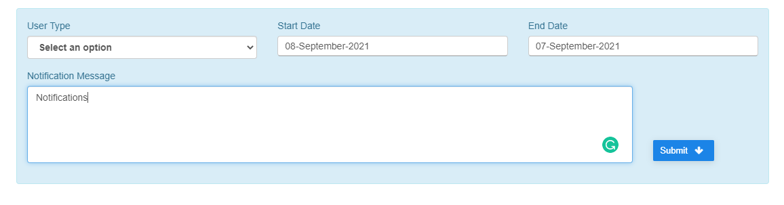

**Step3: The added and previous notifications will be displayed**

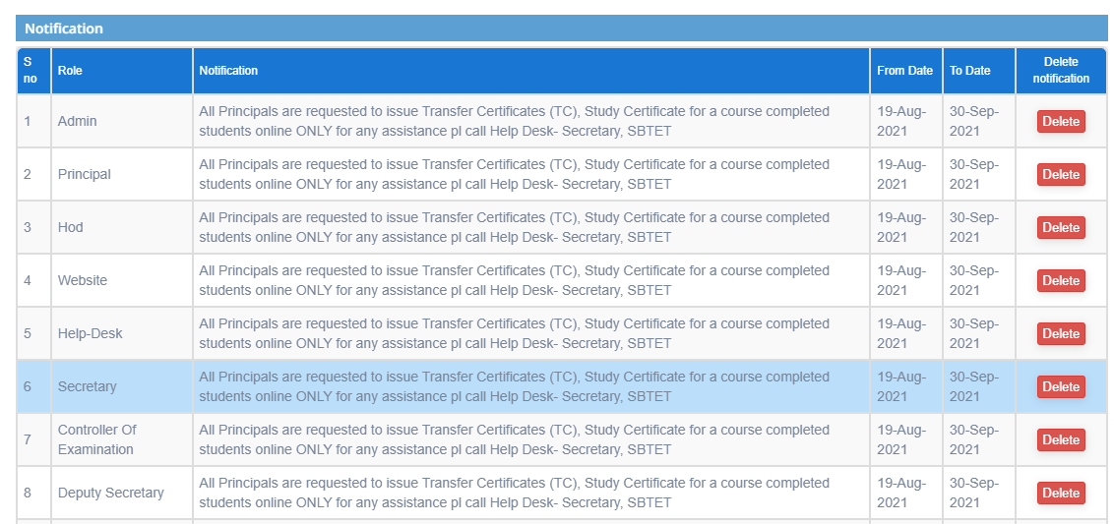

**Step4: By clicking on delete button particular notification will be deleted**

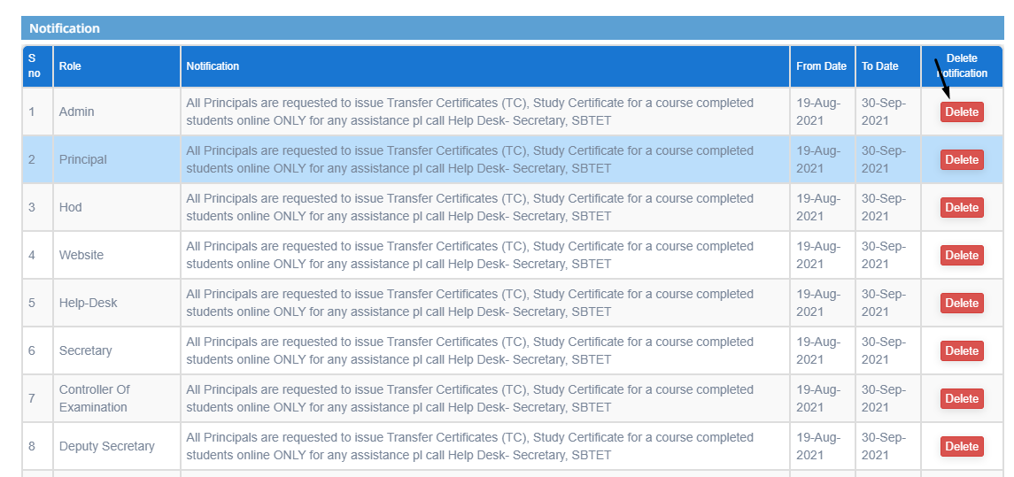

**Note:**   
**The notifications can be seen on top of the home page and dashboard screen**

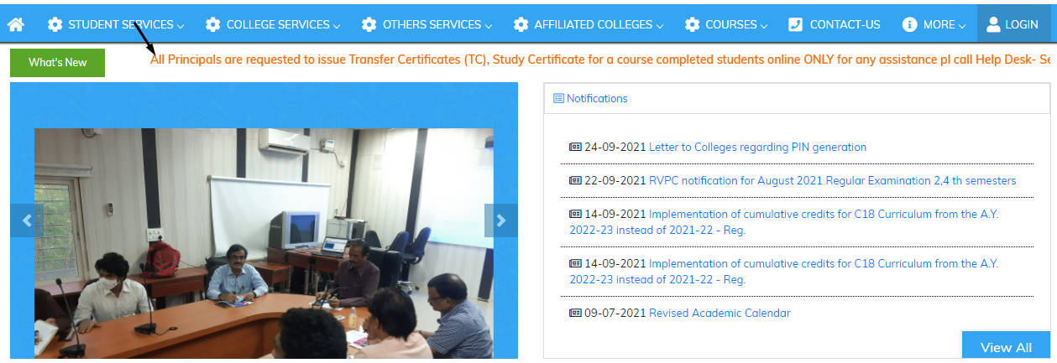

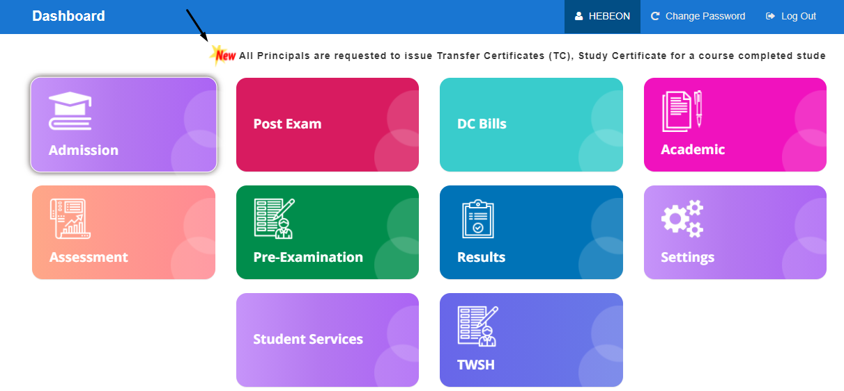

**10) Sub module name: Module settings**

**Description:**

This sub module is used to setup the modules and assign to the particular user

**Navigation steps**

**Step1: Open Module settings**

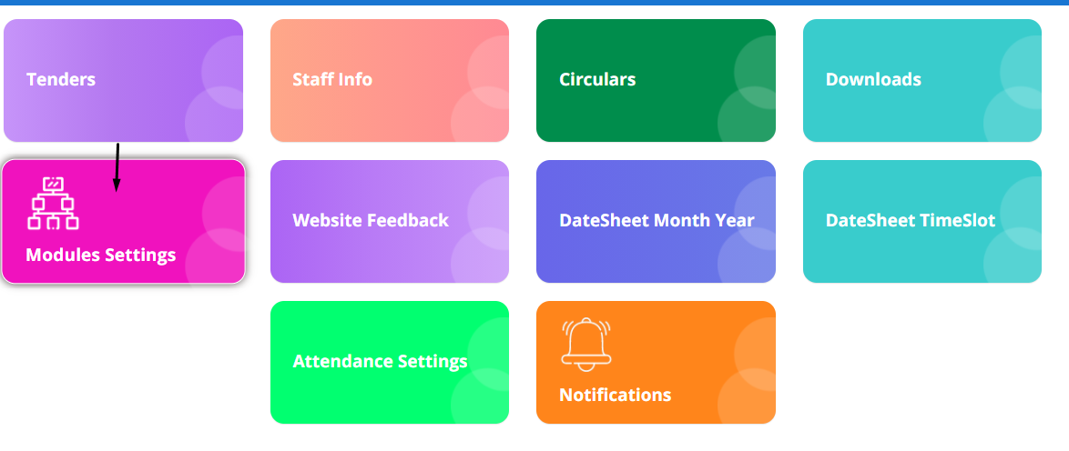

**Step2: The below image is the list of the existed modules details**

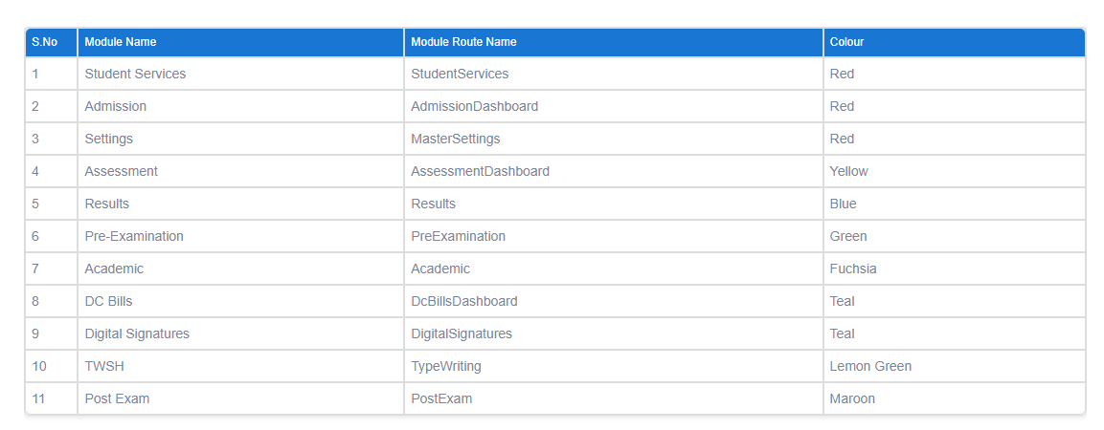

**Step3: To create new module there are 3 steps to follow**

**Information:**  
**Module name, module route name, and colour column details should be taken from the developer before adding new module**

1. **In Add module section, add the details and click on save button**  
   **The details filled and saved are shown below**  
   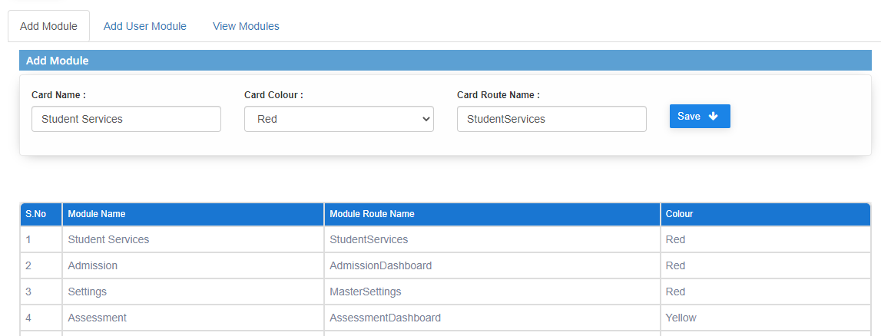
2. **In Add user section, add the details and click on save button**  
   **The details filled and saved are shown below**  
   **Here we can activate or inactivate the module for particular user by clicking on green button as shown in the image**  
   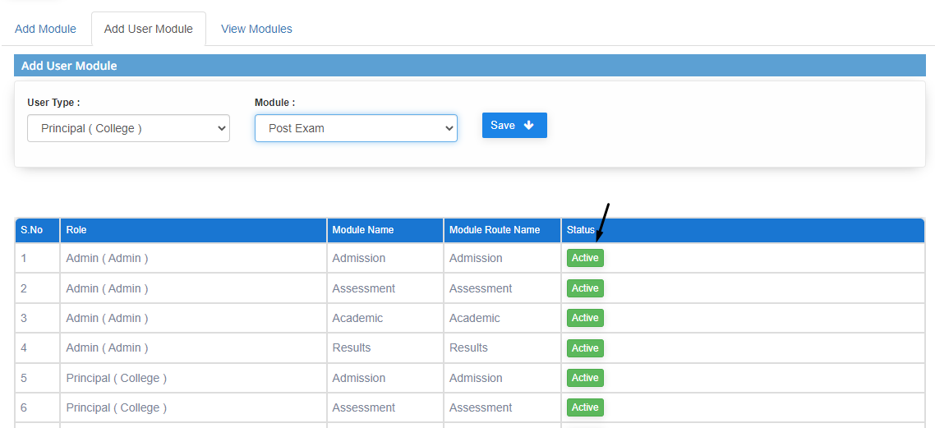
3. **In View module section, the modules can be viewed by selecting user type**  
   **Click on Get modules**  
   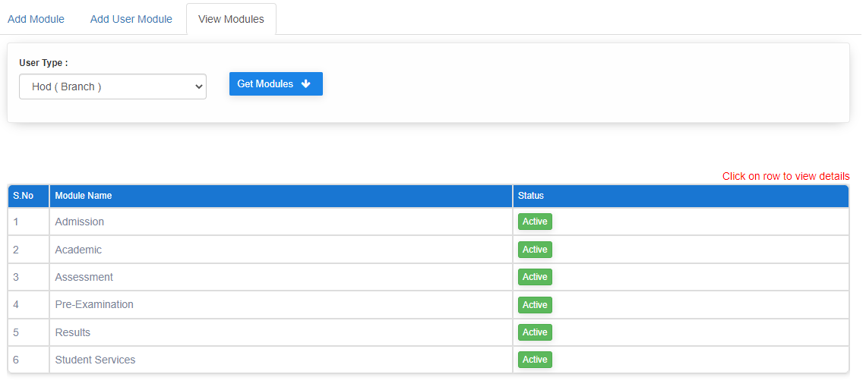

**Step4: Just click on any rows to view or add sub modules**  
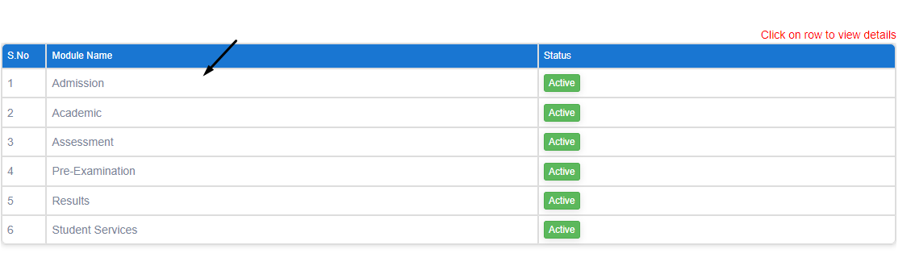

**Step5: To create new sub module there are 3 steps to follow**

**Information:**  
**Sub module name and sub module route name column details should be taken from the developer before adding new sub module**

* **In Add submodule section, add the details and click on save button**  
  **The details filled and saved are shown below**  
  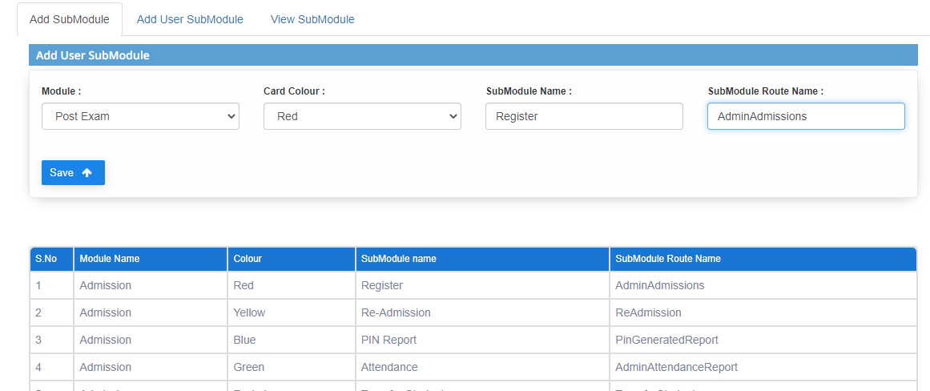
* **In Add user submodule section, add the details and click on save button**  
  **The details filled and saved are shown below**  
  **Here we can activate or inactivate the module for a particular user by clicking on the green button as shown in the image**  
  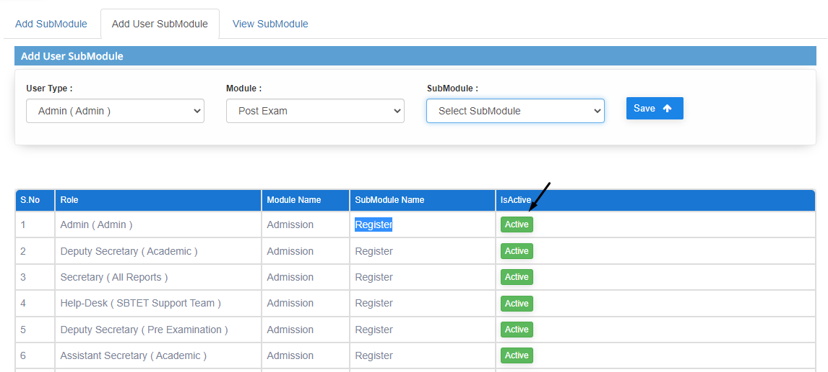
* **In View submodule section, the submodules added and status for the particular module name is displayed**

