**HOD Login**

**Module Name: Academic**

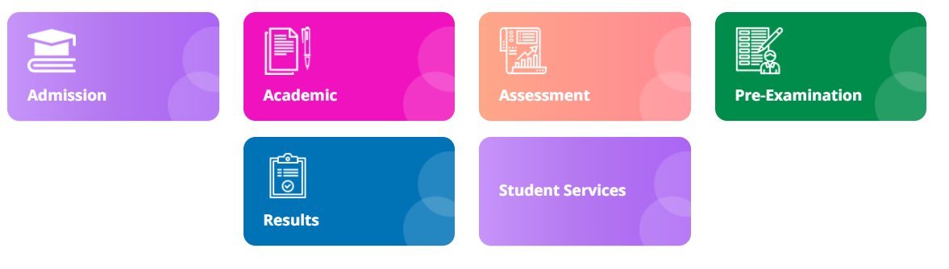

**Module Description:**

**Academic** module consists sub-modules namely **Mark 6th semester, Student Feedback, Faculty Mapping, Syllabus Coverage, Electives**

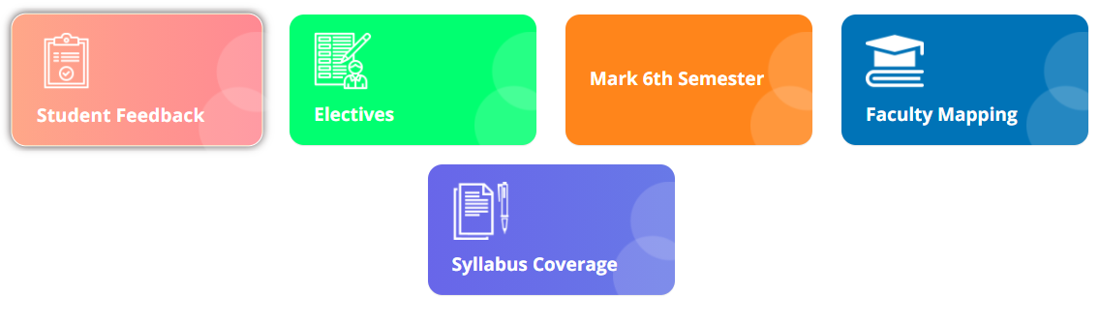

**1) Sub module name: Student feedback**

**Description:**

This sub module gives the feedback from students

**Navigation steps**

**Step1: Open Student feedback**

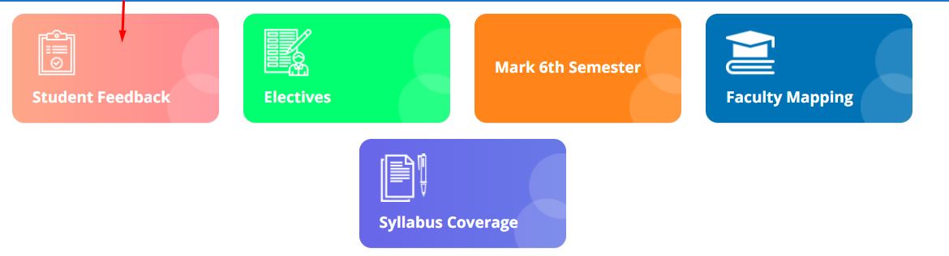

**Step2: Select feedback name and click on get OTP.**  
**The pin number will be sent to the registered mobile number.**  
**Enter the pin code.**  
**The feedback form will be displayed**

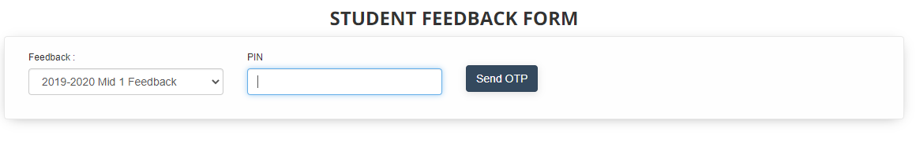

**2) Sub module name: Electives**

**Description:**

This sub module retrieves the elective list for particular semester

**Navigation steps**

**Step1: Open Electives**

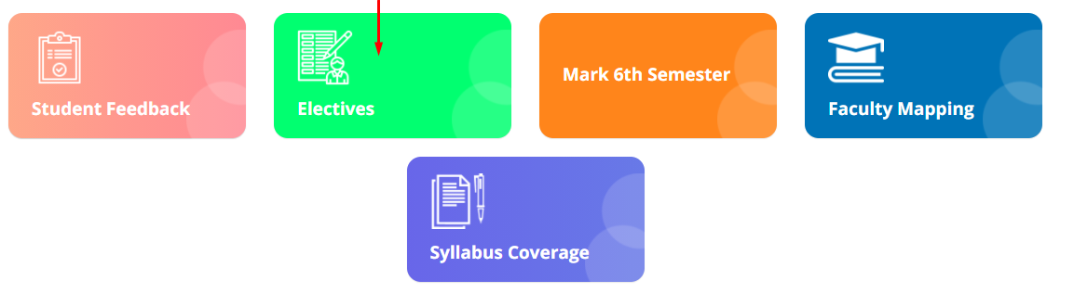

**Step2: Enter the exam type and semester. By default, the academic year will be selected as current year**



**Step3: Electives with semester list will be displayed.**  
**Select the checkbox in ISACTIVE column to activate the subject.**  
**Click on save to save your changes**

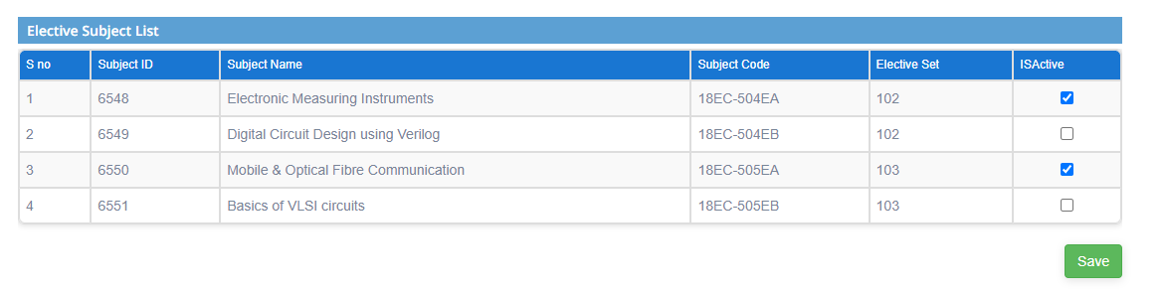

**3) Sub module name: Syllabus coverage**

**Description:**

This sub module used to get the status list of the syllabus covered by particular staff

**Navigation steps**

**Step1: Open Syllabus coverage**

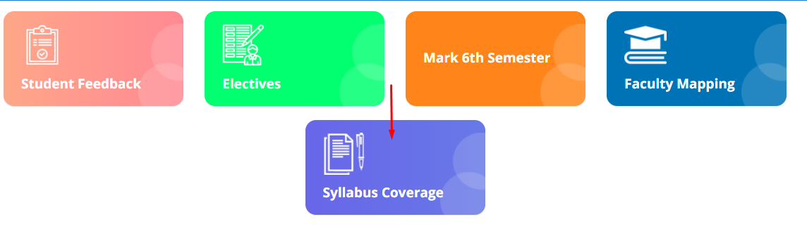

**Step2: Select the scheme, semester and shift from dropdown list.**  
**Click on Submit button**

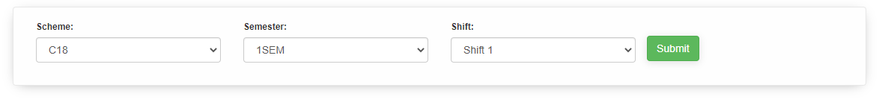

**Step3: The list will be displayed**

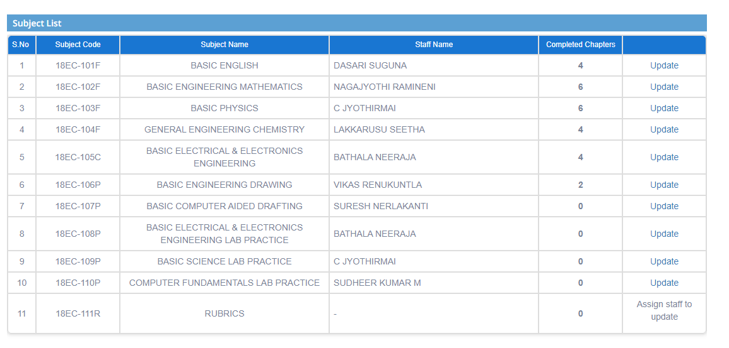

**Step4: Click on Edit button to update the status if required**

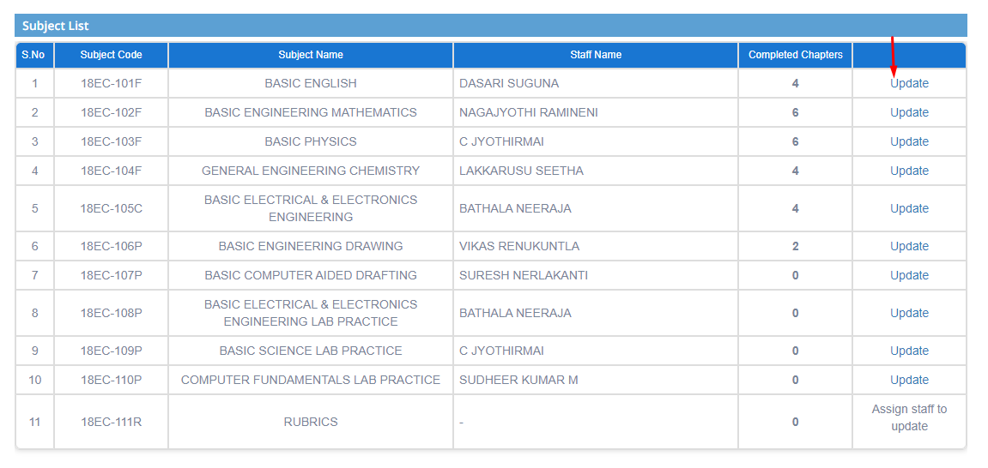

**4) Sub module name: Mark 6th semester**

**Description:**

This sub module used to get the status list of the syllabus covered by particular staff

**Navigation steps**

**Step1: Open Mark 6th semester**

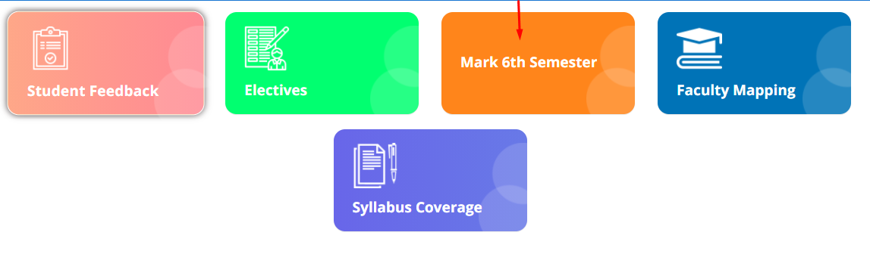

**Step2: By default, college code and branch code will be selected.**  
**Select the academic year to get the students list**

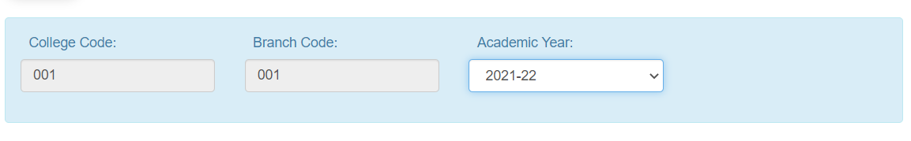

**Step3: A list will be displayed.**   
**No is mentioned if the student is not promoted to 6th sem directly.**  
**Yes is mentioned if the student is promoted to 6th sem directly.**

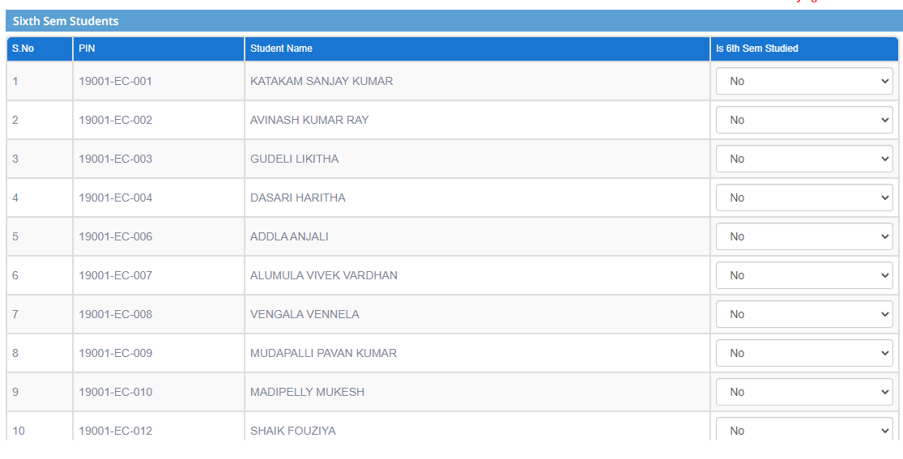

**Step4: To edit the changes change the option by using dropdown**  
**Click on Submit button**  
**Click on Save to save the changes made**

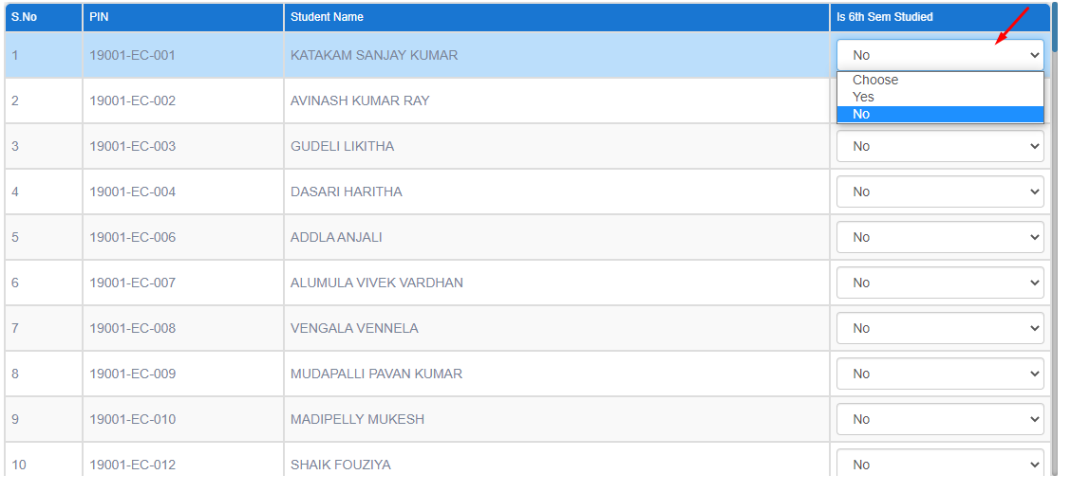

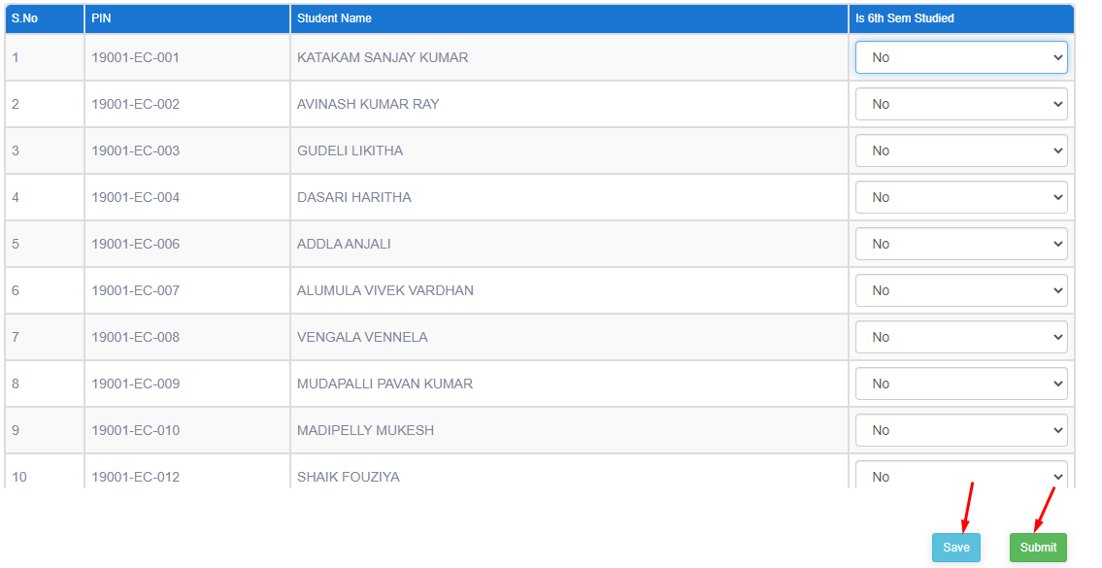

**5) Sub module name: Faculty Mapping**

**Description:**

This sub module used to get the status list of the syllabus covered by particular staff

**Navigation steps**

**Step1: Open Faculty Mapping**

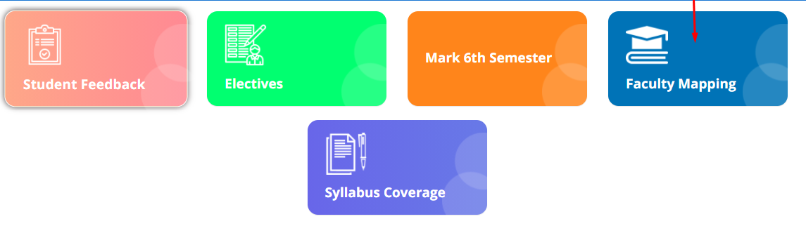

**Step2: Select the fields scheme, semester and shift from dropdown**  
**Click on Get mapping list**

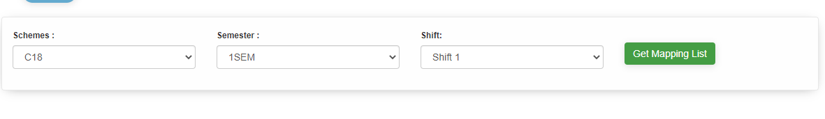

**Step3: student and staff list are displayed**

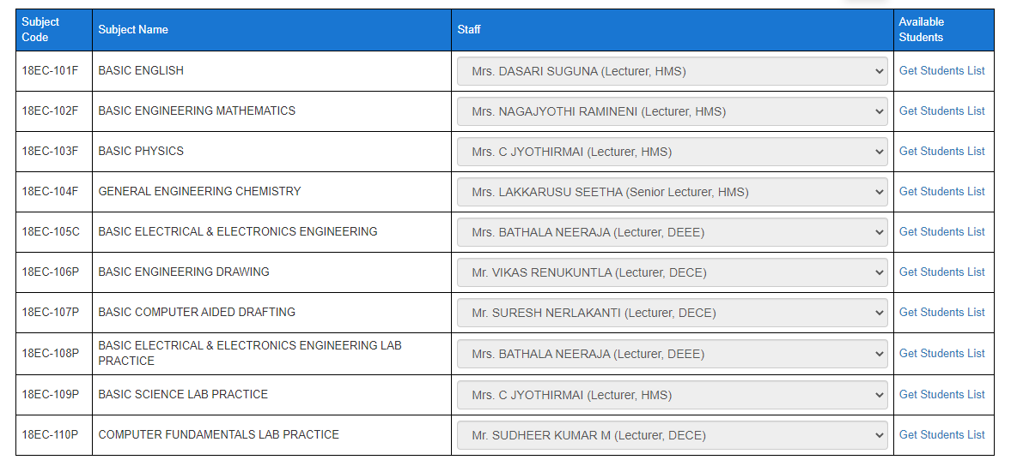**Step4: Click on Get student list to get the list of available students**

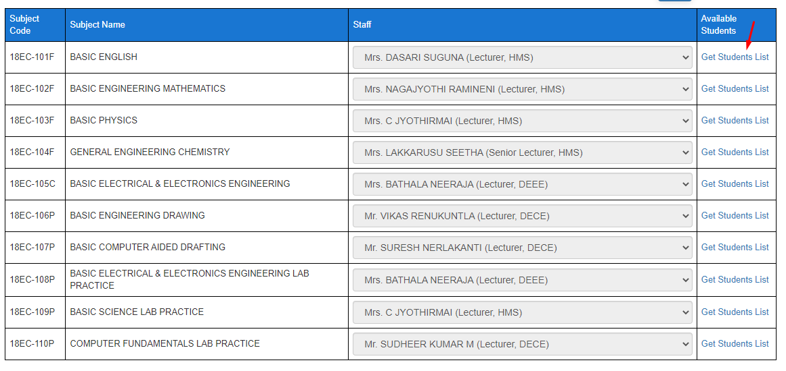

**Step5: Click on Edit button to change the staff name if required.**  
**Save the detail after editing the changes**

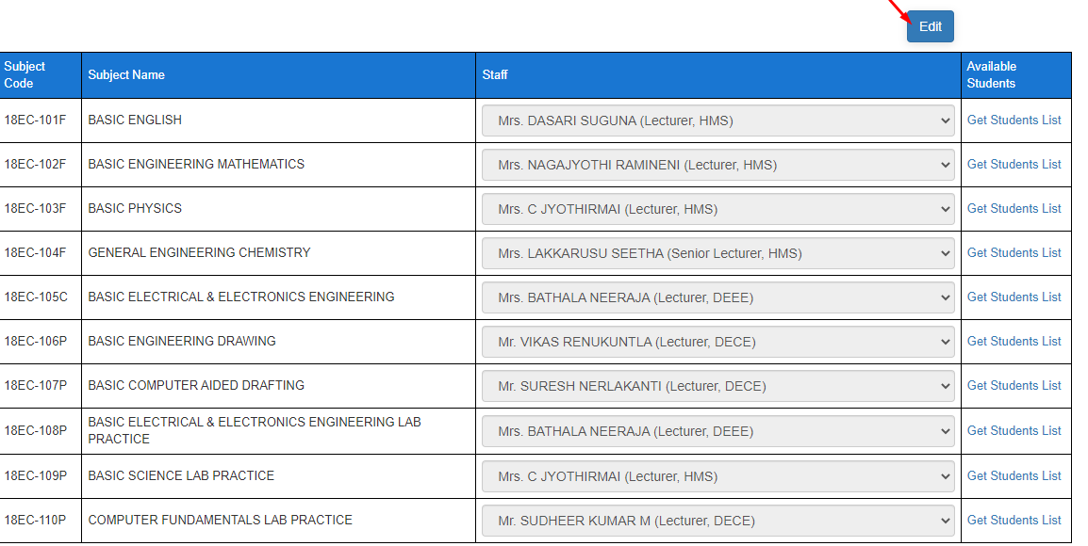

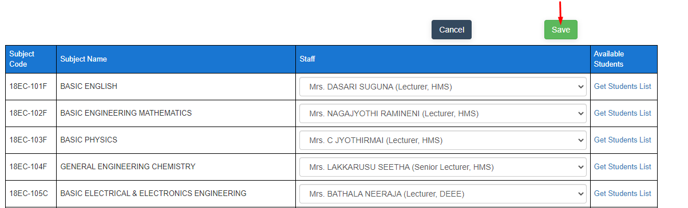

**Principal Login**

**Module Name: Academic**

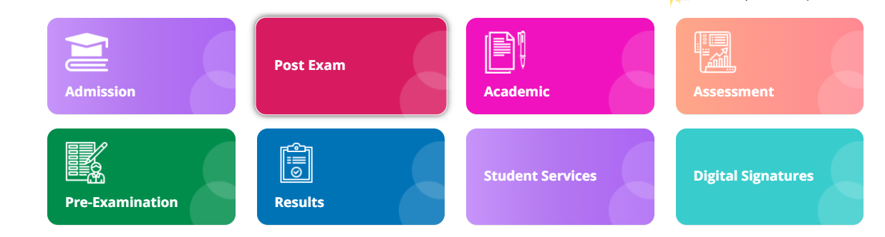

**Module Description:**

**Academic** module consists sub-modules namely **Mapping reports and Syllabus Coverage**

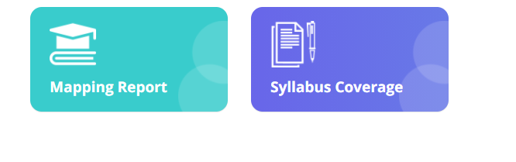

**1) Sub module name: Mapping Reports**

**Description:**

This sub module is used to get the fee payment reports

**Navigation steps**

**Step1: Open Mapping Reports**

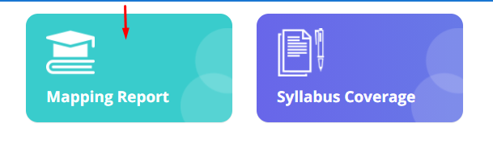

**Step2: Select the scheme and shift to get the mapping reports of the branches for different semesters.**

**Click on Show Results**

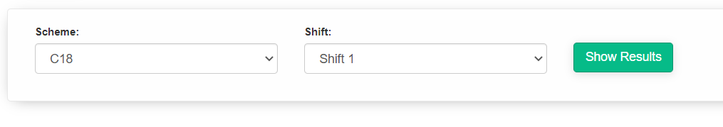

**Step3: The results will be displayed.**

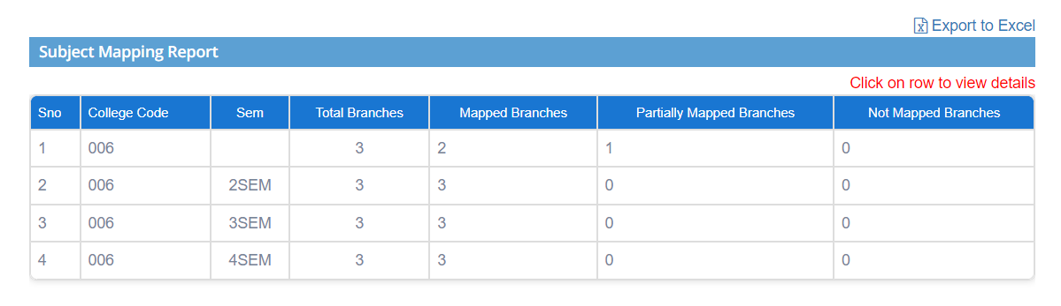

**Step4: By clicking on the row, we can get the details of non-mapped subjects and branches if any colleges are partially mapped(i.e if it is 1)**

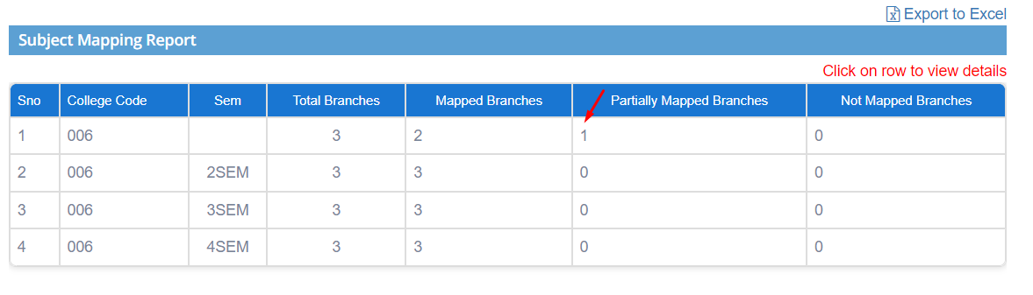

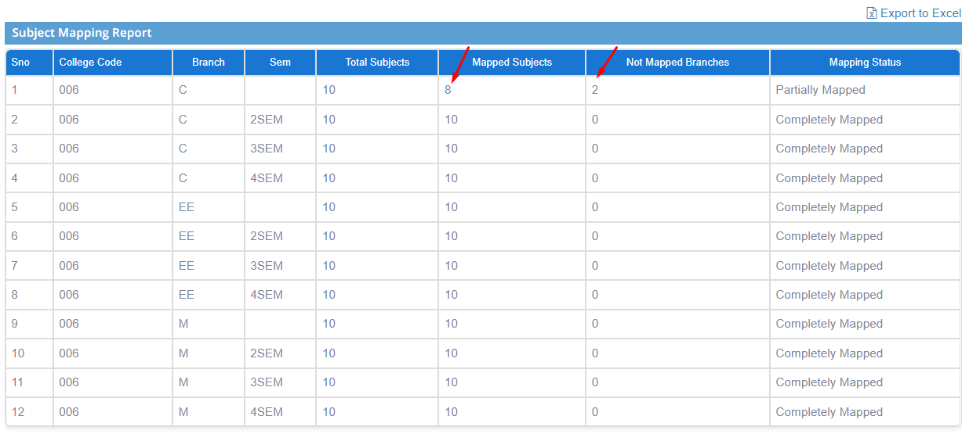

**Step5: The results can also be downloaded in excel format.**

**Click on Export to Excel. The excel will be downloaded as is shown in the second image.**

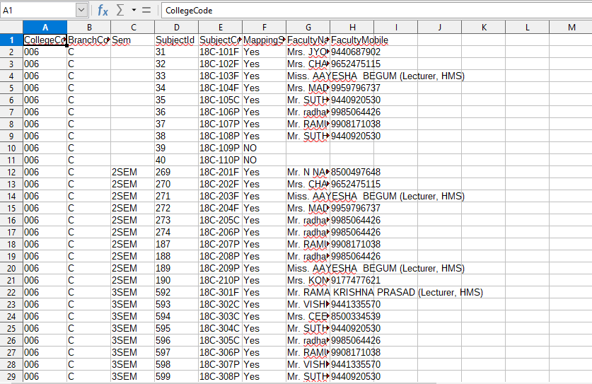

**2) Sub module name: Syllabus coverage**

**Description:**

This sub module is used get the report of the syllabus covered by the colleges for different courses

**Navigation steps**

**Step1: Open Syllabus coverage**



**Step2: Select the shift from the dropdown and click on submit.**

**The overall syllabus reports with all the details will be displayed.**

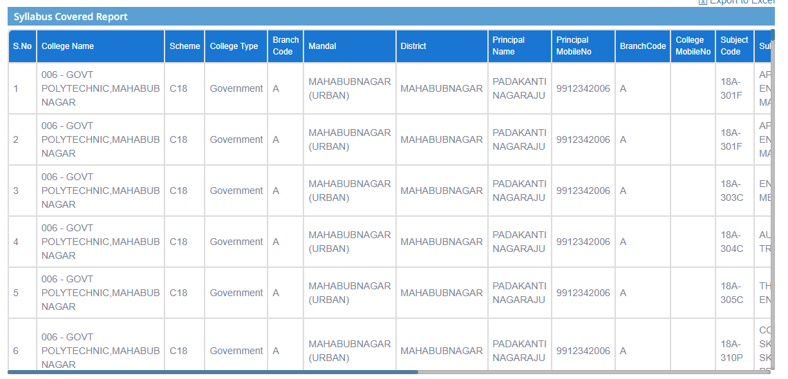

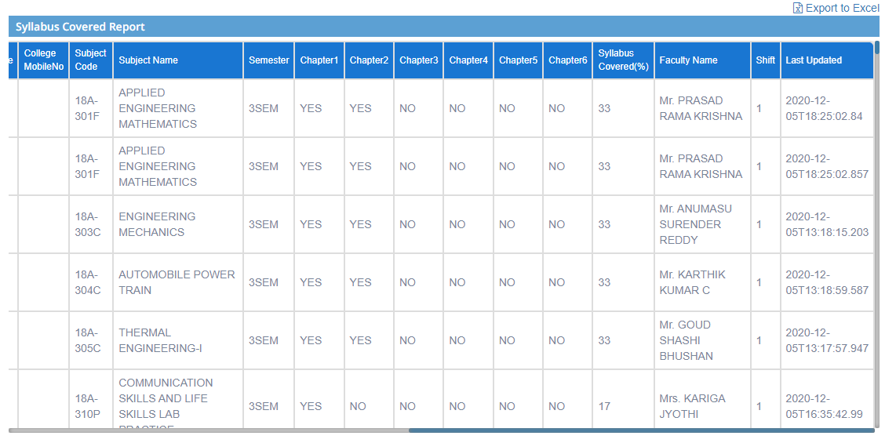

**Step3: The report can also be downloaded in excel format.**

**Click on Export to Excel. The file will be downloaded.**

